Week 7
Rights

Day 1

NAME:______________________

Day 1 Agenda

Topic | Activity
Warm-Up!
English Language Arts | - Read and reflect upon Maslow’s Hierarchy of Needs  - Read background information on the creation of the Universal Declaration of Human Rights  - Respond to questions about the readings and reflect on how human rights apply to them personally.
Science | - Read about Climate Change as a Human Right  - Answer questions about what you read  - Draw a picture and explain
Mindfulness Moment!
Math | - Rights-the Math of Independence thru the Civil War/Voting
Health | - Digital Rights: Privacy
Mindfulness Moment!
Civics/Social Studies | - The Bill of Rights

Warm-up Activity: Write a journal entry around the daily quote on identity.
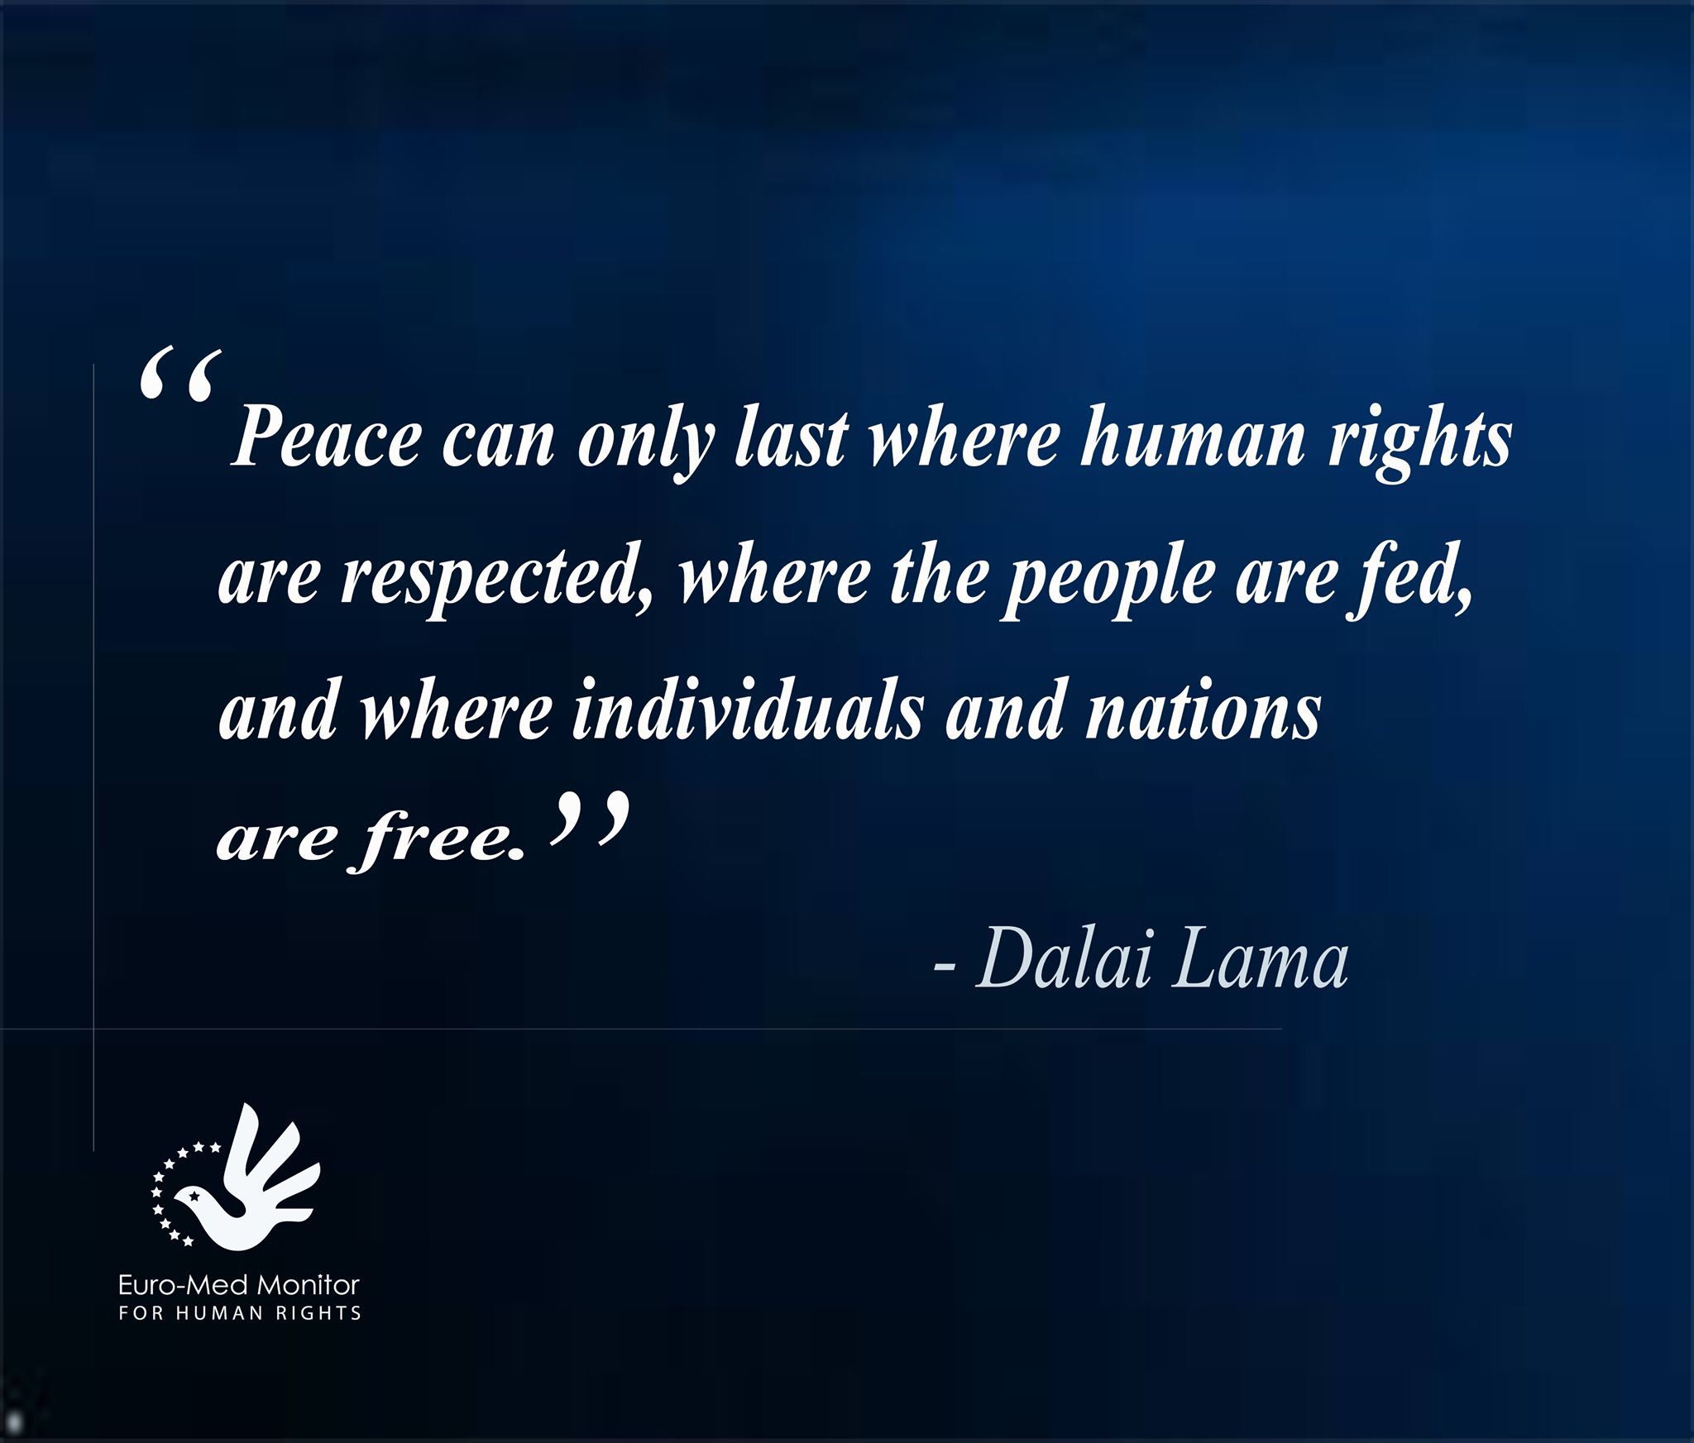

Day 1: Human Rights
English Language Arts

What is this lesson about? Over the next week, you will be reading, thinking, talking and writing about “rights”. When we think about rights, it is necessary to make a distinction between wants and needs. While many of us may want certain things, rights really address what you need to live life as a human being with dignity.

Step 1: Read, Think, Write
In 1943, American psychologist, Abraham Maslow, stated that healthy human beings have a certain number of needs, and that these needs are arranged in a hierarchy (an order) , with some needs being more basic than others). Maslow’s so-called ‘hierarchy of needs’ is often presented as a five-level pyramid. The bottom four levels of the are basic needs. A person does not feel anything if they are met, but becomes anxious if they are not. The fifth level of the pyramid is a ‘growth need’ because it enables a person to ‘self-actualize’ or reach his fullest potential as a human being. Once a person has met his basic needs, he can turn his attention to self-actualization. Only a small minority of people are able to self-actualize because self-actualization requires uncommon qualities such as honesty, independence, awareness, objectivity, creativity, and originality.

Look at the diagram below that outlines Maslow’s Hierarchy of Needs:

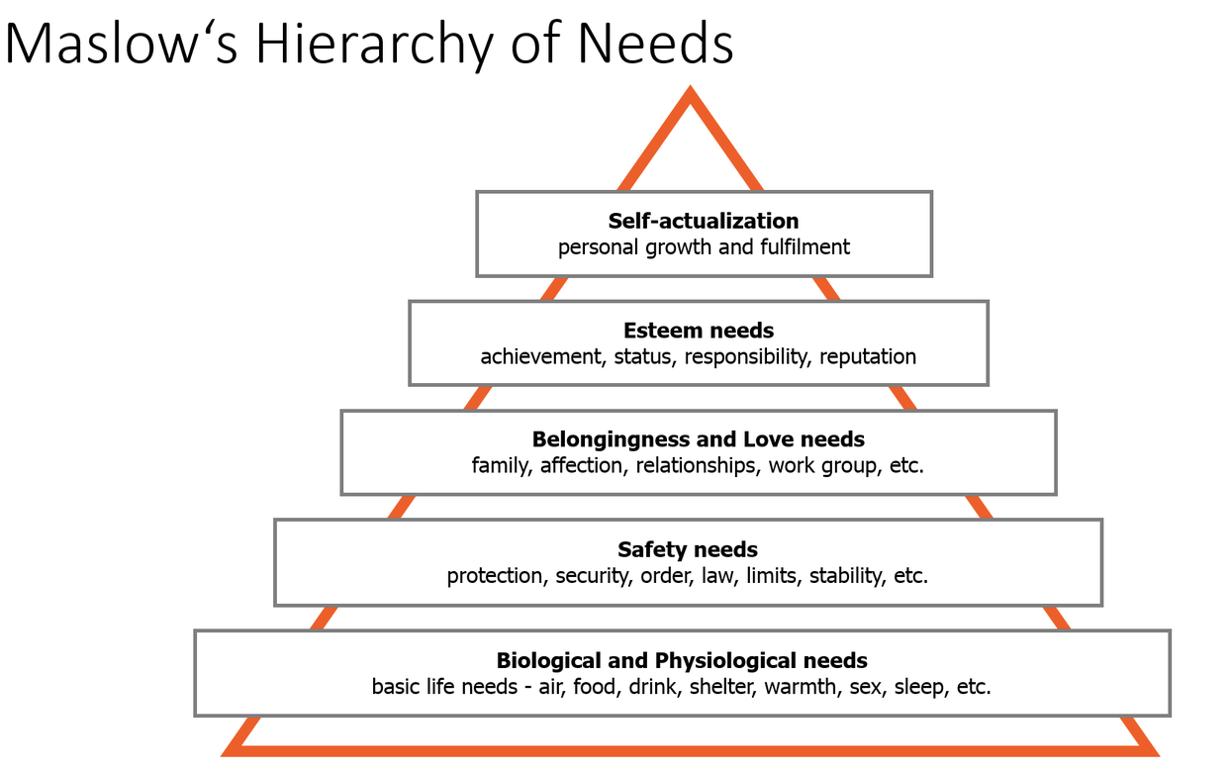

Write about Maslow’s Hierarchy of Needs.

Do you agree that people need to satisfy basic needs before they can think of other needs or wants? Look at the order--Maslow indicated that the most basic or important needs are on the bottom and the level of need is less the higher you go on the pyramid. Do you agree with this order? Why or why not? If these are considered “universal” needs, how do you think this connects with the idea of the rights that every human deserves? There is no right or wrong answer. Just write about what you think.

Step 2: Discuss with a partner or with the group
Share your writing with a partner and look for ideas you have in common.

Step 3: Read and Annotate the Informational Text Below

Before you read: Some vocabulary and references to understand:

United Nations: organization made up of 193 countries that aims to maintain international peace and security, develop friendly relations among nations and international cooperation. | genocide: the deliberate killing of a large group of people, especially those of a particular ethnic group or nation. | gypsies: a member of a traveling people traditionally living by trade and fortune telling. Gypsies speak Romany and are believed to have originated in South Asia.
refugees: a person who has been forced to leave their country in order to escape war, persecution, or natural disaster. | delegate: a person that represents others, in particular an elected representative sent to a conference. | mutual:held in common by two or more parties
taboo: banned on grounds of morality or taste | composite: made up of various parts or elements. | ponder: think about
persecution: oppression or mistreatment because of race or political or religious beliefs. | consciousness: the state of being awake and aware of one's surroundings. | legacy: something or consequence that has been handed down by those that came before
universal: affected by all people or things in the world |  | concentrated: intense

Less than three decades after the First World War, in which more than 18 million soldiers and civilians were killed, Europe was once again in a World War. World War II, which pitted Germany, Japan, and Italy against Great Britain, the United States, and the Soviet Union, was not only a global war, it was a total war in which each nation's entire human and material resources were called into service. About 70 million civilians and fighters were killed, making World War II the deadliest conflict in human history. Millions were left homeless, and millions more began an uncertain life as refugees.

Only when Germany was defeated in May 1945 did the world fully understand the cost of 6 years of warfare: mountains of corpses, entire cities demolished, nations traumatized by the use of violence against civilian populations. Only then did world leaders realize the human cost of 12 years of Nazi rule in Germany: the Holocaust-the genocidal murder of millions of Jews and gypsies and the persecution of homosexuals and other minorities, many of whom died in the last year of the war. In addition, the US firebombed the cities of Hiroshima and Nagasaki and destroyed 70 percent of all buildings and killed over 200,000 people These atomic bombs demonstrated that the world now possessed the tools of its own destruction. Eleanor Roosevelt, the wife of President Franklin Delano Roosevelt later reflected, "I think that if the atomic bomb did nothing more, it scared people to the point where they realized that either they must do something about preventing war or there is a chance that there might be a morning when we would not wake up."

The horrors of World War II reinforced the idea that the world needed to establish a global bill of human rights that would obligate "every state to recognize the equal right of every individual on its territory to life, liberty and property, religious freedom and the use of his own language." This idea was also one of the stated goals of the newly formed United Nations in 1945.

On joining the US delegation to the United Nations at the end of 1945, Eleanor Roosevelt described the enormous responsibility she and her fellow delegates faced: "The time has come... when we must recognize that our mutual devotion to our own land must never blind us to the good of all lands and of all peoples. In the end... we are "One World" and that which injures any one of us, injures all of us. Only by remembering this will we finally have a chance to build a lasting peace."

Her commitment to seeing beyond national interests drew her to the drafting of a Universal Declaration of Human Rights (UDHR). To protect its people and interests, every society develops written and unwritten codes spelling out the liberties, taboos, and obligations of its members. And as different societies and cultures encounter each other, they often seek to find common ground. Representatives from Asia, Europe, North and South America, and the Middle East (most of Africa was still ruled by colonial powers) argued not only about cultural issues but politics as well. After almost three years of negotiations that sometimes escalated into serious conflict, the Universal Declaration of Human Rights, which Eleanor Roosevelt described as a "composite" of international beliefs on the rights, freedoms, and dignity of human beings, became a reality. Thanks in part to Roosevelt's inspiring leadership, the General Assembly of the United Nations adopted the declaration on December 10, 1948.

But this was only a beginning. Roosevelt insisted that the document was designed to serve as the foundation for future human rights protections. And to serve this purpose, it needed to be brought to life, through educational programs, in the consciousness of citizens the world over.

Five years after the adoption of the Universal Declaration of Human Rights, Roosevelt again reminded her audiences that human rights are more than legal or political commitments. Such rights begin, she said, "in small places, close to home-so close and so small that they cannot be seen on any map of the world. Yet they are the world of the individual person: The neighborhood he lives in; the school or college he attends; the factory, farm, or office where he works. Such are the places where every man, woman, and child seeks equal justice, equal opportunity, equal dignity without discrimination. Unless these rights have meaning there, they have little meaning anywhere. Without concerted citizen action to uphold them close to home, we shall look in vain for progress in the larger world."

The Universal Declaration of Human Rights has inspired many individuals and policymakers around the world to work toward a better world. Today we ponder the legacy of this document Despite substantial movement toward equality and understanding, racism and its consequences continue to haunt communities and governments around the globe; wars targeting civilians continue to be waged; and the perpetrators of genocide, torture, and human rights violations often go unpunished.

Adapted from: https://www.facinghistory.org/universal-declaration-human-rights/introduction-universal-declaration-human-rights

Step 4: Answer the following questions.

- Why did the actions committed by the Nazis cause other nations to think of creating an international document about Human Rights?

- The United States’ bombing of Hiroshima and Nagasaki effectively ended WWII. Why do you think that the author says that these bombings scared everyone, including the U.S.?

- Eleanor Roosevelt stated that “we are “One World” and that which injures any one of us, injures all of us.” What did she mean by this?

4. Why was it important to have representatives from different cultures and countries to create a universal document like the Universal Declaration of Human Rights (UDHR) ?

5. Why did Eleanor Roosevelt feel that it was important to create educational programs about the UDHR?

6. Explain what Eleanor Roosevelt meant about the importance of Human Rights being honored in “small places” first, not just on the international level?

Step 5: Write
List three rights that you believe are most important and ALL humans deserve. Explain your choices. Why are these three the most important to you? How can NOT having these right affect others?

Student Feedback:
Circle the emojis that best represents how this activity made you feel. | 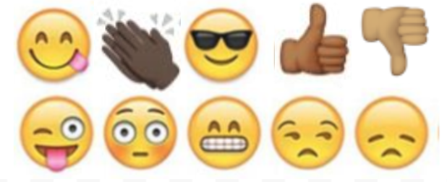  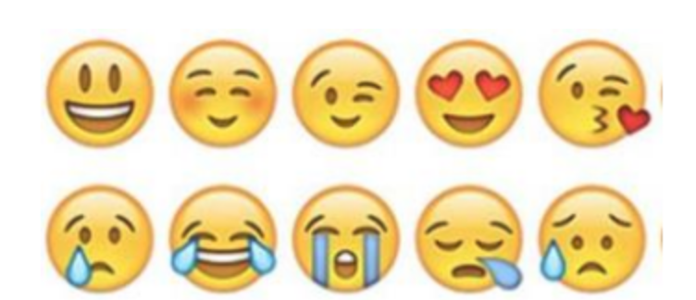

Day 1: Climate Change as a Human Right
Science

What is this lesson about?: Today you will read through the Climate Change is a Human Rights Issue passage. You will answer a few questions about what you read. You will draw a picture and write a response.

Step 1: Read through the Climate Change is a Human Rights Issue passage

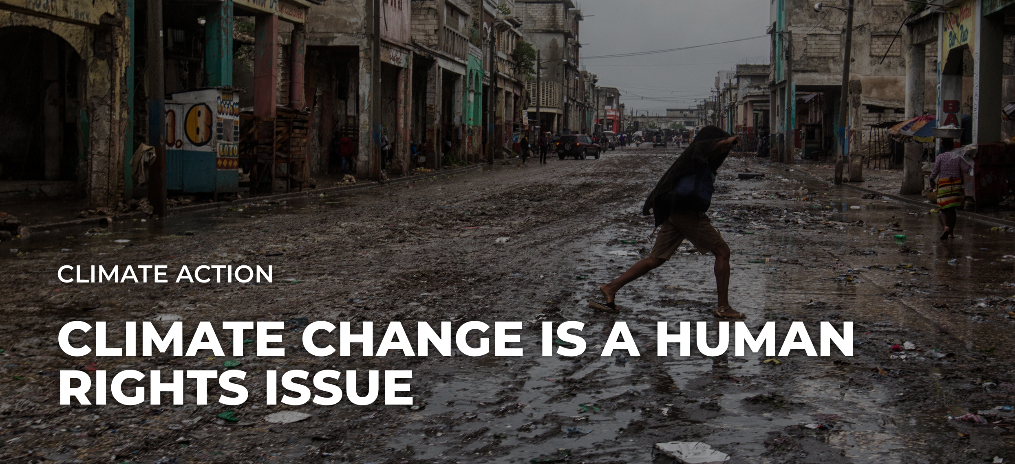
earthday.org (2019)
As the planet heats up, bringing with it more drought, famine and extreme weather events, people will be left without access to basic human needs. Millions of people will suffer and die because of climate change, and as political leaders drag their feet to act on humanity’s biggest threat ever, those numbers will only increase.

Climate change isn’t simply a political or economic issue. It’s a human rights issue, perhaps the biggest one in human history. If we continue spewing greenhouse gases into the atmosphere, we not only destroy ecosystems and drive species to extinction, we indirectly violate human rights.

Extreme weather events are more prevalent in a warming world, leading to death, destruction of property and crops and limited access to food, water, shelter, healthcare and education, as the United Nations Environment Programme outlined in its 2015 climate change and human rights report.

“We need to understand that environmental collapse generally, as well as climate change specifically, is completely a cross-cutting issue,” said Amnesty International Secretary-General Kumi Naidoo, on a October briefing call with Earth Day Network.

As world leaders enter the second week of the United Nations’ COP25 in Madrid, they must understand what’s at stake for humanity and the human rights threats if we continue to delay climate action. Many options lie ahead of us, but the most effective ones are those that reduce greenhouse gas emissions as fast as possible.
That said, humanity’s best-case scenario is to immediately transition into clean-energy economies, fair and equitable systems that don’t exploit lower classes but instead empower and enrich communities.

The worst-case scenario? Civilization, as we know it, collapses.

No matter the outcome, people will suffer. All that carbon dioxide in the air isn’t going away any time soon, even if we miraculously stopped spewing the stuff into the air tomorrow. The impacts from the greenhouse gasses currently in the atmosphere will be felt for decades.

“Today, climate change … constitutes a mass death penalty facing all the people on this planet,” said Naidoo.

Any amount of suffering that can be averted by curbing greenhouse gases, therefore, is something we should strive for. Every hundredth of a degree increase matters.

A panel of human rights experts attempted to make this point and accelerate climate action last year at the United Nations’ COP24 in Poland. They released a joint statement urging countries to achieve an emissions target of 1.5 degrees Celsius above pre-industrial levels, as well as “to commit to urgently increase their ambition, given the grave nature of the climate crisis and the pressing need for scaled-up mitigation efforts.”
Today, climate change … constitutes a mass death penalty facing all the people on this planet. Kumi Naidoo, Amnesty International Secretary-General
As climate change intensifies, people will be forced to adjust, investing billions of dollars in infrastructure or migration. Those who have more money can afford to move out of harms’ way. And those historically neglected or marginalized in society will only be further disadvantaged and threatened in a warming world.

Climate change doesn’t treat everyone equally. Low income communities, people of color and women will all be disproportionately affected as global temperatures rise. The inequality of climate impacts could be a continued hindrance to the progress of climate action.

As Naidoo said, “Sadly, there probably would have been more urgency if the people that were dying first in the largest numbers were people in the most powerful countries.”
Women and children are 14 times more likely to die in climate change disasters, according to the U.N. Women make up most of the world’s poor, and women tend to rely more heavily on natural resources for their livelihoods and societal gender roles.

When Hurricane Maria hit Puerto Rico, for example, women worked overtime to prep houses before the hurricane hit and rebuilt houses after they were demolished. The additional domestic work — with fewer resources — can make it difficult for women to recover financially.
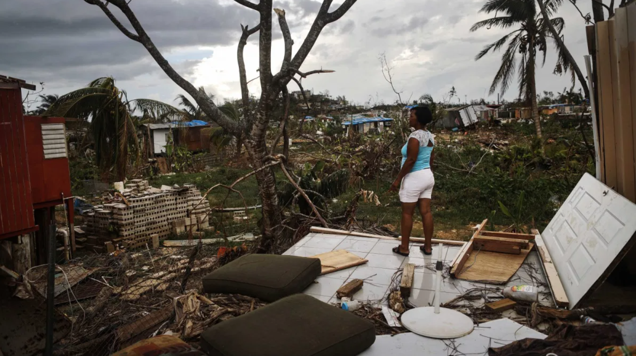
But women and girls may also be a powerful, untapped climate solution: Research organization Project Drawdown lists educating girls as the sixth-most most impactful solution to reducing total atmospheric CO2.
In cities, it’s another story. Air pollution and the heat island effect disproportionately hurt people of color. A 2017 report by the NAACP and the Clean Air Task Force found that black Americans breathe air that’s nearly 40 percent more polluted than white Americans. People of color are also at least 75 percent more likely than other Americans to live in communities that border oil and natural gas refineries.

To level the playing field, we must recognize the double-edged sword of climate change, which both violates human rights and disproportionately affects communities that are already most vulnerable.

“We need to fundamentally change our system on collaboration and equitable development in all parts of the world,” said youth climate activist Jerome Foster II, in an interview this year with Earth Day Network. “Not seeing other countries as a handout, but as responsible to make sure that the entire world is fair and equal.”

One way to work toward a more just, equitable society is for countries to meet their commitments under the Paris Agreement and contribute to the Green Climate Fund, established to limit greenhouse gas emissions in developing countries and help vulnerable societies adapt to climate change.

Recent climate strikes — coordinated by organizations like Fridays for Future, Extinction Rebellion and Sunrise Movement — should make us more optimistic for the future, but they are only a start. Climate change is a global problem that needs global solutions. Everyone, world and youth leaders alike, must be on board to make meaningful change. The future of humanity is on the line.

As climate activist and indigenous hip-hop artist Xiuhtezcatl Martinez told Earth Day Network in September, “For us this is about our survival. This is not just about our future, our future generation. This is about the lives that are being lost today and the people that are being displaced today.”

Step 2: Answer the following questions

According to the article you just read:

- What is the most effective way to delay climate action?

________________________________________________________________________________________________________

- What communities are most vulnerable to climate change? Why?

________________________________________________________________________________________________________________________________________________________________________________________________________________

- What suggestions do you have to help our environment and world?
________________________________________________________________________________________________________________________________________________________________________________________________________________

Step 3: Draw a picture and describe

Draw a picture of your community or world that is not negatively impacted by climate change.

What do you notice about your picture and the pictures in this article?

________________________________________________________________________________________________________
____________________________________________________________________________________________________________________________________________________________________________________________________________________________________________________________________
________________________________________________________________________________________________________________________________________________________________________________________________________________

Student Feedback:

Circle the emojis that best represents how this activity made you feel.

Mindfulness Moment!

Breathing Exercise
To do it:
- Relax your neck and shoulders.
- Keeping your mouth closed, inhale slowly through your nose for 2 counts.
- Pucker or purse your lips as though you were going to whistle.
- Exhale slowly by blowing air through your pursed lips for a count of 4.

Day 1: The Math of Voting: Independence thru the Civil War
Math

What is this lesson about?: In this lesson we will focus primarily on the math of voting during Independence and early years of the United States.

Warm Up Problem-
If Manny gets 20 out of 25 correct on a math test, what grade does that come out to? What percent of the problems did he get correct?

Randy saved $40 in March. In April he saved $50. He saved $10 more in April. But by what percentage did his savings go up by?

Activity #1: Voting and population around 1776

At the time of the American Revolution in 1776, voting was restricted to while male landowners of Protestant faith. Historians estimate that at the time of the Revolutionary War between 10-15% of the population was eligible to vote in the various colonies. Use the chart below to answer questions.

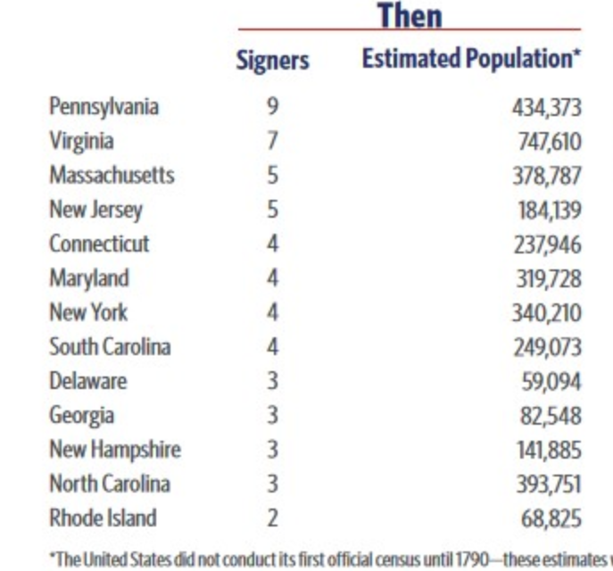

All total, it is estimated that just over 2,500,000 people were living in the US in 1776. Assuming that 10% of them were eligible to vote, how many people was that?

If that 10% figure held across the colonies, how many people would have been eligible to vote in Georgia in colonial elections, about the time of independence?

How would that have compared to Massachusetts?

Activity #2: Women voters in New Jersey

In 1787, with the passage of the US Constitution and Bill of Rights, voting standards were left to each state in the union. All states except New Jersey continued to restrict voting to white male Protestant landowners, which allowed women of all races who owned property to vote as well.

The brief history of how women were granted the right to vote in New Jersey specifically is not widely known. But there are records of white women voting. To date, there is no record of African American women voting in this time period.

Based on 18 New Jersey poll lists from between 1797 and 1807, nine (9) included women’s names.
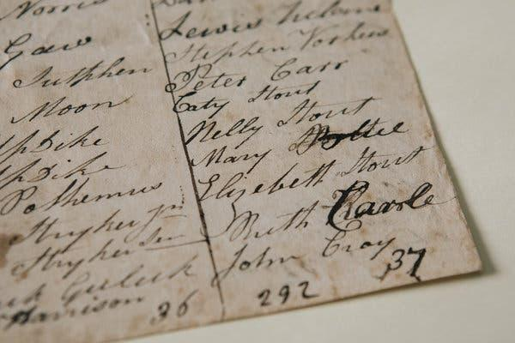

But overall, researchers found that only about 7.7 percent of total votes recorded were cast by women in New Jersey.

- Assume there were approximately 200,000 people living in New Jersey in 1780.
  - If 10% of them voted, how many would that be?

  - And if only 8% of that number were women, about how many women voted, all total in New Jersey?

In the late 1790s, womens’ right to vote began to unravel in New Jersey, amid charges of voter fraud, which coincided with the rise of contested elections and sometimes vicious party politics. More than one election brought complaints of men rounding up carriage-loads of eligible women and bringing them to the polls, to help push their candidate over the top. In 1802, a candidate claimed that he lost a legislative race by a single vote only because a married woman and an enslaved woman had illegally cast ballots.

Finally, in 1806, came a bitterly fought election in Essex County, New Jersey, to decide where a new courthouse would be built. Nearly 14,000 votes were cast — more than the number of eligible voters. The finger was pointed at fraudulent voting by women (and African-Americans, for which there is no record of any voting). So, in 1807, the law was changed to explicitly limit the vote to white men, while also loosening the property requirement. Use the table below to answer a few questions about the voting results from the 1806 election in Essex County.

Eligible Voters, approx # (1800) | 13620
Votes Cast | 14400
Women Voters | 2160
Male Voters | 12240

How many more votes were cast than persons registered?

Approximately, what percentage of the voters were women?

Why do you think so many more men than women voted?

Why do you think, would women and African Americans be blamed for voter fraud?

Activity #3: The Three-Fifths Compromise

The most controversial of all compromises between the North and South, proposed in 1783 as a part of working toward a constitution, was the Three-Fifths Compromise, an agreement to count three-fifths of a state's slaves in apportioning representatives, presidential electors and direct taxes.

This meant that although slaves were NOT allowed to vote, they counted (at a 3/5s rate) when determining the number of representatives each state got to send to the US House of Representatives.

Estimated Population 1780
State | Population | Black | Pct. Black | White | Pct. White
North
New York | 210,701 | 21,054 | 10 | 189,647 | 90
New Jersey | 139,627 | 10,460 | 8 | 129,167 | 93
Pennsylvania | 327,805 | 7,855 | 2 | 319,950 | 98
Connecticut | 206,701 | 5,885 | 3 | 200,816 | 97
Rhode Island | 52,946 | 2,671 | 5 | 50,275 | 95
New Hampshire | 87,802 | 541 | 1 | 87,261 | 99
Massachusetts | 268,627 | 4,822 | 2 | 263,805 | 98
Total | 1,294,209
South
Virginia | 538,004 | 220,582 | 41 | 317,422 | 59
South Carolina | 180,000 | 97,000 | 54 | 83,000 | 46
Maryland | 245,474 | 80,515 | 33 | 164,959 | 67
North Carolina | 270,138 | 91,000 | 34 | 179,138 | 66
Georgia | 56,071 | 20,831 | 37 | 35,240 | 63
Delaware | 45,385 | 2,996 | 7 | 42,389 | 93
Total | 1,335,072

Based on this estimated population chart, above, for 1780, answer the following questions.
What southern state had more African American slaves than whites in 1780?

- All total, about how many African American slaves lived in the 6 southern states in 1780?

- About how many whites lived in those same 6 southern states at that time?

Based on the three-fifths compromise, slaves in the southern states would ‘count’ when it came to deciding on Representatives to Congress even though they could not vote locally.

- Compare the white and black population of South Carolina to Connecticut.

Connecticut: Black Population ______________ White Population _____________

South Carolina: Black Population ___________ White Population_____________

- Compare the overall population of those same states in 1780.

- Which state would have more representatives in Congress.

- Does this seem fair?
  - To residents of Connecticut?

  - To white representatives of South Carolina?

  - To African Americans from South Carolina who ‘counted as ⅗ of human, but could not vote?

Activity #4: Expanding voting rights--to nearly all white men

By 1828, all of the states in the union had amended their state constitutions to remove the limits on any religious groups from voting. And by 1828, it is estimated that nearly 35% of US citizens were eligible to vote, up from 10-15% in 1776.

By 1856, just prior to the Civil War, all states (North Carolina being the last) had amended their constitutions, removing the property-holding requirement.

African Americans and women could still not vote, but all white men over 21 could. The map below shows the percentage of the population in the southern states in 1860, just before the start of the Civil War. Use the map to answer the questions below.

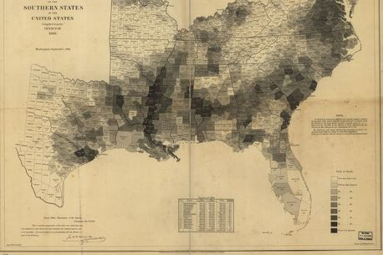
It is hard to see the details of this map, which is an original. But the dark shaded areas represent areas where up to 90% of the population was held as slaves. All together, there were almost 4 million slaves just before the start of the civil war.

- List 2-3 geographic areas where the population was 90% or more slaves?

- Remember back to last week when we studied how the prison population gave voting power to areas with prisoners who could not vote. How does slavery and the 3/5ths rule do the same thing concerning voting rights to those not imprisoned and not enslaved?

Student Feedback:
Circle the emojis that best represents how this activity made you feel.

Day 1: Digital Rights- Privacy
Digital Health

What is this lesson about?: Today you will learn about your digital rights. We will focus on digital privacy and identify your rights. Exploring your rights through the lens of what parents post on social media.

Step 1: What are digital rights?

Digital Rights and Responsibilities:
Every digital citizen is granted rights while in the digital world. These include, but are not limited to: privacy, freedom of speech, the right to internet access, freedom of assembly online, and the right to develop their internet infrastructure.
Answer the question below:
Which of the digital rights explained above are most important to you? Why?

Step 2: Read the article on your digital rights

Alison Santighian flicks her finger over her smartphone screen, and her Facebook profile scrolls past in a blur. She is looking for a particular photo from a few days ago, a picture her 9-year-old son, Arsen, didn't want her to take.

"Found it!" she says, as Arsen, sitting on the family's patio at their Bethesda, Maryland, home, peers over her shoulder. "He looked very handsome that day," Alison explains, and Arsen rolls his eyes. He was dressed in a dapper white suit for a piano performance, and when Alison asked him to pose for a picture that she could share with her Facebook followers, Arsen said he'd rather not.

In the end, they landed on a compromise, and Arsen did strike a pose, by slumping in his seat with a piano music book tented over his face, his expression hidden.
There have been more negotiations like this lately, as the Santighian kids - Arsen and his 11-year-old sister, Elsa - have begun asking questions and expressing opinions when their parents decide to share a photo or personal anecdote on social media. Such conversations have become a nearly ubiquitous rite of passage among families where children of a certain generation - the true digital natives, many of whom may have debuted on Facebook before exiting the womb - are now old enough to have their own ideas about what they want their online presence to look like, and who has the right to define it.

At first, the choice belongs to parents alone since an infant can't object to a soft-filtered selfie with mama; or a toddler won't know if their tantrum becomes a topic of online commiseration. But when, exactly, does it start to change? Is there a turning point somewhere between first steps and first school dance, a clear moment when one's offspring becomes an independent being whose experiences belong to them, too, and not just to a proud (or confounded, or frustrated) parent who just wants to boast (or inquire, or vent)?

The stakes of this particular familial conflict are poised to increase as more members of Gen Z - a generational cohort that the Pew Research Center defines as those age 22 and younger - come of age. Children might first be concerned about what their friends think of a parent's posts or pictures - but later, new concerns are added to the mix: If you made a joke that your dad shared on Twitter, will a college-admissions officer think it's funny? If a potential employer Googles your name, would they find pictures of you and your sister in bathing suits at the beach?

Alison and her husband, Pete, think the line of authority begins to blur a bit as kids become teens and inch closer to legal adulthood. For now, when Elsa and Arsen object to a photo or a social media post, they are encouraged to explain why, and Pete and Alison take those points seriously.

But ultimately - in this household, at least - the parents make the final decisions, and they don't have to ask permission.

"We do post things that they don't know about," Alison says. "Cute pictures of them sleeping, for example."

"Oh, I know about that," Elsa corrects her. "It's kind of creepy, if you think about it." She smiles and shrugs. "But I'm fine with it."
"Why is it creepy, Elsa?" Pete asks.
"Because you're in your sleep," Elsa says.
"We look at you all the time when you're asleep!" Alison says.
"That's looking," Arsen interjects, "not posting."

Alison and Pete consider this for a moment. Alison laughs and starts nodding.
"You know," Pete says, "that's a good argument."

When Stacey Steinberg began the research that would make her a leading expert on "sharenting," she felt sure that - as a lawyer who had prosecuted child abuse cases - she'd wind up concluding that parents really shouldn't post anything about their children online.
"But what I really found in my research, and in my own life - because I'm a mom who shared on social media - is that there are so many benefits that come from sharing our stories," she says. "If we were to silence our voices as parents, I think our families would miss out on opportunities to connect, and society would miss out as well."

Parents offer a myriad of reasons for wanting to share their experiences on social media: There's a sense of community there, a source of solidarity and support amid the triumphs and pitfalls of parenting. It's a way to keep far-flung relatives in the loop. It's a journal, a photo album, a memory box where the magical and mundane moments of fleeting childhood can be revisited again and again with the tap of a finger.

To whom do those memories belong?

"When kids are really little, their story is so connected and embedded with a parent's story," Steinberg says. "Then it gets more complicated as they get older, as they have their own digital identity, and they have more of an interest in controlling what that identity looks like."
Viji Sathy, a photographer and educator in Chapel Hill, North Carolina, sensed this shift in the past year, as her 10- and 12-year-old boys began responding to her camera with a certain wariness.

"They started asking, 'Are you going to post that?' " she says, "and once I got that from them a couple of times, I started asking them, 'Is it okay if I share this?' "

Usually, it is. But sometimes - like when the boys have impromptu jam sessions together on saxophone and piano - they ask her to refrain from recording them. (A video feels more personal and invasive than a photo, they say.)

Sathy has been sharing her family's story through images and video since her boys were infants, "so it's hard for me to surrender that control, because this is something for me, too," she says. "But we talk about the importance of consent in general, and this is another example of how we respect consent and model it for our kids."

That was the precise word used by the actress Gwyneth Paltrow's teen daughter, Apple Martin, who sparked a fervent debate about online privacy when she issued a pointed, public callout to her mom after Paltrow shared a photo of the pair on a ski trip in March.

"Mom we have discussed this," Martin wrote in a comment on Paltrow's Instagram post. "You may not post anything without my consent." (Paltrow posted in response, "You can't even see your face!" )

A torrent of judgment swiftly followed, with thousands of commenters weighing in: Martin was being unreasonable. Paltrow was being irresponsible. Martin had a right to her privacy. Paltrow had a right to her parental pride.

Most kids don't have Hollywood A-lister parents with 6 million Instagram followers. But many of Martin's Gen-Z peers share a desire to curate their own online image, says Jason Dorsey, president of the Center for Generational Kinetics, a global Gen Z and millennial research and consulting firm. The company conducted a survey of thousands of members of Gen Z across the United States, Europe and Australia last year, and found that they are especially savvy about digital privacy on social media.
"These are kids who have always been on social media through their parents, and for a long time, some kids might think that's cool: 'How many likes did we get?' It's almost like a game," Dorsey says. "But what happens is those same kids then become tweens and teens and have not only more awareness about the positives and negatives of social media, but they have all the normal questioning of identity and body image, and now they're very aware of the message that they're sending to the world."

And kids - even young kids - want more control over that message.
"I think that everything that's a picture of me, I have the right to veto," says Sathy's 10 year-old son, who asked not to be named to protect his privacy. "I mean, it's me, isn't it? I should get to control what is shared about me."

In general, Steinberg says she thinks parents should defer to their kids. But there will always be exceptions, she adds. Say, for instance, that a child doesn't like how he looks in a group photo at a family wedding; that picture might be shared anyway.

"What I've learned over time is that this isn't a black and white issue, this is a complicated issue," she says. "They might be the first generation of kids who are growing up with a digital footprint, but we're also the first generation of parents trying to navigate these new seas in our parenting repertoire. Every family needs to talk about it, but I don't think every family needs to come up with the same answer."

For Paltrow, the answer was to leave the disputed Instagram post in place - but to make sure that her daughter's 15th birthday photo was "Apple-approved." (Paltrow included an image of a text exchange to prove she'd obtained Martin's consent.)

Stacey Ferguson, co-founder of the popular Blogalicious online community and conference and a mom of three in Maryland, says she also favors kid-approved photos when she posts to her public Instagram account, where she has nearly 5,000 followers.

But she made a rare choice to overrule her oldest daughter's wishes during a recent spring break trip, when Ferguson posted a picture of her 14-year-old "and she had a meltdown," Ferguson says. "She said, 'You have to take it down, it's awful!' "

Ferguson didn't take the photo down. "I don't want to embarrass her, but she truly looked fine, and I wanted her to know: Even though, in your teenage mind, you think you look bad, you look great," she says. "I didn't want to reinforce that self-consciousness, that concern about 'What are people going to think, how do I look?' And she got over it quickly - she said, 'Fine, Mom,' and moved on."

For Doug French, a single father of two in Ann Arbor, Michigan, who began blogging about fatherhood in 2003 and co-founded the Dad 2.0 Summit, an annual conference about dads, marketing and media, the answer has been to let his 14- and 17-year-old sons have the final say over what he shares.

"I like to post quotes of Robert's on Facebook, because I want to chronicle them; he's funny," French says of his older son. "But anytime he says something that I want to quote, I run it past him first. And there have been a couple he didn't want me to post."
And that should be enough, Robert says.

"In this age, you have to watch your image, and that extends to what your parents post about you, and it's not fair for your parents to be defining your image for you," Robert says. "So when a kid objects, a parent should listen, and yield."

Step 3: Answer these questions about the article above.

- Do you think parents can just post pictures of their kids without getting their permission first?

- How old do you have to be to give permission for your own content?

- What age do you think you crafted your own digital identity? Why?

Step 4: Design a rule book for parents. This should include all the rules about the privacy of their own kids.

Mindfulness Moment!

Draw Your Breath
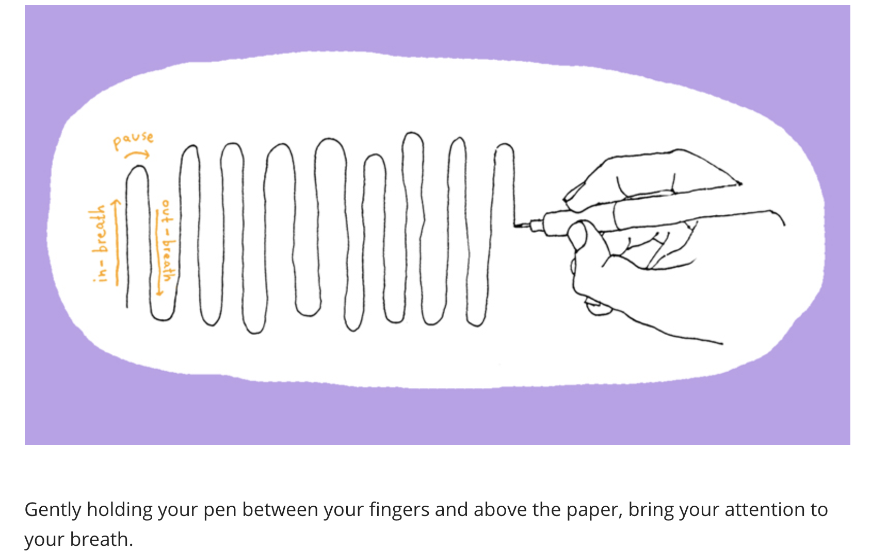

Day 1: The Bill of Rights
Social Studies

What is this lesson about?: Today you will get an introduction to the Bill of Rights in the U.S. Constitution and learn about the rights it protects.

Step 1: Warm-Up

After the Declaration of Independence in 1776, the Founding Fathers began working on state and federal constitutions. Although a bill of rights was not considered to be important at first, supporters realized it was crucial for ratification. Due largely to James Madison, the Bill of Rights officially became part of the Constitution in December 1791. The Bill of Rights consists of the first 10 amendments to the U.S. Constitution.

Can you name any of the rights or freedoms in the Bill of Rights?

Step 2: Read the Article

Give the people what they want: A bill of rights
By Virginia Calkins, Cobbleston Magazine
On a bitterly cold night in January 1789, James Madison suffered a frostbitten nose. It happened while he was campaigning in his Virginia district for the House of Representatives of the First Congress of the United States. Madison and his opponent, James Monroe, had stood outside a church to publicly debate the issues of the campaign. By the time Madison had finished his long ride home afterward, his nose was frozen.
No one expected Madison to win the election. The voters wanted amendments to the Constitution guaranteeing individual rights, and Madison's enemies had spread rumors that he opposed them. At first, Madison had doubted that such amendments were important. But now he supported them, in part because Thomas Jefferson had praised them in his letters from Paris, where he was serving as U.S. ambassador. Madison also realized that it was what the voters wanted. To make his position clear, Madison was traveling throughout his district, promising the people the amendments they wanted.
Madison won by a comfortable majority and in the spring of 1789, began his congressional duties in New York. By the time he arrived there, he had prepared a list of amendments to the Constitution. Most came from the Virginia Declaration of Rights, but some were from other states' bills of rights. All had been taken from 150 or more amendments proposed by the states as they ratified the Constitution.
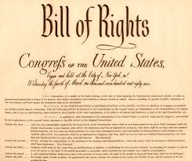
It was more than a month, though, before Madison had the opportunity to read his proposal for a bill of rights to the House of Representatives. He recommended that the points be worked into the main body of the Constitution. After a committee reviewed them, the amendments were put before the House for consideration.
Many of the amendments dealt with personal liberties that had been trampled by the British when the states were still colonies. Concepts such as freedom of religion, freedom of speech, freedom of the press, freedom to assemble in protest and freedom to petition the government for redress (correction) of grievances (wrongs) were very important to American citizens.
Madison also proposed that the Constitution protect the right to keep and bear arms, so that states could form their own militias and citizens could protect themselves, since at the time there were no professional police forces. Congress added a provision prohibiting any army or militia from forcing citizens to house soldiers. During the Revolution, many colonists had suffered the invasion of British soldiers into the privacy of their homes.
The House readily agreed to the clauses Madison had written guaranteeing due process of law; prohibiting self-incrimination and double jeopardy; forbidding cruel and unusual punishment or unreasonable searches and seizures; and the rights to a speedy trial and trial by jury.
Congress now considered the amendment Madison believed to be most important: "No State shall infringe the equal rights of conscience, nor the freedom of speech, or of the press, nor the right of trial by jury in criminal cases." He felt that states, too, should have to protect these basic rights.
Many people had objected to the idea of writing a bill of rights because they felt that listing certain rights this way would imply that others did not exist. So, Madison composed an amendment stating that the inclusion of certain rights in the Constitution "shall not be construed to deny or disparage other rights retained by the people." A final amendment reserved to the states any powers not delegated to the federal government by the Constitution. Madison himself would have preferred that the bill of rights also limit the ability of states to infringe on protected liberties, but Congress preferred to address only federal power. Not until 1868, with the passage of the 14th Amendment, would the states be responsible for the protection of the rights of their citizens.
Twice during the House debates, Roger Sherman of Connecticut rose to suggest that these amendments be numbered and added to the end of the Constitution instead of to articles within the text, as Madison had proposed. The second time Sherman spoke, the other House members agreed. As a result, the amendments were preserved together as a strong statement of individual rights.
As representatives approved each element, they reworked Madison's proposals into 17 amendments and sent them to the Senate for its approval. The Senate reworked them further, dropping one (requiring state guarantees) and combining those concerning freedom of religion, speech, press, assembly and petition into one.
On September 25, 1789, Congress sent these 12 amendments to the president, who forwarded them to the states for ratification. Only the final 10 received the necessary ratification by nine states. The original first and second amendments — dealing with how representation in Congress would be determined and with congressional salaries — were not ratified.
New Jersey was the first state to act, recording its favorable vote on November 20, 1789. On December 15, 1791, Virginia became the last state to ratify the document, and the 10 amendments we now know as the Bill of Rights officially became part of the Constitution. And with Virginia's approval, Madison helped give the American people what they had wanted. The Bill of Rights are natural human rights all people are born with, and that nobody should have to live without. The Bill of Rights was written to protect individuals from government infringing on those rights.

Step 3: Answer questions

What is the Bill of Rights?

Step 4: Matching rights with amendments
Read and review the Bill of Rights on the next page. Then use what you learned to match the amendment with the correct summary.

- 1st Amendment _______
- 2nd Amendment _______
- 3rd Amendment _______
- 4th Amendment _______
- 5th Amendment _______
- 6th Amendment _______
- 7th Amendment _______
- 8th Amendment _______
- 9th Amendment _______
- 10th Amendment _______

- No quartering of soldiers.
- Right of trial by jury in civil cases.
- Right to keep and bear arms in order to maintain a well-regulated militia.
- Other rights of the people.
- Rights of accused persons, e.g., right to a speedy and public trial.
- Freedom from unreasonable searches and seizures.
- Freedom of religion, speech, press, assembly, and petition.
- Right to due process of law, freedom from self-incrimination, double jeopardy.
- Freedom from excessive bail, cruel and unusual punishments.
- Powers reserved to the states

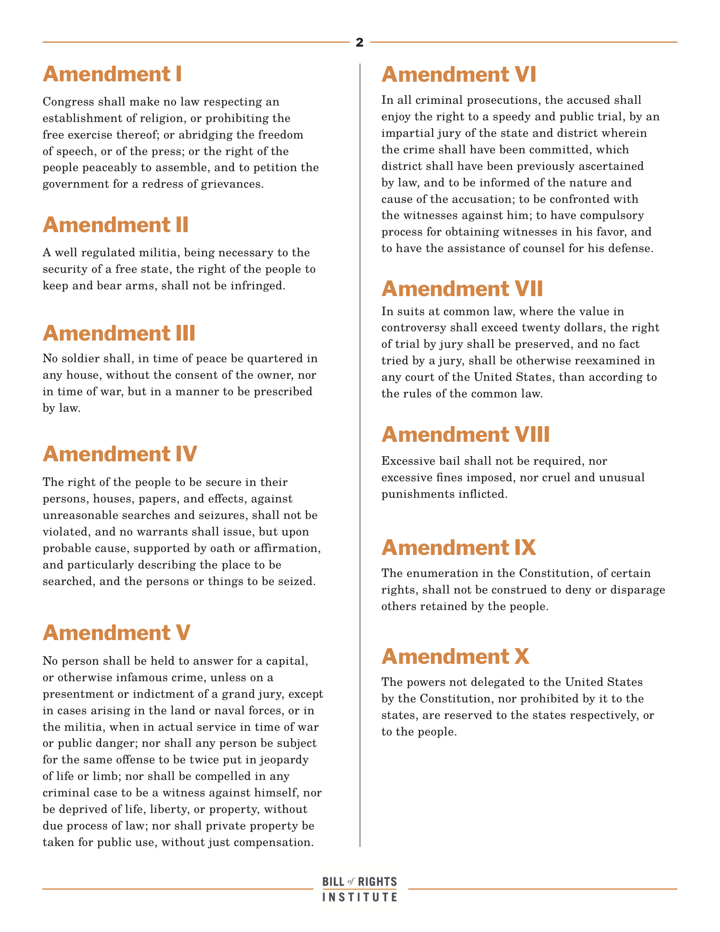

Step 5: The Bill of Rights Practice

Consider the scenarios below and identify 1) which right is being violated? and 2) which amendment offers protection against such a violation?
*if possible, work with a partner for this activity

1. Congress wants to find ways to cut costs because of the soaring budget deficit. Congress passes a law to require American citizens to house US soldiers in their homes during peacetime.  What right is being violated?  What amendment offers protection against such a violation? | 4. Carolyn is arrested for shoplifting a candy bar from a grocery store. At trial, she is found guilty. The judge decides that the right punishment is to cut off Carolyn’s hands so she will not be able to shoplift again.  What right is being violated?  What amendment offers protection against such a violation?
2. Concerned about rising crime, lawmakers for the District of Columbia ban all handguns in the city, and require that shot-guns be kept unloaded and/or disassembled.  What right is being violated?  What amendment offers protection against such a violation? | 5. Elizabeth is twelve years old. Her parents are very religious, but she is not. Once a week, Elizabeth’s parents make her come with them to their place of worship. Elizabeth always says she does not want to go, but her parents make her come with them anyway  What right is being violated?  What amendment offers protection against such a violation?
3. Gennie, a college student, is arrested for stealing a classmate’s designer sweater and selling it on eBay. When Gennie appears before the judge, she asks for a lawyer to help defend her. The judge tells Gennie that if she is smart enough to be in college, she knows enough to defend herself, so she won’t be getting a lawyer.  What right is being violated?  What amendment offers protection against such a violation? | 6. John, a fourteen-year-old public school student, wears a shirt to school that says “Be happy, not gay” to express his belief that homosexuality is wrong. His dean tells him he must change his shirt or be suspended from school. John refuses, and is suspended for a week.  What right is being violated?  What amendment offers protection against such a violation?

Step 6: Create a graphic organizer
Use the below graphic organizer to describe each amendment in the bill of rights and draw an image/doodle to help you remember what the amendment is about!
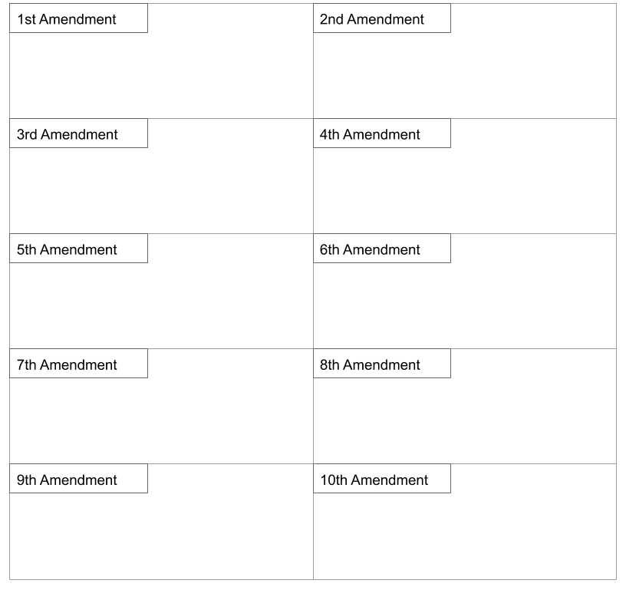
Student Feedback:

Circle the emojis that best represents how this activity made you feel.

Week 7
Rights

Day 2

NAME:______________________

Day 2 Agenda

Topic | Activity
Warm-Up!
English Language Arts | - Read the Universal Declaration of Human Rights ratified by the United Nations.  - Analyze an informational document and respond to questions  - Complete a graphic organizer.
Science | - Read about Ethics of Artificial Intelligence  - Answer questions about what you read  - Draw a picture and explain
Mindfulness Moment!
Math | - Rights: the Math of Voting/Women
Health | - Freedom of Speech Online
Mindfulness Moment!
Civics/Social Studies | - The Bill of Rights Today

Warm-up Activity: Write a journal entry around the daily quote on identity.
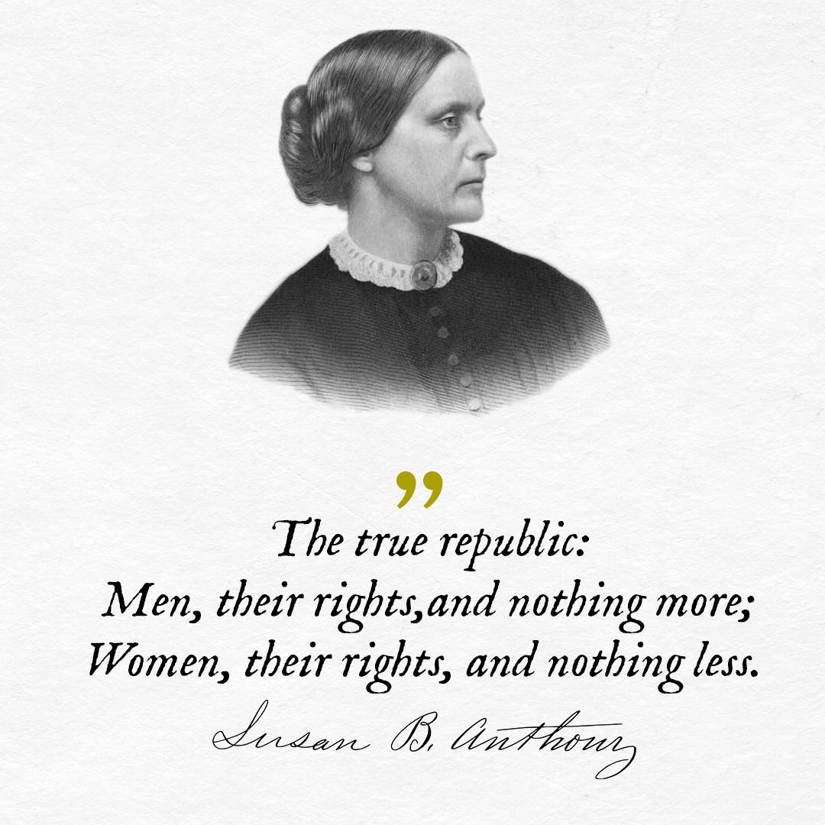

Day 2: The Universal Declaration of Human Rights
English Language Arts

What is this lesson about? Today you will continue to think about the theme of “Rights”. Read the Universal Declaration of Human Rights (UDHR) and consider what each means.

Before you read:
The Universal Declaration of Human Rights (UDHR) is a historic document that was adopted by the United Nations December 10, 1948 as a response to what had happened in World War II. The Declaration includes 30 articles affirming an individual's rights which, although not legally binding, have been referred to and used in subsequent international treaties, economic transfers, regional human rights instruments, national constitutions, and other laws.

Step 2: Read the following text

UNIVERSAL DECLARATION OF HUMAN RIGHTS: Simplified
- We are all born free. We all have our own thoughts and ideas. We should all be treated in the same way.
- These rights belong to everybody; whether we are rich or poor, whatever country we live in, whatever sex or whatever colour we are, whatever language we speak, whatever we think or whatever we believe.
- We all have the right to life, and to live in freedom and safety.
- Nobody has any right to make us a slave. We cannot make anyone else our slave.
- Nobody has any right to hurt us or to torture us.
- We all have the same right to use the law.
- The law is the same for everyone. It must treat us all fairly.
- We can all ask for the law to help us when we are not treated fairly.
- Nobody has the right to put us in prison without a good reason, to keep us there or to send us away from our country.
- If someone is accused of breaking the law they have the right to a fair and public trial.
- Nobody should be blamed for doing something until it has been proved that they did it. If people say we did something bad, we have the right to show this was not true. Nobody should punish us for something that we did not do, or for doing something which was not against the law when we did it.
- Nobody should try to harm our good name. Nobody has the right to come into our home, open our letters, or bother us or our family without a very good reason.
- We all have the right to go where we want to in our own country and to travel abroad as we wish.
- If we are frightened of being badly treated in our own country, we all have the right to run away to another country to be safe.
- We all have the right to belong to a country.
- Every grown up has the right to marry and have a family if they want to. Men and women have the same rights when they are married, and when they are separated.
- Everyone has the right to own things or share them. Nobody should take our things from us without a good reason.
- We all have the right to believe in what we want to believe, to have a religion, or to change it if we want.
- We all have the right to make up our own minds, to think what we like, to say what we think, and to share our ideas with other people wherever they live, through books, radio, television and in other ways.
- We all have the right to meet our friends and to work together in peace to defend our rights. Nobody can make us join a group if we don’t want to.
- We all have the right to take part in the government of our country. Every grown up should be allowed to choose their own leaders from time to time and should have a vote which should be made in secret.
- We all have the right to a home, to have enough money to live on and medical help if we are ill. We should all be allowed to enjoy music, art, craft, sport and to make use of our skills.
- Every grown up has the right to a job, to get a fair wage for their work, and to join a trade union.
- We all have the right to rest from work and relax.
- We all have the right to a good life, with enough food, clothing, housing, and healthcare. Mothers and children, people without work, old and disabled people all have the right to help.
- We all have the right to an education, and to finish primary school, which should be free. We should be able learn a career, or to make use of all our skills. We should learn about the United Nations and about how to get on with other people and respect their rights. Our parents have the right to choose how and what we will learn.
- We all have the right to our own way of life, and to enjoy the good things that science and learning bring.
- We have a right to peace and order so we can all enjoy rights and freedoms in our own country and all over the world.
- We have a duty to other people, and we should protect their rights and freedoms.
- Nobody can take away these rights and freedoms from us
Step 3: Think, Write, Share

Review Maslow’s Hierarchy of needs from yesterday while also looking at the list of human rights in the UDHU. For each level of needs on Maslow’s pyramid, match up one of those human rights that you believe meets that level of need.

- Biological and Physiological Needs:

____________________________________________________________________

- Safety Needs:

____________________________________________________________________

- Belongingness and Love Needs:

____________________________________________________________________

- Esteem Needs:

_____________________________________________________________________

- Self-Actualization Needs:

_____________________________________________________________________

Share your answers with someone else in the room. Explain why you think that each of your answers meets the needs at each level. Do you and your partner have any of the same answers? How do your answers differ?

Step 4: Complete the Graphic Organizer

Look at the list of rights in the Universal Declaration of Human Rights. Pick three of the rights listed (make sure you have not already used them on the previous list. For each, you will create a drawing that shows:
Column 1: this right being enjoyed
Column 2: what it looks like when this right is denied.

Right #:
What it looks like being enjoyed. | What it looks like being denied.
Right #:
What it looks like being enjoyed. | What it looks like being denied.
Right #:
What it looks like being enjoyed. | What it looks like being denied.

Step 5: Share out with a partner.
What do your posters have in common? Tell your partner which one of his/her drawings you found to be the best.

Student Feedback:

Circle the emojis that best represents how this activity made you feel.

Day 2: The Ethics of Artificial Intelligence
Science

What is this lesson about?: Today you will read through the Ethics of AI: Should sentient (able to perceive or feel things) robots have the same rights as humans? passage. You will answer a few questions about what you read. You will complete an AI activity.

Step 1: Read through the article

Ethics of AI: Should sentient (able to perceive or feel things) robots have the same rights as humans?

With the growing pursuit of artificial intelligence, questions about our moral duty towards new technology could become increasingly important
(McLachlan, 2019)
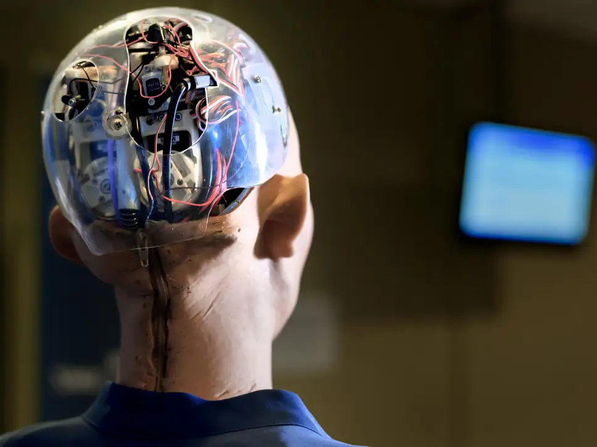
Imagine a world where humans coexisted with beings who, like us, had minds, thoughts, feelings, self-conscious awareness and the capacity to perform purposeful actions – but, unlike us, these beings had artificial mechanical bodies that could be switched on and off.
That brave new world would throw up many issues as we came to terms with our robot counterparts as part and parcel of everyday life. How should we behave towards them? What moral duties would we have? What moral rights would such non-human persons have? Would it be morally permissible to try to thwart their emergence? Or would we have a duty to promote and foster their existence?

Intriguing ethical questions such as these are raised in Ian McEwan’s recent novel, Machines Like Me, in which Alan Turing lives a long successful life and explosively propels the development of artificial intelligence (AI) that leads to the creation of “a manufactured human with plausible intelligence and looks, believable motion and shifts of expression”.

As intellectual speculation, to consider the ethics of the treatment of rational, sentient machines is interesting. But two common arguments might suggest that the matter has no practical relevance and any ethical questions need not be taken seriously.

The first is that such artificial people could not possibly exist. The second, often raised in the abortion debate, is that only persons who have living and independently viable human bodies are due moral respect and are worthy of moral consideration. As we shall see, these arguments are debatable.
Mind, matter and emergent properties

We might suppose that mental phenomena – consciousness, thoughts, feelings and so on, are somehow different from the stuff that constitutes computers and other machines manufactured by humans. And we might suppose that material brains and material machines are fundamentally different from conscious minds. But whether or not such suppositions are true – and I think that they are – it does not follow that sentient, consciously aware, artificially produced people are not possible.

The French sociologist Emile Durkheim argued very convincingly that we should beware of simplistic arguments in social science. Social phenomena, such as language, could not exist without the interaction of individual human beings with their particular psychological and biological features. But it does not follow that the resultant social phenomena – or “emergent properties” – can be completely and correctly explained solely in terms of these features.
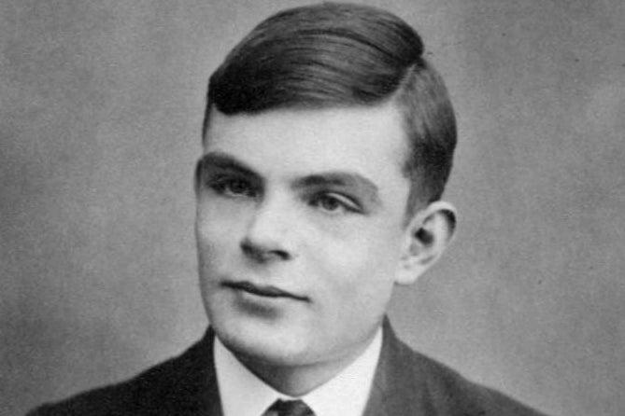

Alan Turing created a test to see if a computer could fool a human into thinking it too was human (Wikimedia Commons)

The same point about the possibility of emergent properties applies to all sciences. There could not be, for instance, computers of the sort I am now working at without the pieces of plastic, wires, silicon chips and so forth that make up the machine. Still, the operations of a computer cannot be explained solely in terms of the features of these individual components. Once these components are combined and interact in particular ways with electricity, a phenomenon of a new sort emerges: a computer. Similarly, once computers are combined and interact in particular ways, the internet is created. But clearly, the internet is a different sort of phenomenon from a tangible, physical computer.
In a similar way, we need not suppose that minds are reducible to brains, molecules, atoms or any other physical elements that are required for them to function. They might be entities of a different sort that emerge from particular interactions and combinations of them.

There’s no obvious logical reason why conscious awareness of the sort that human beings possess – the capacity to think and make decisions – could not appear in a human machine some day. Whether it is physically possible and, therefore likely to actually happen, is open to debate.
Do machines deserve our consideration?
It doesn’t seem controversial to say that we shouldn’t slander dead people or wantonly destroy the planet so that future generations of unborn people are unable to enjoy it as we have. Both groups are due moral respect and consideration. They should be regarded as potential objects of our moral duties and potential recipients of our benevolence.

But the dead and the yet to be born do not have viable bodies of any sort – whether natural or artificial. To deny conscious persons moral respect and consideration on the grounds that they had artificial rather than natural bodies would seem to be arbitrary and whimsical. It would require a justification, and it is not obvious what that might be.
One day, maybe sooner than we think, a consideration of the ethics of the treatment of rational, sentient machines might turn out to be more than an abstract academic exercise.

Step 2: Answer the following questions

- What’s something new you learned from this article?

________________________________________________________________________________________________________________________________________________________________________________________________________________

- Do you believe sentient robots should have the same rights as humans? Why/Why not?

________________________________________________________________________________________________________________________________________________________________________________________________________________

Step 3: Draw an image/picture

Design your own sentient robot. What does it have the power to do? How can your robot have a positive impact on your school, community, and/or the world?

Draw a picture of your robot and share your thoughts.

________________________________________________________________________________________________________________________________________________________________________________________________________________
________________________________________________________________________________________________________________________________________________________________________________________________________________
____________________________________________________________________________________________________________________________________________________________

Student Feedback:
Circle the emojis that best represents how this activity made you feel.

Mindfulness Moment!

Alternate Nostril Breathing
- Choose a comfortable seated position.
- Lift up your right hand toward your nose, pressing your first and middle fingers down toward your palm and leaving your other fingers extended.
- After an exhale, use your right thumb to gently close your right nostril.
- Inhale through your left nostril and then close your left nostril with your right pinky and ring fingers.
- Release your thumb and exhale out through your right nostril.
- Inhale through your right nostril and then close this nostril.
- Release your fingers to open your left nostril and exhale through this side.
- This is one cycle.
- Continue this breathing pattern for up to 5 minutes.
- Finish your session with an exhale on the left side.

Day 2: Right to Vote: the Women’s Suffrage Movement
Math

What is this lesson about?: In this lesson we will look at the math of the Women’s Suffrage Movement

Warm Up Problem
What is ⅗ of 100?

What is 60% of 200?

Which is bigger -- 60% of 500 or 400?

Which is bigger -- 60% of 500 or 275?
Is ⅗ more or less than ½?

Activity #1: The 19th Amendment
In 1920, the 19th Amendment, enfranchising women, was finally ratified by Congress. It was the single largest extension of democratic voting rights in our nation’s history, and it was achieved peacefully, through democratic processes.

Remember, when the 15th Amendment passed, guaranteeing the right to vote to Americans regardless of their race, nonwhites made up approximately 20% of the population...so the percentage of eligible voters overall went up by approximately 20%.

But women made up approximately 50% of the eligible voters in 1920, so then they were granted the right to vote, the percentage of eligible voters almost doubled, immediately!

Activity #2: Voter participation in the Elections following suffrage

According to political scientists J. Kevin Corder and Christina Wolbrecht, few women turned out to vote in the first national elections after the Nineteenth Amendment gave them the right to do so.

1920 Elections-
Eligible Women Voters | 26,000,000
Women Voters | 9,360,000
% of Eligible Women Voting

- In 1920, approximately what percentage of women voted?

- In 1920, approximately 68% of men voted. Why, do you think so fewer women might have voted than men in 1920?

More women than men have voted in each presidential election since 1960! The chart below shows voter participation rates over the last four elections, by gender. Use the chart to answer the questions below.
 | Women | Men
2016 | 64% | 62%
2012 | 60% | 58%
2008 | 62% | 56%
2004 | 58% | 58%

- Over the last four elections, what is the average percentage of eligible women who have voted?

- How does that compare to the average percentage of eligible men who have voted?

- Why do you think that a greater percentage of women are voting than men?

Activity #3: Women in congress and the US Senate

The chart below offers a detailed look at women in Congress, from 1920 to the present. D and R are short for Democrat and Republican. Use the chart to answer the questions below.

Congress | Dates | Women in the Senate |  | Women in the House |  | Total Women
65th | 1917-1919 | 0 | (OD, 0R) | 1 | (OD, 1R) | 1 | (0D, 1R)
66th | 1919-1921 | 0 | (0D, 0R) | 0 | (0D, OR) | 0 | (0D, 0R)
71st | 1929-1931 | 0 | (0D, 0R) | 9 | (5D, 4R) | 9 | (5D, 4R)
72nd | 1931-1933 | 1 | (1D, 0R) | 7 | (5D, 2R) | 8 | (6D, 2R)
73rd | 1933-1935 | 1 | (1D, 0R) | 7 | (4D, 3R) | 8 | (5D, 3R)
74th | 1935-1937 | 2 | (2D, 0R) | 6 | (4D, 2R) | 8 | (6D, 2R)
75th | 1937-1939 | 2 | (1D, 1R)1 | 6 | (5D, 1R) | 8 | (6D, 2R)
80th | 1947-1949 | 1 | (0D, 1R) | 7 | (3D, 4R) | 8 | (3D, 5R)
81st | 1949-1951 | 1 | (0D, 1R) | 9 | (5D, 4R) | 10 | (5D, 5R)
82nd | 1951-1953 | 1 | (0D, 1R) | 10 | (4D, 6R) | 11 | (4D, 7R)
86th | 1959-1961 | 2 | (1D, 1R) | 17 | (9D, 8R) | 19 | (10D, 9R)
87th | 1961-1963 | 2 | (1D, 1R) | 18 | (11D, 7R) | 20 | (12D, 8R)
92nd | 1971-1973 | 2 | (1D, 1R) | 13 | (10D, 3R) | 15 | (11D, 4R)
97th | 1981-1983 | 2 | (0D, 2R) | 21 | (11D, 10R) | 23 | (11D, 12R)
102nd | 1991-1993 | 4 | (3D, 1R)3 | 28 | (19D, 9R)4 | 32 | (22D, 10R)4
103rd | 1993-1995 | 7 | (5D, 2R)5 | 47 | (35D, 12R)4 | 54 | (40D, 14R)4
104th | 1995-1997 | 9 | (5D, 4R)6 | 48 | (31D, 17R)4 | 57 | (36D, 21R)4
109th | 2005-2007 | 14 | (9D, 5R) | 68 | (43D, 25R)11 | 82 | (52D, 30R)11
114th | 2015-2017 | 20 | (14D, 6R) | 85 | (63D, 22R) | 105 | (77D, 28R)18
115th | 2017-2019 | 23 | (17D, 6R) | 87 | (64D, 23R)16 | 110 | (81D, 29R)16
116th | 2019-2021 | 26 | (17D, 9R)17 | 101 | (88D, 13R)19 | 127 | (105D, 22R)

- In general terms, what does this chart show about women in Congress from 1920 to the present?
- Remember, there are 100 US Senators and 435 US Representatives.
- What percentage of US Senators are women right now?
- What percentage of US Senators were women in the year 2000?
- Approximately what percentage of US Representatives (House) are women right now?
- Of the 127 women in congress right now, approximately what percentage are Democrats and what percentage are Republicans?
- Look back to the 1980s. What percentage of women in congress were Democrats and Republicans during the 1980s?
- Do you have any ideas on why this may have changed between the 1980s and the present?
- If you looked at these results on a line graph, the line would stay pretty flat from the 1920s until the 1950s. Then it stayed sort of flat again until the late 1980s.
  - How many more women are in congress today than in 1930?
  - How many more women are in congress now than in the 1980s?
  - Look closely at the chart between 1980 and 2000. When did the number of women in congress really take off, more than doubling over a couple elections?
    - Do you have any ideas on what happened in the1990s to lead to this?

Step 4: Women in your City and State
- Do you have any idea if the Mayor of your city is a man or woman?
- What about the judges down in the courthouse, or the local Sheriff?
- Do you know if you have a woman Governor? Or if you have a woman Senator or Congressperson?

Student Feedback:

Circle the emojis that best represents how this activity made you feel.

Day 2: Freedom of Speech Online
Digital Health

What is this lesson about?: Today you will learn what it really means when you say freedom of speech online. Free speech online is not quite as free as it seems.

Step 1: Warm-up
What is your definition of hate speech?

Step 2: Read the article on your digital rights.
You’ve heard it or have seen it posted…
Someone saying they can say whatever they want, post whatever they want and no-one can do anything to them. As if the First Amendment is their sword and shield. And you can’t do anything about it. Freedom of speech. Three words that get thrown around and written about so often that what the expression means is more about misinformation than truth.

And misinformation can be detrimental to online professionals as they try to separate the wheat from the chaff and understand a right so important to the foundation of the United States that the founding fathers made it the first amendment to the Constitution to better clarify what rights belong to its citizens.

Congress shall make no law respecting an establishment of religion, or prohibiting the free exercise thereof; or abridging the freedom of speech, or of the press; or the right of the people peaceably to assemble, and to petition the Government for a redress of grievances.
Source: First Amendment, U.S. Constitution

This article will specifically focus on the portion relating to speech and how this applies to the online community.

In 1996, in the landmark case Reno v. ACLU, a unanimous Supreme Court specifically extended the First Amendment to written, visual and spoken expression posted on the Internet.
For those of us who work in an increasingly online environment, more and more we’re seeing behavior that would never fly in the “real world.” Social psychologists are having a field day picking apart tweets, status updates, and social network posts.

As you’ve likely seen, people will say anything! Justified or not, the fact is many people feel safe in their cocoon of online anonymity.

Of course, the First Amendment doesn’t give us the right to say whatever we want, whenever we want, to whomever we want. But that doesn’t stop people from thinking otherwise.

“Speech” Is More than Written or Spoken Words
While the dictionary definition of speech may be limited to the written or spoken word, we’re really looking at types of expression. This applies to visual interpretations, as well as artistic forms of speech.

In addition, symbolic speech—symbols that have meaning (for example, a swastika or peace sign)—is covered by what we often refer to as freedom of speech.

What Speech Is Protected by the First Amendment?
The right to free speech means that you are allowed to express yourself without interference or constraint by the government. And while that seems very broad, the U.S. Supreme Court has been involved in this debate for nearly a century and has determined that the government can limit both the content of speech and the ability to engage in speech as long as the government has a “substantial justification.”

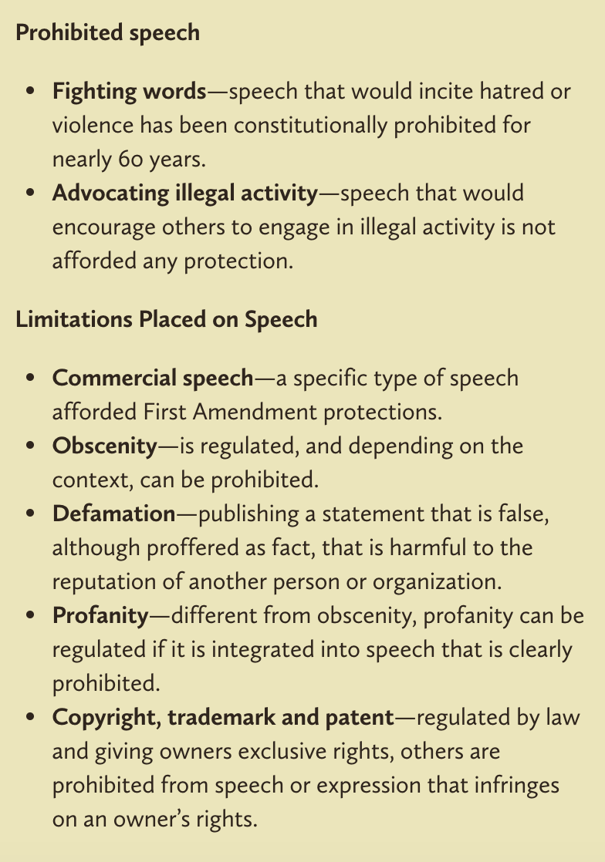
It’s nearly impossible to create a list of what types of speech are protected because there are quite a few caveats, and “it depends” would be tacked onto the end of each enumerated list.

Take advertising, for example. Advertising is a type of commercial speech. Commercial speech is a specific type of speech afforded First Amendment protections. It has been defined by the Supreme Court as speech where the speaker is more likely to be engaged in commerce, where the intended audience is commercial or actual or potential consumers, and where the content of the message is commercial in character.

However, the FTC and the FCC are both permitted to restrict certain types of advertisements. They restrict those that are misleading or deceptive or use profanity, racial slurs or nudity. Clearly, the FTC and FCC are both arms of the government. Advertising (“Commercial Speech”) is then protected speech, sometimes.

What is NOT Protected Speech?
Fortunately, the U.S. Supreme Court over time has created a number of categories of speech that are not afforded protection. What this means is that these types of speech are subject to prohibitions.

Step 3: Answer the questions below.

- How would you explain the difference between free speech and prohibited speech online?

- What did you learn the most from this article?

- What would you do if you saw prohibited speech online?

Step 4: Draw a sign that shows Internet Users what is allowed online and what is not allowed online.

Mindfulness Moment!

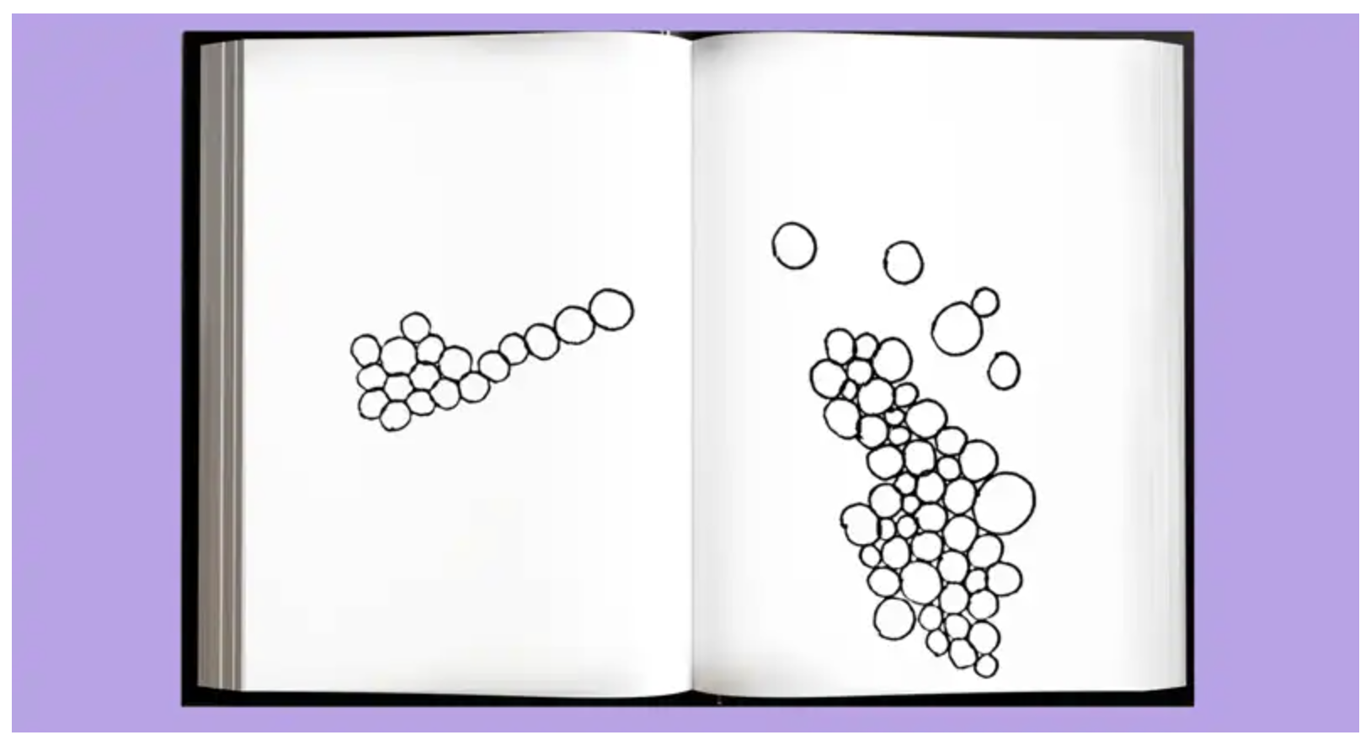
Draw circles that are connected to fill the space below:

Day 2: Bill of Rights Today
Social Studies

What is this lesson about?: Today you will continue to explore the Bill of Rights and consider current events that involve issues about the Bill of Rights.

Step 1: Review the Bill of Rights

Take a moment to read through this breakdown of the Bill of Rights and remind yourself what rights each amendment protects.

FIRST AMENDMENT
This amendment guarantees the right of freedom of religion, freedom of speech, freedom of the press, freedom of association, freedom for people to get together peacefully, and freedom for people to send petitions to their government.

SECOND AMENDMENT
This amendment states that in order to have a prepared military, people are guaranteed the right to keep and bear arms.

THIRD AMENDMENT
This amendment states that the government cannot force people to house and feed soldiers in their homes during times of peace.

FOURTH AMENDMENT
This amendment states that people, their homes or their belongings are protected from unreasonable searches or seizures. Warrants may not be issued except upon probable cause and must specifically describe the place to be searched and the person/thing to be seized.

FIFTH AMENDMENT
This amendment guarantees a person accused of a serious crime the right to be charged by a grand jury. Persons cannot be forced to give evidence against themselves. If a person is found not guilty of a crime, he/she cannot be put on trial for the same crime again. The federal government cannot unfairly take peoples' lives, freedom or property. The government must pay a person for any property it takes for public use.
SIXTH AMENDMENT
This amendment guarantees a speedy and public trial by an impartial jury if a person is accused of a crime. The accused has the right to be told what they are accused of. They have the right to a lawyer. They have a right to see and to question those people who accuse them of the crime.

SEVENTH AMENDMENT
This amendment guarantees a trial by jury in civil cases (Disputes between private parties or between the government and a private party.)

EIGHTH AMENDMENT
This amendment guarantees that excessive bail or excessive fines will not be imposed and that punishment will not be cruel and unusual.

NINTH AMENDMENT
This amendment states that the people have other rights that are not stated here.

TENTH AMENDMENT
This amendment states that the people have all the rights not given to the United States government or forbidden to state governments by the U.S. Constitution.

Step 2: Rank the rights

Now that you have read over the Bill of Rights and the rights protected in each amendment, think about which rights are most important to you. Choose five that you believe are the most important, and list them in the chart below. Then answer the questions below.

Right | Amendment
1
2
3
4
5

Why did you select these rights?

How would life change without the other rights?

Why is it important that we have all of the rights enumerated in the Bill of Rights?

* With a partner or group: Share what rights/amendments made your top 5 list.
- What similarities do your rankings show?
- Do you think people’s rankings might change based on the person’s age? Or time in history?
- Why is it wrong for governments to infringe on these individual rights?

Step 3: Current events and the Bill of Rights

Read the following two articles on current events that involve issues around the Bill of Rights.

Do coronavirus social distancing orders violate religious freedom? Local pastors say yes
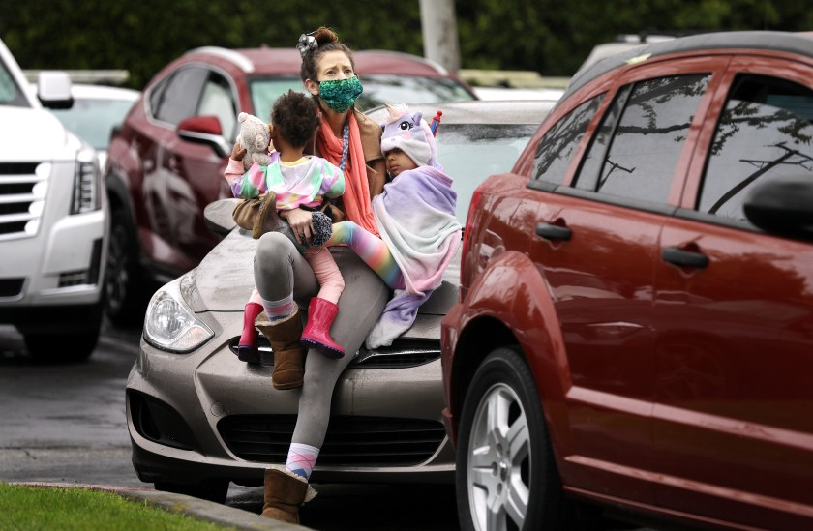
By Cindy Change for the Los Angeles Times - April 15, 2020

On Easter Sunday at a church in Fontana, a pastor delivered a fiery sermon to worshipers who crowded the pews in defiance of government orders prohibiting in-person services even on this holiest of days. The next day, the pastor, Patrick Scales of the Shield of Faith Family Church, filed a lawsuit contesting the stay-at-home orders as a violation of 1st Amendment religious freedom. (pictured: Ashley Amon and her daughters, Alysha, 2, and Alexandria, 4, attend an Easter service with fellow worshipers in their cars in a parking lot)

“We’re not going to stay home. We went to the house of God anyway,” Scales thunders in a video of the Easter service posted on Facebook. “We were threatened by jail. We were threatened by a fine. I chose to come worship.” People in the pews cheered and applauded, many wearing masks and gloves but appearing to be closer to each other than the six-foot distance mandated by officials to stop the spread of the coronavirus that has killed more than 126,000 worldwide.

Much about the COVID-19 pandemic is unprecedented, from the mass closure of schools and restaurants to the social distancing rules requiring that religious services be held online only. The U.S. Constitution is also being tested in unprecedented ways, with religious leaders from Mississippi to Kentucky to San Diego County suing their governments, asserting that they are being treated differently from businesses that can remain open, such as supermarkets and liquor stores.

Other plaintiffs in the lawsuit include one of Scales’ parishioners, Wendy Gish, and two Riverside County pastors, James Moffatt and Brenda Wood. Moffatt was fined $1,000 for conducting a church service on Palm Sunday, according to the complaint. On Easter Sunday, his church held a drive-in service, which was permitted by Riverside County only for that weekend. Photos on the church’s Facebook page show cars lined up in the parking lot, where a live band performed. Some worshipers emerged into the sunshine, standing on the curbs or in the narrow gaps between cars.

“It doesn’t work for the government to tell you or me that it’s good enough to load up Zoom and your high-speed internet and do your service remotely,” said the plaintiffs’ lead attorney, Harmeet Dhillon. “That’s incredibly arrogant and out of touch.” Dhillon noted that in rural areas, many people do not have internet access. On Tuesday, she filed for a temporary restraining order to obtain a ruling on whether the defendants, who include Gov. Gavin Newsom and officials from Riverside and San Bernardino counties, should allow the churches to resume in-person services. A hearing before U.S. District Judge Jesus G. Bernal is scheduled for June 1.

Constitutional law scholars interviewed by The Times were divided on the strength of Scales’ case. During an infectious disease pandemic, government officials have a public health interest in restricting people’s movements, which can clash with constitutional rights such as freedom of religion, speech and assembly.

Barry McDonald, a professor at Pepperdine’s Caruso School of Law, said the plaintiffs have a “decent claim.” The government must have a compelling reason to treat churches differently from other organizations it has deemed essential, he said. If churches agree to maintain safe social distancing, according to McDonald, they could argue for a carve-out like supermarkets and pharmacies. “These are important material needs that must be fulfilled, important social needs — courts, day care, child care,” he said. “You could say spiritual needs are essential and necessary as well.”

In Kentucky, a federal judge granted the On Fire Christian Center’s request for a temporary restraining order against the city of Louisville so it could hold drive-in services. Because Louisville allows drive-through liquor services, it must allow church services, U.S. District Judge Justin R. Walker ruled. “But if beer is ‘essential,’ so is Easter,” Walker wrote.

In San Diego, a judge came out on the other side, rejecting a church’s request for a temporary restraining order so it could hold Easter services. The right to freedom of religion doesn’t “include the right to expose the community to communicable disease,” U.S. District Judge Cynthia A. Bashant said.

Lawrence Sager, a professor at the University of Texas at Austin School of Law and visiting professor at UCLA School of Law, said the Riverside and San Bernardino county churches did not provide strong evidence of unconstitutional religious discrimination. Whereas people cannot rely exclusively on online deliveries of food and medicine, churches can deliver their messages online, he said. “They can behave virtually and do what needs to be done virtually. You can’t give someone food virtually or medicine virtually,” he said. “I think that makes the case that churches aren’t being treated fairly a weak case — a very weak case.”

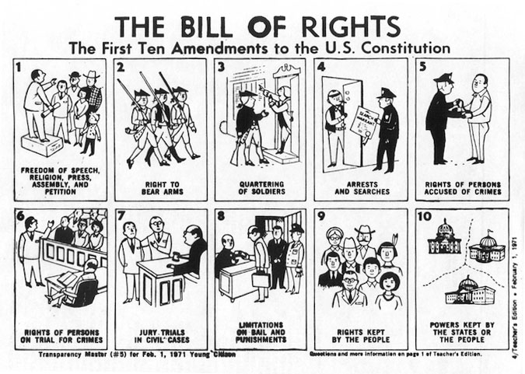
But on Easter in Fontana, Scales recited the 1st Amendment and said the church was “facing the enemy” as best it could by taking legal action. “We can’t roll over and play dead. The devil’s playing for keeps,” he said. “We’re living in the last days. It’s time to stand up — hallelujah — not to run and hide.” The applause from the pews intensified. People rose to their feet, waving hands in rubber gloves.

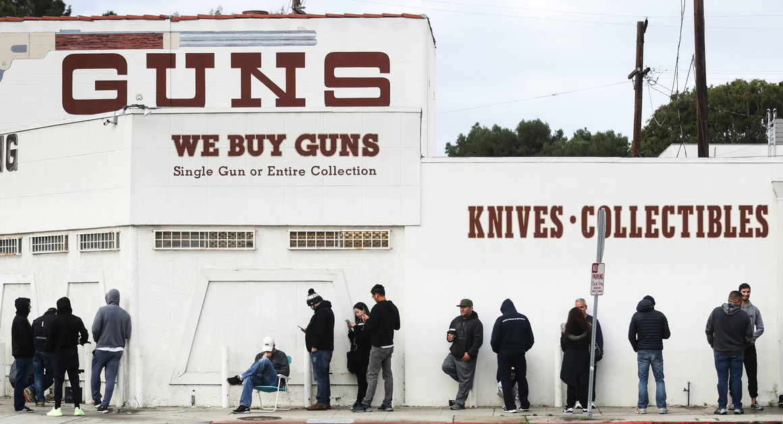
Gun-rights coalition sues New Jersey governor for closing gun dealers during coronavirus pandemic
By Jeff Mordock - The Washington Times - Monday, March 23, 2020

A coalition of gun-rights activists Monday filed a lawsuit against New Jersey Gov. Phil Murphy for closing gun stores and suspending legally required background checks amid the coronavirus pandemic. The lawsuit charges that Mr. Murphy’s actions violate the Second Amendment’s right to bear arms.

“This emergency has its constitutional limits. It would not justify a prior restraint on speech nor a suspension of the right to vote. Just the same, it does not justify a ban on obtaining guns and ammunition,” the plaintiffs wrote in a court filing. Mr. Murphy, a Democrat, issued an executive order Saturday closing all non-essential businesses in New Jersey. Firearms dealers were not deemed essential and the state also stopped processing background checks.

Roughly a dozen states have shuttered “non-essential” businesses as the deadly coronavirus sweeps across the country. Some of those states have kept gun stores opened, while others have shuttered them. Illinois Gov. J.B. Pritzker, a Democrat, issued a shelter-in-place order Friday, but said firearm retailers could stay open “for purposes of safety and security.”

The plaintiffs said Mr. Murphy’s order is essentially a ban on firearm purchases because it does not have an end date and experts have differed on the length of time it will take the pandemic to run its course. “Gov. Murphy cannot simply suspend the Second Amendment and neither can Supt. Callahan,” Alan Gottlieb, executive vice president of the Second Amendment Foundation, said. “Yet, under this emergency order, that’s exactly what they’re doing. The Constitution and federal law don’t allow that.” Mr. Gottlieb told The Washington Times his group is weighing lawsuits against other states and cities that have deemed firearms retailers as “non-essential.”

Gun sales have skyrocketed since the coronavirus outbreak became a pandemic earlier this month. The National Shooting Sports Foundation said the FBI processed more than 300% more background checks on March 16 than it did on the same day in 2019. Ammo.com, which ships ammunition to gun dealers, said its total transactions jumped 222% between Feb. 23 and March 15.

The sales are being driven by fears of an economic recession along with looting and pandemonium because of the pandemic. Many of those flocking to firearms dealers are said to be first-time buyers.
The gun-sale spike is leading to long delays in approvals and wait times could get even longer.

Earlier this month, the FBI office that operates the National Instant Criminal Background Check System said it is considering staff reductions or shuttering some offices in response to the coronavirus pandemic.

Step 4: Current event assessment

Complete the chart below by using the articles above about issues related to the Bill of Rights. As you respond to each article, think about ways the issue or event may touch your life.

Summary of Article | Related Amendment | Your Response to this Issue/Event

Student Feedback:

Circle the emojis that best represents how this activity made you feel.

Week 7
Rights

Day 3

NAME:______________________

Day 3 Agenda

Topic | Activity
Warm-Up!
English Language Arts | - Read an informational text on Women’s Suffrage.  - Read and analyze a speech by Sojourner Truth  - Respond to questions about both texts.  - Create a visual representation of equality using symbols.
Science | - Read about Electricity Rights  - Answer questions about what you read  - Draw a picture and explain
Mindfulness Moment!
Math | - Rights-the Math of Recent Voting Rights Initiatives
Health | - Internet Acccess Rights
Mindfulness Moment!
Civics/Social Studies | - Creating Additional Rights - Amending the Constitution

Warm-up Activity: Write a journal entry around the daily quote on identity.
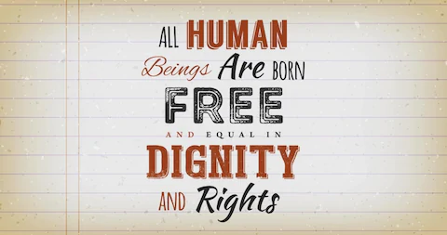

Day 3: Women’s Rights
English Language Arts

What is this lesson about? Today you will read about the fight for Women’s Rights in the United States. As you read, think about how the fight for rights needs to consider one’s own needs but also the needs of others.

Before you Read:
Some vocabulary to review:
domestic: relating to the running of a home or family relations. | sweatshop: a factory or workshop where manual workers are employed at very low wages for long hours and under poor conditions | Moderate (adj): (of a person, party, or policy) not radical or extreme in their opinions and actions.
delegation: a group of representatives; | subordinate: lower in position or importance | affront: insult
ratification: the action of signing a treaty, contract, or agreement, or law making it officially valid. | enfranchisement: the giving of a right or privilege, especially the right to vote. | lobby (v): seek to influence (a politician or public official) on an issue.
suffrage: the right to vote in political elections. | picket: demonstrate or protest against | Abridged: shortened

Step 1: Read the following text.

Overview of Women's Suffrage in the United States Compiled by the Center for American Women and Politics

Women in the Nineteenth Century
For many women in the early nineteenth century (1800s), activity was limited to the domestic life of the home and care of the children. Women were dependent on the men in their lives, including fathers, husbands, or brothers. Once married, women did not have the right to own property, maintain their wages, or sign a contract, much less vote. In colonial America, most Black women were considered property. Women were expected to obey their husbands, not express opinions independent of, or counter to, their husbands’. It was considered improper for women to travel alone or to speak in public.

Immigrant women, women of color, and low-income women nevertheless had to work outside the home, often in domestic labor or sweatshops. In the nineteenth century taking a job was considered neither respectable nor something that an “honest” woman would do, and women who did so were considered to have given up their claim to “gentle treatment” and were often exploited by their employers.

The Seneca Falls Convention
The women's suffrage movement was formally set into motion in July 1848 with the first Women's Rights Convention in Seneca Falls, New York.

Lucretia Mott and Elizabeth Cady Stanton were among the American delegation to attend the World Anti-Slavery Convention held in London in 1840. Because they were women, they were forced to sit in the galleries as observers. Upon returning home, they decided to hold their own convention to "discuss the social, civil and religious rights of women." Using the Declaration of Independence as a guide, Stanton drafted the Declaration of Sentiments which drew attention to women's subordinate status and made recommendations for change, including calling for women to have “immediate admission to all the rights and privileges which belong to them as these citizens of the United States.”

After the Seneca Falls Convention, the demand for the vote became the centerpiece of the women's rights movement.

Suffrage during the Civil War
During the Civil War, women's suffrage and the abolition movement were closely connected. Activists such as Elizabeth Cady Stanton, Susan B. Anthony, Harriet Tubman, and Sojourner Truth lectured and petitioned the government for the emancipation of slaves with the belief that, once the war was over, women and slaves alike would be granted the same rights as white men.

At the end of the war, however, the Fourteenth and Fifteenth Amendments fractured the suffrage movement. The 1868 ratification of the Fourteenth Amendment proved an affront to the women's movement; it defined "citizenship" and "voters" as "male," and raised the question of whether women were considered citizens of the United States at all. The exclusion of women was further reinforced with the ratification of the Fifteenth Amendment in 1870, which enfranchised Black men.

In a disagreement over these Amendments, the women's movement split into two factions. In New York, Stanton and Anthony established the National Woman Suffrage Association (NWSA), which promoted universal suffrage and opposed the Fifteenth Amendment. Lucy Stone, Julia Ward Howe, and Henry Blackwell organized the American Woman Suffrage Association (AWSA) in Boston, which supported the Fifteenth Amendment and had Black and white members. Many Black women worked for women’s suffrage and leading reformers, including Harriet Tubman, Frances E.W. Harper, Ida B. Wells, and Mary Church Terrell, established the National Association of Colored Women’s Clubs (NACWC) and campaigned in favor of women’s suffrage and improved education.

The NWSA and AWSA merged in 1890 to form the National American Woman Suffrage Association (NAWSA) under the leadership of Elizabeth Cady Stanton, and later Susan B. Anthony and Carrie Chapman Catt. The NAWSA campaigned for women’s suffrage at both the national and state levels, and several key states approved women’s suffrage because of the organization’s lobbying. In 1916, one of NAWSA’s members, Alice Paul, believing the organization was too moderate in its approach and focus on state-level campaigns, founded the National Women’s Party, which protested at the White House in support of a national amendment and resulted in the imprisonment of suffragists. In response to public outcry about the prison abuse of suffragists, President Woodrow Wilson reversed his position and publicly supported a suffrage amendment.

Winning the Vote
In 1878, the Woman's Suffrage Amendment was first introduced to Congress. With the formation of numerous groups, such as the Women's Christian Temperance Union (WCTU), the National Council of Jewish Women (NCJW), the National Association of Colored Women (NACW) and the Women's Trade Union League, the women's movement gained momentum and attention during the 1890s and early 1900s. During the U.S. involvement in World War I, the suffrage campaign was eclipsed as women pitched in for the war effort. However, in 1919, after years of petitioning, picketing, and protest parades, the Nineteenth Amendment was passed by both houses of Congress, and in 1920 it became ratified under the presidency of Woodrow Wilson.
AMENDMENT XIX, Ratified August 26, 1920
1. The right of citizens of the United States to vote shall not be denied or abridged by the United States or by any State on account of sex. 2. Congress shall have power to enforce this Article by appropriate legislation.

Taken from: http://tag.rutgers.edu/wp-content/uploads/2020/01/Overview-of-US-Women-Suffrage-4.pdf

Step 2: Answer the following questions.

- List 3-4 of the limitations put on women during the 1800’s.

- What was the purpose of the Seneca Falls Convention?

- Why did the women’s movement break apart into two different organizations?
What was the position of each?

NWSA believed…

AWSA believed…

- Why did President Wilson decide to support women’s suffrage?

Step 3: Read Sojourner Truth’s Speech:
Before you read: Some vocabulary to review:
abolitionist: someone who fought against slavery | denounce: to speak out against | palatable: easier to accept
On May 29, 1851, Sojourner Truth, an abolitionist and formerly enslaved black woman, addressed a Women’s Rights Convention in Akron, Ohio which was organized to urge lawmakers to ensure that the new document expand the legal rights of women.

The women’s rights movement of the 19th century was largely led by white women and shaped around their experiences. Some white women’s rights activists were also active abolitionists who believed in a common womanhood across racial lines. But others had no interest in advocating for the rights of non-white women. Even some white activists sympathetic to the needs of black women advised against interracial coalitions, fearing that the movement for [white] women’s voting rights and legal equality would only attract fiercer opposition if it attempted to also promote racial equality and denounce slavery. In many ways, the women's movement did adopt a segregated approach. The 1851 Ohio Women’s Rights Convention, however, did not and included among the event's speakers a black woman named Sojourner Truth.

Born into slavery in New York in 1797, Truth’s birth name was Isabella Baumfree but she adopted the name Sojourner Truth after escaping enslavement as an adult. As a speaker, preacher, and leader, Truth traveled and worked tirelessly to denounce slavery and defend the rights of African Americans and women. In her speech, she asserted her belief in women's equality and urged men to not fear giving women their rights.

Today, many people learn about Sojourner Truth's famous speech as, "Ain't I A Woman" -- but historians widely believe that the speech she actually gave on that date did not include that phrase. The text below is taken from a transcription published in the Anti-Slavery Bugle in 1851. A later version of the address, printed in The New York Independent in June 1861, is believed to have been rewritten by white feminist and abolitionist Francis Gage in an effort to make the message more palatable to white audiences. Unlike the 1851 transcription, "Ain't I A Woman" is written in a Southern dialect that Sojourner Truth -- who never lived in the South and spoke low-Dutch for much of her childhood -- would not have used. Gage also inserted biographical details that were not included in the original version, such as a reference to having "birthed thirteen chillen," when Sojourner Truth regularly stated that she had five children. The later version became widely popular and soon was the only version most people knew existed.

Sojourner Truth survived the Civil War and the abolition of slavery that followed, dying in Michigan in 1883. We do not know what she thought of Gage's version of her speech or the attention it received. Today, "Ain't I A Woman" is the phrase most widely associated with Truth's name, and the speech is among the most famous addresses by a black woman in America. But the story of that speech's creation, and the way it grew to overshadow and obscure the actual words of the real Sojourner Truth, may offer an even truer statement about the reality of black womanhood and the struggle to be seen as equals.

Below is the original transcript of her speech which was transcribed by Marius Robinson, a journalist, who was in the audience at the Woman's Rights Convention in Akron, Ohio on May 29, 1851. Marius Robinson and Sojourner Truth were good friends and it was documented that they went over his transcription of her speech before he published it. One could infer from this pre printing meeting, that even if he did not capture every word she said, that she must have blessed his transcription and given permission to print her speech in the Anti‐Slavery Bugle. As you read, take note of how Sojourner Truth seeks to persuade her audience

1 | May I say a few words? I want to say a few words about this matter. I am a woman’s rights. I have as much muscle as any man, and can do as much work as any man. I have plowed and reaped and husked and chopped and mowed, and can any man do more than that? I have heard much about the sexes being equal; I can carry as much as any man, and can eat as much too, if I can get it. I am as strong as any man that is now.
2 | As for intellect, all I can say is, if women have a pint and man a quart - why can’t she have her little pint full? You need not be afraid to give us our rights for fear we will take too much, for we can’t take more than our pint’ll hold.
3 | The poor men seem to be all in confusion, and don’t know what to do. Why children, if you have woman’s rights, give it to her and you will feel better. You will have your own rights, and they won’t be so much trouble.
4 | I can't read, but I can hear. I have heard the bible and have learned that Eve caused man to sin. Well if woman upset the world, do give her a chance to set it right side up again. The Lady has spoken about Jesus, how he never spurned woman from him, and she was right. When Lazarus died, Mary and Martha came to him with faith and love and besought him to raise their brother. And Jesus wept - and Lazarus came forth. And how came Jesus into the world? Through God who created him and woman who bore him. Man, where is your part?
5 | But the women are coming up blessed be God and a few of the men are coming up with them. But man is in a tight place, the poor slave is on him, woman is coming on him, and he is surely between-a hawk and a buzzard.

Step 4: Answer the following questions.

Note: If possible, use these questions as discussion questions instead of having to write out the answers. If this is not possible, then have students write out their answers.

- Even though she was speaking at a women’s conference, who is Sojourner Truth talking to in her speech?

- In paragraph 1, why does Sojourner Truth compare herself to men? What point is she trying to make?

- In paragraph 2, Truth changes her tone when she states that men have a “quart” of intellect and women just a “little pint”. Why would she say this? How might this help her persuade lawmakers to grant women the right to vote?

- In paragraph 4, Sojourner Truth asks men “where is your part?” in the story from the Bible. What is she claiming about the role of women?

- In paragraph 5, she acknowledges that white men are feeling pressure from different groups. Who are these groups and what does each want?

Step 5: Create a mural
Create a mural type of drawing that advocates for equality. Make sure to include 2-3 symbols that represent your ideas without words.

Student Feedback:

Circle the emojis that best represents how this activity made you feel.

Day 3: Electricity Rights
Science

What is this lesson about?: Today you will read through the Should electricity be established as a basic human right? passage. You will answer a few questions about what you read. You will complete a Structural Change activity.

Step 1: Read through the passage

Should Electricity Be Established as a Basic Human Right?
(electric choice)
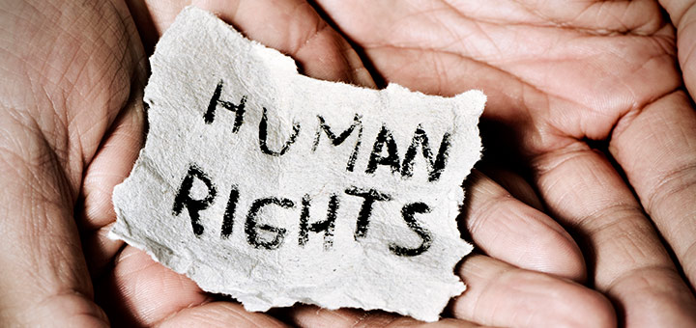
There is no question that electricity has become a completely integrated part of our lives. But does that — and should that — make electricity a basic human right?

The National Association for the Advancement of Colored People (NAACP) recently released a report called Lights Out in the Cold, Reforming Utility Shut-Off Policies as if Human Rights Matter. NAACP believes that electricity and its related services are a basic human right. Through their report, they provide evidence that supports this claim, stating that access to electricity is a critical component to the prosperity, safety and general well-being of every human being.

Utility Disconnection Policies
NAACP believes that utility disconnection policies across the United States significantly contribute to the issues residential customers face when it comes to losing access to power.

The purpose of these disconnection policies is to outline for the consumer the exact steps a utility company will take prior to disconnecting electricity. The major issue claimed here is that these policies become particularly problematic in situations where the consumer can’t afford to pay their bills. In particular, the report states that “The interests of these customers often compete with the interests of utility companies, regulators, and other utility customers.”

Current State Policies
To support the need for re-evaluating current disconnection policies, the report identified many different state policies that prevent electricity and electricity services from being a basic human right.

While there are policies that have been adopted by all states, there are some that have not. For example, before a customer’s electricity is disconnected, the utility company must call or write to inform the customer before the disconnection occurs. That being said, different states have different rules surrounding the actual disconnection process. Some imply that they will not disconnect power during certain times during the week. Others state they will not disconnect before or during a holiday.

When it comes to reconnecting power, there are fifteen states that do not outline any policy regarding reconnection fees. This means that it is up to the utility to decide how much someone has to pay to turn their power back on.

What about disconnection policies around different seasons, like winter or fall? Many states will not disconnect a customer’s power if the temperature drops “below 32°F or above 95°F”, but again, this is not a countrywide standard. There are currently nine states that “Do not provide any state regulated seasonal protections for utility customers. These states include: Alaska, California, Colorado, Connecticut, Florida, North Dakota, Oregon, Tennessee, and Virginia.”

Electricity Assistance and/or Protection
NAACP states that “Eight states do not have regulations establishing standard protections for socially vulnerable groups. Among these states are: Alaska, Arkansas, Colorado, Florida, Kentucky, North Carolina, North Dakota, and Rhode Island.”

Many utilities in many states also charge a fee to reconnect services, but there are many states that offer customers a payment plan to help them pay their bills.
When it comes to medical protection, options are primarily offered to elderly or disabled consumers. In these cases, the utility requires a medical certificate. The medical certificate will help to keep the power on, but only for a defined period of time.

Impacts of Current Policies on Human Rights
According to the report, the impact of current utility disconnection policies has a discriminatory impact on several groups including:
- Low income people
- People of color
- Elderly people
- People with special health needs
- Socially vulnerable customers

“This new report reiterates what low-income communities have known for years — living in poverty is more expensive,” said Cecil Corbin-Mark, deputy director of WE ACT for Environmental Justice, a Harlem-based environmental group. “Poor access to energy efficiency and lower incomes means it is harder to pay your bills.”

Corbin-Mark’s statement helps to highlight several of the NAACP report’s details including the fact that it is more than twice as likely for African Americans to live in poverty compared to non-African Americans. In addition, in general, low income households are required to pay just as much for heat and energy as high income households. However, for low income households, around 13% of their money goes towards energy purchases compared to only the 5% that higher income households spend. As a result, low income African Americans see the greatest impact when utilities or energy companies raise their rates.

Dangers of Disconnected Electricity
The report also notes that this particular group of energy consumers (low income African American households) are the most likely to go without electricity in order to afford other basic necessities. These necessities include health care and food. As a result, “High energy prices can represent a significant health hazard.”

The results of a 2011 survey revealed some insight into low income households. It’s claimed that due to high energy bills:
- Someone within the household was sick because of the cold = 19%
- A person within the household went without food for a minimum of 1 day = 24%
- Someone within the home did not refill a prescription (or take a full dosage) = 34%
- A person within the home did not receive medical or dental care = 24%

Not only do low income households go without other basic necessities to pay their energy bills, they also resort to different methods of obtaining electricity. This is very dangerous to the well-being of every individual living within the household. The NAACP report offers this quote from David Fox of the National Low-Income Energy Consortium (NLIEC), “Regardless of whether it’s shut off or simply that bills are so high that people voluntarily limit usage, several things happen. People use space heaters, kerosene heaters, that increase risk of fire and carbon monoxide poisoning. And people limit use of electricity. They light the home with candles, which are often too close to something combustible.”

The report also states, “According to the National Fire Protection Association, while only 32 percent of home heating fires involve space heaters, heaters are involved in 79 percent of home heating fire deaths.”

Making Electricity a Basic Human Right
To change these policies for the better, NAACP suggests 5 principles that will help utilities to make electricity available to everyone. These policies include,
- INCLUSION: “Ensure INCLUSION of all customers in the development of utility policies and regulations.”
- ACCESS: “Secure ACCESS to utility services for all households.”
- PROTECTION: “Guarantee the PROTECTION of the human and civil rights of all customers.”
- TRANSPARENCY: “Create full TRANSPARENCY of the information and actions of utility companies, regulating bodies, legislatures, and utility affiliated organizations.”
- ELIMINATE POVERTY: “Advance programs that help ELIMINATE POVERTY, so that all customers can pay utility bills.”

NAACP's Vision
The organization firmly believes that if every state implemented policies that prevented instead of implemented disconnections, society as a whole would greatly improve.
These new policies would include:
- If the weather is extremely hot or cold, the power will not shut off.
- Access to programs that help customers pay for their electricity
- Better energy efficient upgrade programs
- Consumers who require life-saving medical technologies gain are protected from losing their power
- Whether or not you believe that electricity should be a basic human right, it is clear that more discussion and attention is required to current utility policies.

The NAACP would like to see a complete overhaul of the way the United States currently offers electricity to consumers. They believe that if every state steps up to take measures to offer their residents better access to affordable electricity, it will, “transform social and structural inequities that render households vulnerable.”

Step 2: Answer the following questions

After reading the article:

- Write down three things that you learned from this article.

________________________________________________________________________________________________________________________________________________________________________________________________________________
____________________________________________________

- Do you believe electricity should be considered a basic human right? Why or why not?

________________________________________________________________________________________________________________________________________________________________________________________________________________

- What recommendations would you make so that everyone has electricity whether they can afford it or not?
________________________________________________________________________________________________________________________________________________________________________________________________________________
____________________________________________________

Step 3: Draw an image/picture

Design a system that would provide electricity for your community and the world. How will you make sure the electricity is available for everyone no matter how much money they make?

________________________________________________________________________________________________________________________________________________________________________________________________________________
________________________________________________________________________________________________________
________________________________________________________________________________________________________________________________________________________________________________________________________________
____________________________________________________

Student Feedback:

Circle the emojis that best represents how this activity made you feel.

Mindfulness Moment!

Equal Breathing
To do it:
- Choose a comfortable seated position.
- Breathe in and out through your nose.
- Count during each inhale and exhale to make sure they are even in duration. Alternatively, choose a word or short phrase to repeat during each inhale and exhale.
- You can add a slight pause or breath retention after each inhale and exhale if you feel comfortable. (Normal breathing involves a natural pause.)
- Continue practicing this breath for at least 5 minutes.

Day 3: Voting Rights-Florida and Beyond
Math

What is this lesson about?: In this lesson we will look at the math of restoring voting rights to individuals once they return from prison. Over the last 25 years, many states have started to enable individuals who are released from prison to vote. In some cases this is immediately, or nearly immediately, upon release. In other cases, individuals remain eligible to vote so long as they are on parole or probation.

Warm Up Problem
Fifty years ago, 58% of college enrollees were men. Today, 56% of all college enrollees are women.

If there were 5,700,000 adults enrolled in college 50 years ago, how many would have been men? How many would have been women?

Today there are approximately 1,400,000 people in college. How many are men? How many are women?

What has taken place over the last 50 years, do you think, that has led to more women than men going to college?

Activity #1: Louisiana

For years, Louisiana has refused to let individuals who have been convicted of felonies to vote once released from prison, even after completing the terms of their parole/probation. This restriction has led thousands unable to vote. Finally, in 2018, Louisiana passed a law that enables individuals who have been released and completed 5 years of parole/probation.

Researchers estimate that there are nearly 37,000 Lousianians who could have had their right to vote restored by this new law.

- In 2016, approximately 1,900,000 individuals voted statewide in Louisiana. Approximately what percentage of 1,900,000 is 37,000?

By January 2020, VOTE (voice of the experienced), estimated that out of the 37,000 people, only 12,000 had registered.

- What percentage of eligible new voters registered during this time?

Based on a survey of those who have NOT registered, the three main reasons the 25,000 individuals gave for not registering are summarized in the chart below.
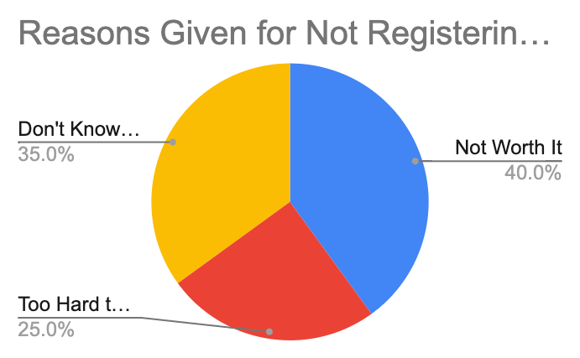
Of the 25,000 individual who didn’t register, how many indicated they didn’t because-
- It’s Not Worth it? _________
- It’s Too Hard to Register? __________
- They don’t know how to get the ‘cleared letter’ from their Parole Officer? _______

If Louisiana got rid of the requirement to get a ‘cleared letter’ and the requirement that they go register in person, approximately how many of the 37,000 individuals would be registered?

Discuss/Consider: Why didn’t Louisiana do that?

Step 2: Nevada

In 2018, Nevado also amended its laws related to allowing former prisoners to vote. BBefore 2018, Nevada had restored voting rights, but not until after an individual was no longer on parole and probation. Further, with specific crimes, there was even a waiting period after that, and in some other circumstances, a former inmate would have to petition a court to get his or her voting rights restored.

Those restrictions limited the percentage of eligible voters who went on to register and vote.
But in 2018, with the passage of its latest law, restoration of voting rights is automatic once an individual leaves prison, making Nevada one of 16 states and the District of Columbia that does that. With the passage of this law, 77,000 formerly incarcerated individuals in Nevada will automatically be registered to vote!
In Nevada, based on estimates in late 2019, there were a total of 1,827,386 registered voters. What percentage, approximately is 77,000 of 1,827,386. If you are not using a calculator round off 77,000 to 80,000 and round off 1,827,386 to 1,800,000.

Office of Nevada Secretary of State Barbara K. Cegavske Voter Registration Statistics
January 2020
Total Voters by County and Party
County | Democrat | Republican | Total
Carson City | 10,813 | 15,674 | 36,370
Churchill | 2,717 | 8,667 | 15,196
Clark | 539,363 | 363,596 | 1,294,147
Douglas | 9,179 | 21,449 | 40,587
Elko | 4,579 | 15,244 | 27,992
Esmeralda | 101 | 322 | 569
Eureka | 93 | 756 | 1,076
Humboldt | 1,742 | 5,134 | 9,596
Lander | 520 | 1,824 | 3,096
Lincoln | 579 | 1,785 | 2,968
Lyon | 8,368 | 19,645 | 39,349
Mineral | 899 | 1,263 | 2,898
Nye | 8,166 | 15,815 | 33,289
Pershing | 579 | 1,542 | 2,887
Storey | 779 | 1,720 | 3,439
Washoe | 108,363 | 110,026 | 308,573
White Pine | 1,204 | 2,736 | 5,354
Statewide | 698,044 | 587,198 | 1,827,386

The chart above lists the state counties and the number of registered voters in each county. Based on this chart, what 2 counties have a larger number of registered voters than the number of now eligible, former inmates?
What would happen if all of the returning citizens registered as Republican in Nevada? How close would the number of Democrats and Republicans be in the state?
Discuss: What would have led the residents of Nevada to vote for a law that would automatically restore voting rights to former inmates immediately (instead of imposing some wait time).
Separately, notice on the chart that more than 1.2 million voters live in Clark County. That is where the city of Las Vegas is. The number of people who voted in the whole state is just over 1.8 million.
- Approximately what percentage of the state’s population lives in Clark County?
- What does that do to voting power in the state?
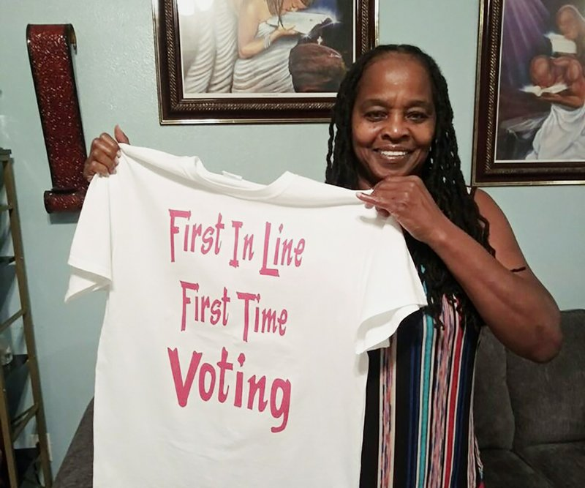
Activity #4: Florida

In Florida, they passed a law in 2018 that “restores voting rights to felons after they complete all terms of their sentence, including parole and probation.” Even with the constraints of having to finish their parole and probation obligations, it was estimated that this law would restore voting rights to nearly 1.1 million people in Florida.

Later, the Florida Supreme Court ruled that the words “all terms of their sentence” would mean that nearly 775,000 of them would not be able to vote because of fines and penalties they owed related to court and other fees. There are estimates that 60% or more of the 775,000 owe more than $1,000 in fines related to their cases.

The Florida court’s ruling was temporarily halted, with a Federal Court ruling that the fines were similar to a poll tax and were discriminatory and ran afoul of the US Constitution.

This case is now (April 2020) being reheard in Federal Courts, with the right to vote of nearly 775,000 people at stake.

The chart below shows you the number of registered voters in Florida in early 2020.
 | Republican | Democratic | Minor Party | No Party | Total
TOTALS | 4,832,285 | 5,115,768 | 152,175 | 3,630,535 | 13,730,763
About what percentage of total registered voters would 1,100,000 be (round off)?

Researchers estimate that approximately 70% of former inmates would register Democrat and 30% would register Republican. If this were true, how many of the 1,100 would register Democrat? How many would register Republican?

Would this make the overall number of Republicans and Democrats closer together or further apart?

Discuss/consider: Should released individuals have to pay off fines related to their crime before gaining the right to vote? Would it matter to you if the fines were big or small?

Student Feedback:
Circle the emojis that best represents how this activity made you feel.

Day 3: Internet Access Rights
Digital Health

What is this lesson about?: Today you learn about your right to internet access. How accessible is the Internet in the United States? And does our access differ from other countries?

Step 1: Warm-up- Answer the questions below.

What percentage of people do you think to have internet access?
___________

Do you think that Internet access should be free? Why or Why not?

Step 2: Read the article on your digital rights.

Frank Camallerys walks up and down the Malecon, a wide street along the seashore in Havana, Cuba. He has a telephone at the end of a pole, which records what he is looking at. His videos attract thousands of views on the Internet, giving them a glimpse of life in Cuba.
The island in the Caribbean Sea has little Internet access, and until recently, it was cut off to visitors from the United States.

Camallerys is a 19-year-old communications student. Like most Cubans, he has no Internet at home, but that has not prevented him from gaining a following on YouTube. When he wants to post a video, he has to trek across the city to a plaza where wireless Internet is available for a dollar an hour. On his latest trip, it took more than half an hour to upload his video.

Unlikely Internet Celebrities
His videos on YouTube usually begin with his cheerful greeting: "Hello everyone, this is a new adventure in Cuba." He is among about 50 young Cubans who have become Internet celebrities.
His channel on YouTube, called Camallerys Vlogs, launched a year ago and now has more than 7,000 followers.

"Create a video, walk 2 or 3 kilometers (up to 2 miles) to put it online, then wait 40 minutes while it uploads: that shows very well how much I like this," Camallerys says.

Other Cubans who want to access the Internet face similar obstacles, in contrast to much of the rest of the world. Most places now have widespread Internet service, which makes accessing sites such as YouTube and Facebook easy through mobile phones or wireless Internet, also called Wi-Fi, at home.

USB Entrepreneurs
Cuba is ruled by the Cuban Communist Party and has been for more than 50 years. Communism, one way of thinking about a government's role in the economy, is a system where the government controls almost everything.
There is a lack of widespread Internet access in Cuba.
Cubans have found creative ways to get access to the online world. Many use what they call the "package," which is a USB storage device that lets them save content from the Internet and then pass it to others by hand.
The distributors of the "package" get the content from a regular Internet connection. Then, they sell the content, which can include everything from bestselling novels to the latest international soccer match, for about a dollar.
A dollar a day is roughly the average income for a government worker but those in private businesses can make more than that. The package menu is updated weekly.

Successful Marketing Within Limits
Another YouTuber, Emma Lopez, 18, says that the "package" has helped her get her videos seen by fellow Cubans.
"The first time, my video was viewed by three people, until the 'package' began circulating and it helped me progress so that I eventually went countrywide," she says.
Her channel, Emma Style, gives makeup tips to young Cubans. Her advice is adapted to life in Cuba, where some makeup products cannot be purchased.
Part of the reason for that has to do with the relationship between Cuba and the United States. Due to longstanding disagreements, the United States does not allow most of its companies to sell products to Cuba, so most of what can be bought in Cuba has to be made on the island.
"If you don't have a brush, use your fingers" to apply eyeshadow, Lopez advises in her show.

Government Has One Eye On The "Package"
These mini-stars of the Internet find audiences well beyond their home country.
"Normally when a YouTuber starts out, he hopes to have support of the population. But among my followers, a small percentage live in Cuba," says Pedro Veitia, 24, of the Pedrito el Paketero channel.
"There are perhaps 50 of us in Havana," he says of the small Cuban YouTube community.
According to the Cuban government, 4.5 million people on the island have Internet access. Unofficial estimates show the "package" has 9 million users, out of a total Cuban population of 11 million, says Max Barbosa, a professor of communications at the University of Havana.
The Cuban government controls people's access to Internet content but it continues to allow the "package" to be widely sold. The government has even tried to compete with it by launching a similar device called the "backpack."
"Even if they don't have Internet to be connected all the time or to generate content, merely saying 'I want to be a YouTuber,' even by alternative means like the USB, is praiseworthy," Barbosa says.

Not Just Cuban YouTubers
Their challenge now "is to start to create experiences more linked to the Cuban reality, to strike up a direct dialogue with the Cuban followers," he adds.
For Lopez, that is a goal worth pursuing.
"We don't seek to be known as Cuban YouTubers just because it's complicated for us or because we live in a communist island. We want to be recognized for our content," she says.

Step 3: Answer the following questions about

- Why do you think these Cuban Youtube stars go to great lengths to upload their video content?

- Do you think Cuba should make Internet access more accessible? Why or Why not?

- How long do you think it will take for Cubans to have regular internet access?

Step 4: Use the graph below to answer your question.
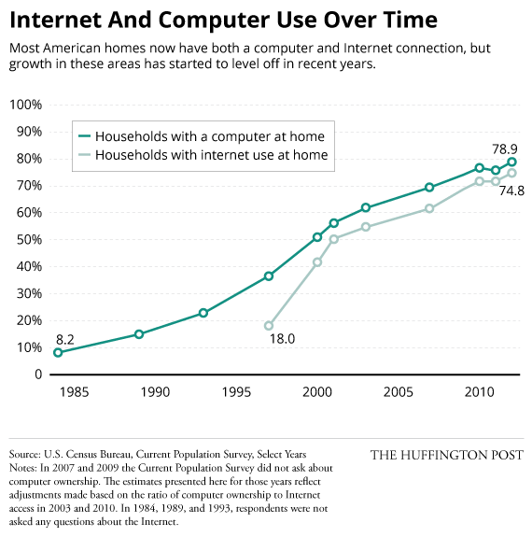

How accurate was your prediction at the beginning of this lesson?

Why do you think not all people in America have Internet access?

Mindfulness Moment!

Zentangles: Easy Patterns for Drawing Meditation
Draw one below:

Day 3: Creating Additional Rights - Amending the Constitution
Social Studies

What is this lesson about?: So far you have learned about the Bill of Rights, which refers to the first 10 amendments added to the U.S. Constitution in 1791. But those are not the only amendments that have been added to the constitution. More amendments can still be added to the constitution as time goes on! Today you will explore how amendments are added to the U.S. Constitution. Do you think it's an easy process? Let’s find out!

Step 1: Introduction

How and why did the Framers devise an amendment process?
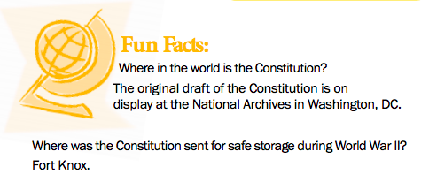
The Framers intended the Constitution to be, and to remain, a fundamental framework of law. They didn't want the Constitution to become confused with ordinary laws and regulations or to be changed in response to short-lived, impulsive ideas. However, they also recognized that American society and conditions would change over time in ways they could not predict in 1787. The Constitution that they proposed, George Mason argued, would “certainly be defective,” just as the Articles of Confederation had proved to be. Mason said, “Amendments therefore will be necessary, and it will be better to provide for them, in an easy, regular, and Constitutional way than to trust to chance and violence.”

The Framers made the Constitution difficult to amend but not too difficult. Article V of the Constitution describes how amendments may be proposed. Amendments may be proposed by both houses of Congress or by a petition of the states calling for a special convention. You’ll read more on this below.

Americans have not been reluctant to suggest changes. Since 1789 more than ten thousand proposed amendments have been introduced in Congress. Only thirty-three amendments have gained enough votes to be submitted to the states for ratification (approval). Of those thirty-three, twenty-seven have been ratified. The other process for proposing amendments—by state legislatures calling a convention—has never been used.

Some critics of the amending process argue that amendments, once proposed, should be put before
a national popular referendum (a vote where if a majority of voters agree on something it will go into effect). They point out that forty-nine of the fifty states now submit state constitutional amendments to popular vote. Delaware is the only exception.

Step 2: Answer questions

Do you think the amendment process should allow for a national popular vote? Why or why not?

Step 3: Read how to amend the constitution

Changing the Constitution
Adapted from: http://www.trumanlibrary.org/whistlestop/teacher_lessons/3branches/15b.htm

In the early 1800s, Chief Justice of the Supreme Court, John Marshall wrote that the United States Constitution was written “to endure for ages to come”. To ensure it would last, the framers made it possible to amend the document in the future. Not all proposed amendments are successful because the process is very difficult.
Article V (five) of the U.S. Constitution outlines two ways to propose amendments, or changes, to the U.S. Constitution and two ways to ratify a proposed amendment by the states. To ratify means to officially accept or approve.
To propose amendments to the U.S. Constitution:
1. Congressional method: two-thirds (2/3) of each house of Congress has to vote in favor of a proposed amendment. This means that 290 of the 435 members of the House of Representatives and 66 of the 100 members of the U.S. Senate have to vote for the proposed amendment.
OR
2. Convention method: two-thirds (2/3) of the states call for a constitutional convention and vote in favor of the proposed amendment. This method has not yet been used successfully.

To ratify amendments to the U.S. Constitution:
1. Three-fourths (3/4) of the state legislatures approve the amendment.
OR
2. State ratifying conventions are held and three-fourths (3/4) of the state conventions approve the amendment. This method was used only once to ratify the 21st Amendment.

Challenges to the amendment process

Between 1789 and 2014, over 11,000 amendments have been proposed; however, only 27 amendments have been ratified. Why is it so hard for proposed amendments to receive support for final ratification? A few roadblocks are standing in the way.

First, every amendment must receive support from three-fourths of state conventions or state legislatures. It’s incredibly difficult to get that many states to agree on a permanent change to the Constitution.

Take, for example, the Equal Rights Amendment, or ERA. The ERA was introduced in 1923. It finally passed Congress in 1972 and was sent to the states for ratification. The ERA was designed to guarantee equal rights for all citizens regardless of sex. It fell three states short of ratification and so was not added to the Constitution.

Second, for an amendment to be passed through the congressional proposal method, two-thirds of Congress must propose the amendment. To introduce a new amendment the two parties must cooperate, as no one party has controlled two-thirds of both the House of Representatives and the Senate. With each party supporting different ideological goals, getting two-thirds of Congress to agree on a change to the Constitution is nearly impossible without some level of cooperation.
The process is so difficult that it could take years before the US Constitution has its 28th amendment. Some amendments continue to pop up in Congress, including an amendment requiring Congress to pass a balanced budget, an amendment setting term limits for members of Congress, and amendments defining who can get married.
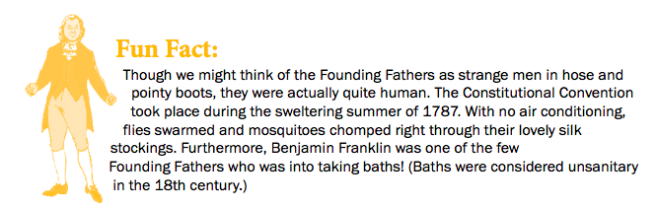

Step 4: Complete the graphic organizer

Use the information you read above about the process for amending the constitution to fill in the graphic organizer below.

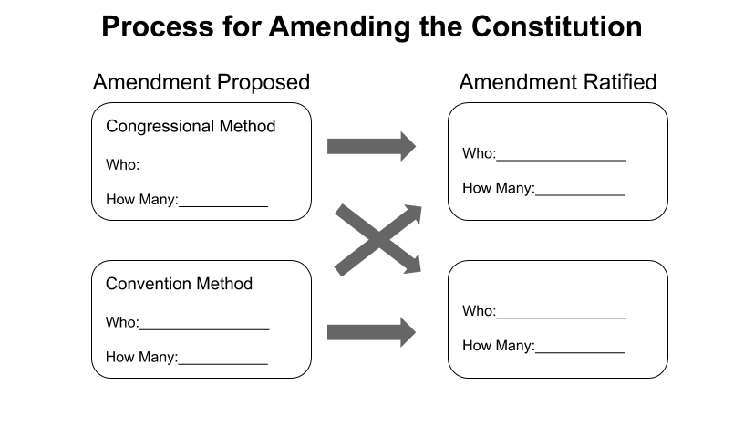
Step 5: Answer questions

Why do you think Chief Justice John Marshall said that the United States Constitution was “written to endure for ages to come”?

Explain why changing the Constitution is so difficult?

Why do you think the framers wanted to make the Constitution difficult to change?

Step 6: Consider the political cartoon
What is the cartoonist saying about the amendment process?

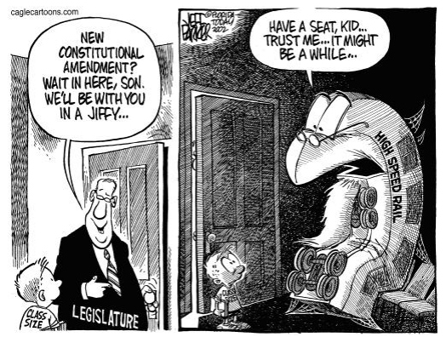

Student Feedback:

Circle the emojis that best represents how this activity made you feel.

Week 7
Rights

Day 4

NAME:______________________

Day 4 Agenda

Topic | Activity
Warm-Up!
English Language Arts | - Analyze images from the Civil Rights Movements  - Answer questions about the symbolism and themes of the images.  - Write a reflection piece about the theme of a set of images.
Science | - Read about Water Rights  - Answer questions about what you read  - Draw a picture and explain
Mindfulness Moment!
Math | - Rights-the Math of the Bill of Rights
Health | - Online Freedom of Assembly
Mindfulness Moment!
Civics/Social Studies | - Amendments Beyond the Bill of Rights

Warm-up Activity: Write a journal entry around the daily quote on identity.
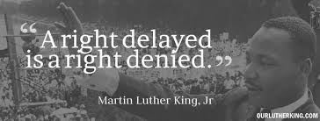

Day 4: The Power of Images in the Civil Rights Movement
English Language Arts

What is this lesson about?: Today you will observe and analyze photographs from the Civil Rights movement and determine their symbolism and how they were able to influence opinion across the U.S.

Before you Start: Today you will be analyzing photographs from the Civil Rights Movement. The power of photographs of what was really happening during this time helped people understand the movement and it also changed a lot opinions--gaining more support for Civil Rights. Please follow the steps for analyzing the photographs. You will be asked to describe what you observe (that means to just describe what you see--without opinion or inference). Later, you will be asked what you think or can infer from the photos.

Step 1: Analyze the following photographs
Annotate them just like you would a poem or a story..making notes on them. Both photographs depict the same event from different perspectives--the Selma to Montgomery March for Civil Rights.
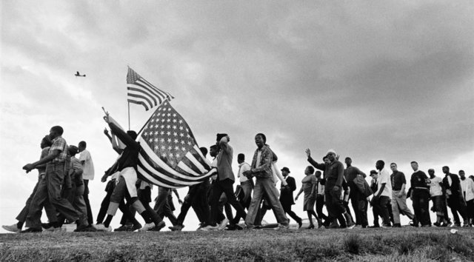

- What people do you observe?

- What are their nonverbal expressions? Describe them carefully, but try not to infer what those expressions mean yet. Example: , “the man on the left is smiling” is an observation, but “the man of the left is happy” is an inference that you make because the person is smiling.

- What are the people doing in this image? Who or what are they looking at?

- What, if any, objects do you observe?

5. What are the people doing in this image? Who or what are they looking at?

6. What movement of people or objects is apparent (although it is a still photograph)?

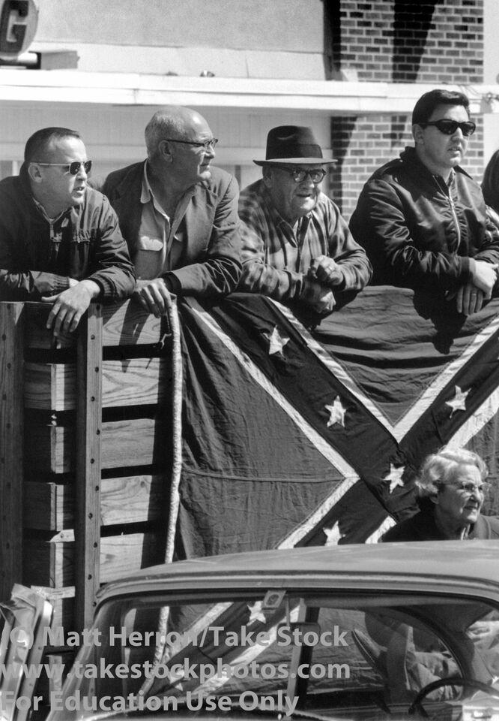
Now observe this photograph of the same event from a different perspective.
7. What people do you observe?

8. What are their nonverbal expressions? Describe them carefully, but try not to infer adjectives or what those expressions mean yet. For example, “the man on the left is smiling” is an observation, but “the man of the left is happy” is an inference that you make because the person is smiling.

9. What are the people doing in this image? Who or what are they looking at?

10. What, if any, objects do you observe?

11. What movement of people or objects is apparent (although it is a still photograph)?

Now think of both photographs: There is a flag featured in each of the photos. Think about why the photographer might have wanted to show these two pictures with the flags.
12. Which set of antonyms best suggests the theme of the flag photos?
A. Harmony/Discord
B. Allegiance/Treason
C. History/Present
Explain your answer:

13. If you could title these two images--what titles would you give to each photograph that would express the theme of the photo without directly saying what is happening (for example, you would not title the photograph as “White people watching the March”).

A. _________________________________________________________

B. _________________________________________________________

 | Analyze the 3 images below:  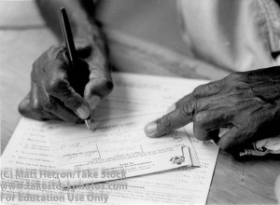  New voter completing voter registration card. | 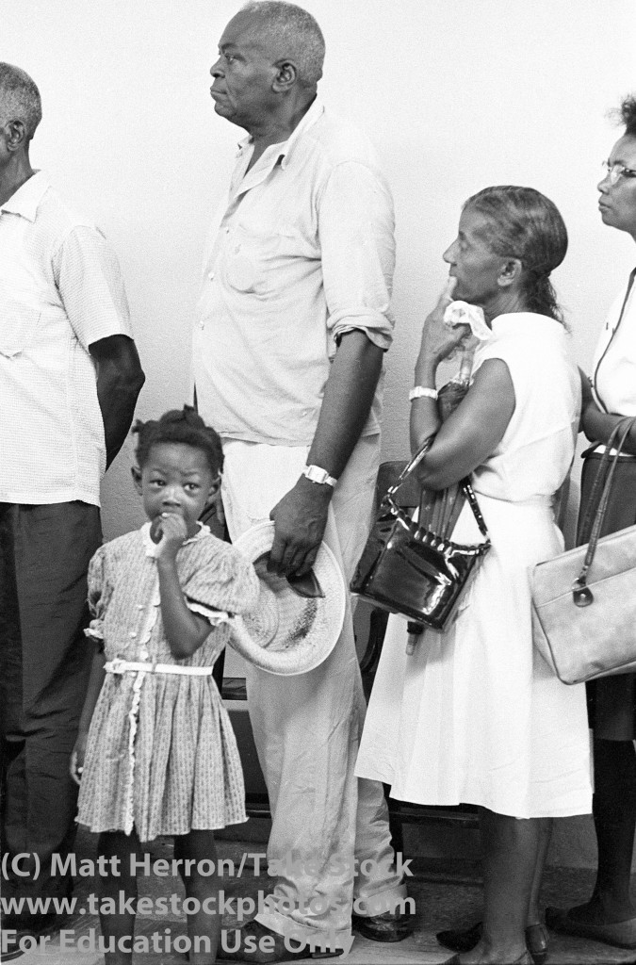  Prospective voters standing in line to register.
 | 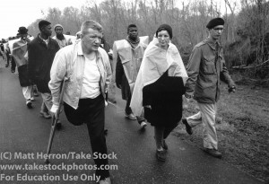Marchers in the rain.
14. Which of the following quotes/adages best describes the set of photos? Draw a star next to it.

We, today, stand on the shoulders of our predecessors who have gone before us. We, as their successors, must catch the torch of freedom and liberty passed on to us by our ancestors. We cannot lose in this battle. —Benjamin E. Mays

Leaving behind nights of terror and fear
I rise
Into a daybreak that’s wondrously clear
I rise
Bringing the gifts that my ancestors gave, I am the dream and the hope of the slave.
I rise—I rise—I rise. —Maya Angelou
If we have the courage and tenacity of our forebears, who stood firmly like a rock against the lash of slavery, we shall find a way to do for our day what they did for theirs. —Mary McLeod Bethune
Step 2: Write
Explain your choice of quote and what you observed in the photograph that connects to the theme of the quote.

Student Feedback:
Circle the emojis that best represents how this activity made you feel.

Day 4: Water Rights
Science

What is this lesson about?: Today you will read through the West’s drought and growth intensify conflict over water rights passage. You will answer a few questions about what you read. You will complete an activity.

Step 1: Read through the passage

West’s Drought and Growth Intensify Conflict Over Water Rights
(New York Times, 2014)
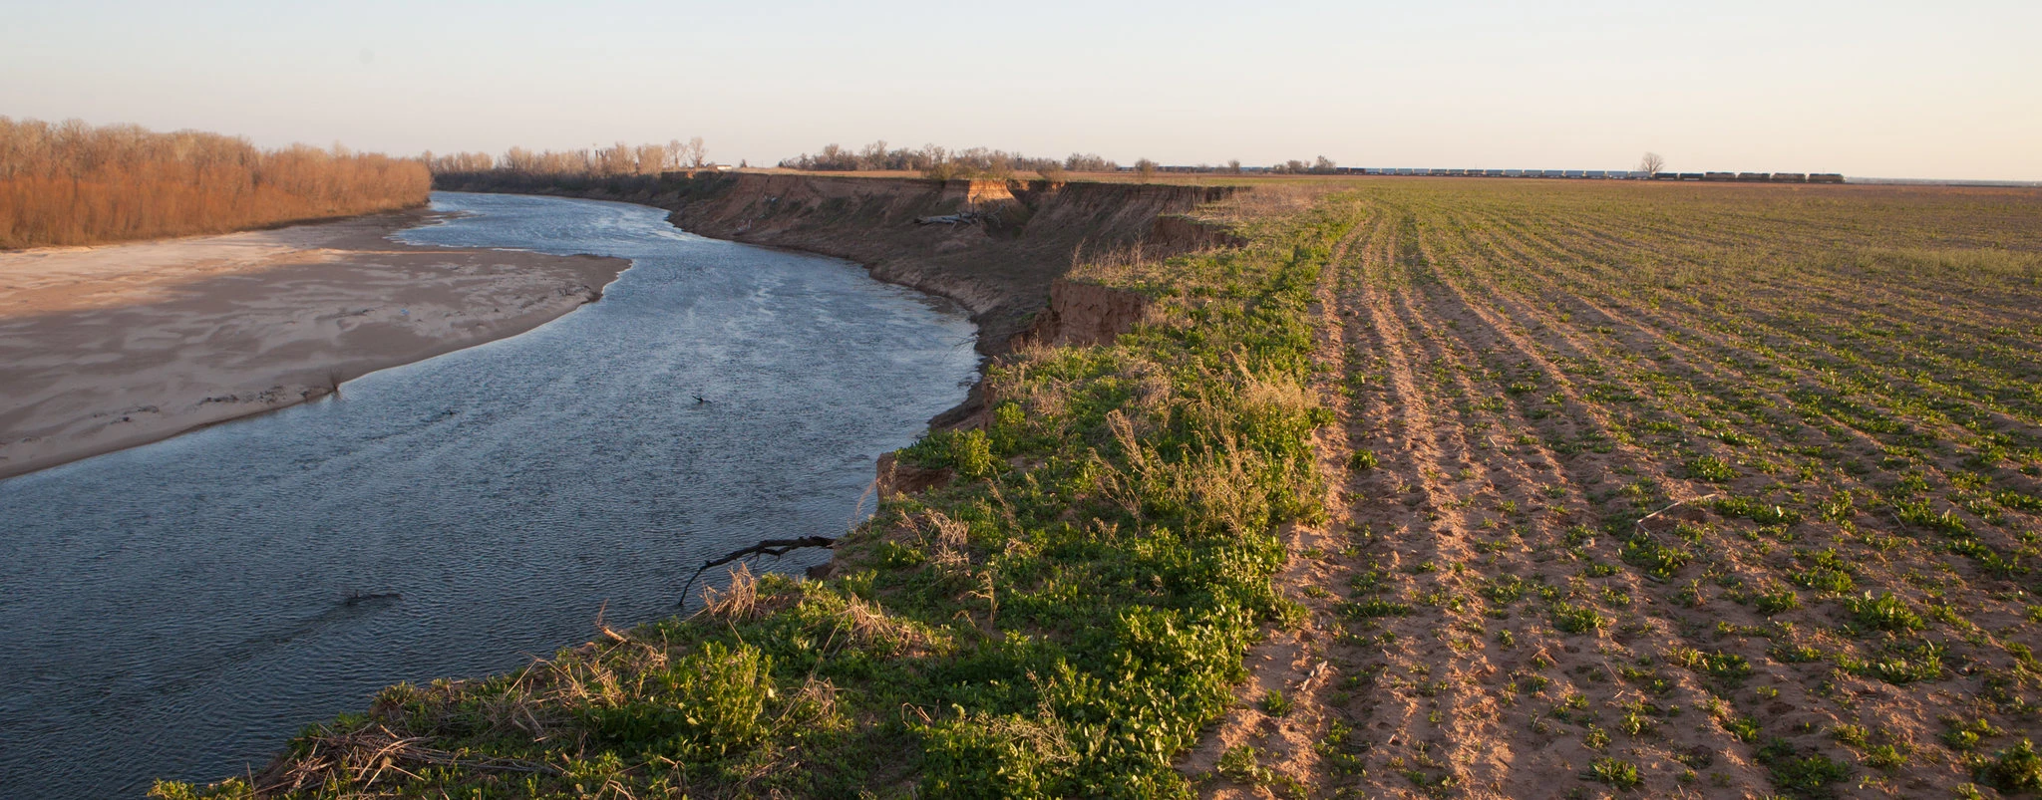
Under restrictions, a Mumford, Texas, farm on the Brazos River could not draw water from it, while cities and power plants could. Credit...Ilana Panich-Linsman for The New York Times

MUMFORD, Tex. — Across the parched American West, the long drought has set off a series of fierce legal and political battles over who controls an increasingly dear treasure — water.

Just outside this minuscule (small) farm town, Frank DeStefano was feeding a 500-acre cotton crop with water from the Brazos River 16 months ago when state regulators told him and hundreds of others on the river to shut down their pumps. A sprawling petrochemical complex at the junction of the Brazos and the Gulf of Mexico held senior rights to the river’s water — and with the Brazos shriveled, it had run short.
State regulators ordered Mr. DeStefano and others with lesser rights to make up the deficit. But they gave cities and power plants along the Brazos a pass, concluding that public health and safety overrode the farmers’ own water rights.

Now Mr. DeStefano and other farmers are in court, arguing that the state is wrong — and so far, they are winning.

“I understand cities need water, people need water, but it kind of gets to me how agriculture is pushed to the back of the line,” he said. “We’re on pins and needles wondering when the next call is going to be made. It’s hard enough to make a living without things like this.”
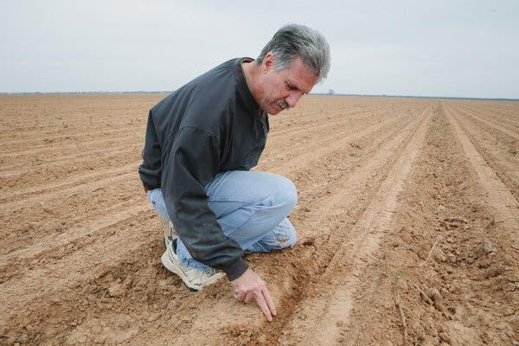
Residents of the arid West have always scrapped over water. But years of persistent drought are now intensifying those struggles, and the explosive growth — and thirst — of Western cities and suburbs is raising their stakes to an entirely new level.
Pictured: Regulators told farmers, like Frank DeStefano in Mumford, Tex., to stop using Brazos River water. Credit...Ilana Panich-Linsman for The New York Times

In southern Texas, along the Gulf coast southwest of Houston, the state has cut off deliveries of river water to rice farmers for three years to sustain reservoirs that supply booming Austin, about 100 miles upstream. In Nevada, a coalition ranging from environmentalists to the Utah League of Women Voters filed federal lawsuits last month seeking to block a pipeline that would supply Las Vegas with groundwater from an aquifer straddling the Nevada-Utah border.

In Colorado, officials in the largely rural west slope of the Rocky Mountains are imposing stiff restrictions on requests to ship water across the mountains to Denver and the rest of the state’s populous eastern half. Fearing for their existence, Colorado farm towns on the Arkansas River have mobilized to block sales of local water rights to Denver’s fast-growing suburbs.
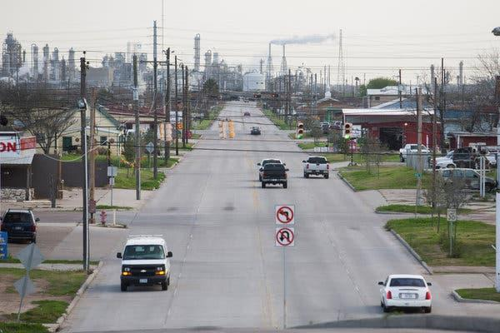
The Freeport, Tex., plant of the Dow Chemical Company, whose water rights were honored when river levels dipped.Credit...Michael Stravato for The New York Times

In Arizona, activists and the federal government are fighting plans to tap groundwater used by a vast housing development — a move that would reduce the water level of a protected river. Kansas accuses Colorado and Nebraska of allowing their farmers to divert Kansas’ share of the Republican River, which flows through all three states. A similar dispute between New Mexico and Texas is before the United States Supreme Court.
California, in the midst of a major drought, so far has witnessed but a few local skirmishes. In January, environmentalists and sport fishermen sued to halt the drilling of hundreds of new groundwater wells sought by Central Valley farmers, saying more pumping would lower stream levels.

That may not last long, said Stuart Somach, a Sacramento water-rights lawyer. California farmers have long grumbled about big-city designs on their water; Northern California has long grumbled about being the spigot that supplies most of the water to the dry south.

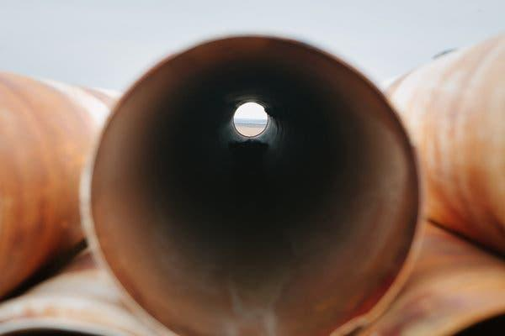
“We’re very close to the time that people are going to start staking out rights. We’re right at the cusp,” Mr. Somach said. “If this drought persists, depending on how state and federal agencies react, you’re going to get some real conflicts going.”

Pictured: Pipes usually used for watering. Credit...Ilana Panich-Linsman for The New York Times
Actually, the laws that govern most of the West’s water seem tailor-made for fighting. In many places, the rules for owning or using groundwater are still in flux: In Texas, landowners own the groundwater beneath their property, but a neighbor pumping groundwater from the same aquifer can siphon it away without penalty. The Arizona court battle over a proposed housing development hinges on the still-murky question of whether the state can allow the builder to pump groundwater that sustains a river that is under federal control.
In contrast, the prevailing law on rivers and streams is all too clear: The earlier someone stakes a claim on a stretch of water, the more bulletproof that owner’s right to it.

“If you’ve got the oldest claim on that river, you get to use that water regardless of what you’re using it for — agriculture, industry, whatever,” said Gabriel Eckstein, a professor at Texas A & M University School of Law and a lawyer with Sullivan and Worcester. “That’s regardless of whether you’re doing it efficiently, regardless of whether it’s the highest use.”

In the rural West of days past, when even arid climes held enough water for everyone, that principle worked well. In the booming West of today, it is increasingly a recipe for conflict.
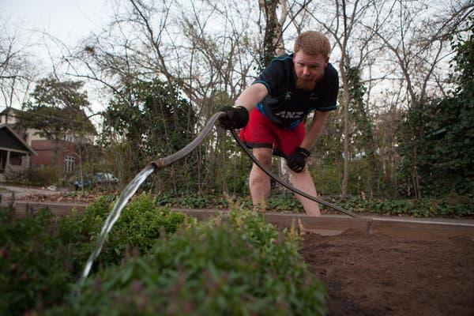
Brandon McCullers of Austin, Tex., gardening. Many complain that city residents have made few sacrifices. Credit...Ilana Panich-Linsman for The New York Times

The Lower Colorado River Authority decided last month to cut off water deliveries to rice farmers after concluding that two reservoirs supplying Austin and other upstream towns were dangerously low — at about 38 percent of capacity. The farmers had no recourse, because they had no water rights: They had sold them to the authority decades ago.
The cutoff nevertheless has come to underscore the tinderbox relationship between the state’s rural past and its urban future. At a packed hearing before an administrative law judge last month, farmers and others downstream complained that they were surrendering their water while Austin residents continued to wash their cars, groom golf courses and water their lawns, albeit only once a week under water-saving restrictions.
Urbanites argue that drinking-water reservoirs were not intended to irrigate farms, a point the farmers contest, and that recreational businesses along the reservoirs are going bankrupt. A town on one of the reservoirs, Lake Travis, has to truck in water to keep taps flowing, they say.

“The tensions exist in every river basin in the state,” Jason Hill, a water-rights lawyer now representing the Texas city of San Angelo in another rights dispute, said. “You don’t really know the value of something until you run out of it and know you want it again. And water has historically been an underappreciated resource.”

Across Texas, as in Austin, rural interests clearly are waging a rear-guard battle. The Texas Water Development Board, the state’s planning agency, figures that cities’ demand for water will rise nearly 75 percent by 2060, while the use of water for irrigation will decline by 17 percent. By then, cities — not farmers — will be the dominant consumers of water.

But the farmers are not giving up without a fight.
In 2011, the Texas Legislature gave a nod to that shifting priority, authorizing the state’s Commission on Environmental Quality to suspend water rights in emergencies like droughts. While the commission still had to allot water to rights holders in order of seniority, the Legislature said, it also could consider — as much as was practical — how that water was being used before ordering a rights holder’s pumps shut off.

A year later, when drought left the Dow Chemical Company’s Freeport petrochemical plant short of Brazos River water, the company asked the commission to honor its 83-year-old water rights and to order more recent users to make up its shortage.
And the commission did — but only after deciding that 66 Texas towns and electric utilities should be exempted from a cutoff for health and safety reasons, even though hundreds of farmers and others who lost their water held more senior rights. Indeed, court documents state, the exempted towns and utilities held rights to 96 percent of the water affected by Dow’s claim. The remaining 4 percent, mostly farmers like Mr. De Stefano, lost all right to irrigate their crops until the suspension ended several weeks later.

In the ensuing lawsuit, Mr. DeStefano and others argued that the commission could not pick winners and losers when enforcing water rights enshrined in law. “State law says that first in time, first in right. That means what it says,” said Joshua Katz, an Austin lawyer representing the farmers’ interest. Prudent cities, he said, do what prudent farmers do to brace for drought: They buy more senior water rights.

A trial court sided last year with the farmers, and the case is on appeal. But should the region’s drought not let up, people here say, further lawsuits in Texas and across the West are all but inevitable.

“It truly is a good time to be a water attorney in Texas,” said Mr. Hill, the lawyer in San Angelo dispute. “There’s work here as far as the eye can see.”

Step 2: Answer questions about what you read

- What issue is raised in this article?
________________________________________________________________________________________________________________________________________________________________________________________________________________
________________________________________________________________________________________________________

- Who do you believe should have rights to the water? Why?

________________________________________________________________________________________________________________________________________________________________________________________________________________
________________________________________________________________________________________________________

Step 3: Draw a picture/explain

What can you design to make sure there are no droughts and everyone has access to the water they need? Draw a picture and write a description of your design/plan.

________________________________________________________________________________________________________________________________________________________________________________________________________________________________________________________________________________________________________________________________________________________________________________________________________________________________

Student Feedback:

Circle the emojis that best represents how this activity made you feel.

Mindfulness Moment!

Sitali breath
To do this:
- Choose a comfortable seated position.
- Stick out your tongue and curl your tongue to bring the outer edges together.
- If your tongue doesn’t do this, you can purse your lips.
- Inhale through your mouth.
- Exhale out through your nose.
- Continue breathing like this for up to 5 minutes.

Day 4: Math of the Bill of Rights
Math

What is this lesson about?: Today we are going to look at three provisions of the original Bill of Rights and look at some of the ‘math’ related to those provisions.

Warm Up Problem-
If Cheryl runs 4 miles per day, 7 days a week, how many miles will she run in a week?

If she increases that to 5 miles per day, how many more miles per week will she run?

This represents an increase of what percentage?

Activity #1: The 5th Amendment to the US Constitution

The 5th Amendment in the Bill of Rights, states:

No person shall be held to answer for a capital, or otherwise infamous crime, unless on a presentment or indictment of a Grand Jury, except in cases arising in the land or naval forces, or in the Militia, when in actual service in time of War or public danger; nor shall any person be subject for the same offence to be twice put in jeopardy of life or limb; nor shall be compelled in any criminal case to be a witness against himself, nor be deprived of life, liberty, or property, without due process of law; nor shall private property be taken for public use, without just compensation.
In this activity we will look at some mathematical examples of the last clause: nor shall private property be taken for public use, without just compensation.
Let’s consider some examples of this:
Suppose that in Milwaukee the CIty wants to build a new NBA arena for the Bucks, their basketball team. The ‘best’ place to build it is in a low income area of the city. The City wants to purchase the land to build the arena.
Company A owns all of the apartment complexes in that area of town. The City offers to buy all the land/buildings for $1,000,000.
Discuss/Consider-
- Is $1,000,000 ‘just compensation’ for Company A?
- Is building a basketball arena ‘public use?’
- If Company A gets $1,000,000 what do the people who live in the apartments but who will be forced to leave get? Anything at all?

You are hired to appraise the value of the land/apartments. Answer the questions below. Use your best judgement. There is no exact right or wrong answer-
- What information would you want to know to help you determine what ‘just compensation’ would be for the owner of Company A?
- What, if anything, would you say the people who are renting apartments should get as ‘just compensation’? Are they entitled to any money?
- What argument would you use to say that building a new basketball arena is a ‘public good.”
- What argument would you use to say that building a new basketball arena is not a public good (and Company A cannot be forced to sell)?

Activities #2, 3 and 4: The 6th Amendment to the US Constitution

The 6th Amendment reads:
“In all criminal prosecutions, the accused shall enjoy the right to a speedy and public trial, by an impartial jury of the State and district wherein the crime shall have been committed, which district shall have been previously ascertained by law, and to be informed of the nature and cause of the accusation; to be confronted with the witnesses against him; to have compulsory process for obtaining witnesses in his favor, and to have the Assistance of Counsel for his defence.”

In this activity we will look at some mathematical examples of three clauses of the 6th Amendment: ‘right to a speedy and public trial,’ ‘by an impartial jury,’ and ‘to have the Assistance of Counsel for his defense.’
The math of a Right to a Speedy Trial: Most states set time limits for what a ‘speedy trial” means. In California, for instance, the law dictates that a person charged with a felony shall be brought to trial within 60 days of the defendant's arraignment and within 30 days for a misdemeanor. Often defendants waive the right to a speedy trial, and prosecution requests delays (which may be granted by the judge).
In addition, most states set stricter time limits for juvenile cases. The chart below shows actual time between arrest/arraignment and trial start date. Use the chart to answer the questions.
Average number of days between arraignment and trial start date, in five cities (2018)
 | Misdemeanor | Felony 1 | Felony 2
New Orleans | 45 | 170 | 440
Washington, DC | 18 | 93 | 270
Houston, TX | 32 | 80 | 320
Albany, NY | 26 | 65 | 220
Seattle, WA | 14 | 110 | 195

What is the average length of time (days) that it takes before a trial to start for a misdemeanor charge?
What is the average length of time (days) that it takes before a trial to start for a Felony 2 charge?

Reminder: How many days are in 1 year?

Why, do you think, it takes longer for trials on Felony charges to start than for misdemeanor charges?

What is one negative outcome of long delays before starting a trial?

Is there any positive benefit for long delays before trials start?

Consider--write your answers out below.
- What factors would you consider in determining if someone had a ‘speedy...trial’ or not?
- Based on your definition of ‘speedy’ what would you do if you were a judge in New Orleans and you wanted to ensure that all defendants had a ‘speedy’ trial?

The math of an Impartial Jury of the State and district where the crime shall have been committed: Impartial means that the jury does not have any prejudice towards you as a defendant and will render a verdict based on the evidence in the case. After the civil war, during the Jim Crow era, many southern states excluded African Americans from serving on juries. In 1935, in Norris v. Alabama (1935), the Supreme Court ruled that African Americans could not be excluded systematically from jury service.

Over many years and many court cases, have determined how to ensure that racial prejudice does not overwhelm the jury selection process, with the courts settling mostly on the notion that a prosecutor may not strike a potential juror solely based on his/her race.

The photo below is an actual list of jurors with the prosecutor’s notes scribbled on them, from a famous 2006 case.
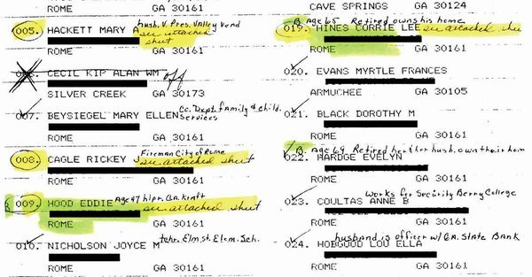

This snapshot shows 12 potential jurors. The prosecutor wrote the letter “B” next to three of their names. Each juror with a “B” next to their name was excluded from serving by the prosecutor, without cause.

The judge found that “B” stood for Black or African American, and based on further inquiry found that the sole reason the jurors were dismissed was because of their race.
Assume that the defendant in this case was Black. And that the city where the crime took place was 30% Black, 40% White, and 20% Latino and 10% other races. Consider and write down short answers. There is no exact right or wrong answer.

- What sort of jury make-up by race would be fair or impartial?

- Does it matter what the race of each juror is or not? Does it matter what the overall make-up of the jury pool?

The Math of Assistance of Counsel for defense:
Some people argue that effective “assistance of counsel” means that public defender services must be funded on par with local prosecutors’ offices. Others say it is a case-by-case matter. We will examine funding for public defense in New Orleans for this activity.
Funding for public defenders varies state-by-state and city-by-city. In New Orleans, the public defenders are funded each based on the city budget (and other taxes). The District Attorney (public prosecutor) is also funded locally.
For 2020, the budget for the District Attorney in New Orleans was slated to be $6.6 million.
For 2020, the budget for the Public Defender in New Orleans was slated to be $1.8 million.
How much larger is the DA’s budget than the Public Defender’s budget in New Orleans?
The chart below shows the average yearly caseload for a public defender in 5 cities.
 | Average Yearly Caseload
New Orleans | 240
Washington, DC | 130
Houston, TX | 210
Albany, NY | 180
Seattle, WA | 160
Based on these five cities, what is the average annual caseload of a public defender?

How does this compare to the average caseload for a public defender in New Orleans?

To consider: What might be one negative ramification of public defenders have large case loads?

Student Feedback:

Circle the emojis that best represents how this activity made you feel.

Day 4: Online Freedom of Assembly
Digital Health

What is this lesson about?: Today you will learn about your freedom of assembly online.

Step 1: Warm-up- How can gathering people online make a big impact?

Can you think of an example when a large group of people online were able to change the outcome of something? Or bring awareness to an issue? Why do you think that happened?

Step 2: Read the article on your digital right to assemble online.
Social media users are changing their profile pictures to blue to show support for protesters in Sudan. The protesters faced a violent military crackdown on June 3. More than 100 people were killed in Sudan's capital city Khartoum. And hundreds more were injured.
The blue wave has spread across various platforms via the #BlueForSudan hashtag. Twitter and Instagram users are using the hashtag to honor the memory of one of the victims. His name was Mohamed Mattar and his favorite color was reportedly blue.
The 26-year-old engineer was fatally shot during the June 3 crackdown blamed by protesters on Rapid Support Forces (RSF). The RSF is a military group led by a senior member of Sudan's ruling Transitional Military Council. However, it is not Sudan's official military.

Hero Shot While Protecting Others
Mattar was reportedly shot while trying to protect two women during the bloody crackdown. The RSF was reportedly trying to get people to leave the protest camp outside the military headquarters.
Shahd Khidir is a friend of Mattar's and a beauty influencer on Instagram. "Once he was murdered, his friends and family changed their profile picture to match his, and eventually other people began to join in," she said. Khidir asked her followers to change their profile pictures to blue, like the image on Mattar's Instagram account.
Now the color represents "all of the Sudanese people who have fallen in the uprising," Khidir said.

Demands For A Government Led By The People
The protest began on April 6. It was the result of months of other protests against Sudan's longtime ruler Omar al-Bashir. He was forced out of office on April 11, but protesters remained at the site until the June crackdown. The protesters have been demanding a government led by the people of Sudan. As it stands, the military has taken over the country.
Since then, the country's military rulers have reduced Internet access. It led to what rights groups have described as a near-total shutdown on June 10, leaving protesters more detached from the outside world.
In a country where the state tightly monitors traditional media outlets, the Internet provided a space for Sudanese to communicate with those inside and outside the country. Protesters and self-styled citizen journalists used social media to organize demonstrations. They also used it to share updates from the uprising with the rest of the world.
Some images from the country went viral, including a striking photo of a young woman standing on top of a car addressing fellow protesters.

Internet Shutdown Poses Significant Challenge
The shutdown has presented a significant challenge to Sudanese living in other countries. Until now they have played a key role in spreading information from the protest movement internationally. Those outside Sudan have been forced to rely on phone calls or word of mouth to receive information from the ground, without any visual footage, which they, in turn, share on social media.
"Sudan is literally in the dark right now," said 25-year-old Aza Elnimah, a young Sudanese professional based in Qatar. "We don't know what's happening. So if something happens, how are we gonna be able to get that footage out? The only way we can reach our families now is through telephone, but that still isn't enough."

Hashtag Spearheads Months-Long Protests
In the days after the attack on the protesters, the #IAmTheSudanRevolution hashtag was backed by the Sudanese Professionals Association (SPA), the group that has spearheaded the months-long protests. Sudanese living in other countries heard the call and the hashtag trended in a number of countries. Since then, stories about Sudan have gained attention online, particularly since the color blue began to go viral.
"People didn't pick it up right away, but the rest of the Sudan population adopted that color because it was working in a way that was gaining attention," Elnimah said. "People kept asking questions like, why is everyone changing their profile picture to that color?"
Elnimah said it has allowed Sudanese to control the story again by telling people what's happening and answering their questions.
Instagram user Lucrezia Brunetti said, "People are unified by this color. It's something so simple, but it symbolizes so much, it symbolizes that people care."
For some in the wider Sudanese community, the #BlueForSudan campaign has brought hope.
"In the beginning, it felt like no one cared," said Elnimah. "Now, it's refreshing to know that Sudan is on people's radars."
Step 3: Answer the questions below

- Why did uniting people online bring comfort to the Sudanese?

- How do you think trends like this spread online?

- Can you think of a cause that you would want to draw attention to online? Why?

Step 4: Tweets
Write two tweets that you would use to spread your message and unite an assembly of people online to join your cause. Don’t forget to include two hashtags!

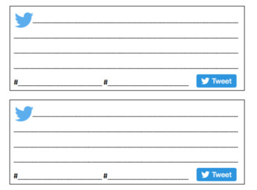

Mindfulness Moment!

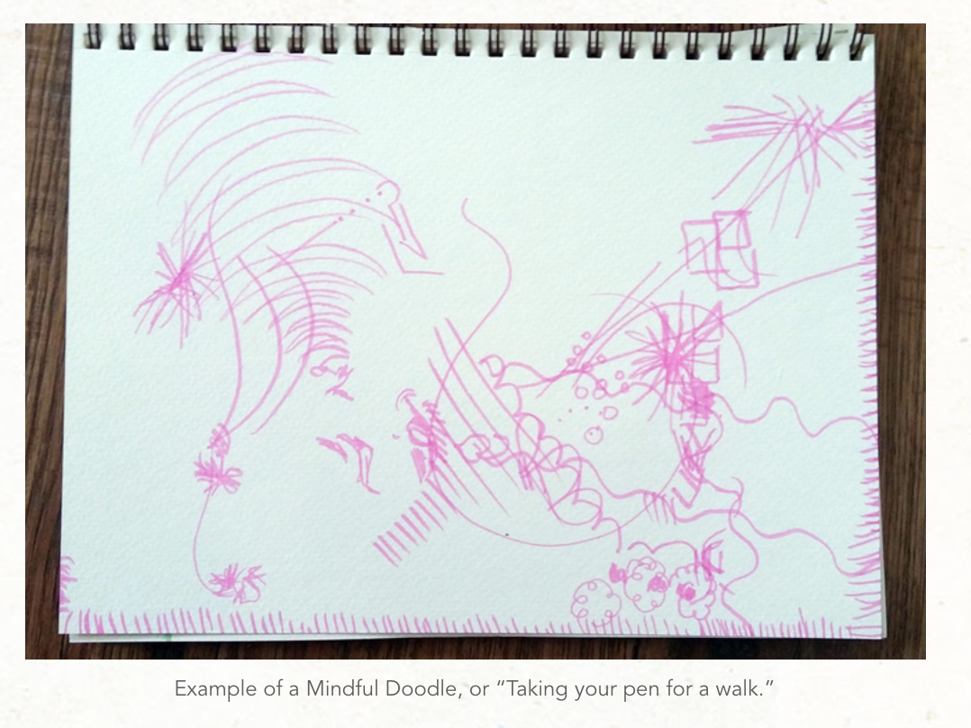

Take your pen for a walk. As you pause and think you will start to draw the things or shapes that come to mind.

Day 4: Amendments Beyond the Bill of Rights
Social Studies

What is this lesson about?: As you learned yesterday, there is a process to make additional amendments to our U.S. Constitution, though it’s not an easy one. Today you will explore some of the seventeen amendments that have made it through the proposal and ratification process. These amendments have created additional rights and protections for U.S. Citizens.

Step 1: Warm-Up

List the amendments are you familiar with outside of the Bill of Rights?

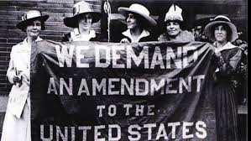
Step 2: Read about the 19th Amendment

“The right of citizens of the United States to vote shall not be denied or abridged by the United States or by any State on account of sex.

Congress shall have power to enforce this article by appropriate legislation.”

Description of Amendment
The Nineteenth Amendment, ratified August 1920, secured women’s right to vote in all elections—local, state, and national. The amendment specified that neither state nor federal governments could legally deny women the vote nor could they “abridge” this right. In other words, they could not place obstacles in the way of women’s exercise of their constitutional right to enfranchisement (the right to vote).
General historical context
American entrance into World War I in 1917 provides the immediate backdrop to passage of the Nineteenth Amendment. By this time, “suffragists” (supporters of women’s suffrage) were determined to pressure Congress to approve a constitutional amendment. Women’s suffrage had been passed over in the Fifteenth Amendment, and bills for a women’s suffrage amendment had been introduced to Congress without success since 1878. Opponents such as the National Association Opposed to Women’s Suffrage (founded 1871) were active, especially in the South.
American involvement in World War I, however, heightened demands for women’s suffrage. President Wilson announced that the purpose of the war was to establish democracy. Suffragist women countered that the United States was hardly a democracy if half its population was denied the right to vote. When President Wilson spoke in public, he found audience members wanting to know why, if he favored democracy around the world, he opposed “the national enfranchisement of woman.” Finally, on January 9, 1918, Wilson changed his position and spoke favorably of women’s suffrage. The House of Representatives passed the amendment the following day, but the Senate refused to deal with it until October, when it failed by three votes.
The following year, supporters urged men to elect pro-women’s suffrage candidates at the November 1918 mid-term election. The new Congress was at last composed predominantly of supporters and by the late spring of 1919, both chambers had overwhelmingly passed the Nineteenth Amendment. In August it was sent to the states for ratification. A year later, passage by the thirty-sixth state, Tennessee, made women’s suffrage the law of the land.
Economic context
In the early nineteenth century, American women generally lived on farms and produced items for home use. Women enjoyed a certain status as home producers, but this status changed as the century progressed and more outside products were bought for home use. By the end of the century and first decades of the next,
the economic roles of significant numbers of women had undergone marked transformation. Nearly 25 percent were in the labor force. Some, who were factory workers, formed unions led by women. Other women could be found in roles previously reserved for men. Thus, women were physicians and surgeons, astronomers, physicists, and biologists, as well as architects and civil engineers. Women also took on the role of successful inventors—the windshield wiper, for example, was invented in 1903 by Alabaman Mary Anderson.
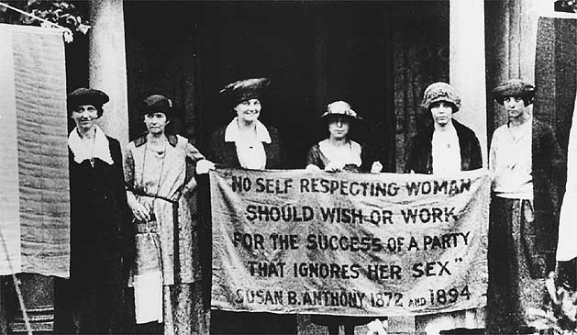
The economic context of World War I gave further impetus to women’s suffrage, as women took their places in war industries. This new situation gave their leaders firmer foundations for their demands for equal rights with men. Opportunities for women were, however, constrained by social class and race, with black women suffering most.
Political context
Women’s suffrage had its roots in nineteenth century organizations to abolish slavery and curtail alcohol abuse—“temperance” societies such as the Woman’s Christian Temperance Union founded in Illinois in 1873. In these organizations women learned the arts of political organizing, pamphleteering, speaking, and demonstrating. (Liquor interests strongly opposed women’s suffrage because they rightly suspected that women would vote for Prohibition.) While participating in such efforts, Women learned first hand about gender discrimination, which helped bring together early leaders to press the case for women’s rights. In the 1830s, for example, women’s anti-slavery associations were opposed in Massachusetts because men believed women should not speak publicly on the issue.
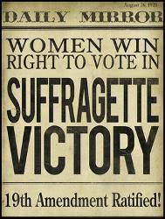
Similarly, in 1840, Lucretia Mott and Elizabeth Cady Stanton were banned from participating in the World Anti-Slavery Convention in London on account of gender; but they later translated their outrage into organizing the Seneca Falls Convention (1848), the first public political meeting in the nation that dealt with women’s issues. At the Seneca Falls Convention, Stanton advocated the radical position of women’s suffrage, an idea that was widely ridiculed, at first, but later adopted by the Convention following the intervention of the abolitionist Fredrick Douglass. Perhaps the most famous suffragist leader, Susan B. Anthony, was also active initially in anti-slavery and temperance causes. She, too, was barred from speaking at a temperance convention and took up women’s rights as a result.
In 1869 Anthony and Stanton founded the National Woman Suffrage Association (NAWSA), which advocated pressing for a constitutional amendment on suffrage. In the same year, the American Woman Suffrage Association (AWSA), which stood for lobbying state legislatures to amend state constitutions, was formed. Five years later, on the one hundredth anniversary of the Declaration of Independence, Susan B. Anthony read a “Declaration of the Rights of Women” before the Liberty Bell in Philadelphia. In 1878, the first of what became annual bills for a women’s suffrage amendment was introduced in Congress.
In 1890, NAWSA and AWSA buried their differences and merged to form a single organization. Increasingly well organized, the suffragist movement saw a new generation of leaders emerge.
The political struggle for suffrage was not without its dangers and difficulties, as illustrated by events in 1913. In that year, Alice Paul led an enormous parade down Pennsylvania Avenue in Washington, D.C., the day before Woodrow Wilson’s presidential inauguration. The parade turned into a riot as thousands of male opponents blocked the marchers’ way. After male supporters came to the women’s rescue, troops had to be called to restore order. Hundreds of women were hospitalized, but no one was arrested for assaulting them.
In 1917, moreover, when women formed a twenty-four hour vigil (“Sentinels of Liberty”) for a constitutional amendment for women’s suffrage around Woodrow Wilson’s White House, nearly five hundred were arrested (illegally, it was later determined). One hundred sixty-eight demonstrators were sent to prison, where they were treated harshly, and were not released until early 1918. But by then President Wilson had changed his position and endorsed women’s suffrage.
Step 3: Answer questions

In one sentence, describe the main focus of the 19th Amendment. What right(s) did it establish?

Briefly explain why the amendment was needed.

Give one example for the economic context of the amendment. What was happening economically that helped progress the women’s suffrage movement?

Give one example for the political context of the amendment. What was happening politically during the suffrage movement and fight for the 19th Amendment?

Many suffragists first worked to abolish slavery. Which famous abolitionist spoke at the Seneca Falls Convention? Why do you think he supported the suffragist movement?

P.S. Did you know this year (2020) marks the 100th anniversary of the ratification of the 19th Amendment! After a 72 year fight, women achieved the right to vote!

Step 4: Read about the 18th and 21st Amendments
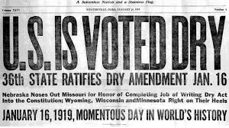
The Rise and Fall of Prohibition
Adapted from the National Constitution Center

Prohibition was a ban on the manufacture, sale, and transport of alcohol within the United States. It began with the ratification of the 18th Amendment in 1919. The roots of Prohibition include the Temperance Movement. Temperance was the effort to persuade individuals not to drink alcohol. Prohibition legally banned its sale and transport for everyone.

Towards Prohibition In the early 19th century, Protestants took part in revivals to convert new followers to Christ. In their eyes, drinking was a worldly evil that needed to be overcome. They became promoters of temperance. This meant they worked to convince people to choose not to drink. Organizations like the Women’s Christian Temperance Union (WCTU) called for schoolchildren to be taught about temperance and wrote textbooks on the subject.

Many Protestant churches joined forces with the Anti-Saloon League. The Anti-Saloon League was the nation’s leading lobbying group for anti-alcohol legislation. It promoted temperance, but also called for laws suppressing the rights of saloon owners. By the early 1900s, the League was gaining influence. By 1917, 26 of the 48 states had passed prohibition measures. Congress was also considering a constitutional amendment for nationwide prohibition of alcohol.

The 18th Amendment was approved by Congress in December of 1917. It prohibited the “manufacture, sale, and transportation of intoxicating beverages.” The amendment went into effect in 1920, one year after the required number of states ratified it. The 18th Amendment was the first ever to limit citizens' personal liberties.

Prohibition and the Progressive Movement
Prohibition was connected to the wider Progressive movement. Advocates for it believed that alcohol was holding back the progress of mankind. Therefore, they believed, the government had to intervene. This belief was consistent with an important shift away from the traditional American understanding of the purpose of government. The founders believed that limiting government power was the best way to ensure citizens could best pursue happiness. They believed people were naturally flawed, and government should be structured with checks and balances. Unlike the framers of the Constitution, Progressives believed that people's natures could be made better through government action. Therefore, government should provide citizens with ways to improve themselves through programs and policies. The Sixteenth through 19th Amendments are sometimes called the “Progressive Era Amendments.”
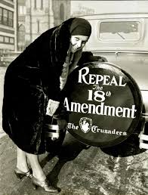
Towards Repeal
The 18th Amendment did not ban the consumption of alcohol, only its manufacture, sale, and transport. Many began hoarding alcoholic beverages while they could. Individuals could legally make wine and alcoholic cider for home use, but moonshine could be deadly if made incorrectly. Smugglers brought liquor into the United States at port cities around the country.

Federal agents charged with enforcing the law were not prepared to deal with the large numbers of bootleggers and speakeasies. Courts were overloaded with Prohibition-related cases. Chicago and New York were hubs for crime bosses who attempted to transport alcohol across the country. The results were corruption, destruction, and death.

The Great Depression struck a major blow to the nation’s economy, and the tide began to turn against Prohibition. Lawmakers believed that a tax on alcohol could help increase federal revenue to aid the struggling country. Citizens were concerned about the upsurge in crime and violence. Franklin Roosevelt reversed his position and came out against Prohibition during his 1932 presidential campaign. Congress approved the 21st Amendment on February 20, 1933, and it was ratified by state conventions throughout the year.

On December 5, 1933, the United States ratified the 21st Amendment, repealing the 18th Amendment. This was the first time in American history a constitutional amendment had been repealed. Many states began controlling liquor usage through licensing requirements, drinking age limits, and specific hours of operation for liquor sellers. Many of these regulations are still in force.

Step 5: Answer questions

What is the historical relationship between the Women’s Suffrage Movement and Temperance/Prohibition?

How did the 18th Amendment differ from every other constitutional amendment in history?

Why do you believe the people changed their minds about Prohibition?

What do the 18th and 21st Amendments teach us about the role of states in policy considerations?

Student Feedback:

Circle the emojis that best represents how this activity made you feel.

Week 7
Rights

Day 5

NAME:______________________
Day 5 Agenda

Topic | Activity
Warm-Up!
English Language Arts | - Read and analyze the speech All Together Now by Barbara Jordan.  - Answer questions about the speech.  - Demonstrate their understanding of the theme “All Together Now” through their choice of a short poem/song/rap, a drawing or an adaptation of Jordan’s speech to update it for an audience in 2020.
Science | - Read about the Flint Water Crisis  - Answer questions about what you read  - Draw a picture  - Reflect
Mindfulness Moment!
Math | - Rights-How about Right Angles
Health | - Internet Rights
Mindfulness Moment!
Civics/Social Studies | - Choose Your Rights!

Warm-up Activity: Write a journal entry around the daily quote on identity.
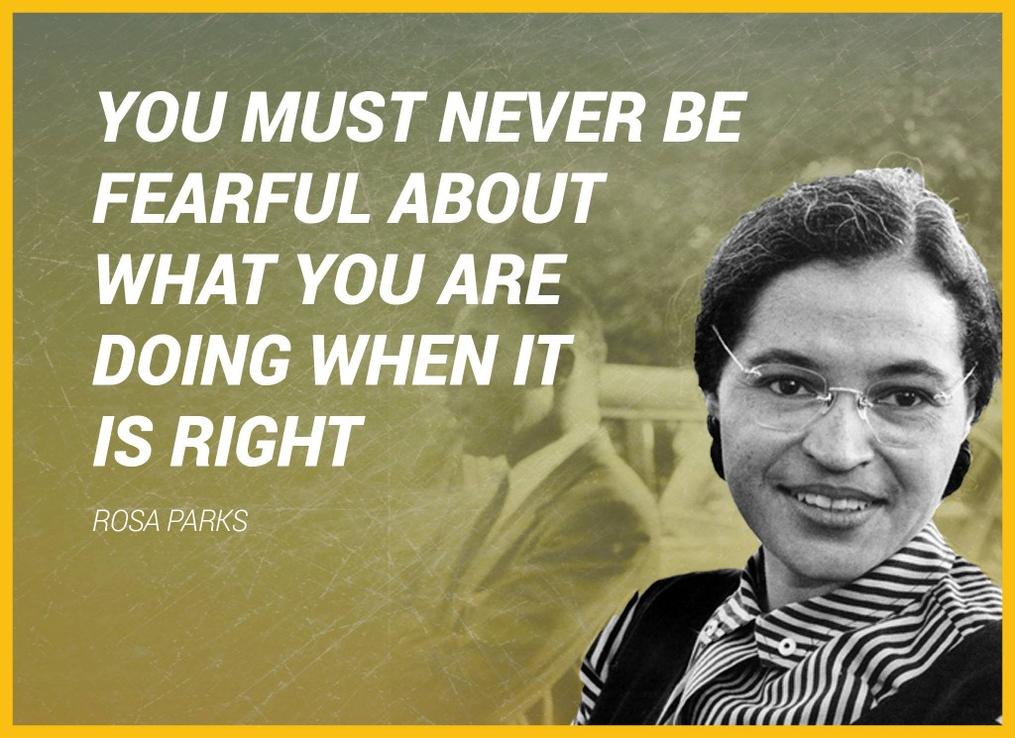

Day 5: Barbara Jordan
English Language Arts

What is this lesson about? Today you will read a persuasive speech by Barbara Jordan given while addressing the Democratic Convention in 1992 where Bill Clinton was declared the Democratic Nominee for President.

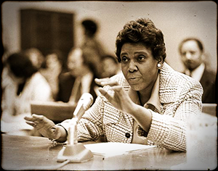
Before you read:
Barbara Jordan was a lawyer and educator who was a congresswoman from 1972 to 1978—the first African-American congresswoman to come from the deep South and the first woman ever elected to the Texas Senate (1966). Advancing in her career, Jordan won election to the U.S. House of Representatives in 1972. As a member of the House Judiciary Committee, she was thrust into the national spotlight during the Watergate scandal. Jordan stood as a moral compass during this time of crisis, calling for the impeachment of President Richard M. Nixon for his involvement in this illegal political enterprise. "I am not going to sit here and be an idle spectator to the diminution, the subversion, the destruction of the Constitution," she said in a nationally televised speech during the proceedings. In 1992, Jordan once again took the national stage to deliver a speech at the Democrats ic National Convention. Her health had declined by this point, and she had to give her address from her wheelchair. Still, Jordan spoke to rally her party with the same powerful and thoughtful style she had displayed 16 years earlier. In 1994, President Bill Clinton appointed Jordan to head up the Commission on Immigration Reform. He also honored her with the Presidential Medal of Freedom that same year. She passed away two years later, on January 17, 1996, in Austin, Texas. Jordan died of pneumonia, a complication of her battle with leukemia.

Some Vocabulary to review:
slate: flat board used for writing on, typically framed in wood, formerly used in schools. | heyday: the period of one's greatest popularity or prosperity | culminate: to reach the highest point
fatigue: tiredness, exhaustion | compassion: concern for the sufferings or misfortunes of others. | optimist: someone who always looks at things positively
harmonious: free from disagreement

Step 1: Read the speech below
All Together Now
Barbara Jordan
When I look at race relations today I can see that some positive changes have come about. But much remains to be done, and the answer does not lie in more legislation. We have the legislation we need: we have the laws. Frankly, I don’t believe that the task of bringing us all together can be accomplished by government. What we need now is soul force—the efforts of people working on a small scale to build a truly tolerant, harmonious society. And parents can do a great deal to create that tolerant society.
We all know that race relations in America have had a very rocky history. Think about the 1960s when Dr. Martin Luther King Jr. was in his heyday and there were marches and protests against segregation and discrimination. The movement culminated in 1963 with the March on Washington.
Following that event, race relations reached an all-time peak. President Lyndon B. Johnson pushed through the Civil Rights Act of 1964, which remains the fundamental piece of civil rights legislation in this century. The Voting Rights Act of 1965 ensured that everyone in our country could vote. At last, black people and white people seemed ready to live together in peace.
But that is not what happened. By the 1990’s the good feelings had diminished. Today the nation seems to be suffering from compassion fatigue, and issues such as race relations and civil rights have never regained momentum.
Those issues, however, remain crucial. As our society becomes more diverse, people of all races and backgrounds will have to learn to live together. If we don’t think this is important, all we have to do is look at the situation in Bosnia today.
How do we create a harmonious society out of so many kinds of people? The key is tolerance—the one value that is indispensable in creating community.
If we are concerned about community, if it is important to us that people not feel excluded, then we have to do something. Each of us can decide to have one friend of a different race or background in our mix of friends. If we do this, we’ll be working together to push things forward.
One thing is clear to me: We, as human beings, must be willing to accept people who are different from ourselves. I must be willing to accept people who don’t look as I do and don’t talk as I do. It is crucial that I am open to their feelings, their inner reality.
What can parents do? We can put our faith in young people as a positive force. I have yet to find a racist baby. Babies come into the world as blank as slates and, with their beautiful innocence, see others not as difficult but as enjoyable companions. Children learn ideas and attitudes from the adults who nurture them. I absolutely believe that children do not adopt prejudices unless they absorb them from their parents or teachers.
The best way to get this country faithful to the American dream of tolerance and equality is to start small. Parents can actively encourage their children to be in the company of people who are of other racial and ethnic backgrounds. If a child thinks, “Well, that person’s color is not the same as mine, but she must be okay because she likes to play with the same things I like to play with,” that child will grow up with a broader view of humanity.
I’m an incurable optimist. For the rest of the time that I have left on this planet I want to bring people together. You might think of this as a labor of love. Now, I know that love means different things to different people. But what I mean is this: I care about you because you are a fellow human being and I find it okay in my mind, in my heart, to simply say to you, I love you. And maybe that would encourage you to love me in return.
It is possible for all of us to work on this—at home, in our schools, at our jobs. It is possible to work on human relationships in every area of our lives.

Step 2: Answer the following questions
Make sure to answer in complete sentences and cite evidence from the text to strengthen your answer.

- How does Jordan summarize the history of race relations in the 1960’s and the 1990’s?

- In your own words, describe what Jordan means by “compassion fatigue”

- Which value is necessary in order to create a “harmonious society”?

- Explain what Jordan means when she says that she has yet to find “a racist baby”.

- What does Jordan suggest that parents do in order to create a sense of community?

- This speech was given in 1992, are there parts of it that still apply today? Why or why not? If yes, which ones? Explain your answer.

Step 3: Think, Write, Draw, Share
The title of the speech is All Together Now. Why might this title be especially appropriate for an audience at a political convention where people were going to decide who the Democratic nominee for President was going to be?

To demonstrate your understanding, you can create any of the following:
- A short poem/song/rap with the theme of All Together Now

- A drawing with the theme of All Together Now

- An adaptation of Jordan’s speech (you can go through the speech and change different portions of it to update it for an audience in 2020.

Make sure you brainstorm your ideas here first then use the following page for work.

Step 4: Share out
Share your All Together Now representation with your peers.

Student Feedback:

Circle the emojis that best represents how this activity made you feel.

Day 5: Flint Water Crisis
Science

What is this lesson about?: Today you will read the Flint water crisis: Everything you need to know passage. You will respond to questions and complete an activity.

Step 1: Read the passage

Flint Water Crisis: Everything You Need to Know

(NRDC, 2018)
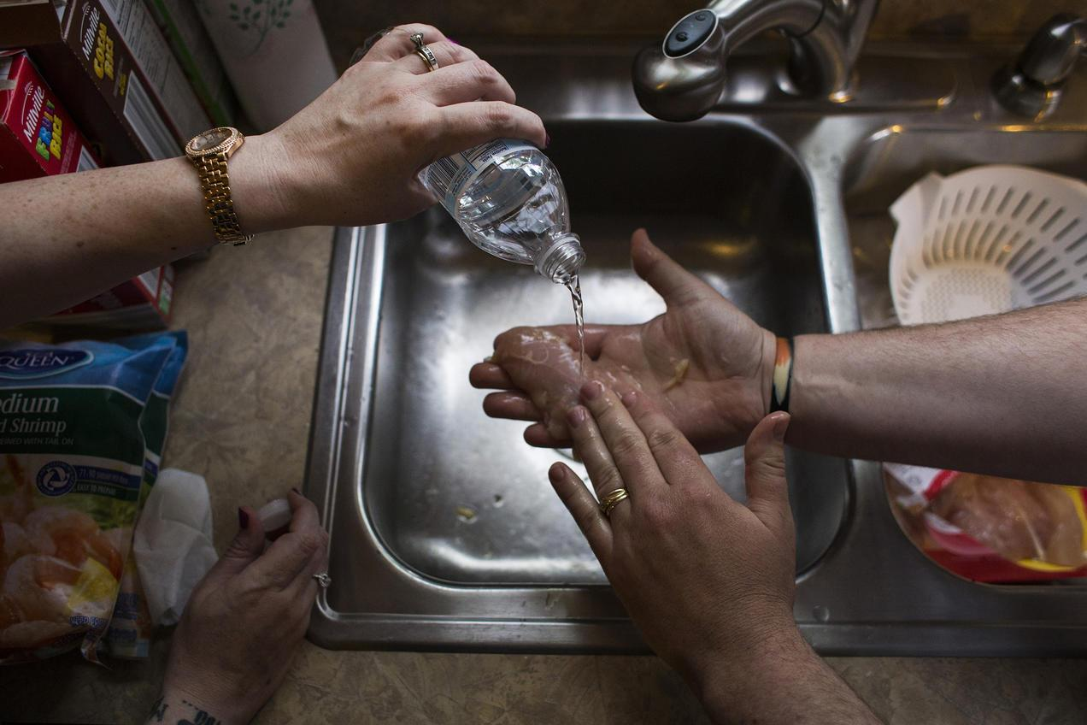
Fearful of using the tap water to wash their food, Flint residents Melissa and Adam Mays prepare meals with bottled water. Brittany Greeson

A story of environmental injustice and bad decision making, the water crisis in Flint, Michigan, began in 2014, when the city switched its drinking water supply from Detroit’s system to the Flint River in a cost-saving move. Inadequate treatment and testing of the water resulted in a series of major water quality and health issues for Flint residents—issues that were chronically ignored, overlooked, and discounted by government officials even as complaints mounted that the foul-smelling, discolored, and off-tasting water piped into Flint homes for 18 months was causing skin rashes, hair loss, and itchy skin. The Michigan Civil Rights Commission, a state-established body, concluded that the poor governmental response to the Flint crisis was a “result of systemic racism.”

Later studies would reveal that the contaminated water was also contributing to a doubling—and in some cases, tripling—of the incidence of elevated blood lead levels in the city’s children, imperiling the health of its youngest generation. It was ultimately the determined, relentless efforts of the Flint community—with the support of doctors, scientists, journalists, and citizen activists—that shined a light on the city’s severe mismanagement of its drinking water and forced a reckoning over how such a scandal could have been allowed to happen.

Flint Water Crisis Summary
Long before the recent crisis garnered national headlines, the city of Flint was eminently familiar with water woes. For more than a century, the Flint River, which flows through the heart of town, has served as an unofficial waste disposal site for treated and untreated refuse from the many local industries that have sprouted along its shores, from carriage and car factories to meatpacking plants and lumber and paper mills. The waterway has also received raw sewage from the city’s waste treatment plant, agricultural and urban runoff, and toxics from leaching landfills. Not surprisingly, the Flint River is rumored to have caught fire—twice.

As the industries along the river’s shores evolved, so too did the city’s economy. In the mid-20th century, Flint—the birthplace of General Motors—was the flourishing home to nearly 200,000 people, many employed by the booming automobile industry. But the 1980s put the brakes on that period of prosperity, as rising oil prices and auto imports resulted in shuttered auto plants and laid-off workers, many of whom eventually relocated. The city found itself in a precipitous decline: Flint’s population has since plummeted to just 100,000 people, a majority of whom are African-American, and about 45 percent of its residents live below the poverty line. Nearly one in six of the city’s homes has been abandoned.
This was the lay of the land in 2011, when Flint, cash-strapped and shouldering a $25 million deficit, fell under state control. Michigan Governor Rick Snyder appointed an emergency manager (basically an unelected official chosen to set local policy) to oversee and cut city costs. This precipitated the tragic decision in 2013 to end the city’s five-decade practice of piping treated water for its residents from Detroit in favor of a cheaper alternative: temporarily pumping water from the Flint River until a new water pipeline from Lake Huron was built. Although the river water was highly corrosive, Flint officials failed to treat it, and lead leached out from aging pipes into thousands of homes.
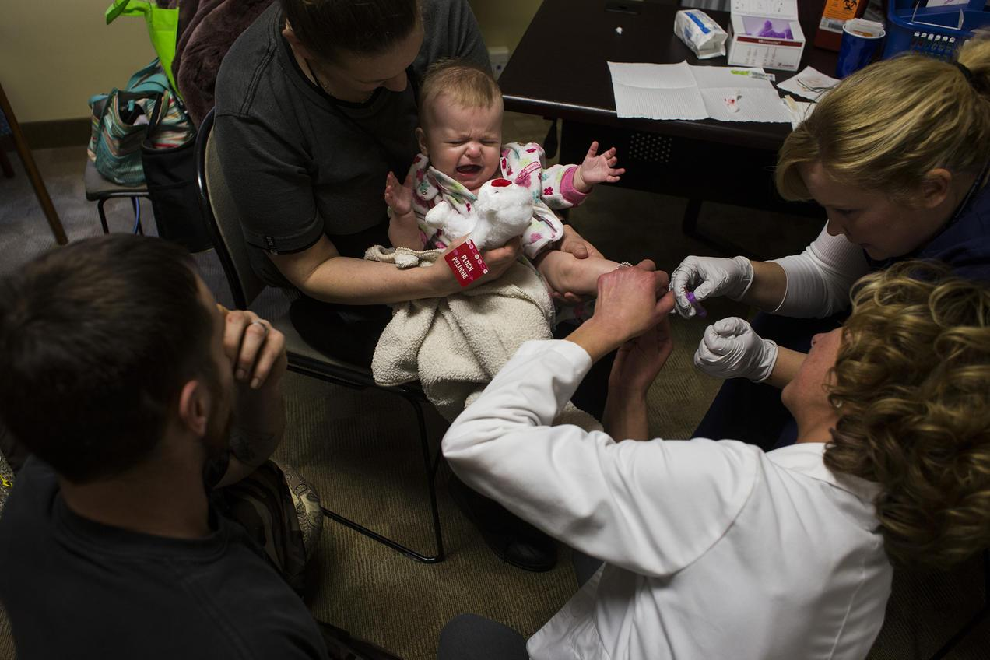

Five-month-old Dakota Erler of Flint gets blood drawn from her heel in order to have her lead levels tested at Carriage Town Ministries in 2016. Brittany Greeson

Lead levels in Flint water
Soon after the city began supplying residents with Flint River water in April 2014, residents started complaining that the water from their taps looked, smelled, and tasted foul. Despite protests by residents lugging jugs of discolored water, officials maintained that the water was safe. A study conducted the following year by researchers at Virginia Tech revealed the problem: Water samples collected from 252 homes through a resident-organized effort indicated citywide lead levels had spiked, with nearly 17 percent of samples registering above the federal “action level” of 15 parts per billion (ppb), the level at which corrective action must be taken. More than 40 percent measured above 5 ppb of lead, which the researchers considered an indication of a “very serious” problem.

Even more alarming were findings reported in September 2015 by Flint pediatrician Mona Hanna-Attisha: The incidence of elevated blood-lead levels in children citywide had nearly doubled since 2014—and nearly tripled in certain neighborhoods. As Hanna-Attisha noted, “Lead is one of the most damning things you can do to a child in their entire life-course trajectory.” In Flint, nearly 9,000 children were supplied lead-contaminated water for 18 months.

More problems with Flint water
Flint’s water supply was plagued by more than lead. The city’s switch from Detroit water to the Flint River coincided with an outbreak of Legionnaires’ disease (a severe form of pneumonia) that killed 12 and sickened at least 87 people between June 2014 and October 2015. The third-largest outbreak of Legionnaires’ disease recorded in U.S. history—as well as the discovery in 2014 of fecal coliform bacteria in city water—was likely a result of the city’s failure to maintain sufficient chlorine in its water mains to disinfect the water. Ironically, the city’s corrective measure—adding more chlorine without addressing other underlying issues—created a new problem: elevated levels of total trihalomethanes (TTHM), cancer-causing chemicals that are by-products of the chlorination of water.
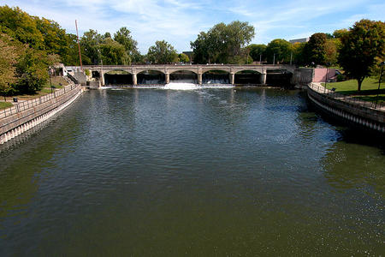
Flint residents go to court
One of the few bright spots of the Flint water crisis was the response of everyday citizens who, faced with the failure of city, state, and federal agencies to protect them, united to force the government to do its job. On the heels of the release of test results in the fall of 2015 showing elevated lead levels in Flint’s water—and its children—local residents joined with NRDC and other groups to petition the U.S. Environmental Protection Agency (EPA) to launch an immediate emergency federal response to the disaster. The EPA failed to act, which only spurred residents on.

Flint Water Crisis
In early 2016, a coalition of citizens and groups—including Flint resident Melissa Mays, the local group Concerned Pastors for Social Action, NRDC, and the ACLU of Michigan—sued the city and state officials in order to secure safe drinking water for Flint residents. Among the demands of the suit: the proper testing and treatment of water for lead and the replacement of all the city’s lead pipes. In March 2016, the coalition took additional action to address an urgent need, filing a motion to ensure that all residents—including children, the elderly, and others unable to reach the city’s free water distribution centers—would have access to safe drinking water through a bottled water delivery service or a robust filter installation and maintenance program.

Those efforts paid off. In November 2016, a federal judge sided with Flint residents and ordered the implementation of door-to-door delivery of bottled water to every home without a properly installed and maintained faucet filter. A more momentous win came the following March with a major settlement requiring the city to replace the city’s thousands of lead pipes with funding from the state, and guaranteeing further funding for comprehensive tap water testing, a faucet filter installation and education program, free bottled water through the following summer, and continued health programs to help residents deal with the residual effects of Flint’s tainted water.

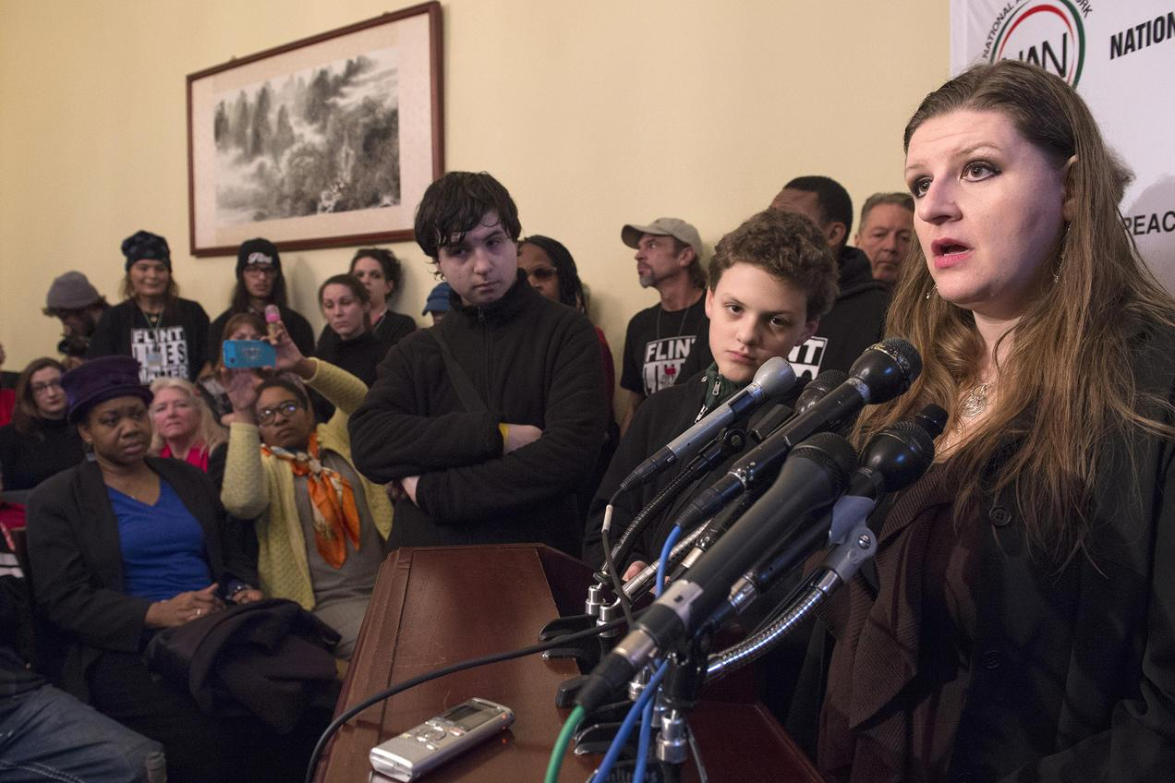
But the work of Flint residents and their advocates isn’t finished yet. Ensuring that the provisions of the 2017 settlement are met is an ongoing task. Indeed, members of the lawsuit have already returned to court to see that the city properly manages its lead service line replacement program and provides filters for faucets.

Melissa Mays and other Flint residents address the media after the House Oversight and Government Reform Committee hearing to examine the Flint water situation in 2016. Molly Riley/Associated Press

Flint Water Crisis Update
Does Flint have safe water yet?
Governor Snyder seemed to signal the all-clear in April 2018 when he announced that the city would stop providing bottled water to residents. Indeed, there is some evidence that the situation in Flint is improving, with lead levels remaining below the federal action level for the past four six-month monitoring periods, from July 2016 to June 2018.

However, it is important to note that thousands of Flint residents are still getting their water from lead pipes. The federal action level for lead is not a health-based number; it merely is an administrative trigger for remediation by the water utility. The EPA and other health authorities agree that there is no safe level of lead in water, so the continuing use of lead pipes by thousands of Flint residents remains a concern, particularly in light of their cumulative lead exposure over many years.

The FAST Start program implemented by the city in March 2016 is working to replace the thousands of lead and galvanized steel service lines that connect Flint water mains to city homes by 2020. But as of October 2018, only a little more than 7,500 pipes had been upgraded. The slow pace of progress drew the group of residents working with NRDC back to court to demand that Flint comply with its obligations to identify and replace lead pipes and supply filters to residents after each pipe replacement.

Flint water crisis charges

In early 2016, Michigan Attorney General Bill Schuette announced an independent review to “determine what, if any, Michigan laws were violated” during Flint’s drinking water disaster. Over the course of his investigation, 15 people have been charged as criminally responsible for causing or contributing to the crisis.

To date, the most senior official to be charged is Nick Lyon, director of Michigan’s Department of Health and Human Services (MDHHS), who is standing trial for involuntary manslaughter in the deaths of two men linked to the Legionnaires’ disease outbreak. While awaiting trial, Lyon remains the state’s health director.

Among other officials charged are the state’s chief medical executive, Dr. Eden Wells, who allegedly threatened to withhold funds for a project after researchers began looking into the Legionnaires’ outbreak, and four state officials charged with tampering with lead test results and instructing residents to flush their taps ahead of testing (which can produce artificially low lead-level results). Two former Flint emergency managers, three Flint city officials, and a handful of Michigan Department of Environmental Quality (MDEQ) and MDHHS employees have also been charged. Meanwhile, Governor Snyder has not been charged with any crime.
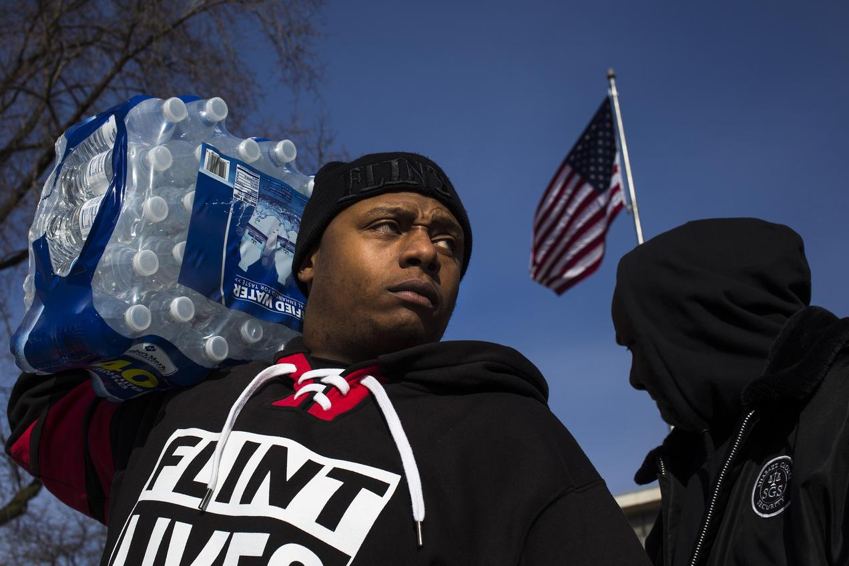
Resident Lorenzo Lee Avery Jr. stands outside of Flint City Hall during a Flint Lives Matter event in 2016. The city’s ongoing water crisis has left residents dependent on bottled water. Brittany Greeson

Step 2: Answer the following questions

- Provide three details that describe the Flint water crisis.

________________________________________________________________________________________________________________________________________________________________________________________________________________________________________________________________________________________________________________________

- If you lived in Flint, what would you do to make sure your rights were not being violated?
________________________________________________________________________________________________________________________________________________________________________________________________________________

- Do you believe those who were charged with the water crisis got “what they deserved”? If not, share what you think should have happened?
________________________________________________________________________________________________________________________________________________________________________________________________________________
________________________________________________________________________________________________________

Step 3: Draw a picture

Draw a picture that shows how you would have tried to help the residents in Flint during the water crisis. Share your drawing and explain what you would do.

Step 4: Reflect

As you think about this week’s science lessons, what’s one thing you will remember about rights?

________________________________________________________________________________________________________________________________________________________________________________________________________________
____________________________________________________

Student Feedback:

Circle the emojis that best represents how this activity made you feel.

Mindfulness Moment!

Deep Breathing
To do this:
- While standing or sitting, draw your elbows back slightly to allow your chest to expand.
- Take a deep inhalation through your nose.
- Retain your breath for a count of 5.
- Slowly release your breath by exhaling through your nose.

Day 5: Right Angles and Related
Math

What is this lesson about?: Today we will take a break from voting rights and related and focus on a bit of geometry, much of which is premised on right angles and related concepts.

Warm Up Problem
 | 1800 | 1850 | 1900
New York, NY | 60,515 | 515,547 | 3,437,202
Philadelphia, PA | 41,220 | 121,376 | 1,293,697

The chart above show the growth of the two largest cities on the East Coast, from 1800 to 1900.
- By approximately how much did New York grow from 1800 to 1850?
- How about from 1850 to 1900?
- What might have been a cause of this huge population increase in the late 1800s, do you think?
Step 1: Basic review
To make sure that everyone has the basic information necessary for today’s activities, we will just review a few key concepts.

Rectangle: A rectangle is a 4 sided figure with all right angles (90⁰). The opposite sides are equal in length.

Example:
Square: A square is a special rectangle, where all 4 sides are the same length.

Example:
Triangle: A triangle is a three sided figure.

Area: The area of a figure is the amount of space inside. It is measured in units² (or square units). Example:
Perimeter: The perimeter is the distance around something. It is measured in units.
Examples:
Measure of an Angle: The measure of an angle is the amount of ‘twist’ you move when you take two lines, connected at one point and move around a circle.
Examples:

Right Triangle:
- A right triangle is a triangle where one of its angles is exactly 90⁰.
- Because the three angles in a triangle add up to 180, if one angle is 90⁰, the other two have to add to 90, as well.
Examples:

Step 2: Area and Perimeter Problems (Round 1)

Find the area, perimeter, or missing length or width of each of the objects below:
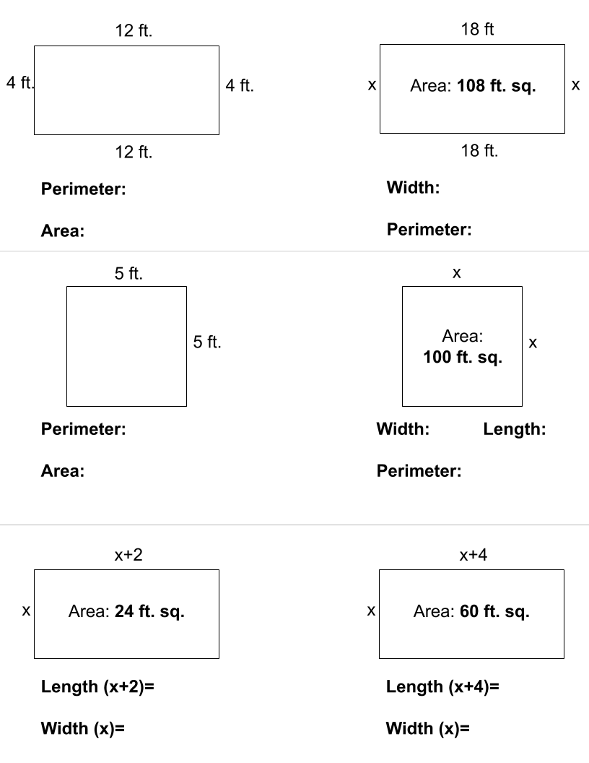
Step 3: Area and Perimeter Problems (Round 2)
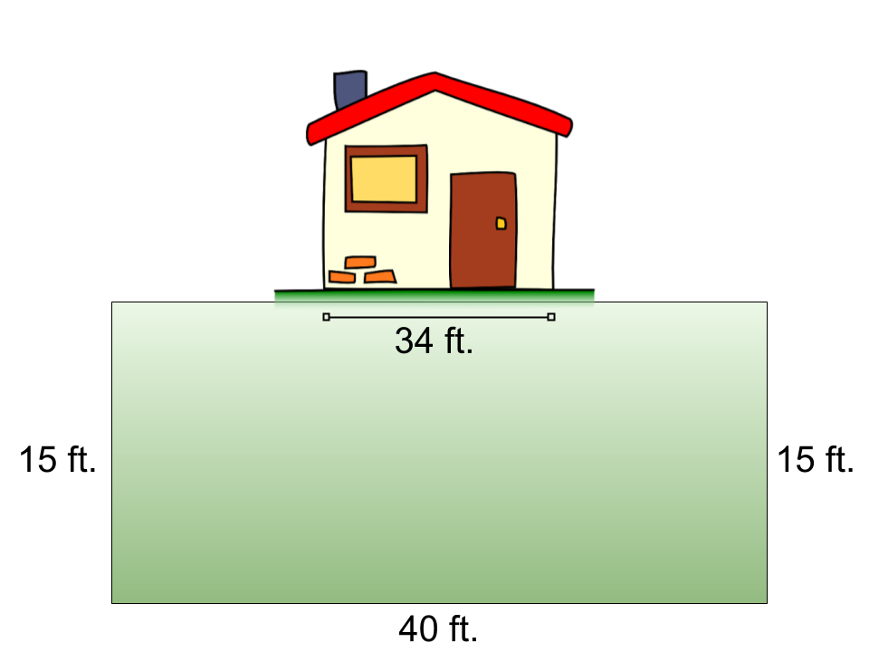
Word problems:

- Marcus wants to put up a small fence around his yard. His yard is 40 feet wide and 15 feet long. He needs to build a fence around 3 sides and have it run directly up to the side of the house on each side. The house is 34 feet side to side….See the diagram to the right.

  - How many feet of fencing does he need to purchase?

  - If the fencing costs $4.00 per foot, how much will it cost him to purchase the fence?

- For years Marcus has been battling weeds in his yard. He wants to start over and put in a rock garden. He can purchase large bags that have an assortment of rocks from Home Depot. Each bag will cover 20 ft^{2.} Each bag costs $12.
  - How many bags of rocks will he need to purchase?

  - How much will he have to spend?

- The city of Cleveland is going to redo all of its swimming pools this summer. They want to fix them up and get rid of all of the cracked concrete and replace it with a newer, safer soft rubber. Using the diagram below, along with the hints--see if you can determine how much it will cost them to replace the old cracked concrete with new material at this one, model swimming pool.
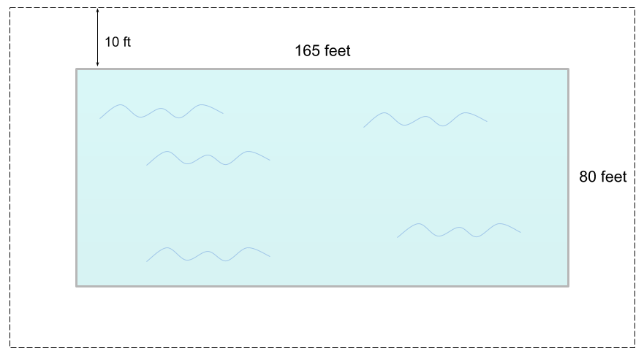
Facts:
- The model pool is 165 feet long and 80 feet wide.
- The city wants to have 10 feet of the new ‘rubber cement’ around the edge of the pool.
Questions:
  - How many square yards of the rubber cement does the city need to purchase to surround the pool?
    - Hint: be careful...How many square yards is the pool and the rubber cement surrounding it? If you ‘take away’ the area of the pool, you will be left with the area needed for the rubber cement.

  - If the rubber cement costs $20 per yd², how much will it cost to purchase it?

- A rectangle has an area of 40in². It is 10 inches long.
- How wide is it?
- What is its perimeter?

- A rectangle is 8 inches long. It is 3 inches shorter in length.
- What is its area?
- What is its perimeter?

- A rectangle is 4 inches longer than it is wide. It has an area of 12 in².
Be careful and check your work!
- How long is it?
- How wide is it?
- What is its perimeter?

- A rectangle is 6 inches longer than it is wide. It has a perimeter of 32 inches.
- How long is it?
- How wide is it?
- What is its area?

Step 4: Triangle Problems
Reminders: The three inside angles of a triangle add up to 180⁰.

What is the measure of angle A in each of the triangles below?

What is the measure of angle a and angle b in the triangle below if angle a and angle b are the same?

What is the measure of angle a and angle b in the triangle below if angle a is twice as large as angle b? (remember, angle a + angle b = 90⁰)

Student Feedback:

Circle the emojis that best represents how this activity made you feel.

Day 5: Internet Rights
Digital Health

What is this lesson about?: Today you will learn about how we have the right to develop an internet infrastructure. In some countries they do not have the internet and communications are monitored and limited.

Step 1: Warm-up

Describe what life would look like without the cellphones?

Step 2: Read the article on your internet infrastructure.

As the World Wide Web approaches its 30th birthday this March, most Americans can't imagine life without it — especially young people born into a digital world. The World Wide Web is a collection of web pages that can be accessed through the internet. The Internet is an electronic communications network. It connects computer networks around the world. It is much older than the World Wide Web.

Toddlers use the Internet to learn colors and letters on their parents' cellphones. Teens Netflix away boredom on hours-long car rides. Young adults Uber food to their doorsteps, and their friends Venmo them to pay their share of the tab.

But, it's not that easy for everyone. In fact, according to "The State of Broadband: Broadband catalyzing sustainable development," a United Nations report tracking the current status of broadband globally, more than half of the world's population has never been online. And many who have been online in developing nations run into obstacles that their peers in developed nations rarely encounter.

Our teen staff at iGeneration Youth wanted to explore the role the Internet plays — and sometimes doesn't play — in the lives of young people who may not be able to access the Internet with the same ease we're accustomed to. What's it like for our peers on the other side of the digital divide?

Of course, finding sources through the internet who struggle to access the Internet presented an obvious challenge. Here's how we did it. First, we combed the Web to find young videographers in 10 countries. Next, we gave them a set of questions to learn where and how youths access the Internet, the quality of Internet service, what young people mainly use the Internet for, the cool things young people are using the Internet for, and what they are hoping for in the future of the Internet.

Each videographer took to the streets to conduct on-camera interviews with young people 21 and younger.

Venezuela
Estefanía García, or "Chia," depends on the Internet for practically everything: doing homework, which is always online; managing social media for her theater group; posting her writing on her Instagram account; and watching music videos on YouTube.

"Sometimes, though, the videos don't load," said the 21-year-old from Caracas, who is studying visual arts and scriptwriting at Venezuela's Católica Andés Bello University. "Or the signal just doesn't work."

The Internet is important for young people in Venezuela because it allows them to earn money, García said. "With the hard economic situation, everyone just tries to work everywhere, even if they have to use their phone."

While the priority is work, people are using the Internet in creative ways, she said. For example, her friend, who is studying graphic design, makes videos and short films with animation. "It wouldn't be possible without the internet," said García. "She wouldn't have even learned it."
The coolest thing she's heard about is the ability to control a house from a phone. "Control the volume of the TV, the lights, turn the kitchen on with your phone. Everything for comfort. It's fantastic."

She hopes in the future that the signal will be good in every corner of the world.

Turkey
Yagiz Akkaya, age 18, spends about five hours a day on the Internet, usually at home in Istanbul. Very rarely, he uses Wi-Fi at Kahve Dünyasi, a Starbucks-style cafe. He doesn't use any other community Wi-Fi because he doesn't think it's safe.

When he's not watching movies or television series, Akkaya uses the internet for self-improvement, such as Google's online marketing training, which he's finished, earning a certificate. Although he's not actually interested in online marketing, it's something to put on his Curriculum Vitae.

"The Internet is important because it is very difficult for us to learn something, whether it is education or things in society," said Akkaya. "There are some online platforms, publishing the classes of world universities such as Cambridge and Sorbonne. Google also offers wonderful free things that are certified. I think they're terrific platforms."

However, although some of the workshops are free, if you want a certificate, you have to pay for it, he said.

Akkaya also likes watching cool things on the Internet, from little kids who post amazing videos to bands who play music on the subway.

He does worry about the younger generations, especially his circle of friends, which he said gets false hope from the Internet.

"There really is a lot of trash content on YouTube," said Akkaya. "Most of them want to make content like others on YouTube. They come up with ideas to me. 'Come on, buddy, I have a video idea. Let's make money on YouTube.' They want to make money, and they think they can use the Internet for this. They are losing time."
He worries about children who grow up on what he considers to be empty content. "Their sole purpose is to watch videos."

Overall, Akkaya thinks the Internet is effective. It helps him to find useful things, he said.
In the future, he hopes more free content will come to the forefront.

Mauritius
Paige McIntyre, age 13, lives in Beau-Bassin Rose Hill on the African island nation, located about 1,200 miles off the continent's southeast coast, in the Indian Ocean. She has access to the Internet most of the time using Wi-Fi at her house or in a commercial center, but the connections are not very good. Although 4G networks are available through her cellphone, mobile packages are expensive.

Like most young people in Mauritius, McIntyre uses the Internet mostly for social media — that is, Facebook, Instagram and sometimes Twitter, she said. She's a student, so she communicates with her teachers via email. But the Internet is much cooler than that, she said.
"I try to post all my photos on Instagram and Facebook, so people would see my work," said McIntyre, who loves photography. "I look at what professional photographers post online."
Her cousin is also recording and sharing her songs on YouTube, she said.

The coolest thing McIntyre said she's found on the Internet are all the YouTube influencers. "They are people who travel the world and post videos on their adventure and the countries they discover. I think this is very interesting, and it pushes me to want to travel more."

McIntyre said the Internet helps young people to reinvent themselves and create new things.
In the future, she hopes to see improvements to the Internet, which is not highly developed in Mauritius. "I would like the Internet to be free for everyone so that we can access it everywhere."

Step 3: Answer the questions below about the article

- List three ways that internet access varied for these teens?

- How does this change your view on communication across the world?

- Why do you think different countries provide different levels of access online?

Step 4: Write a letter

Write a letter to explain why everyone should have access to information. Keep in mind, it is optional whether or not they want to access it but it should be accessible to all.

Dear ,

Sincerely,

Mindfulness Moment!

Draw with your eyes closed. See what happens below:

Day 5: Choose Your Rights
Social Studies

What is this lesson about?: This week you learned about the U.S. Constitution and its Bill of Rights and additional amendments that creat rights and provisions to protect Americans. Now it’s your turn to choose your rights and establish your own Bill of Rights!

Step 1: Warm-Up

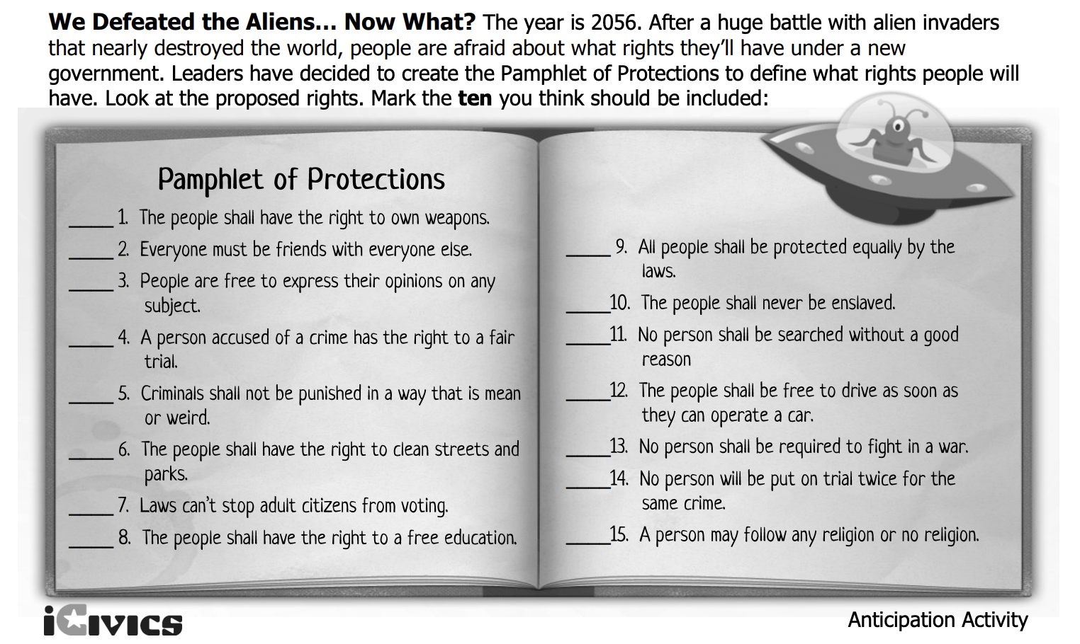

Step 2: Consider your task- activity 1

Directions: The country has just passed a new law: every school must form its own constitution and submit it to the state government for approval. You’ve been tasked to write the proposed constitution for your school. Working together with a partner or individually, write up ten rules and/or rights that will be included in your school constitution.

Step 3: Brainstorm

What is important to making a school safe?

What protections do students need in a school?

How can you make sure students are being treated fairly?

How might you make sure students receive the education they need?

Step 4: Write your school Bill of Rights
___________________________________
(School Name)

Student Bill of Rights

- ____________________________________________
- ____________________________________________
- ____________________________________________
- ____________________________________________
- ____________________________________________
- ____________________________________________
- ____________________________________________
- ____________________________________________
- ____________________________________________
- __________________________________________
Step 5: Consider your task - Activity 2

Directions: Just like you’ve seen with the 18th and 19th Amendments, proposals for new amendments to the Constitution can get started with ordinary citizens who want to see change in their country. Now it’s your turn to encourage congress to consider a new proposal for an amendment! What right or protection would you want to add to our Constitution? Select one from below or come up with your own. Then write a letter to congress requesting they consider your proposal. Be sure to explain why the amendment is needed and how it would help Americans.
- Options to choose from:
  - Equal Rights for all
  - Rights for same-sex marriage
  - Changes to the 2nd Amendment’s right to bear arms
  - Creating the right to affordable housing for all Americans
  - Choose your own!

Step 6: Write your letter!

Dear Congress,

I am writing to propose an amendment to the Constitution. My proposal is to include an amendment that

*Share your letter with a partner and compare what each of you proposed for a new amendment. Ask yourselves:
- Does your partner’s argument for why this amendment is necessary make sense? Do you agree with it?
- How can their argument be stronger?
- Do you think your proposals would be likely to get passed? Why or why not? (remember what is required for the amendment ratification process-- it’s difficult).

Student Feedback:

Circle the emojis that best represents how this activity made you feel.

