Week 3
Identity

Day 2

NAME:______________________

Day 2 Agenda

Topic | Activity
Warm-Up!
English Language Arts | - Read a poem by Jonathan Rodriguez titled “Two Names, Two Worlds”  - Read the article “Your name is part of your identity”.  - Annotate and respond to questions about the Poem  - Create a Bio Poem
Science | - Read about Chromosomes  - Answer questions about what you read  - Draw an image/picture
Mindfulness Moment!
Math | - Real World Math: Identity and Smoking: What it Costs You, and All of Us  - Practice Problems: Interpreting Data and Graphs
Health | - Digital Identity
Mindfulness Moment!
Civics/Social Studies | - Read articles and answer questions on religious identity
PE | - Bingo!

Warm-up Activity: Write a journal entry around the daily quote on identity.
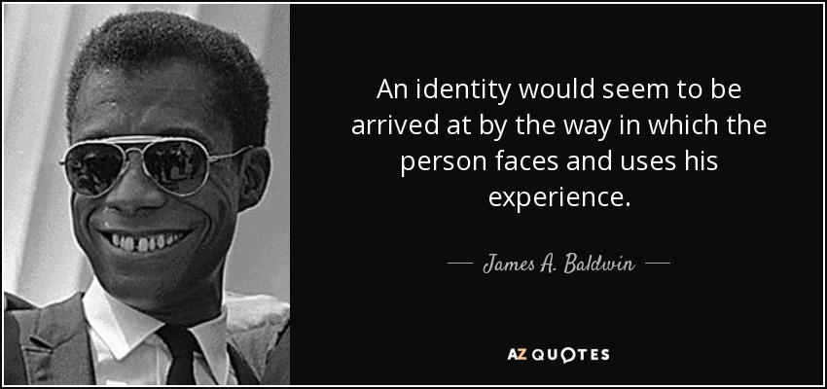

Day 2: What are the different aspects of your identity?
English Language Arts

What is this lesson about?: Today you will continue to explore the theme of identity. You will read a poem about a young man who describes the very different experiences that have shaped his identity. You will also create your own Bio Poem to describe yourself.

Note: There are some words in Spanish in this text. The words are in italics and their definitions are signified by an arrow and short explanation.

Step 1: Read the following text.
Two Names, Two Worlds By Jonathan Rodríguez

Hi I’m Jon...........No—Jonathan
Wait—Jonathan Rodriguez
Hold on—Jonathan Rodríguez
My Name, Two names, two worlds
The duality of my identity like two sides of the same coin
With two worlds, there should be plenty of room
But where do I fit?
Where can I sit?
Is this seat taken? Or is that seat taken?
There never is quite enough room is there?
Two names, Two worlds
Where do I come from?
Born in the Washington Heights of New York City
But raised in good ol’ Connecticut
The smell of freshly mowed grass, autumn leaves
Sancocho, Rice and Beans 🡨--- a popular soup in Puerto Rico
The sound from Billy Joel’s Piano Keys
And the rhythm from Juan Luis Guerra
I’m from the struggle for broken dreams
Of false promises
Of houses with white picket fences
And 2.5 kids
The mountains and campos de la Republica Dominicana < --- countryside of
And the mango trees
I’m not the typical kid from suburbia
Nor am I a smooth Latin cat
My head’s in the clouds, my nose in a comic book
I get lost in the stories and art I’m kinda awkward—so talkin’ to the ladies is hard
I listen to Fernando Villalona and Aventura every chance I get, 🡨popular bands
But don’t make me dance Merengue, Bachata
Or Salsa—I don’t know the steps
I’ve learned throughout these past years I am a mix of cultures, a mix of races
“Una Raza encendida, < ---- “a race that is black, white, and Taina
Negra, Blanca y Taina”
You can find me in the parts of a song, en una cancion. < ---- “a song”
You can feel my African Roots en la Tambora < -- “percussion instrument used in Puerto
Rico”
My Taino screams en la guira < -- “percussion instrument used in the Dominican Republic”
And the melodies of the lyrics are a reminder of my beautiful Spanish heritage
I am African, Taino and Spanish
A Fanboy, an athlete, a nerd, a student, an introvert
I’m proud to say: Yo soy Dominicano < ----- “I am Dominican”
I’m proud to say, I am me
I am beginning to appreciate that I am Una bella mezcla. < ----- “a beautiful blend”
I am beginning to see that this world is also a beautiful mix
Of people, ideas and stories.
Is this seat taken? Or is that seat taken?
Join me and take a seat,
Here we’ll write our own stories

Step 2: Note the Cultural Experience
Throughout the poem, the narrator contrasts his two different experiences growing up. Go through the poem and place a Star next to each line that describes an “American” experience and place a dash next to each line that describes a “Latino” experience.

Step 3: Answer the following questions
- In the first three lines, the narrator repeats his name three times, each time, changing it slightly. What do these three ways of saying his name represent?

- What does Rodriguez mean when he says “”two names, two worlds”? What two worlds does his name represent?

- What are some wrong assumptions that Rodriguez claims some people might make about him because of his name? (list at least two)

- What are some parts of his identity that people might be surprised by if they only think of his name? (list at least two)

- In the first section of the poem, Rodriguez questions “But where do I fit? Where can I fit?” Why does he ask this question? Why do you think it might be hard to fit in somewhere?

- In the last ten lines of the poem, Rodriguez’ tone changes. What does he realize?

- The last two lines of the poem state: “Join me and take a seat, Here we’ll write our own stories.” What does it mean “write your own story, when developing your sense of who you are (your identity)?

Step 3: Look at the following list of words—circle at least three adjectives that describe you.
active | angry | adventurous
affectionate | agreeable | blunt
bold | calm | cautious
compassionate | confident | competitive
cooperative | curious | cynical
deep | determined | diplomatic
direct | disciplined | easygoing
emotional | empathetic | energetic
fair | flexible | focused
forgiving | friendly | funny
generous | goofy | happy
helpful | imaginative | independent
kind | lazy | likeable
logical | messy | mean
neat | nice | nosy
Share with a partner, how these three words describe you. Give an example that shows this quality in your personality.

Step 4: Writing a Bio Poem

A Bio Poem is a structured type of poem that follows a strict form with 11 lines that each specific characteristics about a person.

How to Write a Bio Poem
(Line 1) First name
(Line 2) Three or four adjectives that describe the person
(Line 3) Important relationship (daughter of . . . , mother of . . . , etc)
(Line 4) Three items or people the person loves

(Line 5) Three feelings the person has experienced
(Line 6) Three things the person needs (these can be emotions, experiences or
material things.
(Line 7) Three fears the person experienced
(Line 8) Three things the person is good at or has accomplished
(Line 9) Three things the person wants to see happen or wants to experience
(Line 10) Your Location/Home
(Line 11 ) Last Name
Example:

Lateef
Artistic, strong, funny, loyal
Son of Monique and Andre and brother to Samantha
Loves the feeling of a basketball in his hands, painting, and Ben’s Chili
Who feels happy when hanging with friends, at peace when sketching and
confused when reading poetry.
Who needs time outside, family, and music to be happy in life
Fears the silence, clowns and snakes
Who makes people laugh when someone is sad, who creates beautiful art,
and helped the team win the district trophy.
Would like to visit the ocean, be able to sell his art and own a house
Resident of Washington, DC
Crandall

Write your own Bio Poem in the space below. Be sure to follow the format provided.

Step 3: Share out your poem with other students.
Student Feedback:
Circle the emojis that best represents how this activity made you feel. | 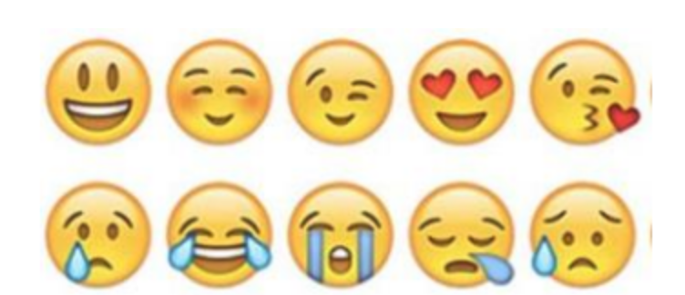  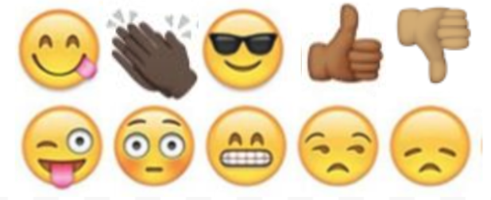

Day 2: Science
Chromosomes

What is this lesson about?: Today you will read through the Chromosomes passage. You will answer a few questions about what you read. You will complete a Chromosome activity.

Step 1: Read through the Chromosomes passage

Chromosomes
(Technological Solutions, 2020)
What are chromosomes?
Chromosomes are tiny structures inside cells made from DNA and protein. The information inside chromosomes acts like a recipe that tells cells how to function and replicate. Every form of life has its own unique set of instructions, including you. Your chromosomes describe what color eyes you have, how tall you are, and whether you're a boy or a girl.

Inside the Cell
Chromosomes are found in the nucleus of every cell. Different forms of life have a different number of chromosomes in each cell. Humans have 23 pairs of chromosomes for a total of 46 chromosomes in each cell.

Can we see them?
Normally we can't see chromosomes. They are so small and thin, we can't see them even with a powerful microscope. However, when a cell gets ready to divide, the chromosomes wind themselves up and become tightly packed. With a high powered microscope, scientists can see chromosomes. They are usually in pairs and look like short little worms.
What do they look like?  When a cell is not dividing (called the interphase of the cell cycle), the chromosome is in its chromatin form. In this form it is a long, very thin, strand. When the cell begins to divide, that strand replicates itself and winds up into shorter tubes. Before the split, the two tubes are pinched together at a point called the centromere. The shorter arms of the tubes are called the "p arms" and the longer arms are called the "q arms." | 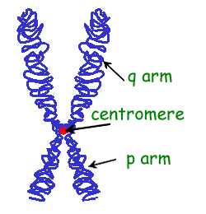
Different Chromosomes
Different chromosomes carry different types of information. For example, one chromosome may contain information on eye color and height while another chromosome may determine blood type.

Genes
Within each chromosome are specific sections of DNA called genes. Each gene contains the code or recipe to make a specific protein. These proteins determine how we grow and what traits we inherit from our parents. The gene is sometimes called a unit of heredity.

Allele
When we talk about a gene we are referring to a section of DNA. One example of this would be the gene that determines the color of your hair. When we talk about the specific sequence of a gene (like the sequence that gives you black hair versus the sequence that gives you blonde hair), this is called an allele. So everyone has a gene that determines their hair color, only blondes have the allele that makes the hair blonde.

Human Chromosomes
As we mentioned above, humans have 23 different pairs of chromosomes for a total of 46 chromosomes. We all get 23 chromosomes from our mother and 23 from our father. Scientists number these pairs from 1 to 22 and then an extra pair called the "X/Y" pair. The X/Y pair determines if you are a boy or a girl. Girls have two X chromosomes called the XX, while boys have an X and a Y chromosome called the XY.

Chromosomes in Different Animals
Different organisms have different numbers of chromosomes: a horse has 64, a rabbit 44, and a fruit fly has 8.

Interesting Facts about Chromosomes
- Some animals have lots of chromosomes, but much of the DNA is blank. This blank DNA is called "junk DNA."
- Nearly every cell in your body carries a complete set of chromosomes.
- Some chromosomes are longer than others because they contain more DNA.
- Humans have about 30,000 genes in their 46 chromosomes.
- The word "chromosome" comes from the Greek words "chroma", meaning color, and "soma", meaning body.

Step 2: Answer the following questions
- Chromosomes are made from protein and what other molecule?
  - ATP
  - Carbon dioxide
  - DNA

- Chromosomes are found inside what structure in the cell?
  - Membrane
  - Nucleus
  - Mitochondria

- How many pairs of chromosomes are in a human being?
  - 23
  - 44
  - 89
- What form does the chromosome take when the cell is not dividing?
  - Wound up like a tube
  - Tubes shaped like an X
  - Long and thin strand

- Which of the following is considered the basic unit of heredity?
  - Chromosomes
  - Genes
  - Enzymes

- What does the X/Y pair of chromosomes determine in humans?
  - What color eyes you have
  - How tall you will be
  - Whether you are a male or female

- Every chromosome carries exactly the same information.
  - TRUE
  - FALSE

Step 3: Draw an image/picture

Draw an image/picture that comes to mind from the passage you read about Chromosomes. What is something you want to remember about this topic? What would you like to learn more about?

Student Feedback:

Circle the emojis that best represents how this activity made you feel. | 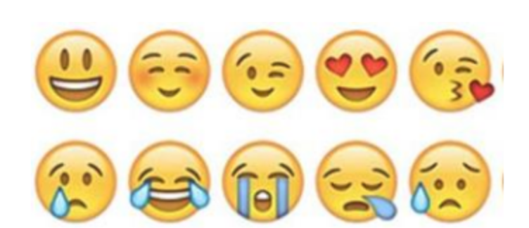  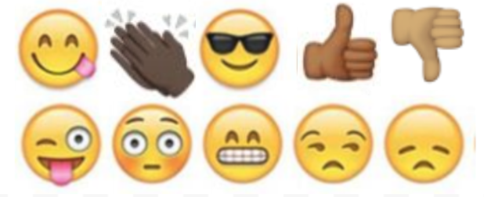
Day 2: Identity/Cigarettes and Smoking
Math

What is this lesson about?: This lesson focuses on the cost cigarettes--to individuals and to society. And as we look at the costs, we will also try to understand the role that smoking plays in one's identity, and in the identity of regions of the country.

But First: Today’s Warm-Up
Let’s go back to those hoodies/sweatshirts…

You go online and look up the same sweatshirt at a few sites. The chart below shows the prices.

What is the average cost of the sweatshirt?

What is the median cost of the sweatshirt?

What if the sweatshirt sold at Store A is a fake.
- What is the new average price in the remaining 4 stores?

- What is the median price in the remaining 4 stores?

Hint:
- To find the average, add up all the items and divide by the # of items.
- To find the median, arrange the numbers from smallest to largest and select the middle number. If there are 2 middle numbers, add them and divide by 2.

Step 1/Activity 1: Let’s use the chart below to answer a few questions.
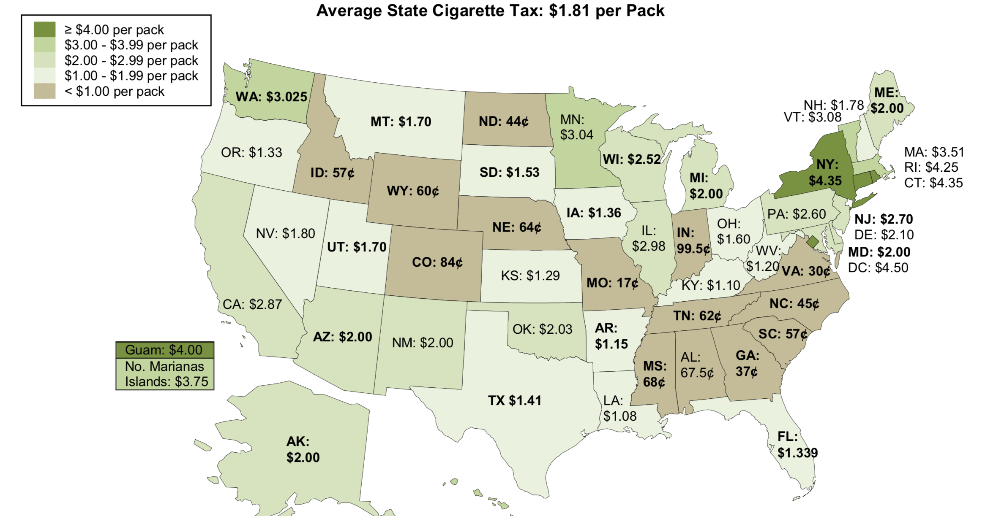
What states have the 5 lowest taxes on a pack of cigarettes. List them below:

- What is the average tax on a pack of cigarettes in those 5 states?

- What is the median tax on a pack of cigarettes in those 5 states?

What states have the highest taxes on a pack of cigarettes. List them below:

- What is the average tax on a pack of cigarettes in those 5 states?

- What is the median tax on a pack of cigarettes in those 5 states?

Looking at the map:
What region of the country has the lowest tax rates on cigarettes? (Circle one)
- North East, Southeast, Midwest, Southwest, Northwest

What other region of the country has pretty low taxes?
- (Circle one) Northeast, Southeast, Midwest, Southwest, Northwest

Discuss/Consider: One of the primary reasons states charge a high sales tax on a pack of cigarettes is to REDUCE cigarette smoking.
- Is there any historical or cultural reason that might be the reason for low sales tax on cigarettes in either the southeastern or midwestern parts of the US?

  - Where in the US was most of the tobacco in the US grown from the 1600s through the early 1900s?

  - What part of the country do you think of when you see the Marlboro Man?

- Would you be surprised to know that in 2015 17% of the adult population in the Midwest and 16% of the adult population in the south smokes cigarettes?

- What % of the adult population do you think smokes in the northeast (New York, Massachusetts, etc.)

Step 2: Teens and Cigarette smoking…
For many teenagers, smoking is something that they start and something that they start to take on as a part of their identity. The chart below shows the 3 primary reasons teens and young adults say they smoke.
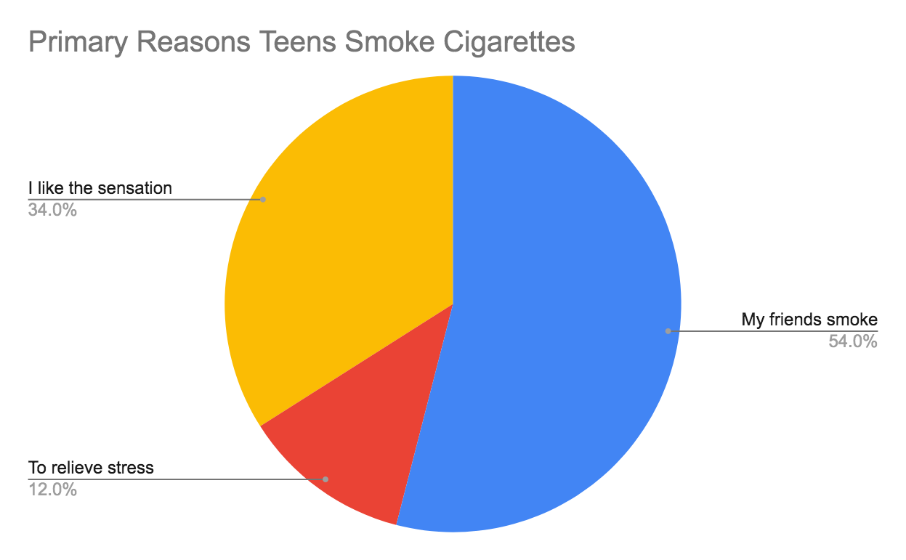
Based on the chart, what is the #1 reason why teens and young adults smoke?

The chart below shows the percent of high school students who smoked cigarettes in the last 30 days, in 1995 compared to 2015.
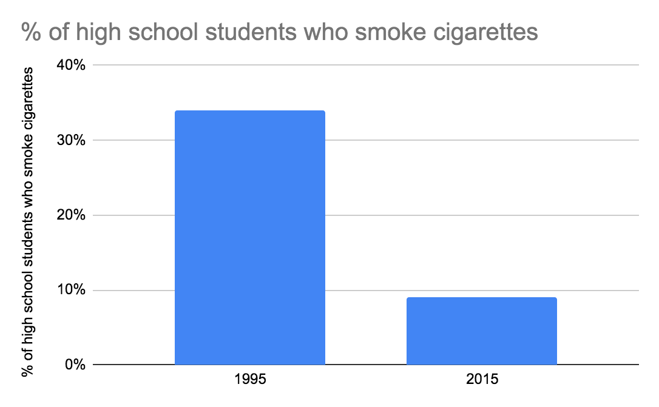

- Out of 100 students in 1995, about how many smoked cigarettes?
- Out of 100 students in 2015 about how many smoked cigarettes?
- Discuss/Consider: what are some reasons for this decline, do you think?
The chart below shows the percent of high school students who smoked cigarettes on average, compared to high school students involved in the juvenile justice system, in 2015.
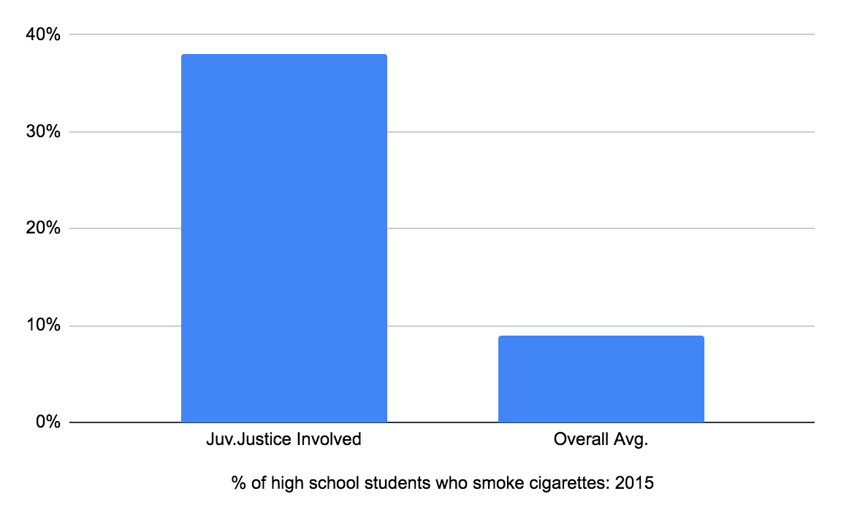
- Out of 100 high school students in 2015, about how many smoked cigarettes?
- Out of 100 high school students who were involved in the juvenile justice system in 2015 about how many smoked cigarettes?
- Discuss/Consider: what are some reasons for this difference, do you think?

The chart below compares smoking habits to education, as of 2015.
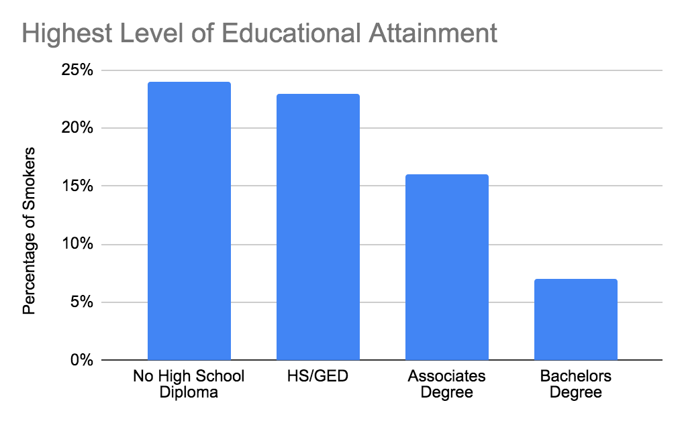
- Out of 100 adults who earn a 4-year college degree, what % smoke cigarettes?
- Out of 100 adults who get their GED but don’t complete college, what % smoke cigarettes?
- Discuss/Consider: what are some reasons for this difference, do you think?

Step 3: Smoking, Addiction and Health Challenges

Each day approximately 2,500 high school students will try a cigarette across the country.
- In one 5-day week, how many students is that?
- The average school year has about 35 weeks in it. About how many students is that over one school year, across the country?

Almost 1 out of every 5 high school students who try a cigarette will become long-term smokers.
- So, of the students who try cigarettes in one year (above), how many of them will become long-term smokers?

The chart below shows the average life expectancy of smokers vs nonsmokers.
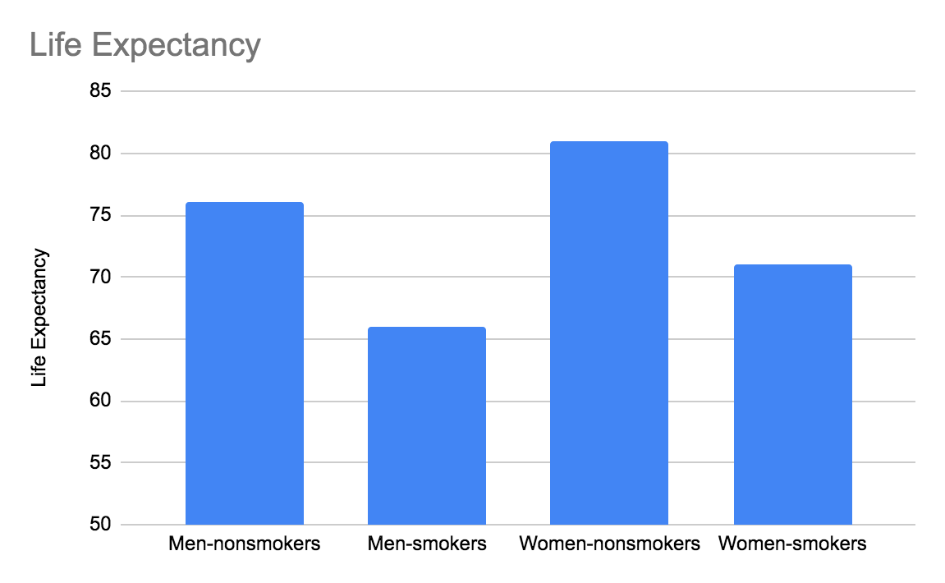
What is the average life expectancy for a non-smoking male?

What is the average life expectancy for a smoking male?

What is the average life expectancy for a non-smoking female?

What is the average life expectancy for a smoking female?

Based on your current identity as a smoker or nonsmoker, what is your current life expectancy?

Step 4: The cost of smoking….Last questions and Identifying as a smoker or nonsmoker?

Complete the chart below and then answer the questions…
State | Cost of 1 pack of cigarettes |  | # of packs/week |  | Cost per week |  | Annual cost |  | Cost after 20 years
New York | 10.00 | x | 1 | = |  | x50 |  | x20
Missouri | 4.00 | x | 1 | = |  | x50 |  | x20
Kentucky | 5.50 | x | 1 | = |  | x50 |  | x20
Arizona | 7.00 | x | 1 | = |  | x50 |  | x20

Based on the 4 states listed, what is the average cost for 1 pack of cigarettes?

How much would you spend over 1 year (1 pack /week) on cigarettes if you live in Kentucky? And in Arizona?

How much would you spend over 20 years on cigarettes if you live in Missouri?
How about in New York? And in Arizona?

Assume that you smoke 2 packs per week, how much would you spend over 20 years in:
New York? Missouri? Kentucky? Arizona

Discuss: Do these amounts seem like a lot of money, or a minor amount?

Discuss/consider: You probably identify yourself in a lot of ways--as a teenager, as a male or female, as Black or White or Latinx, as a scholar, as a son or daughter…

- Do you identify yourself as someone who smokes cigarettes?

- Yes/No? If yes, is this an identity that is essential to you?

- Is this a part of your identity that you would like to keep or shed?

Skill Builders and Review Problems
- Interpreting Data in Charts

Student Feedback:

Circle the emojis that best represents how this activity made you feel.

Day 2: Digital Identity
Health

Step 1: Warm-up
How can you create a digital footprint that showcases your purpose?

Step 2: What’s this Lesson About?
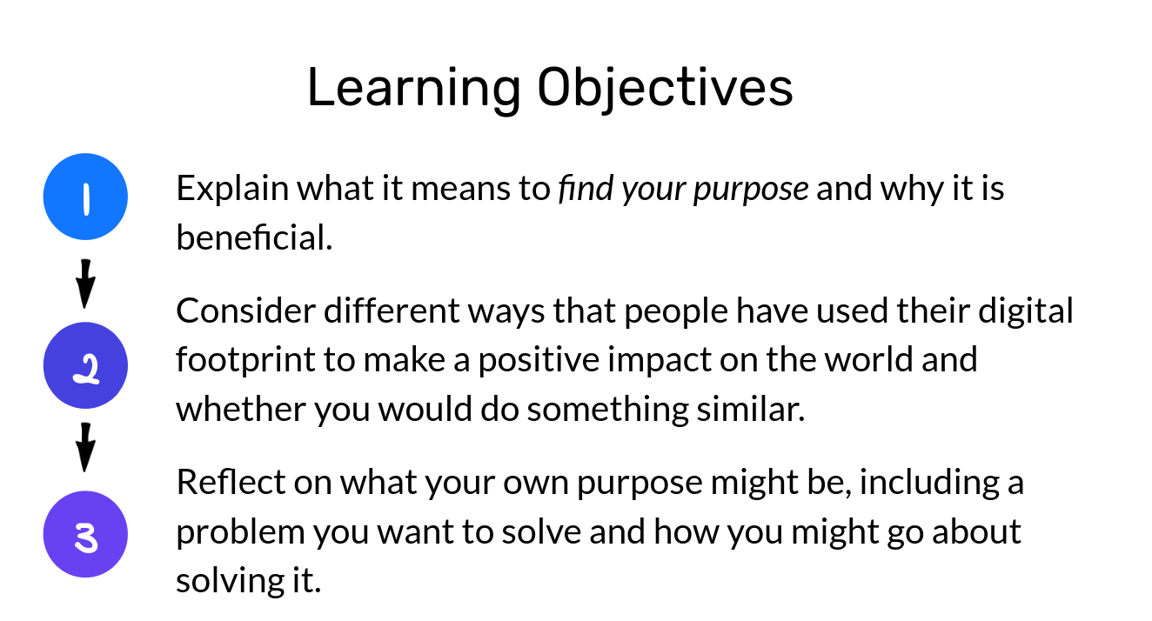
Step 3: Read the text.

We’re not okay with it. We’ll fight back
When we look at 16-year old Jamie Margolin’s bright eyes and impressive scope of work she has done to spread awareness of climate change, we realize how right Satyarthi has been.
Jamie is the founder of This Is Zero Hour. The “Zero Hour” is a youth-led movement that became one of the leading platforms for all young people who feel the need to take concrete action on climate change — before it’s too late. They are young, powerful, and endlessly inspiring.
Their most well-known action is the Zero Hour Youth March, which will take place in Washington D.C. on July 21st. In the midst of doing all the hard work in the face of such a big protest, Jamie was kind enough to answer some questions we had for her. Many of her answers left us standing in awe.
Hi Jamie, thanks for talking to us today. It is always inspiring and touching to see a young person so dedicated to the single most critical issue of today. How did you first engage in climate activism?
When I was 14, I was an intern in the WA state headquarters for Hillary Clinton’s 2016 campaign and did a lot of volunteer training as well as translating for the office because I was the only fluent Spanish speaker there.
After Hillary lost, I wallowed in grief for a bit, and then joined a local environmental organization called Plant for the Planet where I did tons of lobbying, advocacy and work in alliance with local indigenous tribes. I also joined the Washington state Youth vs Government trial by the pro bono law firm “Our Children’s Trust”, where lawyers are helping young people sue the US government over actively making climate change worse and denying our constitutional rights to life, liberty, and the pursuit of happiness.
Can you tell us how, after that, your movement “This Is Zero Hour” came to be?
I had a vision of youth all over the US and the world marching for urgent climate action since the first Women’s March back in January of 2017. At that time I was still fresh to the community organizing world and was nervous to take on the enormous task of starting a mass movement. So I suppressed that vision and continued to do local environmental organizing.
Then, the summer of 2017 happened. That July, I was at a month-long Political Speech and Communication course for high school students at Princeton University. I found myself away from my family for the first time, on the other side of the country, surrounded by politically engaged high schoolers.
By that time I had had a ton of community organizing experience. That was also a summer full of natural disasters, and thick smog that covered Seattle thanks to stronger-than-usual wildfires up north in Canada. That was when I finally decided to take the plunge.
Picking up the courage and taking that plunge yourself is surely challenging, but gathering the core team of people is even more so. How was your team formed?
We are not a movement that happened overnight at all. It took grueling hours and hours every day of slow but gradual movement-building, and it still does.
At first, I had social media friends, like Nadia Nazar, who was also willing to take the plunge with me. My friends from Princeton camp Madeline Tew and Zanagee Artis also joined, and are now the two core team leads.
For a while, we did tons of visioning and brainstorming, struggling to find our footing. Soon we brought on some adult mentors, like Mrinalini Chakraborty, a Women’s March co-founder, and Laura Sanders from DC Local Ambassadors who guided us in the right direction.
We reached out to frontline communities who we knew had to be at the center of the movement, like some of the youth from the Standing Rock tribe who famously led the #NODAPL fight, who were excited by the idea. Since then, we’ve expanded into a full-fledged organization.
What exactly is the “Hour Zero” as a symbol for you?
Zero Hour means that there is no more time to act on climate change. It’s a means of communicating the urgent emergency that we are in.
Our logo speaks volumes about the symbolic. It was beautifully designed by Nadia Nazar, a 16-year-old co-founder of this movement. If you see any Zero Hour graphics out there, chances are they were all designed by Nadia.

The part of the earth that is greyed out represents the time we have already lost, the habitats and lives that have already been destroyed. The damage that has already been done. The little sliver of orange left represents the time and hope that we have to combat the crisis.
We the youth are the sliver of hope — and This Is Zero Hour to act on climate change. Our leaders need to wake up and realize that we have no more time to act. It is Zero Hour.

Your digital identity can also be a platform of purpose. Share some ideas around things that you care about that you want the world to take action on.

Student Feedback:
Circle the emojis that best represents how this activity made you feel.

Mindfulness Moment!

Day 2: Comparing Judaism, Islam and Christianity
Social Studies

What is this lesson about?: In today’s lesson you will read about the three major religions in the world.

Step 1: Read the article, review the chart, and answer the questions-

Understanding the basic tenets of major religions

Judaism, Christianity and Islam are the world's three largest Abrahamic religions. This means the followers of these religions believe that they are all descended from Abraham.

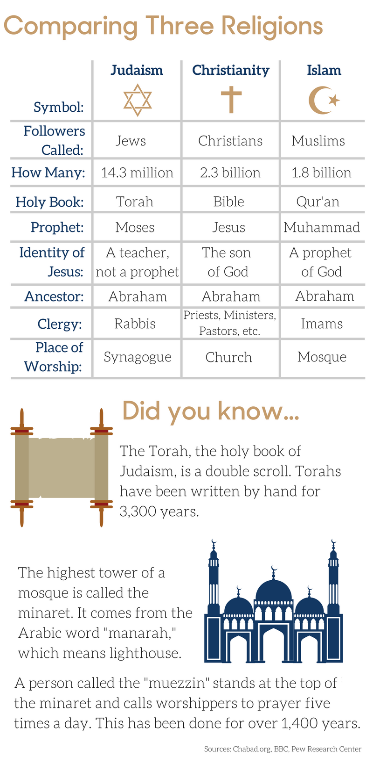
The chart outlines the similarities and differences between these three religions:

Answer the questions based on the chart-

- Which religion has the most followers around the world?
- What is the holy book for:
Judaism:
Christianity:
Islam:
- What it the place of worship for:
Judaism:
Christianity:
Islam:

Step 2: Read this article-

Despite differences, Jews, Christians and Muslims worship the same God
It is often assumed that the God of Islam is fierce and warlike, whereas the God of Christianity and Judaism is loving and merciful. Despite the various differences in the way they worship, Jews, Christians and Muslims actually all worship the same God.
The founder of Islam, Muhammad, saw himself as the last in a line of prophets that included both Jesus and Moses. Going farther back, the line of prophets included Abraham and even Noah. According to the Quran, God (known as Allah) revealed to Muhammad:
"The Book with the truth [the Quran], confirming what was before it, and [before He sent down the Quran] He sent down the Torah of Moses and the Gospel of Jesus … as a guidance for the people."
Thus, since Muhammad inherited the Jewish and Christian understandings of God, it is not surprising that the God of Muhammad, Jesus and Moses has a similarly complex and ambivalent character – a blend of benevolence and compassion, combined with wrath and anger. If you were obedient to his commands, he could be all sweetness and light. But you didn't want to get on his wrong side
To those who turned to him in repentance, this God was infinitely forgiving. Those who failed to find the path, though, or those who found the path but failed to follow it, would know God's judgment and wrath.

God Was Seen As Both Good And Evil
For Jews, God was fully revealed in the Torah (the first five books of the Hebrew Bible, called the Old Testament). The God of the Old Testament was both good and evil. He could act in ways that seem cruel, such as when he ordered Abraham to offer up his son as a burnt sacrifice. He was also a warrior God who murdered the first child of every Egyptian and drowned the army of Pharaoh. He even approved of Elijah killing the 450 prophets of an opposing God, the ancient Canaanite God Baal.
He was, at other times, a merciful God. In Psalm 23 in the Book of Psalms, for example, he is described as a loving guide who brings comfort and happiness to his followers. In the Old Testament, he loves Israel like a father loves a son.
The Christian Bible includes the Old Testament as well as the New Testament, which tells of the life and teachings of Jesus. As in older texts, the God of the New Testament is a complicated figure. On the one hand, Jesus describes him as tender and loving, referring to him as "Father." On the other hand, the God of the New Testament is still very much to be feared.
Like the prophets of the Old Testament, Jesus predicted a day when God would punish humankind, and would be merciless in doing so. On this day, called the Last Judgement, God would bring an end to history. The dead would then be brought back to life. The people that God favored, a fortunate few, would receive eternal happiness in heaven. The wicked majority, including those who refused to listen to Jesus, would be cast into the eternal fires of hell.

A Day Of Judgment
Muhammad warned of a similar day of judgment. At the end of the world, God would act as a God of justice. All the dead would be resurrected to receive God's judgment. God would then reward or punish each person in the gardens of paradise or the fires of hell according to their deeds. Each would be presented with a record of their deeds – in the right hand for those to be saved, in the left for those to be damned to the fires of hell.
For those who were saved, the pleasures and comforts of paradise awaited. Those who died in the cause of Allah, however, did not need to wait for the Last Judgment, as they would go straight to heaven.
The key to being saved was, above all, to surrender to Allah ("islam" means "surrender" in Arabic). In other words, the key was to obey his commands, as described in the Quran, and pledge loyalty to his messenger Muhammad. Like the God of Moses, Allah was a lawmaker. The Quran provided rules and guidelines on various subjects, including marriage and family law, inheritance, food and drink, warfare, punishments for adultery and false accusations of adultery, alcohol and theft. Over the coming centuries, it provided the foundation for an Islam-based system of law, called sharia.
In sum, Muslims, Christians and Jews all worship the same complex God. Each religion believes, however, that its books and teachings reveal the true nature of that God.
This disagreement has helped shape the course of history. The followers of each religion believe that only they will be saved by God and see each other as damned. This way of seeing others, as disfavored by God and beyond any hope of being saved, has led to centuries of violence and intolerance. So it is that these religions both unite and divide.
Step 3: Answer the following Questions:

Which selection from the article BEST explains a key difference between Judaism and Christianity?
- Despite the various differences in the way they worship, Jews, Christians and Muslims actually all worship the same God
- Those who failed to find the path, though, or those who found the path but failed to follow it, would know God's judgment and wrath.
- The Christian Bible includes the Old Testament as well as the New Testament, which tells of the life and teachings of Jesus.
- Like the prophets of the Old Testament, Jesus predicted a day when God would punish humankind, and would be merciless in doing so.
Which two sentences from the article include CENTRAL ideas of the article?
- It is often assumed that the God of Islam is fierce and warlike, whereas the God of Christianity and Judaism is loving and merciful.
- Despite the various differences in the way they worship, Jews, Christians and Muslims actually all worship the same God.
- For Jews, God was fully revealed in the Torah (the first five books of the Hebrew Bible, called the Old Testament).
- The followers of each religion believe that only they will be saved by God and see each other as damned.
Strict followers of religion tend to think only their religion is correct. Which sentence from the article provides the BEST support to the statement above?
- (A) In sum, Muslims, Christians and Jews all worship the same complex God.
- (B) This disagreement has shaped the course of history.
- (C) The followers of each religion believe that only they will be saved by God.
- (D) So it is that these religions both unite and divide.

Step 4: Read this article.

During Ramadan, young Muslims slowly get used to fasting

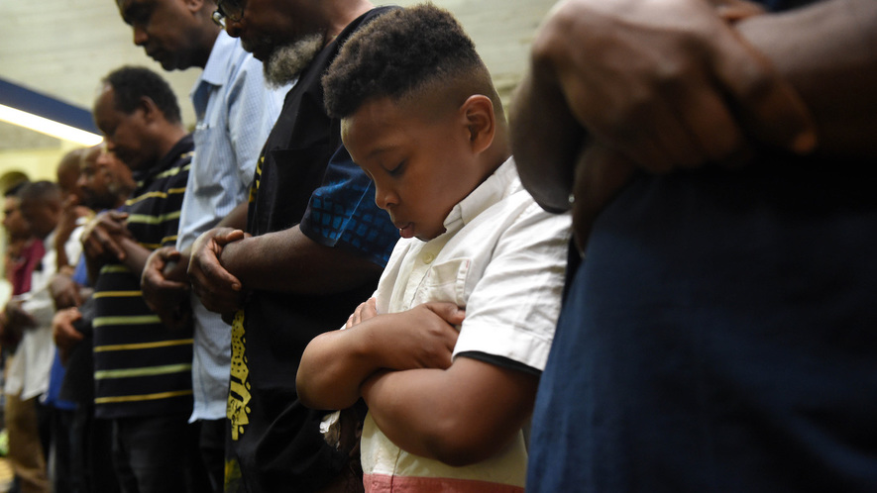
At 8:35 on a Wednesday evening, the sun sets in Washington, D.C., and the call to prayer resounds. In Arabic, a man recites a declaration of faith, practically singing as he praises God — Allah, as he is known in Arabic. The man is signaling to the hundred members at Masjid Muhammad that it is time for two very important events. The first is evening prayer. The second is breaking of the day's fast.

Most of the men, women and children at Masjid Muhammad, a mosque, have not eaten or drunk in nearly 15 hours. They have been fasting since dawn, praying and reading the Quran in snatches while at work or school. They are hungry, but it is Ramadan. Ramadan is a holy month of fasting and prayer for Muslims around the world — and they say their hunger is not important.

"Fasting," explains Imam Talib Shareef, "makes you conscious of human life, aware of universal human needs. Regardless of your race, ethnicity or nationality, you have to eat, drink and sleep," important daily tasks that are carefully controlled during Ramadan. Waking up early to eat before dawn and fasting during the day forces you to think about the essentials in life, he says.

Shareef heads Masjid Muhammad, built in 1960 and one of the oldest mosques in Washington, D.C. He wears a black kufi — a short, brimless hat — and leads daily prayer services for the mosque's 1,500 members, most of whom are black.

Ramadan is the ninth month of the Islamic calendar. It is believed to be the month when the Quran was first revealed to Muhammad, who is considered a prophet and a central figure in Islam. The Islamic calendar is based on the lunar cycle. In a lunar-based calendar, there are 354 or 355 days in a year. This is fewer than in a calendar based on the solar cycle, which has 365 days in a year. That is why Ramadan occurs at a different time each year.

This year, most Muslims are observing Ramadan from May 15 through June 15. The day after Ramadan ends is a holiday, Eid al-Fitr, during which families feast and give gifts.

Fasting isn't the only thing encouraged during Ramadan.

"You try to be the best person you can be," says Asiya Khokhar, one of about a dozen kids at the prayer service. "You try and be nice and polite to other people and try not to fight and yell."

Muslims are expected to pray five times a day and read all of the Quran during Ramadan. Asiya, 14, says she feels "more spiritual, more focused and more happy" during the month.

Members of Masjid Muhammad break their fast with a traditional meal called an "iftar," which is offered for free at the mosque every night during Ramadan. Everyone has water and dates, a fruit common in Africa and the Middle East, and sheds their shoes to take part in a service in the mosque's prayer hall. Women stand in the back, their heads covered by scarves called "hijabs."

The service is in Arabic. Many kids take classes at the mosque to learn the language, but Shareef switches to English for a short sermon. "Help people. Don't be a burden on people," he says. "This is the month where we change habits."

Evening prayer is followed by a larger meal: chicken, rice, salad, watermelon and a slice of cake. Second helpings are discouraged in the name of moderation.

Fasting is hard, many kids say, but you get used to it. Khaled Mohamed, 17, has been fasting since he was about 3. (Most kids start at 12 or 13.) "In winter, it's very easy to fast," he says, "because all you're thinking about is trying to keep warm during the day."

One helpful trick Khaled has learned: Telling his friends he's fasting for the month so that they don't eat around him. "It's easier that way."
Step 5: Answer these Questions
Explain the Muslim holiday of Ramadan?

What part does the calendar play in the holiday?

How do people observe the holiday?

Student Feedback:

Circle the emojis that best represents how this activity made you feel.

