Week 4
Community

Day 3

NAME:______________________
Day 3 Agenda

Topic | Activity
Warm-Up!
English Language Arts | - Read a chapter from the book Seedfolks by Paul Fleischman.  - Respond to questions about the text.  - Reflect upon and write about the challenges of maintaining a sense of community.
Science | - Read about Species’ Impact on Community Structures  - Write down key facts  - Draw an image/picture
Mindfulness Moment!
Math | - Real World Math: The math of Community: Planning a birthday party. What does it cost to host a b-day party.  - Practice Problems
Health | - How can we impact our community health
Mindfulness Moment!
Civics/Social Studies | - A New Community: Learn about Kuwait and its culture

Warm-up Activity: Write a journal entry around the daily quote on identity.
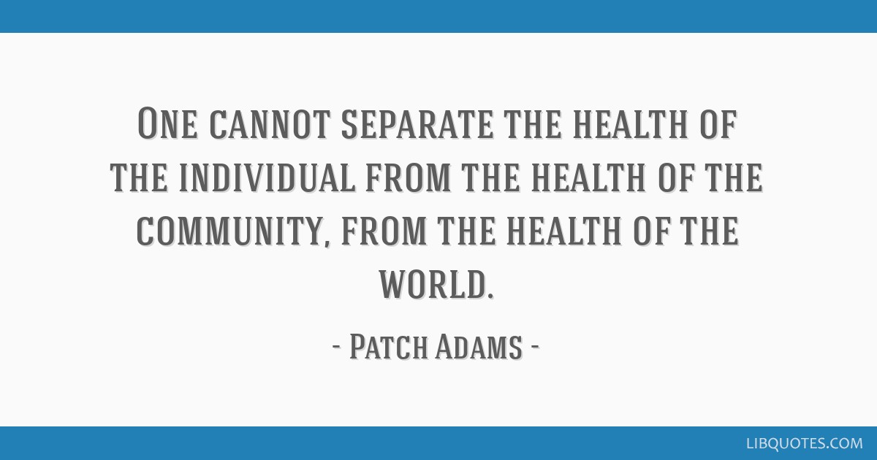

Day 3: What Challenges Can Fracture a Community?
English Language Arts

What is this lesson about? Today, you will read a chapter from the book Seedfolks by Paul Fleischman. You will reflect upon the challenges of keeping a community together.

Step 1: Before reading

Complete an 8 minute quick-write where you just write your ideas, don’t worry about your spelling or grammar, just focus on what you feel and want to say.

Write for 8 minutes: think about a time that you have been part of a group or community. What kept your community together? (What did people do, to keep people feeling like a part of the group and contributing to the group?). What were actions/events that threatened to break the community apart?

Step 2: Read the excerpt from the novel Seedfolks by Paul Fleischman.

The novel takes place in the city of Cleveland, Ohio. In the novel, a neighborhood, where people mostly keep to themselves, started a community garden and it starts to bring people together. In this chapter, Sam, a former community organizer, describes his experience and perspective on what is happening in the garden. As you read, look for how the speaker in the chapter describes the different “communities” in the garden and what starts to happen to make it break apart.
Some vocabulary to review before reading:
pacifism—the belief that all disputes should be settled by peaceful means | spigot: a faucet
Tower of Babel: According to the Bible, the Babylonians wanted to make a name for themselves by building a mighty city and a tower “with its top in the heavens.” God disrupted the work by so
confusing the language of the workers that they could no longer understand one another. The city was never completed, and the people were dispersed over the face of the earth. (Taken from https://www.britannica.com/topic/Tower-of-Babel)

CHAPTER 6: SAM

I saw people on the sidewalk, watching something. I crossed to join them, like a cat who smelled herring. Men in jumpsuits, from the jail I think, were clearing the lot. Unbelievable. The woman beside me told me the land was for anyone who wanted a garden. Even more unbelievable. The word “paradise” came out of my mouth, without thinking. The woman looked at me strange. It’s a hobby with me, studying words. I looked at the three walls surrounding the lot, then at a garden coming up beautiful, planted there close to the sidewalk. “paradise” comes from a Persian word…
It means “walked park”. I told the woman that. This time she gave me a little smile. I smiled back. That’s my occupation.
You’ve seen fishermen mending the rips in their nets. That’s what I do, only with people. I used to try to patch up the whole world. For thirty –six years I worked for different groups, promoting world government, setting up conferences on pacifism, raising money, stuffing envelopes. Not that I’ve given up the fight. I‘ve just switched battlefields, from the entire planet to this corner of Cleveland. Sometimes I think I’ve actually had more effect on the world since I retired. What do I do? I smile at people, especially black people and the ones from different countries. I get ‘em looking up at me instead of down or off to the side. I start up conversations in lines and on the bus and with cashiers. People see I’m friendly, no matter what they’ve heard about whites or Jews. If I’m lucky, I get’em talking to each other. Sewing up the rips in the neighborhood.
I hadn’t had a garden since I was a kid. I wanted one now, only this time I was seventy-eight to be exact, and in no condition to dig up the soil. So I hired a teenager, Puerto Rican, who said he knew where he could get a shovel. He knew he’d have to do a good job to be paid. He worked that soil until it flowered through your fingers like silk. I paid him well and offered him a row. He wanted to grow marijuana, to sell. A real businessman. We discussed this. We finally compromised on pumpkins, after I explained how much he could probably get for them a Halloween, not to mention the advantages of staying out of jail. He was new to the neighborhood. We chatted back and forth. Squatting there in the cool of the evening, planting our seeds, a few other people working, a robin singing out strong all the while, it seemed to me that we were in truth in Paradise, a small Garden of Eden.
In the Bible, though, there’s a river in Eden. Here, we had none. Not even a spigot anywhere close by. Nothing. People had to lug their own water, in buckets or milk jugs or soda containers. Water is heavy as bricks, trust me. And new seeds have to be always moist. And in all of June it didn’t rain but four days. The result? People bent over like coolies, walking sometimes three or four blocks, a gallon jug in each hand, complaining all the time about the water. Mine I had hauled by a third-grader with a wagon. The contest I started came later.
Water aside, we had other problems. People in the garden told friends and relatives. The lot was big, there was plenty of room. But newcomers joined, at least at the beginning, they could usually get a spot near people they knew. One Saturday, when the garden was fullest, I stood up a minute to straighten my back. And what did I see? With a few expectations, the blacks on one side, the whites on another, the Central Americans and Asians toward the back. The garden was a copy of the neighborhood. I guess I shouldn’t have been surprised. A duck gives birth to a duckling, not a moose. Each group kept to itself, spoke, its own language, and grew its own special crops. One man even put up a pole and flew the Philippine flag above his plot.
Then there was the garbage. A few well brought-up people in the buildings around the lot still used it for a trash can. Just couldn’t get out of the habit. They emptied their ashtrays out the windows and tossed out all sorts of stuff. One day a bottle came down, like a meteor. A man picked it up and threw it back, straight through the window it came out of. A minute later, five more flew out. Next, I thought to myself, come gunshots. Instead, thank God, it was only shouting.
That crazy homeless man, the one who used to sleep on the broken-down-couch-he also missed the lot being a dump. He showed up, saw his couch had been taken, and started ripping out people’s plants. The police had to come. Some people started worrying, looking ahead to ripe beans and tomatoes and thinking about strangers coming in. That week, a man put chicken wire around his garden, five feet high, complete with a little gate and padlock. The week after that someone built a board fence. Then came the first KEEP OUT sign. Then, the crowning achievement -barbed wire.
God, who made Eden, also wrecked the Tower of Babel, by dividing people. From Paradise, the garden was turning back into Cleveland.

Step 3: Answer the following questions

1. What is Sam’s reason for becoming involved in the garden?

2. Sam uses a metaphor to describe what he likes to do in a neighborhood by comparing it to sewing up ripped fishing nets. He says that he “likes to sew up the rips in the neighborhood”, what does this mean? What are some ways that he does this?

- What does Sam observe about how people have set themselves up in the garden?

- How does Sam feel about the way the garden is segregated?

- The garden starts off without fences between plots and by the end of the chapter, he describes what has happened to the garden. What causes the fences,“Keep Out” signs and barbed wire?

Step 3: Writing

At the beginning of the chapter, Sam describes the garden as paradise, but that end of the chapter, he describes it as “From Paradise, the garden was turning back into Cleveland.” Look at the definition of the Tower of Babel (in vocabulary before the chapter) again and explain how sometimes it seems like members of a community are speaking different languages or they stop being able to “understand one another”. Think about what you read and what you have experienced, what sometimes causes us to create a “we” and a “they” even inside our own communities. How can we work to prevent that?

____________________________________________________________________

____________________________________________________________________

____________________________________________________________________

____________________________________________________________________

____________________________________________________________________

____________________________________________________________________

____________________________________________________________________

____________________________________________________________________

____________________________________________________________________

____________________________________________________________________

____________________________________________________________________

____________________________________________________________________

____________________________________________________________________

____________________________________________________________________

____________________________________________________________________

____________________________________________________________________

____________________________________________________________________

____________________________________________________________________

____________________________________________________________________

Student Feedback:

Circle the emojis that best represents how this activity made you feel.

Day 3: Species’ Impact on Community Structures
Science
What is this lesson about?: Today you will read through the Species with a Large Impact on Community Structure passage. You will answer a few questions about what you read. You will draw a picture and describe your own community.

Step 1: Read through the Species with a Large Impact on Community Structure passage

Species with a Large Impact on Community Structure
Delbert L. Smee - Nature Education
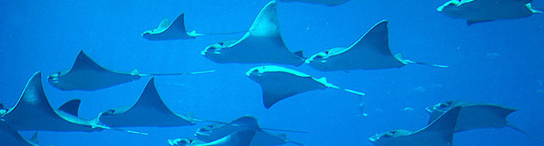
Of course predators consume prey, but in doing so, they may have broader impacts on communities as a whole. That is to say, predators help to maintain a balance among organisms, both by consuming prey and by altering prey behavior and prey habitat selection. This article describes how predators influence the composition and distribution of species in communities.

Some Species Have a Greater Impact Than Others on Community Structure
Dominant species are the most abundant species in a community, exerting a strong influence over the occurrence and distribution of other species. In contrast, keystone species have effects on communities that far exceed their abundance. That is to say, the importance of keystone species would not be predicted based upon their occurrence in an ecosystem. Dominant and keystone species influence the presence and abundance of other organisms through their feeding relationships. Feeding relationships — eating or being eaten — are called trophic interactions.

In addition, some organisms, called foundation species, exert influence on a community not through their trophic interactions, but by causing physical changes in the environment. These organisms alter the environment through their behavior or their large collective biomass. Foundation species may also be dominant species.

Predation can have large effects on prey populations and on community structure. Predators can increase diversity in communities by preying on competitive dominant species or by reducing consumer pressure on foundation species. For example, in rocky intertidal systems of the Pacific Northwestern US, mussels, barnacles, and seaweeds require a hard substrate to grow on, and they compete for space on the rocks. Mussels (dominant species) are superior competitors and can exclude all other species within a few years. However, starfish (keystone species) eat mussels, and in doing so, free up space for many other organisms to settle and grow, thus increasing biodiversity within this ecosystem.

Human Activities Adversely Affect Communities by Removing Important Species, Especially Predators
Unfortunately, human activities are causing the populations of many predatory species to decline worldwide. These declines may have significant consequences for communities, and deprive humans of the benefits we receive from these natural communities. In coastal systems, scallops and other bivalves are consumed by stingrays, which in turn are preyed upon by sharks. Overfishing of large shark species (top-predators) has led to an increase in the numbers of rays (intermediate consumers), and greater predation by sting rays has destroyed the scallop fishery along the East Coast of the US.
Predators May Affect Communities through Lethal and Non-lethal Processes
Lethal effect (sometimes referred to as a consumptive effect) occurs when predators consume lower trophic levels. Non-lethal effect (also referred to as a non-consumptive effect) occurs when prey react to predators by altering their behavior, morphology, and/or habitat selection. Classic studies of predation, such as those described above, have focused on the lethal or consumptive effects predators have on lower trophic levels. That is to say, predators consume prey, and by reducing prey numbers, have sometimes large effects upon communities. Recent studies however have shown that predators also affect prey populations through non-lethal or non-consumptive means.
In these situations, predators alter prey behavior, morphology, and/or habitat selection. Some prey species may remain in refuges and forgo foraging opportunities to avoid predators, while others may alter their morphology to make themselves less susceptible to predation.
Examples of non-lethal predator effects abound. In oyster reefs, juvenile oysters (basal trophic level) are consumed by mud crabs (intermediate consumers), but predation on juvenile oysters is alleviated when toad fish (top-predators) are present. Toad fish consume mud crabs (lethal effect) and also cause mud crabs to seek refuge within the reef matrix and stop foraging (non-lethal effect). Both of these effects benefit juvenile oysters by reducing predation on them by mud crabs.
In this example, it is clear that predators can have significant effects on the composition of entire communities by consuming lower trophic levels, and by altering the behavior or habitat selection of prey. Understanding how predators affect communities remains a central goal of contemporary ecology as changes in predator population densities or predator behavior may have significant effects on entire ecosystems.

Step 2: Write down five key facts

Write down five key facts you learned about species’ impact on community structures:

Step 3: Draw a picture and describe

When you think about your own community, what predators and what prey exist? How might you help make sure your community is healthy, so every member benefits from your community?

________________________________________________________________________________________________________

Student Feedback:
Circle the emojis that best represents how this activity made you feel.

Mindfulness Moment!
Reflect on the Poem below.
Autobiography In Five Short Chapters  Chapter I  I walk down the street.  There is a deep hole in the sidewalk.  I fall in.  I am lost… I am hopeless.  It isn’t my fault.  It takes forever to find a way out.  Chapter II  I walk down the same street.  There is a deep hole in the sidewalk.  I pretend I don’t see it.  I fall in again.  I can’t believe I am in this same place.  But it isn’t my fault.  It still takes a long time to get out.  Chapter III  I walk down the same street.  There is a deep hole in the sidewalk.  I see it there.  I still fall in… it’s a habit… but,  my eyes are open.  I know where I am.  It is my fault.  I get out immediately.  Chapter IV  I walk down the same street.  There is a deep hole in the sidewalk.  I walk around it.  Chapter V  I walk down another street.  – Portia Nelson | What holes do you often fall into?  What holes do you often fall into?  Why is it so easy to make the same mistakes over and over?  What new streets do you think you could walk down?  What changes could you make that will help you better take care of yourself?

Day 3: Hosting a Birthday Party…
Math

What is this lesson about?: In today’s lesson, you will explore the Paradox of Choice.

But first: Today’s Warm-Up
Everyone believes that the more choices you have, the better off you are. Do you think this true?

The most recent psychological evidence suggests otherwise. Having too many choices can be crippling. Decisions can be tough to make and we, as human beings, can be paralized as a result.

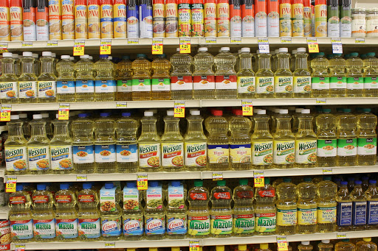
Step 1/Activity 1: Trader Joe’s

Scenario #1. Your spouse sends you to the grocery store for cooking oil. This simple task is much more complex once you reach the aisle marked cooking oils.This what you see →

Yikes! There are an almost unlimited amount of choices. Cooking oils come in different sizes, different brands and there are at least 15 different types of oils in a traditional grocery store (vegetable, peanut, olive,etc.) This confrontation with an abundance of choices is stress inducing and can make people anxious.

Here is where Trader Joe’s comes in. Trader Joe’s was founded in1958 in Los Angeles, California (same year Jiff peanut butter was introduced.) Trader Joe’s has been growing across the country and now has over 500 locations. At first glance it is hard to see why they are successful. They do not claim to be the cheapest, they don’t generally locate in prime real estate areas and their selection is a fraction of a traditional grocery store. It is in the last fact that social psychologists believe Trader Joe’s has an edge over its rivals. Less is sometimes more. Trader Joe’s sells cooking oils, but just a few. Same for spaghetti sauce, peanut butter, etc. People prefer to avoid the paralysis of excess choice.

Step 2/Activity 2: Its a Birthday Party
Scenario #2. You are married and have a 3 year old daughter. She is turning 4 soon and you want to have a proper birthday party for her and her friends. You and your spouse work full time and everything you earn goes towards your monthly bills.

Your spouse is a dental hygienist and is maxed out at 40 hours per week. You are an electrician’s apprentice making $12 per hour. The job has been a good opportunity for you. As you become more skilled, your employer can bill out your time at a higher rate, and thus raise your wages. For the foreseeable future, $12 per hour is what you can plan on earning. However, you have the opportunity to work overtime.
Most work past 40 hours per week is compensated at time and a half. In your case $12 times 1.5 = $18 per hour. Your firm is busy so you can work as many extra hours as you can handle.

You want to do right by your daughter and give a birthday party she will have pleasant memories of. How many overtime hours do you need to work in the next 8 weeks until her birthday? To make this decision we will have to look at the costs associated with a children’s birthday party....

Step 3/Activity 3: The paradox of choice returns

The first choice you are confronted with is the location of the party. The easiest solution is to let the professionals handle it. There are places that specialize in kids’ birthday parties. There are several themes, swimming, bouncing, even pizza with a singing rat. These places provide almost everything, food, balloons, plates,napkins. All you have to do is bring the birthday cake.

Decision #1. What will be the venue for the party?
You believe there will be 30 people attending the birthday party, kids and adults. The cake will cost $40. Calculate the cost of each venue with the pricing provided:

Venue | Cost per person | Cost of Cake | Total Cost
Swimming Party | $20 | $40
Pizza Party | $15 | $40
Bounce Party | $25 | $40

You also have the choice to host the party at your home for free. Of course, there will need to be a bunch of choices to make. Costs associated with hosting a birthday party:

Items/Activities | Costs
Napkins and plates | $10
Cups | $5
Meal | $300
Ice Cream | $20
Drinks | $30
Balloons | $30
Bounce House Rental | $150
Magician | $150
Clown | $150
Cake | $40
Total Cost

Step 4/Activity 4: Making a Decision.

Now that you have all the information, describe in the space below exactly what birthday party you are going to have for your daughter. Use the information you have been given to calculate a final cost.

Using the final costs associated with the party of your choice (as calculated above), how many hours per week and in total of overtime work you will need to put in to achieve your goal?
- Pretend that there are no taxes and you can keep all $18 per overtime hour you earn. We will talk more about taxes tomorrow.

Skill Builders and Review Problems
- See separate document-

Student Feedback:

Circle the emojis that best represents how this activity made you feel.

Day 3: How can we impact our community’s health?
Health

What is this lesson about?: In today’s lesson, you will discover the impact you could have on your community.

Step 1: Read the article
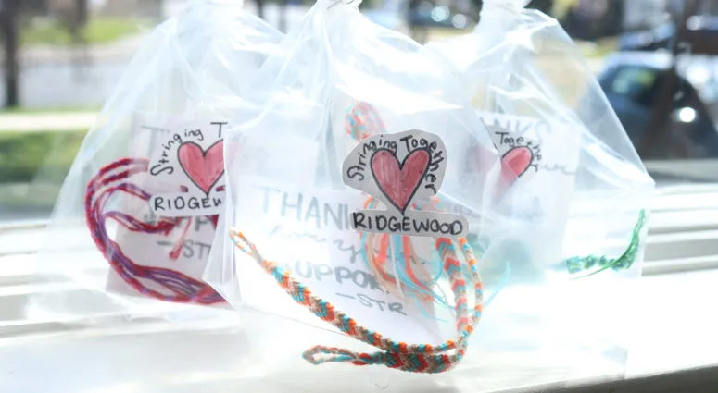
A group of high school students in New Jersey have come together to raise money for health care workers on the front lines of the coronavirus fight.
When schools across the state closed and moved over to remote learning, Ridgewood High School students Lili Weissberg, 16, and her 14-year-old sister, Jane, were thinking of how to spend their time now that they were confined to the house.
"My sister said to me, 'Lili, you love making string bracelets, why don't you make a few string bracelets for yourself?' And I was like, 'Oh yeah, that's cool,'" Weissberg said.
The idea soon blossomed and the sisters turned a simple hobby into a potentially life-saving project.
Weissberg said they decided to sell their bracelets and donate the money for COVID-19 relief.
The girls named the project “Stringing Together Ridgewood" and enlisted their friends, including junior Claire Sullivan.
"When we were in school I would probably spend four hours a day making bracelets but now that we're on spring break I pretty much do it all hours of the day," Sullivan said.
Depending on the pattern, it can take between 5 minutes and three hours to complete a bracelet.
The money is going to Valley Hospital to buy gowns, masks and gloves.
"That was really heartwarming to see the impact we're having on the community, not just those in the healthcare field," Sullivan said.
"It just feels really good, and I want people to know that there are people out there that want to help," Jane Weissberg said.
The bracelets sell for between $3 and $10.
So far, they've raised more than $3,000.
Step 2: What community health issues exist in your neighborhood?

You are the youth ambassador of your community, and you are going to take action to improve some of the unhealthy problems in your neighborhood. Using the chart below, make a list of the issues that concern you in column 1, what are possible solutions in column 2, and then rank how easy they would be to fix in Column 3. After you finish this chart, choose one of your issues to focus on and circle it.

Issues that concern you... | Possible Solutions... | Are these Easy, Medium, or Hard to solve?

How to Make an Impact
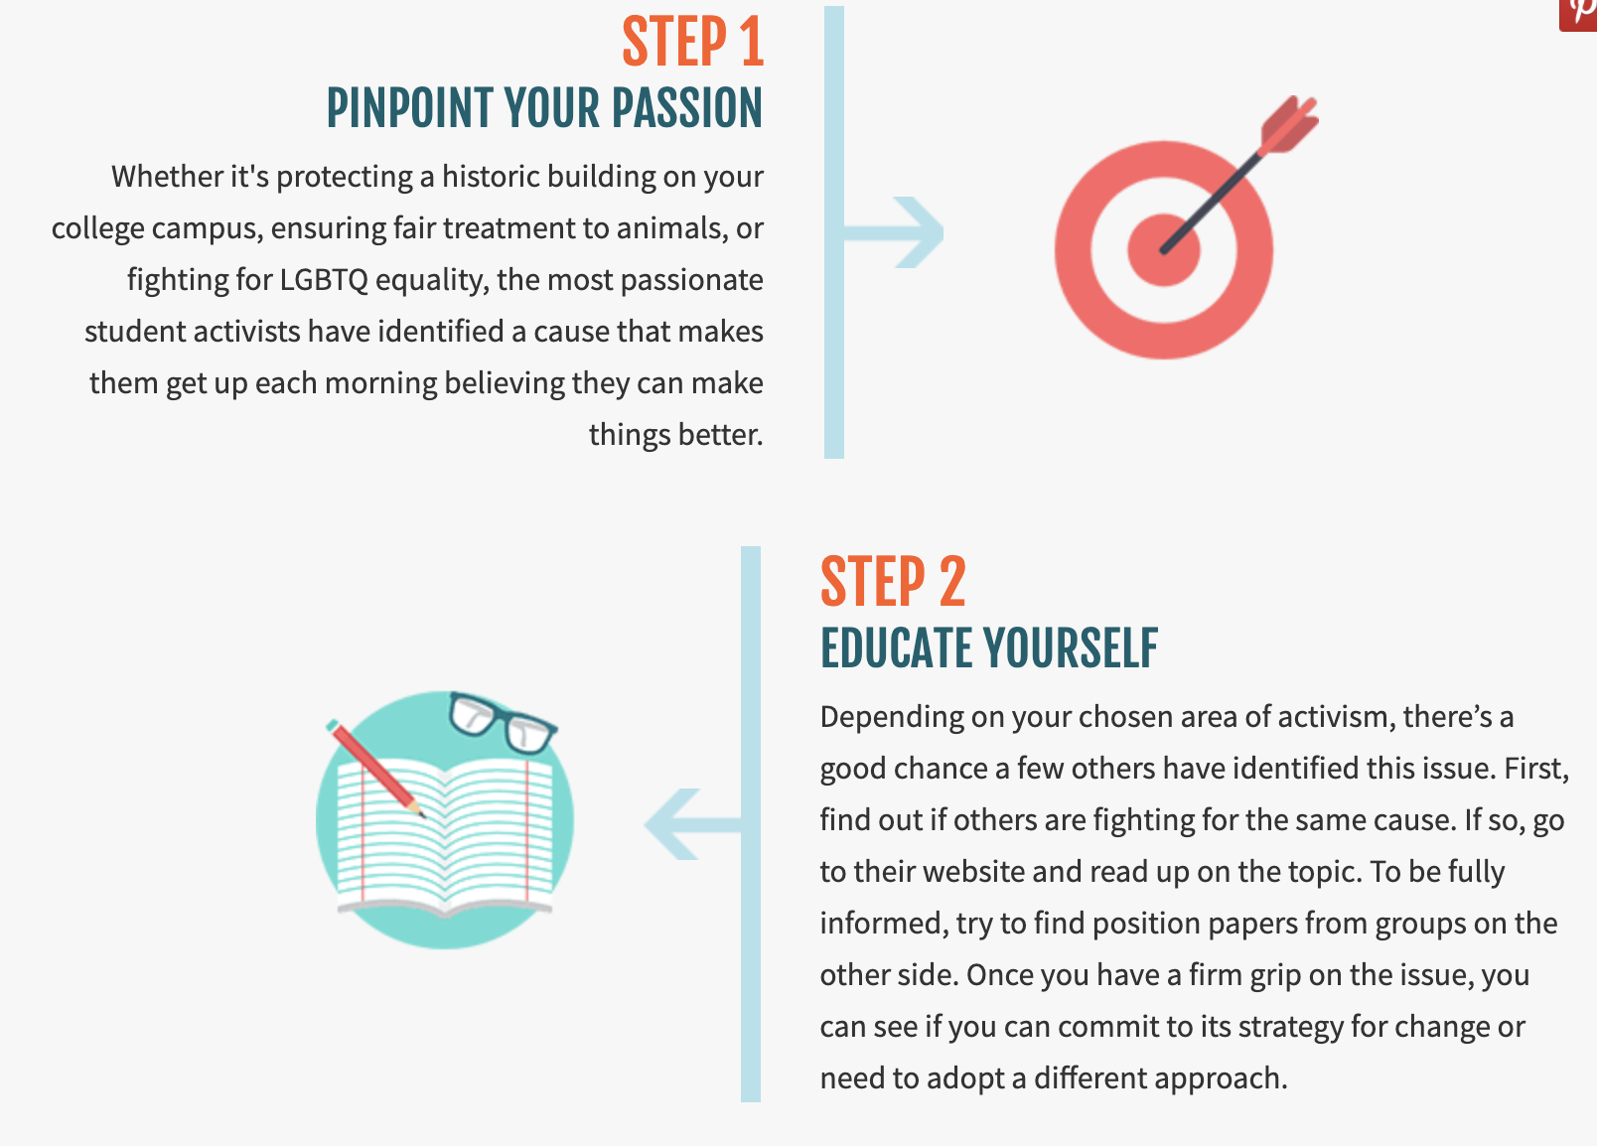

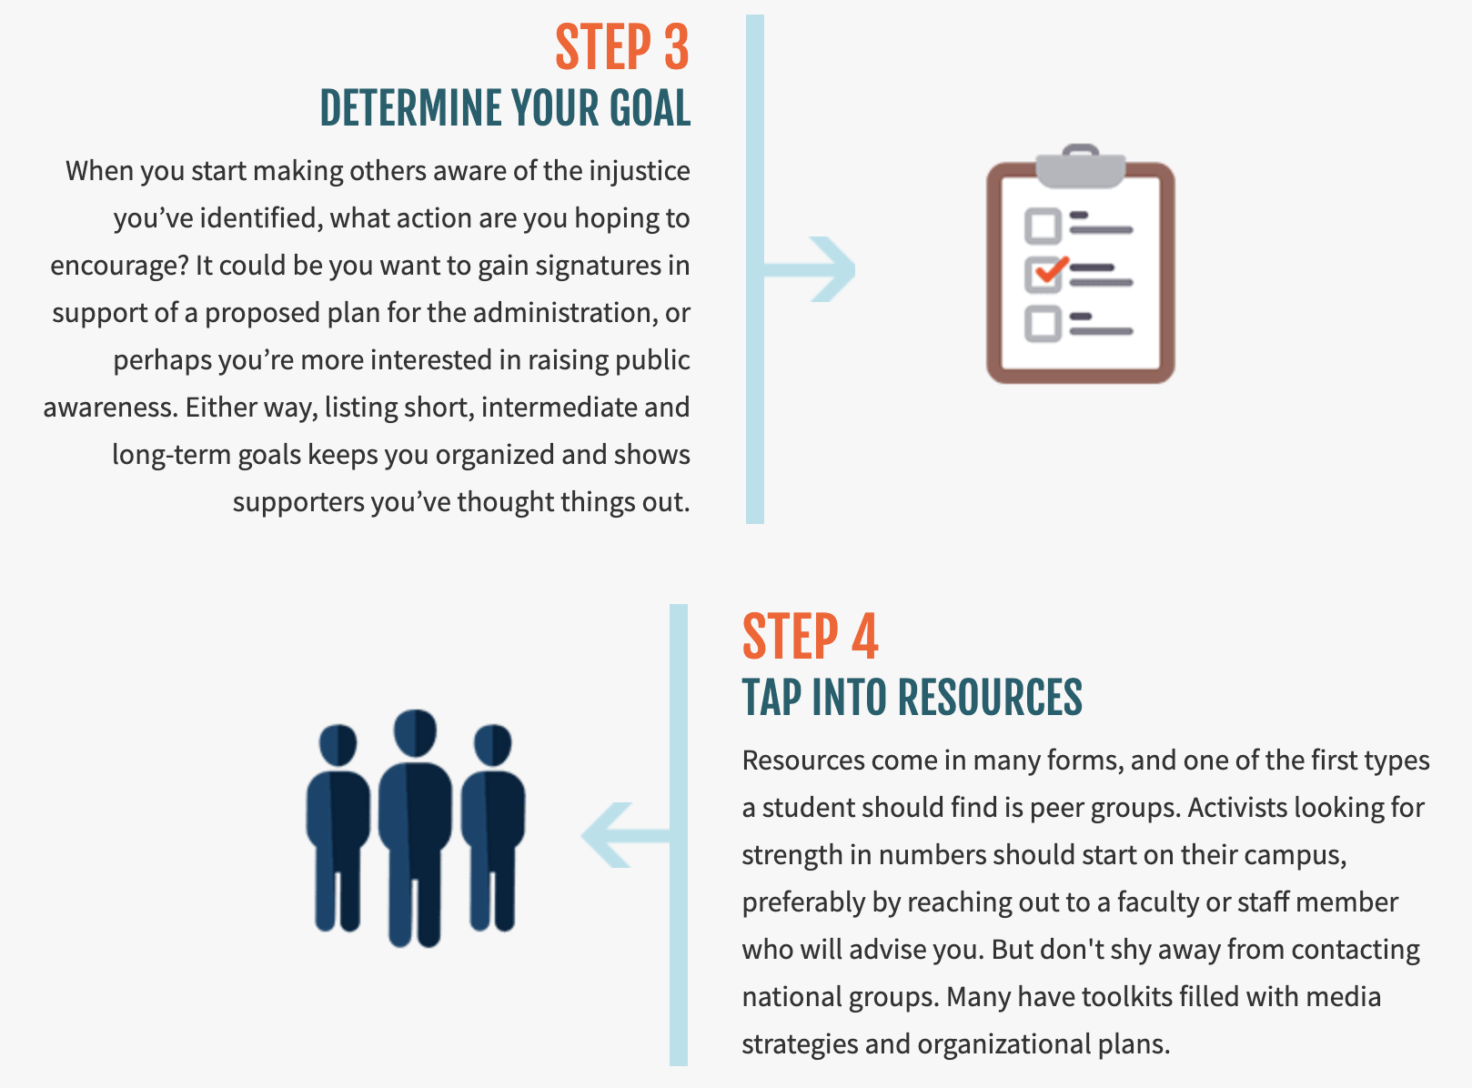
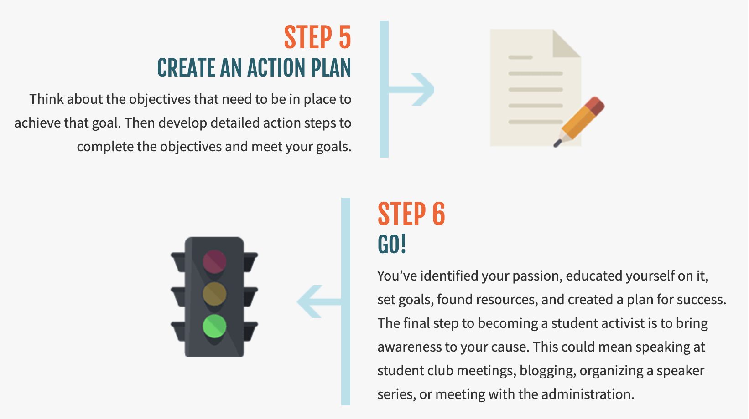

In your next Health activity, you will dig deeper into this idea that will impact your community. Share your idea here and why it means so much to you.

Mindfulness Moment!
Write your own Autobiography poem.

Autobiography In Five Short Chapters
Chapter I

Chapter II

Chapter III

Chapter IV

Chapter V

– YOU

Day 3: Communities of the World: Kuwait
Social Studies

What is this lesson about?: In today’s lesson you will learn about a community that may be different from your own. Today we will focus on Kuwait.

Step 1: Learn about Kuwait
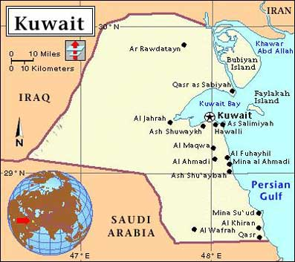
Kuwait is a small nation situated on the Arabian Peninsula in Southwest Asia. Before the discovery of oil in the 1930’s made it one of the world’s wealthiest countries, Kuwait was a poor, little-known Arab state. Its people had traditionally earned their livelihood from boat building, pearl diving, fishing, and raising livestock. Oil transformed Kuwait, enabling it to finance a broad range of social welfare programs for its citizens. The country’s wealth made it a tempting prize to its more powerful neighbor Iraq, which invaded Kuwait in 1990, setting off the 1991 Persian Gulf War.

FACTS AT A GLANCE
Location: Southwest Asia.
Area: 6,880 sq mi (17,818 km2).
Population: 2,000,000 (estimate).
Capital and Largest City: Kuwait (including metropolitan area).
Major Language(s): Arabic (official).
Major Religious Group(s): Muslim.
Government: Constitutional monarchy. Head of state emir. Head of government—prime minister (appointed by the emir). Legislature— National Assembly.
Monetary Unit: Kuwaiti dinar
The People
Ethnic Groups, Religion, Language. The Kuwaitis are Muslims. Arabic is the language of the country, although English is widely spoken. Traditionally, less than half the population were Kuwaiti citizens. The rest were immigrant workers and their descendants. Palestinian Arabs long made up the largest group of foreign workers. Others came from various parts of the Middle East. Thousands of Europeans and Americans were also employed by the oil companies. Kuwait has since adopted a policy of relying less on foreigners. Palestinians were hardest hit because of support for Iraq during the Gulf War by Palestinian leaders abroad.

Way of Life. Before the oil boom, most of the people lived in the old walled town of Kuwait, in mud and brick houses packed into winding alleyways. The people outside the town were Bedouin nomads, herders of camels, goats, and sheep. This way of life was changed abruptly, in the years following World War II (1939-45), when Kuwait began to export oil in large quantities. Most of the old town of Kuwait was replaced by Kuwait city—a modern capital with wide boulevards, a variety of shops, banks, luxury hotels, and the most up-to-date urban services.

The Land
Kuwait is located on the eastern coast of the Arabian Peninsula, at the northwestern tip of the Persian Gulf. Kuwait’s neighbors are Iraq and Saudi Arabia. Nearly all of the country is flat, sandy desert, with a few small hills. Here and there a few oases (watered, fertile areas) provide shelter and subsistence for the Bedouin nomads and their flocks and herds. Rainfall is little, falling mostly between October and April.
The climate of Kuwait is one of the hottest in the world, often reaching temperatures of 125°F (52°C) in the summer. During the winter months, temperatures are much cooler.
Step 2: Answer questions

- What were the traditional ways that Kuwaitis earned their livelihood, before working in oil became the popular career?

- What is the main religion of Kuwait? Do Americans also practice that religion?

- What is the geography like in Kuwait? What is the land and weather like?

- Why did the Persian Gulf War start? (hint: why did Iraq invade Kuwait?)

- Based on what you’ve learned about Kuwait so far, would you want to live there? Would you want to visit?

Step 3: What do people eat in Kuwait?
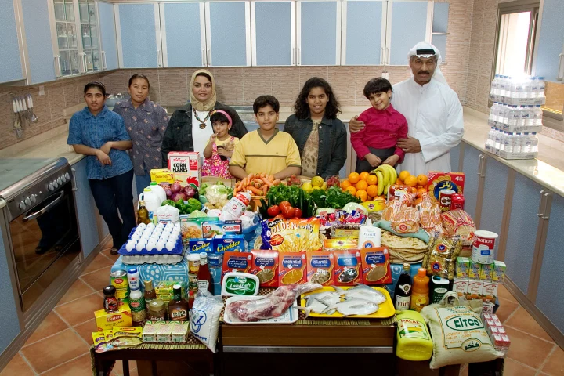
Picture to right:
The Al Haggan family of Kuwait City. Food expenditure for one week: 63.63 dinar or $221.45. Family recipe: Chicken biryani with basmati rice. From the book, "Hungry Planet: What the World Eats” by Peter Menzel.

Food in Daily Life.
After centuries of living as nomads, surviving off of subsistence farming and breeding farm animals, the relatively recent increase in the income of many Kuwaitis has lead to a rapid rise in the relative obesity of the general population. Still operating under the belief that plump children are healthy, Kuwaitis eat a very rich diet, and do not engage in physical exercise like they did in the past. The shift from a nomadic to sedentary (spending a lot of time seated) lifestyle happened quickly with industrialization and urbanization coinciding with the advent of the oil industry in the past century, and habits of nutrition have not completely changed to adjust to the present environment.
An average Kuwaiti person eats three meals each day. Breakfast often includes some meat, such as fried liver or kidneys, and a dairy product such as cheese or yogurt. For lunch and dinner, several meat dishes may be served. In the desert, vegetables and grains were largely unavailable. Therefore, meat was a staple of the desert nomad's diet. As in the past, meat remains a central part of the Kuwaiti diet.
Excerpt from everyculture.com

Step 4: Answer Questions

Do Kuwaitis eat similarly to you? What is the same? What is different from what you eat?

Step 5: What does a typical home in Kuwait look like?
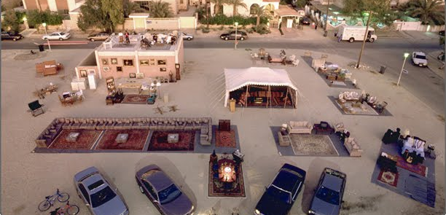
The Abdulla family with all of their possessions pose for a portrait in front of their home in Kuwait City, Kuwait. Published in the book Material World. Their house is 4,850 square foot one-story house (with a full basement) in a residential neighborhood.

Excerpt from everyculture.com
Over the span of just two hundred years, Kuwait shifted from a nomadic population to an urban population. The development of the urban environment has largely been influenced by Islam, and Kuwaiti homes reflect the tenets of Islam as clearly as they reflect the influence of desert life and culture. Most homes are rectangular in shape and are organized around an inner courtyard. This courtyard allows for an enclosed yet open environment, and at the same time protects from the wind and direct sunlight in the arid desert climate. Generally homes are clustered together to unite and serve the needs of an extended family. As family size increases, more rooms are built on to accommodate the new members.
The manner in which space is used in Kuwait reflects the traditional relationship between men and women. In nomadic times, tents would be separated by screens or a cloth, so that men could entertain unrelated men, as is their custom, without having the guests come into contact with female kin. With the advent of urban living, homes were built with what is known as a "double circulation system" so that men and women could avoid contact with one another, and most importantly so that women were not in contact with strange men.
Step 5: Answer questions

What do you think is interesting about the picture of the Abdulla Family’s home above?

Why do Kuwati families expand their homes?

What are the two most intersting things you learned about Kuwait?

What more do you want to learn about Kuwait?

Student Feedback:

Circle the emojis that best represents how this activity made you feel.

