Week 6
Change

Day 4

NAME:______________________

Day 4 Agenda

Topic | Activity
Warm-Up!
English Language Arts | - Read and analyze the lyrics to the songs , Same Drugs and 7 years  - Answer questions about the lyrics and themes of the songs.  - Write a reflection piece where they give their younger and future selves advice.
Science | - Read about Environmental Changes  - Answer questions about what you read  - Draw a picture and explain
Mindfulness Moment!
Math | - Change and the Environment, Day 3: Water Case Studies (Flint, California, South Africa and Mumbai)
Health | - P.E.
Mindfulness Moment!
Civics/Social Studies | - Changing views on the battle of the Alamo  - Read and respond to the text

Warm-up Activity: Write a journal entry around the daily quote on identity.

Day 4: Relationship Changes
English Language Arts

What is this lesson about?: Today you will read and analyze the lyrics of two songs that talk about changes in relationships.

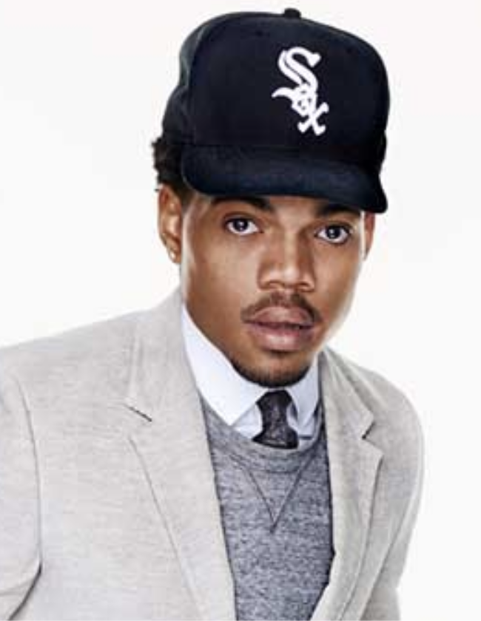
Before you Read:
Chance the Rapper, born Chancelor Johnathan Bennett, is an American rapper, singer, songwriter, actor, and activist.
Born in Chicago, Illinois, Chance the Rapper released his debut mixtape 10 Day in 2012. He began to gain mainstream recognition in 2013 after releasing his second mixtape, Acid Rap. But it was his third mixtape, Coloring Book, in 2016, which earned him three Grammy Awards, including the award for Best Rap Album; upon winning, it became the first streaming-only album to win a Grammy Award. He is also known for his activism, especially in his hometown of Chicago. In 2016, co-created a nonprofit called SocialWorks set up to create youth programs for residents of Chicago, among other goals. He has also actively fought to combat gun violence in his hometown of Chicago and in 2014, along with his father, promoted the "#SaveChicago" campaign. The campaign sought to stop gun violence over Memorial Day Weekend. During 2014's Memorial Day weekend, Chicago went 42 straight hours without a shooting. In March 2017, he announced his intention to donate $1,000,000 to Chicago Public Schools in order to help offset the lack of government funding provided.

Step 1: Read the following text
As you read, take note of two things. First, Chance the Rapper has stated that “Same Drugs” is not about drugs. As you read, think about how he uses “same drugs” as a metaphor for something else. Secondly, there is an allusion in this song. An allusion is when a writer indirectly makes mention of a famous character or event from another work of art or history in order to communicate a message to the reader. In this song, there is a reference to “Wendy”. Wendy was Peter Pan’s friend when she was a child--and Peter Pan is a young boy who never wants to grow up. Think about how Chance uses this allusion to communicate his message in this song.

 | Same Drugs  Chance the Rapper | Notes:
1 | We don't do the same drugs no more  We don't do the, we don't do the same drugs, do the same drugs no more  Cause she don't do the same drugs no more  We don't do the, we don't do the same drugs, do the same drugs no more  When did you change?  Wendy you've aged  I thought you'd never grow up  I thought you'd never  Window closed, Wendy got old  I was too late, I was too late  A shadow of what I once was  Cause we don't do the same drugs no more  We don't do the, we don't do the same drugs, do the same drugs no more  She don't laugh the same way no more  We don't do the, we don't do the same drugs, do the same drugs no more
2 | Where did you go?  Why would you stay?  You must have lost your marbles  You always were so forgetful  In a hurry, don't wait up  I was too late, I was too late  A shadow of what I once was  Cause we don't, we don't do what we say we're gonna
3 | You were always perfect, and I was only practice  Don't you miss the days, stranger?  Don't you miss the days?  Don't you miss the danger?  We don't (we don't) do the same drugs no more (do the same drugs no more) (x5)
4 | (Turn it around  I remember when  This age of pathetics)  Don't forget the happy thoughts  All you need is happy thoughts  The past tense, past bedtime  Way back then when everything we read was real  And everything we said rhymed  Wide eyed kids being kids  When did you stop?  What did you do to your hair?  Where did you go to end up right back here?  When did you start to forget how to fly?  (This shit, wanna chew  Tastes like Juicy Fruit  Words have magnitude  Please get me out of that)  Don't you color out  Don't you bleed out, oh  Stay in the line, stay in the line  Dandelion  (Do the same drugs no more  We don't do the, we don't do the same drugs, do the same drugs no more  We don't, we don't, we don't)  Don't you color out  Don't you bleed out, oh  Stay in the line, stay in the line  Dandelion

Step 2: Answer the following questions.

- The chorus of the song is “We don’t do the, we don’t do the same drugs no more”. If the speaker is talking about relationships, what is the phrase “same drugs” a metaphor (a comparison) for?

- In the first stanza, the speaker tells Wendy that she has aged and gotten old. Is he surprised, angry, upset? What words tell you how he feels? Why do you think he feels this way?

- Why do you think that the speaker says “we don't do what we say we're gonna”? (Hint: Again, think about a relationship that is either ending or changing)

- The last stanza refers to what life was like when they were kids. PIck 2-3 lines and explain how he describes childhood and how that might be different as we grow up.

Step 3: Read the lyrics to the following song.

7 years was written by Lukas Forchhammer who stated that the songs is about his life so far and what he hopes to achieve in the future. He said that the reason the lyrics go as far as the age of 60 is because his father died at 61 and he needed to "pass it to believe it." He continued: "It's a song about growing older. As you read the lyrics, think about how he describes the changes in his life and in his relationships as he grows older.

 | 7 Years  Lukas Graham  Songwriters: Christopher Brown / David Labrel / Lukas Forchhammer / Morten Pilegaard / Morten Ristorp Jensen / Stefan Forrest | Notes
1 | Once I was seven years old my momma told me  Go make yourself some friends or you'll be lonely  Once I was seven years old
2 | It was a big big world, but we thought we were bigger  Pushing each other to the limits, we were learning quicker  By eleven smoking herb and drinking burning liquor  Never rich so we were out to make that steady figure
3 | Once I was eleven years old my daddy told me  Go get yourself a wife or you'll be lonely  Once I was eleven years old
4 | I always had that dream like my daddy before me  So I started writing songs, I started writing stories  Something about that glory just always seemed to bore me  'Cause only those I really love will ever really know me
5 | Once I was twenty years old, my story got told  Before the morning sun, when life was lonely  Once I was twenty years old
6 | I only see my goals, I don't believe in failure  'Cause I know the smallest voices, they can make it major  I got my boys with me at least those in favor  And if we don't meet before I leave, I hope I'll see you later
7 | Once I was twenty years old, my story got told  I was writing about everything, I saw before me  Once I was twenty years old  Soon we'll be thirty years old, our songs have been sold  We've traveled around the world and we're still roaming  Soon we'll be thirty years old
8 | I'm still learning about life  My woman brought children for me  So I can sing them all my songs  And I can tell them stories  Most of my boys are with me  Some are still out seeking glory  And some I had to leave behind  My brother I'm still sorry
9 | Soon I'll be sixty years old, my daddy got sixty-one  Remember life and then your life becomes a better one  I made a man so happy when I wrote a letter once  I hope my children come and visit, once or twice a month  Soon I'll be sixty years old, will I think the world is cold  Or will I have a lot of children who can warm me  Soon I'll be sixty years old  Soon I'll be sixty years old, will I think the world is cold  Or will I have a lot of children who can warm me  Soon I'll be sixty years old
10 | Once I was seven years old, momma told me  Go make yourself some friends or you'll be lonely  Once I was seven years old  Once I was seven years old

Step 4: Answer the following questions

- What do you think of the pieces of advice given by the singer’s mom and dad? Have you ever been given similar advice from your parents?

- Fill out three of the sections of the timeline below by listing three major life events that happen to the speaker in the song.

7 years old | 11 years old | 20 years old | 30 years old | 60 years old

- How does the speaker change throughout his life? Pick one transitional period (between 7 and 11, between 11 and 20, between 20 and 30, or between 30 and 60) and describe how he is different and how his life has changed.

Step 5: Reflect and Write

The song is filled with a lot of advice. For example, the speaker’s mother tells him to "Go out and make some friends or else you'll be lonely." Think of what advice you would give to your younger or older self at different points in your life.

Pick 4 ages (2 younger and 2 older than you are now) and give yourself advice that you believe will make your life happier and more successful.

Example:
Age 6: I was an intense kid and afraid of being laughed at by others so I kept to myself. My advice to 6 year old me: Be brave and play with others more. You’ll make friends and not be so lonely.
Age 12: I never like to worry my Grandmother, so I didn’t tell her I was having trouble at school until it was too late. My advice to 12 year old me: Ask for help when you need it. You are just a kid, accept help if you need it.
Age 19 I’ll be on my own and ready to start a new life. My advice to 19 year old me: Try new things, take chances and keep your goals in mind.
Age 30: I’ll be secure in my career. My advice to 30 year old me: Don’t just work, it’s not worth it to make money if you don’t use it to live a real life.

Age _____:

Age _____:

Age _____:

Age _____:

Student Feedback:
Circle the emojis that best represents how this activity made you feel. | 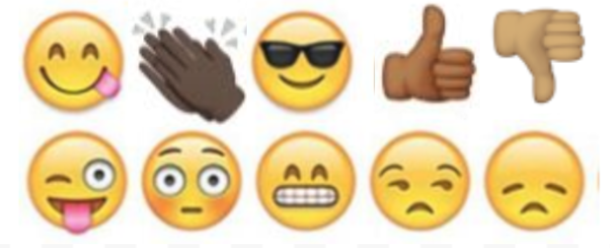  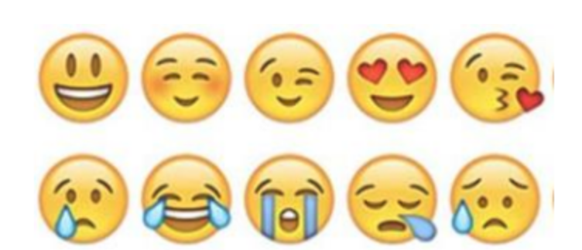

Day 4: Environmental Change
Science

What is this lesson about?: Today you will read through the Scientists have found there's a crucial change we can make to better serve our planet passage. You will answer a few questions about what you read. You will complete an Environmental Change activity.

Step 1: Read through the Scientists have found there's a crucial change we can make to better serve our planet passage

Scientists Have Found There’s a Crucial Change We Can Make
to Better Serve Our Planet
TESSA KOUMOUNDOUROS 23 SEPTEMBER 2019

The planet is struggling. Study after scientific study warns that we've pushed far beyond the physical boundaries of what our living world can sustain.

From increasing temperature extremes causing disastrous weather - including record breaking droughts and unprecedented fires - to plastic choked oceans and ecosystem collapses, it's painfully clear something massive's got to give. And yet most governments are waiting for it to make economic sense before they take action.
In light of this, a background document for the United Nations' (UN) draft Global Sustainable Development Report 2019 suggests we seriously need to consider making drastic changes to our economic systems.

"[T]he economic models which inform political decision-making in rich countries almost completely disregard the energetic and material dimensions of the economy," the researchers wrote in the document.

"Economies have used up the capacity of planetary ecosystems to handle the waste generated by energy and material use."

In other words, maybe it's time to accept we can't somehow maintain endless economic growth on a finite planet.

The UN report is overseen by a group of independent scientists from different disciplines around the world.

This background document for the chapter of the report called Transformation: The Economy, has been written by scientists from environmental fields, such as ecosystem scientist Jussi Eronen from the University of Helsinki, as well as economic, business and philosophy researchers, like economist Paavo Järvensivu from Finland's independent BIOS research unit.

Not only have we reached the point where using our land, water and atmosphere as a giant garbage dump is no longer viable, the document warns that our current economic systems are also causing critically widening gaps between the rich and poor.

This is leading to a rise in unemployment, and debt which are all contributing to destabilising our societies.

In fact, data shows continuing to pursue economic growth in wealthy nations doesn't continue to improve human wellbeing, as ecological economist Dan O'Neill explains for The Conversation.

Still, the notion of changing our economic system to fit within the physical limits of our reality is seen as highly controversial and isn't something many policy makers will discuss.

Especially when leaders of wealthy nations such as the US and Australia openly deny climate change. Or as a leaked document from the UK's foreign office reads: "Trade and growth are now priorities for all posts… work like climate change and illegal wildlife trade will be scaled down."

Meanwhile, we're failing to meet the Paris agreement to hold temperatures within 2 degrees Celsius of warming above pre-industrial times.

Every indication from our scientists is that we have two options: make widespread drastic but controlled changes to the way we live or continue as we are, blundering towards disaster.

"Market-based action will not suffice – even with a high carbon price," the UN document warns.

It's not the first time humans have had to rally together and find unique solutions to extraordinary scientific challenges – the document points out the fact that the US Apollo program only succeeded because the government set a clear mission and then found ways to achieve the funding and research required.

They didn't wait for market-based mechanisms to make the Moon landing happen. So why are we still waiting for the market to miraculously steer us away from disaster, especially when so much is at stake, the document questions.

Journalist Naomi Klein, author of This Changes Everything: Capitalism Vs the Climate, points out that "we humans are capable of organizing ourselves into all kinds of different social orders, including societies with much longer time horizons and far more respect for natural life-support systems."

"Indeed," she writes, "humans have lived that way for the vast majority of our history and many Indigenous cultures keep Earth-centred cosmologies alive to this day. Capitalism is a tiny blip in the collective story of our species."

No one is suggesting we revert to technology-less societies. Instead, the idea is to learn from different ways of living that have proven track records of longevity. From there, we can find new and better ways forward with the help of our advanced technologies.

Klein believes we should view this need to transition our economies as an opportunity to shape them for the better, a chance for us to create both a fairer and more sustainable world.

The background document does not cover what transitioned economies would look like, but it does suggest they "must enable politics to acknowledge transformational social goals and the material boundaries of economic activity". And that economies should primarily be a tool to "enable a good life" rather than as excuse to dogmatically pursue profits.

Järvensivu and colleagues also acknowledge that to transition our societies in time to prevent hurtling ourselves beyond the critical 2 degrees Celsius threshold of warming, it will take an emergency scale response.

This echoes warnings from other scientists: "Incremental linear changes … are not enough to stabilize the Earth system. Widespread, rapid and fundamental transformations will likely be required to reduce the risk of crossing the threshold."

Such a response could look something like an accelerated World War II style transformation of industry, as discussed by leading Harvard atmospheric scientist James Anderson.

Meanwhile, experts around the world are exploring alternative ways we can set up our economic systems, such as Doughnut Economics, Post Growth Economics, Prosperity without Growth, and Steady State Economy - and Järvensivu and colleagues have asked all forward-thinking leaders around the world to start testing possible transitional strategies, such as a universal job guarantee.

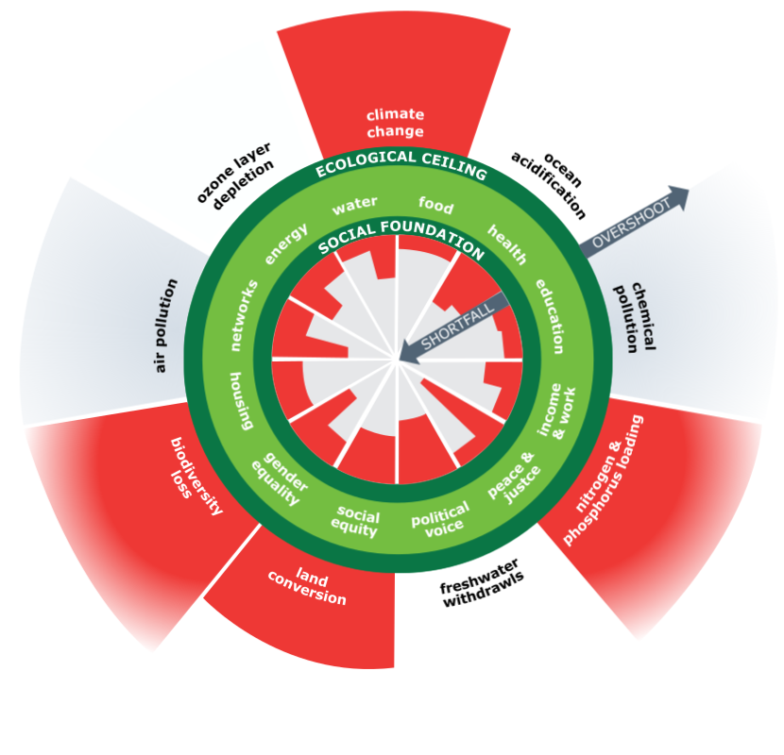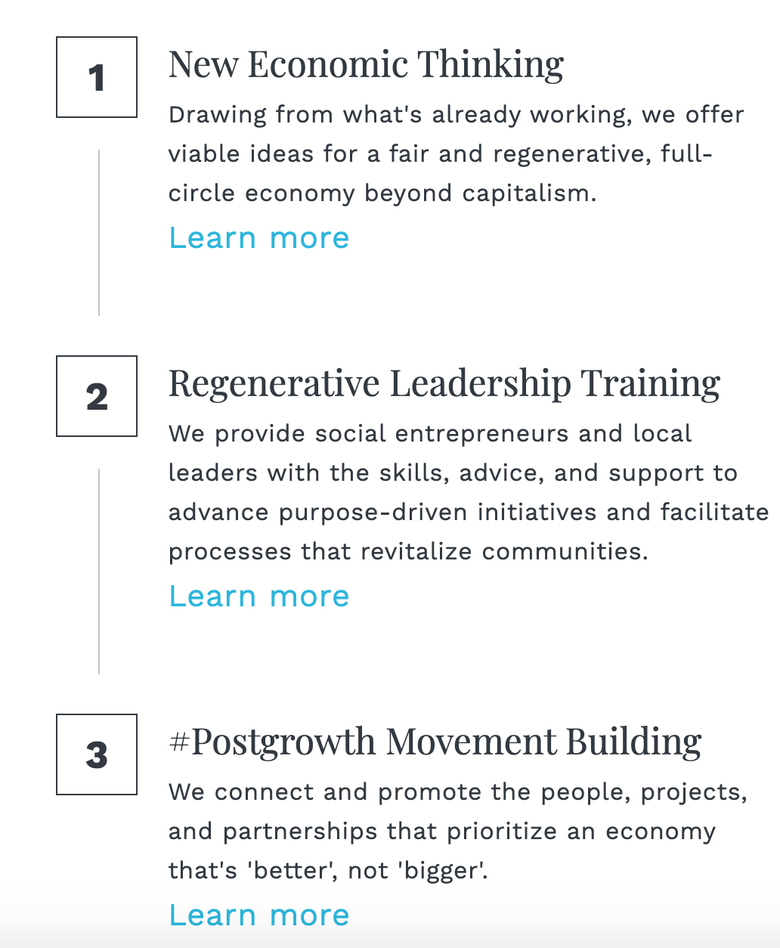

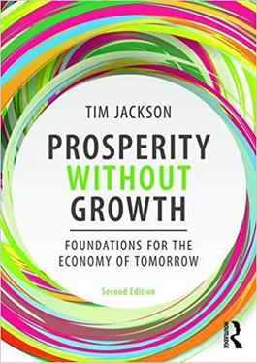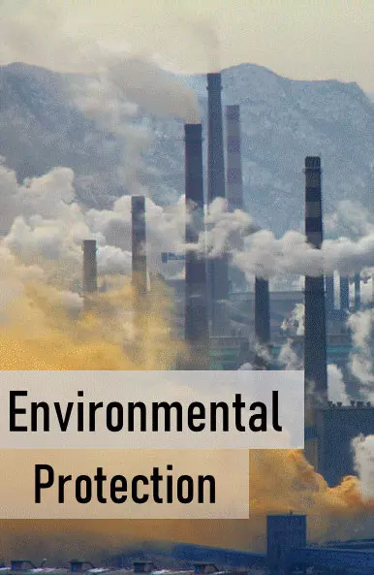

These suggestions are pretty daunting, but if we humans have proven anything with our time on Earth so far, it's that we can achieve incredible things when we work together.

Step 2: Answer questions about what you read

- Based on the article, what important change do we need to make to help save our planet?

- One definition of global warming is a gradual increase in the overall temperature of the Earth's atmosphere generally attributed to the greenhouse effect caused by increased levels of carbon dioxide, chlorofluorocarbons, and other pollutants. What suggestion would you make to help lower the temperature of the Earth’s atmosphere?

Step 3: Draw a picture/explain

Think about your own environment. What changes do you think are needed in your own environment to help make it a better place to live? Draw a picture of what your current environment looks like and a picture of what it looks like with the changes you are recommending. Write a brief description of your “before” and “after” drawings.

Current environment

Environment after the needed changes

____________________________________________________________________________________________________________________________________________________________________________________________________________________________________________________________________

Student Feedback:
Circle the emojis that best represents how this activity made you feel.

Mindfulness Moment!
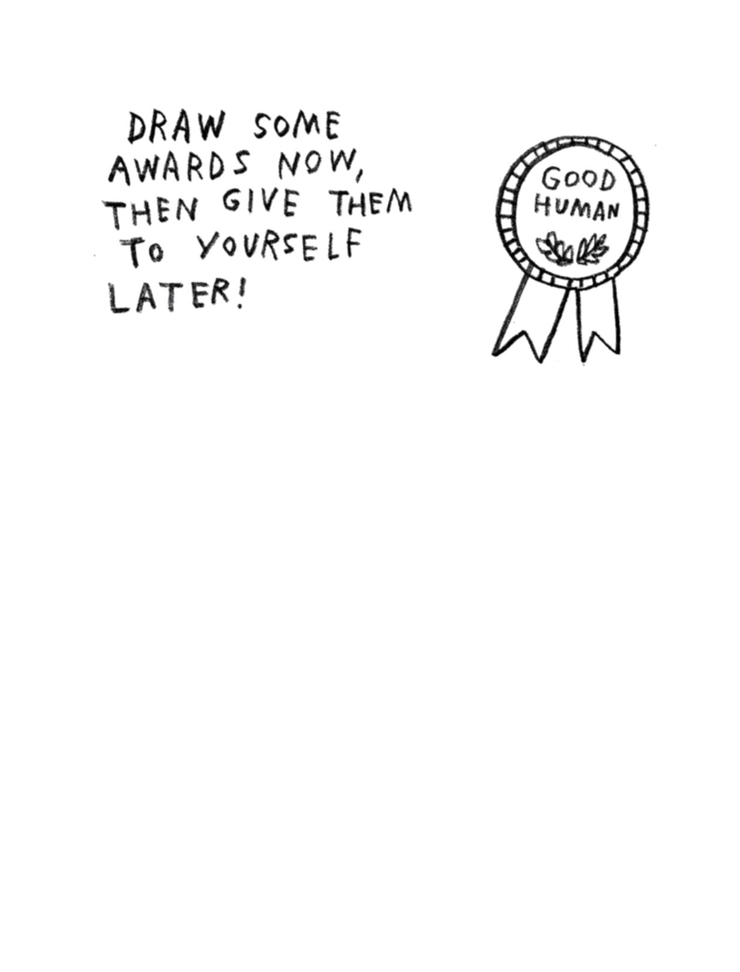

Day 4: Change/Flint, Michigan
Math

What is this lesson about?: Today’s lessons focus on the water crisis in Flint, Michigan that ran for a number of years. The activities focus on the changes that took place in Flint, in light of the City’s decision to try and save money by changing its water source.

Today’s Warm-Up Problem
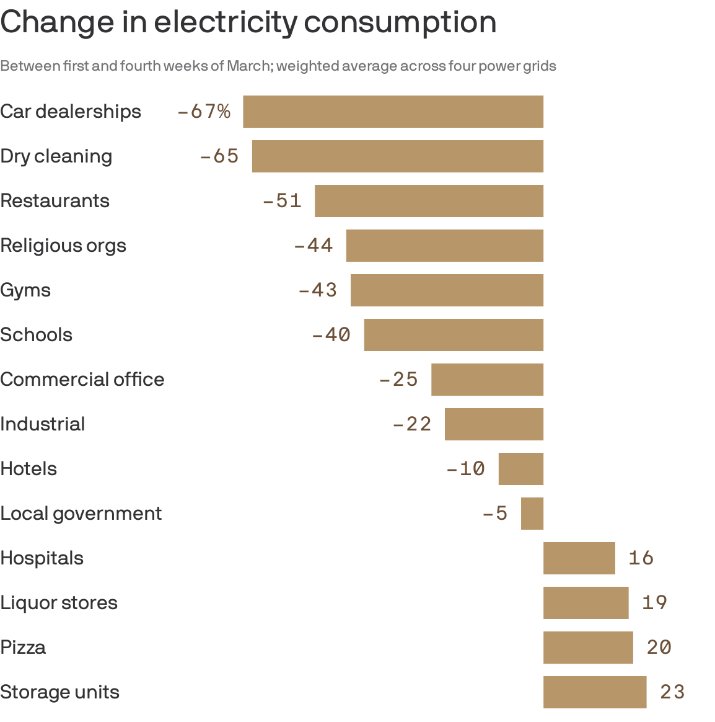
The chart above shows how different industries are using more or less electricity, comparing the first week in March 2020 to the last week in March 2020. A negative % means that industry used that much less electricity. Looking at the chart:
- What industries are using a lot LESS energy now?

- Does it make sense to you that those industries are using less electricity? Yes/No

- What 2-3 industries are using more electricity?

- What do you think that both pizza delivery and liquor stores are using more electricity?

Activity 1: Flint’s population

Flint, Michigan is located about 60 miles from Detroit. For many years, it received its water from Detroit--a much larger city that has a well-tested water treatment system. In 2013, facing a budget shortfall and other challenges, the City of Flint decided to start pulling its water directly from the Flint River (Lake Huron), without adequate processes in place to test and purify the water.

Background on Flint: Use the chart below to answer some basic questions about Flint and its population, in 1990 and in 2018.

Flint, Michigan Statistics | 1990 | 2018
Population | 140,000 | 96,000
Population: Afican Americans | 56,000 | 51,840
% with College Degree | 15% | 12%
Median Household Income | 34,000 | 27,000
Population: People living in Poverty | 35,000% | 38,400

By how much did Flint’s population decline between 1990 and 2018?
What sort of percentage change (decline) is this?

How much did the ‘average’ family earn in 1990 in Flint?
How much was that in 2018?
What sort of percentage change (decline) is this?

What percent of the population was African American in 1990?
What percent of the population was African American in 2018?

What percentage of the population in Flint lived below the poverty level in 1990?
What was this percentage in 2018?

Activity 2: Level of lead in home water

Soon after the city began supplying residents with Flint River water in April 2014, residents started complaining that the water from their taps looked, smelled, and tasted foul. Despite protests by residents lugging jugs of discolored water, officials maintained that the water was safe.

A study conducted the following year by researchers at Virginia Tech revealed the problem: Water samples collected from 352 homes through a resident-organized effort indicated citywide lead levels had spiked. Homes were put into 3 categories:
- Safe tap water,
- “Action Level” tap water, meaning the level was so high that immediate action should be taken based on federal guidance
- “Very Serious” tap water, meaning the level was high enough that based on federal guidance, it was above safe levels and needed to be addressed.

Number of households tested (tap water supply)- | 352
Number of households with Lead with "Quick Action" levels | 53
Number of households with Lead with "Very Serious" levels | 142

Out of the 352 homes tested, how many had lead levels at the “Action Level”?
- What percentage of the tested homes is this (approximately)?

Out of the 352 homes tested, how many had lead level at the ‘Very Serious’ level?
- What percentage of the tested homes is this (approximately)?

Taken together, what % of the homes had problems with high levels of lead in their water?

Discuss/Consider: What would you do if you lived in a neighborhood and more than 50% of the homes were determined to have unsafe drinking water?

Note: Similar testing conducted in 2010 revealed 0% of the homes with lead at the ‘action level’ and less than 5% at the ‘very serious’ level.

Activity #3: Legionnaires Disease in Flint after water crisis

Other problems also struck vulnerable populations in Flint. Legionnaires' Disease--a rare form of pneumonia--had never before been present in Flint, took hold, killing a number of adults and leaving others very sick.

Legionnaires' Disease
Year | Illness | Deaths
2012 | 0 | 0
2013 | 2 | 0
2014 | 31 | 7
2015 | 56 | 5

Use the data to the left to plot a double bar chart showing the spike in illnesses and deaths caused by the disease between 2012 and 2015. (we’ve already added the 2015 illness bar to the graph for you)
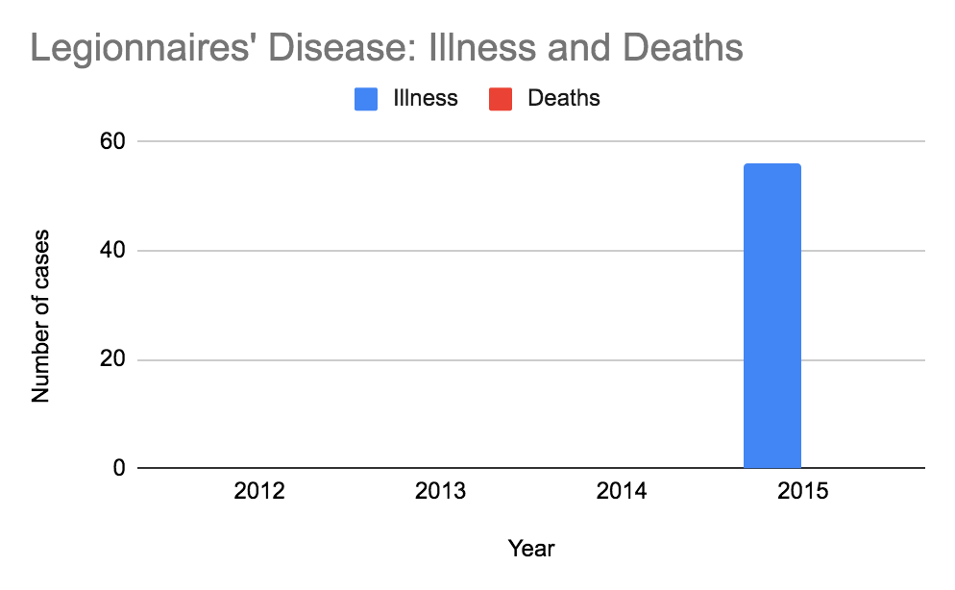
- What does this bar graph make clear to the viewer?

Activity 4: Cost of water in Flint

A survey of the 500 largest water systems in the country, conducted in 2015, found that on average, Flint residents paid about $910 a year for water service, the highest in the nation and nearly double the national average. The figure is based on an annual household consumption of 60,000 gallons. The chart below pulls the cities with the highest annual water bills and those with the lowest water bills.

In addition, the chart compared the cost of household water to Detroit.
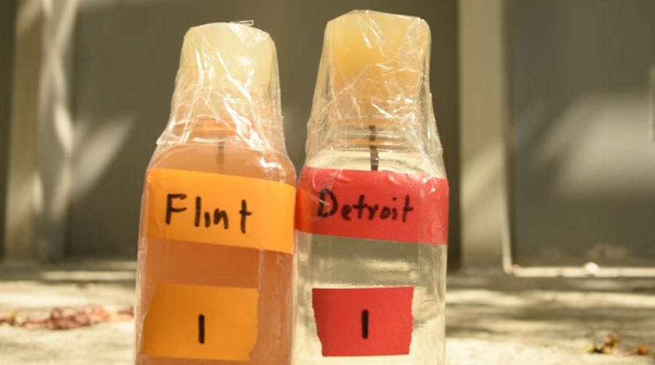
Photo from Metro Times, the Flint, Michigan Newspaper in 2014.

Annual Water Bills--2015  City | State | Population | Av. Annual Water Bill
Flint | MI | 124,943 | $910.05
Detroit | MI | 787,289 | $246.21
Pittsburgh | PA | 516,411 | $792.84
Monterey | CA | 94,700 | $716.18
Harrisburg | WV | 217,959 | $710.63
Memphis | TN | 671,450 | $120.71
Miami-Dade | FL | 2,100,000 | $116.46
Jefferson Parish | LA | 308,362 | $104.40
Phoenix | AZ | 1,500,000 | $84.24
* Based on 60,000 gallon/year usage-

How much more $ does the average family in Flint pay for water than a family in Detroit?

Approximately, how much does a family in Flint pay for water each month?
How much is this for a family in Detroit?

How much does a family in Memphis spend per month on water?
How about a family in Phoenix?

Housing advocates say that families shouldn’t pay more than 1% of their income for basic water in their homes. In Detroit, if the average household income is $27,000 and a family spends approximately $900 per year on water.

- About what % of $27,000 is $900.

Consider/discuss: Back in 2010, the average resident in Flint, MI paid just slightly more for water than the average resident living in Detroit. The water quality in both cities was the same, coming from the same source. Five years later, residents in Flint are paying 3xs as much for water. The water for years had been dirty, with high lead levels.

- In hindsight, was the city’s decision to try and purchase ‘cheaper’ water a good one?

Student Feedback:

Circle the emojis that best represents how this activity made you feel.

Day 4: PE
Health

What is this lesson about?: In today’s lesson, you will work on your PE BINGO card.

Step 1: Try to complete the PE BINGO card.

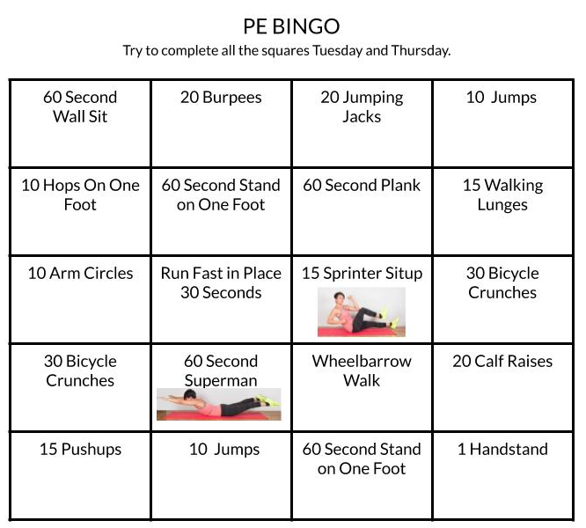

Mindfulness Moment!
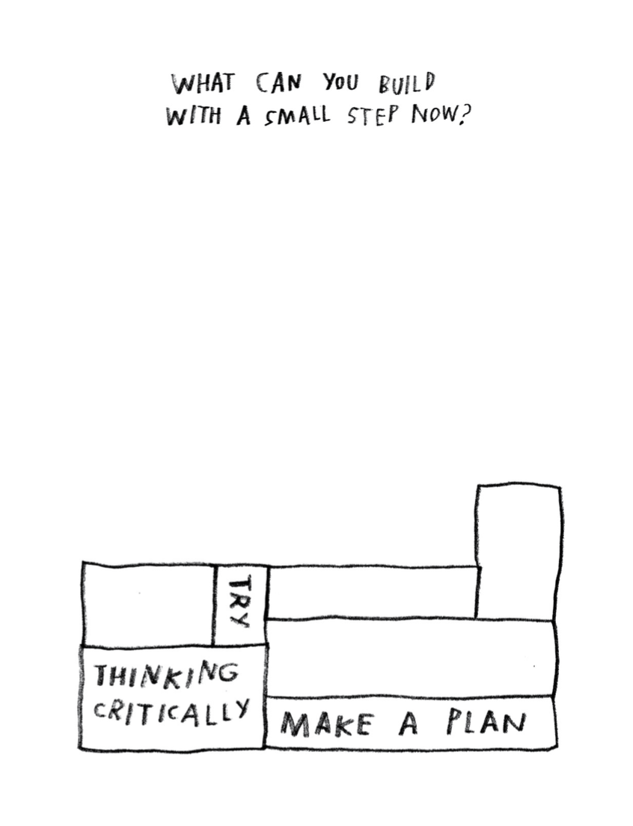

Day 4: Changing Views on the Battle of the Alamo
Social Studies

What is this lesson about?: Today you will compare articles about the battle of the Alamo from different time periods and assess how views of the battle have or have not changed over time.

Warm-up: free-write

Take 5 minutes to read the quote below and reflect on it. Write what you think it means?
"Who controls the past controls the future: who controls the present controls the past." – George Orwell

Step 1: Read an article from 1836

Time Machine (1836): The Battle of the Alamo
By Telegraph and Texas Register, adapted by Newsela staff
Newsela Editor's Note: This article originally appeared in the March 24, 1836, edition of the Telegraph and Texas Register, published in San Felipe, Texas. It was the first article in print about the fall of the Alamo and is considered to be the most influential account of the battle. The Battle of the Alamo was part of the Texas Revolution, when English-speaking settlers called Texians in Northern Mexico – which is now Texas – rebelled against the Mexican government. In the Battle of the Alamo, the Texians were beat badly by the Mexican army, but it inspired other Texians to join the revolution.
That event is so lamentable and yet so glorious to Texas. It is of such deep interest and feeling that we shall never stop celebrating it. We regret that we do not know the names of those who fell in that fort. We would print them and make sure that future ages remember our heroes who perished. Such examples should be held up so we may learn to change our own behavior.

Better To Be A Dead Hero Than A Living, Merciless Victor
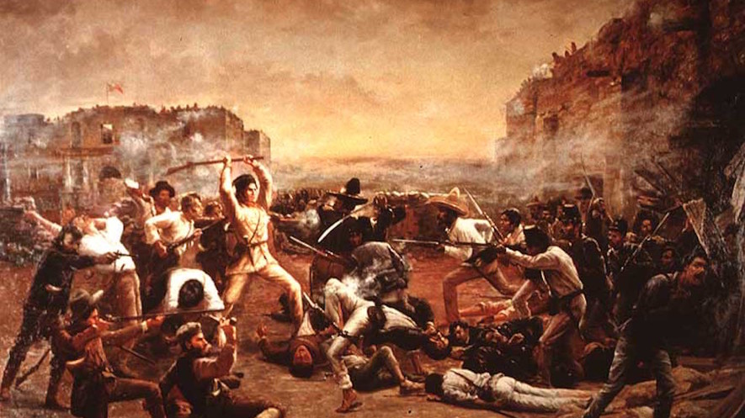
At sunrise, the enemy surrounded the fort with their soldiers. Their soldiers on horseback formed a circle outside to prevent escape. The number consisted of at least 4,000 against 140! General Santa Ana was commanding them, assisted by four generals and a fearsome train of weapons. Our men had been previously much fatigued and harassed by night watching and toils. Some days ago they experienced a heavy bombardment and several real and feigned attacks. But American courage and American love of liberty displayed themselves to the last, they were never clearer. Twice did the enemy put their scaling ladders on the walls, and twice did they fail. Our men were determined to uphold Colonel Travis's words, “to make the victory worse to the enemy than a defeat.” There was a pause after the second attack. They then poured in over the walls, “like sheep.” The struggle, however, did not even end there. Unable from the crowd and for lack of time to load their guns and rifles, our men made use of the butt ends of their rifles to continue to fight. They fought until life ran out through their numberless wounds and the enemy had conquered the fort. Total extermination followed. The darkness of death occupied the unforgettable Alamo. We envy not the feelings of the victors. They must have been bitter, not proud. Who would not be rather one of the Alamo heroes, than of the living of the merciless victors? Spirits of the mighty, though fallen! Honors and rest are with you. The spark of greatness which animated you shall brighten into a flame. Texas and the whole world shall worship you like demigods of old, and will try to be like you.

Battle Was Only An Hour But Its Glory Will Last Generations
From the beginning to its end, the fighting lasted less than an hour. The end of the great hunter David Crockett of Tennessee was as glorious as his life had been useful. He and his fellow fighters were found surrounded by piles of men they had killed. Texas places him amongst the most respected people. Colonel Travis stood on the walls cheering his men till he received a second shot and fell. It is stated that a Mexican general, Mora, then rushed upon him and lifted his sword to destroy his victim. But Colonel Travis collected all the energy he had left and came at Mora. The victim became the victor, and both began a never ending sleep.

4 Were Spared, Including Woman Who Told World What Happened
Travis’s slave was spared, because as the enemy said, “his master had behaved like a brave man.” These are words which are already engraved on the hearts of Texans, and should be inscribed on his gravestone. Colonel James Bowie, who had for several days been sick, was gruesomely murdered in his bed. We shudder at describing these scenes.
Mrs. Dickinson, her child, and two slaves were spared. Our dead were not given a Christian funeral. If only we could gather up their ashes and place them in vases to honor them!
It is stated that about 1,500 of the enemy were killed and wounded in the attacks.
Step 2: Reflect and answer questions

How does the article describe the Texians who fought against the Mexican Army at the Alamo?

Why did the Texians rebel against the Mexican government and engage the Mexican Army in this battle? What were they fighting for?

Put yourself in the shoes of a historian who is writing a book about the Alamo. Based on this piece of evidence from 1836, how would you interpret the battle of the Alamo? Did the Texians have a good reason to rebel against the Mexican government? Between the two sides, who was in the right and who was in the wrong?

Step 3: Read a current article about the Alamo

Expansion and Reform: Remembering the Alamo
By Linda K. Salvucci, The Gilder Lehrman Institute of American History, adapted by Newsela staff

Thanks to movies, TV shows and books, most students already know at least a little about the Alamo.

The Alamo, found in San Antonio, Texas, was once a Roman Catholic mission. It was built in the 18th century to teach Native Americans who had converted to Christianity. After years of abandonment, it became a military fortress in the early 1800s. Today, it is a museum, commemorating the famous Battle of the Alamo in 1836.

The Battle of the Alamo was the turning point in the Texas Revolution, when American colonists in the Mexican province of Texas rebelled against the Mexican government. In the end, Texas won its independence from Mexico and became part of the United States. This did not happen without bloodshed, however.
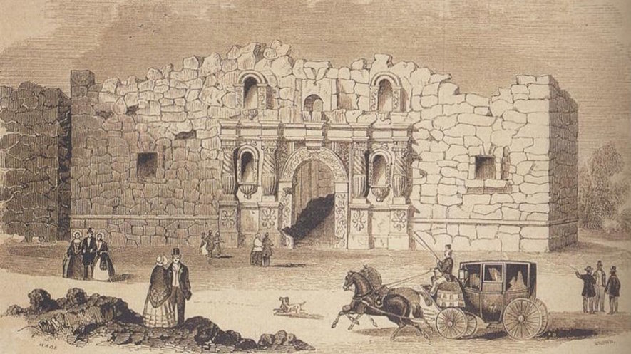
The Battle of the Alamo is often recounted as the simple tale of outnumbered defenders overwhelmed by an invading army. It is usually remembered as a tale of brave men who chose to die in order to create the Republic of Texas.

More recently, however, studies have emerged that frame the event from new angles. They provide opportunities to think about the relationships between history and myth, history and memory, and history and meaning.

The Battle of the Alamo
How was it that such a dramatic confrontation came to take place at the Alamo? The usual explanation highlights the westward migration of mostly white Americans to Texas in hopes of securing land to grow cotton. The Mexican government encouraged such settlement in the early 1820s to form a barrier against the American Indians.

In return for land, the new arrivals — including many slaveholders and aspiring slaveholders — promised to respect Mexican laws and customs. The number of settlers grew faster than anticipated. Soon there were clashes over slavery, trade and other issues.

Mexico had abolished slavery in its territories, and the original American settlers had agreed to follow Mexican law. Still, by 1835, disputes over the payment of taxes sparked armed rebellion.

Texans raised an army to fight against the Mexican government. At this same time, Mexico had entered its own civil war.

Fighting
After a number of battles in the territory, the Texas rebels prepared to defend the Alamo, expecting Mexican retaliation. With more than 2,500 troops, Mexican General Antonio Lopez de Santa Anna began the siege of the Alamo on February 23, 1836. Death was the traditional punishment for “pirates,” as he called the Texans. The bombardment continued until the evening of March 5, when all grew quiet. Then, near dawn on March 6, the final assault began.

The battle itself lasted barely more than an hour, but was particularly vicious inside the walls. Hundreds of soldiers were killed in and around the Alamo. After the fighting ended, Santa Anna released a few people who were huddled in the chapel, so that they would spread word of Mexico's victory.

Instead of calming the rebellion, however, the bloody defeat encouraged the Texans to fight harder. On April 21 at San Jacinto, near present-day Houston, they inflicted a terrible revenge. In barely 18 minutes of battle, they killed more than 700 Mexicans, and captured Santa Anna himself, to cries of “Remember the Alamo.”

The state of Texas and the Mexican-American War
In 1836, the victorious rebels founded the Republic of Texas, also known as the Lone Star Republic. It would exist until 1845, when it was finally made part of the United States. This was the outcome many of the Texas revolutionaries had hoped for.

Step 4: Read one more article

Remembering the Alamo Is Easier When You Know Its Many-Sided History
By Edward Rothstein for The New York Times, adapted, published April 30, 2007

Before visiting San Antonio, I really didn’t remember the Alamo. I had a small memory from youth in which heroism, independence and Davy Crockett were major elements, and Mexicans were the bad guys, but that was about it. It was like a childhood fairy tale.
That’s fine for myths: they are not really meant to survive with photographic realism. But when it comes to the Alamo — particularly here in San Antonio where this old Spanish mission turned fort attracts nearly three million visitors a year — the history and its mythical meanings have been wrestled over almost as much as the blood-soaked land it stands on was in earlier centuries. “Remember the Alamo!” was the old battle cry; in recent decades the fight was over just what was being remembered.
Even now, the Alamo is often looked at by local Latinos as a relic of white imperialism (whites imposing on others and expanding their power and control), with Mexico losing Texas in a land grab. For its advocates, though, the Alamo reflects a stubborn Texan drive for independence won from Mexico in 1836, just as Mexico was losing its way and entering its own civil war.

The mythic power of the place is plain in the bare outlines of Texas history. But after the 1970s, as James E. Crisp writes in his fascinating 2004 book, “Sleuthing the Alamo,” “a new and radicalized generation of historians saw the origins of the conflict in the prejudices of White-Americans.” Race, for some historians, became the central issue in the revolution. Texan immigrants from the Southern United States relied on slavery, which was forbidden in Mexico, creating a major incentive for Texas independence and the application of a selective idea of liberty. Instead of liberty being the sole purpose behind the Texas fight for independence, it was instead centered around their desire to maintain the right to own slaves.
As Mr. Crisp writes, “We should never allow even the most revered of our society’s ‘sacred narratives’ to be accepted as simple truths, nor to be mistaken for legitimate history.”
Step 5: Reflect and answer questions

Based on these last two articles, Why did the Texians rebel against the Mexican government and engage the Mexican Army in this battle? What were they fighting for?

Did you answer the last question change as compared to when you answered it after reading the first article?

Why do you think historians are reinterpreting the meaning behind the battle of the Alamo? Discuss your answer with a partner.

Choose one of the historical viewpoints of the battle of the Alamo and draw a cartoon to represent that viewpoint.

Student Feedback:

Circle the emojis that best represents how this activity made you feel.

