Week 8
Freedom

Day 4

NAME:______________________

Day 4 Agenda

Topic | Activity
Warm-Up!
English Language Arts | - Read two informational texts about School Policies on Appropriate Dress and Grooming.  - Answer questions about the texts
Science | - Read about if an Elephant Should Have Freedom  - Answer questions about what you read  - Draw a picture and explain
Mindfulness Moment!
Math | - Word Problems: Earlonne Woods: Freedom through Podcasting  - Skills: Fractions
Health | - P.E. Bingo
Mindfulness Moment!
Civics/Social Studies | - The establishment clause of the First Amendment

Warm-up Activity: Write a journal entry around the daily quote on identity.
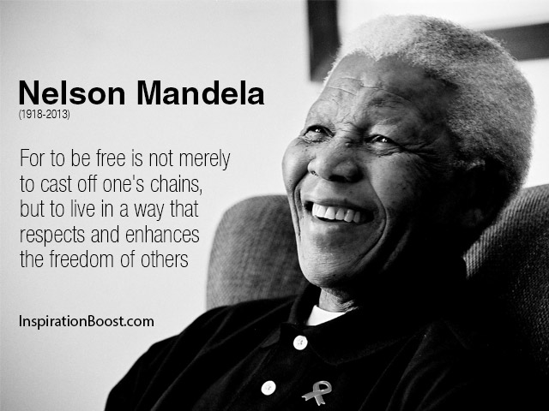

Day 4: Freedom of Expression
English Language Arts
NOTE: Teacher, leader, mentor: Both articles are lengthy. If possible, have some students read one of the articles while others read the other one. They can then discuss the general ideas and points of the articles.

What is this lesson about?
Today you will be reading about how schools and other institutions are being challenged about how they create and enforce student dress codes.

Step 1: Read the following article
As you read, think about how schools and other places regulate how students can express themselves through their appearance and dress.

Some vocabulary to review:
ultimatum: a final demand or statement of terms, the rejection of which will result in retaliation or a breakdown in relations. | Eurocentric: focusing on European culture or history to the exclusion of a wider view of the world; implicitly regarding European culture as superior | micro-aggression: indirect or unintentional discrimination against members of a marginalized group such as a racial or ethnic minority.
marginalized: treat (a person, group, or idea) as unimportant | implication: likely consequence of something. | Institutional: established as a norm in an organization or culture.
underscore: emphasize | subtle: indirect | overt: direct, obvious
perpetuate: to keep going |  | authentic: honest, true

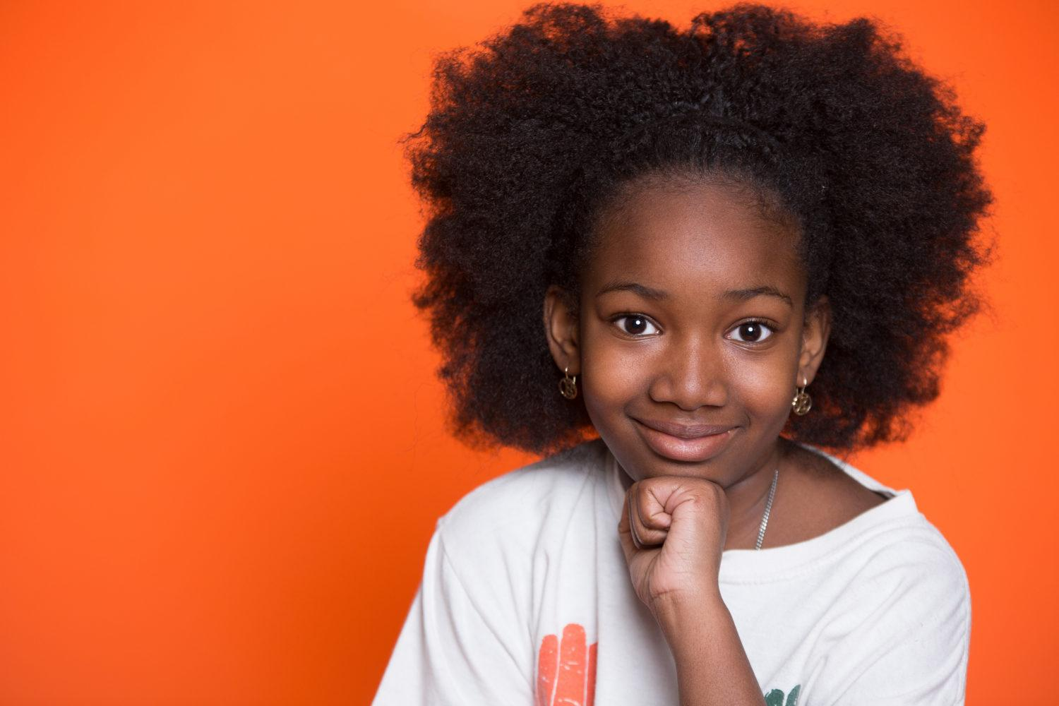
When Natural Hair Wins, Discrimination in School Loses
BY BRENDA ÁLVAREZ
Late last year, a video of a black high school wrestler in New Jersey hit a public nerve when he was given an ultimatum by the referee: cut your hair or forfeit the match. Several news outlets reported that Alan Maloney, who is white, told Andrew Johnson that the cover he had over his hair was non-compliant. Johnson’s hair raised no previous concerns during a match four days earlier, but under pressure, Johnson decided to have his hair cut by the team’s athletic trainer.

The problem here runs deep. “This is not about hair. This is about race,” tweeted the ACLU of New Jersey. “How many different ways will people try to exclude Black people from public life without having to declare their bigotry? We’re so sorry this happened to you, Andrew. This was discrimination, and it’s not okay.” Anti-black hair sentiment in the U.S. has existed for centuries, with Eurocentric norms of beauty taking main stage. This sentiment is directly tied to institutional racism.

According to author Courtney Nunley, “school policies and microaggressions reinforce the idea that Black hair, as it naturally grows and as it has historically been styled, is ‘bad’ because it’s not white enough—and that those policies are part of a nationwide anti-Blackness problem,” she wrote in “Hair Politics: How discrimination against black hair in schools impacts black lives”.

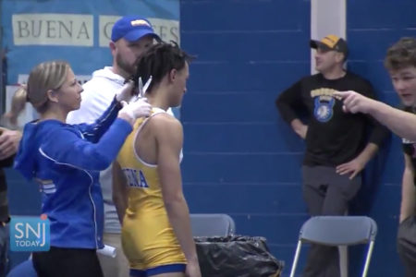
Angel Boose, an elementary school teacher in New Jersey recalls seeing the video of Andrew Johnson and feeling infuriated. “Students are coming to school to learn and participate in activities so they can become well-rounded individuals. These grooming policies make it difficult for students to simply feel comfortable and be their own authentic selves,” Boose says, “and they create another barrier particularly for African American students because clearly these rules don’t affect people of all races.”

While many, specifically black women, have fought against hair discrimination in the workplace by taking their employers to court, the problem is deeply rooted in our culture and it shows up in schools nationwide.

Black students have been asked to cut or straighten their hair to meet dress code policies. Some school districts have banned certain hairstyles, like locs and afros, while other districts have prevented students from attending school events—for example prom—for refusing to remove their braids. Kids have been kicked off school grounds, too.

“This is typical of those in power. They don’t see that something is an issue because they find themselves unable to relate, and since the issue is outside of their immediate experience, they doubt its validity,” explains Gerardo Muñoz, a high school social studies teacher in Denver, Colorado.

“Oppression comes in many forms. We have to believe the victims of this type of oppression. We have to listen to them and make changes where necessary,” he adds. Muñoz is also co-creator and co-host of the podcast “Too Dope Teachers and a Mic.”

Johnson’s incident, which occurred in December 2018, became a spark that led to California becoming the first state in the nation to ban discrimination against black employees and students based on their natural hairstyles.

Los Angeles Democrat Sen. Holly Mitchell wrote the language for the CROWN Act (Creating a Respectful and Open Workplace for Natural Hair) and said the law is about “inclusion, pride and choice,” reports the L.A. Times. The CROWN Act goes into effect on Jan. 1 2020.

“It’s a big win, because every systemic change to fight the effects of oppression and ignorance is a move toward a more just society. The type of body shaming that students of color and people of color in general endure requires a sustained organizing effort, which can only happen through policy changes that may build on the previous ones,” underscores Muñoz, an educator of nearly 20 years.

Banning Hair Discrimination
July 3, 2019 marked an important turning point for racial and social justice when California’s Gov. Gavin Newsom signed the CROWN Act into law, which now legally protects people in workplaces and K-12 public schools from discriminatory grooming policies.

This new law specifically protects African Americans who have historically experienced discrimination based on their hair. The act protects certain hairstyles, too, such as afros, braids, twists, cornrows, and locs.
Pushed Out: The Injustice Black Girls Face in School
Black girls make up 16% of girls in U.S. public schools, but 42% of girls’ expulsions. Monique Morris, author of “Pushout: The Criminalization of Black Girls in Schools”, discusses the forces that have made these students targets.

“[This issue] is played out in workplaces, played out in schools,” said Newsom during the signing ceremony. “Every single day, all across America in ways subtle and in ways overt.” The act is meant to stop these behaviors and practices. California officials are not the only ones to consider such protections.

New York became the second state to officially ban natural hair discrimination. In August, lawmakers amended the state’s Human Rights Law and Dignity for All Students Act, which makes it clear that discrimination based on race includes hairstyles or traits “historically associated with race, including but not limited to hair texture and protective hairstyles.”

New Jersey currently has a bill in the works, too. If passed, it will include protections similar to that of California and New York laws. New Jersey’s Angel Boose says laws that protect natural hair styles are necessary. “We need to name racism when we see it, call it out, and discuss it. Otherwise, we ignore it, pretend it doesn’t matter, and continue to perpetuate racism in a different form other than slavery and Jim Crow,” says the educator of 13 years.

It’s still too early to tell if other states will join California and New York. However, the CROWN Coalition, an alliance that includes the National Urban League, Western Center on Law & Poverty, Color of Change, and Dove, is planning to pursue legislation similar to the California measure in other states.

Color of Change is helping to expand federal protections to end hair discrimination nationwide and have created a petition to get more people involved in ending these unjust and racist practices.

Don’t Wait—Educators Can Take Action Now
While only two states now ban racial discrimination based on natural hair, educators don’t have to wait for legislatures to pass laws that address hair discrimination in schools. Hair discrimination is often included in dress code policies.

This year, for example, the Seattle School Board developed an inclusive dress policy districtwide for students. Previously, each school in the district set its own code, allowing for individual discretion and space for bias. Now, the same rules apply to all students.

According to Seattle’s new policy:
“Students should be able to dress and style their hair for school in a manner that expresses their individuality without fear of unnecessary discipline or body shaming; students have the right to be treated equitably [and] dress code enforcement will not create disparities, reinforce or increase marginalization of any group, nor will it be more strictly enforced against students because of racial identity, ethnicity, gender identity, gender expression, gender nonconformity, sexual orientation, cultural or religious identity, household income, body size/type, or body maturity.”

Adding inclusive hair policy explicitly to school board policy is an important protection against implicit and explicit bias. To learn more, go to NEA EdJustice.

Taken from: http://neatoday.org/2019/09/17/banning-black-hair-discrimination/

Step 2: Think and Respond
Many schools and programs for youth claim that they have different dress and hair policies because they want to make sure that students are getting ready for the work-force where they will be expected to follow certain rules. Do you agree? Why or why not? Explain your opinion.

Step 3: Read the following article

Before you read: Some vocabulary to review.
infraction: violation of a law or rule | debut: first appearance | vain: self-centered, conceited
cis-gender: relating to person whose personal identity and gender corresponds with their birth sex. | dictate: order | advocacy: public support for or recommendation of a particular cause or policy.
disparate: widely different | heed: pay attention to | constitute: make up
vague: not clear | lax: relaxed, not strict

Students are waging war on sexist and racist school dress codes — and they’re winning
Traditional dress codes punish marginalized students disproportionately, but this anti-racist, anti-sexist dress code could fix that. By Nadra Nittle Sep 13, 2018

Emma Stein was just a freshman when she was cited for a dress code violation at her school, suburban Chicago’s Evanston Township High School. A security guard said her dress was too short, so Stein had to pull a pair of sweatpants over her clothes. She was not punished for the infraction, but it was still a really upsetting experience.
“It added a level of insecurity to this already stressful time,” Stein recalled.
Stein wasn’t the only one troubled by the dress code at the 3,700-student school. In 2016, students staged a protest demanding a new policy that didn’t discriminate along gender or racial lines.
And the school’s administration listened. “We needed to look at getting a new dress code, and we wanted to make sure it was body-positive and didn’t marginalize students,” the school’s principal, Marcus Campbell, said.
In 2017, Evanston Township High School debuted its new dress code, which permitted tank tops, leggings, hats, and other previously banned items. The policy also stated that students were not to be marginalized based on race, class, gender, sexual orientation, or other identity markers.
The story of Evanston Township High School’s dress code is an increasingly common one. As dress code controversies sweep the education system, parents and students are fighting back against policies that they see as sexist, racist, or both. And more and more schools are listening to these protests, adopting guidelines that reflect a new understanding of what constitutes “appropriate” student dress.

Oregon NOW’s model dress code has had an international impact
Adopting a new dress code isn’t easy when most existing policies are several years old and contain many of the biases schools are edging away from now. So, the Oregon chapter of the National Organization for Women devised a model policy for Portland Public Schools that took effect in 2016 and has since spread across the country.
School districts such as Evanston’s District 202 and California’s San Jose Unified have either borrowed heavily from the dress code policy or adopted it outright. Praised for being inclusive, progressive, and body-positive, the Oregon NOW model may be the foundation for the dress code policies of the future.
“Boys can dress like girls, and girls can dress like boys,” explained Oregon NOW president Lisa Frack about the code. “You can be trans. You can be cis. Part and parcel on our mind is whoever you are, you can wear whatever you want.”
Within reason, that is. Clothing featuring images of drugs, alcohol, or obscenities is out, as is gang attire. Still, the dress code affords students a great deal of freedom to present themselves how they see fit. The main dictate is: “You have to cover your parts,” Frack said. But how students do so is up to them. They can wear short clothing, leggings, and tank tops — all garments that have been the source of school dress code conflicts.
Oregon NOW turned its model into Portland Public Schools’ official policy by approaching the school board about it during a 2015 meeting where students raised complaints about the existing code, Frack said. The board quickly agreed to form a working group, a mixture of Oregon NOW members and educators, to develop new guidelines. A few months later, the board agreed to implement the model for the 2016–2017 school year. Frack calls the dress code “the fastest advocacy” she’s worked on to date.
The policy has sparked interest from school officials in both the US and Canada, Frack said. Administrators from Evanston’s District 202, which consists only of Evanston Township High School, reviewed the Oregon model after 300 students protested and asked for changes to be made to the previous policy.
The demonstration prompted Campbell, assistant superintendent as well as principal, to research alternatives online, leading him to the Oregon NOW dress code. He and four Evanston Township High School assistant principals looked over the dress code piece by piece to see if it aligned with the high school’s values. They agreed that it did, and so they presented it to the superintendent, who signed off on it. The new policy took effect during the 2017–2018 school year.
The Oregon model also allows students to wear their hair as they please, an ongoing issue for both African Americans and Native Americans in schools. As recently as August, two religious schools faced criticism for telling black children they couldn’t attend classes because of their hairstyles. At A Book’s Christian Academy in Florida, school officials turned away a 6-year-old black boy for wearing dreadlocks. His family ultimately withdrew him from the school. Later that month, an African-American girl at Christ the King Elementary School in Terrytown, Louisiana, was forced out of class for wearing her hair in braided extensions, a popular black hairstyle that school officials said they banned over the summer.
Hearing about these sorts of dress code scandals drove Oregon NOW to write its model policy. “There was no answer,” Frack said. “Everybody’s got the problem, but what’s the answer? We’re a super small organization, but we thought we could do something besides saying, ‘Doesn’t this stink?’ We could write a model code, and it could be progressive, feminist, and anti-racist.”
Historically, school dress codes in the US have been anything but. While many schools continue to impose dress codes shaped by outmoded race, class, and gender constructs, a growing number are addressing how their policies disproportionately affect certain groups of students more than others, and they are letting students dress mostly as they please.

Students are challenging schools to devise fair and equitable dress codes
Dane Caldwell-Holden, director of student services for the San Jose Unified School District, didn’t realize how dress codes targeted certain groups of students until his district came under fire for its policy. “I’ll be honest,” he said. “As a teacher and administrator, I never gave a thought about that.”
Then, in 2015, a female student was pulled out of class and told to change into a baggy pair of shorts because hers didn’t pass the “fingertip test.” (Many schools say that shorts, skirts, or dresses are too short if they don’t hang past a student’s fingertips.) Humiliated, the student decided to fight the dress code. She and her mother spoke to school officials about how the policy harmed girls, and the following year, her mother sent Caldwell-Holden a link to Oregon NOW’s model.
After they reviewed that policy, district officials and school principals reviewed and revised the policy over several months. In June 2017, the board voted to approve the new dress code.
The new policy permits spaghetti straps, halter tops, and short shorts. The previous code in his district had been in use for about 15 years, Caldwell-Holden said, pointing out that’s the case for a number of California districts. Typically, the state develops some sample codes, and school districts adopt one.
“Board policies tend to be replicated,” Caldwell-Holden said. “When you look at dress codes, they all look remarkably similar.”
The old San Jose dress code was never meant to body-shame girls, he said, but to prevent youth from wearing truly disruptive apparel to school. He considers such clothing to be gang attire or T-shirts with violent or profane messages. Rather than direct their attention to these sorts of violations, faculty members unevenly applied the dress code, citing girls nearly all of the time.
“That was completely unfair,” Caldwell-Holden said.
Since about 2010, the disparate impact that school dress codes have on girls and young women has received more attention,
“It’s probably the accumulation of a number of policy streams,” Todd DeMitchell, a professor from the University of New Hampshire, said. “And stories of female students disproportionately being singled out over male students started to be put into more of the popular press. It’s no one single thing, but we do see the news reporting a number of shaming incidents based on student attire.”
He recalled that in 2014, an Orange Park, Florida, high school student was forced to wear a “shame suit” consisting of a shirt and pants printed with the words “dress code violation” because the school considered her clothing too short. The story became national news fodder, complete with photographs of the student in the humiliating outfit.
Whether student complaints about dress codes go viral or stay local, they have the power to effect change. Carrie Truitt, a member of the Marion County school board in Kentucky, became interested in adopting a new dress code after a 5-foot-10 high school student, who was wearing business attire for Dress for Success Day, was told her dress was too short. The student’s father complained, arguing that male students who wear shorts the same length as his daughter’s dress do not receive citations. Truitt thought the parent had a point and began researching dress codes, leading her to Oregon NOW’s model.
“We have a little bit of bias in enforcement,” Truitt admitted. “I don’t know if we can go as far as Oregon NOW in Kentucky; you have to take into account perceptions and beliefs.”
For example, the idea that a tube top is acceptable to wear to school might rub some community members the wrong way, she said. But Marion County is a fairly liberal community, and school leaders will likely take an interest in a progressive new dress code if they know girls typically get the most citations, Truitt explained.
Not every school or district is open to changing its dress code. In fact, some schools continue to spark controversy with policies that shame female students and police their bodies.

LGBTQ youth are vulnerable to school dress code policies
Schools nationally have tried to prevent LGBTQ youth from wearing their preferred attire to prom, homecoming, graduation, and other high-profile events. But choosing clothing for school can be a daily struggle for gender-nonconforming students because dress codes have historically served to make students heed traditional gender roles. And a scan of school dress codes from several decades ago make it clear how administrators viewed gender through a narrow lens. Policies dictated that girls wear skirts, dresses, or blouses.
But boys had to conform to strict gender roles, too. In the early 1960s, the dress code at Pius X High School in Downey, California, cautioned boys as follows:
“Two extremes are to be avoided: both a careless, untidy appearance, and a vain, effeminate use of extreme fashions. What the school seeks to promote in a student is a clean, neat, well-groomed, manly appearance.”
The expectation for a “manly appearance” is why boys, regardless of gender identity or sexual orientation, continue to face school earring bans. Plus, some schools, such as North Carolina’s public K–8 Charter Day School, require girls to wear skirts.
Increasingly, students are challenging gender-based dress codes, and GLSEN (formerly the Gay, Lesbian & Straight Education Network) is one of many organizations advocating for them. In 2015, it updated its model district policy for transgender and gender-nonconforming students. The policy includes guidance about student attire, stating that dress codes may not be based on gender and that students have the right to dress in accordance with their gender identity. Moreover, schools can’t use dress codes to target transgender and gender-nonconforming students.
Ikaika Regidor, GLSEN’s director of education and youth programs, said that he understands that schools have dress code policies to prepare students for adulthood and the workforce, but the enforcement of the policies is often problematic.
“We ended up getting into a place in which some groups of students end up getting hurt more than others,” he said. Students feel, “I’m coming to school. I’m being my authentic self,” only to be told they can’t, he continued.
Regidor said that schools need more training and need to streamline who enforces dress codes. Doing so ensures the staffers imposing these policies on students have the tools to do so fairly, properly, and sensitively to gender-nonconforming youth. GLSEN offers training to schools and educates students about their rights as well. The organization teamed up with the ACLU to give youth a wallet-sized card they can show to administrators who wrongfully cite them for dress code violations.
To avoid litigation, more school districts have implemented gender-neutral dress codes. In 2015, Puerto Rico, where students wear uniforms, changed its policy to permit boys to wear skirts and girls to wear pants. It’s a move GLSEN urges more school systems to make. Regidor said some school officials are ignorant about best practices for dress codes and LGBTQ youth. But once they’re educated, they stop enforcing discriminatory policies. Sometimes, though, the discrimination is intended.
“We could try to train them,” he said. “We could try to change hearts and minds, but we also know there are some administrators who have biases. There’s still work to be done by schools, by states.”

Disciplined for wearing braids to school
Deanna and Mya Cook object to how dress codes have long regulated both gender and race. The twins attend a Boston-area charter school that dictates skirt length, shoe color, nail polish, and makeup. But the girls never thought they’d get in trouble for wearing braided extensions. Last year, that’s exactly what happened.
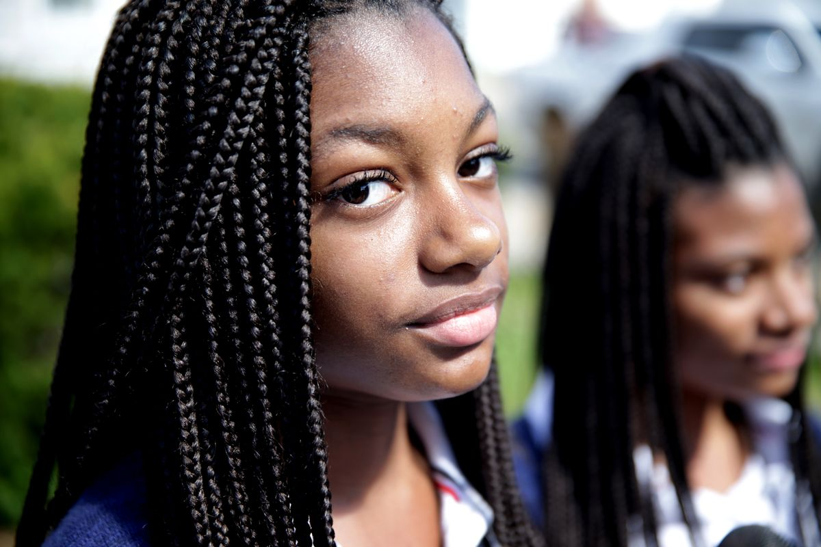
Adopted by white parents, the girls said they got braids for the first time to connect with their African-American heritage. When they showed up at Mystic Valley Regional Charter School with the hairstyles, however, the school disciplined both girls, now 17. Mystic Valley did not respond to Vox’s request for comment about its dress code.
“When we came back to school, we were told braids were not allowed,” Mya said. “They were inappropriate, drastic, needed to be fixed. It really hurt me to my core. I didn’t know what to do because braids meant a lot to me, and they kept telling me to take them out.”
She thought she’d be expelled, and no one would be the wiser. But the school’s treatment of the Cook sisters garnered media attention, and the ACLU, the NAACP, and other groups advocated for the girls.
After a complaint was filed with the state accusing the school’s dress code of being discriminatory, Mystic Valley relented. The school now permits braids, but the twins say it has implemented new rules they believe are retaliatory. Black hair ties, the most common color available in stores, are forbidden; students must wear either navy blue or white hair ties to match the school uniform colors, they said. The girls are not allowed to accessorize their braids with clips, clasps, or beads either.
Similar incidents keep happening to black girls, who are disproportionately pushed out of school due to dress code violations, according to the National Women’s Law Center “Dress Coded” report. Their bodies, hair, and hair accessories such as head wraps are policed more, the study found.
“Many dress code policies include a lot of vague and subjective language that really rubs against our biases,” said Nia Evans, NWLC’s manager of campaign and digital strategies for education. “They include words like ‘appropriate,’ ‘not distracting.’ Because of racism and sexism, I think there are black girls who have kinky, natural hair and are not perceived as clean or appropriate.”
She said rigid dress codes signal to female students that their bodies are a problem. Black girls are uniquely vulnerable because they’re already more likely than other female students to be suspended from school. Evans argues that forcing them out of class for any reason increases their chances of quitting school and entering the prison system. Accordingly, missing class because of dress code citations may have serious consequences.

Concerns about liberal dress code policies
As schools implement new dress codes in an effort to make these policies more equitable for students, they still contend with some doubts and concerns from community members. When San Jose Unified updated its dress code, some school officials and parents feared that a more lax policy would result in girls showing up to school in attire more fit for the nightclub than for school. Caldwell-Holden says that hasn’t happened. Instead, he rarely hears about schools issuing dress code citations and no longer receives complaints from students about the policy.
So far, the district has received just one nasty comment about its new code, he said. Sent in August 2017, it said, “I am just writing to say how disgusted I was to read … that halter tops, spaghetti straps, and short shorts will be allowed in school now. Seems to be that you are following in the new California tradition: slut everything up and dumb everything down.”
But there was a twist. The writer ended the comment by remarking, “I’m sure glad I don’t have kids in school.”
Actual parents have been highly supportive of the change, according to Caldwell-Holden. A few have worried that it might be harder to get kids to follow the rules they set at home about appropriate dress, but that’s it, he said.
While some community members worried that students would dress provocatively, others feared that a less formal code would fail to prepare students for professional life.
But, Frack pointed out, “We’re not raising all of our kids to work in a bank. Some are going to have jobs where they don’t have a collar.”
Good school dress codes show compassion for students and begin with an equity statement, according to the “Dress Coded” report. Evanston’s District 202 dress code states that it “does not reinforce stereotypes and that [it] does not reinforce or increase marginalization or oppression of any group based on race, sex, gender identity, gender expression, sexual orientation, ethnicity, religion, cultural observance, household income or body type/size.”
“Dress Coded” recommends that policies be culturally sensitive, gender-neutral, body-positive, and not shame students. The report also calls for all staff members who enforce them to receive training. Because most schools don’t collect data about dress code citations, the NWLC advises them to start doing so. A record of these citations gives the public an idea of which students are most often cited and why. Additionally, the organization urges schools to give students a say in dress code policies.

How District 202 changed after updating its dress code
Two years ago, Emma Stein protested outside the District 202 superintendent’s office in a bid to get Evanston Township High to change its dress code. An 11th-grader then, Stein remained at the high school after the Oregon NOW model went into effect her senior year. When the school transitioned to its new dress code, Stein realized that getting dressed in the morning was no longer stressful.
“The amount of anxiety I personally had about even wearing a skirt my grandmother bought me dropped,” she said.
Now in her first year at Northwestern University, Stein recalled how each morning at Evanston Township High, a security guard would scan the students entering campus for dress code violations. The day she received a citation, Stein had been excited to attend an assembly about racial equity. In the end, she found herself derailed by a dress code that framed her appearance unfit for school.
About five years have passed since then, but Stein said the day of her dress code citation is burned into her memory because it caused her such embarrassment. Still, she knew she wasn’t the only girl with the same experience. Stein said she routinely saw other girls pulled aside by female security guards and teachers because of their dress. The fact that so few boys ever received dress code citations made her question the fairness of the policy.
When the more liberal code took effect, “The attire of the students didn’t change very much,” Stein said. This was the outcome Marcus Campbell expected. He said he believed in his students enough to know they wouldn’t abuse the new policy.
“We’re happy people have found it affirming, so they can focus on learning,” he said.
Campbell and Stein described the first day of school under the new code similarly. Both remember the tension on campus dissipating.
“It felt so great,” Campbell recalled. “That feeling is still palpable. It’s so great to have the administration listen to some very reasonable guidelines.”
Now, it’s largely up to students and their parents to determine which attire works best for school, he said.
Stein said that when the current dress code rolled out, students appeared lighter, less burdened. “It was such a dramatic change,” she said. “The change was almost tangible. At least for me, when this policy was amended, there was this collective sigh of relief.”
Adapted for length from: https://www.vox.com/the-goods/2018/9/13/17847542/students-waging-war-sexist-racist-school-dress-codes
Step 4: Think and Respond

Do you believe that dress codes are necessary? Why or why not?

Student Feedback:
Circle the emojis that best represents how this activity made you feel. | 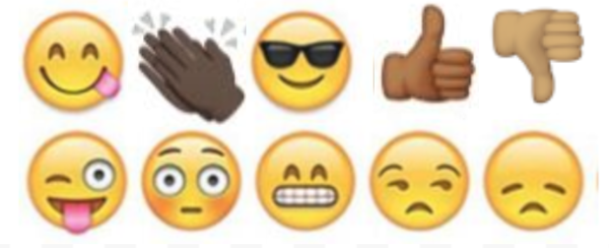  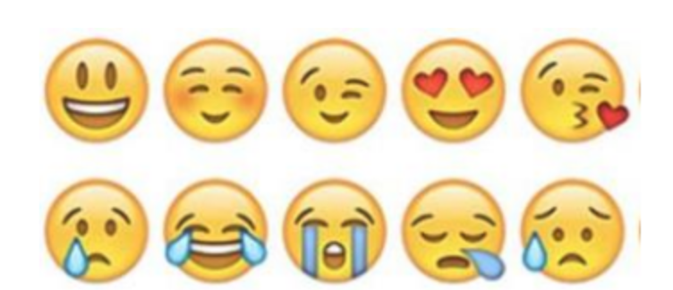

Day 4: Should an Elephant Have Freedom
Science

What is this lesson about?: Today you will read through the Lawyers argue Happy the elephant should have right to freedom passage. You will answer a few questions about what you read. You will complete an activity.

Step 1: Read through the passage

Lawyers argue Happy the elephant should have right to freedom
(The Guardian, 2019)

Lawyers representing an elephant say she is being detained by the Bronx Zoo ‘illegally’ due to her personhood
Happy the elephant at the Bronx Zoo in New York City on 2 October 2018. Photograph: Bebeto Matthews/AP

Lawyers representing an elephant have argued in New York court that their trunked client be considered a person, in a fresh attempt to upend human dominance over this designation.

Happy the elephant is, contrary to her sunny name, being detained by the Bronx Zoo “illegally”, due to her personhood, and must be released, according to her self-appointed legal team.

The case’s instigator, an animal rights group, hopes it will effect a legal breakthrough that will elevate the status of elephants, which the group calls “extraordinarily complex creatures” similar to humans that should have the fundamental right to liberty.

On Monday, the Bronx supreme court was the latest stage in what has been a quixotic pursuit of animal personhood by the Nonhuman Rights Project. Steven Wise, the founder and lead attorney of the group, has led a quest that is dogged – appropriately, as he has ruminated that dogs may be “legal persons”, too – to confer personhood on a pair of chimpanzees and now Happy.

Wise has yet to taste success. In 2017, a New York appeals court ruled that Kiko and Tommy, two chimps in their 30s kept in captivity in the state, could not be considered persons in order to invoke habeas corpus – the right to avoid unlawful detention.

A presiding judge wrote that while chimps share many fundamental characteristics of humans, it would be difficult to hold any ape to account for its personhood by arresting and prosecuting it for a crime. A further blow to Wise came in August, when a Connecticut court similarly decided that three elephants – Beulah, Minnie and Karen – could not be deemed persons.

Undeterred, Wise is now arguing on behalf of Happy, an animal that scientists found can recognize herself in a mirror. The 47-year-old elephant has spent almost all her life in a one-acre enclosure at the Bronx Zoo after being captured along with six other calves – named Sleepy, Grumpy, Sneezy, Doc, Dopey and Bashful – in Thailand and brought to the US.

Happy and Grumpy cohabited until 2002, when they were relocated to an enclosure with two other elephants – Maxine and Patty. This arrangement turned sour when Maxine and Patty fatally attacked Grumpy. Happy has never been able to live contentedly with the duo, with a recent reconciliation attempt ending badly.

Happy’s lone captivity is anathema to the intricate social arrangements elephants have in the wild, according to experts cited by the Nonhuman Rights Project, which wants her relocated to a far larger sanctuary in California that has other elephants.

“Wouldn’t that just be like a larger prison?” asked the Bronx supreme court judge Alison Tuitt, who earlier in proceedings remarked that she had watched a TV show in which a lemur attacked its own reflection in the mirror.

“That’s a bit like saying the Earth is a prison,” Wise replied. The two later had an inconclusive exchange over whether a guide dog could claim personhood.

During lengthy testimony, Wise compared Happy’s situation to the plight of slaves in the US, who weren’t considered fully human, and pointed out how a river in New Zealand and a Colombian portion of the Amazon rainforest have been granted human-like rights. “She is one depressed elephant,” Wise said of Happy, unhappily. “She’s being harmed every day.”

The Wildlife Conservation Society (WCS), which runs Bronx Zoo, strongly rejects any notion that Happy is distressed or badly treated. Jim Breheny, the zoo’s director, has called the lawsuit “ludicrous” and said the Nonhuman Rights Project is “exploiting the Bronx Zoo elephants to advance their own failing cause”.

WCS said that Happy is not kept in isolation given that she has tactile contact with Patty through a barrier, to ensure neither elephant is hurt. The conservation organization said that Happy is “subordinate in nature”, is comfortable with her keepers and likely to be bullied by other elephants if she were to be moved. The zoo has declined to add additional elephants for the past decade.
“It would be irresponsible and risky for Happy’s wellbeing for us to bow to uninformed outside voices with political agendas,” a WCS spokesperson said.

Polling of Americans has shown strong support for granting animals the same rights as humans, with the concept also backed by some philosophers who argue that animals have moral standing and shouldn’t be considered merely as property.

US courts, however, disagree and critics have claimed unintended consequences of animal personhood, such as the potential erosion of rights of disabled people, and difficulties defining which animals deserve rights and who speaks for them.
The idea of “freedom” from humans may also be more opaque at second glance. On Monday, across the road from the court in the Bronx’s Joyce Kilmer Park, starlings cavorted in the bubbling water of a grand fountain dedicated to the German poet Johann Heine. The contrast with Happy, and other captive animals, would appear obvious.

But in the past month it has been revealed that human activity in North America has wiped out an incredible one in four birds since 1970. Two-thirds of the remaining species face being obliterated due to the climate crisis. There may be freedom, even an outpouring of what may look to us as joy in the weak autumn sunshine. But there’s not much escape.

Happy’s case will plod on regardless, with the further court date set for January.

Step 2: Answer questions about what you read

- Do you believe Happy the elephant should be free? Why or why not?

- Do you believe animals and humans should have the same freedoms? Why or why not?

- What’s something new you learned as you read through this article?

Step 3: Draw a picture/explain

What can you design to make sure animals have their appropriate freedom? Draw a picture and write a description of your design.

___________________________________________________________________________________________________________________________________________________________________________________________________________________________________________________________________

Student Feedback:

Circle the emojis that best represents how this activity made you feel.

Mindfulness Moment!

One of my favorite memories is…

Day 4: Fractions/Freedom
Math
What is this lesson about?: Today you will continue to learn about adding and subtracting fractions.

Warm Up and Review Problems:
Earlonne Woods spent over 20 years locked up in prison in California. A few years ago, while incarcerated at San Quentin State Prison, he started working and learning about sound production. He met a woman named Nigel Poor who was volunteering there as an art teacher. They ended up creating an award winning podcast called Ear Hustle, which is all about life inside of the prison.

In November of 2018, Earlonne was pardoned by the Governor Brown of California, earning his freedom after all those years. He now lives and works in the Oakland area. He loves his freedom, even though making ends meet can be tough for him.

Earlonne was shocked to learn how expensive it is to live in northern California. Even with lots of help and subsidized rent, housing costs are expensive.

Here are some of his monthly bills:
Rent: $1400/month
Utilities: $200/month
Cell phone: $50/month
Transportation $5/day to get to and from work (Mon-Friday)
Groceries, etc $75/week

How much money does Earlonne have to spend each month just to pay his basic bills?
If Earlonne decides to go out to dinner 1x per week and that dinner costs $15...how much will that cost him in a month?

Earlonne earns a pretty good salary now. He is paid $65,000 per year to keep producing the show. He end up paying about 30% of that in taxes all total.
- How much does he pay in taxes?
- How much does he have for ‘take-home’ pay?
- How much is that per month?
- How much money does Earlonne have each month after he pays his basic bills from above?
- What are some fun things Earlonne might be able to do with that ‘extra’ money?
- What are some things you think he might want to be saving money for?

When asked what he likes best about being free in an interview, Earlonne said: “It’s impossible to narrow it to one thing. My apartment, learning how to use a cell phone, being able to hug my nephew and niece, going out on a date, sitting down at a restaurant…I’m working hard, but living real well…”
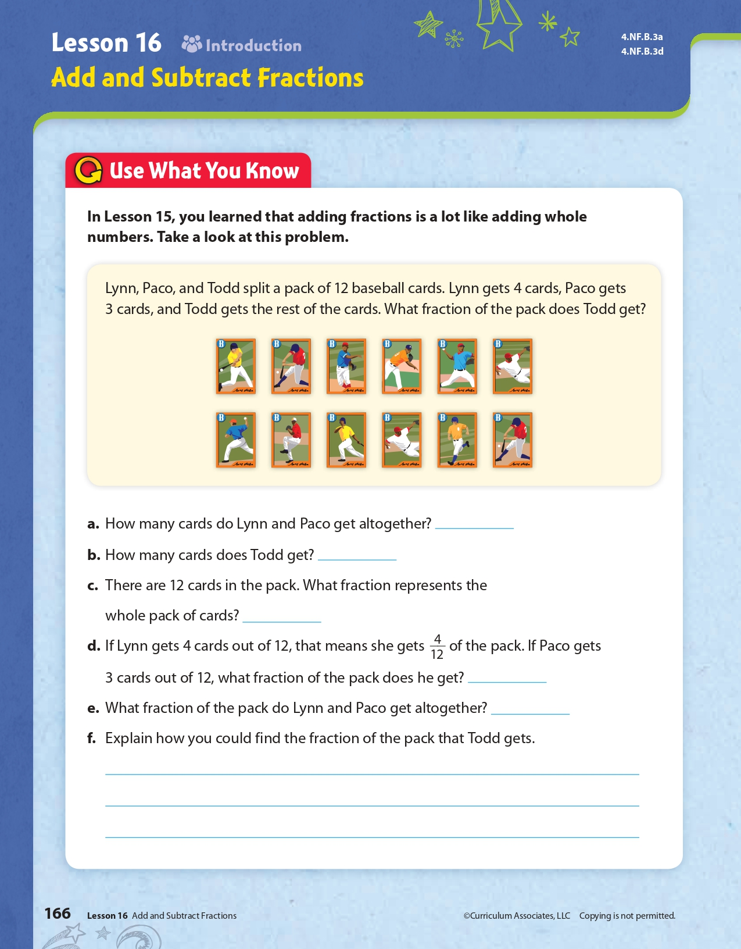
Activities/Fraction Problems: Complete the following fractions worksheets.
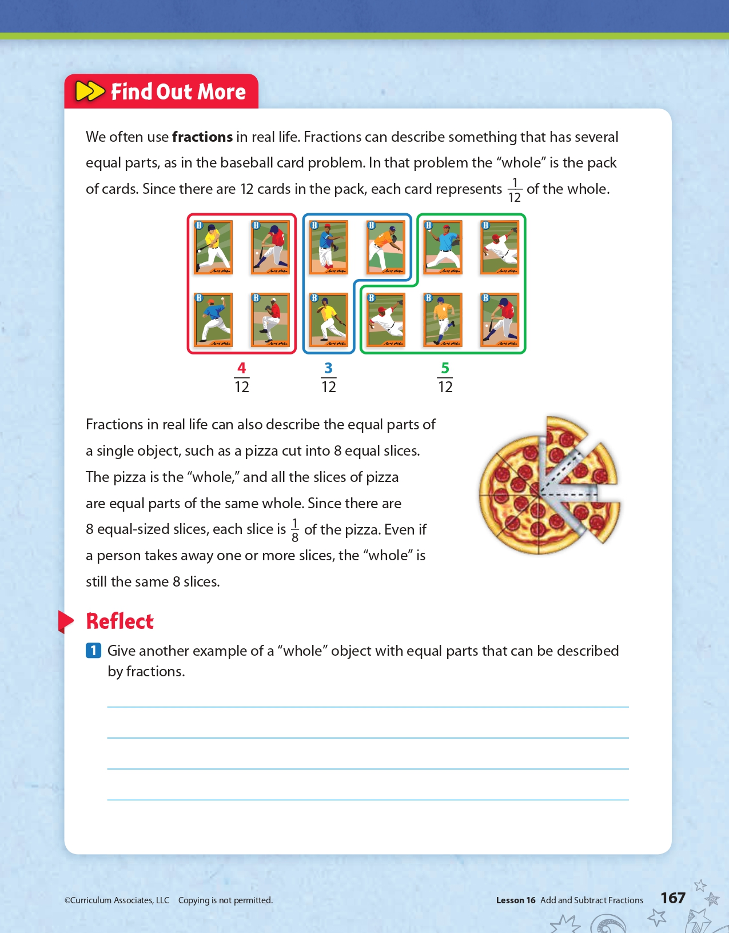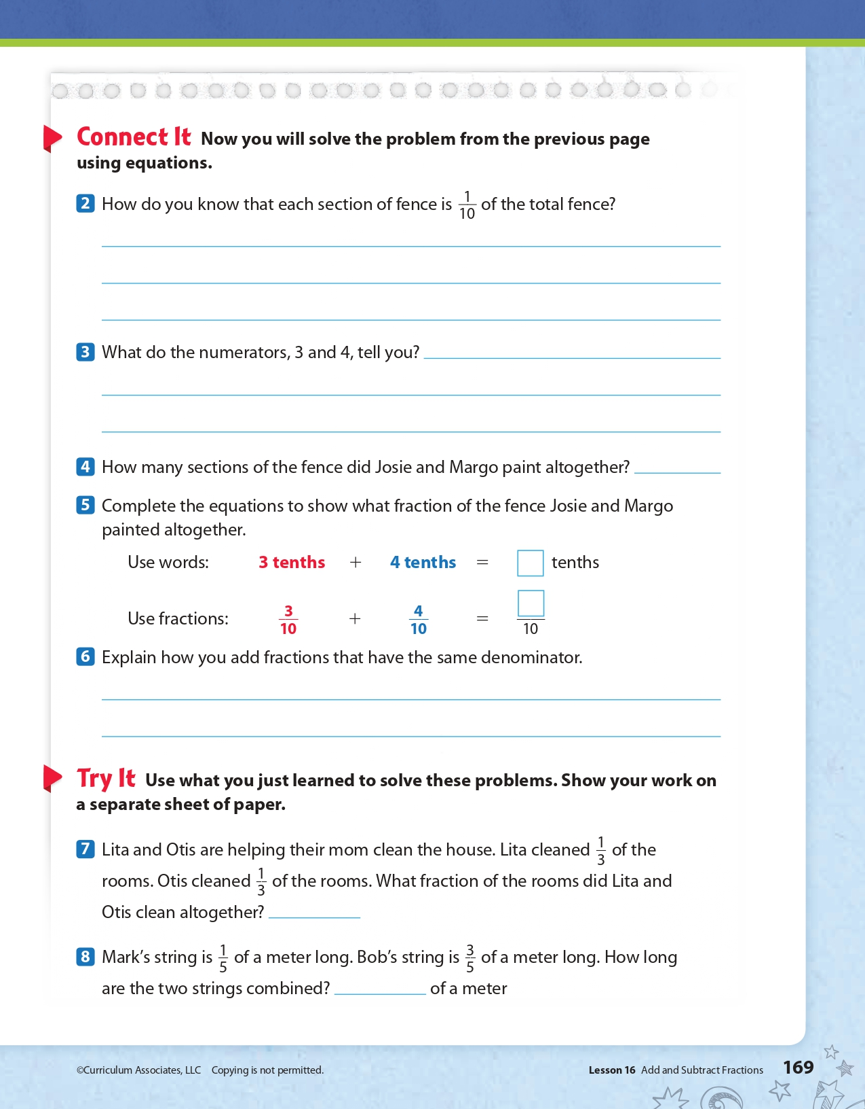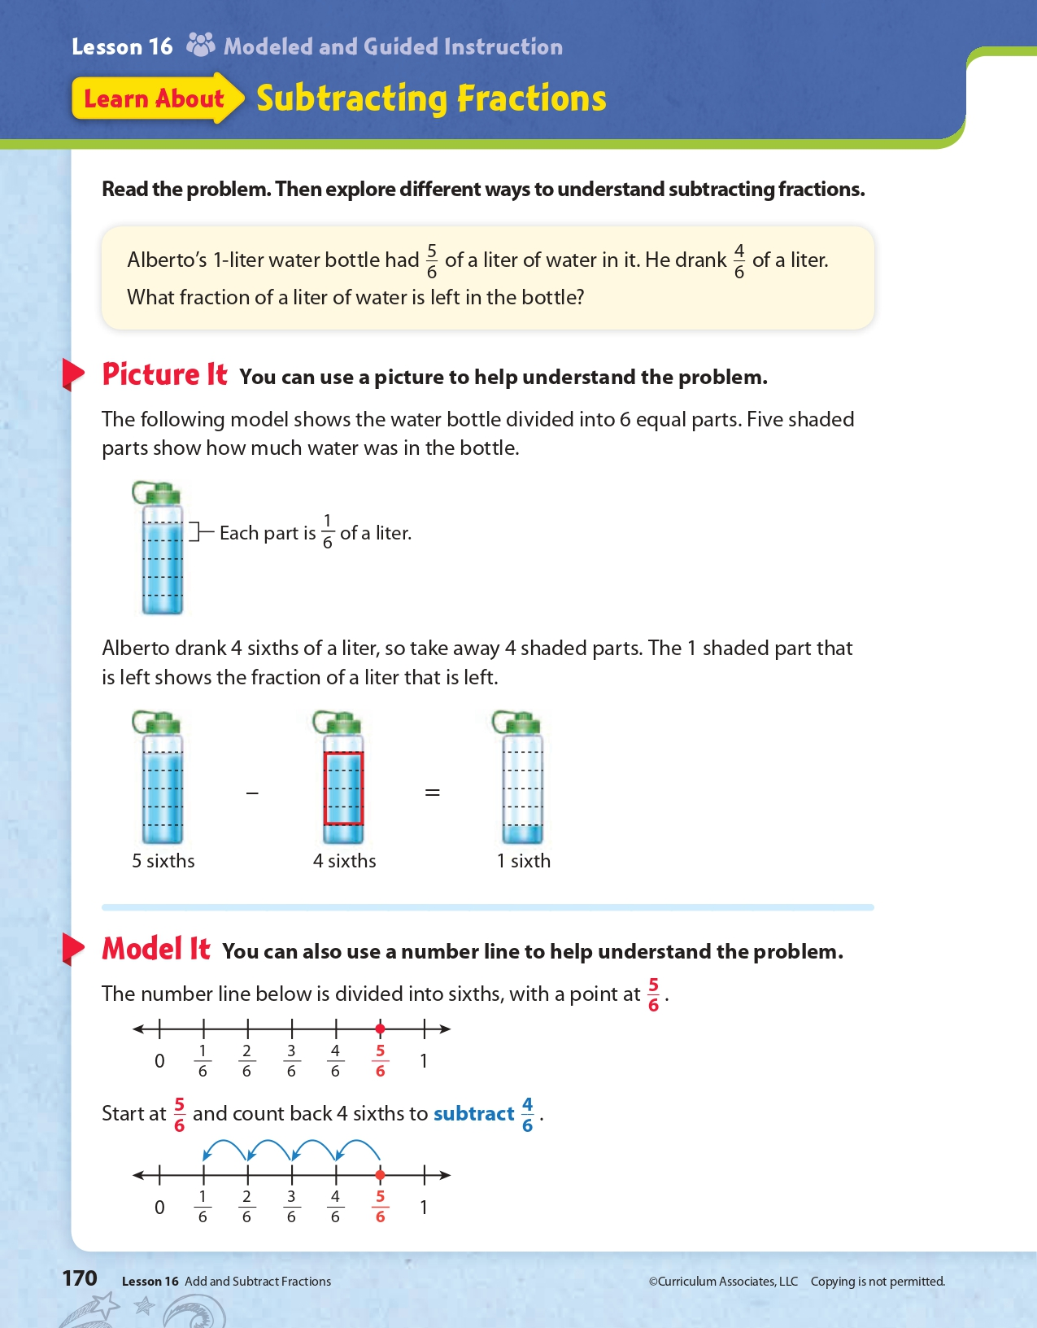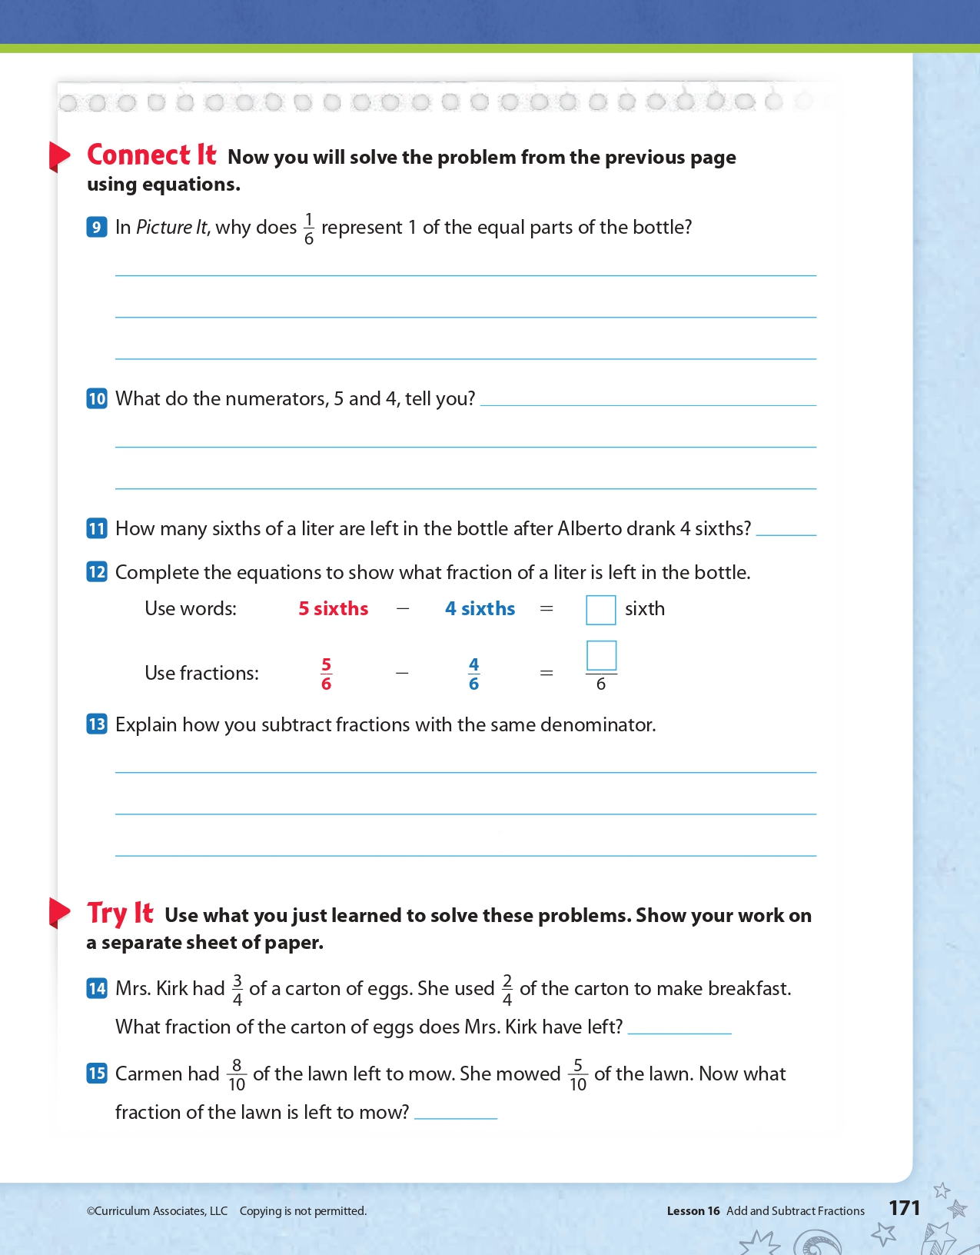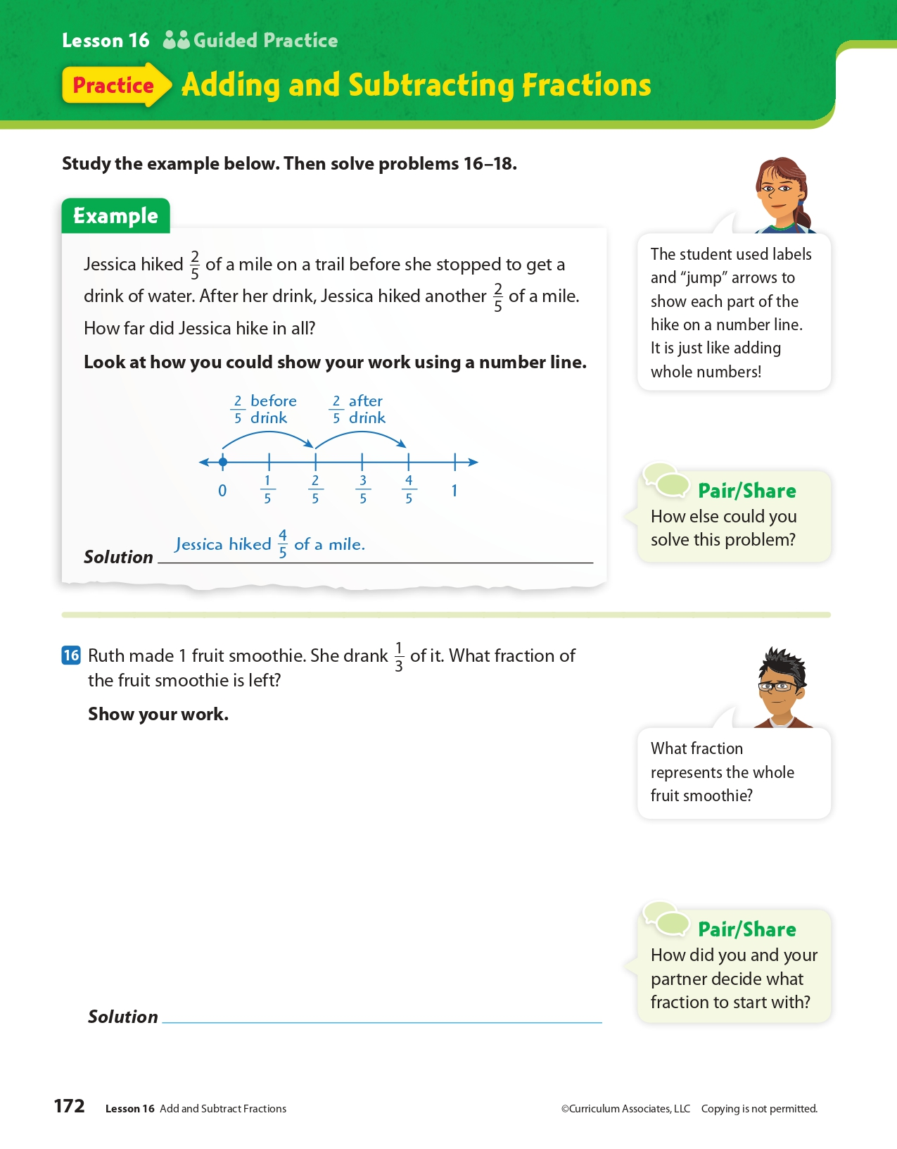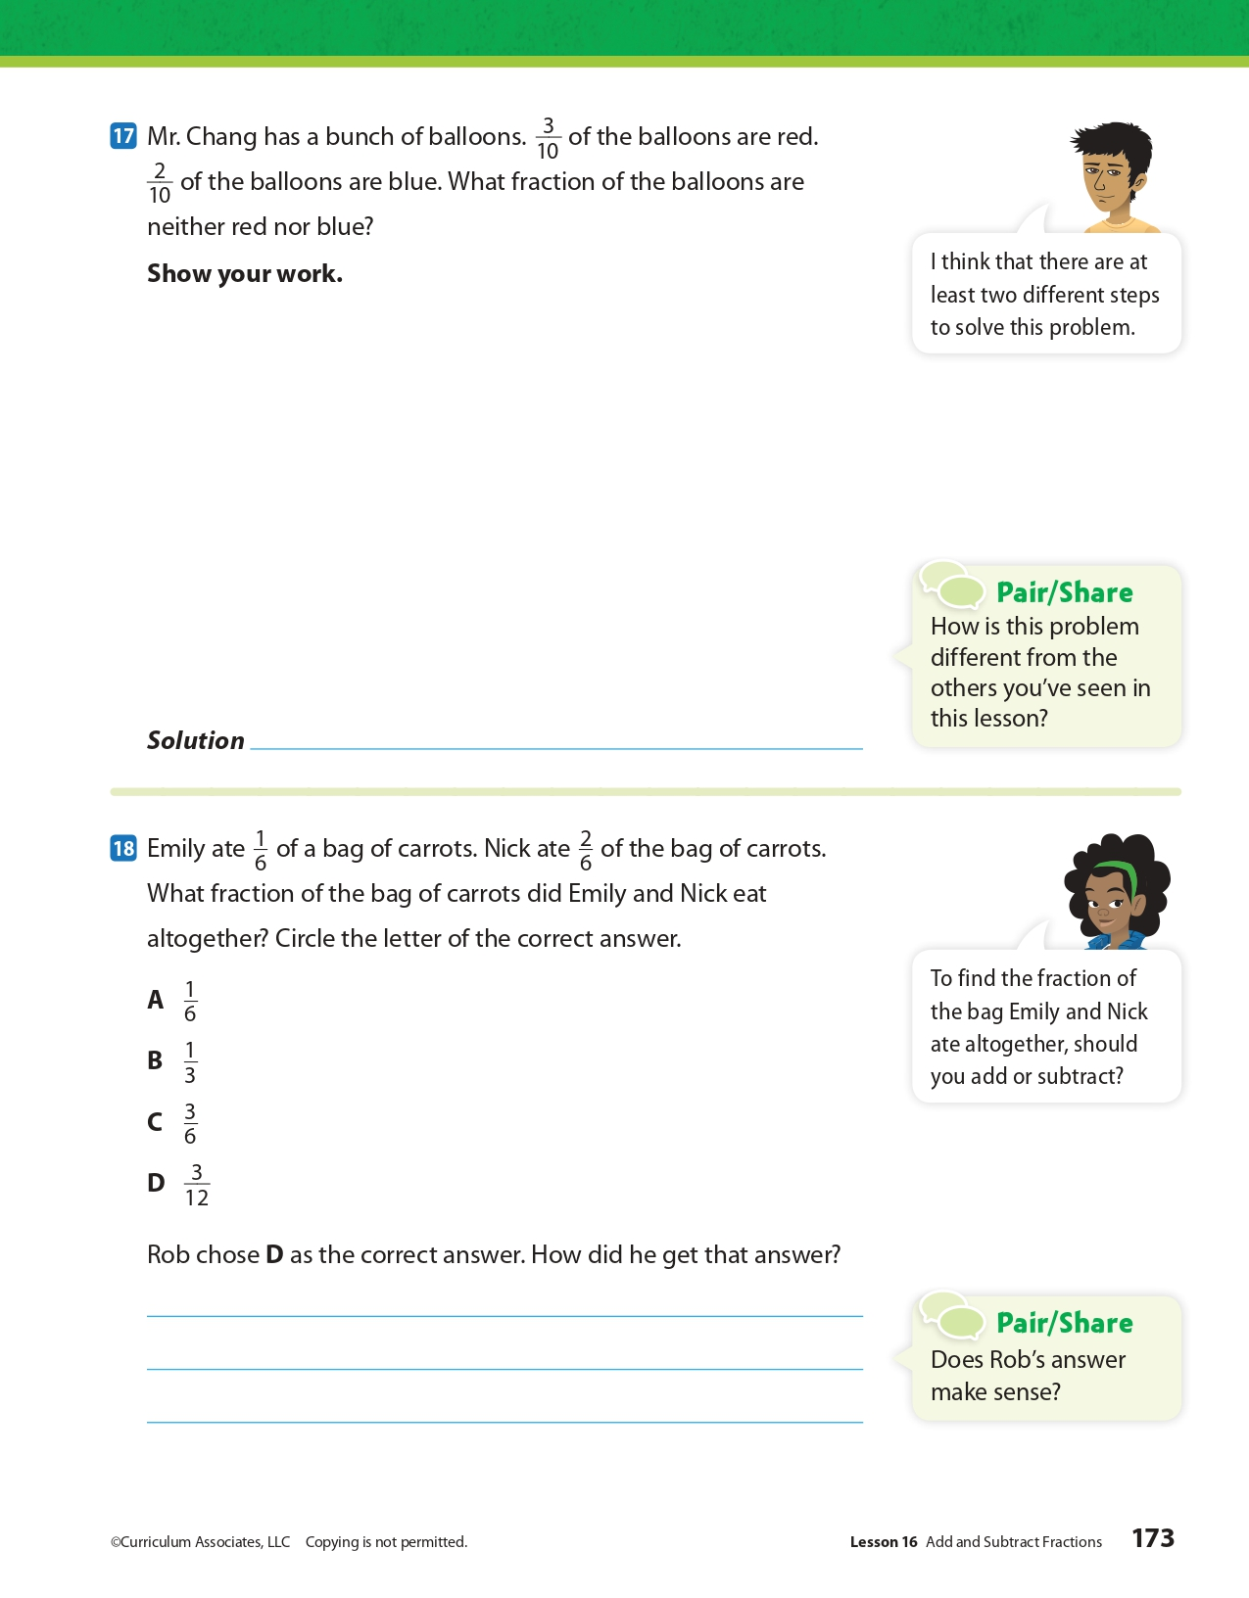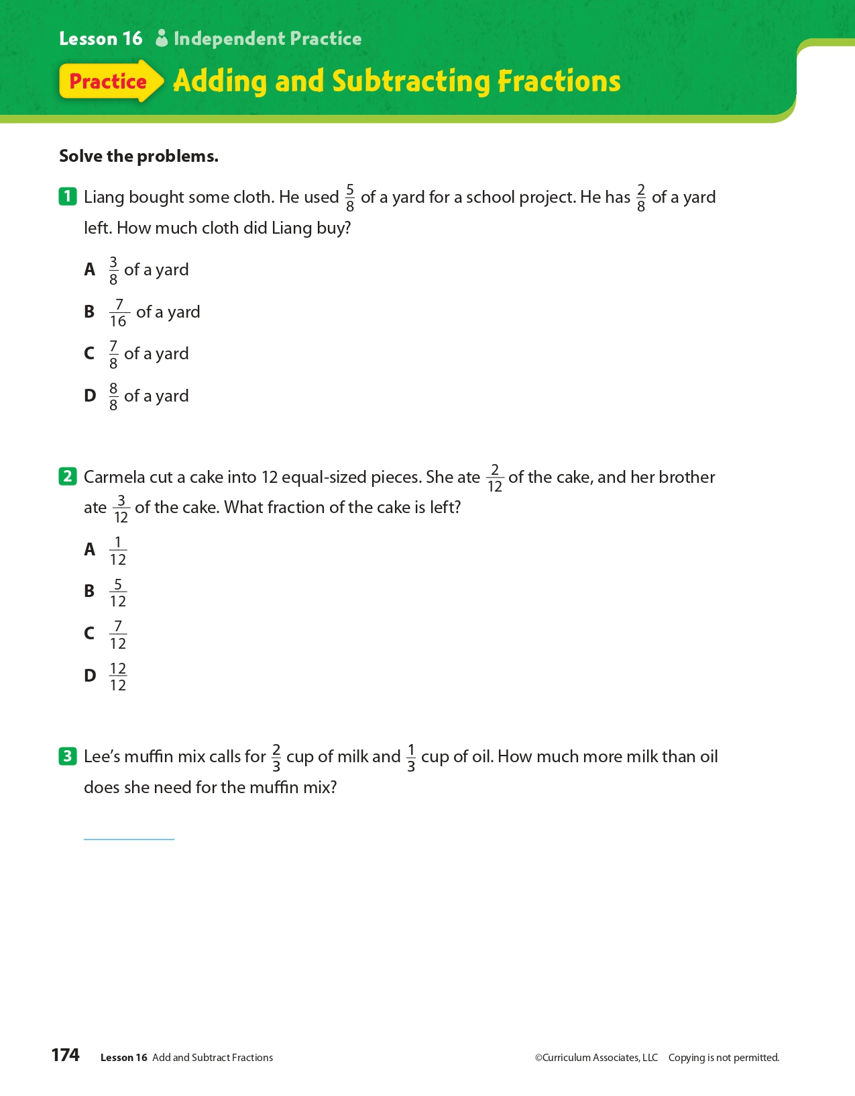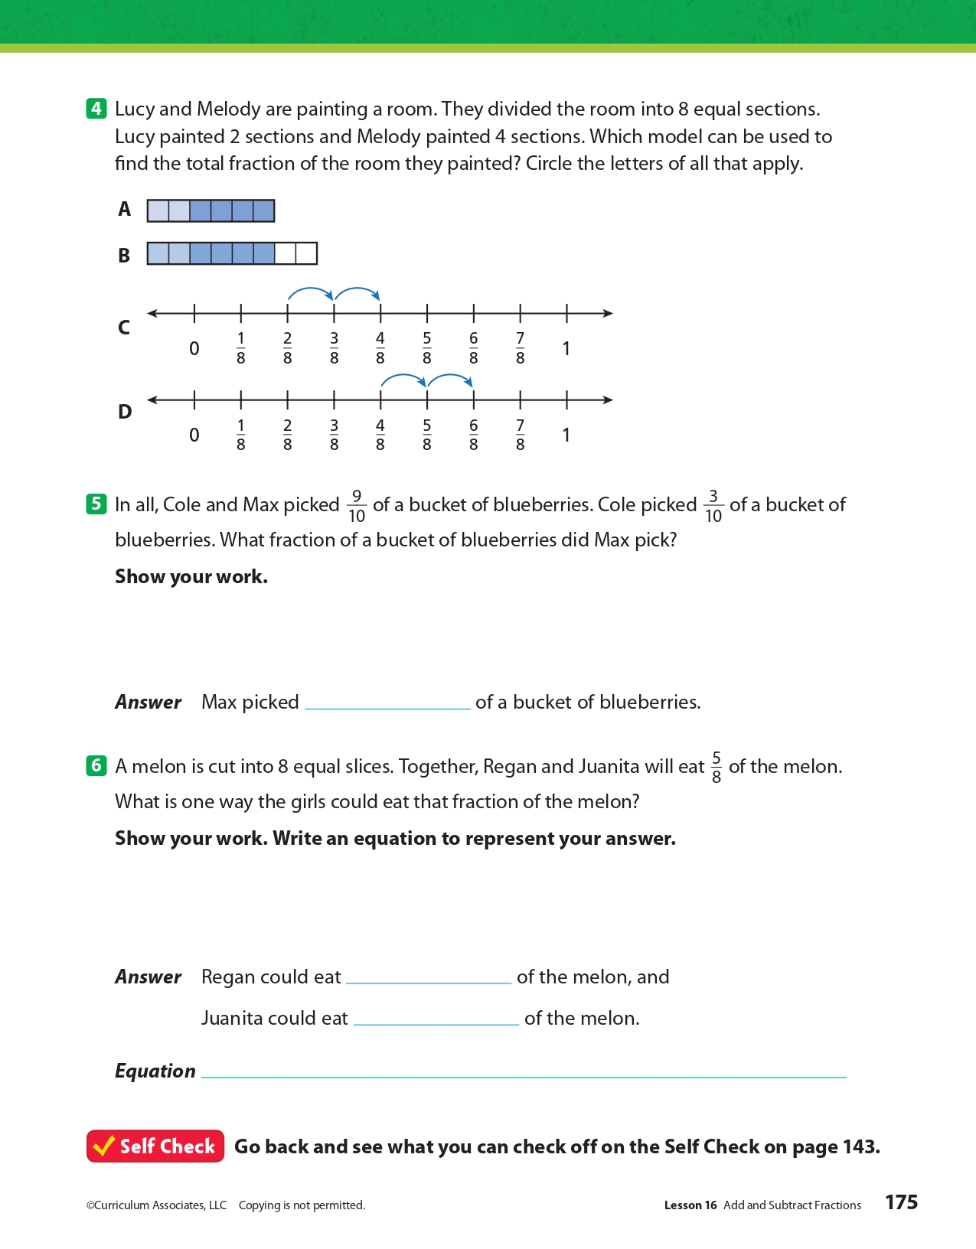
Day 4: PE
Health

What is this lesson about?: In today’s lesson, you will work on your PE BINGO card.

Step 1: Try to complete the PE BINGO card.

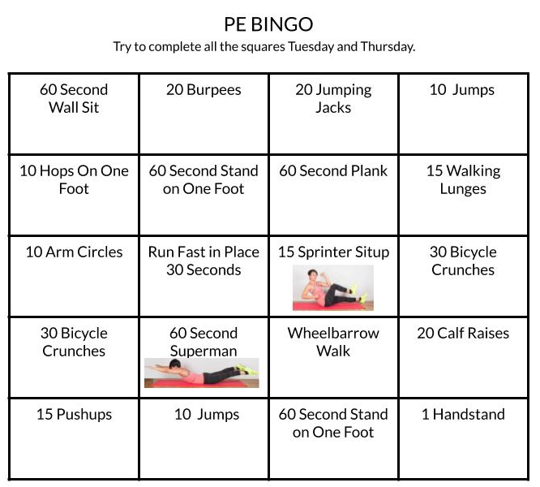

Student Feedback:
Circle the emojis that best represents how this activity made you feel.
Mindfulness Moment!

A song that makes me want to get up and dance is…

Day 4: Establishment Clause of 1st Amendment
Social Studies

What is this lesson about?: Today you will learn more about the ‘Establishment’ clause of the 1st Amendment. You will consider situations that raise issues related to the clause and you will see how the U.S. courts have ruled over those issues.

Step 1: Warm-up on religious liberty

A store clerk who is a Seventh-day Adventist is scheduled to work on a Saturday, his Sabbath. Despite the willingness of a coworker with the same level of experience to switch shifts with him, his supervisor tells him that he must work Saturday or be fired. What do you think?

Step 2: Revisit the Establishment clause of the 1st Amendment

“Congress shall make no law [1] respecting an establishment of religion or [2] prohibiting the free exercise thereof.”

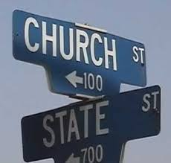
During colonial times, the Church of England was established by law in all of the southern colonies, while localized Puritan establishments held sway in most New England states. In those colonies, clergy were appointed and disciplined by colonial authorities and colonists were required to pay religious taxes and (often) to attend church services. Dissenters were often punished for preaching without a license or refusing to pay taxes to a church they disagreed with. Delaware, New Jersey, Pennsylvania, Rhode Island, and much of New York had no established church.

After Independence, there was widespread agreement that there should be no nationally established church. The Establishment Clause of the First Amendment, principally authored by James Madison, reflects this consensus. The language of the Establishment Clause itself applies only to the federal government (“Congress shall pass no law respecting an establishment of religion”). All states disestablished religion by 1833, and in the 1940s the Supreme Court held that disestablishment applies to state governments through the Fourteenth Amendment.

Adapted from the National Constitution Center

Step 3: Consider the scenarios

- A football coach at a public high school was put on paid administrative leave and was not allowed to coach the football team after leading students in voluntary prayers before and after games.

Do you think this violates the Establishment Clause based on the text of the First Amendment? Why or why not?

- A state constitution prohibits state funding from going to religious institutions. A religiously operated school applies to receive funding to receive materials made from used tires for a playground, arguing that the specific benefit has no relation to religion. Can the state prevent the religiously operated school from receiving the playground materials?

Do you think this violates the Establishment Clause based on the text of the First Amendment? Why or why not?

Step 4: Read about a Supreme Court case

Case Summary: Trinity Lutheran Church of Columbia v. Comer
The Bremerton (WA) School District suspended, and later fired, Coach Kennedy over his silent, 15-second prayer. First Liberty Institute filed a lawsuit against the school district, Kennedy v. Bremerton School District. A federal district court upheld Coach Kennedy’s termination. On appeal, a three-judge panel of the U.S. Court of Appeals for the Ninth Circuit concluded that, because Coach Kennedy could be seen by students and fans engaging in religious expression, the school lawfully terminated his employment and his silent prayers were not protected by the Constitution. In January 2019, the Supreme Court of the United States declined to review Coach Kennedy's case but the case has returned to the District Court to answer some of the questions raised by the Justices. Upon re-hearing, the District Court again sided with the school district setting up a return to the Ninth Circuit.

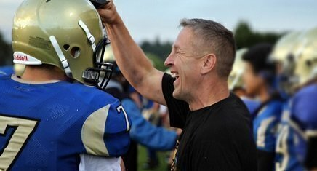
Ex-football coach loses federal appeal over prayer case
August 25, 2017 by Scott Bomboy
A former Washington state public high school football coach has lost his latest court battle over his right to lead prayers on the gridiron after games.
We first wrote about the case of former Bremerton High School assistant coach Joseph Kennedy back in October 2015. At the time, the school district put Kennedy on paid administrative leave. The district didn’t agree with Coach Kennedy’s practice of leading voluntary prayer on a publicly owned football field.
Back then, Kennedy's lawyers said they planned to go to court. And nearly two years later, the case has made it to the federal Ninth Circuit Court of Appeals after Kennedy lost in the United States District Court for the Western District of Washington.
On Wednesday, the three-judge Ninth Circuit appeals court panel upheld the lower court’s decision against Kennedy, who sought an injunction against the school district seeking his reinstatement as a coach and the resumption of his prayer practice after his reinstatement.
The appeals court decision stated that Kennedy didn’t apply for a coaching position for the 2016 season after the team’s head coach left. The school athletic director also recommended that Kennedy not be rehired, said the court documents.
Kennedy’s attorneys filed suit in the Western District in August 2016. He claimed his rights under the First Amendment and Title VII of the Civil Rights Act of 1964 were violated.
The lower court denied the injunction request because it believed Kennedy as a public employee fell under the school district’s policy rights to ensure the First Amendment’s Establishment Clause was respected and that the district wasn’t advocating a religion.
The Ninth Circuit appeals court panel agreed on Wednesday.
“By kneeling and praying on the fifty-yard line immediately after games while in view of students and parents, Kennedy was sending a message about what he values as a coach, what the District considers appropriate behavior, and what students should believe, or how they ought to behave,” the appeals court concluded. “Because such demonstrative communication fell well within the scope of Kennedy’s professional obligations, the constitutional significance of Kennedy’s job responsibilities is plain—he spoke as a public employee, not as a private citizen, and his speech was therefore unprotected.”
The First Liberty Institute, which helped in Kennedy’s legal representation, told the Seattle Times on Wednesday that it was disappointed and considering its options, including a Supreme Court appeal.
How did the Ninth Circuit Court rule on this case?

After reading about this case, would you change your answer to the 2nd scenario above? Explain.

Step 5: Read another Supreme Court Case

Case Summary: Trinity Lutheran Church of Columbia v. Comer

In this case, a church that operates a preschool applied for a state grant that provides funds for resurfacing playgrounds with rubberized material. 1 Missouri denied Trinity Lutheran Church’s application because Article I, Section 7 of the Missouri Constitution states, “no money shall ever be taken from the public treasury, directly or indirectly, in aid of any church, sect or denomination of religion.” Missouri refused to provide a grant to the church based on its state constitutional policy of denying grants to religiously affiliated organizations—a policy that is rooted in the fundamental principle that the government must not “establish” an official religion, but rather maintain the separation of church and state. In refusing the grant, the state was upholding a long-standing state policy of enforcing the state’s anti-establishment interests. As the Eighth Circuit observed, Missouri “has a long history of maintaining a very high wall between church and state.”

However, contrary to Missouri’s anti-establishment concerns, the Supreme Court in Trinity Lutheran determined that the state could not deny generally available benefits to the church because of its religious character.

Supreme Court rules for church in playground materials case
June 26, 2017 by Scott Bomboy
A divided Supreme Court said on Monday that a Missouri church had a right to receive a public grant for rubber playground materials, but it stopped short of determining if the state’s Blaine Amendment was unconstitutional.
In Trinity Lutheran Church of Columbia v. Comer, Chief Justice John Roberts said that the Missouri Department of Natural Resources violated the church’s rights under the First Amendment’s Free Exercise Clause by denying it “an otherwise available public benefit on account of its religious status.”
The case involved the constitutional question of whether a religiously-operated school has an equal right to take part in a state program of handing out materials made from used tires to be used as school playground matting. Such aid was barred for the school under the Missouri state constitution’s ban on any public aid to religion, even though the specific benefit had no religious content.
That provision in Missouri’s constitution is one of the Blaine amendments. The controversy over Blaine amendments has its origins in the presidential campaign of 1876. At the time, Republican candidate James G. Blaine sought anti-Catholic voters in his quest for the White House.
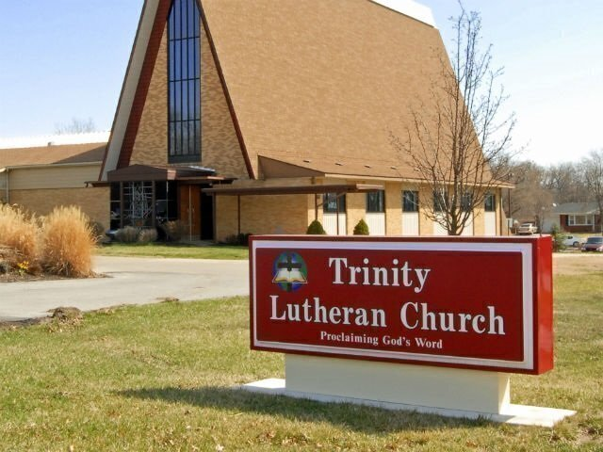
Blaine proposed a federal constitutional amendment that stated in part that “no money raised by taxation in any State for the support of public schools, or derived from any public fund therefor, nor any public lands devoted thereto, shall ever be under the control of any religious sect.”
Blaine’s effort for a national constitutional amendment failed in Congress, but many states over the years adopted their own “Blaine amendments” in their own constitutions. About 35 states now have some form of a Blaine amendment on the books.
In the majority opinion, Roberts said in one of his footnotes that the decision was limited in scope to just the issue involving the playground. “This case involves express discrimination based on religious identity with respect to playground resurfacing. We do not address religious uses of funding or other forms of discrimination,” Roberts said in the opinion’s footnote 3.
“The State in this case expressly requires Trinity Lutheran to renounce its religious character in order to participate in an otherwise generally available public benefit program, for which it is fully qualified. Our cases make clear that such a condition imposes a penalty on the free exercise of religion that must be subjected to the ‘most rigorous’ scrutiny,” Roberts concluded.
“The result of the State’s policy is nothing so dramatic as the denial of political office. The consequence is, in all likelihood, a few extra scraped knees. But the exclusion of Trinity Lutheran from a public benefit for which it is otherwise qualified, solely because it is a church, is odious to our Constitution all the same, and cannot stand,” Roberts said.
Two Justices, Neil Gorsuch and Clarence Thomas, objected to Roberts’ footnote, but agreed with the rest of his opinion. “Of course the footnote is entirely correct, but I worry that some might mistakenly read it to suggest that only ‘playground resurfacing’ cases, or only those with some association with children’s safety or health, or perhaps some other social good we find sufficiently worthy, are governed by the legal rules recounted in and faithfully applied by the Court’s opinion,” said Gorsuch.
Justice Sonia Sotomayor issued a strongly worded 27-page dissent, which was joined by Justice Ruth Bader Ginsburg.
“To hear the Court tell it, this is a simple case about recycling tires to resurface a playground. The stakes are higher. This case is about nothing less than the relationship between religious institutions and the civil government—that is, between church and state,” Sotomayor said.
“The Court today profoundly changes that relationship by holding, for the first time, that the Constitution requires the government to provide public funds directly to a church. Its decision slights both our precedents and our history, and its reasoning weakens this country’s longstanding commitment to a separation of church and state beneficial to both,” she concluded.
Justice Stephen Breyer concurred with Roberts’ controlling opinion. “Public benefits come in many shapes and sizes. I would leave the application of the Free Exercise Clause to other kinds of public benefits for another day,” he said.
In recent years, the United States Supreme Court has made it clear that states can relax some of their Blaine amendment provisions, and they can provide some forms of neutral aid to religious institutions.
How did the Supreme Court rule on this case?

After reading about this case, would you change your answer to the 2nd scenario above? Explain.

Step 6: Reflection
Think back on the two cases you read about today and choose one to answer the following questions about:

Do you agree with the Supreme Court’s decision? Why or why not?

Do you think the Supreme Court followed the First Amendment’s Free Exercise clause in their ruling? Why or why not?

Student Feedback:
Circle the emojis that best represents how this activity made you feel.

