Week 3
Identity

Day 5

NAME:______________________

Day 5 Agenda

Topic | Activity
Warm-Up!
English Language Arts | - Read the essay “My Past Has Shaped Me Into The Person I Am Today”  - Answer questions about the text.  - Write a short reflection about what has shaped their identity and who they hope to become.
Science | - Read about multiple intelligences  - Answer questions  - Reflect
Mindfulness Moment!
Math | - Real World Math: Identity and Incarceration: The math of mass incarceration  - Practice Problems: Factors
Health | - Digital Identity
Mindfulness Moment!
Civics/Social Studies | - National Identity
PE | - Bingo!

Warm-up Activity: Write a journal entry around the daily quote on identity.
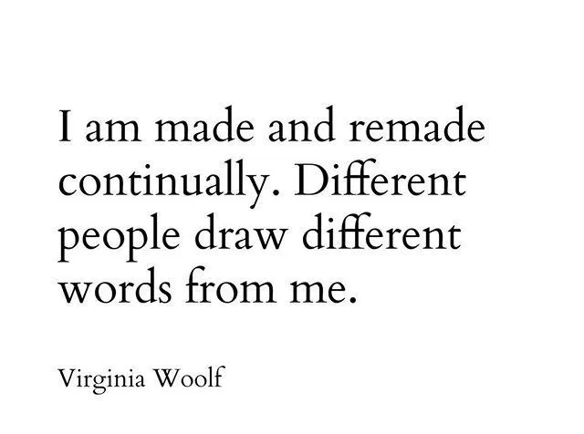

Day 5: English Language Arts
What has and continues to shape my Identity?

What is this lesson about? Identity is something that is always changing as it is shaped by different experiences and influences. Today, you will be reading two essays that talk about the author’s identities and what has shaped those identities. Afterwards, you will write a short reflection about what has helped shape your identity and who you hope to become.

Both of these essays are taken from a website called “This I Believe.” This I Believe, Inc., was founded in 2004 to engage youth and adults from all walks of life in writing, sharing, and discussing brief essays about the core values that guide their daily lives.
Selected contemporary “This I Believe” essays were featured in regular broadcasts on National Public Radio (NPR) in the United States from 2005 to 2009, in a series produced and hosted by Jay Allison. These essays are now collected and stored on their website and also provided in audio form on the This I Believe podcast.

Step 1: Read the Essay.

My Past Has Shaped Me Into The Person I Am Today
Danyelle - Wichita, Kansas
Entered on November 29, 2011

I believe my past has shaped me into the person I am today. The way I have grown up, people would expect me to have already had a child or children, never gone to college, and never made it out of high school. Well, I have turned out to be the total opposite.
My family and I lived in homeless shelters about five or six different times. My mother did not receive a college degree, so she only worked minimum wage jobs. When I was a child, I did not notice as much as I do now. I would dread going to these shelters, but while we were there, we made great friends. Most of the time when we left, we would keep in touch with our friends from the shelter, or the “special apartments,” are what we preferred to call them. My brother and I never really worried about if we had money for food or necessary things when we were younger. We just sat back and enjoyed life, wherever that may be.
When I look back on my childhood, there are problems we faced that I see now, that I did not understand back then. My family moved around quite a bit. I attended about seven elementary schools, and three middle schools. When I was eight, my family moved to Arizona with nowhere to live and no clue of what we were going to do once we got there. When we got back to Wichita, we stayed with my aunt until she kicked us out. Then we lived in Wesley Inn for a week. From there, we lived in another homeless shelter. The first couple weeks of my sixth-grade year, I was forced to ride in a taxicab to school. When we moved into our house, we switched schools, and I had to ride the city bus.
In high school, our situation only got worse. My mother has always received money from the government and has not worked since I was in elementary school. During my junior and senior year, the government started decreasing the amount of money and food stamps my mother was receiving. The only food my brother and I could depend on was the food from school. Dinner has never been promised. My mother became more depressed, as did I. During my junior year, I was tempted to drop out completely.
Despite everything that has happened in my lifetime, I still continue to keep a positive attitude. In high school, I made decent grades, had jobs, was involved in about ten different clubs, and I made it to college. My goal in life is to help people in need, so they do not have to go through what my family struggles with every day. There is so much more that has happened in my life, but without God, my aunt, and my past, I would not be where I am today.
Step 2: Answer the questions.

- What are some of the challenges that the author experienced as a child?

- How did the author’s perspective (the way she looked at her situation) change? Why do you think this changed from elementary school to high school?

- The author says that she has turned out to be the “total opposite” of what others would expect of her. What has been her motivation?

- The author claims that she is a positive person. According to the text, was she always a positive person or is this something that has developed in her?

- The author says that her past has shaped who she has become today but in a positive sense. Describe a challenge that has changed you, but in a positive way.

Step 3: Read the second essay.

I Am Who I Say I Am
Angela - Upper Marlboro, Maryland
Entered on February 15, 2011
That I am who I say I am. My mother was the oldest girl of eight children when she got pregnant with me as a teenager. After I was born, I spent the next 19 years living between my grandmother and my mother. My mother joined the military because there was a serious lack of employment opportunities in Mississippi. My father was never in the picture. I found out later that he had denied that I was his child until I started to look like him. Around that same time, I found out that my father was a rolling stone. He had six children by six different women. The only one he took care of was my youngest sister, whose mother he married.
Four of my grandmother’s eight children were still living with her when my mother asked her to take care of me. She graciously took care of me whenever my mother asked. There were times when I lived with her for years. Some of my happiest memories happened while I was living with my grandmother. She took care of me the best way she knew how. She made me feel loved even though she was a functioning alcoholic. She told me funny and sad stories about her childhood in Mississippi. The story that stuck with me was the one she told me about her mother permanently taking her out of school in the third grade to pick cotton. My grandmother raised eight children and me with a third grade education. That would drive anyone to drink.
My mother had two more daughters after I was born. She got married and had her middle child while I was living with my grandmother. I never understood why she did that. It was so bizarre. How could she leave me with her mother while she was off starting another family? She didn’t have an answer when I asked her about it. While she was apologizing for leaving me I heard, “I don’t want you. I don’t love you. You’re a mistake that I tried to forget about.” I don’t remember being happy living with my mother. I think it was because of her preoccupation with herself that made me feel like an afterthought. Maybe it was because the two men she married made sure I knew that they weren’t there to be my father. Maybe it was because the only emotion I got from my mother was anger when I didn’t do something right. Maybe it was because I felt invisible.
With my family history, I should be messed up in the head in ways that no psychiatrist could fix. Well, I was messed up in the head until I did two things. I changed how I see myself and I forgave my mother. We have a good relationship now. I had to stop seeing myself as little orphan Angela. I had to stop seeing myself as the stepchild that no one wants. I had to stop seeing myself through other people’s eyes because they’re too messed up to know what they’re looking at anyway. They didn’t see the woman I could become. I am a woman that cares for others because I know what it feels like to suffer. I am a woman that is a loyal friend because I know what it’s like to feel abandoned. I am a woman that tells the truth with compassion because I know how it feels to be lied to. I am a woman that listens with my ears and my heart because I know what it’s like to feel unheard. I am a woman that can adapt and recover from negative experiences because that’s what I’ve had to do to survive. I am a woman who isn’t defined by what other people believe about me. I believe I am who I say I am.
What do you believe about yourself?

Step 3: Answer the questions.

- In the first half of her essay, the author describes the challenges she faced as a child. Despite feeling her mother’s neglect, what was something positive in her life at that time?

- Like the author of “My Past Has Shaped Me Into The Person I Am Today”, this author also claims that she should be “…messed up in the head” because of everything that happened to her as a chlld. What did she have to do so she wouldn’t be “messed up”?

- In her last paragraph, the author has a series of statements where she defines who she is and why. How have her experiences allowed her to become a better person?

Step 4: Now it’s your turn to write.

Pre- Writing: First think about 2-3 challenges that you have faced. How have those challenges changed you? Have they changed you for better or for worse? Explain.

Write a short reflection in the style of the “This I Believe” essays you have read. The first paragraph should include a short description of some experiences that have shaped who you are. In the second paragraph, explain how these experiences have made you grow or change. Finally, give at least two more skills or qualities that you want to continue to develop to become the person you want to be.

Student Feedback:
Circle the emojis that best represents how this activity made you feel. | 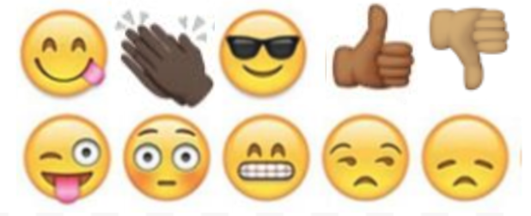

Day 5: Science
Multiple Intelligences

What is this lesson about?: Today you will read through What are multiple intelligences and how do they affect learning? You will answer a few questions and reflect on this week’s science lessons.

Step 1: Read through What are multiple intelligences and how do they affect learning?

WHAT ARE MULTIPLE INTELLIGENCES AND HOW DO THEY AFFECT LEARNING?
By Eve Herndon (2018)

What are multiple intelligences and how do they affect learning?
Over the past few decades, research in the field of learning has led to the discovery of the Theory of Multiple Intelligences. In short, this theory states that each person has different ways of learning and different intelligences they use in their daily lives.

While some can learn very well in a linguistically-based environment (reading and writing), others are better taught through mathematical-logic based learning. Still others benefit most from body-kinesthetic intelligence (learning by doing with the hands).

Each person possesses each intelligence to an extent, but there is always a primary, or more dominant, intelligence.

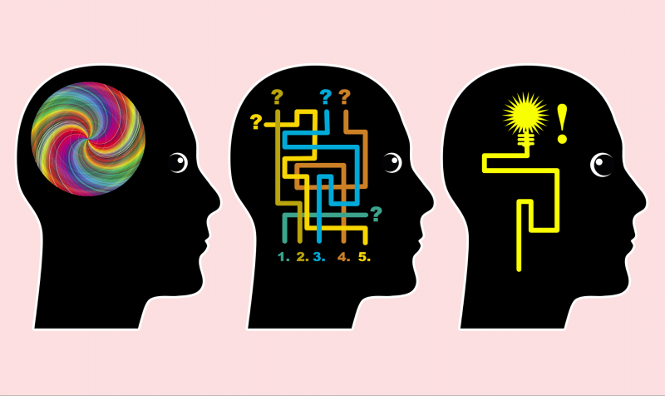
The work on multiple intelligences began in the early 1980s with Howard Gardner, and the research continues.

HOWARD GARDNER'S THEORY OF MULTIPLE INTELLIGENCE

Howard Gardner of Harvard University originally identified seven distinct intelligences. According to Gardner, this theory, which emerged from cognitive research, "documents the extent to which students possess different kinds of minds and therefore learn, remember, perform, and understand in different ways."
In greater detail, the theory proposes that "we are all able to know the world through language, logical-mathematical analysis, spatial representation, musical thinking, the use of the body to solve problems or to make things, an understanding of other individuals and an understanding of ourselves. Where individuals differ is in the strength of these intelligences and the ways in which such intelligences are invoked and combined to carry out different tasks, solve diverse problems and progress in various domains." Hani Morgan (2014) supports Gardner's theory. Morgan's research indicated that differentiated instruction benefits all students, but must be presented by well-prepared, experienced and knowledgeable teachers.
This diversity, according to Gardner, should impact the way people are educated. He stated that these differences "challenge an educational system that assumes that everyone can learn the same materials in the same way and that a uniform, universal measure suffices to test student learning." Joan Hanifin, an Irish researcher, determined in a 2014 publication that the outdated system of education in Ireland was adversely affecting students in the long-term. By not embracing multiple methods of teaching based on different intelligences, students often left school feeling "under-valued."
Gardner goes on to say that, "Indeed, as currently constituted, our educational system is heavily biased toward linguistic modes of instruction and assessment and, to a somewhat lesser degree, toward logical-quantitative modes as well."
Gardner argues that "a contrasting set of assumptions is more likely to be educationally effective. Students learn in ways that are identifiably distinctive. The broad spectrum of students—and perhaps the society as a whole—would be better served if disciplines could be presented in a number of ways and learning could be assessed through a variety of means." In 2010, Bas and Beyhan presented findings based on their study of using Multiple Intelligences theory in learning English. They determined that Multiple IntelligencesI-based learning is more effective in terms of student achievement levels and their attitudes toward learning. Their research supports Gardner's assertion that Multiple Intelligences-based learning will serve students well.

THE 9 MULTIPLE INTELLIGENCES

Gardner claims that all human beings have multiple intelligences. These multiple intelligences can be nurtured and strengthened or ignored and weakened. His research from 1991 identified seven intelligences; in the intervening time, he has come to believe there are a total of nine intelligences:

- Verbal-Linguistic Intelligence: Well-developed verbal skills and sensitivity to the sounds, meanings and rhythms of words.

- Mathematical-Logical Intelligence: The ability to think conceptually and abstractly, and the capacity to discern logical or numerical patterns.

- Musical Intelligence: The ability to produce and appreciate rhythm, pitch and timbre.

- Visual-Spatial Intelligence: The capacity to think in images and pictures, to visualize accurately and abstractly.

- Bodily-Kinesthetic Intelligence: The ability to control one's body movements and to handle objects skillfully.

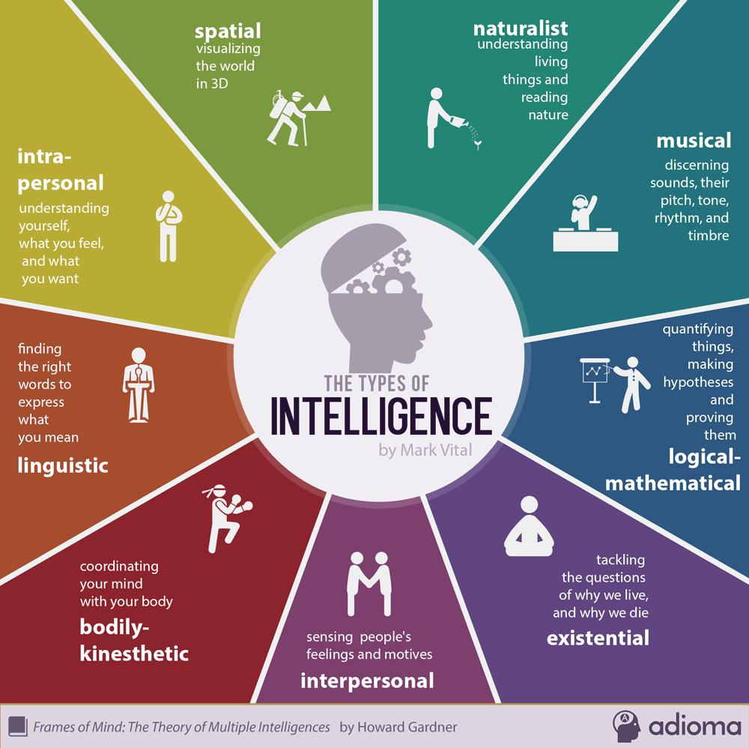
- Interpersonal Intelligence: The capacity to detect and respond appropriately to the moods, motivations and desires of others.

- Intrapersonal Intelligence: The capacity to be self-aware and in tune with inner feelings, values, beliefs and thinking processes.

- Naturalist Intelligence: The ability to recognize and categorize plants, animals and other objects in nature.

- Existential Intelligence: The sensitivity and capacity to tackle deep questions about human existence, such as the meaning of life, why we die and how we got here.

While all people possess some level of each intelligence, most will experience more dominant intelligences which impact the way they learn and interact with the world around them.

Step 2: Answer the questions

As you think about what you just read, and you go back to the descriptions of the nine intelligences (you can refer to the chart above), write down which of these intelligences you believe are your strongest intelligences.

How might school or your learning be different for you if you were able to tap into your different intelligences on a regular basis?

Step 3: Reflect

As you think about this week’s science lessons, what have you learned about your own identity?

Student Feedback:
Circle the emojis that best represents how this activity made you feel. | 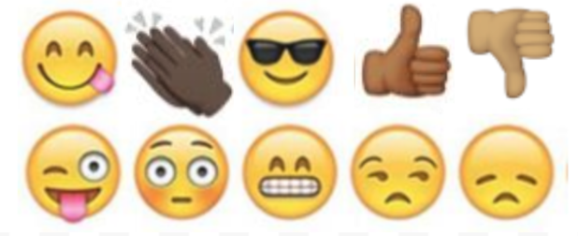

Mindfulness Moment!

Day 5: Identity/Race, Education, Employment and Incarceration
Math

What is this lesson about?: In this lesson, we will look at some of the math behind a range of topics including racial disparities in education, juvenile and criminal justice, and employment. As a part of this we will try and assess how this ‘math’ may impact one's sense of self-identity.

But first: Today’s Warm-Up
Let’s look at this quote from Nipsey Hussle-

"If you look at people in your circle and you don't get inspired you don't have a circle you have a cage.”
What does this quote mean to you, in your own words?

In your view, do your friends form a circle around you, or more of a cage around you?

Step 1: Race and Economics in DC

The charts below analyze a number of race and economic issues facing Washington, DC between 2007 and 2011. Please take a few minutes to review them and then we will move to the questions below.

Chart 1: High School Age Students in DC Public Schools: 2010-2012, By Race (rounded)
Year/Race | Black | White | Other | Total
2010 | 16,020 | 1,440 | 540 | 18,000
2011 | 16,340 | 1,710 | 950 | 19000
2012 | 16,150 | 1,710 | 1,140 | 19000
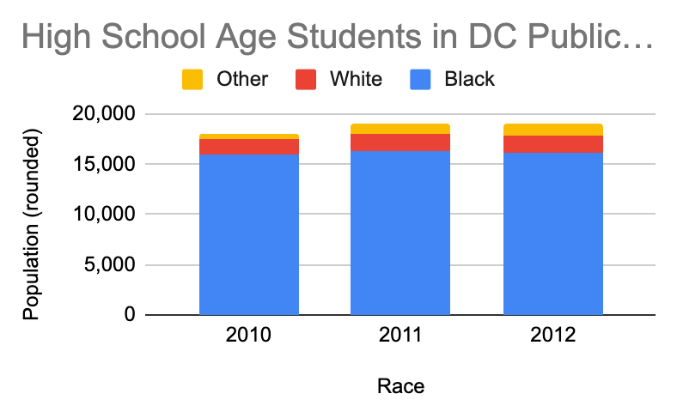

Based on the charts above:
- About how many high school aged students attended public schools Washington, DC in:
2010? 2011? 2012?

- About how many of those students were Black and how many were white in:
2010-Black? White? 2011-Black? White? 2012--Black? White?

Based on these charts, what percentage of DC’s population would you estimate was:
- Black? White? Other?

In fact, DC’s population during this time was about 45% Black, 45% White and 10% other.

If this is the overall population, why do you think the number of Black vs White students in the public schools isn’t almost equal?

Chart 2: Number of students: long-term suspension, expelled and known drop-outs--Grade 9
Year/Race | Black | White | Other
2010 | 650 | 10 | 100
2011 | 525 | 10 | 92
2012 | 400 | 5 | 80

Based on these charts:
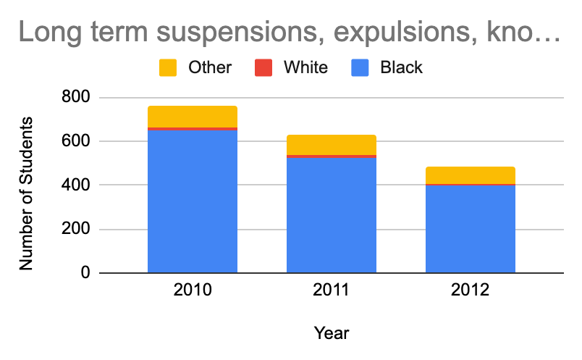
- About how many students total either were suspended, or expelled or dropped out of school in 9th grade in:
2010?

2011?

2012?

- About how many of those students were Black and how many were white in:
2010-Black? White?
2011-Black? White?
2012-Black? White?

Chart 3: Students Committed to New Beginning Youth Development Center -- 2010-2012 - DC’s (rounded)
Year/Race | Black | White | Other
2010 | 150 | 0 | 5
2011 | 130 | 2 | 7
2012 | 100 | 0 | 3

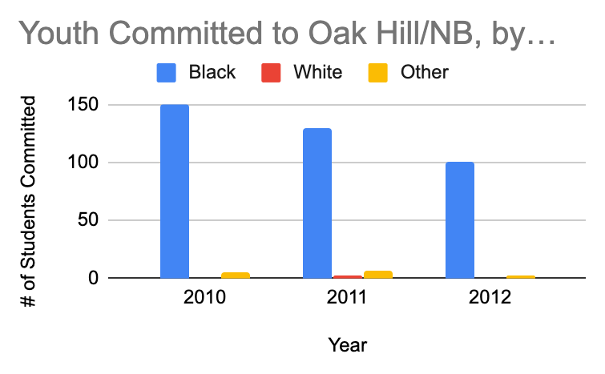
Based on the chart above and to the right:
- About how many students all total were sent to New Beginning Youth Center in:
2010?
2011?
2012?

- About how many of those students were Black and how many were white in:
2010-Black? White?
2011-Black? White?
2012-Black? White?

Step 2: How does your life compare?
Based on these charts, your review of them, and your own life experiences-

- What are some of the factors that lead some students to dropout of high school, especially in 9th grade?

- What could be done in schools in DC to reduce the number of students who were getting expelled or suspended?

- What are some of the factors that are leading teens to getting arrested and sent to DC’s youth facility (called New Beginnings?

- What questions would you want to ask to better understand why there is such a large gap in the number of Black students compared to White students ending up at New Beginnings?

Step 3: Earnings and Education
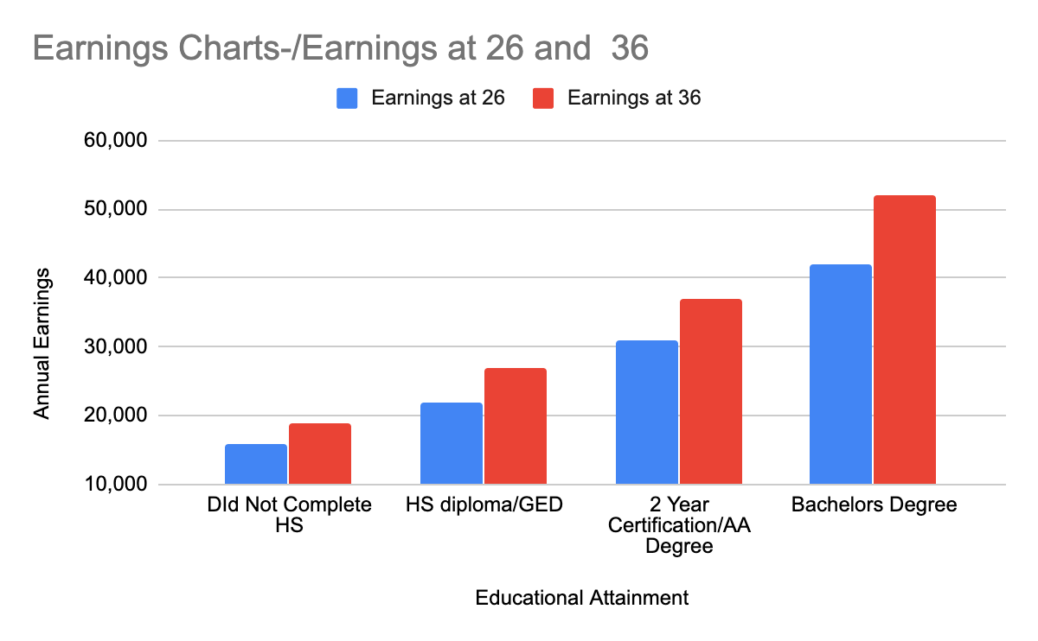
We are now going to look at earnings of adults at age 26 and 36, based on how far they went in school.

Based on this chart:
- How much money per year does a 26 year old:
  - Who has a high school diploma/GED earn?

  - Who earned a two year certification/associates degree earn?
  - Who completed a four-year college degree earn?
  - Who never completed high school earn?

Based on this chart:
- How much money per year does a 36 year old:
Who has a high school diploma/GED earn?
Who earned a two year certification/associates degree earn?
Who completed a four-year college degree earn?
Who never completed high school earn?

Based on this chart:
- How much more per year does a 36 year old earn than a 26 year old, if:
She/he has a high school diploma/GED?
She/he earned a two year certification/associates degree?
She/he completed a four-year college degree?
She/he never completed high?

Discuss/Consider: Does anything about these charts and the earnings raise any specific questions for you?
- Right now, what steps can you be taking to help you increase your earnings potential in the future?
- Many people have an identity that is closely related to the job they have. What sort of “identity” do you want to have as you get older?

Step 4: Criminal Justice Involvement and Education
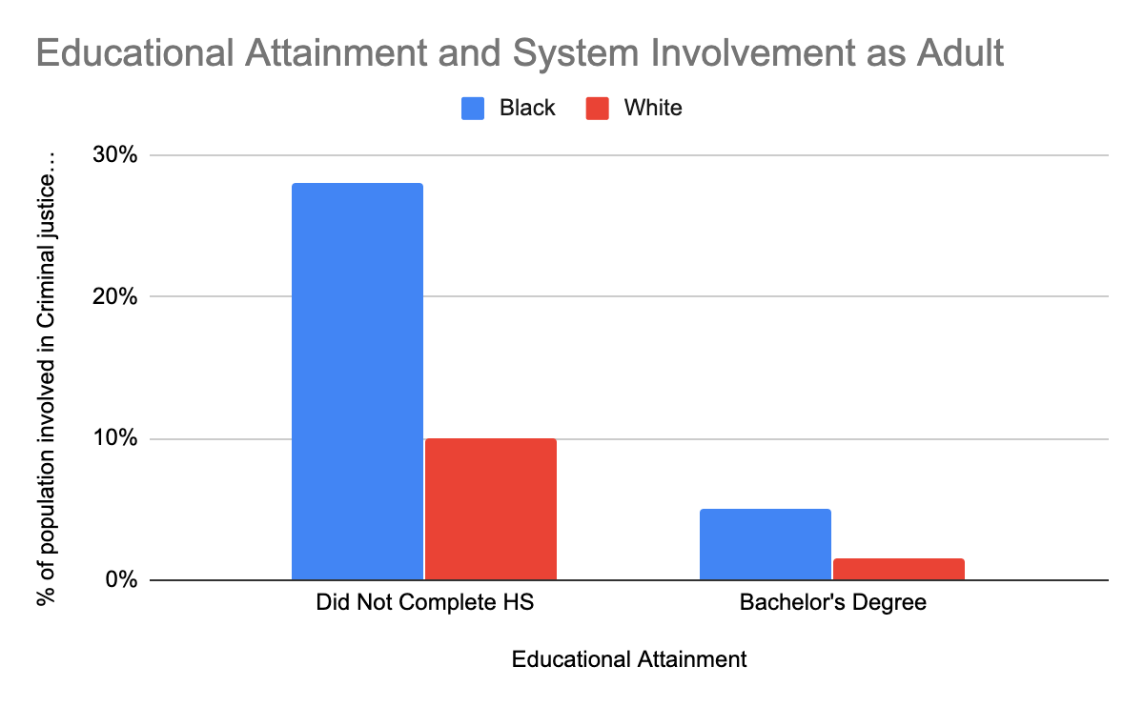
Based on this chart:
- If 100 students drop out high school in the 9th grade, what % of them may end up involved in the criminal justice system as adults if:
They are Black?

They are White?

- If 100 students complete high school and college, what % of them may end up involved in the criminal justice system as adults if:
They are Black? They are White?

- Based on everything we have looked at today, one thing is clear. Making it through 9th grade and graduating high school is really important in helping students, particularly Black students, stay out of the juvenile and criminal justice systems. Systematic racism makes this even more important.

  - What are 3 things that should be put in place to make sure that more and Black students flourish in 9th grade and go on to graduate?

Step 5/Activity 5: Taking ownership of your identity

- The topic of this week’s work was Identity. Often, when teens and young adults are arrested, people unfairly label them or give them an identity (inmate, juvie, etc.)

- But many of us believe in you and identify you in a different way--as a student, or a scholar, or a poet, or hard worker, or funny…..

- How do you want to be identified right now? Feel free to write an answer or make a drawing or sketch.

Skill Builders and Review Problems
- Multiples

Student Feedback:
Circle the emojis that best represents how this activity made you feel.

Day 5: Digital Identity
Health

Step 1: Warm-up

How can you respect the privacy of others online?

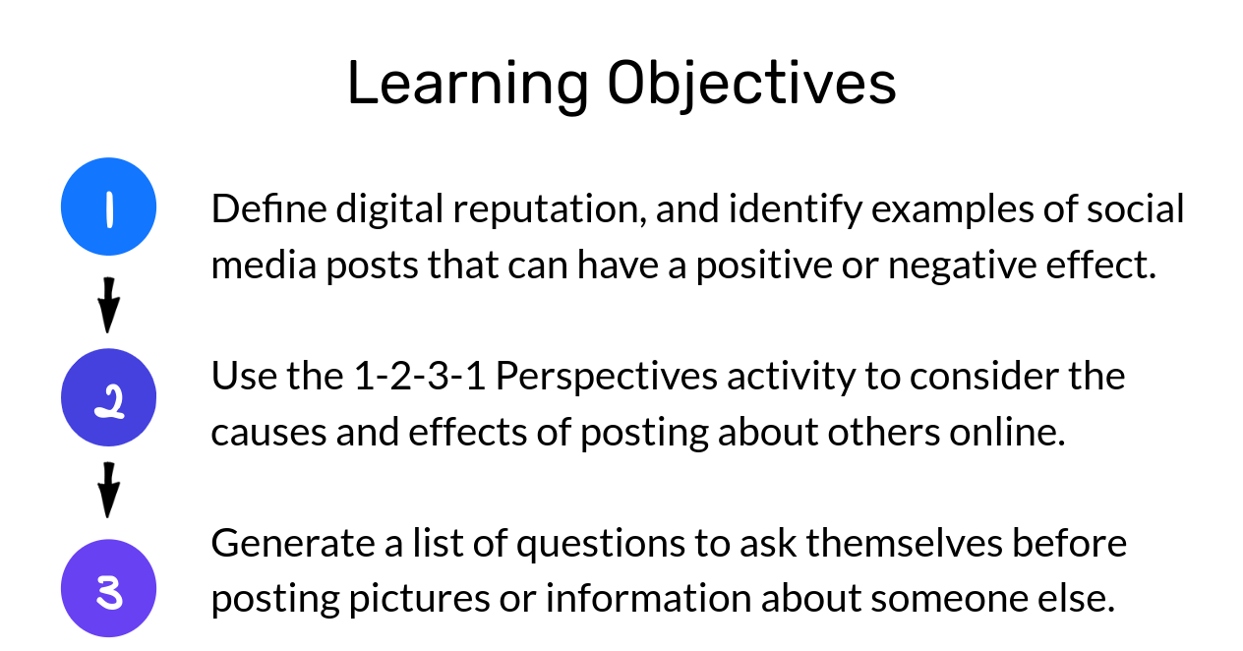
Step 2: What’s this Lesson About?
Step 3: What is digital Reputation?

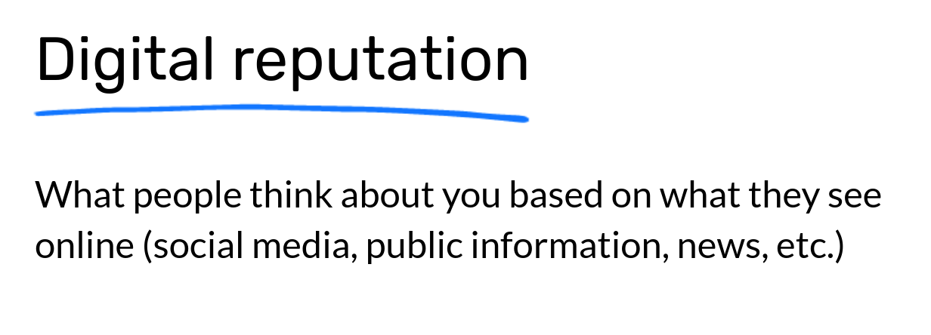

Step 4: Brainstorm

Write down as many ideas as you can in each column below.
Good for digital reputation | Not so good for digital reputation

Step 5: Read the text

Alex and Joran are good friends. One day when they're hanging out after school, as a joke, Joran decides to carve profanity into the sign out front that shows the school name. Alex takes a picture of Joran doing it, tags him, and shares it on social media. Aimee and Max, a couple of friends on social media, see it. Aimee responds with "haha" and a thumbs-up emoji, and Max adds a surprised-face emoji.
A few days later, Alex and Joran get called to see Ms. Varma, the principal, who shows them the photo on her screen. They don't know how she saw the photo. She tells them that Joran will be expelled from school and Alex will be suspended for three days. Alex serves his suspension and returns to school. Joran is forced to find a new school, which ends up being far from his home and a place where he doesn't know any other students.

On your own, notice your gut reaction. What do you think? Do you agree or disagree with the punishments that Alex and Joran received? Why?

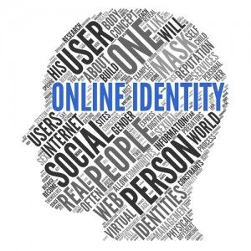
WE Define who WE are.
Mindfulness Moment!

Day 5: National Identity
Social Studies

What is this lesson about?: Today you will learn about national identities and what that means. You will read two articles and see how language can impact national identity.

Step 1: Read the article

It's language – you don't say! – that matters most to national identity
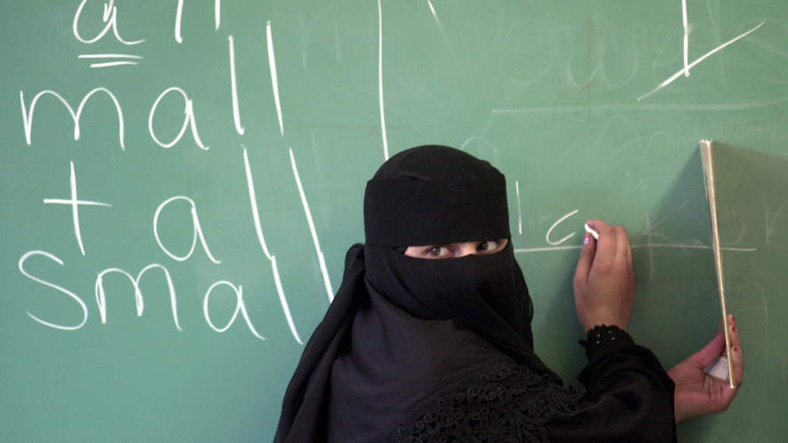
How do people decide what makes someone an American? Many things make up a country's identity, and these things are changing constantly. The same characteristics, though, are used by many different countries to define themselves.
On February 1, the Pew Research Center released a study about national identity. The Pew Research Center studies people's beliefs and attitudes. At the beginning of last year, they asked people across 14 countries about what defines their nation.
Some of the answers were surprising. For instance, many Americans do not think where someone is born matters. In fact, only a handful of the countries Pew surveyed thought where people were born was important. Another surprising fact is that most Americans do not think that customs and religion are really important.

Language Is The Key Factor
Instead, Pew's study found that language was what really defined a country. In all countries, a majority of people said it was "very important" to speak the national language. The importance of language is not surprising. Two people will struggle to find anything in common if they cannot talk to each other. British historian Eric Hobsbawm has written that as countries gradually became democracies, a shared language became a necessity. People need to be able to communicate with each other in order to make decisions about the country instead of the decisions being made by a king or queen.
Many modern states developed around a common language, like Germany, which started as many different German-speaking states. Today, some languages have become symbols for people who want to separate and become their own countries. One example is the Basque language in Spain. There, the Basque people, who speak Basque, want to separate from Spain.
Pew's study does not include countries with many different languages, like India or Switzerland. Instead, most of the countries listed in the research use mostly one language. Often, the language began and is only used in that country.

Canada And The United States Are Exceptions
Canada and the United States, though, are different. Canada is a country where there are two national languages, French and English. Both languages began not in Canada but in Europe. This might be why fewer people in Canada think language is "very important" to national identity than in other countries. It also has the highest number of those who think language is "not at all important."
However, the relationship might be a bit more complicated. For instance, Italy has similar beliefs as Canada, although Italy has strong ties to its language. Also, the United States, another country whose main language is from Europe, seems to have stronger views about language than some European nations.
Pew's study shows that beliefs about national identity are divided across political parties. More Republicans than Democrats say that being able to speak English is very important to being truly American. More Republicans also think American traditions and Christianity are important, too. Many Republicans have conservative beliefs and do not want things to change. Both Republicans and Democrats attach relatively low importance to being born in the United States.

Politics Also Matters In Europe
The connection to political parties is also important across Europe. People who like conservative parties such as the United Kingdom Independence Party (UKIP) and France's National Front thought national customs were very important. These parties are often against people moving in from other countries. They favor what they see as traditional values.
In most of the countries surveyed, people already need to speak the national language to become citizens. In fact, citizenship tests have been becoming more difficult over recent years. For example, the British citizenship test asks people questions about Rudyard Kipling. Kipling was a British writer who published more than a hundred years ago. Some academics say these tests are often a response to conservative political pressure and serve little practical purpose.
The importance of language might change. For one thing, new people can change a language. For example, Germany has developed a conversational language called "Kiezdeutsch," which is used by German speakers whose native tongue is Turkish or Arabic. Also, Pew's study suggests that there is a big generational divide on whether language is very important in most countries. In America, that shift is especially strong. Many more people age 50 or older say language is very important to national identity than people between the ages of 18 to 34.

Step 2: Answer the questions

What is a national identity?

How does speaking a national language form a national identity? What does the article say about this?

What language(s) do you speak? How do you think speaking those languages helps to identify who you are?

What is your national identity?

If you could create your own nation, think about what would it look like. Nations/countries have flags that symbolize who they are. Draw your own flag that represents your identity, below.

Step 3: Read the second article.
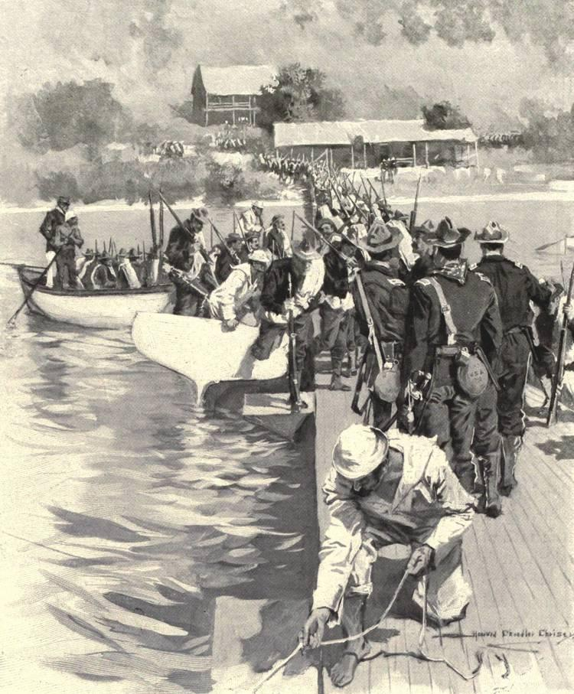
Puerto Ricans continue their search for identity in the United States
The island of Puerto Rico is about 1,150 miles from Florida, just to the east of Cuba. Since 1898, it has been considered a United States territory. It is part of the United States, but it is not a state.
For many years, Puerto Rican citizens lived in uncertainty. Are they citizens of the United States, or something else? Today, being born in Puerto Rico is not much different than being born in the United States. But it wasn't always that way, and a lot of questions still remain.

Status Of Those Born In Puerto Rico
U.S. law still describes Puerto Rico as an "unincorporated territory." That is a general term used in U.S. law. It means it is controlled by the United States government, but not officially a state.
Puerto Rico, Cuba and other islands were once part of the Spanish empire. Spain ruled these islands from thousands of miles away. These islands wanted independence from Spain. In the 1800s, they began to fight against Spain. Sometimes, they asked the U.S. for help in fighting Spain.

In 1898, the United States declared war against Spain in what was called the Spanish-American War. The U.S. won, and it claimed Puerto Rico and other islands owned by Spain.
After this, lawmakers discussed the Constitution. They said that the Constitution allowed the United States to govern Puerto Rico and the other territories taken from Spain after the war.
In 1901, the Supreme Court case Downes v. Bidwell took place. It decided that territories taken after 1898 would be ruled as "unincorporated territories." In other words, these territories were not meant to become states. The decision said that the islands "are inhabited by alien races, differing from us in religion, customs, laws" and "modes of thought."
But how would the Constitution apply to these territories? Are Puerto Ricans considered U.S. citizens?

Are Puerto Ricans Constitutional Citizens?
The Downes v. Bidwell case contains three basic ideas. These ideas are considered by lawmakers to be official rules.
First, it says there's a difference between U.S. states and unincorporated territories like Puerto Rico.
Second, people in unincorporated territories like Puerto Rico are not fully protected by the Constitution. U.S. citizens are fully protected, though.
Third, the U.S. Congress can treat Puerto Rico as a foreign country whenever it wants.

The Citizenship Clause
The 14th Amendment of the Constitution has a special part called the Citizenship Clause. It says that anyone born or "naturalized" in the United States is officially a U.S. citizen. A "naturalized" citizen is someone who wasn't born in the United States, but has lived in the United States for some time and obtained citizenship.
To this day, Puerto Ricans are not protected by the Citizenship Clause.
There was another big problem. In the early 1900s, anyone seeking to become a U.S. citizen had to say they weren't loyal to their old country anymore. For Puerto Rican citizens, this got confusing. In order to become a U.S. citizen, a Puerto Rican also had to reject the United States.
Because of this contradictory requirement, Puerto Ricans could not get U.S. citizenship.
In 1906, Congress passed a law that canceled this requirement. After this, many Puerto Ricans started to become official U.S. citizens. However, they still did not have all the rights of a true U.S. citizen. For example, they cannot vote in U.S. elections.
The Nationality Act of 1940 said that Puerto Rico was a part of the United States for citizenship purposes. Since 1941, when it comes to citizenship, being born in Puerto Rico is officially the same as being born in the United States.

Full Citizenship For Puerto Ricans
However, the general agreement among lawmakers and experts is that Puerto Ricans cannot get full constitutional citizenship. Puerto Ricans are officially U.S. citizens, but the territory remains unincorporated. This has allowed the United States to rule Puerto Rico as a separate and unequal territory. It belongs to the U.S., but is not a part of it.

Step 4: Answer the Questions

What do you think of how the U.S. is treating Puerto Ricans? Is it fair? Why or why not?

Put yourself in the shoes of someone who was born in Puerto Rico. Would you identify as an American, a Puerto Rican, or both? Explain why.

Although English is one of the two official languages in Puerto Rico, only a little more than 10% of people speak it. Most people speak spanish. How do you think this affects Puerto Rico’s national identity?

Student Feedback:
Circle the emojis that best represents how this activity made you feel.

