Week 4
Community

Day 1

NAME:______________________

Day 1 Agenda

Topic | Activity
Warm-Up!
English Language Arts | - Read the story, “Thank you, Ma’am” by Langston Hughes.  - Identify how the author helps the reader understand his characters.  - Respond to questions about the story.
Science | - Read about Ecosystems  - Answer questions about what you read  - Draw a picture of an ecosystem
Mindfulness Moment!
Math | - Real World Math: Defining Your Community: Looking more closely at the census data (census tracts, etc,)  - Practice Problems
Health | - What makes communities healthy or unhealthy
Mindfulness Moment!
Civics/Social Studies | - A New Community: Learn about Guatemala and its culture

Warm-up Activity: Write a journal entry around the daily quote on identity.

Day 1: How Do People in a Community Influence Us?
English Language Arts

What is this lesson about? Over the next week, you will be reading and reflecting on the idea of Community. Today, you will have the opportunity to read a short story about an interaction between two strangers who live in the same community and how they impact each other’s lives.

Step 1: Before reading

Read, think about and answer the following pre-reading questions. There is no wrong or right answer for these questions. They are designed to get you thinking about what the story will be about and to consider your own thoughts and ideas on some of the issues that it brings up.

- Should people be given a second chance after they have done something wrong? (lying, cheating, stealing?). Why or why not?

- A famous African proverb says that “It takes a village to raise a child”. Do you think this is true? Why or why not? (Should other people, other than your parents be involved in raising you to understand the difference between right and wrong?).

Step 2: Read and Annotate

The short story you are about to read, “Thank you Ma’am” was written by Langston Hughes, one of the most well-known writers of the Harlem Renaissance. As you read, think about how the author uses dialogue and descriptive language to create his characters.

Thank You, Ma'am
by Langston Hughes

She was a large woman with a large purse that had everything in it but hammer and nails. It had a long strap, and she carried it slung across her shoulder. It was about eleven o’clock at night, and she was walking alone, when a boy ran up behind her and tried to snatch her purse. The strap broke with the single tug the boy gave it from behind. But the boy’s weight and the weight of the purse combined caused him to lose his balance so, intsead of taking off full blast as he had hoped, the boy fell on his back on the sidewalk, and his legs flew up. the large woman simply turned around and kicked him right square in his blue-jeaned sitter. Then she reached down, picked the boy up by his shirt front, and shook him until his teeth rattled.

Stop: Write a couple of sentences summarizing what is happening in the text.

After that the woman said, “Pick up my pocketbook, boy, and give it here.” She still held him. But she bent down enough to permit him to stoop and pick up her purse. Then she said, “Now ain’t you ashamed of yourself?”
Firmly gripped by his shirt front, the boy said, “Yes’m.” The woman said, “What did you want to do it for?” The boy said, “I didn’t aim to.”
She said, “You a lie!”
By that time two or three people passed, stopped, turned to look, and some stood watching. “If I turn you loose, will you run?” asked the woman.
“Yes’m,” said the boy.
“Then I won’t turn you loose,” said the woman. She did not release him.
“I’m very sorry, lady, I’m sorry,” whispered the boy.
“Um-hum! And your face is dirty. I got a great mind to wash your face for you. Ain’t you got nobody home to tell you to wash your face?”
“No’m,” said the boy.
“Then it will get washed this evening,” said the large woman starting up the street, dragging the frightened boy behind her.
He looked as if he were fourteen or fifteen, frail and willow-wild, in tennis shoes and blue jeans.
The woman said, “You ought to be my son. I would teach you right from wrong. Least I can do right now is to wash your face. Are you hungry?”
“No’m,” said the being dragged boy. “I just want you to turn me loose.” “Was I bothering you when I turned that corner?” asked the woman. “No’m.”
“But you put yourself in contact with me,” said the woman. “If you think that that contact is not going to last awhile, you got another thought coming. When I get through with you, sir, you are going to remember Mrs. Luella Bates Washington Jones.”

Stop: Write a couple of sentences about what is happening. Predict what will happen next.

Sweat popped out on the boy’s face and he began to struggle. Mrs. Jones stopped, jerked him around in front of her, put a half-nelson about his neck, and continued to drag him up the street. When she got to her door, she dragged the boy inside, down a hall, and into a large kitchenette- furnished room at the rear of the house. She switched on the light and left the door open. The boy could hear other roomers laughing and talking in the large house. Some of their doors were open, too, so he knew he and the woman were not alone. The woman still had him by the neck in the middle of her room.
She said, “What is your name?”
“Roger,” answered the boy.
“Then, Roger, you go to that sink and wash your face,” said the woman, whereupon she turned him loose—at last. Roger looked at the door—looked at the woman—looked at the door—and went to the sink.
Let the water run until it gets warm,” she said. “Here’s a clean towel.”
“You gonna take me to jail?” asked the boy, bending over the sink.
“Not with that face, I would not take you nowhere,” said the woman. “Here I am trying to get home to cook me a bite to eat and you snatch my pocketbook! Maybe, you ain’t been to your supper either, late as it be. Have you?”
“There’s nobody home at my house,” said the boy.
“Then we’ll eat,” said the woman, “I believe you’re hungry—or been hungry—to try to snatch my pockekbook.”
“I wanted a pair of blue suede shoes,” said the boy.

Stop: Why did the boy want money? How is the relationship between the lady and the boy changing? How do you know?

“Well, you didn’t have to snatch my pocketbook to get some suede shoes,” said Mrs. Luella Bates Washington Jones. “You could of asked me.”
“M’am?”
The water dripping from his face, the boy looked at her. There was a long pause. A very long pause. After he had dried his face and not knowing what else to do dried it again, the boy turned around, wondering what next. The door was open. He could make a dash for it down the hall. He could run, run, run, run, run!
The woman was sitting on the day-bed. After a while she said, “I were young once and I wanted things I could not get.”
There was another long pause. The boy’s mouth opened. Then he frowned, but not knowing he frowned.
The woman said, “Um-hum! You thought I was going to say but, didn’t you? You thought I was going to say, but I didn’t snatch people’s pocketbooks. Well, I wasn’t going to say that.” Pause. Silence. “I have done things, too, which I would not tell you, son—neither tell God, if he didn’t already know. So you set down while I fix us something to eat. You might run that comb through your hair so you will look presentable.”
In another corner of the room behind a screen was a gas plate and an icebox. Mrs. Jones got up and went behind the screen. The woman did not watch the boy to see if he was going to run now, nor did she watch her purse which she left behind her on the day-bed. But the boy took care to sit on the far side of the room where he thought she could easily see him out of the corner of her eye, if she wanted to. He did not trust the woman not to trust him. And he did not want to be mistrusted now.
“Do you need somebody to go to the store,” asked the boy, “maybe to get some milk or something?”
“Don’t believe I do,” said the woman, “unless you just want sweet milk yourself. I was going to make cocoa out of this canned milk I got here.”
“That will be fine,” said the boy.
She heated some lima beans and ham she had in the icebox, made the cocoa, and set the table. The woman did not ask the boy anything about where he lived, or his folks, or anything else that would embarrass him. Instead, as they ate, she told him about her job in a hotel beauty-shop that stayed open late, what the work was like, and how all kinds of women came in and out, blondes, red-heads, and Spanish. Then she cut him a half of her ten-cent cake.
“Eat some more, son,” she said.
When they were finished eating she got up and said, “Now, here, take this ten dollars and buy yourself some blue suede shoes. And next time, do not make the mistake of latching onto my pocketbook nor nobody else’s—because shoes come by devilish like that will burn your feet. I got to get my rest now. But I wish you would behave yourself, son, from here on in.”
She led him down the hall to the front door and opened it. “Good-night! Behave yourself, boy!” she said, looking out into the street.
The boy wanted to say something else other than “Thank you, m’am” to Mrs. Luella Bates Washington Jones, but he couldn’t do so as he turned at the barren stoop and looked back at the large woman in the door. He barely managed to say “Thank you” before she shut the door. And he never saw her again.

Stop: What happened? What do you guess happened after the boy left the lady’s house?

Step 2: Complete the Characterization Graphic Organizer

Characterization is how an author tells us about the characters in her/her stories.
When an author uses DIRECT Characterization, he/she tells us DIRECTLY/CLEARLY what the character is like: For example: If the author says, “Fabian is funny and kind”. They don’t show us what he is like, they tell us directly.

When an author uses INDIRECT Characterization, we find out about the characters through actions, dialogue, appearance, thoughts and feelings or what other characters say about them. For example: If an author says, “When Fabian saw that Hope was sad, he started making jokes and acting silly. Sure enough, she soon started to laugh and forget her worries.” Here we see that Fabian is kind and caring, and that he is also funny…but we saw that through his actions.

Practice: Think about some of your own characteristics or personality traits (polite, enthusiastic, moody, etc.). Write one or two sentences about yourself where you use direct characterization Then write one or two sentences where you use Indirect characterization to show the same thing.

Direct Characterization | Indirect Characterization
Share your Indirect Characterization with a partner or with the group: Have them guess what your characteristic is. If they can’t guess, then revise your sentence to make it more descriptive.

Remember:

Direct Characterization | Indirect Characterization
Direct comments by the author | Actions  Words/Dialogue  Appearance  Thoughts and Feelings  Other Characters’ feeling about them

Now: Go back and look at the story and your notes: Choose ONE character from Thank you, Ma’am and identify 3 character traits that the character displays in the story. Provide evidence for your choice and then say whether it is direct or indirect characterization. There is an example set up for you.

Which character did you choose? _______________________

Trait:  (Example: Shy, Funny, Mean) | Evidence:  (Example: Fabian was making jokes that made others laugh.) | Type of Characterization: (Direct or Indirect)

Step 3: Answer the following questions

            - Why doesn’t Mrs. Luella Bates Washington Jones call the police? What do you think her intentions are when she deals with the situation with Roger?

            - Mrs. Luella Bates Washington Jones is first depicted (shown) as a tough lady. Is she? Or is she soft-hearted? Explain using text evidence.

            - After Roger washes his face, he has the opportunity to escape, why do you think he decides to stay? What does this decision reveal about the type of person he is?

            - Mrs. Luella Bates Washington Jones reveals something about her past. How does this impact how she treats Roger?

- Go back and look at your pre-write. Think about what you wrote. Now, apply the meaning of “It takes a village to raise a child” to this story. Do you agree with what Mrs. Louella Bates Washington Jones did? Why or why not?

Step 4: Write a Letter
Imagine that you are Roger and it has been 10 years since what happened in the story took place. Write a letter to Mrs. Luella Bates Washington Jones. Tell her what happened to you after you left her home and how this has influenced your sense of the meaning of community.

Dear Mrs. Luella Bates Washington Jones,

____________________________________________________________________

____________________________________________________________________

____________________________________________________________________

____________________________________________________________________

____________________________________________________________________

____________________________________________________________________

____________________________________________________________________

____________________________________________________________________

____________________________________________________________________

____________________________________________________________________

____________________________________________________________________

____________________________________________________________________

____________________________________________________________________

____________________________________________________________________

____________________________________________________________________

Student Feedback:
Circle the emojis that best represents how this activity made you feel.

Day 1: Ecosystems
Science

What is this lesson about?: Today you will read through the Ecosystems passage. You will answer a few questions about what you read. You will draw a picture of an ecosystem.

Step 1: Read through the Ecosystems passage
Ecosystems
softschools.com
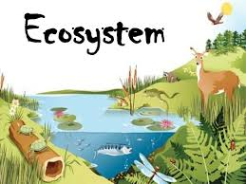
What is needed to survive? How do living things interact? Is there food, water, comfortable temperature, or shelter? All of the answers to these questions are found in the ecosystem. An ecosystem is all living things and non-living things and how they interact with each other. Ecology is the study of how all these things interact with each other in order to survive.
An ecosystem may be very small like a backyard or a pond. Or it can be large like a prairie, a desert, or a rainforest. There are freshwater ecosystems that cover less space than saltwater ecosystems. Regardless of where they are located or how small or large they may be; all ecosystems are made up of the same parts. These parts are either living or non-living parts and are equally important to the ecosystem.
The non-living parts of the ecosystem are called abiotic factors. All living things need non-living things in order to survive. Some of these abiotic factors include water, minerals, sunlight, air, climate, and soil.
All living things need water to survive. Living organisms are made up of between 50 and 95 percent water. The processes that keep living things alive like photosynthesis and respiration can only take place in the presence of water. Living things also need minerals such as calcium, iron, phosphorus, and nitrogen. Some living things need sunlight to make food. Animals need oxygen to produce energy for their bodies. The environment must also have the right temperature for organisms to survive. Without these non-living things, life would cease to exist. Abiotic factors are essential to the ecosystem.
Just like abiotic factors make it possible for organisms in an ecosystem to survive; biotic factors are equally important for survival in the ecosystem. Biotic factors or living parts of the ecosystem include animals, plants, fungi, protists, and bacteria.
Plants and algae are called producers. They produce oxygen and food that animals need. Animals are called consumers. They consume or eat the plants and other animals. Animals also give off carbon dioxide that plants need to make food. Thus the ecosystem is a continuous cycle of living and non-living things interacting with each other to survive.

What do fungi and bacteria contribute to the ecosystem? They are very important because they are called decomposers. They decompose, or break down, dead plants and animals and turn them into useful things like minerals that enrich the soil. Plants need this to grow. Each of these kinds of organisms helps the other to survive in the ecosystem.

Each kind of organism whether it is an animal, plant, fungus, or bacteria is a member of a different species. All the organisms of a species living in the same area make up a population. And all populations living in certain areas make up a community.
Scientists study the interactions of different populations in an ecosystem's community. This helps them to determine how an ecosystem stays healthy and continues to grow. It further describes how living and non-living organisms work together to provide survival for each other. Whether large or small, whether abiotic or biotic, the ecosystem depends on the interaction of each in order to remain healthy.
Step 2: Answer the following questions

- An ecosystem is best described by which of the following?
  - All living things and non-living things and how they interact with each other.
  - How living things survive and remain healthy.
  - All living things and non-living things and how they survive independently.
  - When the sunlight gives life to the non-living things.

- The non-living parts of the ecosystem are called which of the following?
  - Biotic factors
  - Environmental factors
  - Abiotic factors
  - Climate factors

- The living parts of an ecosystem are called which of the following?
  - Abiotic factors
  - Environmental factors
  - Climate factors
  - Biotic factors

- Each kind of organism whether it is an animal, plant, fungus, or bacteria is a member of a different:
  - Family
  - Species
  - Culture
  - Factor

- All the organisms of a species living in the same area make up which of the following?
  - An ecosystem
  - A producer
  - A population
  - A consumer

- Fungi and bacteria contribute which of the following to the ecosystem?
  - They decompose dead plants and animals and turn them into useful things.
  - They consume dead plants and survive in the community.
  - They provide oxygen to other plants and animals in the ecosystem.
  - They give off carbon dioxide to plants so they can make food.

- The environment must have the right temperature for organisms to survive.
  - TRUE
  - FALSE

Step 3: Draw a picture

Draw a picture of an ecosystem that you care most about. Be prepared to explain your drawing.

________________________________________________________________________________________________________

Student Feedback:

Circle the emojis that best represents how this activity made you feel.

Mindfulness Moment!

Make a Mixtape: Write out the songs you would add to your mixtape and give the tape a name on the lines below.

Side A  1.  2.  3.  4.  5.  6. | Side B  1.  2.  3.  4.  5.  6.

Day 1: The U.S. Census-why do they ask all those questions?
Math

What is this lesson about?: Today’ lesson focuses on the US Census and tries to answer the question: “why do they ask all of those questions?”

But first: Today’s Warm-Up
Kenny earns $9 per hour. He works 40 hours per week. He works 50 weeks per year. How much money does he earn in one year?

Melinda earns $12 per hour. She works 40 hours per week. She works 50 weeks per year. How much money does she earn in one year?

Adrian earns $25 per hour. He works 40 hours per week. He works 50 weeks per year. How much money does he earn in one year?

Based on these three examples, can you quickly estimate how much someone who earns $10 and works full time for 1 year would earn? How about someone who earns $7 per hour?

Step 1/Activity 1: Looking at Census data from 5 cities.
Review the chart below and answer the questions.
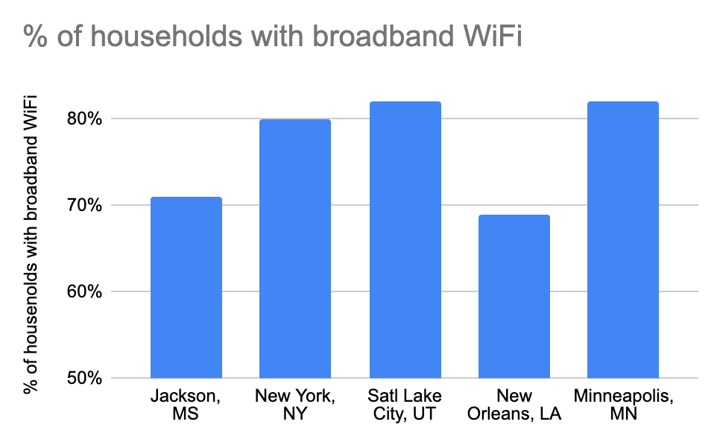

What CIty has the highest percentage of households with broadband WiFi?

What City has the lowest percentage of households with broadband WiFi?

Based on these 5 cities, what would your estimate be for a city like Birmingham, Alabama? What about a city like San Francisco or Seattle?

What is the average percentage of households with broadband for these 5 cities (you may need to approximate the %s based on looking at the graph)?

Does the average feel like it gives you an accurate picture? Yes/No? If no, write out a short sentence that would offer the reader a more complete story….

Step 2/Activity 2: Use the two charts to answer questions about the Census.

Here is a sample question from the actual US. Census.
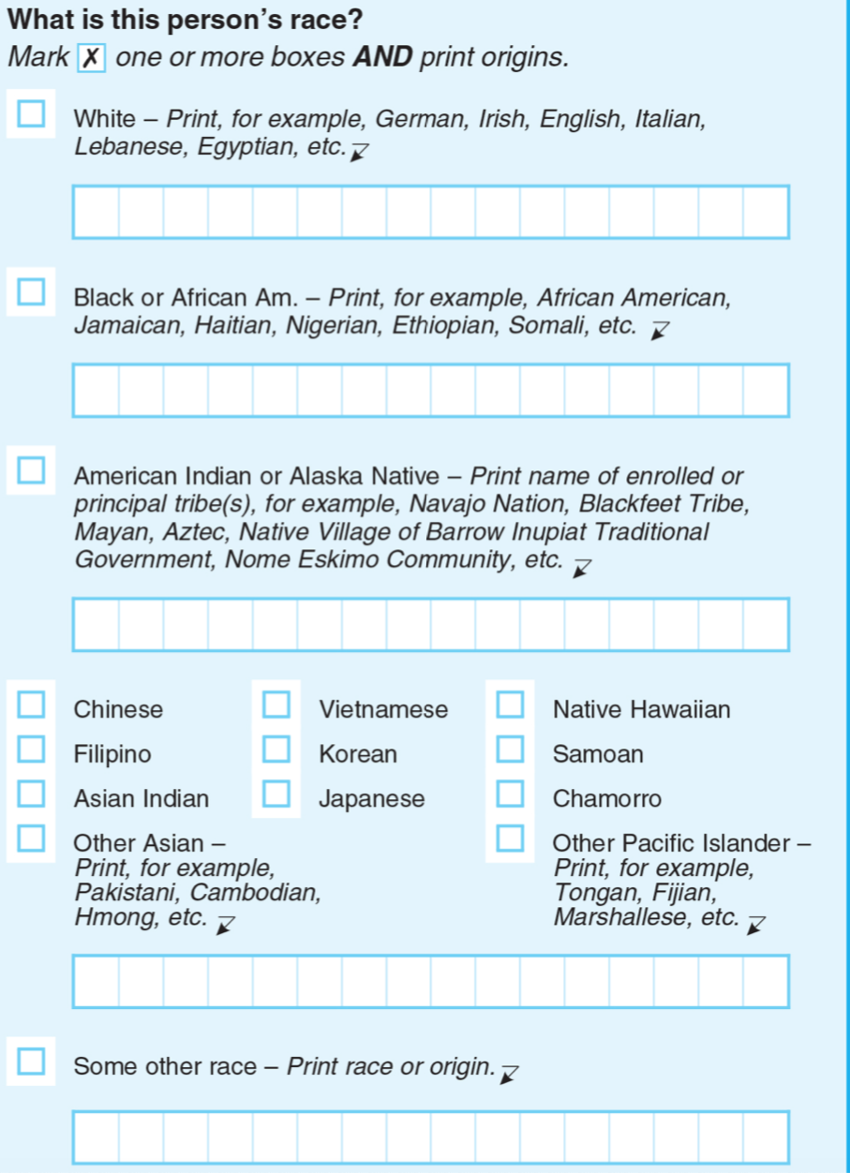
Many people wonder why we ask about race in the census. You see at the right what the census says about this question. Using the results of the question about race on the census, we can now take an even closer look at the data about who has access to broadband/WiFi. Use the chart below to answer the questions.
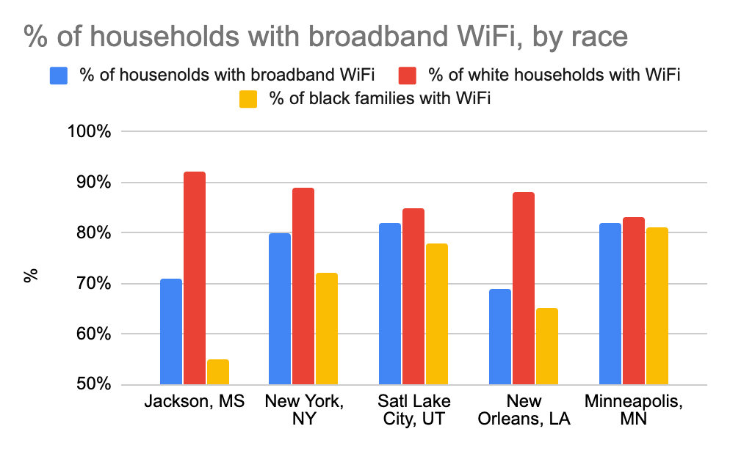

In what CIty is the % of black and white residents who have broadband the least disparate--meaning the % is almost the same?

In what CIty is the % of black and white residents who have broadband the most disparate--meaning there is a wide gap in the %?

Assume you are hired to be the new Superintendent of Schools for Jackson, MS. It is just a few months after the COVID-19 crisis has started to get better. You know how important it is for all students and families to have access to broadband internet access.

- Based on the data you now have, what policy might you try to enact to help bridge this gap in access?

- Is there a mayor of any of these other cities who you might want to talk to?
- Does having data about WiFi broken down by race going to help you try and come up with some smart decisions? How might that impact your decisions or policies as superintendent?

Step 3/Activity 3: Use the charts to answer questions about the Census.
Here is another sample question from the Census.
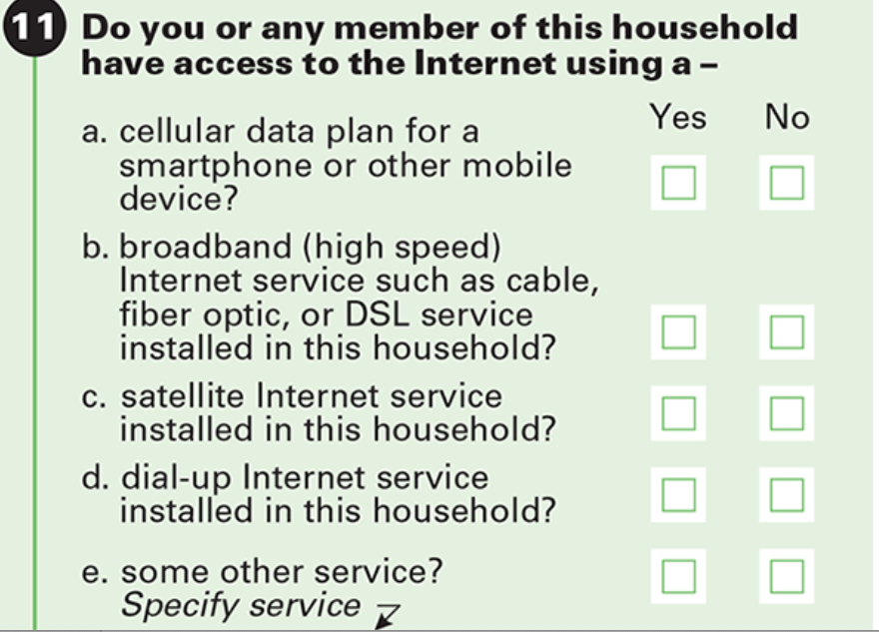

Many people wonder why we ask about internet access and family income in the census. Using the results of questions about family income and internet access on the census, we can now take an even closer look at the data about who has access to broadband/WiFi. Use the chart below to answer the questions.

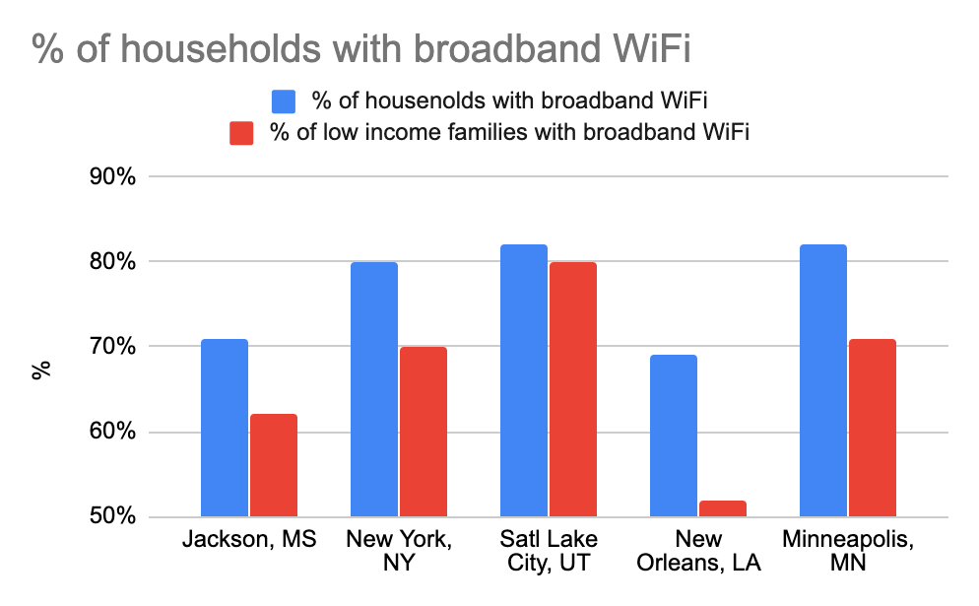
In what CIty is the % of lower income and wealthier residents who have broadband the least disparate--meaning the % is almost the same?

In what CIty is the % of lower income and wealthier residents who have broadband the most disparate--meaning there is a wide gap in the %?

Assume you are hired to be the new Superintendent of Schools for Jackson, MS. It is just a few months after the COVID-19 crisis has started to get better. You know how important it is for all students and families to have access to broadband internet access.

- Based on the data you now have, what policy might you try to enact to help bridge this gap in access?

- Is there a mayor of any of these other cities who you might want to talk to?

- Does having data about WiFi broken down by family income going to help you try and come up with some smart decisions? How might that impact your decisions or policies as superintendent of schools?

Step 4/Activity 4: Concluding Thoughts-

What is one benefit of including questions about family income or race or educational attainment in the Census?

What could be one downside, or negative, of including questions like this in the Census?

Skill Builders and Review Problems
- See separate handout

Student Feedback:

Circle the emojis that best represents how this activity made you feel.

Day 1: What makes communities healthy or unhealthy?
Health

What is this lesson about?: In today’s lesson, you will reflect on what makes something or someplace healthy, and how you measure the health of something. You will then explore how aspects of neighborhoods affect the health of the people who live in those neighborhoods.

Step 1: Warm-Up

Take a moment to reflect on what makes something healthy and how do you measure it.
Fill in the below table with your thoughts. Remember, health can be physical, mental, or environmental (ex: conflict, pollutions, etc.).

 | Healthy/Unhealthy? | How do you know?  (indicators)
Individual | What do you do to make yourself healthy or unhealthy? | How do you know whether your healthy or not?
School | What is healthy or unhealthy about your school? | How do you measure it?
Neighborhood | What is healthy or unhealthy about your neighborhood? | How do you measure it?

Step 2: Read and learn

How Can Your Neighborhood Affect Your Health?
Our neighborhoods are highly correlated with the quality of our housing, municipal services, health care and educational and employment opportunities, which can have a significant impact on our health. Depending on where we live, our health may be adversely affected by neighborhood characteristics such as poor air and water quality, proximity to hazardous substances, substandard housing, and lack of access to nutritious foods and safe places to exercise or play. Conversely, for many, neighborhood aspects such as the presence of sidewalks and playgrounds, after-school programs for children, and affordable nutritious food encourage healthy behaviors and make it easier to maintain them.

Step 3: Neighborhood features activity

Complete the following table. Try and focus on features in your own neighborhood.

Neighborhood Feature | Potential Health Impacts
Example: Living near a freeway or road with lots of truck traffic | Asthma from diesel pollution; noise disturbs sleep
Plenty of parks
Lots of fast-food restaurants
Noise

Step 3: Reflection

On your own, or with a partner, reflect on the following questions.

One a scale from 1 (super unhealthy) to 10 (super healthy), how healthy do you think your community is? Why?

How do you think you could make your community/neighborhood healthier?

Mindfulness Moment!

Favorite Lyrics: Write down the lyrics to your favorite song.

Day 1: Communities of the World: Guatemala
Social Studies

What is this lesson about?: This week in Social Studies, you will explore different communities from around the world. You’ll learn about 4 countries and the people who live there, and then you will complete a project on your own community. Today, we will focus on the country of Guatemala.

Step 1: Warm-up

Have you heard of Guatemala before? What do you know about it? List some things you know about Guatemala (like where it is, what language Guatemalans speak, what they eat, etc.)

Step 2: Read the article on Guatemala.

Countries Of The World: Guatemala
By National Geographic Kids, adapted by Newsela staff
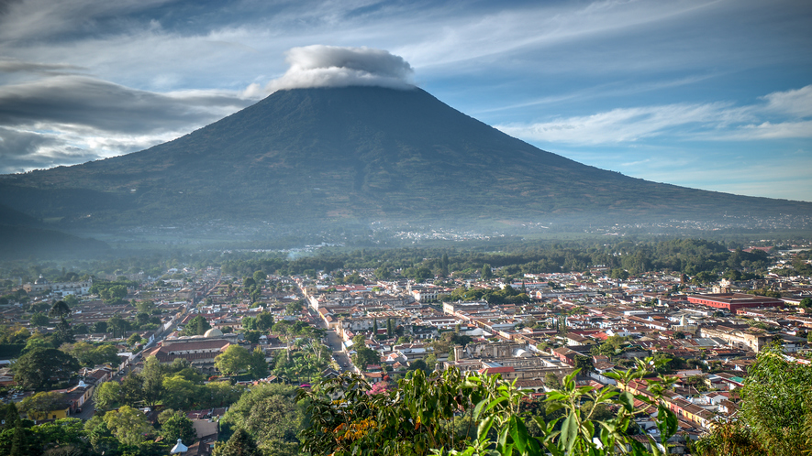
Guatemala is a country of volcanoes, mountains and beaches on the Pacific Ocean and the Caribbean Sea. This small country is marked by contrasts. The land includes everything from highlands to long, sandy coastlines. Guatemala has more than two dozen volcanoes, and four of them are still active.
The Pacaya volcano near Guatemala City is one of the most active in the country. Lake Atitlan formed when a volcano exploded over 84,000 years ago and caved in to form a crater. The lake is the deepest lake in Central America. It is believed to be more than 1,000 feet deep and covers 49 square miles.
Guatemala is only slightly larger than the U.S. state of Tennessee. It is a mountainous country. One-third of the population lives in cooler highland villages. The coastal lowlands are warm and humid. The country is bordered by Mexico, Honduras, El Salvador and Belize.

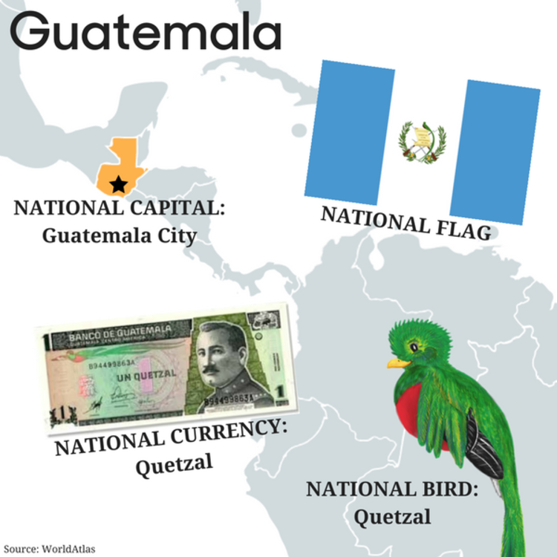
Nature
High in the mountains lives a bird called the Resplendent Quetzal. In the bright sunshine, both the male and female quetzal have bright green, white and red feathers. The male has a fabulous tail that can reach 3 feet long.
The cloud forest mist provides a water source to air plants known as bromeliads. These plants cling to tree trunks. The branches, tree trunks and forest floor are home to orchids, ferns and mosses.
The lowland Petén region in the northeastern part of the country is home to many animals. They include jaguars, tapirs, monkeys and mule deer.

People And Culture
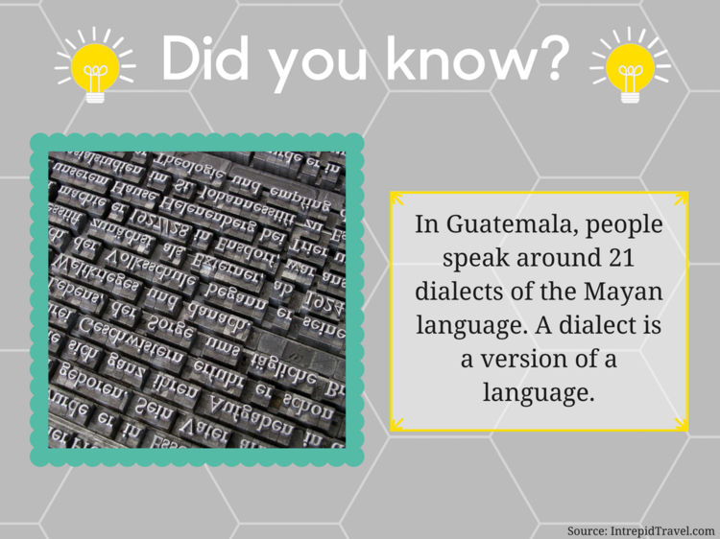
Guatemala was once home to an ancient civilization called the Maya. The Maya were very advanced in math and science. They probably developed the concept of zero and left written records using glyphs, symbols that stood for different words.
Today, Maya women continue to weave brightly colored cloth. They fashion the same traje, or suit, that their ancestors wore. The population of Guatemala is almost 40 percent native (mostly Maya). The largest of the 20 Maya groups is the K'iché. They live near the city of Quetzaltenango, called Xela (SHEH-la) by the locals.
Guatemala was the ancient name of the region where the K'iché people lived. Historians are not completely sure what it means. Some say that "Guatemala" means "land of many trees." Others think it refers to the "mountain that vomits water," a volcano near the old capital in Antigua. Today, this volcano is called Volcán de Aqua, "Volcano of Water."

Government And Economy
Guatemala's economy boomed in the 1870s thanks to coffee exports. To make way for more coffee plantations, wealthy landowners pushed Maya communities off their land. The conflict between the government and native groups led to decades of civil war. More than 200,000 Guatemalans were killed in the ongoing conflict. In 1996, a new president named Alvaro Arzú signed a peace agreement with the rebels. This brought the long civil war to an end.
A new constitution in 1986 established three branches of government. The president serves for only one term and is assisted by a vice president and the Council of Ministers. New laws are passed by Congress.
The current president is Jimmy Morales. He was elected in 2015.

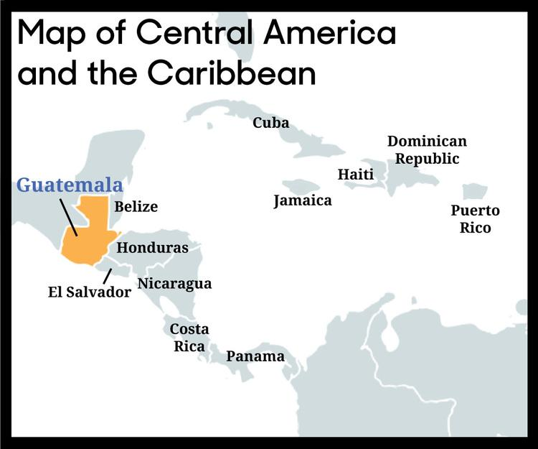
History
Scientists believe that people have lived in Guatemala for at least 11,000 years. People began to farm and form villages here possibly as long ago as 2300 B.C. Some of them became the Maya. The Maya civilization ruled this region from about 1000 B.C. to A.D. 900.
One of the great Mayan cities in Guatemala was Tikal, which was once home to about 100,000 people. The great Temple I in Tikal was built over 1,300 years ago. Tikal began to decline in the year A.D. 850 and was abandoned about 50 years later. The ruins were not discovered for another thousand years.
In the 1500s, the Spanish invaded Guatemala and fought the largest remaining group called the K'iché. The K'iché were overpowered and forced to work on vast estates. Soon, this land became part of a huge colony called "New Spain."
In 1821, Guatemala declared independence from Spain.

Step 3: Answer questions

Correct me if I’m Wrong: Read the following statements and decide whether they are true or false. If a statement is false, correct it by finding the correct information from the article above.

Example: FALSE Guatemala has many volcanos. None of the volcanos are currently active.
4 of Guatemala’s valcanos are currently active.

- ________ About 40% of Guatemalans are of indigenous decscent.

- ________ Guatemala had a civil war that lasted for decades and ended in 2006.

- ________ Oil is a big export in Guatemala.

- ________ The Maya civilization ruled the region of Guatemala for alost 2,000 years

- ________ In 1821, Guatemala declared independence from Mexico.

Step 4: Read about the typical food of Guatemala
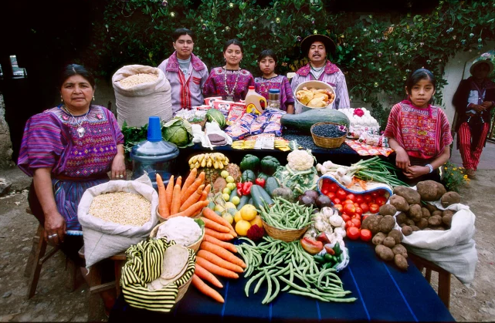
Photo and excerpt from the book, "Hungry Planet: What the World Eats, by Peter Menzel.

The Mendozas of Todos Santos, Guatemala in their courtyard with a week’s worth of their food - Food expenditure for one week: 573 Quetzales or $75.70. Family Recipe: Turkey Stew and Susana Perez Matias's Sheep Soup.

Except during holidays, most families in Guatemala eat meat less than once a week. Three times a say they eat rice, beans, potatoes, eggs, and tortillas in one combination or another. Some families who do not live near the ociean rarely eat fish. One of the Mendoza daughters shown above explained that they do not eat candies or dessert. “If we want dessert, we have a banana.” The Mendozas eat fruit and vegetables when they are in season only because the stores and local market don’t have refrigeration and transportation necessary to stock out-of-season items.

Recipe: Arroz Guatemalteco (Guatemalan-Style Rice)
Ingredients
2 cups long grain rice
2 Tablespoons oil
1 cup mixed vegetables (carrots, celery, sweet red peppers, green peas), finely chopped
Salt and pepper, to taste
4 cups chicken stock
Procedure
Heat the oil in a heavy saucepan and add rice.
Sauté lightly until the rice has absorbed the oil, being careful not to let it change color.
Add the mixed vegetables, salt, pepper, and chicken stock.
Bring to a boil, cover, and reduce heat to low.
Cool for about 20 minutes until rice is tender and the liquid has been absorbed.

Excerpt from Foodbycountry.com

Guatemala does not have a national dish, but there are many foods that have become a part of the everyday diet. Just as during the time of the Mayans, corn continues to be a staple food. It is most often eaten in the form of a tortilla (a thin corn pancake). These are usually served warm and wrapped in cloth. Black beans ( frijoles) , another Mayan staple, are eaten at almost every meal. They are usually refried ( volteados ), mashed, or simply eaten whole ( parados ). Rice, eggs, and cheese are also widely consumed.
Chicken, turkey, and beef (roasted, grilled, or fried) are the country's most popular meats and are normally accompanied by beans and rice ( frijoles con arroz ). Meats are often served in stews ( caldos ) or cooked in a spicy chili sauce, though whole chickens may occasionally be served with the feet still attached. Pepián , a thick meat and vegetable stew, is a common dish in the area of Antigua (a town just outside of Guatemala City, the country's capital). Seafood is most common along the coasts, and is usually prepared with various spices.
Other popular dishes are bistec (grilled or fried beef), guacamole (mashed avocado with onions and spices), mosh (porridge), churrasco (charcoal-grilled steak), and chiles rellenos (chiles stuffed with meat and vegetables). Fresh fruits and vegetables, such as yucca, carrots, plantains, celery, cucumbers, and radishes, help to keep the Guatemalan diet healthy. However, snacks, such as doughnuts ( donas ), are also widely popular.
Guatemalan coffee, which is most often exported, is considered some of the best in the world. Most Guatemalans, however, tend to drink weak coffee loaded with plenty of sugar. Rich, savory coffee is more commonly found in tourist areas. Aguas , soft drinks, are also abundant. Sweetened fruit juice mixed with either water or milk, called licuado , is a refreshing alternative.
Step 3: Answer questions

What foods do the Mendozas have at their house?

What do you eat that the Mendozas do not?

What is the biggest difference between the food the Mendozas have and the food you have at your home?

The excerpt mentions that many Guatemalan dishes are based on Mayan culture and recipes. Do you think American food is based on food from different cultures? What cultures? And why do those cultures influence our food?

Step 4: What does a typical family home look like in Guatemala?
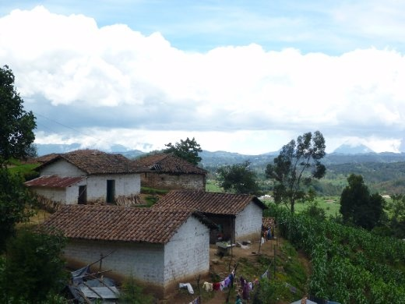
Photo ro right: A typical home, overlooking mountainous Guatemalan highlands.

Adapted from Scholastic’s The New Book of Knowledge

Most Guatemalans in rural communities live in simple, one-room houses. The houses are made of sun-dried adobe bricks with tile roofs or wood with thatched roofs. In general, everyone lives, sleeps, and eats in the same room.

Houses are clustered into villages. Several villages make up a municipio, or municipal district. The center of each municipio is the focus of local social and economic life. Most residents go to the center regularly to sell goods at the market, buy necessities, or catch public transportation to their workplaces in larger cities. Rural Guatemalans tend to retain strong ties to their village and municipio even if they move away.
Step 5: Explore the culture of Guatemala.
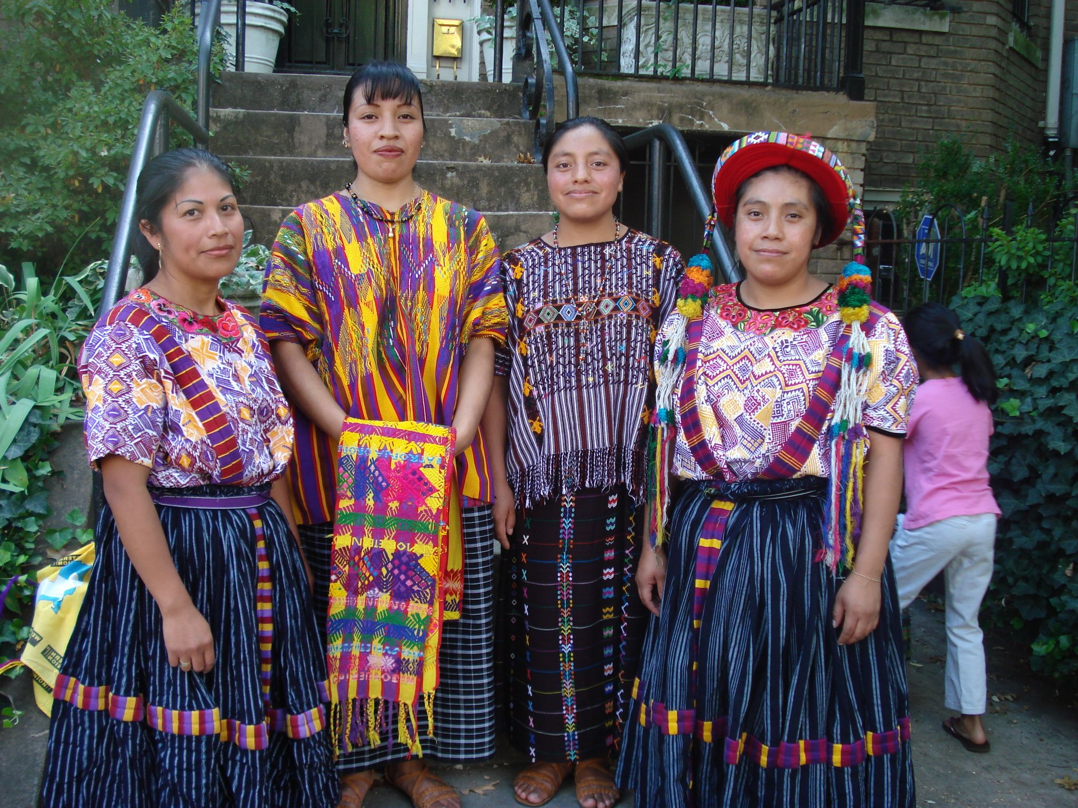
Adapted from Scholastic’s The New Book of Knowledge

People
Approximately half of all Guatemalans are indígenas, or native Indians who consider themselves descendants of the ancient Maya. The Maya lived in the region long before Spanish conquerors arrived in 1524.

The other major group in Guatemala is made up of ladinos. They are either of mixed Spanish and Maya descent or are ethnic indígenas who have given up the culture of their ancestors. Westernized practices and Spanish speech distinguish ladinos from the Indians.
The Garífuna people, a third group, live along the Caribbean coast. They are also known as Black Caribs. Their cultural and ethnic roots are part African and part Caribbean.

Language
Spanish is the official language. It is used in business, politics, and legal proceedings. Some 5 million Guatemalans speak native Maya languages in addition to Spanish or as their only tongue.

Guatemala has 21 different Maya languages. The most common are Kekchí, Quiché, Cakchiquel, and Mam. Some of the other Maya languages are threatened by extinction. They are spoken only among older generations and are not being passed down to their children. The Garífuna speak their own language. It is of South American origin.

Religion
Roman Catholicism is the principal religion in Guatemala. It has been so since Spanish missionaries introduced it in the 1500's. But today Evangelical Protestantism is attracting an increasing number of followers. Other Guatemalans practice a religion that is a unique blend of Catholicism and Maya traditions and rituals.

Education
Only about half of all Guatemalans receive formal education. Less than 15 percent finish high school. Boys are more likely than girls to be literate (able to read and write). Just over 50 percent of Guatemalans above the age of 15 are literate.

Classes in almost all the country's schools are conducted in Spanish. This is a disadvantage to schoolchildren in rural areas where Maya languages are dominant. Recently there have been efforts at bilingual education, with classes taught in both Spanish and a native language. But the national education system still tends to discourage Maya children from using the language of their ancestors.
Step 3: Answer questions

- What are the religions of Guatemala? Are any of them the same as in the USA?

- What are the houses typically made from in Guatemala?

- What are houses typically made of in the USA? How do you think our homes are different than guatemalan homes?

- What are the two most interesting things you learned about Guatemala?

- What more do you want to know about Guatemala?

Student Feedback:
Circle the emojis that best represents how this activity made you feel.

