Week 6
Change

Day 1

NAME:______________________

Day 1 Agenda

Topic | Activity
Warm-Up!
English Language Arts | - Read and annotate the poem Nothing Gold Can Stay  - Find common themes in the song “Stay Gold”  - Respond to questions about the poems.
Science | - Read about Chemical and Physical Changes  - Answer questions about what you read  - Draw a picture and explain
Mindfulness Moment!
Math | - Focusing on Percents and Percent Change...
Health | - What impact does change have?
Mindfulness Moment!
Civics/Social Studies | - Does history change over time?  - Read and respond to the text

Warm-up Activity: Write a journal entry around the daily quote on identity.
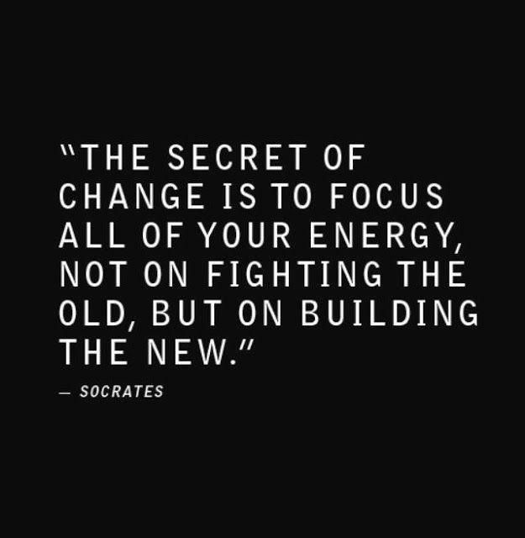

Day 1: Change
English Language Arts

What is this lesson about? Over the next week, you will be reading, thinking, talking and writing about “change”. Change is constantly happening, internally and externally and whether we want it or not. You will be reading about how the teen brain changes and how it handles change and you will read a variety of texts about personal and social change. Today, you will read two pieces of poetry about change and analyze them. You’ll reflect on the theme of change and write about your own experiences.

Before you read: Some vocabulary and references to understand:

hue: color or shade of color | subside: to become less intense, to go down | Eden: the garden as described in the Bible where Adam and Eve lived in paradise or perfection until they fell to temptation and paradise was lost.

Step 1: Read and Annotate the Poem
Before you read, think about springtime in nature and what happens. What are some of the early signs that winter is over and spring is coming? As you read, write notes interpreting what you think it is talking about.

Nothing Gold Can Stay
By Robert Frost.
1  2 | Nature’s first green is gold  Her hardest hue to hold
3  4 | Her early leaf’s a flower;  But only for an hour.
5  6 | Then leaf subsides to leaf,  So Eden sank to grief.
7  8 | So dawn goes down to day  Nothing gold can stay.

Step 2: Answer the following questions.

- In line 1, what is “nature’s first green”? Hint: Think about what happens in the spring.

- The speaker says that nature’s first green “is gold.” What are some words, ideas, images, or emotions that we associate with gold? Are these associations mostly positive or negative?

3. Considering your answer to question 2, what is the speaker saying about “nature’s first green” when he calls it “gold”?

4. In line 2, the speaker says that gold is nature’s “hardest hue to hold.” As it is used in this line, what does hold mean?

5. In lines 3 and 4, the speaker says that nature’s early leaf is a flower that lasts only for “an hour.” Do you think he means this literally—that the flower dies after one hour? If he doesn’t mean it literally, what is the speaker saying here?

6. Tone is the attitude that the speaker or poet has towards what he is writing about. Look at lines 1-4 then lines 5-6. What is the change or shift in tone that happens? What words reveal this change?

7. Consider the three things in the poem that change: a bud, Eden, and dawn. What do these three things have in common?

Step 3: Read the lyrics to the following song.

The Outsiders is a coming-of-age novel by S. E. Hinton, first published in 1967 when] Hinton was 18 years old. The book tells the story of the the conflict between two rival gangs divided by their socioeconomic status: the working-class "greasers" and the upper-class "Socs" (short for Socials).

In the novel, after a particularly dramatic scene, one character tells his very close friend to “Stay Gold” as he is dying, referring to the poem by Frost. When a movie based on the novel was made in 1983, Stevie Wonder wrote and performed a song for the movie called “Stay Gold”. As you read the lyrics think about how this song connects to the original poem by Frost and how it is different.

Before you read: review some vocabulary and references:

seize: to hold on to | steal away: to escape to | compassion: concern for the suffering of others.

 | Stay Gold  By Stevie Wonder | Notes: Summarize your interpretation of what the speaker is saying.
1  2  3  4  5 | Seize ... upon the moment of long ago  One breath away and there you will be  So young and carefree again you will see  That place in time  So gold
6  7  8  9  10 | Steal ... away into that way back when  You thought that all would last forever  But like the weather nothing can ever  And be in time  Stay gold
11  12  13  14  15  16  17  18  19  20  21  22  23 | But can it be ... when we can see  So vividly a memory  And yes you say so must the day  To fade away  And leave a ray of sun  So gold  Life ... is but a twinkling of an eye  Yet filled with sorrow and compassion  Though not imagined all things that happen  Will age too old  Though gold  Stay gold

Step 4: Answer the following questions

- Where does the speaker want the reader to go (in his/her imagination) in lines 1-5?

- According to the speaker, how did they feel about life “way back when”?

- Why do you think most people tend to look at the past in that way? Why is that time considered “so gold”?

- There is a tone shift starting on line 8. What does the speaker start to describe?

- Interpret the lines 17-18 into your own words:
“Life ..is but a twinkling of an eye
Yet filled with sorrow and compassion”

- In the movie, one friend is telling the other to “stay gold”, what does he mean by that?

- In Frost’s poem, he is talking about nature. In Stevie Wonder’s song, he is referring to a friendship. What is the common theme (message of the poem)? What can we learn from this theme?

Step 5: Think, Write and Share your responses with a partner

Read, think about and answer the following questions.. There is no wrong or right answer. The questions are designed to have you reflect on what you read and your own feelings about change.

Write for 8 minutes: Why do we tend to see events “back in the day” or in our pasts generally more positively than what we experience in the present? Do you think that change is good or bad? Explain.

Student Feedback:

Circle the emojis that best represents how this activity made you feel.

Day 1: Chemical and Physical Changes
Science

What is this lesson about?: Today you will read through the Chemical and Physical Changes passage. You will answer a few questions about what you read. You will draw a picture and write a response.

Step 1: Read through the Chemical and Physical Changes passage

Chemical and Physical Changes
(Generation Genius)

In a chemical change, a new substance is made, like when you burn a candle. In a physical change, no new substance is made, like when water turns to ice. To better understand the difference, let’s break it down!

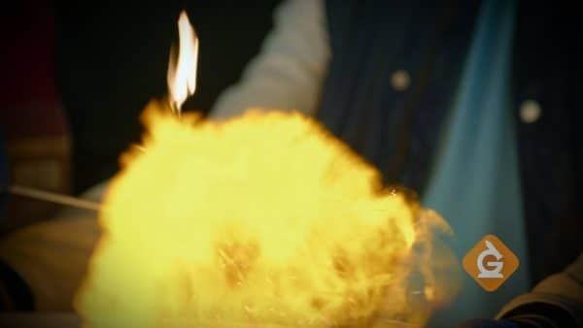
Chemical changes make new substances
Anytime a new substance is made, a chemical change takes place. Usually two or more materials are combined and a new substance is formed. A chemical change can produce amazing explosions, like fireworks. Some chemical changes are a little more difficult to spot, like when a nail rusts.
If you notice bubbles being formed, or a change in color or temperature, there is a good chance a chemical change has taken place, but not always. Scientists can determine if a chemical change has occurred by asking this question: Was the substance formed present before? If the answer is no, then it is a chemical change.

Since chemical changes make new substances, most of them cannot easily be undone. For example, when you burn wood, you can’t really turn the gases back into a log very easily.

Physical changes do not make a new substance.
Physical changes come in many forms. It can be a change in the shape or appearance of an object, like crumpling a piece of paper, or cutting, bending, or dissolving something.

Since objects do not become a different substance during a physical change, it is usually easy to reverse the change. For example, if you dissolve sugar in water you can easily reverse the change by evaporating the water from the solution. When all the water evaporates, sugar crystals will be left behind.

Physical changes also happen when matter changes states.
There are three common states of matter: solid, liquid, and gas. When a substance changes states (from a liquid to a gas, for example), it is undergoing a physical change.

In the video, when the gallium spoon melted in hot water, the gallium did not become a different metal. Melting is an example of a phase change, where a solid is changed to a liquid. Freezing and boiling are also physical changes.

Chemical and physical changes are all around us.
Chemical and physical changes take place around you all the time. When you make cereal for breakfast, combining the milk and cereal is a physical change. When you eat the cereal, a chemical change happens during digestion.

Sometimes, it can be difficult to tell if a chemical or physical change is taking place. In the video, Dr. Jeff and the team explore a few different reactions to determine if they are chemical or physical changes, by figuring out if the material made after the reaction was present before the reaction.

EXAMPLES OF CHEMICAL AND PHYSICAL CHANGES
Chopping a banana - Since cutting a banana only changes its appearance, a new substance is NOT formed. That makes this an example of a physical change.
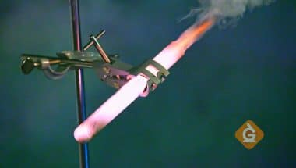
Burning a gummy bear - When the gummy bear was placed into a test tube with the oxidizer, the gummy bear burned up and created new chemicals. Since new chemicals were formed, it is an example of a chemical change.

Coke and Mentos - Mixing Coke and Mentos looks like a chemical change, but since the gas released is carbon dioxide AND it was present before the foaming happened, it is actually a physical change.

Vocabulary for Chemical and Physical Changes

Catalyst - A substance that speeds up a chemical reaction.
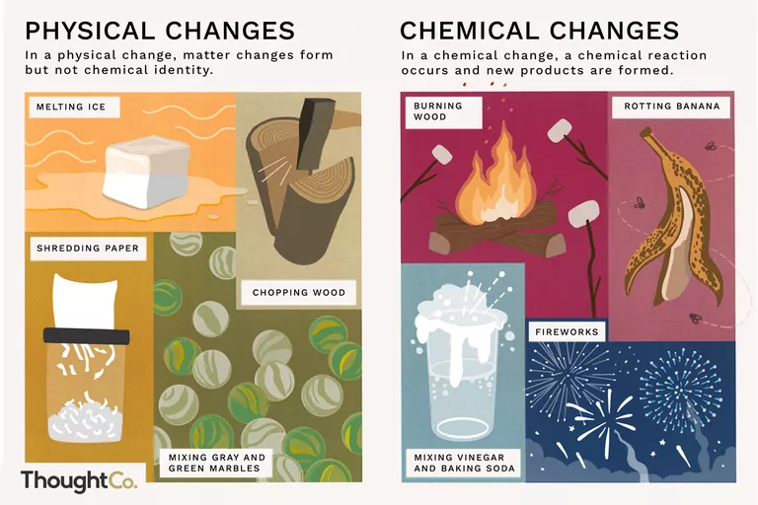
Chemical Change - a type of change in which a new substance is formed; for example: burning something.

Physical Change - a type of change in which a new substance is NOT formed; for example: boiling water.

Oxidizer - a chemical that provides a lot of oxygen to help things burn.

Carbon Dioxide - a gas without any color or smell that is commonly found in soda. It is also called CO2 and comes out the back of a car or bus that is running.

Hydrogen - a gas less dense than air that has no color or smell. It is extremely flammable, meaning it can burn.

Step 2: Answer the following questions

Study the vocabulary words above. Try to complete the vocabulary quiz without referring back to the text.

- ______________________________ is a type of change in which a new substance is formed; for example: burning something.

- ______________________________ is a type of change in which a new substance is NOT formed; for example: boiling water.

- ______________________________ is a substance that speeds up a chemical reaction.

- ______________________________ is a chemical that provides a lot of oxygen to help things burn.

- ______________________________ is a gas less dense than air that has no color or smell. It is extremely flammable, meaning it can burn.

- ______________________________ is a gas without any color or smell that is commonly found in soda. It is also called CO2 and comes out the back of a car or bus that is running.

Word Bank
Catalyst Oxidizer Carbon Dioxide
Chemical Change Physical Change Hydrogen

Step 3: Draw a picture and describe

Draw a picture and describe 2 examples of a chemical change.

________________________________________________________________________________________________________
____________________________________________________________________________________________________________________________________________________________
Draw a picture and describe 2 examples of a physical change.

________________________________________________________________________________________________________________________________________________________________________________________________________________

Student Feedback:

Circle the emojis that best represents how this activity made you feel.

Mindfulness Moment!

Day 1: Change/Understanding %
Math

What is this lesson about?: Today we are going to focus on understanding percentages, and percentage change. These concepts come up often in everyday life and it is important to be able to understand them.

Today’s Warm-Up Problem
Kenny invested $100 in the stock market. One year later his stock was worth $110.
Alvin invested $10 in the stock market. One year later his stock was worth $20.
- Who made more money over the course of the year?
- Who made a better investment?
- Do you know what % return Kenny got on his investment?
- How about Alvin?

San Antonio had a population of 2,000,000 in 1980. By 1990 it had a population of 3,000,000.
Houston had a population of 5,000,000 in 1980. By 1990 it had a population of 6,000,000.
- What city grew more over that 10 year period?
- What city, do you think, experienced a greater % increase over the 10 year period.

Activity #1: Getting the Basics down…

Percent is a way of saying “out of one hundred”

Example: If you get a 90% on a test that means you earned 90 out of 100.
- Consider: How does your teacher know that you got a 90% if the test only had 50 questions (and not 100).

Example: James Harden shoots 40% from behind the three point line means that out of every 100 three point shots he takes, he makes 40.
- Consider: How do we calculate his % shooting in a game when he only takes 20 shots (and not 100?)

When you see decimals written out to 2 decimal places, that is also “out of one hundred” or x “hundredths.”

Example: How do you say: 5.25. Many people say: “five point two-five”.

- But a more correct way to say that is: “five and 25 hundredths.” 25 hundredths is the same as twenty-five percent. You might also think of it as 25 cents….

Practice writing out below how to ‘say’ each of the decimals below. Do NOT write out “point 20” or ‘point 02” or “one hundred point 40”. Use the word “hundredths” -- that will get you thinking in percents!
- Example: 5.25= five and twenty-five hundredths…

.07 = _________________________________ .44 = _________________________________

.21 = _________________________________ 3.14 = ________________________________

21.21 = _________________________________ .09 = _________________________________

.80 = _________________________________ 2.88 = ________________________________

100.07 = _________________________________ .22 = _________________________________

Activity 2: Converting decimals to percents…

When you say .07 as “seven hundredths” you are saying that it is the same as 7 out of 100….and that is the same as 7%!

When you say .50 as “fifty hundredths” you are saying that is the same as 50 out of 100….and that is 50%.

Now, write each of the decimals below as a percent…
- Example: .04 = four percent or 4%

.07 = seven percent or 7% .44 = _________________________________

.21 = _________________________________ .14 = _________________________________

.29 = _________________________________ .18 = _________________________________

.89 = _________________________________ .88 = ________________________________

.079 = _________________________________ .24 = _________________________________

NOTE: If the decimal goes beyond 3 places, round it off to the hundredths place (2 digits) and convert to a %...

- Example: .048 → rounds off to .05 = five percent or 5%
- Example: . 089218 → rounds off to .09 = nine percent or 9%

Round each decimal below to the hundredths place and convert to a %.

Example: .071 rounds to .07 = seven percent or 7%

.222 rounds to _______ = ____________________________

.0295 rounds to ______ = ____________________________

.589 rounds to _______ = ____________________________

.009 rounds to _______ = ____________________________

.8598 rounds to ______ = ____________________________

.031 rounds to _______ = ____________________________

.7575 rounds to ______ = ____________________________

Step 3: Converting Fractions to Decimals

There are two main ways to convert a fraction to a decimal.

- Option 1: You can find an equivalent fraction that has 100 in the denominator (the number at the bottom of the fraction). In that case, the numerator (the number in the top of the fraction) is the number ‘out of one hundred” do it is the %.

Note, you only do this when the denominator can easily be converted to 100. So it works well if the fraction has 2, 4, 5, 10. 20. 25 or 50 in the denominator. Let’s try some of those below-

Example:
¼ = __/100 → ask yourself what you multiply 4 by to = 100. That is 25. So, multiply 1 x 25. → ¼ = 25/100 == 25%

25/100 is the same as twenty-five one hundredths...or 25%

Convert each of the fractions below to a fraction with 100 in the denominator, the write the % below

2/10 = __/100 5/10 = ___/100 9/10 = ___/100

= _____% = _____% = _____%

2/5 = ___/100 4/5 = ____/100 1/5 = ____/100

= _____% = _____% = _____%

2/25 = ___/100 20/25 = ____/100 10/25 = ____/100

= _____% = _____% = _____%

2/50 = ___/100 20/50 = ____/100 40/50 = ____/100

= _____% = _____% = _____%

2/4 = ___/100 1/4 = ____/100 3/4 = ____/100

= _____% = _____% = _____%

- Option 2: You simply divide the numerator by the denominator, and then round the decimal off to two digits (remember from above).... This is what a fraction means: ¾ is the same as three (3) divided by four (4).

If you have a calculator, this can be quite quick (clearly). If you have to do it by hand, make sure only go out to 3 digits and not spend lots and lots of time on it. So, try out a few of these below. If you don’t have a calculator, just try and handful of these to get a feel for how these fractions convert to a decimal...and then to a percentage.

Example:

2/5 = 2 divided 5 = .40 → you say that as “forty hundredths” or 40%

⅛ = ____________________ = _____ → you say that as ____________________ or ____%
Write it out decimal how many hundredths %

3/9= ____________________ = _____ → you say that as ____________________ or ____%
Write it out decimal how many hundredths %

7/15 = ____________________ = _____ → you say that as ____________________or ___%
Write it out decimal how many hundredths %

5/12 = ____________________ = _____ → you say that as ____________________or ___%
Write it out decimal how many hundredths %

Step 4: Percentage Increase or Decrease
One of the most-used tools is to calculate the % change, or increase or decrease, in an amount, over time.

If you look back on the warm-up problem, or problems similar to it, you see why this is so important.

Example:
- Don takes $5,000 and invests it. Two years later, he has $6,000. Manny takes $2,000 and invests it. Two years later, he has $3,000.
- Who earned more money over the two years?
- Who’s investment increased by a greater percent?
Practice: To calculate the Percentage Change between two amounts, or over time you create a fraction that has the amount of change divided by the original amount. You then convert the decimal to a %.

Let’s try that:
Don started with $5,000 and ended up with $6,000.
- His Amount of Change is: $6,000-$5,000= $1,000
- Next, create a fraction -$\frac{Amount of change}{Original amount}$→ write this as $1,000/$5,000
- Next, convert that to a decimal → .20 → say that as Twenty Hundredths...or 20%
- So, Don earned 20%.

Manny started with $2,000 and ended up with $3,000
- His Amount of Change is: $3,000-$2,000= $1,000
- Next, create a fraction -$\frac{Amount of change}{Original amount}$→ write this as $1,000/$2,000
- Next, convert that to a decimal → .50 → say that as Fifty Hundredths...or 50%

So, both Don and Manny earned $1,000. But Manny’s investment went up by 50%. Don’s investment went up by 10%.

Practice problems-

Rember: Percentage change =($\frac{Amount of change}{Original amount}$-))→ then convert the decimal to a %

In 2018, the average number of students held at the DC detention center was 80. In 2019 the average number of students there was 64. By what percentage did the detention population go down?

Janelle averaged 18 points a game during her junior year in high school. During her senior year, she averaged 24 points a game. By what percentage did her scoring average go up?

In April, there is approximately 12 hours of daylight in Alaska each day. By the late June there is nearly 18 hours of daylight. By what percentage has the amount of daylight per day gone up?

In 1980 cars in the US averaged 15 miles per gallon. By 2020, cars in the US averaged 25 miles per gallon. By what % has fuel economy gone up over the 40 years?

Student Feedback:
Circle the emojis that best represents how this activity made you feel.

Day 1: What impact does change have?
Health

What is this lesson about?: In today’s lesson, you will look at the impact of change. The focus will be on adolescence and how you can cope with the change that comes with it.

Step 1: Warm-Up: Respond to the statement below.
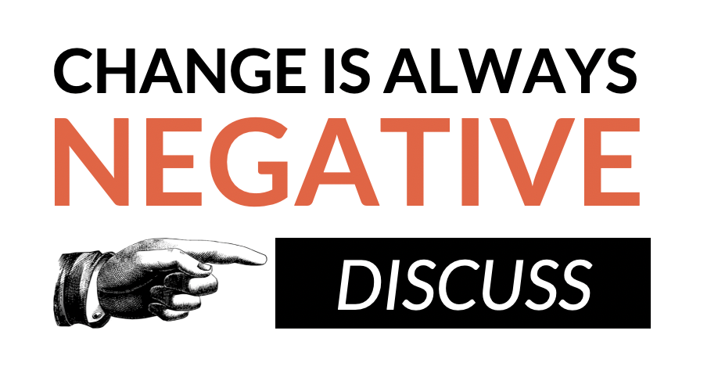
Do you agree with this statement?

Step 2: Respond to the prompts below by using the scale.

Place a letter for each prompt below on the scale.

- How confident are you in identifying changes that can take place in adolescence?

- How confident are you in understanding the effect that change can have? (eg. on friendships, mood, routines, confidence, etc.)

- How confident are you in knowing strategies to manage chance and where to seek support?

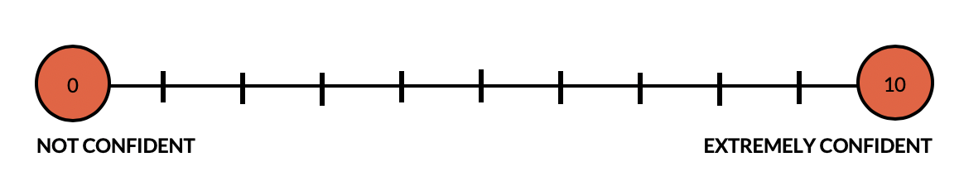
Step 3: Malcolm Chase wrote this Haiku about the struggles he faces when he is trying to write.

Struggle

I can’t do it right
Try and try with all my might
Whatever I write

What would you say to help Malcolm change his perspective on his writing skills:

Step 4: Map out your response to upcoming changes.

Imagine it is the first year of high school:

What are some changes that could take place for a student?
Think about: personal interests, relationships, home life, school life, homework, and society.

Circle the changes that are expected and underline the ones that are unexpected.

Draw emojis that show the impact of each change or write the emotions these changes will cause.

Step 5: Reflection

On your own, or with a partner, reflect on the following questions.

•Do you think some life changes are expected? If so, can you think of any examples?

•Do you think some life changes are unexpected? If so, can you think of any examples?

•What times in your life do you think the most change will take place and why?

Student Feedback:
Circle the emojis that best represents how this activity made you feel.

Mindfulness Moment!

Day 1: Does History Change Over Time?
Social Studies

What is this lesson about?: Today you will begin the week by considering the question: Does history change over time? You will explore how history is interpreted and “produced” by historians and will understand why history evolves. This lesson will prepare you for considering the history lessons for the rest of the week.

Warm-up:

Do you think there is only one correct version of history? Why or why not?

Step 1: Read about how history is produced

Why is history important to society?
History provides a sense of identity, it helps us make sense of the world, and provides lessons in right and wrong. Like a person who has lost their memory and finds the world confusing, a society with no sense of history is unaware of where it has come from or where it is going. A historian’s job is to provide society with its memory. After all, history means “What historians have interpreted from the surviving evidence of the past.” Therefore it is important to carefully analyze and inspect the surviving evidence and how historians present that evidence.

How is history produced?
There is a simple equation as to how history is produced:

Sources + Historians = “History”
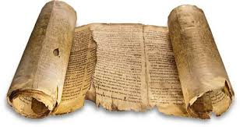
So, let’s start with the first part of the equation: Sources.
When we talk about sources, we are talking about sources of historical evidence. Things like diaries, governmental documents, and other written materials. Also, things like witnesses (people who lived through a historical event), artifacts (antiques), and stories that have been carried down generations verbally are also sources. What’s important to remember is that sources that survive throughout time may not give us the full picture and sources that have been lost (due to decay or destruction) leave major gaps in our ability to understand what truly happened long ago. For example, historically we know far less about poor, working-class people, than we do of the ruling classes, who leave behind much more evidence due to their power, wealth, and literacy.

Next, let’s consider the second part of the equation: Historians.
In order for a historian to piece together what happened in the past, they must select evidence to use and they must interpret (determine the meaning) of the evidence and present it to the public. The role of the historian is to make sense of the facts they discover in the evidence.

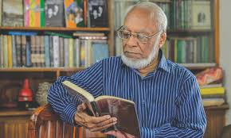
This process, however, of selecting and interpreting the evidence, can distort things. The historian has their own views and perceptions (formed by their life experiences, social background, and current life), which will affect the interpretation they make of the evidence. To give an example, “one man’s terrorist is another man’s freedom fighter.” Different historians will determine different meanings to evidence. Unlike the physical sciences (physics, chemistry, biology), history often produces different answers to the same question. Historians frequently study the same sets of facts (evidence) but end up reaching different explanations or conclusions.

The last part of our equation is “history,” the sum of combining evidence with historians. The history we learn has been weakened or changed from the past. First, this is because some evidence has been lost; some destroyed; and the remaining evidence does not give us the full picture (remember, we read about this above under ‘sources’). Then, historians will use their imagination to fill gaps in the evidence, select the bits of evidence that they think is the most interesting, and then interpret and present that evidence to the public. As such, the history we read about or are taught, is really an interpretation of available evidence made by historians. We rely on historian’s interpretations to explain what has happened in the past.

So, is “objective” history possible?
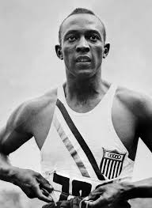
If we think history has been changed by historians, maybe the best thing to do is aim for objective history… history that can be proven; to tell it as it really was. However, even while some historical facts are beyond dispute and can be proven, history will continue to be affected by historians and our own way of interpreting the facts.

- First, those facts are boring and meaningless until a historian helps us learn something more from them. For example, Hitler was born in 1889, but this fact only becomes important when a historian uses it to argue (for example) that Nazism sprung from late 19th Century Austrian nationalism.
- Second, those facts may be the truth, but not the whole truth. For example, Hitler refused to shake hands with the black American athlete Jesse Owens (pictured), who won 8 gold medals at the 1936 Olympics. That is a fact. However, it is also true that Hitler refused to shake anyone’s hand after the first day (he got into trouble for only greeting German athletes).

In conclusion, factual or objective history is impossible. But it also would not be a good thing. The point of history is not to collect facts, but to deal with interpretations, lessons, morals, and values.

What to takeaway: History is evolving
While the past itself never changes, history – in other words, our understanding and interpretations of the past – is always evolving. New historians explore and interpret the past through their own methods, priorities and values. They develop new theories and conclusions that may change the way we understand the past.
Step 2: Answer questions

Why is history so important to society?

Why is it too simple to describe history as “what happened in the past”? What more is in the equation of what history is?

Do you think objective history would be a good thing? Explain your answer.

Why is history evolving?

Step 3: Read a sports analogy

Let’s dig a little deeper and explore this idea that history is evolving because historians' interpretations of historical evidence are evolving. First we need to understand that the history we read in a textbook, watch in a documentary, or hear in a classroom has all been written, told, or explained by a historian. That historian has examined evidence and has made a determination what the evidence means. So in the end, what we read, watch, or hear is the meaning of a historical event as determined by the historian. Further, how the historian interprets the evidence is affected by the historian’s personal and political viewpoints, as well as their life experiences.
Now, think of a significant historical event as being like a major sporting event, such as an important football or basketball game watched by thousands of people. Football games have factual outcomes: scoring charts, a final score, team and player statistics, player injuries and so forth. These are the ‘historical facts’ of the game.
Explaining these outcomes, however, can be a very subjective process (based on or influenced by personal feelings, tastes, or opinions). Witnesses to a football game might attribute its outcomes to different factors – team selections, the performance of individual players, fitness or injuries, referee decisions, weather, grass/turf conditions, ‘home field advantage’, coaching tactics and so forth. There may be some consensus about these causes but not total agreement. In other words, how the event will be interpreted by people will be different based on what factors people focus on.
In some respects, historians are like sports journalists: they explain outcomes after the fact, relying on evidence but also their own judgement and interpretations. These interpretations can vary markedly, to the point where the conclusions of one historian may directly contradict the conclusions of another other.
Step 4: Confirm your understanding

In 8-10 sentences, write a letter to your teacher explaining why history is evolving. Use your own words and examples.

Student Feedback:

Circle the emojis that best represents how this activity made you feel.

Week 6
Change

Day 2

NAME:______________________

Day 2 Agenda

Topic | Activity
Warm-Up!
English Language Arts | - Read the article, The Evolutionary Advantage of the Teenage Brain  - Respond to questions about the article  - Analyze an informational document  - Create their own informational sheet directed at an audience of their peers.
Science | - Read about Recycling  - Answer questions about what you read  - Draw a picture and explain
Mindfulness Moment!
Math | - Change and the Environment, Day 1: Pollution, race and wealth
Health | - P.E.
Mindfulness Moment!
Civics/Social Studies | - Changing explanations of the Salem Witch Trials  - Read and respond to the text

Warm-up Activity: Write a journal entry around the daily quote on identity.
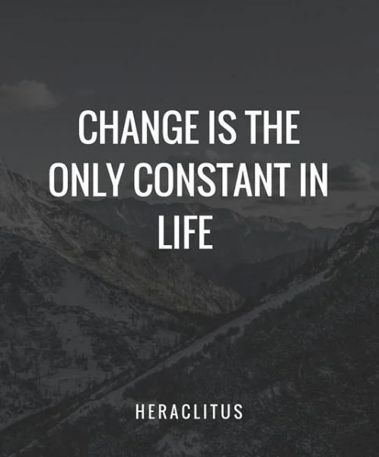

Day 2: How is our brain changing?
English Language Arts

What is this lesson about?: Today you will continue to think about the theme of “change”. You will learn about how the teen brain works and changes as you mature and you will also read and discuss some ways that we can deal with changes in a positive way.

Before you read: Review key vocabulary

delusion: belief or impression that is firmly kept despite being contradicted by what is generally accepted as reality | neuroscience: sciences, that deal with the structure or function of the nervous system and brain. | evolutionary: gradual development of living organisms from one form to another.
arbitrary: based on random choice | adaptive: changeable | refine: to improve (something) by making small changes
impulsive: acting or done without thinking beforehand. | Misguided: wrongly informed, foolish | immortality:ability to live forever
neural: related to the nervous system. | analogy: comparison between two things for the purpose of explaining

Step 1: Read the following text.

The evolutionary advantage of the teenage brain
By Andy Murdock, UC Newsroom, Thursday, November 30, 2017

Teens. OMG. What on earth is going on inside their brains to make them act so, well, like crazy teenagers?
The mood swings, the fiery emotions, the delusions of immortality, all the things that make a teenager a teenager might just seem like a phase we all have to put up with. However, research increasingly shows that the behaviors of teenagers aren’t just there to annoy parents, they serve a real evolutionary purpose.
Changing minds
What is a teenager? Our standard definition is arbitrary: If your age ends in “-teen,” you’re a teenager. The brain, however, follows a different set of rules.

“From a neuroscience perspective, we know that the brain keeps growing and developing,” said Adriana Galván, associate professor of psychology at UCLA and director of the UCLA Developmental Neuroscience Lab. “Current literature suggests that it's around age 25 or so when the brain finishes the period of adolescence.”
It’s not that the brain stops changing — every time we learn something new, our brain changes — but by around 25, our brain has finished its long process of structural development. For teens, not only is the brain still very much in development, but different regions of the brain are changing at different rates, with important consequences.
“What that means is the regions in these different parts of the brain keep refining themselves,” said Galván. “In particular, there's greater activation in emotion centers deep in the brain, and there's also continued development of the prefrontal cortex, which is found right above the eyes.”
The prefrontal cortex is what allows us to think about the future, to understand consequences, and generally make better decisions. Not surprisingly, the prefrontal cortex of teens still has a lot of work to do to grow into adulthood.
One way to think about it is that brain has two sides, an impulsive side, and a cautious side, that balance one another.
Before we reach adulthood, the impulsive side of the brain is charging ahead, while the cautious side of the brain is still playing catchup. The result is a teenager.
“The analogy is that these two are kind of going head-to-head. And then eventually, as individuals become adults, the prefrontal cortex will win out, and have more influence over behavior than the impulsive part of the brain,” said Galván.
The game of risk
The delayed development of the prefrontal cortex might not be a simple side-effect of human development. Teen behaviors that grownups often dismiss as mere annoyances are actually adaptive traits that help teens learn and succeed, Galván and others have found.
Teenage behaviors aren’t unique to humans: adolescent chimpanzees, for example, begin courtship behaviors, play less, and increase their grooming of other, among other changes.
While some teens can appear chimp-like at times, humans have their own unique set of adolescent behaviors, including increased risk-taking and the onset of powerful emotions that weren’t present in childhood.
“Risky behavior, regardless of what the risk is, taps into the very same neural regions that process reward,” explained Galván. “So when you experience a risk in a positive way, the brain activation is the same as if you experienced a reward.”
Galván’s research has found that not only are teens more sensitive to rewards than adults, this makes them better learners.
“Compared to adults, adolescents have more [reward center] activation when they're learning a new task, and this greater activation helps them learn from the environment in a more adaptive and efficient way than the adults,” said Galván. “It's kind of a surprising result.”
High emotions may also benefit teens in ways that even the teens themselves likely don’t appreciate.
“There is probably an evolutionary reason for why teenagers are more emotional. One reason is that emotions help us connect with other people,” said Galván. “Emotions also serve as an important learning tool. When you feel a particular emotion, you're more likely to remember the event.”
If something negative happens, the emotions you experience will help you steer clear of those events in the future. Positive emotions will reinforce a behavior, making you more likely to repeat it.
If Galván could bust one myth about teenagers, it’s that teenagers should be quieted down until adulthood.
“The idea that the adolescent years don't serve a purpose other than annoying parents or hanging out with friends, is, I think, misguided,” said Galván. “All of the experiences that happen during adolescence are important for the individual's growth.”
The evolutionary advantage of the teenage brain https://www.universityofcalifornia.edu/news/evolutionary-advantage-teenage-brain via @UofCalifornia
Step 2: Answer the questions below:

- What does the pre-frontal cortex part of the brain control? How does the fact that it is not fully developed until someone is in their 20’s affect teen behavior?

- Teens tend to increase their “risky” behavior during adolescence. What does the article note as the positive side of this risky behavior?

- How does being more sensitive or emotional during adolescence help teens become better learners?

- What additional benefit do teens experience because they are more emotional?

Step 3: Read the informational fact sheet
Now that you have a background on how the teen brain is changing and adapting during adolescence, you are going to read an informational sheet that presents information in a clear and concise way that uses graphics or pictures to help readers understand. As you read, underline or star 3-4 facts that you find interesting.

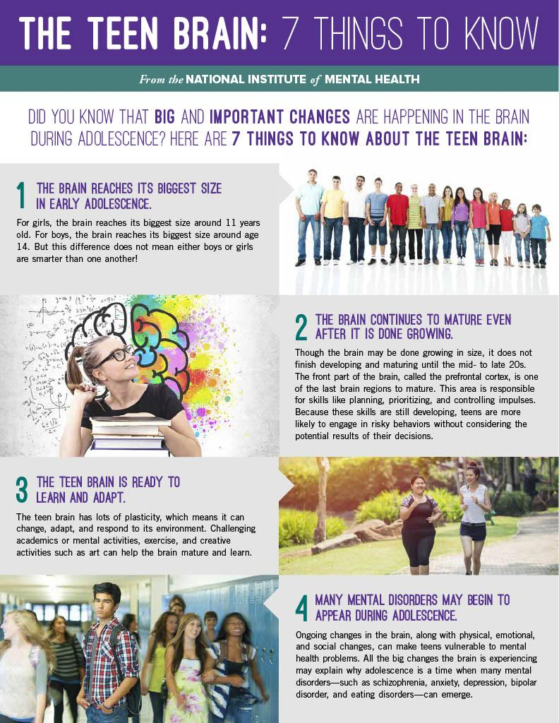
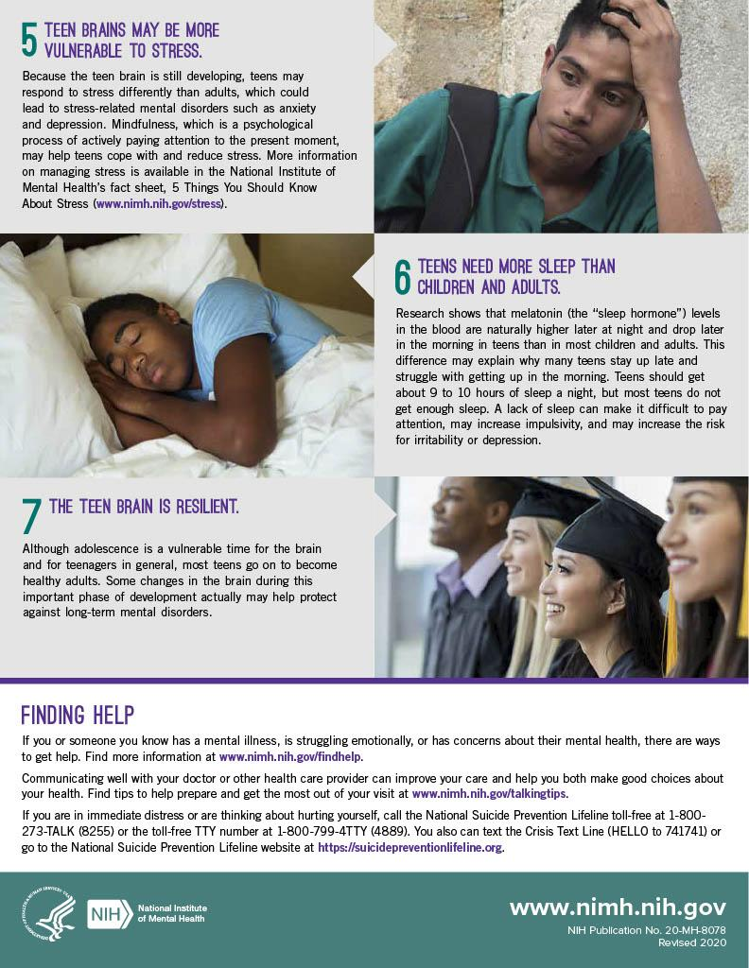

Step 4: Create your own Informational Sheet
Create an informational sheet/flyer to inform teens about their brains and give advice to teens on how to promote healthy brian development. Use information from the article and the poster but make sure to paraphrase (put into your own words) what you have learned. Use the template with the background provided but make sure to include at least 4 facts about the teen brain and at least 3 pieces of advice for teens on what they can do to support healthy brain development and change.

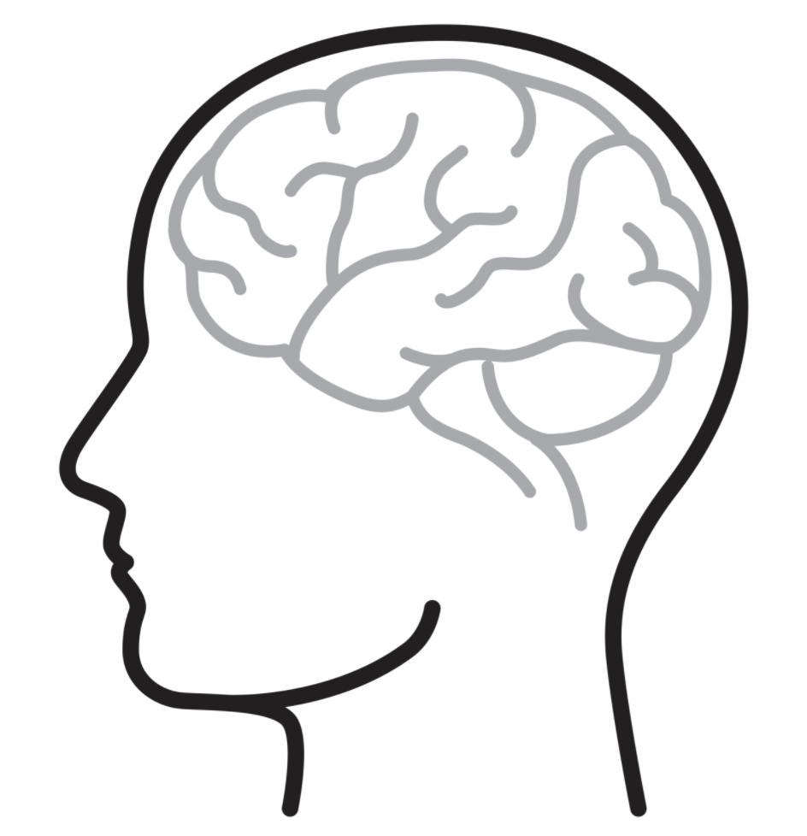

Step 5: Share out with a partner.
What do your posters have in common? What wording or graphic did your partner use to specifically address the teen audience?
Student Feedback:

Circle the emojis that best represents how this activity made you feel.

Day 2: Recycling
Science

What is this lesson about?: Today you will read through the Recycling passage. You will answer a few questions about what you read. You will complete a Recycling activity.

Step 1: Read through the Recycling passage

Recycling
(Technological Solutions)
What is recycling?
Recycling is a way to take trash and turn it into new products. There are a number of different recycling processes that allow materials to be used more than once.

What can be recycled?
All sorts of materials can be recycled. Some of the most common processes in use today involve recycling plastic, glass, metals, paper, electronics, and textiles. Typical used items made of these materials include soda cans, plastic milk cartons, newspapers, old computers, and cardboard boxes.

Recycling bins for different types of materials

How does recycling work?
Recycling is actually a complicated process and is different for each type of material.

Aluminum cans - Aluminum cans were one of the first items to be heavily recycled. The process isn't quite as complicated as it is for some other materials. The cans are first shredded and then melted. From there, the aluminum can be used to make new cans and other aluminum items.

Plastic bottles - There are a lot of types of plastics and each type is made from a different combination of chemicals. As a result, plastic bottles are first sorted into their various chemical types. Then they are cleaned to get rid of any leftover food or other waste. Next, the bottles are crushed or shredded into fine plastic chips. Then the chips can be melted down to create new plastic or turned into a fiber used for making carpets or clothing.

Paper - Paper starts its recycling process by being mixed with water and other chemicals to break it down. It then gets shredded and heated up. This process eventually turns the paper into a pulp or slurry. The pulp gets strained in order to remove any glues or plastics. After that, it gets cleaned and bleached to remove any left over inks or dyes. Now the pulp is ready to be made into new paper.

Computers and Batteries - Computers and batteries are usually recycled in order to remove harmful chemicals as well as to recover, or salvage, some valuable materials such as gold from electronics boards.

The Recycling Loop
The recycling symbol, or loop, has three arrows. Each arrow represents a different step in the recycling process. These steps are:
- Collecting recyclable materials, like aluminum cans and plastic bottles.
- Processing the old materials and making new items.
- Buying items made from recycled materials

Benefits of Recycling
There are a number of benefits from recycling. These include:
- Landfills - Recycling materials means less trash and saves space in dumps and landfills.
- Resources - When we use materials again, this means we can take fewer resources from the Earth.
- Pollution - In general, recycling materials can produce less pollution helping to keep our environment clean.
What can you do?
Be sure to recycle everything you can in your house and school. There is almost always a "recycle" trash can around. Be sure to drop your used aluminum cans and plastic bottles there. At home, be sure to put paper items like the newspaper, cereal boxes, and homework pages into the recycle bin.

Fun Facts About Recycling
- Plastics are usually marked with an identification code that shows a recycling symbol and a number from 1 to 7. This indicates the type of chemicals, or polymer, used in making the plastic.
- Used paper can be recycled around seven times. After this the fibers get too short and are filtered out by the recycling process.
- Some waste material is turned into electricity energy by burning it in modern incinerators.
- Glass is one of the best recycling materials. Clear glass can be recycled over and over again.
- In 2009, the United States recycled around 1/3 of all its waste. Around 7 million tons of metals were recycled.
Step 2: Answer the following questions

- Which of the following is sometimes recycled into fibers for carpets or clothing?
  - Aluminum cans
  - Plastic bottles
  - Paper

- Which of the following materials is converted into a pulp or slurry during the recycling process?
  - Aluminum cans
  - Plastic bottles
  - Paper

- Gold is sometimes recovered from recycling which of the following materials?
  - Computers
  - Aluminum cans
  - Plastic bottles

- How many arrows are there in the typical recycling loop?
  - 3
  - 4
  - 5

- What do the arrows of the recycling loop represent?
  - The main materials that can be recycled
  - A different step in the recycling process
  - A different method of recycling materials

- Around what percentage of trash in the United States is recycled?
  - 33%
  - 27%
  - 10%

- Recycling can be a very complicated process and is different depending on the type of material.
  - TRUE
  - FALSE

Step 3: Draw an image/picture

Imagine if there was no recycling. Draw a picture of what your community would look like. What would you do to help your community understand the importance of recycling?

Explain what you would do to help your community understand the importance of recycling?

____________________________________________________________________________________________________________________________________________________________
____________________________________________________________________________________________________________________________________________________________
________________________________________________________________________________________________________________________________________________________________________________________________________________________________________________________________________________________________________________________

Student Feedback:

Circle the emojis that best represents how this activity made you feel.

Mindfulness Moment!
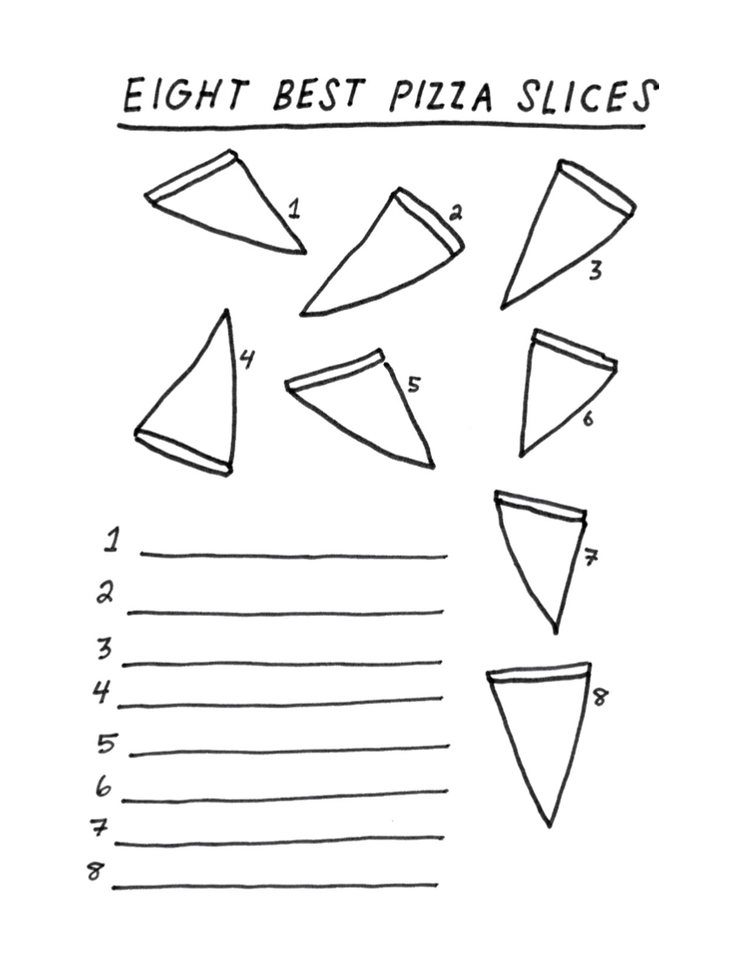

Day 2: Change/Pollution & COVID-19
Math

What is this lesson about?: Today we are going to focus on how the COVID-19 outbreak has influenced and is influenced by pollution. It has created significant changes to the pollution we see and feel and are influenced by.

Today’s Warm-Up Problem
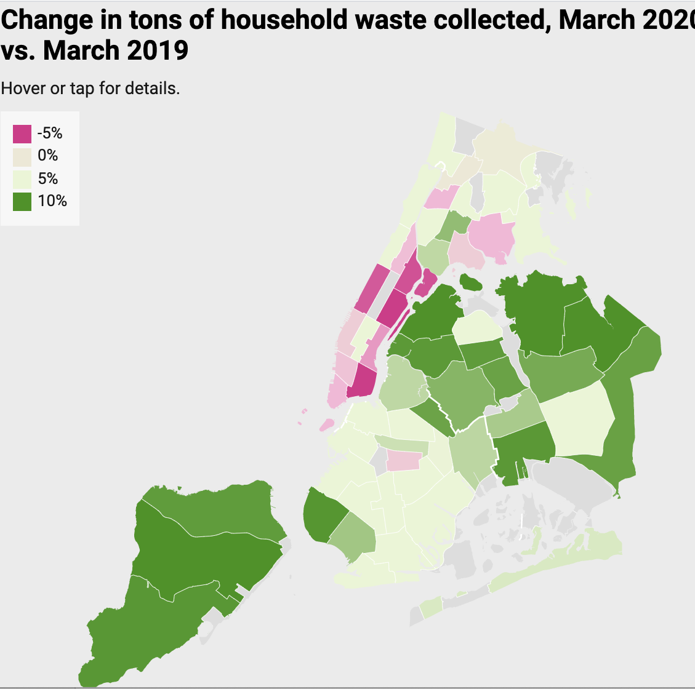
The above map shows the amount of trash collected in March of 2019 vs March of 2020 in New York City.
- Why, do you think, one part of the city would be seeing trash collections going down, while other parts are seeing it go up?

- In general, do you think trash collection from homes is going up or down between March 2019 and March 2020?

- If you were told that the areas in light pink/red--where residential trash collections have gone down are the wealthiest part of the city, what might you think this chart shows?

Note: Researchers have concluded that the reason for the decline is that many of the wealthy residents in Manhattan have left the city and gone to 2nd homes...to get away from New York during Covid-19….

Discuss/Consider: Does this raise any questions or concerns for you?

Activity 1: Carbon Monoxide in NYC

The photos below, show the carbon Monoxide levels in New York City, in March of 2019 and then again in March of 2020. The darker (purple if in color) reveal higher levels of carbon monoxide in the atmosphere.

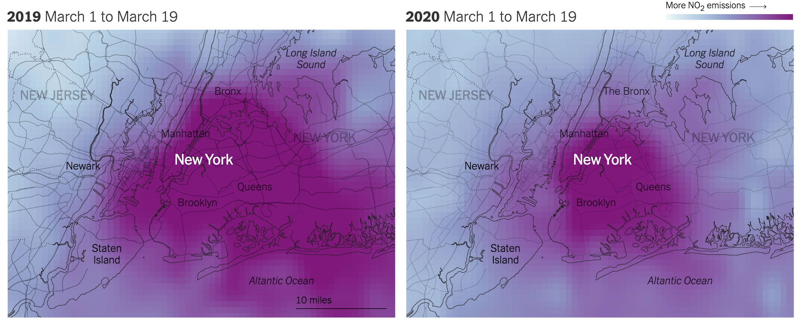
Although this is an image of just one gas--carbon monoxide -- measures of air pollution yield similar results.

- List 1-2 reasons why you think air pollution might be down this March and April compared to last March and April.

- The chart below shows average miles that families in Washington, DC drive in their cars over two time periods, as well as the cost of commuting to work by someone who uses public transportation
 | March 2019 | March 2020
Average Miles Driven Per Week | 110 | 20
Average cost for a gallon of gasoline | $3.50 | $2.25
Monthly subway/metro cost | $140 | $5

How many fewer miles is the family driving in 2020 than 2019 each week?

Assuming that their car gets 20 miles to the gallon, approximately how much money did they spend on gas each week in March, 2019?

How about in March 2020?

The person who used to commute on the metro to and from work is now working from home. How much is she saving each week subway/metro costs?

Many car insurance companies are offering rebates or reducing their car insurance rates this spring.

- Why would they be doing that?

A recent study in California indicated that the number of car accidents per day in March 2020 was ½ what it was in March 2019 in California. In addition, the number of accidents resulting in injury was also cut in ½.

- In March 2019, there were on average 980 accidents and 390 injuries per day related to auto accidents.

- How many auto accidents and how many auto injuries were there per day in March 2020?

Activity 2: Traffic in Los Angeles

The chart below shows the average speed along a major interstate in Los Angeles. It compares the speeds on Wednesday, March 18, 2020 compared to the average speeds on Wednesdays earlier in the year.
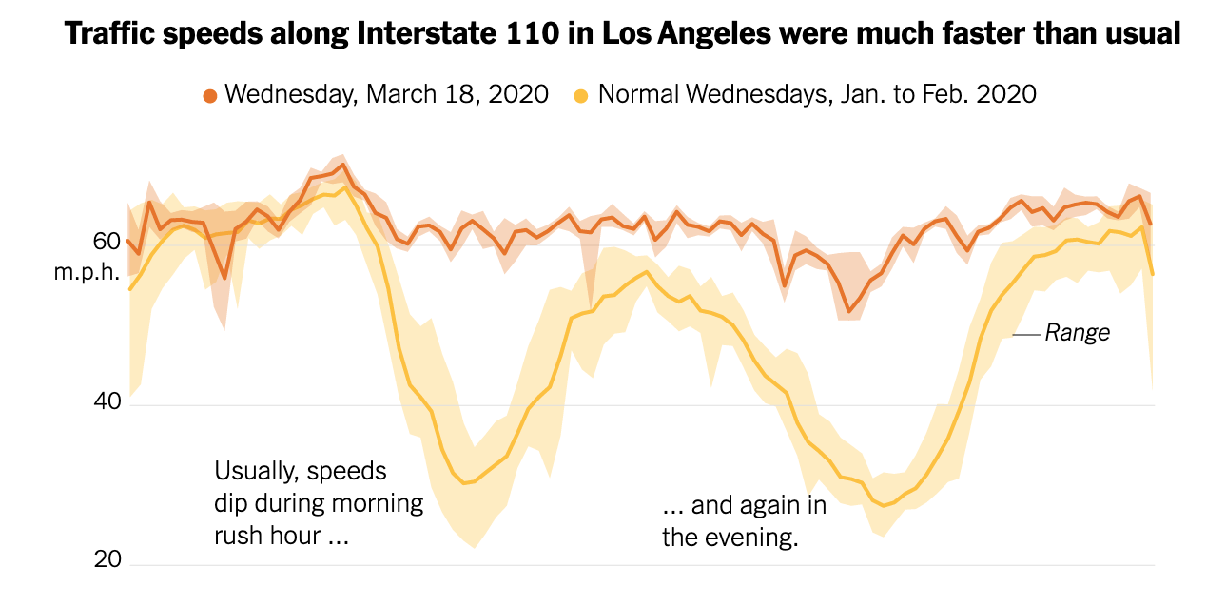
3am 9am 5pm 10pm

Based on this chart-
- Back in January 2020,
  - What was the average speed on the highway at approximately 9am?
  - How about at 5am?
  - What happens to the average speed between about 3pm and 7pm?
  - And if you were driving late at night or early in the morning, what is the average speed on the highway?
  - What is the difference between the average speed at 3am and 9am (approximately?)
- On Wednesday, March 18, 2020,
  - What was the average speed on the highway at approximately 9am?
  - How about at 5am?
  - What happens to the average speed between about 3pm and 7pm?
  - And if you were driving late at night or early in the morning, what is the average speed on the highway?
  - What is the difference between the average speed at 3am and 9am (approximately?)

Why is there such a wide swing of speeds on the highway early in the year and such a narrow swing (almost a straight line) in March?

What do you think this pattern will look like in October, 2020?

Step 3: Gallon of Gasoline

This chart shows the average cost of a gallon of gasoline in 4 states, comparing prices on April 20, 2020 compared to April 20, 2019.
 | Price for 1 Gallon of Oil
 | April 2019 | April 2020 | Price Decrease | % Decrease
California | $4.50 | $2.80
Texas | $2.50 | $1.55
Florida | $3.45 | $1.80
New York | $3.90 | $2.20

Complete the last two columns of the above chart. Use the reminder below if you need help completing the last column.

Rember: Percentage change =($\frac{Amount of change}{Original amount}$-)→ then convert the decimal to a %

In what state did the price of gasoline fall the most?
In what state did the price fall by the greatest percentage?
The price fell by the same amount in California and New York. Why is the percentage decrease different?

Predict what you think the average price of 1 gallon of gasoline is in your home state:
What do you think that price will be in October 2020?

Step 4: Thought Questions
Based on the information you have read about traffic, driving habits, price of gas, and pollution…..
- Why has the price of gasoline gone down so much during the COVID-19 time?

- What are 1 - 2 good things that are happening right now when it comes to keeping people and our environment healthy?

- Assuming that by the fall many people are going to head back to work..and start taking trips...will these benefits stay with us or go away?

- What might we do to make some of the ‘benefits’ stay with us after this pandemic subsides?

Student Feedback:

Circle the emojis that best represents how this activity made you feel.

‘

Day 2: PE
Health

What is this lesson about?: In today’s lesson, you will work on your PE BINGO card.

Step 1: Try to complete the PE BINGO card.

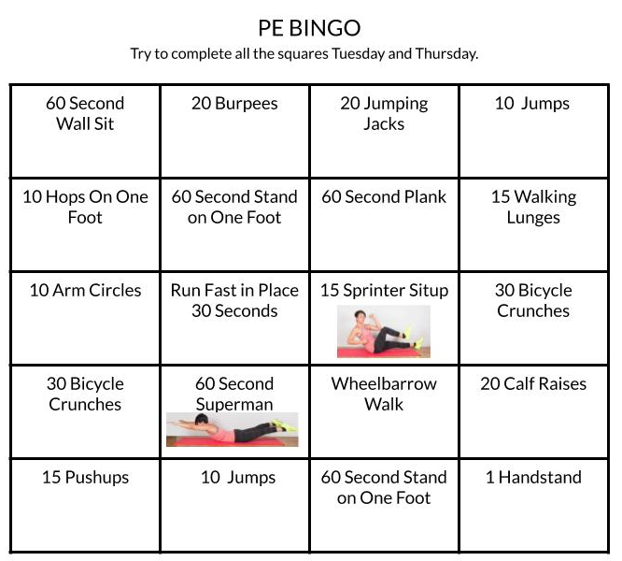

Mindfulness Moment!
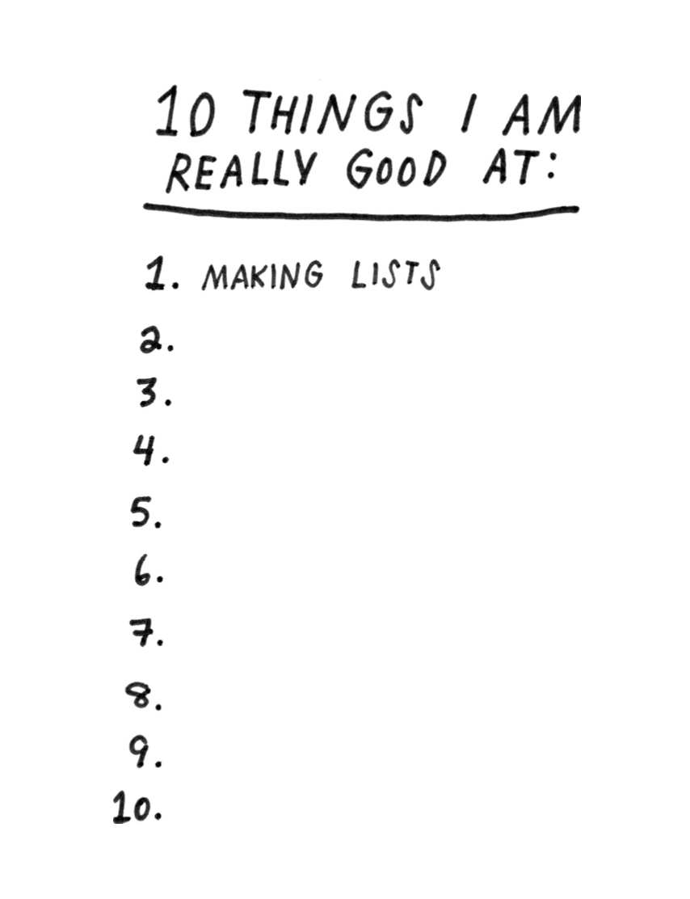

Day 2: Changing Explanations of the Salem Witch Trials
Social Studies

What is this lesson about?: In today’s lesson you will explore how our understanding of what happened during the Salem witch trials has evolved or changed throughout time.

Warm-up: free-write

Take 5 minutes to read the quote below and reflect on it. Write what you think it means?
"History is like a story in a way; it depends on who is telling it." – Dorothy Salisbury

Step 1: Read about the Salem Witch Trials

Were witches burned at the stake during the Salem Witch Trials?
By Evan Andrews for History.com

In January 1692, a group of young girls in Salem Village, Massachusetts became consumed by disturbing “fits” accompanied by seizures, violent contortions and blood curdling screams. A doctor diagnosed the children as being victims of black magic, and over the next several months, allegations of witchcraft spread like a virus through the small Puritan settlement. Twenty people were eventually executed as witches, but contrary to popular belief, none of the condemned was burned at the stake. In accordance with the law at the time, 19 of the victims of the Salem Witch Trials were instead taken to the infamous Gallows Hill to die by hanging. The elderly Giles Corey, meanwhile, was pressed to death with heavy stones after he refused to enter an innocent or guilty plea. Still more accused sorcerers died in jail while awaiting trial.

The myth of burnings at the stake in Salem is most likely inspired by European witch trials, where execution by fire was a disturbingly common practice. Medieval law codes stated that evil witchcraft should be punished by fire, and church leaders and local governments oversaw the burning of witches across parts of modern day Germany, Italy, Scotland, France and Scandinavia. Historians have since estimated that the witch-hunt hysteria that peaked between the 15th and 18th centuries saw some 50,000 people executed as witches in Europe. Many of these victims were hanged or beheaded first, but their bodies were typically incinerated afterwards to protect against postmortem sorcery. Other condemned witches were still alive when they faced the flames, and were left to endure an excruciating death by burning and inhalation of toxic fumes.

Step 2: Reflect and answer questions

Were ‘witches’ burned at the stake as punishment in Salem? If not, how were they punished?

Why do you think people have the misconception that burnings at the stake happened in Salem?

Step 3: Read about Explanations for the Salem Witch Trials

6 Logical Explanations For The Hysteria That Caused The Salem Witch Trials
By All That's Interesting
Published November 12, 2017; Updated October 15, 2019
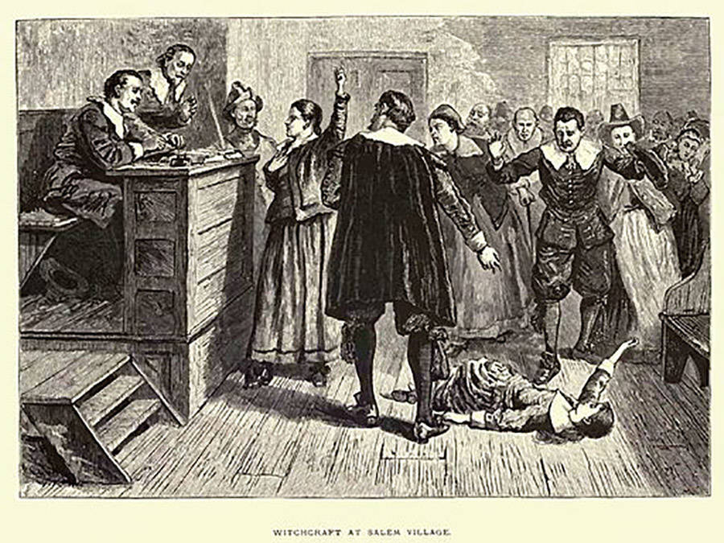
In 1692, "witchcraft" swept through the settlement of Salem, Massachusetts, leading to mass hysteria and several executions. Now, several theories hope to find what really caused the Salem Witch Trials.

In 1692, the settlement of Salem, Massachusetts came under threat almost overnight. The cause? Accusations of witchcraft flying back and forth between the citizens of this quiet Puritan settlement. Known as the Salem Witch Trials, the causes for this notorious episode of moral panic in the early colonial era has been hotly debated for the past three hundred plus years.

Within the span of a year, 20 people had been executed and hundreds arrested after being accused of witchcraft, but almost as suddenly as the trials began, they stopped; Salem came to its senses, and life carried on.

Since then, the events of the Salem witch trials have fascinated and perplexed scholars like few other episodes in American history.

What caused this quiet Puritan town to descend into total paranoia and persecution? The following theories might offer a more rational explanation than the supernatural.

Salem Witch Trials: Impact Of The Native American Wars
A number of new theories have suggested that the Native American Wars which raged during the 17th century close to Salem may have contributed to the witch hysteria that took hold in 1692.

King Philip’s War was raging in the colonies at the time, and the front lines were only about 70 miles away from Salem. Most people in the region had been impacted in one way or another, and many in Salem were refugees from parts of the region being torn apart by the war.

What’s more, raids from the native tribes in the area left many citizens of Massachusetts in a near constant state of fear over future attacks, creating an atmosphere of intense anxiety in which a violent death could come at any time and entirely without warning.
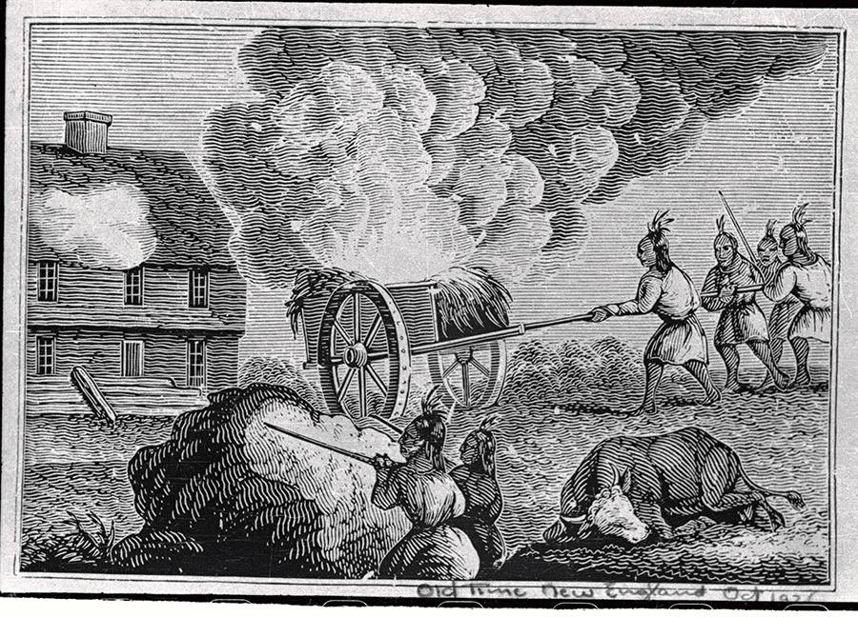
Several of the “afflicted” girls whose “bewitchment” kicked off the Salem Witch Trials had witnessed these raids first hand. It has been suggested that post-traumatic stress from witnessing these terrifying attacks and the culture of fear generated by the continued threat may have played a large role in generating the subsequent mass hysteria.

Historian Mary Beth Norton suggests the Native American Wars may have impacted the trials in another way.

She contends that the accusation and execution of ex-minister George Burroughs, who led a number of small, failed campaigns against the Native Americans, for witchcraft is indicative of the town officials attempting to shift “blame for their own inadequate defense of the frontier” to supernatural causes.

They wanted to believe that it had to be the devil that was threatening them, in other words, not their own inherent weakness. If safety is just one more witch-hanging away — in the minds of the public at least — it would be a powerful incentive to try to root out the culprit who was bringing this threat of death into their community.

Teen Angst And Patriarchal Oppression
When examining who exactly was accused of witchcraft, there are a number of demographic discrepancies which point to the possibility of that timeless, social antagonism: teenage angst, overbearing parents being insufferable killjoys, and historical patriarchy.

In his book Entertaining Satan: Witchcraft and the culture of Early New England, John Putnam theorizes that the witch trials were essentially a teenage rebellion against the authority of their elderly parents, as most of the accusers were teenagers and most of the accused adults.

Feminist historians have interpreted the trials as just another means of the patriarchy to persecute women who acted in ways contrary to the accepted social norms of the time. In the Salem Witch trials, as was historically the case with many similar prosecutions in Europe, women were the primary targets of accusation – particularly women who did not follow the social norms of the time, or were considered outcasts.

While the exact cause of the Salem Witch Trials remains contested, there is no doubt that underlying social forces of sexual oppression, individual repression, and Patriarchal reinforcement were a factor in the ensuing hysteria.
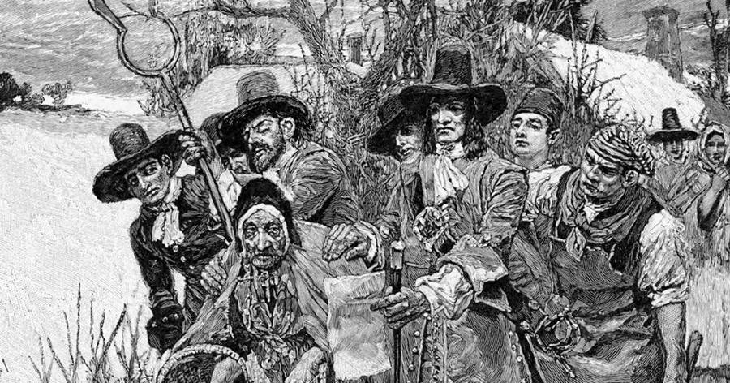
The Cold Weather Theory
One theory proposed in 2004 by Harvard graduate Emily Oster suggests that there is a more simplistic answer to what caused the Salem witch trials: the weather.

Her theory points out that there exists a strong correlation between outbreaks of witch persecution and periods of cold weather in Europe between the 13th and 17th century.

“The most active period of the witchcraft trials (mainly in Europe) coincides with a period of lower-than-average temperature known to climatologists as the ‘little ice age,'” Oster wrote in her Harvard thesis. “The colder temperatures increased the frequency of crop failure, and colder seas prevented cod and other fish from migrating as far north, eliminating this vital food source for some northern areas of Europe.”

The year 1692 falls right in the middle of a nearly 50-year-long cold spell that afflicted the world from 1680 to 1730, giving some weight to the theory.

She theorizes that the connection stems from the fact that witches were believed to be able to control the weather and destroy crops. When the people suffered from poor harvests due to poor weather, some concluded that it must be the work of witches who needed to be identified and dealt with.

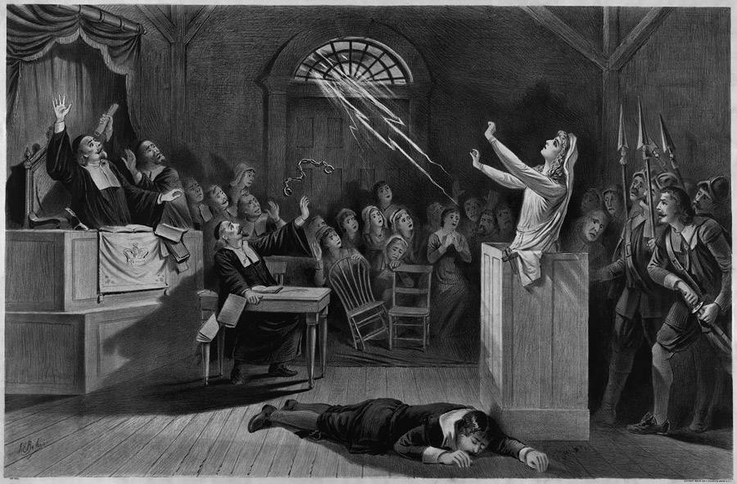
Mass Hysteria
Mass Hysteria is the “rapid spread of conversion disorder, a condition involving the appearance of bodily complaints for which there is no organic basis. In such episodes, psychological distress is converted or channeled into physical symptoms.”

Many scholars have argued that this is exactly what the girls who were first “bewitched” were actually experiencing.

Many scholars believe that mass hysteria was a primary cause of the Salem Witch Trials. The stress of living in such a rigid and religious society on the dangerous wilderness frontier led these girls to convert this stress into physical symptoms in which no natural explanation could be found.

Similar cases of hysteria have been reported throughout history. The mass hysteria experienced by the girls may then, in turn, have triggered a collective delusion among the villagers that Satan and witches were in their midst, thus providing a foundation for the witch hunt.

Boredom And Guilt
The story of the witch trials begins in February of 1692 when Betty Parris, age nine, and her cousin Abigail Williams, age eleven, began to exhibit strange behavior.

They began to hide under furniture, scream, and bark like dogs. Samuel Parris, the father of Betty Parris and a well-known minister, called for a physician to look at the girls who subsequently found nothing physically wrong with them. It was then concluded that they had been bewitched.

However, a modern theory suggests that the girls began to act strangely after they became frightened by a fortune-telling game.

In Salem at the time, children were restricted from almost all forms of play and leisure. They were expected to spend most of their time doing chores and studying the bible. This lack of stimulation naturally seeded to boredom.

This boredom may help to explain why Betty Parris and Abigail Williams became so interested in the fortune-telling and magical stories which a slave named Tituba introduced them to. As one of their only outlets for activity they naturally became drawn to these superstitions.

It is believed that their involvement with these forbidden supernatural activities and a combination of the guilt and fear they felt from participating in them, as well as a frightening omen they saw, may have been the cause of their strange behavior.

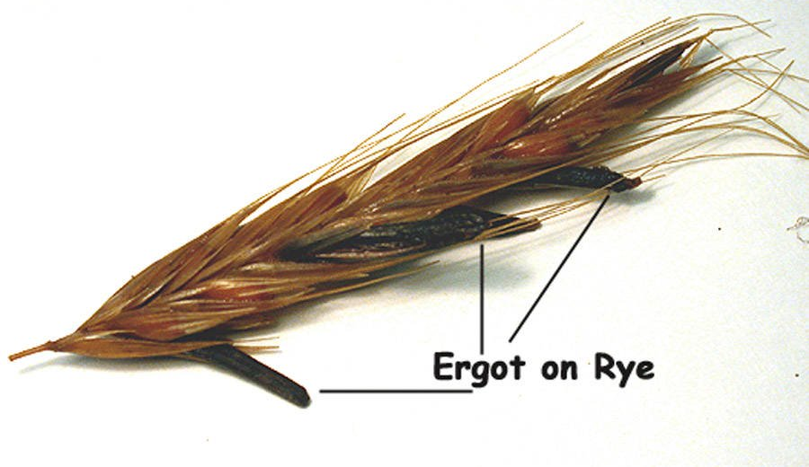
What Caused The Salem Witch Trials? Ergot Poisoning
One of the most interesting theories which has emerged about the cause of the Salem witch trials was first introduced in 1976 by Linnda Caporeal. She theorizes that the cause of the bizarre physical afflictions first witnessed in the “bewitched” girls could be the result of ergot poisoning.

Ergot is a fungus which in the right conditions can grow on grains. The fungus (which LSD is a derivative of) has been known to cause convulsions, hallucinations, and pinching sensations.

These are the very afflictions suffered by the girls as described by first-hand accounts and interestingly enough the weather conditions in Salem Village in the winter of 1691 were just right for ergot to grow.

Other studies on Ergot poisoning have also found that, like most drugs, children and females are the most susceptible. Is it possible that the afflicted were suffering from ergot poisoning? This question is still debated by scholars, but the theory is considered one of the more plausible explanations.

Step 3:

The author explains two way the Native American wars may have caused the hysteria of the Salem witch trials:
1) post-traumatic stress disorder, and
2) that after failed attempts to fight off the Native Americans, the townspeople needed to blame their failure on something and decided to place blame on the supernatural (witchcraft) rather than their own weakness or inability.
What explanation seems stronger to you and why?

In the section on teen angst and patriarchal oppression, the author explains how some historians believe teenage angst and societal rules that favor men played a role in causing the witch trials. What are some pieces of evidence or factors used to support this argument by historians?

In the section headed ‘boredom and guilt” the author explains that the witch trials started with two young girls “began to hide under furniture, scream, and bark like dogs.” In your opinion, based on your life experiences, do these seem like frightening or very odd behaviors for young girls? Why or why not?

In 1692, the girls’ behavior was determined to be very alarming. Based on your answer above would you say that interpretations of this type of behavior has changed over time?

Why do you think so many theories for explaining the Salem witch trials have been developed by historians? How can you explain why there are so many different theories?

What do you think is the best theory? Why?

*With a partner, share your answers to the above questions. For the last question, discuss how your personal experiences may have contributed to why you chose different theories or why you chose the same theory.

Student Feedback:

Circle the emojis that best represents how this activity made you feel.

Week 6
Change

Day 3

NAME:______________________

Day 3 Agenda

Topic | Activity
Warm-Up!
English Language Arts | - Read the short story, The Circuit.  - Respond to questions about the text.  - Read and analyze the poem Coming of Age  - Write a structured poem, I used to, but now I...
Science | - Read about Structural Changes  - Answer questions about what you read  - Draw a picture and explain
Mindfulness Moment!
Math | - Change and the Environment, Day 2: Earth Day
Health | - How can we deal with change?
Mindfulness Moment!
Civics/Social Studies | - Changing Historical Interpretations of Columbus  - Read and respond to the text

Warm-up Activity: Write a journal entry around the daily quote on identity.
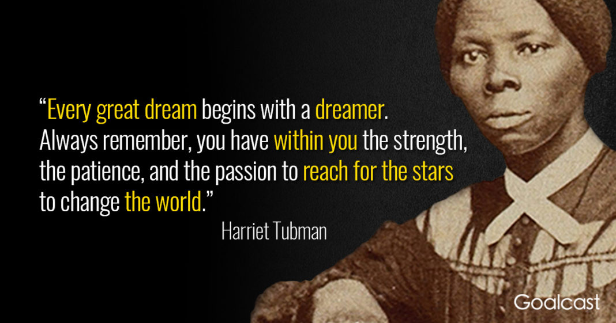

Day 3: Coming of Age
English Language Arts

What is this lesson about?: Today you will read two literary pieces about the the changes people go through as they grow up and mature.
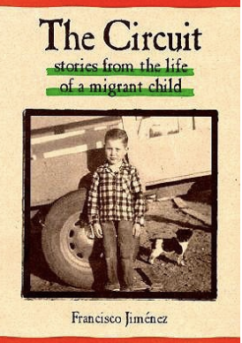
Before you Read:
Francisco Jiménez (1943–) was born in Tlaquepaque, Mexico, and grew up in a family of migrant workers in California. He spent much of his childhood moving around California with no permanent home or regular schooling. Nevertheless, he went on to attend and graduate from Santa Clara University. He also attended Harvard University and received both a master’s degree and a PhD from Columbia University. He is currently a full-time writer and professor at Santa Clara University. “The Circuit” is based on his childhood.

Some vocabulary and phrases to review:
There are some words and phrases in Spanish in the text. Translations are provided below.

Bracero: Mexican workers who were invited to the U.S. to work as laborers during WW2. | corrido: Mexican narrative song and poetry that forms a ballad | migrant: a person who moves to another country or area to find employment, usually seasonal or temporary work
listo: ready | grade: a slope or incline | Es todo: that’s all
jalopy: old worn down ca | vamonos: let’s go | quince: 15
Ya esora: It’s time | Mi olla: my pot (cooking pot) | Tienen que tener cuidado: You have to be careful.

Step 1: Read the following text.

The Circuit
by Francisco Jiménez

It was that time of year again. Ito, the strawberry sharecropper, did not smile. It was natural. The peak of the strawberry season was over and the last few days the workers, most of them braceros, were not picking as many boxes as they had during the months of June and July.
As the last days of August disappeared, so did the number of braceros. Sunday, only one—the best picker—came to work. I liked him. Sometimes we talked during our half-hour lunch break. That is how I found out he was from Jalisco, the same state in Mexico my family was from. That Sunday was the last time I saw him.

When the sun had tired and sunk behind the mountains, Ito signaled us that it was time to go home. “Ya esora,” he yelled in his broken Spanish. Those were the words I waited for twelve hours a day, every day, seven days a week, week after week. And the thought of not hearing them again saddened me.

As we drove home Papá did not say a word. With both hands on the wheel, he stared at the dirt road. My older brother, Roberto, was also silent. He leaned his head back and closed his eyes. Once in a while he cleared from his throat the dust that blew in from outside.

Yes, it was that time of year. When I opened the front door to the shack, I stopped. Everything we owned was neatly packed in cardboard boxes. Suddenly I felt even more the weight of hours, days, weeks, and months of work. I sat down on a box. The thought of having to move to Fresno and knowing what was in store for me there brought tears to my eyes.

That night I could not sleep. I lay in bed thinking about how much I hated this move.

A little before five o’clock in the morning, Papá woke everyone up. A few minutes later, the yelling and screaming of my little brothers and sisters, for whom the move was a great adventure, broke the silence of dawn. Shortly, the barking of the dogs accompanied them.

While we packed the breakfast dishes, Papá went outside to start the “Carcanchita.” That was the name Papá gave his old ‘38 black Plymouth. He bought it in a used-car lot in Santa Rosa in the winter of 1949. Papá was very proud of his little jalopy. He had a right to be proud of it. He spent a lot of time looking at other cars before buying this one. When he finally chose the Carcanchita, he checked it thoroughly before driving it out of the car lot. He examined every inch of the car. He listened to the motor, tilting his head from side to side like a parrot, trying to detect any noises that spelled car trouble. After being satisfied with the looks and sounds of the car, Papá then insisted on knowing who the original owner was. He never did find out from the car salesman, but he bought the car anyway. Papá figured the original owner must have been an important man because behind the rear seat of the car he found a blue necktie.

Papá parked the car out in front and left the motor running. “Listo,” he yelled. Without saying a word, Roberto and I began to carry the boxes out to the car. Roberto carried the two big boxes and I carried the two smaller ones. Papá then threw the mattress on top of the car roof and tied it with ropes to the front and rear bumpers.

Everything was packed except Mamá’s pot. It was an old large galvanized pot she had picked up at an army surplus store in Santa María the year I was born. The pot had many dents and nicks, and the more dents and nicks it acquired the more Mamá liked it. “Mi olla,” she used to say proudly.

I held the front door open as Mamá carefully carried out her pot by both handles, making sure not to spill the cooked beans. When she got to the car, Papá reached out to help her with it. Roberto opened the rear car door and Papá gently placed it on the fl oor behind the front seat. All of us then climbed in. Papá sighed, wiped the sweat off his forehead with his sleeve, and said wearily: “Es todo.”

As we drove away, I felt a lump in my throat. I turned around and looked at our little shack for the last time.

At sunset we drove into a labor camp near Fresno. Since Papá did not speak English, Mamá asked the camp foreman if he needed any more workers. “We don’t need no more,” said the foreman, scratching his head. “Check with Sullivan down the road. Can’t miss him. He lives in a big white house with a fence around it.”

When we got there, Mamá walked up to the house. She went through a white gate, past a row of rose bushes, up the stairs to the front door. She rang the doorbell. The porch light went on and a tall husky man came out. They exchanged a few words. After the man went in, Mamá clasped her hands and hurried back to the car. “We have work! Mr. Sullivan said we can stay there the whole season,” she said, gasping and pointing to an old garage near the stables.

The garage was worn out by the years. It had no windows. The walls, eaten by termites, strained to support the roof full of holes. The dirt floor, populated by earth worms, looked like a gray road map.

That night, by the light of a kerosene lamp, we unpacked and cleaned our new home. Roberto swept away the loose dirt, leaving the hard ground. Papá plugged the holes in the walls with old newspapers and tin can tops. Mamá fed my little brothers and sisters. Papá and Roberto then brought in the mattress and placed it on the far corner of the garage. “Mamá, you and the little ones sleep on the mattress. Roberto, Panchito, and I will sleep outside under the trees,” Papá said.

Early next morning Mr. Sullivan showed us where his crop was, and after breakfast, Papá , Roberto, and I headed for the vineyard to pick.

Around nine o’clock the temperature had risen to almost one hundred degrees. I was completely soaked in sweat and my mouth felt as if I had been chewing on a handkerchief. I walked over to the end of the row, picked up the jug of water we had brought, and began drinking. “Don’t drink too much; you’ll get sick,” Roberto shouted. No sooner had he said that than I felt sick to my stomach. I dropped to my knees and let the jug roll off my hands. I remained motionless with my eyes glued on the hot sandy ground. All I could hear was the drone of insects. Slowly I began to recover. I poured water over my face and neck and watched the dirty water run down my arms to the ground.

I still felt a little dizzy when we took a break to eat lunch. It was past two o’clock and we sat underneath a large walnut tree that was on the side of the road. While we ate, Papá jotted down the number of boxes we had picked. Roberto drew designs on the ground with a stick. Suddenly I noticed Papá’s face turn pale as he looked down the road. “Here comes the school bus,” he whispered loudly in alarm. Instinctively, Roberto and I ran and hid in the vineyards. We did not want to get in trouble for not going to school. The neatly dressed boys about my age got off . They carried books under their arms. After they crossed the street, the bus drove away. Roberto and I came out from hiding and joined Papá. “Tienen que tener cuidado,” he warned us.

After lunch we went back to work. The sun kept beating down. The buzzing insects, the wet sweat, and the hot dry dust made the afternoon seem to last forever. Finally the mountains around the valley reached out and swallowed the sun. Within an hour it was too dark to continue picking. The vines blanketed the grapes, making it difficult to see the bunches. “Vámonos,” said Papá, signaling to us that it was time to quit work. Papá then took out a pencil and began to figure out how much we had earned our first day. He wrote down numbers, crossed some out, wrote down some more. “Quince,” he murmured.

When we arrived home, we took a cold shower underneath a water-hose. We then sat down to eat dinner around some wooden crates that served as a table. Mamá had cooked a special meal for us. We had rice and tortillas with carne con chile, my favorite dish.

The next morning I could hardly move. My body ached all over. I felt little control over my arms and legs. This feeling went on every morning for days until my muscles finally got used to the work.

It was Monday, the first week of November. The grape season was over and I could now go to school. I woke up early that morning and lay in bed, looking at the stars and savoring the thought of not going to work and of starting sixth grade for the first time that year. Since I could not sleep, I decided to get up and join Papá and Roberto at breakfast. I sat at the table across from Roberto, but I kept my head down. I did not want to look up and face him. I knew he was sad. He was not going to school today. He was not going tomorrow, or next week, or next month. He would not go until the cotton season was over, and that was sometime in February. I rubbed my hands together and watched the dry, acid stained skin fall to the floor in little rolls.

When Papá and Roberto left for work, I felt relief. I walked to the top of a small grade next to the shack and watched the “Carcanchita” disappear in the distance in a cloud of dust.

Two hours later, around eight o’clock, I stood by the side of the road waiting for school bus number twenty. When it arrived I climbed in. Everyone was busy either talking or yelling. I sat in an empty seat in the back.

When the bus stopped in front of the school, I felt very nervous. I looked out the bus window and saw boys and girls carrying books under their arms. I put my hands in my pant pockets and walked to the principal’s office. When I entered I heard a woman’s voice say: “May I help you?” I was startled. I had not heard English for months. For a few seconds I remained speechless. I looked at the lady who waited for an answer. My first instinct was to answer her in Spanish, but I held back. Finally, after struggling for English words, I managed to tell her that I wanted to enroll in the sixth grade. After answering many questions, I was led to the classroom.

Mr. Lema, the sixth grade teacher, greeted me and assigned me a desk. He then introduced me to the class. I was so nervous and scared at that moment when everyone’s eyes were on me that I wished I were with Papá and Roberto picking cotton. After taking roll, Mr. Lema gave the class the assignment for the first hour. “The first thing we have to do this morning is finish reading the story we began yesterday,” he said enthusiastically. He walked up to me, handed me an English book, and asked me to read. “We are on page 125,” he said politely. When I heard this, I felt my blood rush to my head; I felt dizzy. “Would you like to read?” he asked hesitantly. I opened the book to page 125. My mouth was dry. My eyes began to water. I could not begin. “You can read later,” Mr. Lema said understandingly.

For the rest of the reading period I kept getting angrier and angrier with myself. I should have read, I thought to myself.
During recess I went into the restroom and opened my English book to page 125. I began to read in a low voice, pretending I was in class. There were many words I did not know. I closed the book and headed back to the classroom.

Mr. Lema was sitting at his desk correcting papers. When I entered he looked up at me and smiled. I felt better. I walked up to him and asked if he could help me with the new words. “Gladly,” he said.

The rest of the month I spent my lunch hours working on English with Mr. Lema, my best friend at school.

One Friday during lunch hour Mr. Lema asked me to take a walk with him to the music room. “Do you like music?” he asked me as we entered the building.

“Yes, I like corridos,” I answered. He then picked up a trumpet, blew on it, and handed it to me. The sound gave me goosebumps. I knew that sound. I had heard it in many corridos. “How would you like to learn how to play it?” he asked. He must have read my face because before I could answer, he added: “I’ll teach you how to play it during our lunch hours.”

That day I could hardly wait to get home to tell Papá and Mamá the great news. As I got off the bus, my little brothers and sisters ran up to meet me. They were yelling and screaming. I thought they were happy to see me, but when I opened the door to our shack, I saw that everything we owned was neatly packed in cardboard boxes.

Step 2: Answer the following questions.

- Reread the opening paragraphs. What kind of work do the narrator and his family do? Cite details from the story that support your answers.

- How does the narrator feel about moving? How do you know? Cite examples from the text.

- Describe the narrator’s work day once he moves to Fresno.

- Why does the narrator consider Mr. Lema his “only friend”?

- Reread the last paragraph of the story. How do you think that the constant change of moving so often affects the narrator? What do you predict will happen to him?

Step 3: Read the following poem
Coming of age stories are stories about the transition from childhood to adulthood. That transition often involves rituals and experiences that symbolize the person’s maturation. As you read this poem, think about how the speaker has changed as she has grown.

 | Coming of Age  Kells Garcia | Notes:
1 | Everyday momma would take me to the window  she would sit me on her lap  reach across and open the curtains  Sweetie, What do you see?
2 | I see children laughing momma  I see trees so high  their leaves look like they're caressing the sky  I see a new born baby opening its eyes for the first time  I see oceans, so beautiful they look endless  One day I may sail on them  the possibilities endless  And the sky, Oh the sky  so blue so innocent
3 | But it's not always a pretty blue  Sometimes it’s gray  Sometimes I see children crying  starving, I see  famine momma and poverty  I see wars and blood  I see guns with bullets not meant to protect but to kill  I see innocent people dying  Momma closed the curtains
4 | And that day momma did the strangest thing  she hugged me and whispered  you’ve come of age  it’s time you knew the world isn't such a pretty place.

Step 4: Answer the following questions.
Note: If possible, use these questions as discussion questions instead of having to write out the answers. If this is not possible, then have students write out their answers.

- What ritual does the speaker in the poem experience with her mother?

- Her mother asks her the same question each day. Is she asking the speaker to literally describe what she sees out the window? Explain your answer.

- Explain the speaker’s view of the world as a child. Use specific examples from the text.

- How does the speaker’s tone change? Cite examples from the text.

- How does the mother interpret these changes?

- What does knowing “the world isn't such a pretty place” symbolize? Explain how the change in how she sees the world has signalled her change from child to adult.

Step 5: Reflect, Brainstorm and Write: I Used to...Now, I Poem

Reflect on the two characters you just read about. Each is growing and changing. Think about how you have changed in the last 2-3 years. Some questions you might consider as you think about this change:

- How has your role in your family changed? (as an older/younger brother/sister or role model or your relationship with an adult in your family: parent, grandparent, guardian, etc..)
- How you view your education and your role in it.
- Your relationships with friends.
- Your own view of yourself.
- How you view your future and what you need to do to achieve your goals.
- Your role in your community.
- Something you used to like (or hate) and now you don’t or you do differently.
- A skill or talent that you have acquired or honed (improved).

You are going to write a poem using the template below where you will describe how your have changed. Only write what you feel comfortable sharing, but please be thoughtful and reflective of how you have changed.

Sample Poem:
I Used To, But Now I
I used to torment my little brother every day just for fun
But now I see how he looks up to me and try to set the example
I always focused on the cheap phone my mom gave me on my birthday
But I never realized she had worked overtime to afford it because she thought I deserved a nice phone.
I never wanted to raise my hand in class
But I might speak up this time because I have something to say
I can’t go back in time
But I can make the future better
I won’t ever be perfect
But I might do better if I stay focused on what I have to do
I used to follow anyone
But now I realize I have my own places to go.

I Used To, But Now I

I used to___________________________________________________

But now I __________________________________________________

I always ___________________________________________________

But I never _________________________________________________

I never ____________________________________________________

But I might _________________________________________________

I can’t _____________________________________________________

But I can___________________________________________________

I won’t ____________________________________________________

But I might _________________________________________________

I used to___________________________________________________

But now I __________________________________________________

Student Feedback:

Circle the emojis that best represents how this activity made you feel.

Day 3: Structural Changes
Science

What is this lesson about?: Today you will read through the Virus could cause biggest emissions drop since World War II passage. You will answer a few questions about what you read. You will complete a Structural Change activity.

Step 1: Read through the Virus could cause biggest emissions drop since World War II passage

Virus could cause biggest emissions drop since World War II
But analysts warn this positive change could be short-lived if no structural changes occur.
(Aljazeera - April 3, 2020)
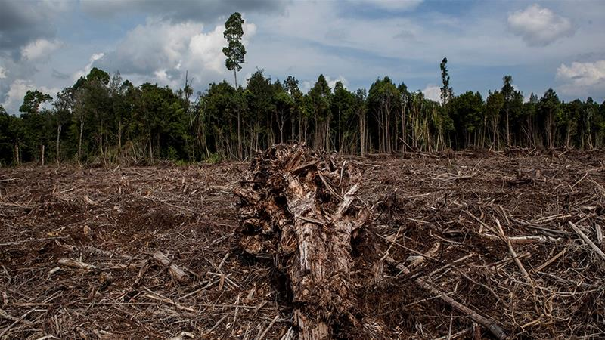
Carbon dioxide emissions could fall by the largest amount since World War II this year as the coronavirus outbreak brings economies to a virtual standstill, according to the chair of a network of scientists providing benchmark emissions data.
Rob Jackson, who chairs the Global Carbon Project, which produces widely watched annual emissions estimates, said carbon output could fall by more than 5 percent year-on-year - the first dip since a 1.4 percent reduction after the 2008 financial crisis.
"I wouldn't be shocked to see a 5 percent or more drop in carbon dioxide emissions this year, something not seen since the end of World War II," Jackson, a professor of Earth system science at Stanford University in California, told Reuters news agency in an email.
"Neither the fall of the Soviet Union nor the various oil or savings and loan crises of the past 50 years are likely to have affected emissions the way this crisis is," he said.
The prediction - among a range of new forecasts being produced by climate researchers - represents a tiny sliver of good news in the midst of crisis: Climate scientists had warned world governments that global emissions must start dropping by 2020 to avoid the worst impacts of climate change.
But the improvements are for all the wrong reasons, tied to a world-shaking global health emergency that has infected more than 950,000 people - while shuttering factories, grounding airlines and forcing hundreds of millions of people to stay at home to slow the contagion.
Experts warn that without structural change, the emissions declines caused by coronavirus could be short-lived and have little effect on the concentrations of carbon dioxide that have accumulated in the atmosphere over decades.
"This drop is not due to structural changes so as soon as confinement ends, I expect the emissions will go back close to where they were," said Corinne Le Quere, a climate scientist at the University of East Anglia in eastern England.
After world greenhouse gas emissions dipped in the aftermath of the 2007-2008 global financial crisis, they shot back up a whopping 5.1 percent in the recovery, according to Jackson.
The pattern of a swift rebound has already begun to play out in China, where emissions fell by an estimated 25 percent as the country closed factories and put in place strict measures on people's movement to contain the coronavirus earlier this year, but have since returned to a normal range.
That kind of resilience underscores the magnitude of the economic transformation that would be needed to meet the goals of an international deal brokered in Paris in 2015 to try to avert the most catastrophic climate change scenarios.
A United Nations report published in November found that emissions would have to start falling by an average of 7.6 percent per year to give the world a viable chance of limiting the rise in average global temperatures to 1.5 celsius (2.7 Fahrenheit), the most ambitious Paris goal.
"I don't see any way that this is good news except for proving that humans drive greenhouse gas emissions," said Kristopher Karnauskas, associate professor at the Department of Atmospheric and Oceanic Sciences at the University of Colorado Boulder.

A thinner silver lining
With the world dependent for fossil fuels for 80 percent of its energy, emissions forecasts are often based on projections for global economic growth.
Last month, Glen Peters, research director of the Center for International Climate Research in Oslo, predicted carbon emissions would fall between 0.3 percent and 1.2 percent this year, using higher and lower forecasts for global GDP growth from the Organisation for Economic Co-operation and Development or OECD.
A few days later, The Breakthrough Institute, a research center in California, predicted emissions would decline 0.5-2.2 percent, basing its calculations on growth forecasts from JP Morgan, and assuming the global economy recovers in the second half.
"Our estimates indicate that the pandemic's climate silver lining is vanishingly thin," said Seaver Wang, a climate and energy analyst at the institute.
"It's as if we went back in time and emitted the same amount we were a few years ago - which was already too much. In the grand scheme of things, it really makes no difference."
Some foresee a bigger hit to the economy. The London-based Centre for Economics and Business Research estimates that world GDP will fall by at least 4 percent this year - albeit with a "huge margin of error."
That drop would be more than twice as large as the contraction during the financial crisis and the largest annual fall in GDP since 1931, barring wartime, the centre said.
With governments launching gigantic stimulus packages to stop their economies collapsing, investors are now watching to see how far the United States, and China, the European Union, Japan and others embrace lower-emission energy sources.
"Even if there is a decline in emissions in 2020, let's say 10 percent or 20 percent, it's not negligible, it's important, but from a climate point of view, it would be a small dent if emissions go back to pre-COVID-19 crisis levels in 2021," said Pierre Friedlingstein, chair in mathematical modelling of the climate system at the University of Exeter in southwest England.
"This is why it is important to think about the nature of the economic stimulus packages around the world as countries come out of the most immediate health crisis," said Dan Lashof, US director at the World Resources Institute.

Step 2: Answer the following questions

- What problem/issue is discussed in this article?

- What structural changes do you think are important to address this issue/problem?

Step 3: Draw an image/picture

Draw a picture of a structural change that is needed to address the emissions problem.

What recommendations would you make to help the environment?

________________________________________________________________________________________________________________________________________________________________________________________________________________________________________________________________________________________________________________________________________________________________________________________________________________________________________________________________________________________________________________________________________

Student Feedback:

Circle the emojis that best represents how this activity made you feel.

Mindfulness Moment!
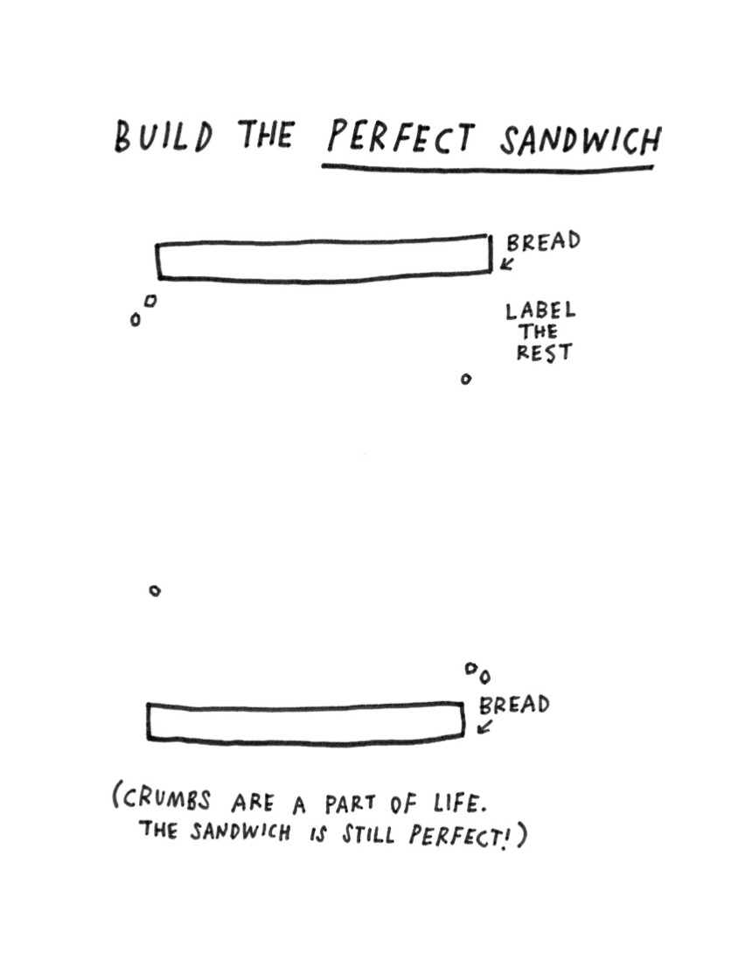

Day 3: Change/Population
Math

What is this lesson about?: This lesson is about world population and the percentage change over time.

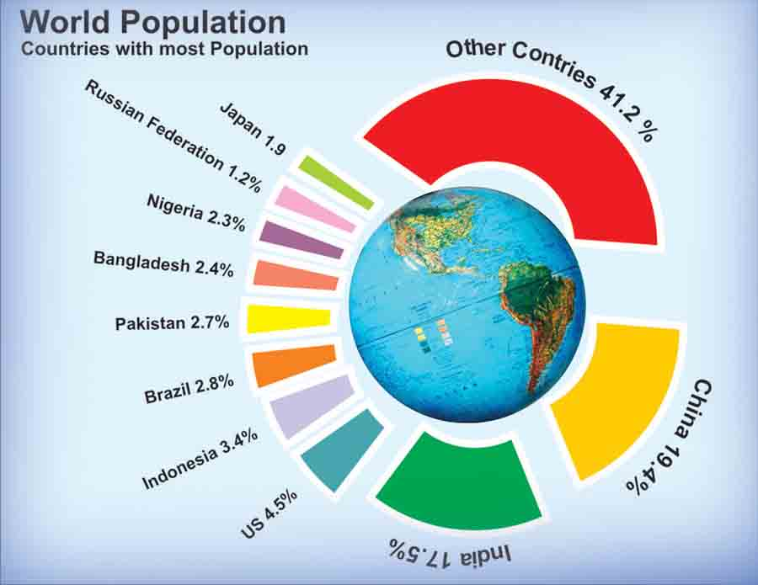

Step 1: Country populations
The United Nations estimates that the world population for April 2020 is approximately 7.8 Billion people. In standard numeric form that’s 7,800,000,000. Wow! Our global population is growing and there are currently more people on the Earth today then combining all the people who have ever died. Certain countries are continuing to grow, such as China, India and many African countries. Others, such as the Russian federation and Japan have shrinking populations.

To calculate how many people are currently in our country, we need to multiply 4.3%(.043) times 7,800,000,000. That is the percent of the world’s population that is in the U.S. multiplied by the total world population.

7,800,000,000 times .043 = 335,400,000.

There are roughly 335 Million people currently living in the U.S. Using this method, please calculate the population for these three countries.

Country | Population
United States | 335,400,000
Nigeria
Pakistan
India

Step 2: Differing populations by country

You can see from the pie chart above that the U.S. has a greater population than both Nigeria and Pakistan, but how much greater?

If you calculated step 1 correctly you should have found Nigeria’s population to be 179,400,000. If we subtract Nigeria’s population from the population of the U.S.(335,400,000-179,400,000) we find the difference to be 156,000,000. The U.S. has 156 Million more people than Nigeria.

Please fill out the chart below with the correct differences in populations for the other two countries compared with the U.S. Remember, if we are comparing them to the U.S. we use a negative sign if they are smaller and a positive sign if they are larger.

Country | Population | Population difference
United States | 335,400,000 | 0
Nigeria | 179,400,000 | -156,000,000
Pakistan
India

Step 3: Calculating a percentage difference

To calculate a percent difference we need to use a ratio (fancy word for a fraction.) If we take the difference in population for a country as the numerator, we then divide it by the U.S. population, the denominator.

In the case of Nigeria we would calculate 156,000,000 divided by 335,400,000 to get .465. Then we convert our decimal to a percentage by moving the decimal point 2 units to the right which equals 46.5%. In other words, Nigeria has 46.5% less people than the U.S.

Using the information you found in step 2, please calculate the percent difference in population for Pakistan and India.

Country | Population | Population difference | Percent difference
United States | 335,400,000 | 0 | 0
Nigeria | 179,400,000 | -156,000,000 | -46.5
Pakistan
India

Step 4: Population and pollution
One of the challenges of a huge and growing population in India and China, is pollution. Both countries have historically relied on coal to produce electricity for their citizens, leading to dangerous levels of air pollution. Coal is the dirtiest, most inefficient way to produce electricity,

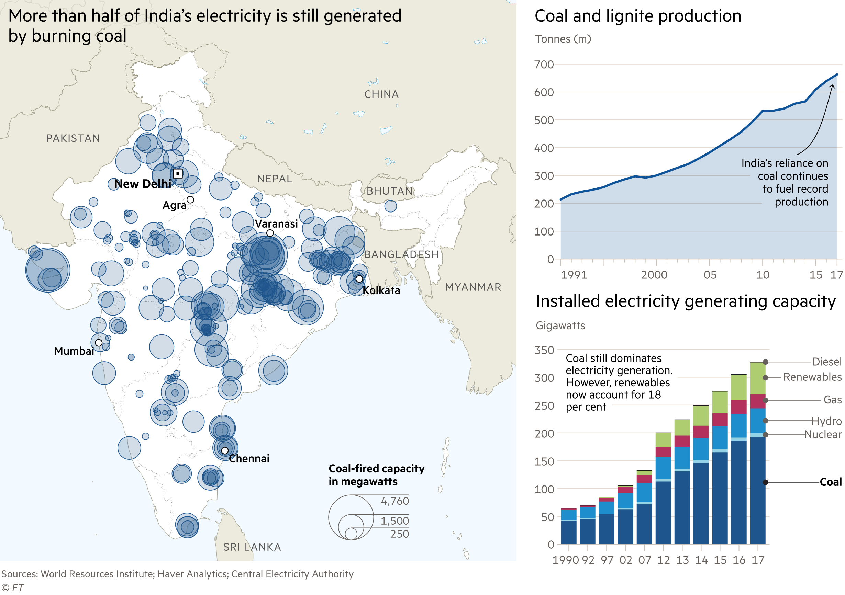
Based on these charts and graphs, answer the following questions:
- How many approximately how many tons of coal did India produce back in 1990?
- And how much are they producing now (2017)
- Back in 1990, coal was used to generate most of the electricity in India. Today (2017), renewable energy such as solar and wind are a pretty big part (18%) of how India produces electricity. That is good. But...
- Does India use more coal now (2017) or in 1990 to produce electricity?

- Why, do you think, does India use so much more electricity today than in 1990?

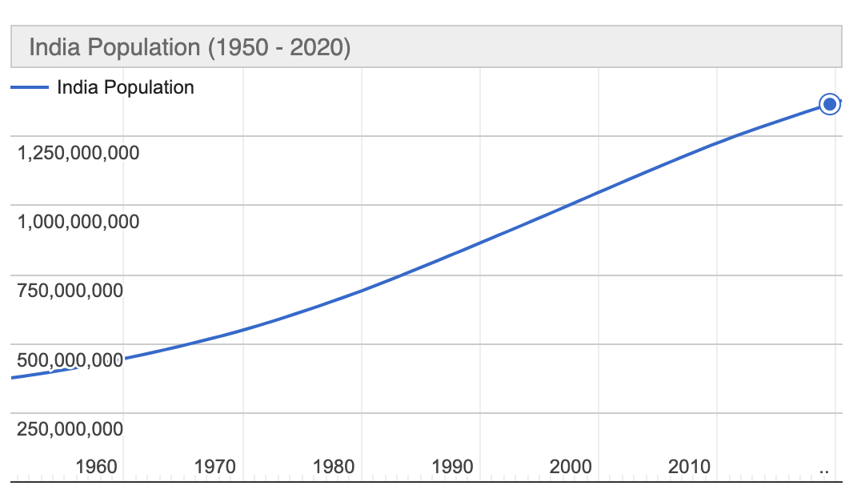
- Based on this chart, what was India’s population, approximately in 1990? And what is it today, approximately?

- Discuss/consider: As populations increase, what pressure does that put on energy needs? How can we provide energy needs to an increasing population and keep pollution down and keep the environment clean?

Student Feedback:

Circle the emojis that best represents how this activity made you feel.

Day 3: How can we deal with change?
Health

What is this lesson about?: In today’s lesson, you will think of ways that you can deal with change. Dealing with change can have a big impact on your mental and physical health.

Step 1: Respond to the prompts below by using the scale.

Place a letter for each prompt below on the scale.

- How confident are you in identifying changes that can take place in adolescence?

- How confident are you in understanding the effect that change can have? (eg. on friendships, mood, routines, confidence, etc.)

- How confident are you in knowing strategies to manage change and where to seek support?

Reflect: Did your answers change from Monday?

Step 2: Read this excerpt from Chicken Soup for the Soul. 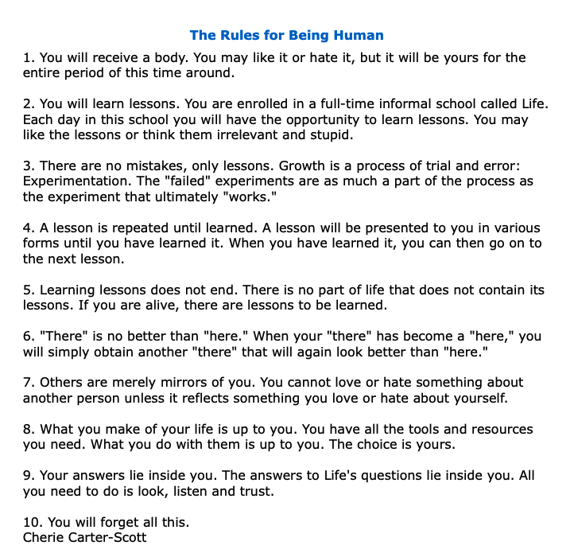
Which rule was most important to you? Why?

Which rule do you think will change you the most? Why?

What rule do you think is missing? Why?

Step 3: Dealing with Change

You have been asked to give advice to each person in the situations below. Use some of the strategies below if you need ideas.
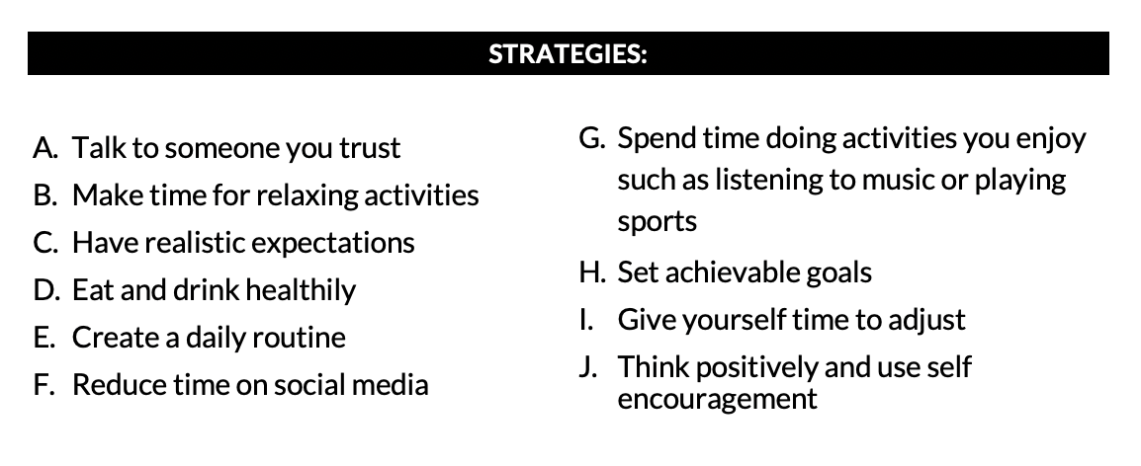
Who Scenario What advice would you give to these students?
 | Someone who is starting a new job.
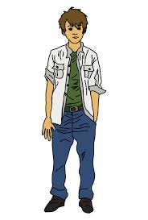 | Someone who has just moved to this country.
 | Someone who is going through a physical change as they grow.
 | Someone whose parents are separating.
 | Someone who has experienced a change in their friendship group.

Step 4: Reflect

Which scenario was hardest to give advice on?

Can you think of a scenario that we could add?

Why do you think it is important to practice these scenarios?

Student Feedback:

Circle the emojis that best represents how this activity made you feel.

Mindfulness Moment!
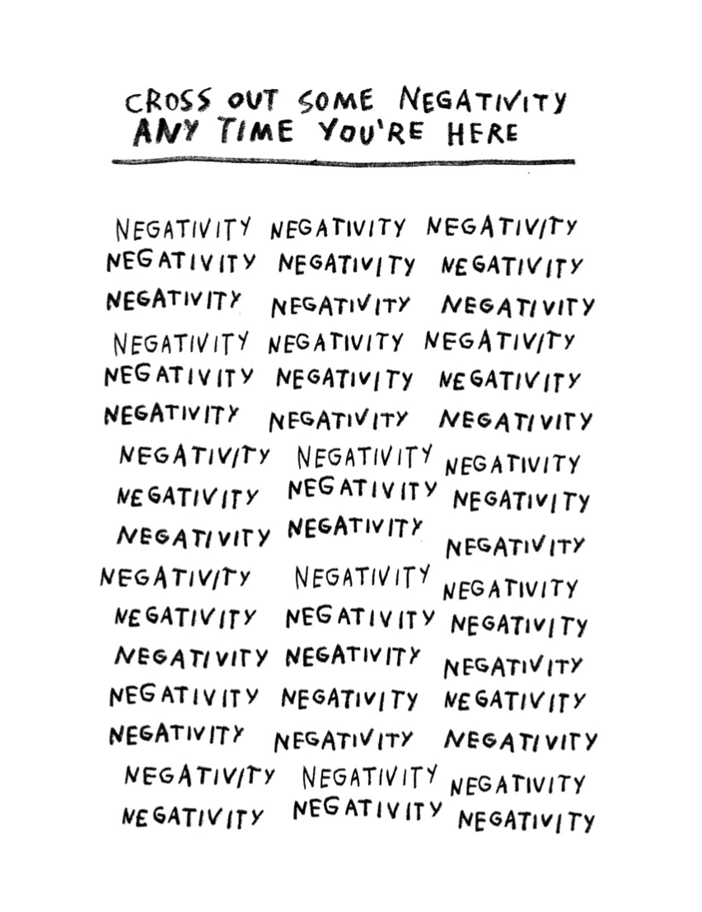

Day 3: Changing Historical Interpretations of Columbus
Social Studies

What is this lesson about?:

Warm-up: free-write

Take 5 minutes to read the quote below and reflect on it. Write what you think it means?
"Each age tries to form its own conception of the past. Each age writes the history of the past anew with reference to the conditions uppermost in its own time." – Frederick Jackson Turner

Step 1: Consider what you know

Before you begin reading about Christopher Columbus, take a few minutes to write down 5 things on what you already know about him.

Step 2: Read the text

Historical Interpretations of Christopher Columbus

As historians write history, they analyze and interpret sources (evidence). Because they bring different approaches to their work, they often interpret the past in different ways. Consider the following interpretations of one of the best-known figures in our history – Christopher Columbus. Few historians would disagree that his four voyages to the Americas set in motion events that would change the world. But historians do differ in how they view Columbus and his legacy, or impact on future generations.

Washington Irving: Columbus as a mythic hero
Nineteenth-century author Washington Irving spent years in Spain researching the life of Columbus. Irving was one of the first American writers to focus on subjects and themes of American life. His four-volume biography of Columbus portrayed the explorer as an American icon, painting him in heroic terms.
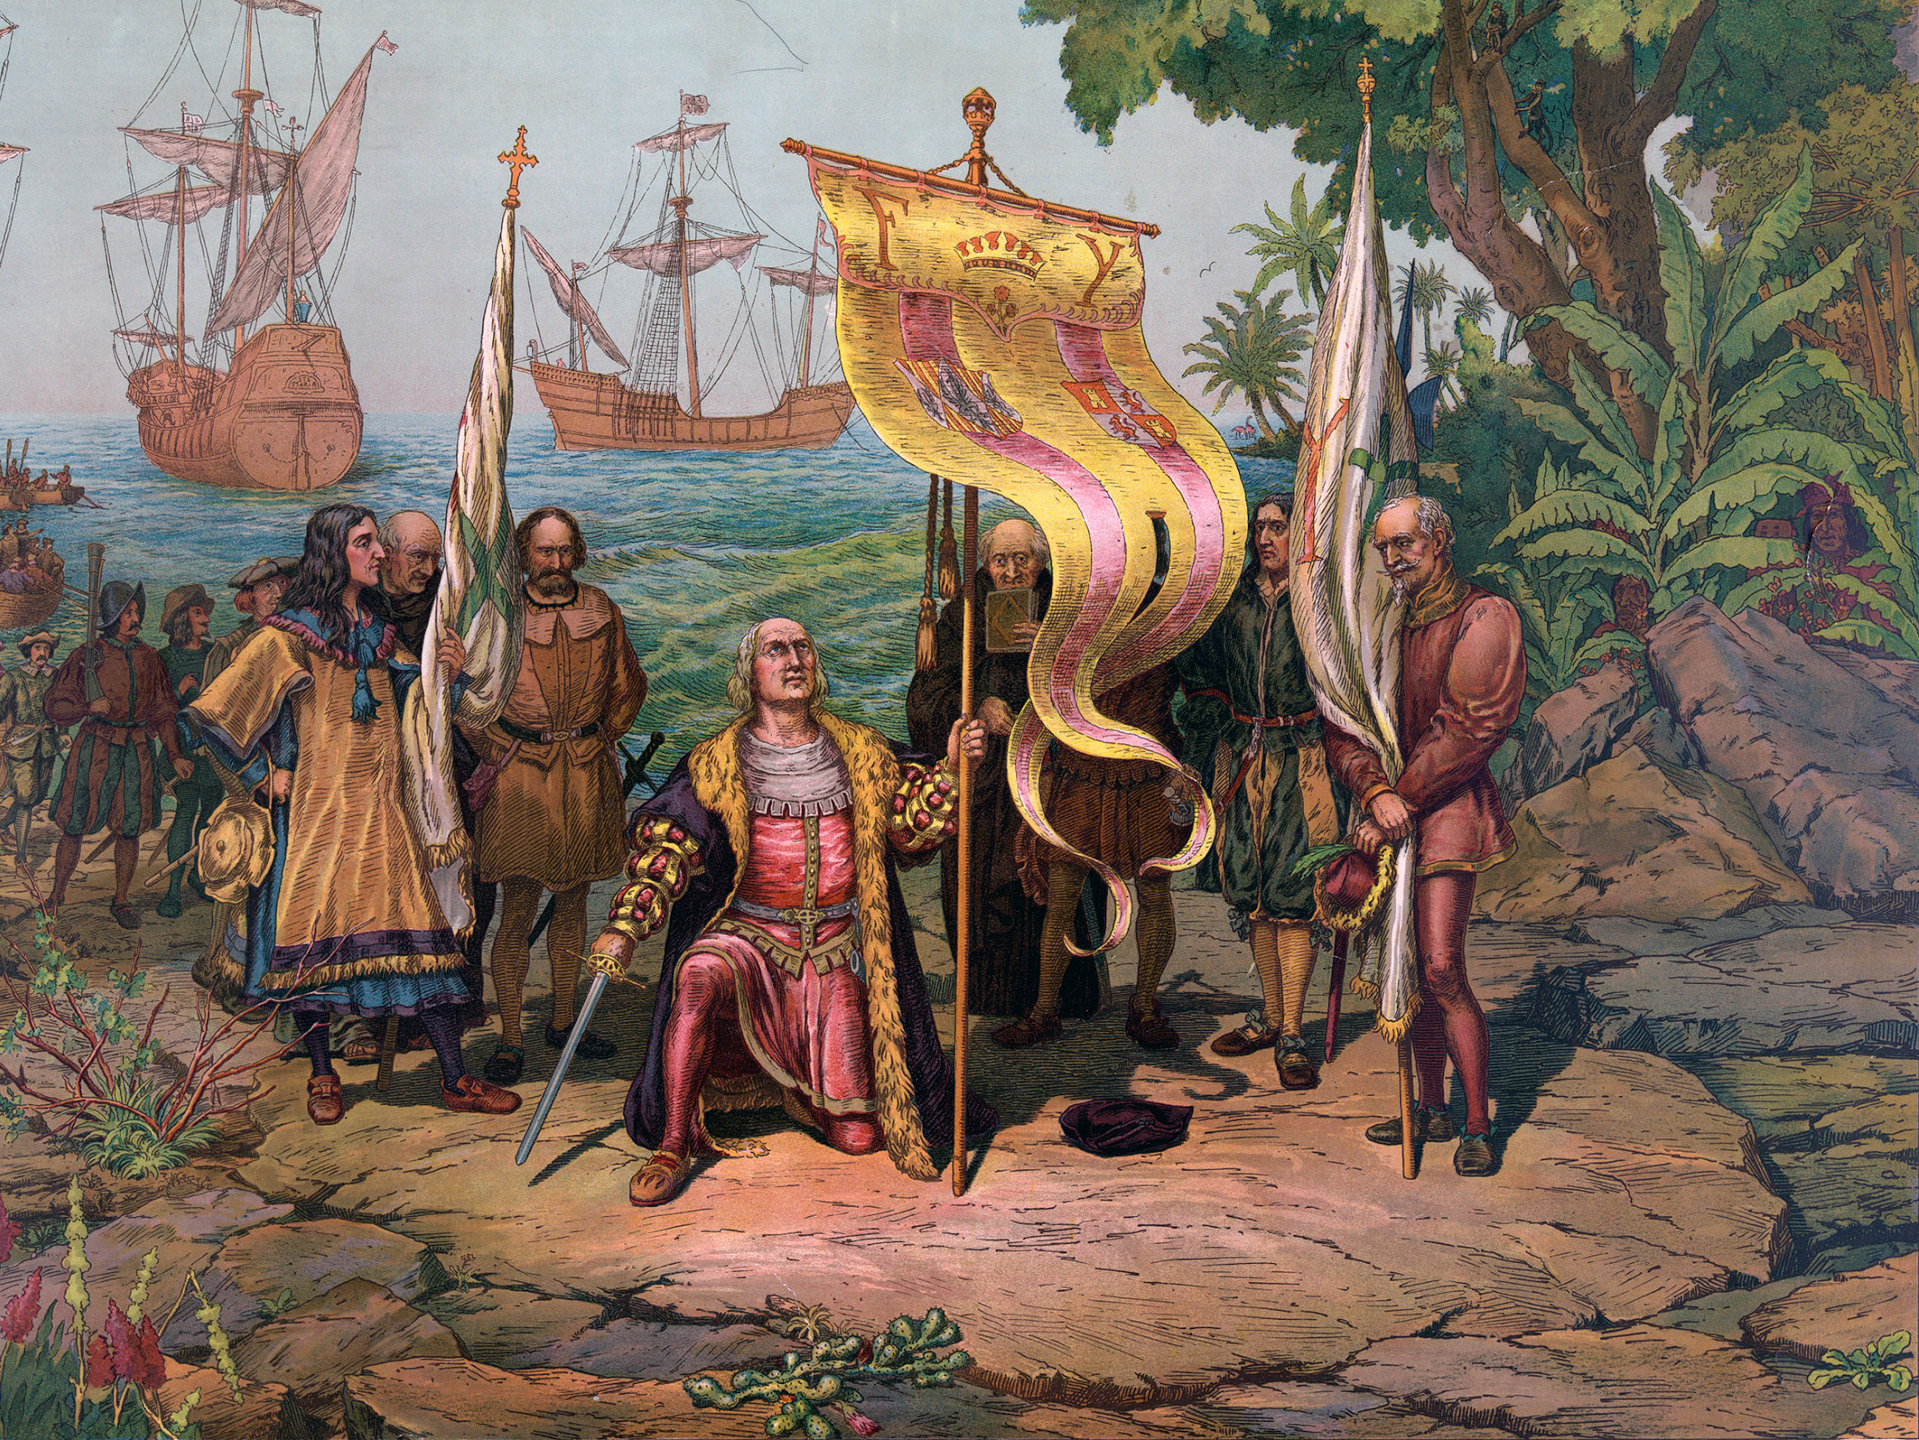
“Columbus was a man of great and inventive genius...His ambition was lofty and noble, inspiring him with high thoughts, and an anxiety to distinguish himself from great achievements...His conduct was characterized by the grandeur of his views and the nobility of his spirit. Instead of ravaging the newly found countries...he sought to colonize and cultivate them, to civilize the natives...A valiant and indignant spirit...a visionary of an uncommon kind.”
-Washington Irving, The Life and Voyage of Christopher Columbus, 1828

Irving admitted that Columbus made mistakes, such as enslaving and killing native peoples, but he dismissed them as “errors of the times.”

Samuel Eliot Morison: Columbus as Master Mariner
Writing more than a century after Irving, historian Samuel Eliot Morison portrayed Columbus as a real
person with both strengths and flaws. Morison, a naval historian, focused on Columbus’s skills as a mariner, or sailor and navigator.

“Now, more than five hundred years after his birth...(Columbus’s discovery of the New World) is celebrated throughout the length and breadth of the Americas, his fame and reputation may be considered secure for all time. He had his faults and his defects, but they are largely the defects of the qualities that made him great – his indomitable will, his superb faith in God and in his own mission as the Christ-bearer to lands beyond the seas, his stubborn persistence despite neglect, poverty and discouragement. But there is no flaw, no dark side to the most outstanding...of all his qualities, his navigation skills. As a master mariner and navigator, Columbus was supreme in his generation. Never was a title more justly bestowed than the one which he most jealously guarded, Admiral of the Ocean Sea.”
-Samuel Eliot Morison,Christopher Columbus, Mariner, 1955

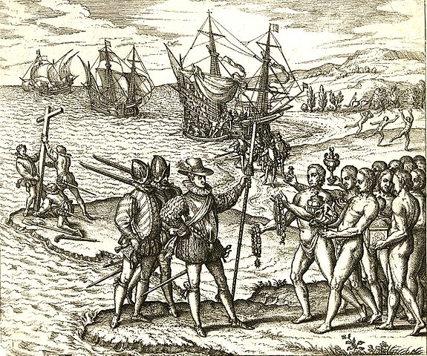
Kirkpatrick Sale: Columbus as overrated hero
Writer and environmentalist Kirkpatrick Sale is far more critical of Columbus. In a 1990 book, Sale portrays Columbus as a ruthless fortune hunter who set in motion the destruction of native peoples and the American landscape that continues to this day. Sale also takes issue with the view of Columbus as a “master mariner.”

“For all his navigational skills, about which the salty types make such a fuss, and all his fortuitous headings, (accidental but lucky directions), about which they are largely silent, Admiral Columbus could be a wretched mariner. The four voyages, properly seen, quite apart from bravery and endurance, are replete with clumsy mistakes, misconceived sailing plans, foolish disregard of elementary maintenance, and stubborn neglect of basic safety...Almost every time Columbus went wrong it was because he had refused to bend to the inevitabilities of tide and wind and reef, or, more arrogantly still, had not botherend to learn about them; the very same reckless courage that led his across the ocean in the first place, same his through storm and tumult to return, lay behind his numerous misfortunes.”
-Kirkpatrick Sale, The Conquest of Paradise, 1990

Different interpretations serving different purposes
You may be wondering how three different writers could produce such different interpretations of the same subject. The answer lies, in part, in each one’s purpose in writing about Columbus and his legacy.

Irving was an author and essayist looking for a heroic story that would appeal to American readers in the 1800s. His colorful biography of Columbus was filled with dramatic episodes, with many based on more myth than on reliable sources.

Morison’s purpose was quite different. He wanted to rescue Columbus from earlier mythmakers like Irving. A sailor himself, Morison was impressed by Columbus’s seafaring skills. He acknowledged that Columbus was not a saint but portrayed him as a master sailor who, through persistence, daring and courage, changed the course of history.

Sale had yet another purpose. He wanted to show how Columbus’s legacy looked from the point of view of its victims – Native Americans and Africans brought as slaves to the Americas. From Sale’s perspective, Columbus and those who followed him across the Atlantic, set in motion a dark history of exploitation and environmental destruction that had been ignored far too long.

The facts of Columbus’s life and legacy have not changed in all this time. But how people view those facts has and will continue to change.

Step 3: Reflect and answer questions

Look back to your answer above in step 1. Based on what you wrote, what version of Columbus’ history have you been taught? Which one matches up best with what you already knew about columbus.

After reading the different interpretations of Columbus’ voyage to America, has your opinion changed? Why or why not? Write at least three sentences explaining your answer.

What more do you want to learn or study about Columbus to better understand him and his actions?

Step 4: Read one more article

Opinions- PRO/CON: Should we celebrate Christopher Columbus?
By Silvio Laccetti, McClatchy Tribune, and Los Angeles Times Editorial Board, adapted by Newsela staff

PRO: Columbus was a man of his time, history shows he is worth celebrating
Monuments honoring Christopher Columbus are being defaced and destroyed. This year’s Columbus Day celebrations will spark strong debate over the explorer’s legacy. However, looking at Columbus in the big picture of history, one can see today’s anti-Columbus sentiment is misguided.

First, let’s consider the spread of European disease, principally smallpox. Smallpox is estimated to have killed 70 to 80 percent of Native Americans. Though these numbers are staggering, the deaths happened over many decades. Holding Columbus responsible is not logical. Further, calculating an actual number of deaths is impossible. Estimates of pre-Columbus populations vary widely. In Hispaniola, the island that now makes up the countries of Haiti and the Dominican Republic, for example, the estimates run from 250,000 to 3 million.

It’s also worth remembering all other epidemics. The Black Death, originating in Central Asia, killed 40 percent or more of the European population. Roughly 50 million people died between 1346 and 1353. This is a negative result of the interaction of any civilizations.

Let’s also remember the exchange of disease worked both ways. Most historians believe the Great Pox that killed 5 million in Renaissance Europe came from the Americas.

Mayans Were Barbaric People
Next, consider the early civilizations of the Americas. They have left behind beautiful monuments. However, the earliest societies, like the Mayans, were as brutal in exploiting subject peoples as any civilization elsewhere.

Tourists love to visit the magnificent pyramids of Teotihuacan and Mayan sites close to resorts.

So beautiful! So inspiring! So conveniently located! Not so beautiful if you consider the human sacrifice that regularly occurred there.

War, slavery and human sacrifice pre-dated the 1492 arrival of Columbus.

European civilization has evolved, but 20th century wars, atrocities, genocide and terrorism show humanity is prone to the same savage impulses.

Columbus was a product of his time. He was also a great explorer, a fearless adventurer, a man of faith and a leader who blazed a path to the modern world.

Italian And Hispanic Descendants Celebrated Him
He holds a special place in the minds of Italian-Americans and Hispanic-Americans in particular. These groups celebrate Columbus Day with parades and statues.

Parks, playgrounds, streets, squares and schools throughout the U.S. bear Columbus' name.

No question, we must examine the accomplishments of Columbus. Doing so in the proper context shows there’s no reason to destroy, deface or remove his monuments — or minimize his legacy.

Silvio Laccetti is a retired professor of social sciences at Stevens Institute of Technology in Hoboken, New Jersey.

***
CON: We must recognize that progress for some led to injustice for others
The Los Angeles City Council in California has joined many other cities in replacing Columbus Day. A holiday called Indigenous Peoples Day will instead recognize the contributions, and suffering, of Native Americans.

Of course, giving workers a day off does not make up for centuries of discrimination, enslavement and government-approved killing of Native Americans., nor would wiping Columbus Day off the calendar.

Without question, the nation must do a far better job recognizing the violent history against the country’s indigenous people. California’s leaders in the 1850s made no secret of their desire to destroy the area’s native people. Legislators funded anti-Indian armed forces. Natives were massacred. Villages were destroyed and tribes forcibly relocated.

Special Holiday Could Appease Opponents
Would a holiday help Californians learn about this shameful period? Would it encourage reconciliation? Possibly.

Leaders could consider an official public apology. Or they could consider compensating tribes that lost sacred sites or returning land of special value. Los Angeles, in particular, could provide greater protection for sacred sites. It could offer official support for local tribes. Many tribes still seek federal recognition.

The true stories of native peoples, beyond the simplistic portrayal of the first Thanksgiving meal, must become part of our national story. Schools should be required to teach the history, even the parts we'd like to forget.

Supporters of Indigenous Peoples Day say the government also must remove Columbus Day from the calendar. Columbus was a cruel slave trader who brought about the mass killing of native peoples.

Columbus Day Appeased Special Interests
But why must this be a choice? The debate over Columbus Day reflects confusion about how the history of racism and oppression in the U.S. fits into a proud national identity. The U.S. has taken in millions of needy immigrants but also grew through colonization that devastated native populations. Columbus Day wasn’t created to celebrate colonial domination. It was designated a federal holiday in 1934 after a campaign by Italian-Americans and Catholics. They were targets of ethnic and religious discrimination at the time.

Erasing history is not the answer. The better approach is confronting it honestly.

Whether the holiday is called Columbus Day or Indigenous Peoples Day or Explorers Day or History Day, isn’t there a way to celebrate a nation rising on a promise of liberty and equality, while also recognizing that progress for some led to displacement, injustice and death for others? There should be.

The Los Angeles Times Editorial Board represents the opinions of the staff of the newspaper.
Step 5: Reflect and respond

Do you think interpretations of Christopher Columbus have changed since the time Columbus Day was created to today? Why or why not?

Respond to the following statements and explain your position. Write in the corner of the graph that represents the position you have on the statement.
Agree
Strongly agree

Columbus Day should be a national holiday.
Strongly Agree
Agree
Strongly Disagree
Disagree

Student Feedback:

Circle the emojis that best represents how this activity made you feel.

Week 6
Change

Day 4

NAME:______________________

Day 4 Agenda

Topic | Activity
Warm-Up!
English Language Arts | - Read and analyze the lyrics to the songs , Same Drugs and 7 years  - Answer questions about the lyrics and themes of the songs.  - Write a reflection piece where they give their younger and future selves advice.
Science | - Read about Environmental Changes  - Answer questions about what you read  - Draw a picture and explain
Mindfulness Moment!
Math | - Change and the Environment, Day 3: Water Case Studies (Flint, California, South Africa and Mumbai)
Health | - P.E.
Mindfulness Moment!
Civics/Social Studies | - Changing views on the battle of the Alamo  - Read and respond to the text

Warm-up Activity: Write a journal entry around the daily quote on identity.

Day 4: Relationship Changes
English Language Arts

What is this lesson about?: Today you will read and analyze the lyrics of two songs that talk about changes in relationships.

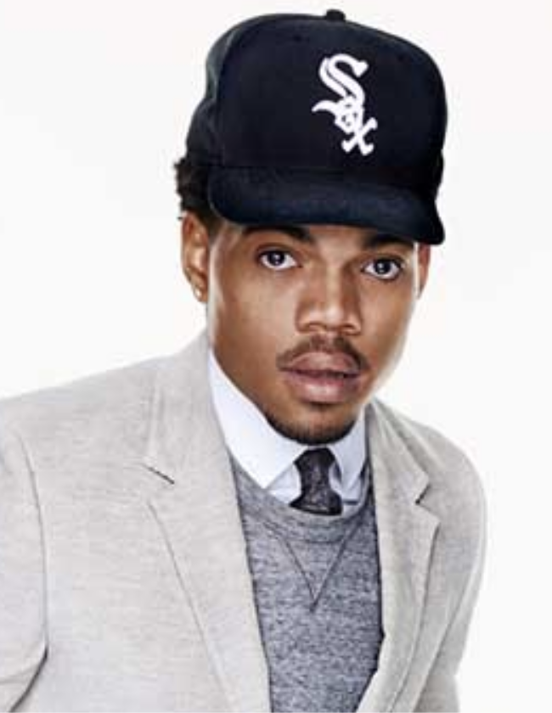
Before you Read:
Chance the Rapper, born Chancelor Johnathan Bennett, is an American rapper, singer, songwriter, actor, and activist.
Born in Chicago, Illinois, Chance the Rapper released his debut mixtape 10 Day in 2012. He began to gain mainstream recognition in 2013 after releasing his second mixtape, Acid Rap. But it was his third mixtape, Coloring Book, in 2016, which earned him three Grammy Awards, including the award for Best Rap Album; upon winning, it became the first streaming-only album to win a Grammy Award. He is also known for his activism, especially in his hometown of Chicago. In 2016, co-created a nonprofit called SocialWorks set up to create youth programs for residents of Chicago, among other goals. He has also actively fought to combat gun violence in his hometown of Chicago and in 2014, along with his father, promoted the "#SaveChicago" campaign. The campaign sought to stop gun violence over Memorial Day Weekend. During 2014's Memorial Day weekend, Chicago went 42 straight hours without a shooting. In March 2017, he announced his intention to donate $1,000,000 to Chicago Public Schools in order to help offset the lack of government funding provided.

Step 1: Read the following text
As you read, take note of two things. First, Chance the Rapper has stated that “Same Drugs” is not about drugs. As you read, think about how he uses “same drugs” as a metaphor for something else. Secondly, there is an allusion in this song. An allusion is when a writer indirectly makes mention of a famous character or event from another work of art or history in order to communicate a message to the reader. In this song, there is a reference to “Wendy”. Wendy was Peter Pan’s friend when she was a child--and Peter Pan is a young boy who never wants to grow up. Think about how Chance uses this allusion to communicate his message in this song.

 | Same Drugs  Chance the Rapper | Notes:
1 | We don't do the same drugs no more  We don't do the, we don't do the same drugs, do the same drugs no more  Cause she don't do the same drugs no more  We don't do the, we don't do the same drugs, do the same drugs no more  When did you change?  Wendy you've aged  I thought you'd never grow up  I thought you'd never  Window closed, Wendy got old  I was too late, I was too late  A shadow of what I once was  Cause we don't do the same drugs no more  We don't do the, we don't do the same drugs, do the same drugs no more  She don't laugh the same way no more  We don't do the, we don't do the same drugs, do the same drugs no more
2 | Where did you go?  Why would you stay?  You must have lost your marbles  You always were so forgetful  In a hurry, don't wait up  I was too late, I was too late  A shadow of what I once was  Cause we don't, we don't do what we say we're gonna
3 | You were always perfect, and I was only practice  Don't you miss the days, stranger?  Don't you miss the days?  Don't you miss the danger?  We don't (we don't) do the same drugs no more (do the same drugs no more) (x5)
4 | (Turn it around  I remember when  This age of pathetics)  Don't forget the happy thoughts  All you need is happy thoughts  The past tense, past bedtime  Way back then when everything we read was real  And everything we said rhymed  Wide eyed kids being kids  When did you stop?  What did you do to your hair?  Where did you go to end up right back here?  When did you start to forget how to fly?  (This shit, wanna chew  Tastes like Juicy Fruit  Words have magnitude  Please get me out of that)  Don't you color out  Don't you bleed out, oh  Stay in the line, stay in the line  Dandelion  (Do the same drugs no more  We don't do the, we don't do the same drugs, do the same drugs no more  We don't, we don't, we don't)  Don't you color out  Don't you bleed out, oh  Stay in the line, stay in the line  Dandelion

Step 2: Answer the following questions.

- The chorus of the song is “We don’t do the, we don’t do the same drugs no more”. If the speaker is talking about relationships, what is the phrase “same drugs” a metaphor (a comparison) for?

- In the first stanza, the speaker tells Wendy that she has aged and gotten old. Is he surprised, angry, upset? What words tell you how he feels? Why do you think he feels this way?

- Why do you think that the speaker says “we don't do what we say we're gonna”? (Hint: Again, think about a relationship that is either ending or changing)

- The last stanza refers to what life was like when they were kids. PIck 2-3 lines and explain how he describes childhood and how that might be different as we grow up.

Step 3: Read the lyrics to the following song.

7 years was written by Lukas Forchhammer who stated that the songs is about his life so far and what he hopes to achieve in the future. He said that the reason the lyrics go as far as the age of 60 is because his father died at 61 and he needed to "pass it to believe it." He continued: "It's a song about growing older. As you read the lyrics, think about how he describes the changes in his life and in his relationships as he grows older.

 | 7 Years  Lukas Graham  Songwriters: Christopher Brown / David Labrel / Lukas Forchhammer / Morten Pilegaard / Morten Ristorp Jensen / Stefan Forrest | Notes
1 | Once I was seven years old my momma told me  Go make yourself some friends or you'll be lonely  Once I was seven years old
2 | It was a big big world, but we thought we were bigger  Pushing each other to the limits, we were learning quicker  By eleven smoking herb and drinking burning liquor  Never rich so we were out to make that steady figure
3 | Once I was eleven years old my daddy told me  Go get yourself a wife or you'll be lonely  Once I was eleven years old
4 | I always had that dream like my daddy before me  So I started writing songs, I started writing stories  Something about that glory just always seemed to bore me  'Cause only those I really love will ever really know me
5 | Once I was twenty years old, my story got told  Before the morning sun, when life was lonely  Once I was twenty years old
6 | I only see my goals, I don't believe in failure  'Cause I know the smallest voices, they can make it major  I got my boys with me at least those in favor  And if we don't meet before I leave, I hope I'll see you later
7 | Once I was twenty years old, my story got told  I was writing about everything, I saw before me  Once I was twenty years old  Soon we'll be thirty years old, our songs have been sold  We've traveled around the world and we're still roaming  Soon we'll be thirty years old
8 | I'm still learning about life  My woman brought children for me  So I can sing them all my songs  And I can tell them stories  Most of my boys are with me  Some are still out seeking glory  And some I had to leave behind  My brother I'm still sorry
9 | Soon I'll be sixty years old, my daddy got sixty-one  Remember life and then your life becomes a better one  I made a man so happy when I wrote a letter once  I hope my children come and visit, once or twice a month  Soon I'll be sixty years old, will I think the world is cold  Or will I have a lot of children who can warm me  Soon I'll be sixty years old  Soon I'll be sixty years old, will I think the world is cold  Or will I have a lot of children who can warm me  Soon I'll be sixty years old
10 | Once I was seven years old, momma told me  Go make yourself some friends or you'll be lonely  Once I was seven years old  Once I was seven years old

Step 4: Answer the following questions

- What do you think of the pieces of advice given by the singer’s mom and dad? Have you ever been given similar advice from your parents?

- Fill out three of the sections of the timeline below by listing three major life events that happen to the speaker in the song.

7 years old | 11 years old | 20 years old | 30 years old | 60 years old

- How does the speaker change throughout his life? Pick one transitional period (between 7 and 11, between 11 and 20, between 20 and 30, or between 30 and 60) and describe how he is different and how his life has changed.

Step 5: Reflect and Write

The song is filled with a lot of advice. For example, the speaker’s mother tells him to "Go out and make some friends or else you'll be lonely." Think of what advice you would give to your younger or older self at different points in your life.

Pick 4 ages (2 younger and 2 older than you are now) and give yourself advice that you believe will make your life happier and more successful.

Example:
Age 6: I was an intense kid and afraid of being laughed at by others so I kept to myself. My advice to 6 year old me: Be brave and play with others more. You’ll make friends and not be so lonely.
Age 12: I never like to worry my Grandmother, so I didn’t tell her I was having trouble at school until it was too late. My advice to 12 year old me: Ask for help when you need it. You are just a kid, accept help if you need it.
Age 19 I’ll be on my own and ready to start a new life. My advice to 19 year old me: Try new things, take chances and keep your goals in mind.
Age 30: I’ll be secure in my career. My advice to 30 year old me: Don’t just work, it’s not worth it to make money if you don’t use it to live a real life.

Age _____:

Age _____:

Age _____:

Age _____:

Student Feedback:
Circle the emojis that best represents how this activity made you feel.

Day 4: Environmental Change
Science

What is this lesson about?: Today you will read through the Scientists have found there's a crucial change we can make to better serve our planet passage. You will answer a few questions about what you read. You will complete an Environmental Change activity.

Step 1: Read through the Scientists have found there's a crucial change we can make to better serve our planet passage

Scientists Have Found There’s a Crucial Change We Can Make
to Better Serve Our Planet
TESSA KOUMOUNDOUROS 23 SEPTEMBER 2019

The planet is struggling. Study after scientific study warns that we've pushed far beyond the physical boundaries of what our living world can sustain.

From increasing temperature extremes causing disastrous weather - including record breaking droughts and unprecedented fires - to plastic choked oceans and ecosystem collapses, it's painfully clear something massive's got to give. And yet most governments are waiting for it to make economic sense before they take action.
In light of this, a background document for the United Nations' (UN) draft Global Sustainable Development Report 2019 suggests we seriously need to consider making drastic changes to our economic systems.

"[T]he economic models which inform political decision-making in rich countries almost completely disregard the energetic and material dimensions of the economy," the researchers wrote in the document.

"Economies have used up the capacity of planetary ecosystems to handle the waste generated by energy and material use."

In other words, maybe it's time to accept we can't somehow maintain endless economic growth on a finite planet.

The UN report is overseen by a group of independent scientists from different disciplines around the world.

This background document for the chapter of the report called Transformation: The Economy, has been written by scientists from environmental fields, such as ecosystem scientist Jussi Eronen from the University of Helsinki, as well as economic, business and philosophy researchers, like economist Paavo Järvensivu from Finland's independent BIOS research unit.

Not only have we reached the point where using our land, water and atmosphere as a giant garbage dump is no longer viable, the document warns that our current economic systems are also causing critically widening gaps between the rich and poor.

This is leading to a rise in unemployment, and debt which are all contributing to destabilising our societies.

In fact, data shows continuing to pursue economic growth in wealthy nations doesn't continue to improve human wellbeing, as ecological economist Dan O'Neill explains for The Conversation.

Still, the notion of changing our economic system to fit within the physical limits of our reality is seen as highly controversial and isn't something many policy makers will discuss.

Especially when leaders of wealthy nations such as the US and Australia openly deny climate change. Or as a leaked document from the UK's foreign office reads: "Trade and growth are now priorities for all posts… work like climate change and illegal wildlife trade will be scaled down."

Meanwhile, we're failing to meet the Paris agreement to hold temperatures within 2 degrees Celsius of warming above pre-industrial times.

Every indication from our scientists is that we have two options: make widespread drastic but controlled changes to the way we live or continue as we are, blundering towards disaster.

"Market-based action will not suffice – even with a high carbon price," the UN document warns.

It's not the first time humans have had to rally together and find unique solutions to extraordinary scientific challenges – the document points out the fact that the US Apollo program only succeeded because the government set a clear mission and then found ways to achieve the funding and research required.

They didn't wait for market-based mechanisms to make the Moon landing happen. So why are we still waiting for the market to miraculously steer us away from disaster, especially when so much is at stake, the document questions.

Journalist Naomi Klein, author of This Changes Everything: Capitalism Vs the Climate, points out that "we humans are capable of organizing ourselves into all kinds of different social orders, including societies with much longer time horizons and far more respect for natural life-support systems."

"Indeed," she writes, "humans have lived that way for the vast majority of our history and many Indigenous cultures keep Earth-centred cosmologies alive to this day. Capitalism is a tiny blip in the collective story of our species."

No one is suggesting we revert to technology-less societies. Instead, the idea is to learn from different ways of living that have proven track records of longevity. From there, we can find new and better ways forward with the help of our advanced technologies.

Klein believes we should view this need to transition our economies as an opportunity to shape them for the better, a chance for us to create both a fairer and more sustainable world.

The background document does not cover what transitioned economies would look like, but it does suggest they "must enable politics to acknowledge transformational social goals and the material boundaries of economic activity". And that economies should primarily be a tool to "enable a good life" rather than as excuse to dogmatically pursue profits.

Järvensivu and colleagues also acknowledge that to transition our societies in time to prevent hurtling ourselves beyond the critical 2 degrees Celsius threshold of warming, it will take an emergency scale response.

This echoes warnings from other scientists: "Incremental linear changes … are not enough to stabilize the Earth system. Widespread, rapid and fundamental transformations will likely be required to reduce the risk of crossing the threshold."

Such a response could look something like an accelerated World War II style transformation of industry, as discussed by leading Harvard atmospheric scientist James Anderson.

Meanwhile, experts around the world are exploring alternative ways we can set up our economic systems, such as Doughnut Economics, Post Growth Economics, Prosperity without Growth, and Steady State Economy - and Järvensivu and colleagues have asked all forward-thinking leaders around the world to start testing possible transitional strategies, such as a universal job guarantee.

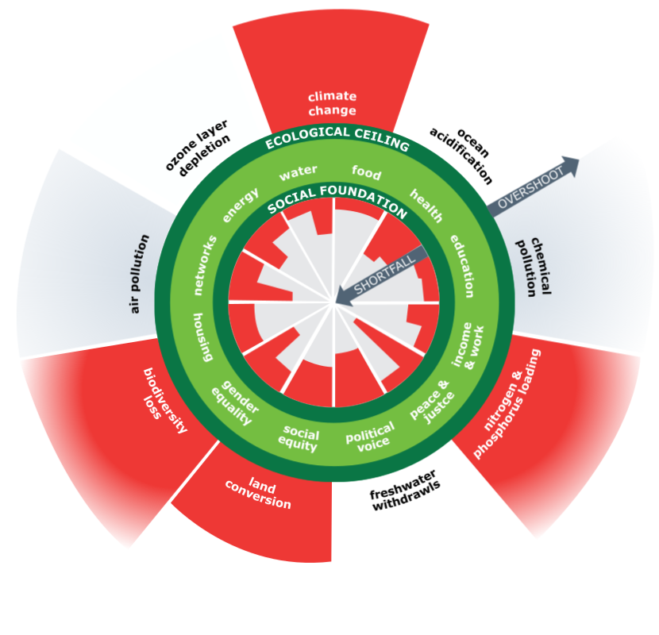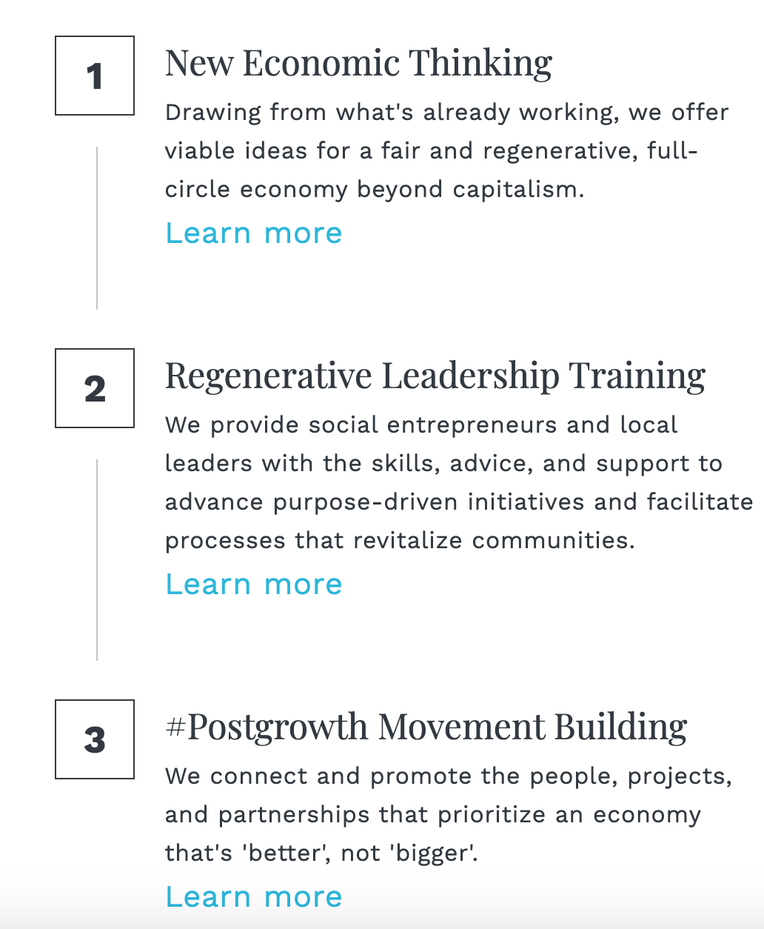

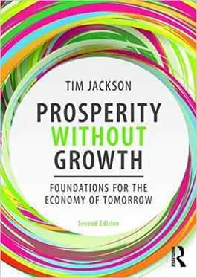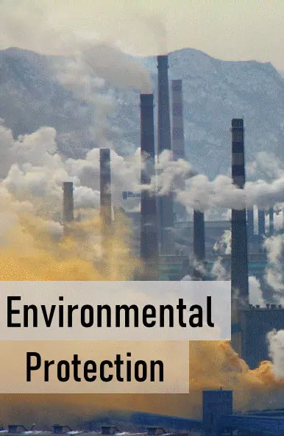

These suggestions are pretty daunting, but if we humans have proven anything with our time on Earth so far, it's that we can achieve incredible things when we work together.

Step 2: Answer questions about what you read

- Based on the article, what important change do we need to make to help save our planet?

- One definition of global warming is a gradual increase in the overall temperature of the Earth's atmosphere generally attributed to the greenhouse effect caused by increased levels of carbon dioxide, chlorofluorocarbons, and other pollutants. What suggestion would you make to help lower the temperature of the Earth’s atmosphere?

Step 3: Draw a picture/explain

Think about your own environment. What changes do you think are needed in your own environment to help make it a better place to live? Draw a picture of what your current environment looks like and a picture of what it looks like with the changes you are recommending. Write a brief description of your “before” and “after” drawings.

Current environment

Environment after the needed changes

____________________________________________________________________________________________________________________________________________________________________________________________________________________________________________________________________

Student Feedback:
Circle the emojis that best represents how this activity made you feel.
Mindfulness Moment!
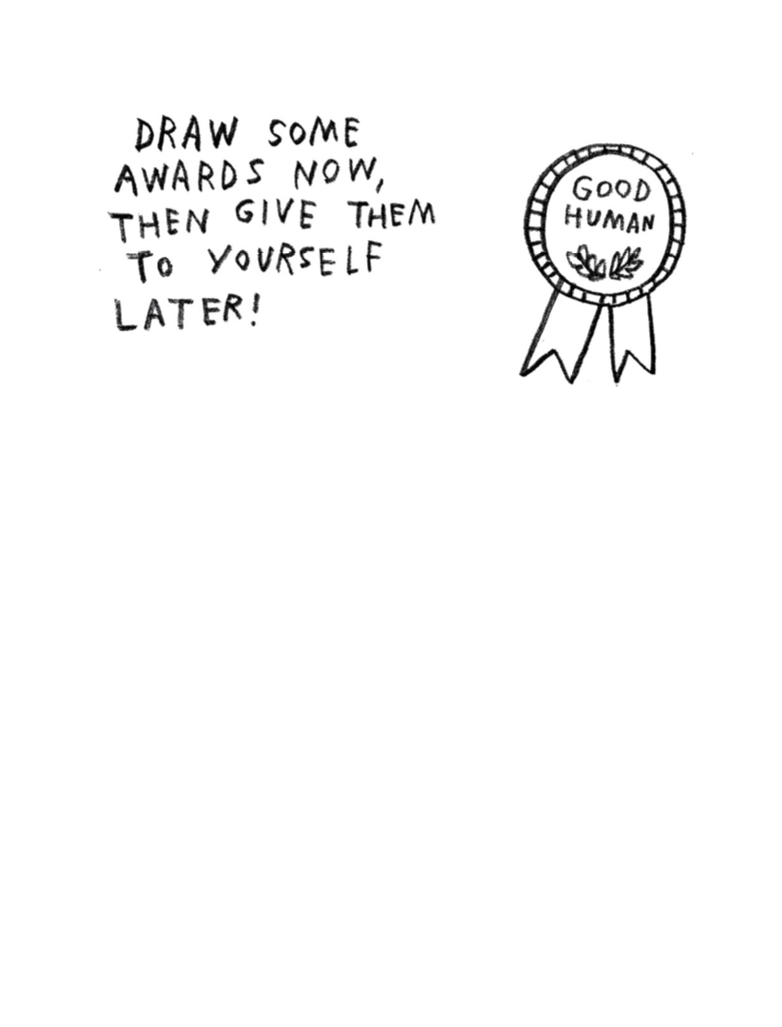

Day 4: Change/Flint, Michigan
Math

What is this lesson about?: Today’s lessons focus on the water crisis in Flint, Michigan that ran for a number of years. The activities focus on the changes that took place in Flint, in light of the City’s decision to try and save money by changing its water source.

Today’s Warm-Up Problem
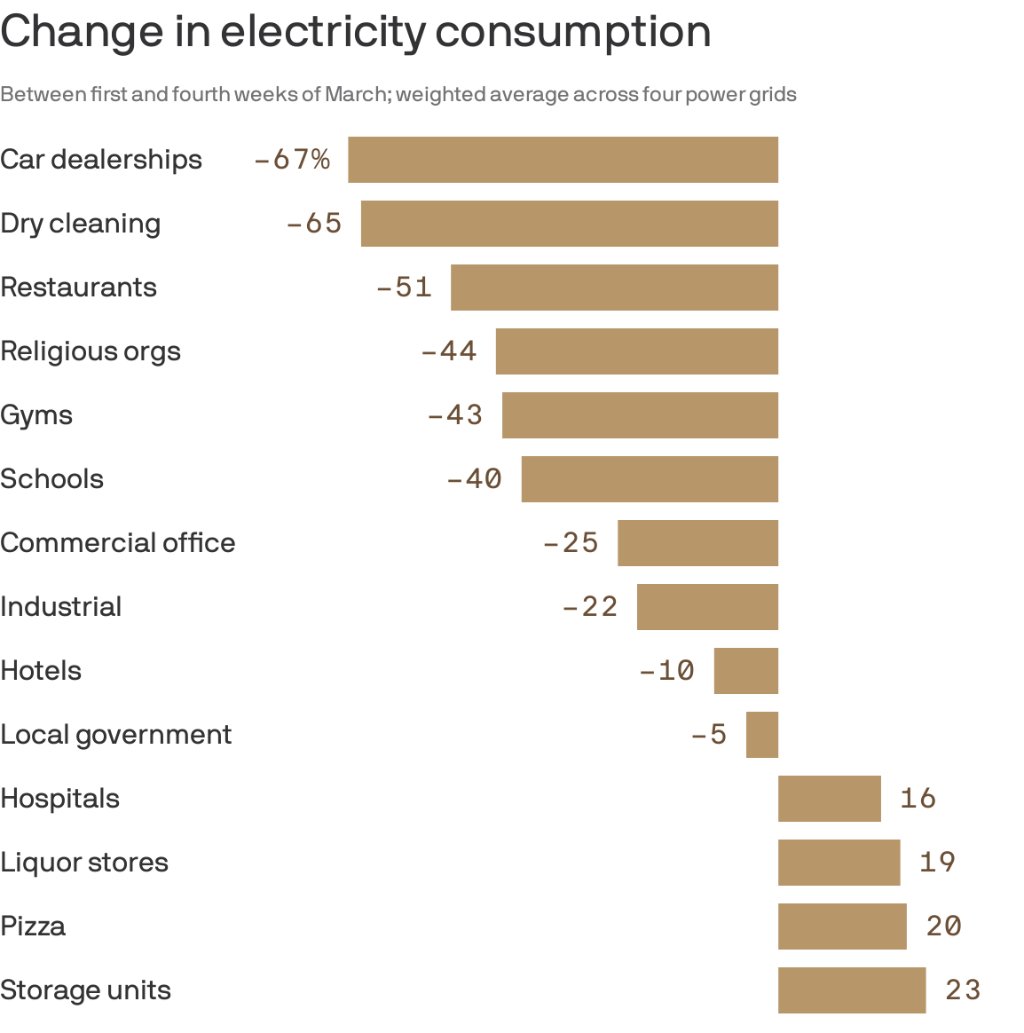
The chart above shows how different industries are using more or less electricity, comparing the first week in March 2020 to the last week in March 2020. A negative % means that industry used that much less electricity. Looking at the chart:
- What industries are using a lot LESS energy now?

- Does it make sense to you that those industries are using less electricity? Yes/No

- What 2-3 industries are using more electricity?

- What do you think that both pizza delivery and liquor stores are using more electricity?

Activity 1: Flint’s population

Flint, Michigan is located about 60 miles from Detroit. For many years, it received its water from Detroit--a much larger city that has a well-tested water treatment system. In 2013, facing a budget shortfall and other challenges, the City of Flint decided to start pulling its water directly from the Flint River (Lake Huron), without adequate processes in place to test and purify the water.

Background on Flint: Use the chart below to answer some basic questions about Flint and its population, in 1990 and in 2018.

Flint, Michigan Statistics | 1990 | 2018
Population | 140,000 | 96,000
Population: Afican Americans | 56,000 | 51,840
% with College Degree | 15% | 12%
Median Household Income | 34,000 | 27,000
Population: People living in Poverty | 35,000% | 38,400

By how much did Flint’s population decline between 1990 and 2018?
What sort of percentage change (decline) is this?

How much did the ‘average’ family earn in 1990 in Flint?
How much was that in 2018?
What sort of percentage change (decline) is this?

What percent of the population was African American in 1990?
What percent of the population was African American in 2018?

What percentage of the population in Flint lived below the poverty level in 1990?
What was this percentage in 2018?

Activity 2: Level of lead in home water

Soon after the city began supplying residents with Flint River water in April 2014, residents started complaining that the water from their taps looked, smelled, and tasted foul. Despite protests by residents lugging jugs of discolored water, officials maintained that the water was safe.

A study conducted the following year by researchers at Virginia Tech revealed the problem: Water samples collected from 352 homes through a resident-organized effort indicated citywide lead levels had spiked. Homes were put into 3 categories:
- Safe tap water,
- “Action Level” tap water, meaning the level was so high that immediate action should be taken based on federal guidance
- “Very Serious” tap water, meaning the level was high enough that based on federal guidance, it was above safe levels and needed to be addressed.

Number of households tested (tap water supply)- | 352
Number of households with Lead with "Quick Action" levels | 53
Number of households with Lead with "Very Serious" levels | 142

Out of the 352 homes tested, how many had lead levels at the “Action Level”?
- What percentage of the tested homes is this (approximately)?

Out of the 352 homes tested, how many had lead level at the ‘Very Serious’ level?
- What percentage of the tested homes is this (approximately)?

Taken together, what % of the homes had problems with high levels of lead in their water?

Discuss/Consider: What would you do if you lived in a neighborhood and more than 50% of the homes were determined to have unsafe drinking water?

Note: Similar testing conducted in 2010 revealed 0% of the homes with lead at the ‘action level’ and less than 5% at the ‘very serious’ level.

Activity #3: Legionnaires Disease in Flint after water crisis

Other problems also struck vulnerable populations in Flint. Legionnaires' Disease--a rare form of pneumonia--had never before been present in Flint, took hold, killing a number of adults and leaving others very sick.

Legionnaires' Disease
Year | Illness | Deaths
2012 | 0 | 0
2013 | 2 | 0
2014 | 31 | 7
2015 | 56 | 5

Use the data to the left to plot a double bar chart showing the spike in illnesses and deaths caused by the disease between 2012 and 2015. (we’ve already added the 2015 illness bar to the graph for you)
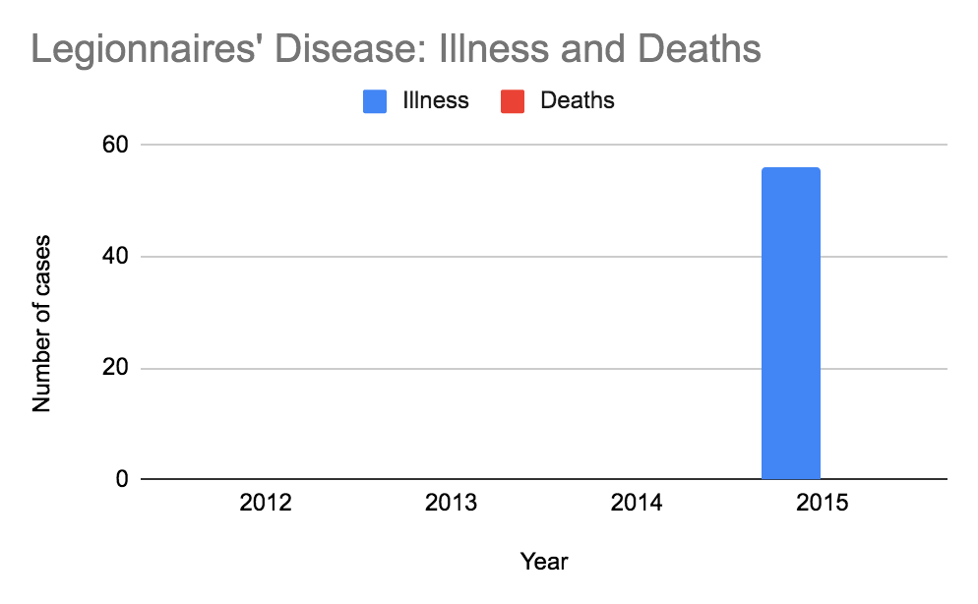
- What does this bar graph make clear to the viewer?

Activity 4: Cost of water in Flint

A survey of the 500 largest water systems in the country, conducted in 2015, found that on average, Flint residents paid about $910 a year for water service, the highest in the nation and nearly double the national average. The figure is based on an annual household consumption of 60,000 gallons. The chart below pulls the cities with the highest annual water bills and those with the lowest water bills.

In addition, the chart compared the cost of household water to Detroit.
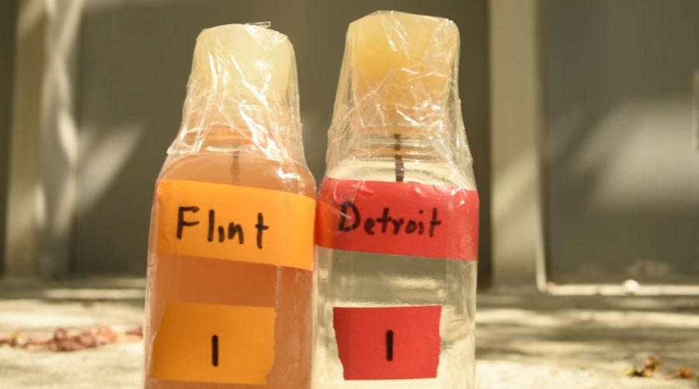
Photo from Metro Times, the Flint, Michigan Newspaper in 2014.

Annual Water Bills--2015  City | State | Population | Av. Annual Water Bill
Flint | MI | 124,943 | $910.05
Detroit | MI | 787,289 | $246.21
Pittsburgh | PA | 516,411 | $792.84
Monterey | CA | 94,700 | $716.18
Harrisburg | WV | 217,959 | $710.63
Memphis | TN | 671,450 | $120.71
Miami-Dade | FL | 2,100,000 | $116.46
Jefferson Parish | LA | 308,362 | $104.40
Phoenix | AZ | 1,500,000 | $84.24
* Based on 60,000 gallon/year usage-

How much more $ does the average family in Flint pay for water than a family in Detroit?

Approximately, how much does a family in Flint pay for water each month?
How much is this for a family in Detroit?

How much does a family in Memphis spend per month on water?
How about a family in Phoenix?

Housing advocates say that families shouldn’t pay more than 1% of their income for basic water in their homes. In Detroit, if the average household income is $27,000 and a family spends approximately $900 per year on water.

- About what % of $27,000 is $900.

Consider/discuss: Back in 2010, the average resident in Flint, MI paid just slightly more for water than the average resident living in Detroit. The water quality in both cities was the same, coming from the same source. Five years later, residents in Flint are paying 3xs as much for water. The water for years had been dirty, with high lead levels.

- In hindsight, was the city’s decision to try and purchase ‘cheaper’ water a good one?

Student Feedback:

Circle the emojis that best represents how this activity made you feel.

Day 4: PE
Health

What is this lesson about?: In today’s lesson, you will work on your PE BINGO card.

Step 1: Try to complete the PE BINGO card.

Mindfulness Moment!
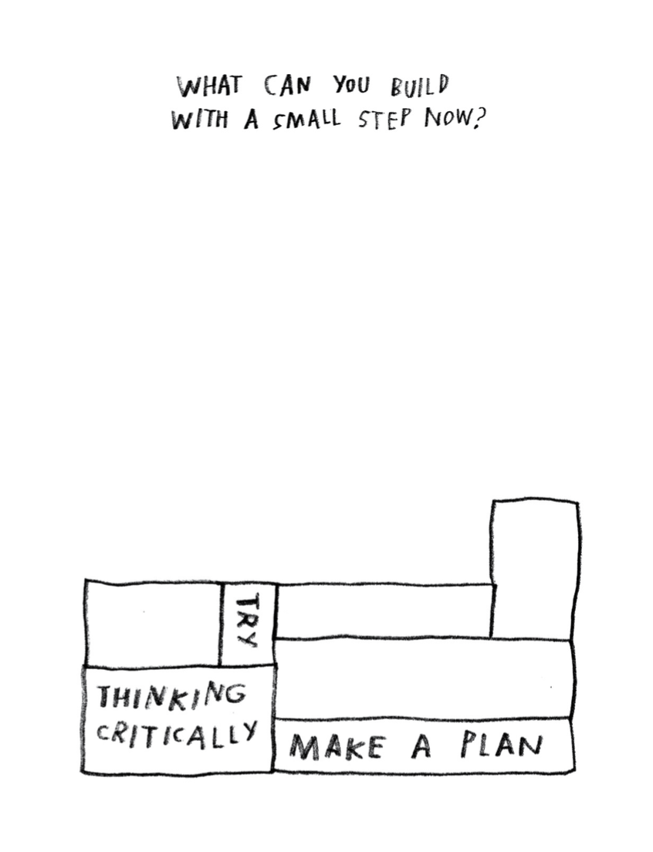

Day 4: Changing Views on the Battle of the Alamo
Social Studies

What is this lesson about?: Today you will compare articles about the battle of the Alamo from different time periods and assess how views of the battle have or have not changed over time.

Warm-up: free-write

Take 5 minutes to read the quote below and reflect on it. Write what you think it means?
"Who controls the past controls the future: who controls the present controls the past." – George Orwell

Step 1: Read an article from 1836

Time Machine (1836): The Battle of the Alamo
By Telegraph and Texas Register, adapted by Newsela staff
Newsela Editor's Note: This article originally appeared in the March 24, 1836, edition of the Telegraph and Texas Register, published in San Felipe, Texas. It was the first article in print about the fall of the Alamo and is considered to be the most influential account of the battle. The Battle of the Alamo was part of the Texas Revolution, when English-speaking settlers called Texians in Northern Mexico – which is now Texas – rebelled against the Mexican government. In the Battle of the Alamo, the Texians were beat badly by the Mexican army, but it inspired other Texians to join the revolution.
That event is so lamentable and yet so glorious to Texas. It is of such deep interest and feeling that we shall never stop celebrating it. We regret that we do not know the names of those who fell in that fort. We would print them and make sure that future ages remember our heroes who perished. Such examples should be held up so we may learn to change our own behavior.

Better To Be A Dead Hero Than A Living, Merciless Victor
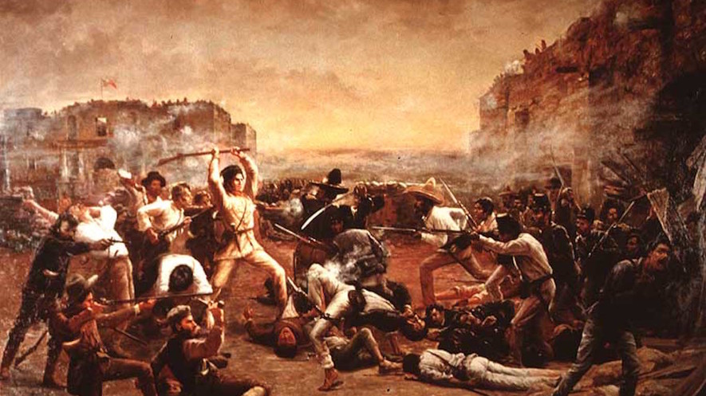
At sunrise, the enemy surrounded the fort with their soldiers. Their soldiers on horseback formed a circle outside to prevent escape. The number consisted of at least 4,000 against 140! General Santa Ana was commanding them, assisted by four generals and a fearsome train of weapons. Our men had been previously much fatigued and harassed by night watching and toils. Some days ago they experienced a heavy bombardment and several real and feigned attacks. But American courage and American love of liberty displayed themselves to the last, they were never clearer. Twice did the enemy put their scaling ladders on the walls, and twice did they fail. Our men were determined to uphold Colonel Travis's words, “to make the victory worse to the enemy than a defeat.” There was a pause after the second attack. They then poured in over the walls, “like sheep.” The struggle, however, did not even end there. Unable from the crowd and for lack of time to load their guns and rifles, our men made use of the butt ends of their rifles to continue to fight. They fought until life ran out through their numberless wounds and the enemy had conquered the fort. Total extermination followed. The darkness of death occupied the unforgettable Alamo. We envy not the feelings of the victors. They must have been bitter, not proud. Who would not be rather one of the Alamo heroes, than of the living of the merciless victors? Spirits of the mighty, though fallen! Honors and rest are with you. The spark of greatness which animated you shall brighten into a flame. Texas and the whole world shall worship you like demigods of old, and will try to be like you.

Battle Was Only An Hour But Its Glory Will Last Generations
From the beginning to its end, the fighting lasted less than an hour. The end of the great hunter David Crockett of Tennessee was as glorious as his life had been useful. He and his fellow fighters were found surrounded by piles of men they had killed. Texas places him amongst the most respected people. Colonel Travis stood on the walls cheering his men till he received a second shot and fell. It is stated that a Mexican general, Mora, then rushed upon him and lifted his sword to destroy his victim. But Colonel Travis collected all the energy he had left and came at Mora. The victim became the victor, and both began a never ending sleep.

4 Were Spared, Including Woman Who Told World What Happened
Travis’s slave was spared, because as the enemy said, “his master had behaved like a brave man.” These are words which are already engraved on the hearts of Texans, and should be inscribed on his gravestone. Colonel James Bowie, who had for several days been sick, was gruesomely murdered in his bed. We shudder at describing these scenes.
Mrs. Dickinson, her child, and two slaves were spared. Our dead were not given a Christian funeral. If only we could gather up their ashes and place them in vases to honor them!
It is stated that about 1,500 of the enemy were killed and wounded in the attacks.
Step 2: Reflect and answer questions

How does the article describe the Texians who fought against the Mexican Army at the Alamo?

Why did the Texians rebel against the Mexican government and engage the Mexican Army in this battle? What were they fighting for?

Put yourself in the shoes of a historian who is writing a book about the Alamo. Based on this piece of evidence from 1836, how would you interpret the battle of the Alamo? Did the Texians have a good reason to rebel against the Mexican government? Between the two sides, who was in the right and who was in the wrong?

Step 3: Read a current article about the Alamo

Expansion and Reform: Remembering the Alamo
By Linda K. Salvucci, The Gilder Lehrman Institute of American History, adapted by Newsela staff

Thanks to movies, TV shows and books, most students already know at least a little about the Alamo.

The Alamo, found in San Antonio, Texas, was once a Roman Catholic mission. It was built in the 18th century to teach Native Americans who had converted to Christianity. After years of abandonment, it became a military fortress in the early 1800s. Today, it is a museum, commemorating the famous Battle of the Alamo in 1836.

The Battle of the Alamo was the turning point in the Texas Revolution, when American colonists in the Mexican province of Texas rebelled against the Mexican government. In the end, Texas won its independence from Mexico and became part of the United States. This did not happen without bloodshed, however.
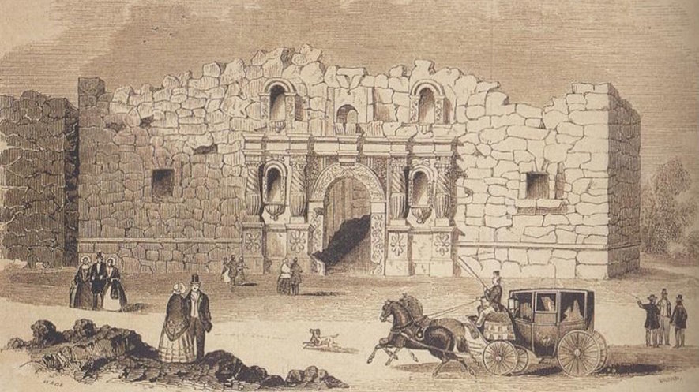
The Battle of the Alamo is often recounted as the simple tale of outnumbered defenders overwhelmed by an invading army. It is usually remembered as a tale of brave men who chose to die in order to create the Republic of Texas.

More recently, however, studies have emerged that frame the event from new angles. They provide opportunities to think about the relationships between history and myth, history and memory, and history and meaning.

The Battle of the Alamo
How was it that such a dramatic confrontation came to take place at the Alamo? The usual explanation highlights the westward migration of mostly white Americans to Texas in hopes of securing land to grow cotton. The Mexican government encouraged such settlement in the early 1820s to form a barrier against the American Indians.

In return for land, the new arrivals — including many slaveholders and aspiring slaveholders — promised to respect Mexican laws and customs. The number of settlers grew faster than anticipated. Soon there were clashes over slavery, trade and other issues.

Mexico had abolished slavery in its territories, and the original American settlers had agreed to follow Mexican law. Still, by 1835, disputes over the payment of taxes sparked armed rebellion.

Texans raised an army to fight against the Mexican government. At this same time, Mexico had entered its own civil war.

Fighting
After a number of battles in the territory, the Texas rebels prepared to defend the Alamo, expecting Mexican retaliation. With more than 2,500 troops, Mexican General Antonio Lopez de Santa Anna began the siege of the Alamo on February 23, 1836. Death was the traditional punishment for “pirates,” as he called the Texans. The bombardment continued until the evening of March 5, when all grew quiet. Then, near dawn on March 6, the final assault began.

The battle itself lasted barely more than an hour, but was particularly vicious inside the walls. Hundreds of soldiers were killed in and around the Alamo. After the fighting ended, Santa Anna released a few people who were huddled in the chapel, so that they would spread word of Mexico's victory.

Instead of calming the rebellion, however, the bloody defeat encouraged the Texans to fight harder. On April 21 at San Jacinto, near present-day Houston, they inflicted a terrible revenge. In barely 18 minutes of battle, they killed more than 700 Mexicans, and captured Santa Anna himself, to cries of “Remember the Alamo.”

The state of Texas and the Mexican-American War
In 1836, the victorious rebels founded the Republic of Texas, also known as the Lone Star Republic. It would exist until 1845, when it was finally made part of the United States. This was the outcome many of the Texas revolutionaries had hoped for.

Step 4: Read one more article

Remembering the Alamo Is Easier When You Know Its Many-Sided History
By Edward Rothstein for The New York Times, adapted, published April 30, 2007

Before visiting San Antonio, I really didn’t remember the Alamo. I had a small memory from youth in which heroism, independence and Davy Crockett were major elements, and Mexicans were the bad guys, but that was about it. It was like a childhood fairy tale.
That’s fine for myths: they are not really meant to survive with photographic realism. But when it comes to the Alamo — particularly here in San Antonio where this old Spanish mission turned fort attracts nearly three million visitors a year — the history and its mythical meanings have been wrestled over almost as much as the blood-soaked land it stands on was in earlier centuries. “Remember the Alamo!” was the old battle cry; in recent decades the fight was over just what was being remembered.
Even now, the Alamo is often looked at by local Latinos as a relic of white imperialism (whites imposing on others and expanding their power and control), with Mexico losing Texas in a land grab. For its advocates, though, the Alamo reflects a stubborn Texan drive for independence won from Mexico in 1836, just as Mexico was losing its way and entering its own civil war.

The mythic power of the place is plain in the bare outlines of Texas history. But after the 1970s, as James E. Crisp writes in his fascinating 2004 book, “Sleuthing the Alamo,” “a new and radicalized generation of historians saw the origins of the conflict in the prejudices of White-Americans.” Race, for some historians, became the central issue in the revolution. Texan immigrants from the Southern United States relied on slavery, which was forbidden in Mexico, creating a major incentive for Texas independence and the application of a selective idea of liberty. Instead of liberty being the sole purpose behind the Texas fight for independence, it was instead centered around their desire to maintain the right to own slaves.
As Mr. Crisp writes, “We should never allow even the most revered of our society’s ‘sacred narratives’ to be accepted as simple truths, nor to be mistaken for legitimate history.”
Step 5: Reflect and answer questions

Based on these last two articles, Why did the Texians rebel against the Mexican government and engage the Mexican Army in this battle? What were they fighting for?

Did you answer the last question change as compared to when you answered it after reading the first article?

Why do you think historians are reinterpreting the meaning behind the battle of the Alamo? Discuss your answer with a partner.

Choose one of the historical viewpoints of the battle of the Alamo and draw a cartoon to represent that viewpoint.

Student Feedback:

Circle the emojis that best represents how this activity made you feel.

Week 6
Change

Day 5

NAME:______________________

Day 5 Agenda

Topic | Activity
Warm-Up!
English Language Arts | - Read 2 articles from a choice of 4 articles about Young Activists  - Complete a graphic organizer comparing and contrasting the articles.  - Write a letter to inform others and call them to action about an issue that is important to them and that they want to change.
Science | - Read about Personality Changes  - Answer questions about  - Draw a picture  - Reflect
Mindfulness Moment!
Math | - Change and Youth Climate Change Leaders
Health | - How can you change the world?
Mindfulness Moment!
Civics/Social Studies | - Historiography and the American Revolution  - Read and respond to the text

Warm-up Activity: Write a journal entry around the daily quote on identity.
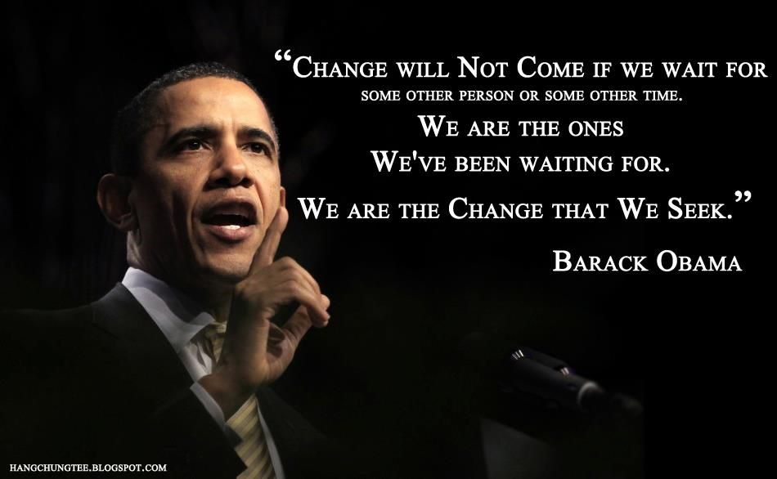

Day 5: Changing the World Around Us
English Language Arts

What is this lesson about?: Today you will read about young people who are working to change the world around them.

Step 1: Read the profiles

There are 4 profiles of young people who are activists for a cause that is very personal and important to them. Pick 2 profiles to read (1 short and 1 long) and as you read, think about the experience that changed this young person’s life and inspired him/her to become an activist.
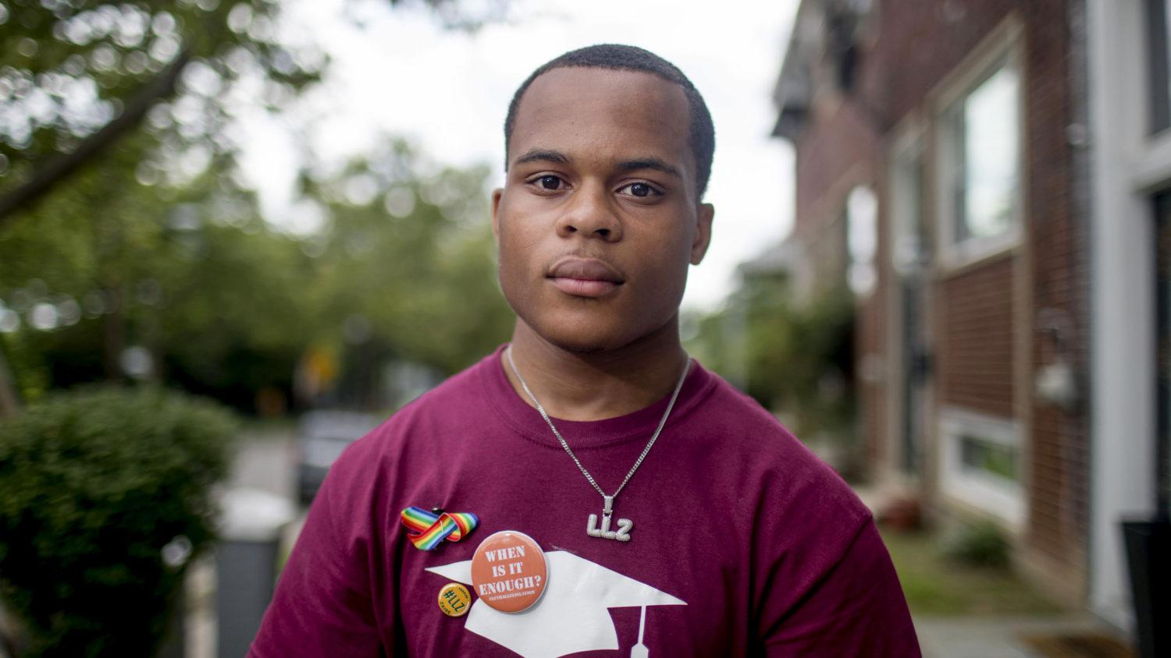
Zion Kelly
Gun control, 17 years old.
By Cheree Franco
Last September – a month before his 17th birthday – Zion Kelly was walking through the park near his home in Washington DC when a strange man asked him for his phone.
Unsettled, Zion bolted and later texted his twin, Zaire, to tell him about the encounter. What Zion couldn’t have known is that the same man – armed with a gun – would kill his brother just two hours later. Eight months on, Zion remembers Zaire as “goofy and always cracking a joke. He was the centre of our friend group.”
A shy kid, Zion often relied on Zaire to make friends for both of them. Growing up in the inner city, gun violence was always in the background. A month before Zaire’s death, the twins attended a vigil for a girl killed close to their house.
“We just accepted it,” says Zion. “Like, we have to be careful. There are guns, but what can we do?”
In February, 17 students from Marjory Stoneman Douglas High School were killed by a gunman in Parkland, Florida, and 17 others were shot but survived. A few weeks later, a woman named Mary Beth Tinker spoke at Zion’s school about the power of students to change policy.
In 1965, Mary Beth fought her middle school all the way to the US Supreme Court, after she was suspended for wearing an armband to protest the Vietnam War.
Zion felt inspired. He invited Parkland survivors to speak at his school. On 24 March, Zion joined these survivors at March for Our Lives to demand legislative gun control in front of the US Capitol building.
Waiting to speak, Zion trembled. This was Zaire’s thing. His twin had been captain of the track team, a candidate for student council president, the kid who grabbed the mic at a political fair and asked a DC councilman about gentrification.
But when he was introduced, Zion suddenly became confident. “I feel like change can happen, especially with the movement going on,” he says. “I want to step up and honour my brother.”
“Stepping up” means giving up his free time to speak at rallies, at the mayor’s breakfast, in front of congressional representatives and news cameras. It means advocating for a city ordinance, named after his brother, that would expand gun-free zones to create safe passage for students travelling to and from school. It means making sure no one forgets that Zaire was a teenager and a twin, rather than a statistic.
Taken from: https://www.huckmag.com/perspectives/activism-2/teenage-activists-protest-worldwide-
agents-of-change/
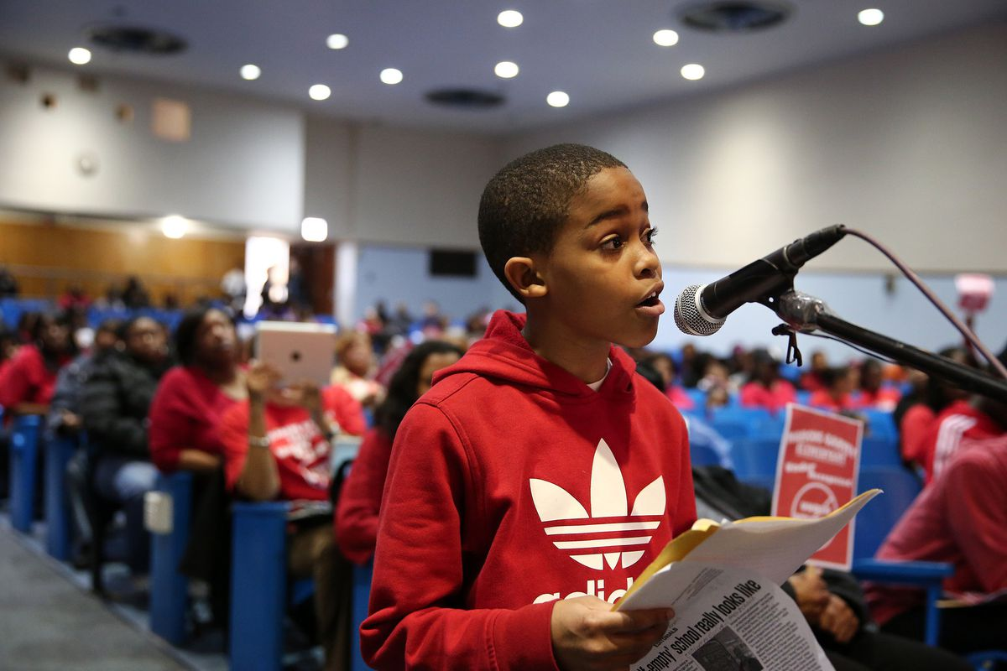

Asean Johnson
Public Education Reform, 9 years old.
By Jonathan P. Hicks

Since his appearance at the commemorative March on Washington last weekend, Asean Johnson has become an Internet sensation.
The 9-year-old Chicago student was the youngest speaker at the event in Washington, D.C., a distinction that fell 50 years ago to John Lewis. The young elementary school student spoke on the need for renewed funds and resources for the nation’s public schools.
“Every school deserves equal funding and resources,” he said to the crowd of thousands on Saturday. “I encourage all of you to keep Dr. Martin Luther King Jr.’s dream alive. Help us fight for freedom, racial equality, jobs and public education, because I have a dream that we shall overcome.”
While young Asean, a student at Marcus Garvey Elementary School in Chicago, has attracted the interest of the nation since he spoke on the steps of the Lincoln Memorial last weekend, he has been well known to residents of Chicago for his electrifying speeches in the face of planned school closures.
Since May, when the Chicago Board of Education voted to close nearly 50 schools, he has been widely followed. During the weeks that led to the vote, the young elementary school student offered a number of impassioned speeches criticizing the plan of the administration of Chicago Mayor Rahm Emanuel to close school buildings in an effort to reduce costs.
Asean said it was a special thrill to speak in front of the crowd at the Lincoln Memorial. “It was a very amazing experience,” Asean said, speaking with BET.com. “I was proud of myself. It was a great feeling to speak in front of all those people on the 50th anniversary of the March on Washington.”
The role of elementary school activist came almost by happenstance. His mother, who works for Chicago Public Schools, was on strike last year and her young son took extraordinary interest in the issues.
“I’m not an activist nor were we an activist family,” said Shoneice Reynolds, Asean’s mother, in an interview with BET.com. “When all the schools closed during the strike, he wanted to come to the picket line with me. He had a choice to stay with the babysitter, but he said he wanted to come with me and learn about the issues.”
Before long, he was walking along picket lines in the area closer to where his family lived, accompanied by his mother. His interest on the topic of school inequities grew to the point where he asked for permission to attend community forums called by elected officials in Chicago.
“At the first hearing, he wasn’t scheduled to speak,” Reynolds said. “They had a schedule of speakers, but they had a few minutes left at the end. And he said, ‘Mommy, I want to speak.’ And he did. And he has been speaking ever since. I've always said that he's a little old man," she said, laughing. "But he and his brother — my two boys — keep me grounded."
As far as his plans when he grows up, he has several paths he is considering. “I want to be a professional football player,” he said. “But, if that doesn’t work out, my backup plan is to be a politician — like president — or a lawyer or a scientist. We’ll see.”
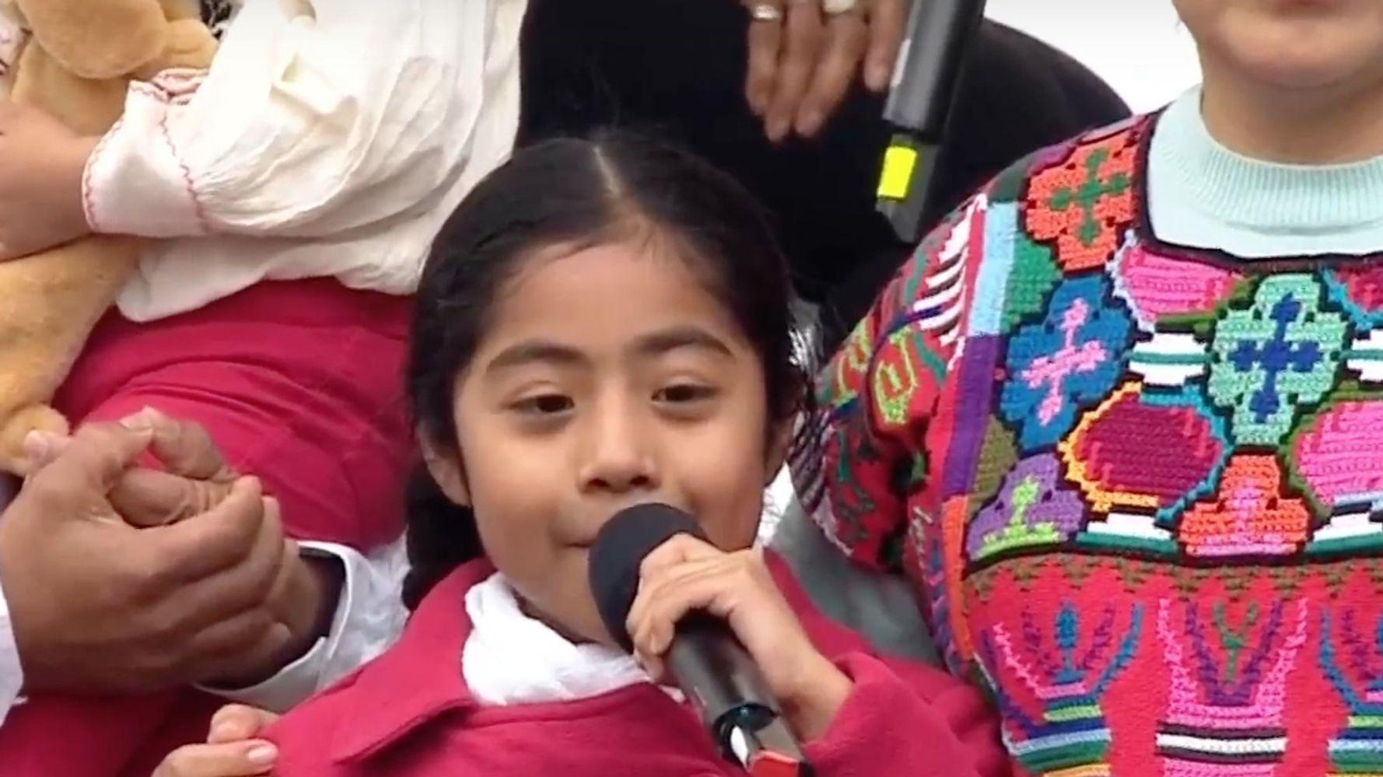
Taken from : https://www.bet.com/news/national/2013/08/27/asean-johnson-a-nine-year-old-who-captivated-a-nation.html
Sophie Cruz
Immigration reform. 8 years old.
Sophie Cruz proves that you are never be too young to make a stand for what is right. Her first real feat of activism was weaseling her way through tight security to give Pope Francis a letter that said, in Spanish: “my friends and I love each other no matter our skin color.” She asked the Pope to speak with “the president and Congress” about immigration: she fears that her parents, who are undocumented immigrants living in America, could be deported from the U.S. at any day with the increasingly divisive and racist rhetoric towards immigrants in this country. When a six year old has to deal with things of that magnitude—and knows to ask for help—is when you know you know there’s a problem. Cruz isn’t just a one-hit wonder, though. She spoke at the Women’s March on Washington in January 2017, when she again advocated for immigrants’ rights. “We are here together making a chain of love to protect our families,” Cruz said. “Let us fight with love, faith, and courage so that our families will not be destroyed.” Cruz was also the recipient of the Define American Award for Activist of the Year in 2017.
https://www.complex.com/life/young-activists-who-are-changing-the-world/sophie-cruz

Sonita Alizadeh
Child Brides. 20 years old.
Sonita Alizadeh has taken a slightly less traditional but no less effective route to fighting against the patriarchal policies of forced marriages in her home country of Afghanistan: rap. Alizadeh was almost married twice, once at 10 years old and again at 16, before she rebelled by releasing a rap video titled “Brides For Sale” about the experience of women being sold into marriage by their families. It was a huge risk—for starters, it is illegal for women to sing publicly in Iran, where she was living by that time. However, it paid off: the song went viral, and she was able to get a scholarship to finish her studies at a U.S. high school. She continues to perform her powerful brand of rap and inspire a new generation of women to rebel against the outdated and cruel tradition of child brides in her home country.
https://www.complex.com/life/young-activists-who-are-changing-the-world/sonita-alizadeh

Step 2: Complete the Graphic Organizer

Complete the graphic organizer for each of the activists your chose to learn more about.

Activist 1: _________________________  Event that changed their life:  How he/she responded: | Activist 2: _________________________  Event that changed their life:  How he/she responded:
Notable achievement: What is something he/she accomplished? | Notable achievement: What is something he/she accomplished?

Step 3: Think and Write
Each of these young people has chosen to act on an issue that is important to them and try to change the world around them. Think about an issue that is important to you and that you believe should change.

Write a letter directed to your peers, or to the general public making them aware of the issue or problem, why it is important (who does it affect and how) and what they can do to help you bring awareness and change to this issue.

Use the template provided to write your letter.

____________________________ ← Date of Correspondence

Your Name
Address Line 1
Address Line 2

Recipient First Name Last Name, Title
Organization/Agency
Address Line 1
Address Line 2

Dear ____________________

My name is _________________ and I am _____________ (a resident of, a student, a community member of ) I am writing to ask for your support/help to _____________________________________________
__________________________________________________________ ← Use first paragraph to briefly identify yourself and your purpose for writing.

__________________________ (your issue and why it is a problem) Tell us who it affects too. ← Use second paragraph to explain why you think the action should be taken/should not be taken.

I am asking you/ I want for you to.. ← Use third paragraph to call recipient to action.

Sincerely,

Write your letter here:

Step 4: Share out.
Share your letter with a partner.

Student Feedback:
Circle the emojis that best represents how this activity made you feel.

Day 5: Personality Changes
Science

What is this lesson about?: Today you will read the Scientists say you can change your personality and Is it possible to change your personality? passages. You will respond to questions and complete a personality change activity.

Step 1: Read the Scientists say you can change your personality and Is it possible to change your personality? passages

Scientists say you can change your personality

But it Takes Persistent Intervention
Date: December 12, 2019
Source: University of California - Davis
Summary: A review of recent research in personality science points to the possibility that personality traits can change through persistent intervention and major life events.

It has long been believed that people can't change their personalities, which are largely stable and inherited. But a review of recent research in personality science points to the possibility that personality traits can change through persistent intervention and major life events.

Personality traits, identified as neuroticism (a neurotic character, condition, or trait), extraversion (outgoing), openness to experience, agreeableness and conscientiousness (doing work well and thorough), can predict a wide range of important outcomes such as health, happiness and income. Because of this, these traits might represent an important target for policy interventions designed to improve human welfare.
The research, scheduled to be published in the December issue of American Psychologist, is the product of the Personality Change Consortium, an international group of researchers committed to advancing understanding of personality change. The consortium was initiated by Wiebke Bleidorn and Christopher Hopwood, University of California, Davis, professors of psychology who are also co-authors of the latest paper, "The Policy Relevance of Personality Traits." The paper has 13 other co-authors.
Policy change could be more effective
"In this paper, we present the case that traits can serve both as relatively stable predictors of success and actionable targets for policy changes and interventions," Bleidorn said.
"Parents, teachers, employers and others have been trying to change personality forever because of their implicit awareness that it is good to make people better people," Hopwood added.
But now, he said, strong evidence suggests that personality traits are broad enough to account for a wide range of socially important behaviors at levels that surpass known predictors, and that they can change, especially if you catch people at the right age and exert sustained effort. However, these traits also remain relatively stable; thus while they can change, they are not easy to change.
Resources are often invested in costly interventions that are unlikely to work because they are not informed by evidence about personality traits. "For that reason, it would be helpful for public policymakers to think more explicitly about what it takes to change personality to improve personal and public welfare, the costs and benefits of such interventions, and the resources needed to achieve the best outcomes by both being informed by evidence about personality traits and investing more sustained resources and attention toward better understanding personality change," researchers said.
Why focus on personality traits?
Research has found that a relatively small number of personality traits can account for most of the ways in which people differ from one another. Thus, they are related to a wide range of important life outcomes. These traits are also relatively stable, but changeable with effort and good timing. This combination -- broad and enduring, yet changeable -- makes them particularly promising targets for large-scale interventions. Both neuroticism and conscientiousness, for example, may represent good intervention targets in young adulthood. And certain interventions -- especially those that require persistence and long-term commitment -- may be more effective among conscientious, emotionally stable people. It is also important to consider motivational factors, as success is more likely if people are motivated and think change is feasible, researchers said.
Bleidorn and Hopwood said examples of important questions that could be more informed by personality science include: What is the long-term impact of social media and video games? How do we get children to be kinder and work harder at school? How do we help people acculturate to new environments? And, what is the best way to help people age with grace and dignity?

Is It Possible to Change Your Personality?

New research says yes, but it depends on your follow-through.
Posted Sep 23, 2019 (Psychology Today)
If you've ever thought about how you might improve your personality, you're not alone. Research suggests that all of us, to a certain extent, possess an inherent desire to cultivate positive personality traits (such as being outgoing, optimism, and charisma) and to minimize negative traits (like pessimism and neuroticism). But is it even possible to change one's personality? Or, is personality better thought of as a fixed, unalterable entity?
New research appearing in the Journal of Personality and Social Psychology contends that personality change may be more attainable than we might think. Specifically, a group of researchers led by Nathan Hudson of Southern Methodist University found that people who actively worked to change aspects of their personality were, in many cases, successful in achieving the results they desired.
To arrive at this conclusion, the researchers recruited 377 undergraduates at the University of Illinois and Michigan State University to participate in a 15-week study. Participants were first asked to complete a short personality test that measured five core dimensions of personality: extraversion, agreeableness, emotional stability, conscientiousness, and openness to experiences. After completing the survey, participants were asked to choose which of these dimensions they would most like to change over the 15-week test period.
Depending on what they chose, participants received weekly "challenges," sent by the research team, that were meant to push people outside of their comfort zone on the personality dimensions they wanted to change. For example, someone who wanted to become more extraverted might be challenged to introduce themselves to someone new. Or, a person who wanted to improve their emotional stability might be asked to spend at least one hour doing something they enjoy.
The researchers requested that participants retake the personality test every week throughout the 15-week test period. They also sent new challenges every week of varying levels of difficulty. For example, for the trait of extraversion, an easy challenge asked participants to "Go to a public place where people mingle and say hello to someone new" while a difficult challenge required participants to "Introduce yourself to someone new and ask them at least two questions about themselves."
Through this design, the researchers tested whether participants were able to change their personalities by engaging in the challenges. Interestingly, they found that it worked. Participants who desired to change the traits of extraversion, conscientiousness, agreeableness, and emotional stability all showed improvement in these personality dimensions over the 15-week test period. Openness to experiences was the only personality dimension for which the exercise did not work (in fact, people who attempted to become more open to experiences actually ended up less open than when they started out).
The researchers also found that personality change did not have much to do with the difficulty of the challenges people accepted. What mattered more was consistently completing challenges, regardless of their level of difficulty.
The researchers conclude, "Our study provides evidence that actively making behavioral changes that pull one’s behaviors in alignment with desired traits is a viable strategy for volitionally (willingly) changing one’s own personality. Although this appears to be a promising prognosis for those who might seek out programs designed to help them change their traits, our findings emphasize a major caveat: Merely desiring change and formulating plans is not enough; it is necessary to follow through."

Step 2: Answer the following questions

- What words would you use to describe your personality:

- What do you like about your personality?

- What do other people like about your personality?

- What, if anything, do you dislike about your personality?

- What, if anything, do other people dislike about your personality?

- According to the articles you read, how can someone change their personality?

- Is there anything you would like to change about your personality?

- Using an example from one of the articles, what will you try to do to improve or change part of your personality?

Step 3: Draw a picture
Draw a picture of yourself that shows you with your improved personality.

Step 4: Reflect

As you think about this week’s science lessons, what’s one thing you will remember about change?

Student Feedback:
Circle the emojis that best represents how this activity made you feel.

Mindfulness Moment!
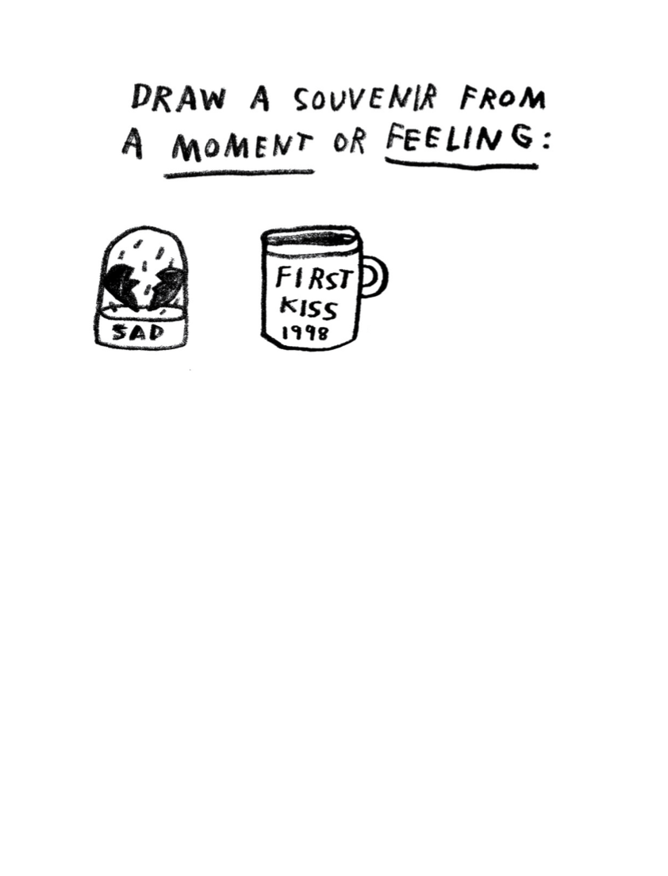

Day 5: Change/Youth Change Makers (Climate)
Math

What is this lesson about? Today’s lesson will look into how young people and each of us can help slow climate change and reduce pollution.

Today’s Warm-Up Problem
In many of the largest cities in the world, and in many small, rural communities in India and Africa, large portions of the population, earn their living by selling items each day, and using that money to enable them to purchase food for dinner in the evening.

The recent COVID-19 outbreak is making this nearly impossible for them to survive day to day. Estimates suggest that up to 265 million people in the world could be pushed to the brink of starvation this year.

- The entire population of the USA is 326 million people.

- Approximately what percentage of the US population is 265 million?

Step 1: Background

“We do not inherit the Earth from our ancestors. We borrow it from our children,” an oft-quoted saying from the Oglala-Sioux Native American nation.

- What does this quote mean, do you think?

“We will be known as the solution to the climate crisis,” 17-year-old Nadia Nazar, co-founder of the youth-led climate activist organization Zero Hour, said this September in Washington, D.C.

Later that week, 16-year-old Greta Thunberg addressed the United Nations General Assembly. "You have stolen my dreams and my childhood with your empty words. And yet I'm one of the lucky ones. People are suffering. People are dying. Entire ecosystems are collapsing. We are in the beginning of a mass extinction, and all you can talk about is money and fairy tales of eternal economic growth. How dare you!

"For more than 30 years, the science has been crystal clear. How dare you continue to look away and come here saying that you're doing enough.

What are some of her main points, do you think?

Greta Thunberg has gained prominence as a leading activist for changes to policies that might slow the rate of climate change and reduce the harm of pollution and greenhouse gasses.

She has highlighted the cost of air travel in terms of pollution, and has tried to avoid air travel and travel by boat, for example.
- What are some simple things that could be done to reduce air travel and pollution produced by airplanes?

Step 2 and 3: Greenhouse gas in the U.S. data and analysis

The chart below shows the major contributors to Greenhouse Gas Emissions in the US (in 2018).

Total Emissions in 2018 = 6,677 Million Metric Tons of CO2 equivalent. Percentages may not add up to 100% due to independent rounding.

* Land Use, Land-Use Change, and Forestry in the United States is a net sink and offsets approximately 12 percent of these greenhouse gas emissions, this emissions offset is not included in total above. All emission estimates from the Inventory of U.S. Greenhouse Gas Emissions and Sinks: 1990–2018.

Answer the questions below, based on the pie graph. We will round off numbers so that you don’t spend too much time doing long division…

Researchers have estimated that if we stopped eating all red meat (beef and pork), greenhouse gasses we would reduce overall output by almost 10%. The ‘agriculture’ slice of the pie chart is almost all a result of greenhouse gas emissions from raising livestock.
- If the US puts out 6,677 million metric tons of greenhouse gas in 1 year, how many metric tons of that is from agriculture?

The transportation ‘slice’ is primarily emissions from trucks and automobiles, but it also includes air travel, etc. Researchers say that if we could replace 50% of our current gas powered cars with electric cars we could reduce the greenhouse gasses produced by the transportation sector by that same amount (50%).

- How many metric tons of greenhouse gas would we ‘save’ if we converted over ½ of the car and truck fleet to electricity

We also put out greenhouse gasses when we use coal plants (and others) to produce electricity. There are other ways to produce electricity, including wind, sun, and water (rivers, ocean currents). Right now this can’t work for all of our electric needs, but as we build better batteries, we will get closer.

- How many metric tons of greenhouse gas would we ‘save’ if we were able to cut the pollution we put out in generating electricity by approximately 30%?

Another way to reduce greenhouse gasses is to find ways to absorb the CO2 that we all put in the atmosphere. The best way to do this ‘naturally’ is to increase our forests, trees and plants, all of which ‘take in’ CO2. Right now, forests and woodlands in the US take in about 12% of the greenhouse gasses that we emit.

- How many metric tons of greenhouse gas do trees and forests take in?

Researchers do NOT believe that we could plant enough trees to offset all of the carbon emissions we currently put out into the atmosphere. But many believe that we could likely double the amount of this intake over time if we were really smart.

- If we did double the amount of carbon emissions we took in by forests and trees, how many metric tons would that be?

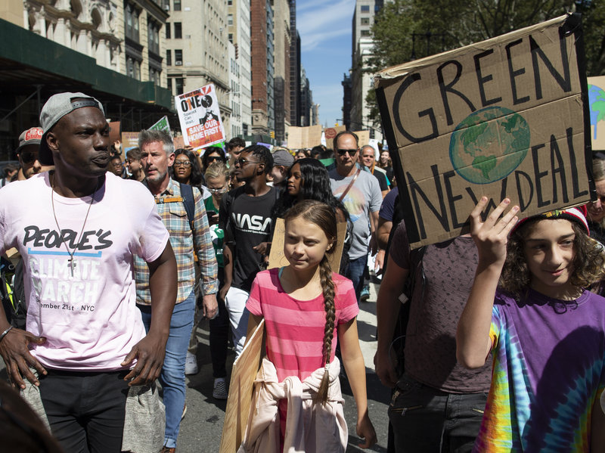
Step 4: How can you make a difference in your community--while detained or back at home

One of the hardest things about fighting climate change and working to reduce greenhouse gasses is that it is hard to see how small things matter. But it is important to know that a bunch of little things really add up.

- Example, if each person recycled their plastic water and soda bottles, well, wouldn’t all these plastic bottles that take hundreds of years to break down polluting the oceans. Similarly, if each person stopped using single-use plastic bags when they go to the grocery store or dollar store, we would nearly eliminate their use and the problems they create. Each person decides what car to buy and makes a decision to buy one that does or does not get good gas mileage or s or is not a hybrid or electric car...

- What are 1-2 things that you could be doing now and when you are released to reduce the pollution and carbon emissions you put out into the world?

Student Feedback:

Circle the emojis that best represents how this activity made you feel.

Day 5: How can you change the world?
Health

What is this lesson about?: In today’s lesson, you will focus on positive things that can change the world! Change doesn’t always have to be negative. Positive change can shape our future.

Step 1: Respond to the prompts below by using the scale.

Place a letter for each prompt below on the scale.

- How confident are you in identifying changes that can take place in adolescence?

- How confident are you in understanding the effect that change can have? (eg. on friendships, mood, routines, confidence, etc.)

- How confident are you in knowing strategies to manage change and where to seek support?

Reflect: Did your answers change from Wednesday?

Step 2: Reading about Change.

Shana Grant, 17, Washington, D.C.

Cause: Gun control and nonviolence
There were 116 homicides in the nation’s capital in 2017. It took just one to change Shana Grant’s life.
“I had always been interested in social justice and how I could improve my community,” the 17-year-old Washington native said. “But I wasn’t sure how to go about it.”

After September 20, 2017, she knew. That was the night that her 16-year-old friend, Zaire Kelly, was shot to death outside his home by a teenager trying to rob him.

Zaire was the first person Shana knew personally who had died from gun violence. And she wanted him to be the last. Police statistics showed that the percentage of gun-related deaths in the city was rising.
“It was time for it to be enough,” Shana said.

Believing strongly that youths can make a difference, she engaged in anti-violence activism. She was on Pennsylvania Avenue a few months later for the student-led March for Our Lives demonstration supporting gun-control measures. Other rallies and meetings followed. Last year, she was elected a D.C. youth “mayor” through a city-run program that develops future leaders.

“I have a unique perspective as an African American girl living in Ward 8 and seeing how gun violence and poverty affect families in my community,” Shana said.

Now she is working on a proposal to help students who are at risk of turning to a life of crime. She calls it “preventing the school-to-prison pipeline.”
At youth government meetings and town hall gatherings, she urges nonviolent solutions to problems. She calls it “practicing peace.”

Here are some of her suggestions for young people feeling angry or stressed: Breathe deeply, write down your feelings, talk to someone, try to see the other person’s point of view, and look for activities you enjoy, such as listening to music.

Shana expects to graduate in May from BASIS DC charter school. She wants to attend Spelman College in Atlanta, Georgia, in the fall and plans to become a doctor. She is not planning on giving up her activism, though.
“Things need to be changed,” she said. “I want to be part of that change.”
— Marylou Tousignant

Sidney Keys III, 14, Missouri

Cause: Improving literacy among boys
From a young age, Sidney Keys III loved to read. But finding characters he could relate to was a challenge, because most of the books at his school library featured white protagonists. “I’d never been exposed to African American literature in a fun way,” Sidney said.

That changed when Sidney’s mother, Winnie Caldwell, took him to EyeSeeMe, an African American children’s bookstore in University City, Missouri. Sidney, then 10 years old, picked up “Danny Dollar Millionaire Extraordinaire: The Lemonade Escapade,” by Ty Allan Jackson. “I couldn’t put that book down, because it was about a black boy who looked like me,” said Sidney, now 14.

Sidney wanted his peers to experience the same excitement in finding characters that resonated with them. In 2016, he created Books n Bros, a reading club for boys ages 7 to 13. The club, which now has 100 members, focuses on African American literature and meets each month to discuss a book; past topics have included history, sci-fi and fantasy genres.

Meetups take place in the Saint Louis area, but out-of-town “bros” can participate by Skype. Caldwell, who manages the club’s business and communications, said Books n Bros wants to eventually offer the program in schools.

The club is open to boys of all races and backgrounds and has an “Adopt a Bro” option enabling donors to sponsor memberships, which cost $25 a month.

People assume boys don’t enjoy reading, Sidney said. But he hasn’t found that to be true. “Now that kids are having fun while reading, boys don’t want to leave the meetups,” he said.

“Marvel’s Hero Project,” a new Disney Plus series recognizing kids who are making a positive impact, profiled Sidney in a documentary and comic book titled “The Spectacular Sidney.” The video premiered in January.
Getting to be in the documentary was “definitely pretty awesome,” Sidney said. But his favorite part of the Books n Bros experience has been helping boys like him improve their literacy skills and enjoy themselves at the same time.

“It really warms my heart knowing they’re having fun,” he said.
— Gina Rich

Step 3: How will you change the world?

What is something you want to change?

What ways would you cause others to make the change?

How would you know when a change has been made?

Step 4: Reflecting on change. Think back to the beginning of the week and summarize what you have learned about change.

Something I know now which I didn’t before is…

Something I now think/believe about change is…

Something I can do now as a result of this lesson is….

Mindfulness Moment!
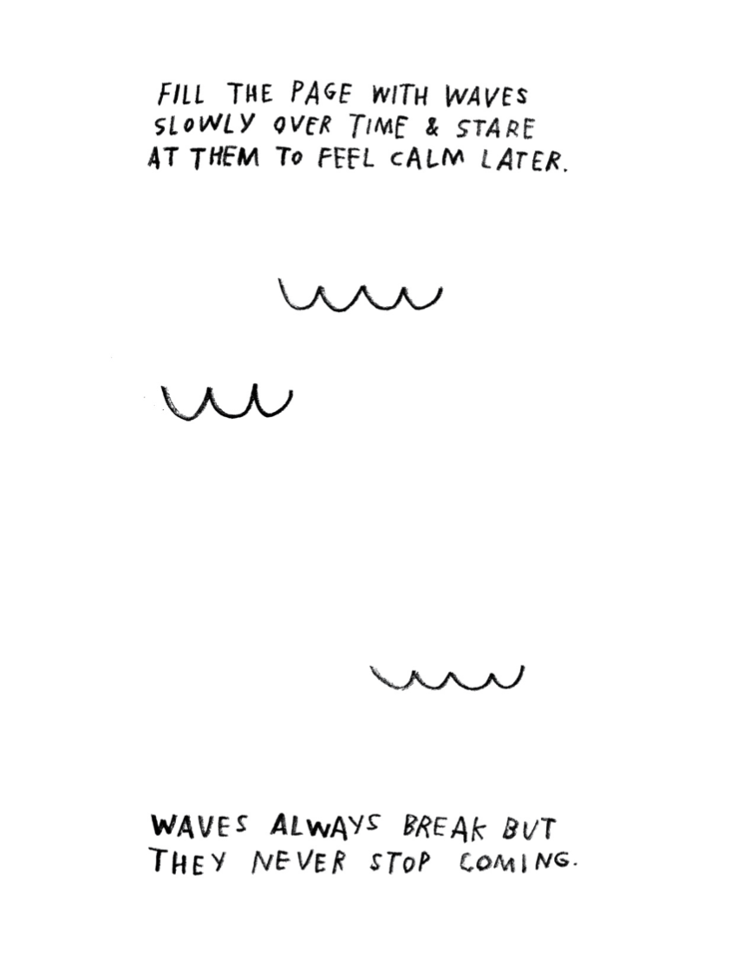

Day 5: Historiography and the American Revolution
Social Studies

What is this lesson about?: In today’s lesson we will briefly review what we’ve learned about history evolving or changing over time because of historians’ interpretations. We will take a look at one last example of this, perhaps the most important example in American history: The American Revolution. Then you will consider how the idea of history changing over time may affect your own life and personal history.

Warm-up: free-write

Take 5 minutes to read the quote below and reflect on it. Write what you think it means?
"The past does not influence me; I influence it." – William De Kooning

Step 1: Review

This week, you have learned that while the past itself never changes, history – in other words, our understanding and interpretations of the past – is always evolving. New historians explore and interpret the past through their own methods, priorities and values. They develop new theories and conclusions that may change the way we understand the past. We’ve seen how this has been true with examples of the Salem witch trials, Christopher Columbus, and the battle of the Alamo. What you have been learning about is called “historiography” (defined further, below).

Step 2: Before reading, some key terms

Continental Congress | Initially a convention of delegates from a number of British American colonies at the height of the American Revolution, who acted collectively for the people of the Thirteen Colonies that ultimately became the United States of America.
Loyalist | People who were loyal to Britain and did not want America to become its own nation
Tyranny | Cruel and oppressive government or rule
Whig | During the American Revolution, “whig” was a term to refer to patriots or those people who supported the revolution and wanted a free America

Step 3: Read the article

What is Historiography?
Historiography is, essentially, the history of history, or, more precisely, the history of history writing. It’s what we’ve been considering throughout this whole week as we’ve compared different interpretations of significant events in U.S. History. So, what’s the historiography of the most significant event in U.S. history, the American Revolution?

How have historians in different times and places interpreted the causes and character of the American Revolution differently? Perhaps no other topic in American history has been subject to so many differing interpretations as the American Revolution.

What follows is a summary of the different ways in which historians have interpreted the causes and character of the Revolution. It encompasses a debate that is as old as the Republic itself.

An understanding of the way historians have interpreted the Revolution differently can enrich the general reader’s own perspective and open up questions that promote critical and historical thinking on the part of the reader. Below is an explanation of different interpretations of the American Revolution.
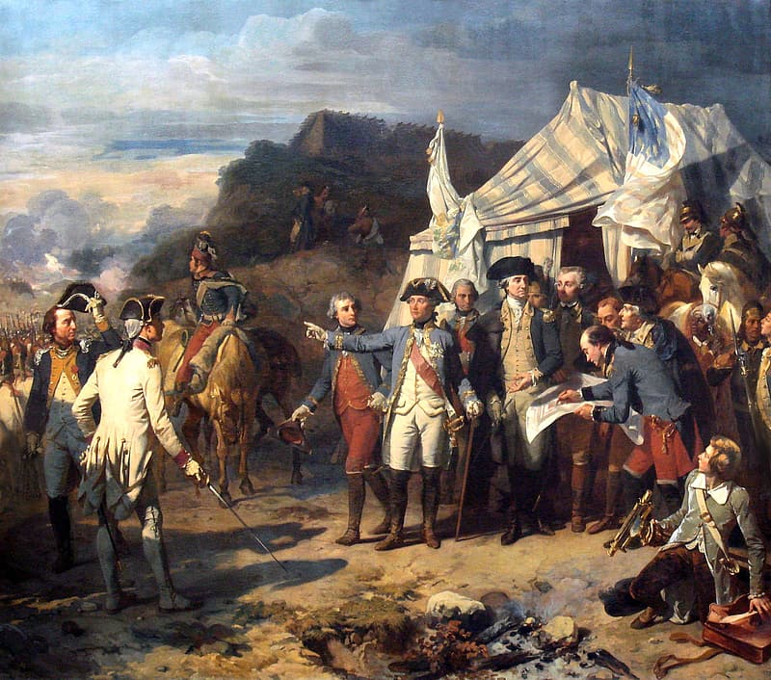

Historiography of the
American Revolution

1780-1820
Revolutionary Interpretation
Loyalist Interpretation

1820-1880
Whig Interpretation

1900-1940
Imperial Interpretation

1960-1980
New Left Interpretation

1980-Present
Neo-Progressive Interpretation
Revolutionary Interpretation:
The two major contemporary historians of the Revolution were David Ramsay of South Carolina and Mercy Otis Warren of Massachusetts. Ramsay, in 1789, told the story of how virtuous “husbandmen, merchants, mechanics, and fishermen” won independence from the corrupt British. He saw the Revolution as a constitutional crisis brought on by the conflict between Britain’s imperial interests and the colonists’ experience in self-government. The first female historian of the Revolution, Mercy Otis Warren, in her 1805 book, described the Revolution as a “boon of liberty.” [a “boon” is a blessing.] Being the sister of James Otis, Jr. and the wife of Dr. James Warren, she had been personally involved in the coming of the Revolution and saw the actions of the British in the 1760s and 1770s as attempts to establish tyranny over the colonies. Having been participants in the events of which they wrote, both saw their histories as a moral story and warned their readers against siding with the evil and corruption of the British.

Loyalist Interpretation:
Prominent Loyalists, too, wrote a number of contemporary histories of the Revolution, though some were only published after their death including Thomas Hutchinson, the former royal governor of Massachusetts, and Joseph Galloway, a former member of the Continental Congress. Unsurprisingly, these loyalist histories tended to focus on justifying British actions during the conflict and crisis. Hutchinson was an exception. He believed that party politics in Britain contributed to Britain’s confused and unorganized approach to governing the colonies. Galloway, however, believed that the disorganization came largely from politicians and officials’ unfamiliarity with the colonies, its governments, and its people. All the Loyalist historians tended to agree that the creation of popular anti-British sentiment in the 1760s and early 1770s was the product of a small number of ill-designing men who wanted to agitate things and create more conflict.

Whig Interpretation:
The Whig interpretation is best exemplified by a man whom Edmund Morgan called “the first great historian to deal with [the Revolution].” George Bancroft, like a number of historians of the pre-academic 19th century, used the leisure time his wealth afforded him to travel the country collecting and preserving primary source documents and to produce a massive multi-volume history of the United States. In the Whig interpretation, the underlying and unifying theme of American history was an effective march toward liberty and democracy away from the tyranny and absolutism of the Old World. In the Revolution, “the Americans seized as their peculiar inheritance the traditions of liberty.” This interpretation held sway through much of the nineteenth century.
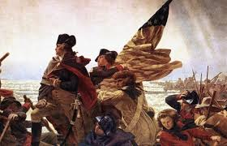

Imperial Interpretation:
In the early part of the twentieth century (early 1900s), a number of historians began looking at the colonial period from the British perspective. Unlike the Whigs, the imperial historians did not see a tyrannical ministry and British government bent on restraining the liberty of the colonists through harsh policies. Rather, historians such as George L. Beer, Charles Andrews, and Lawrence Gipson, studied British colonial policy and saw Britain’s attempts to manage trade and seek revenue from the colonies as reasonable policies, especially considering Britain’s war debt and colonists’ relatively light tax burden.

New Left Interpretation:
In the late 1960s and 1970s, “social history,” which focused on the lives of everyday persons, became predominant. At the same time, the Civil Rights movement and the feminist movement helped provide a spark for a new generation of historians to study the history of race and slavery in early America, as well as women’s history. Around the same time, young historians engaged in this “history from the bottom up” in an effort to recover the agency of common class colonists. Similarly, Mary Beth Norton and Linda Kerber both published books in 1980 about the impact of the Revolution on women.In the 1980s and 1990s, there was a resurgence of interest in class conflict and economic aspects of the Revolution. New-Leftists have argued that ordinary Americans during the Revolution were radical and eager to fight for their own interests, thereby bringing in the ordinary Americans into the historical conversation of the Revolution.

As we can see, the way historians have interpreted the Revolution has been influenced by the times in which they lived. The English historian, E. H. Carr, wrote, “Before you study the history, study the historian” and their own “historical and social environment.” This is true in all fields of history. Nevertheless, each of these interpretations made unique contributions to the ways in which we understand the Revolution today.

Step 4: Reflect and answer questions

Match the following explanations with the proper interpretation from above.

A. Britain acted fairly in raising taxes in the colonies and managing trade when considering the debt they had created through earlier wars. The argument that the British government was tyrannical is not accurate.
B. The American Revolution was about establishing a fair democracy and was a push towards liberty for the New World.
D. It was the ordinary American and their desire to fight for their own interests and rights that led to the revolution against Britain.

E. The revolution was justified because the Americans were rebelling against unfair treatment by the British government.

C. The revolution was caused by a small group of men in America who wanted to create trouble. Britain was not to blame for the revolution.
Loyalist
Whig
Revolutionary
Imperial
New Left

Create a timeline of the different interpretations using the graphic organizer below, or make your own on a separate piece of paper.

Name:______________
Dates:
Key aspects of interpretation: ______________________
_____________________________________________________________________
Name:______________
Dates:
Key aspects of interpretation: _______________________
_____________________________________________________________________
Name:______________
Dates:
Key aspects of interpretation: _______________________
_____________________________________________________________________
Name:______________
Dates:
Key aspects of interpretation: _______________________
_____________________________________________________________________
Name:______________
Dates:
Key aspects of interpretation: ______________________
_____________________________________________________________________
1700
2000

Step 5: Your personal history

You have explored how many historical events in U.S. history have been interpreted in different ways throughout time. As interpretations change (based on interests, morals, and values of the times, as well as historians personal perspective), our understanding of history also changes. With this in mind, answer the following questions about your own personal history.

Think about your life so far. Think back to a time when you felt your actions were misunderstood. Write what your actions were below.

How did people interpret your actions? How did they respond to what you did and why?

If history can change over time, why can’t your personal history change too? Reflect below on how you might get people to interpret your actions in another way. In other words, if a historian was writing your biography, what information would you want to make sure they had so that they would understand your actions better?

Student Feedback:

Circle the emojis that best represents how this activity made you feel.

