Week 5
Power

Day 2

NAME:______________________

Day 2 Agenda

Topic | Activity
Warm-Up!
English Language Arts | - Read the article, Bird, Plane or SuperMensch? Jews and Superheros Share a Rich History  - Respond to questions about the poem.  - Create their own Superhero
Science | - Read about Solar Power  - Answer questions about what you read  - Draw a picture and explain
Mindfulness Moment!
Math | - Power: Striking and the Power of Holding Out and Holding Strong
Health | - Showing respect: What do you say?
Mindfulness Moment!
Civics/Social Studies | - Consider types of governmental powers  - Theocracy v. Dictatorship

Warm-up Activity: Write a journal entry around the daily quote on identity.
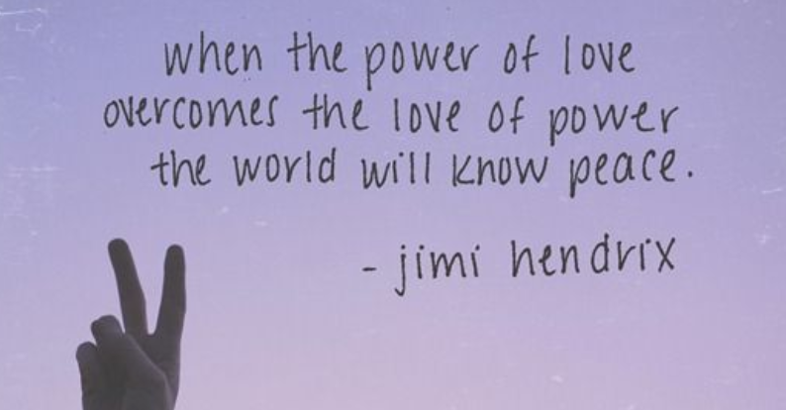

Day 2: Using Superpowers to Fight Injustice
English Language Arts

What is this lesson about?: Today you will continue to explore the theme of power by reading about the creation of superheroes. As you read today, think about how the experiences of the comic book creators affected the Superheroes they created and how they used these characters to protest against injustice and abuse of power.

Step 1: Review Vocabulary

mensch: Yiddish word that means person of integrity and honor. | idealized: represented as perfect or better than reality. | wield: to hold and use or to be able to use
wimp: a weakling or coward | psyche: a human mind, soul or spirit | persecuted: to abuse or punish someone especially because of their race or political or religious beliefs
harmony: agreement and peace | conscious: aware, having knowledge of | herald: to announce
orthodox: traditional or strict about one’s religion | legacy: something of value handed down by an elder | archetype: an original that has been imitated.

Step 2: Read and annotate the transcript from an interview in Wired Magazine.

Bird, Plane or SuperMensch? Jews and Superheroes Share a Rich History
Danny Fingeroth SAN DIEGO – Superman, Batman, Captain American and a slew of other superheroes have something in common besides funny-looking tights. They were all created by Jews, many from Eastern European backgrounds. Jewish comics creators and co-creators include Joe Shuster and Jerry Siegel (Superman); Bob Kane and Bill Finger (Batman); Will Eisner (The Spirit); Jack Kirby (Fantastic Four, Incredible Hulk, the X-Men); Jack Kirby and Joe Simon (Captain America); and of course Stan Lee (who helped create Spider-Man and a whole bunch of others).

This is more than a coincidence, argues Danny Fingeroth, former editorial director of the Spider-Man comic books, in his upcoming book Disguised as Clark Kent: Jews, Comics and the Creation of the Superhero. While he may not go as far as some authors who claim Superman is an incarnation of Moses, he does believe the Jewish heritage of their creators influenced the first generation of superheroes and the worlds in which they lived.

In an interview with Wired News, Fingeroth – author of 2004's well-received Superman on the Couch: What Superheroes Really Tell Us about Ourselves and Our Society – talked about Jews and superheroes prior to this weekend's Comic-Con, the world's largest comics convention.

Wired News: How do you think the lives of Jewish comics creators influenced the fictional worlds they created?

Danny Fingeroth: You had a bunch of young men whose parents were immigrants, writing stories about a very idealized world, where force is wielded wisely and people are judged by their individual character, not by who they are or who their parents were. For the guys who made the comics, it was a way to transcend who you were and become locked into and involved with the American mainstream, to blend in.

Wired News: Do you think Jews worked in comics because they couldn't get jobs elsewhere?

Fingeroth: That was a big part of it. Because of various types of prejudice, things were closed off to Jews in the first half of the 20th century. Maybe it's hard to believe now, but Jews were not accepted in a lot of the publishing or advertising industries. There was a great deal of discrimination. There were no official policies like “No Jews allowed,” but you could interview all you want and still not get work you might have been highly qualified for.

Wired News: Many superheroes, if not all of them, are outsiders in some way in their civilian incarnations. They're orphans, weaklings, ordinary men. Is there a connection here to their creators being Jewish?

Fingeroth: Historically, the racist caricature of the Jew is of someone who somehow is simultaneously weak and yet controls the world, or significant aspects of it. So one could say that the wimpy secret identity was the Jewish creators' ways of saying that we're powerful, in an individual sense, not wimps, and guided, individually and as a group, by the selfless desire to do good. Of course, this is all reading things into the work way after the fact. None of the creators consciously thought about this stuff when they were writing and drawing the stories. It's also a comment on the immigrant desire, Jewish and otherwise, to both be part of the society – be Clark Kent – and also be separate from it as a being of superhuman power. On a larger metaphorical level, it's about the need we all have to feel that we are more than the world thinks we are. "If only they knew my secret, they'd be sorry for the way they treated me!"

Wired News: Do you think the heritage of the creators made them especially interested in secret identities?

Fingeroth: I think they were interested in the part of the psyche that compels us to operate on multiple levels, playing different roles depending on the circumstances.
I don't know if there's anything exclusively Jewish about that, although as a group with a history of being persecuted, doing what you can to achieve harmony with the dominant society could make someone preoccupied with what role they're playing when.
Wired News: Do you think the creators consciously thought of the Jewish influences on their work?

Fingeroth: They were sitting around thinking, “How can I make a living and move out of my parents’ house or help my parents out? How can I survive the Depression as a creative person, when there aren't many options?” They were 18, 19, 20 years old.
Some of them were from really poor families and couldn’t afford to go to college. What were they going to do?
What I also found was that a lot of early comics creators were from families that, when they were kids, had been relatively prosperous and then lost everything in the (stock market) crash of 1929 that heralded the beginning of the Great Depression. They had this weird background of having been fairly secure as kids, and suddenly having nothing at all. It's like Superman having his whole planet blown up, or Bruce Wayne (Batman) having his parents murdered, or Peter Parker (Spider-Man), already an orphan as a baby, having his adoptive father – Uncle Ben – murdered.
Wired News: How did these men look at being Jewish? Did they tend to be very observant?

Fingeroth: No. I think back in the '30s and '40s, if you were Orthodox, you wouldn’t do something like comics. I think it was considered something not serious. (Today), you can see 125,000 people migrate to San Diego to the Comic-Con to pray in the Church of Popular Culture. There's something about being able to take a lot of what would ordinarily be religious impulses (and direct them) into creating fiction. It's like a religious substitute, where nobody ever – well, hardly ever – gets into violent confrontations about if their favorite superhero is somehow better than someone else’s.

Wired News: Did critics – including psychologist Frederic Wertham, who helped launch public and political outrage against comic books in the 1950s – ever pick up on the fact that many comics creators were Jewish?

Fingeroth: Wertham was from a more-well-to do German/Austrian Jewish background, as opposed to the mostly Russian- and Polish-descended Jewish men and women who worked in comics (along with Italian-Americans and people of all sorts of backgrounds). In hindsight, you could see his hostility to comics as his seeing the comics publishers and creators as being the cultural equivalent of junk dealers, an embarrassment to Jewish people.

Wired News: You're Jewish yourself. Are you worried that your book might give ammunition to anti-Semites who like to make claims about Jewish domination?

Fingeroth: My joke is that it's of most interest to Jews and anti-Semites. Most other people don’t give a shit. I think it's one of the best things I've written, but it was one of the hardest to write, too, because of how careful I wanted to be about how I framed things so as not to give ammunition to bigots who might want to twist what I was saying. I ultimately decided that if I was going to write this book, and I did and do think it was important to write, I had to put that fear out of my mind and figure that if someone has a reason to hate Jews, they don’t need to me as an excuse to do it.

WN: What is the legacy of the superheroes these men created?

Fingeroth: Seventy years later, these characters, such as Superman, Batman, and Spider-Man (who was created in the 1960s) are still such powerful archetypes that nothing has come along to replace them. The creations of these mostly Jewish guys now being interpreted by people from all backgrounds because their appeal is universal. The characters and what they symbolize mean a lot to people – although what they symbolize is different for each reader or moviegoer. People find the most lasting superheroes entertaining, of course, but also inspiring.

Taken from: https://www.wired.com/2007/07/jews-comics-qa/. Wired Magazine, 2007.

Step 3 : Answer the Following Questions

- How did the experience of being the children of immigrants influence the creation of superheroes in comic books?

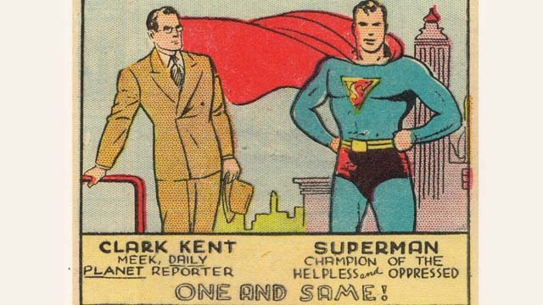
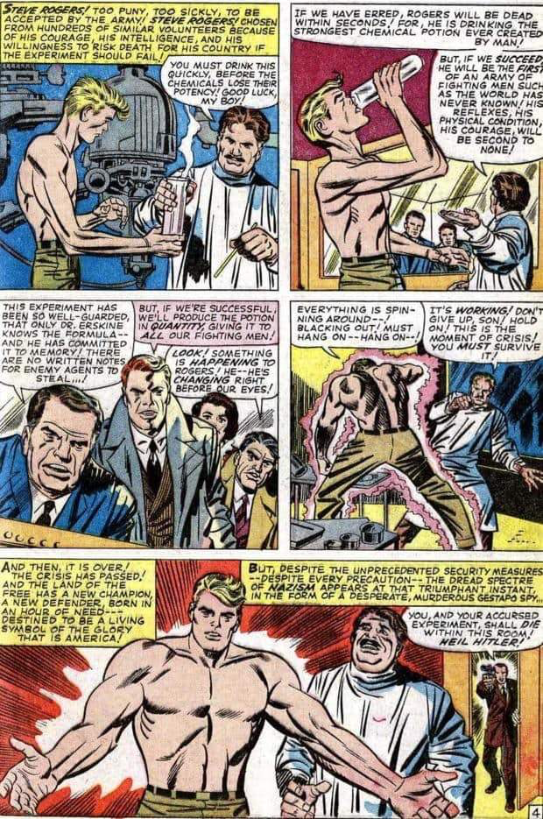

- Look at the images above. These were taken from comic books in the 1940s and show Clark Kent/Superman and Steve Rogers/Captain America. Both superheroes had identities as “wimpy” or meek men who turned into superheroes. How do you think this might connect to how the young Jewish writers felt during World War II?

- Look at the illustrations below that show scenes from comic books in the 1940’s. One shows Superman and the other shows Captain America—each punching or beating Adolf Hitler.
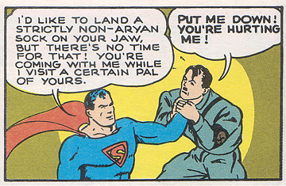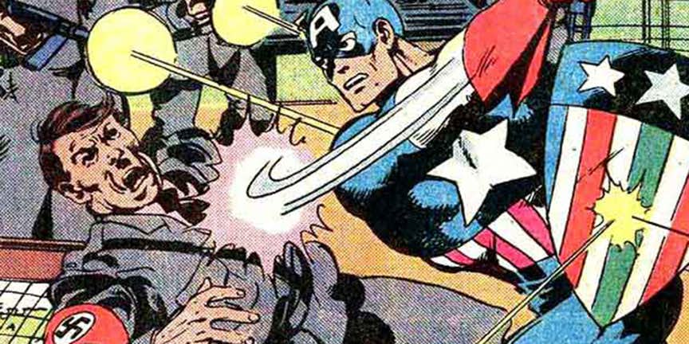
How do you think that these representations were a way that young Jewish writers and illustrators were able to assert some power against the Nazis?

- Fingeroth states that now people from different kinds of backgrounds are interpreting the characters and that the characters are popular because their “appeal is universal”. What theme do most of these comic books illustrate that makes them “universal” and something that everyone can relate to?

- Is there a superhero that you find inspiring? If yes, which one and why? If not, name one that you cannot relate to and explain why.

Step 4: Create your own superhero.
Superheroes come in many forms—From Captain America to Black Panther to Wonder Woman and Valkyrie. Create your own Superhero.
How did your character come to have his/her superpower?

What are your hero’s superpowers?

What is your superhero’s normal life like? What did they experience in the past that influences them now?

Describe what your Superhero looks like (if you don’t want to use words, draw him/her/it out.

What is your Superhero’s Name?

Who or what is your superhero’s arch-nemesis? What does he/she fight against?

Step 5: Share Out

*Share your superhero with a partner. After he/she has shared their superhero, answer the following question. Do you think your superheroes would get along? Could they work together or are they too different? Why?

Step 6: Write
Think of a local, national or world problem that currently exists. Create an archnemesis that embodies (takes on the characteristics) of this problem. How would your superhero battle this problem? How can his/her super-power help him/her try to defeat this problem?

Student Feedback:
Circle the emojis that best represents how this activity made you feel. | 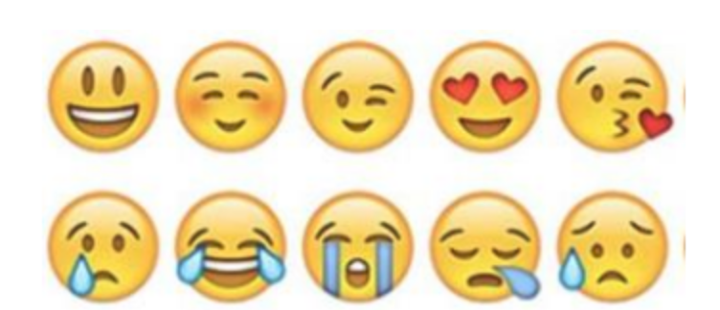  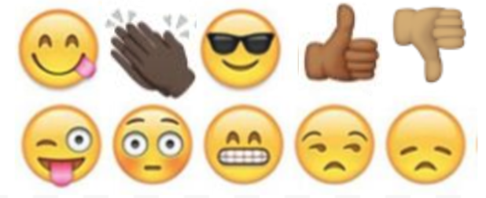

Day 2: Solar Power
Science

What is this lesson about?: Today you will read through the Solar Power passages. You will answer a few questions about what you read. You will complete a Solar Power activity.

Step 1: Read through the Solar Power passages

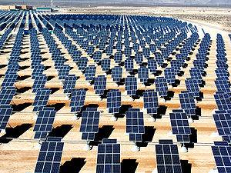
Solar Power
(Technological Solutions)

What is solar power?
The primary source of all energy on planet Earth is from the sun. Solar power is power generated directly from sunlight. Solar power can be used for heat energy or converted into electric energy.

Renewable Energy
When we use solar power, we don't use any of the Earth's resources like coal or oil. This makes solar power a renewable energy source. Solar power is also clean power that doesn't generate a lot of pollution.

Solar Power for Heat
Solar power can be used for heating up homes and other buildings. Sometimes solar power for heating can be passive. This is when there are no mechanical components used to move the heat around. Passive heating helps to keep houses warm in the winter, to heat up swimming pools, and even makes our car warm when we park it outside (which is nice in the winter, but not so much on a hot summer day).

Active heating is when there are mechanical components to help move the heat around. The sun could be used to heat up water or air that is then pumped around a building to provide even heat in all the rooms.

Solar Power for Electricity
When most of us think of solar power, we think of the solar cells that turn rays of sunshine into electricity. Solar cells are also called photovoltaic cells. The word "photovoltaic" comes from the word "photons", which are particles that make up sunlight, as well as the word "volts", which is a measurement of electricity.

Today solar cells are commonly used in small handheld devices like calculators and wrist watches. They are becoming more popular for buildings and homes as they become more efficient. One nice thing about solar cells is that they can be placed on the roof of a building or home, not taking up any extra space.

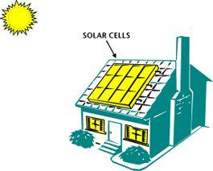
How do solar cells work?
Solar cells convert the energy of photons from the sun into electricity. When the photon hits the top of the cell, electrons will be attracted to the surface of the cell. This causes a voltage to form between the top and the bottom layers of the cell. When an electric circuit is formed across the top and the bottom of the cell, current will flow, powering electrical equipment.

It takes a lot of solar cells to power a building or a home. In this case, a number of solar cells are connected into a large array of cells that can produce more total energy.

History of Solar Power
The photovoltaic cell was invented in 1954 by researchers at Bell Labs. Since then, solar cells have been used on small items such as calculators. They have also been an important power source for spaceships and satellites.

Starting in the 1990s the government has funded research and offered tax incentives to people using clean and renewable power such as solar energy. Scientists have made advances in the efficiency of the solar cell. Today solar cells are around 5 to 15% efficient, meaning a lot of the energy of the sunlight is wasted. They hope to achieve 30% or better in the future. This will make solar energy a much more economical and viable energy alternative.

Are there any drawbacks to solar power?
Solar power has two major drawbacks. One drawback is that the amount of sunshine in a specific place changes due to the time of day, the weather, and the time of the year. The other drawback is that with current technology it takes a lot of expensive photovoltaic cells to produce a decent amount of electricity.

Fun Facts about Solar Power
- The world's largest solar thermal plants are located in the state of California.
- Many large photovoltaic plants are being built around the world. Some of the largest are located in China, Canada, and the United States (Nevada).
- If only 4% of the world's deserts were covered in photovoltaic cells, they could supply all of the world's electricity.
- Many people think that as solar panels become more efficient and less expensive they will become a standard feature of new homes and buildings.
- In 1990 a solar powered aircraft flew across the United States using no fuel.
- Albert Einstein won a Nobel Prize in 1921 for his research into photovoltaic power.
Solar energy is the technology used to harness the sun's energy and make it useable. As of 2011, the technology produced less than one tenth of one percent of global energy demand.

Many are familiar with so-called photovoltaic cells, or solar panels, found on things like spacecraft, rooftops, and handheld calculators. The cells are made of semiconductor materials like those found in computer chips. When sunlight hits the cells, it knocks electrons loose from their atoms. As the electrons flow through the cell, they generate electricity.
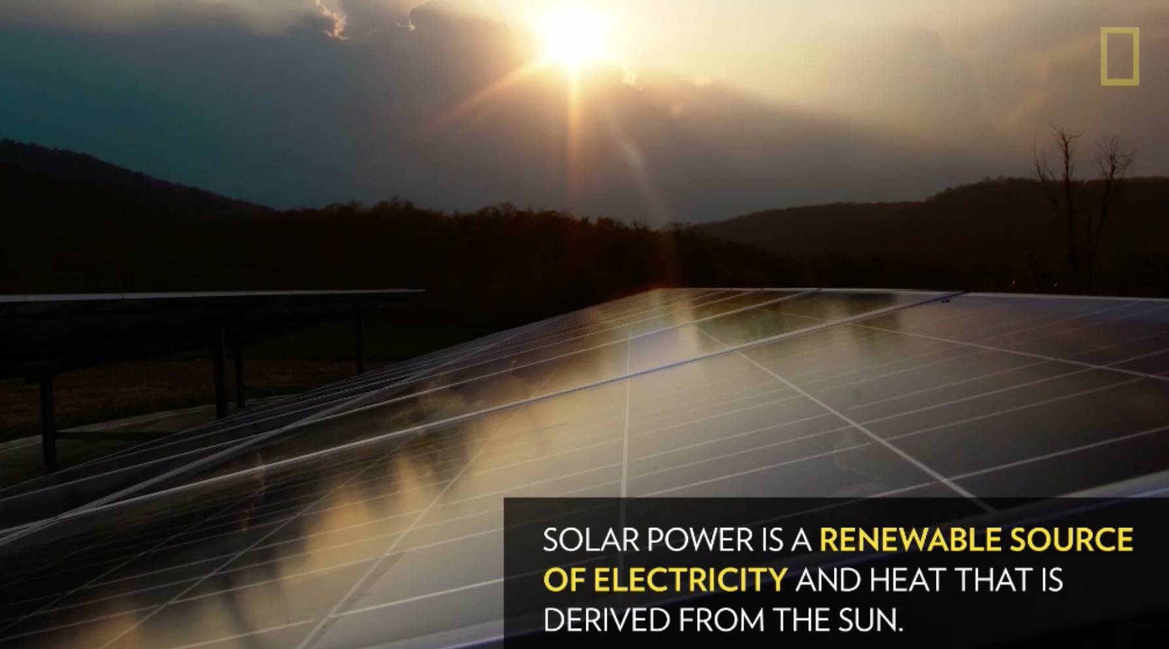
On a much larger scale, solar-thermal power plants employ various techniques to concentrate the sun's energy as a heat source. The heat is then used to boil water to drive a steam turbine that generates electricity in much the same fashion as coal and nuclear power plants, supplying electricity for thousands of people.

How to Harness Solar Power
In one technique, long troughs of U-shaped mirrors focus sunlight on a pipe of oil that runs through the middle. The hot oil then boils water for electricity generation. Another technique uses moveable mirrors to focus the sun's rays on a collector tower, where a receiver sits. Molten salt flowing through the receiver is heated to run a generator.

Other solar technologies are passive. For example, big windows placed on the sunny side of a building allow sunlight to heat-absorbent materials on the floor and walls. These surfaces then release the heat at night to keep the building warm. Similarly, absorbent plates on a roof can heat liquid in tubes that supply a house with hot water.

Solar energy is lauded as an inexhaustible fuel source that is pollution- and often noise-free. The technology is also versatile. For example, solar cells generate energy for far-out places like satellites in Earth orbit and cabins deep in the Rocky Mountains as easily as they can power downtown buildings and futuristic cars.

Pitfalls
Solar energy doesn't work at night without a storage device such as a battery, and cloudy weather can make the technology unreliable during the day. Solar technologies are also very expensive and require a lot of land area to collect the sun's energy at rates useful to lots of people.

Despite the drawbacks, solar energy use has surged at about 20 percent a year over the past 15 years, thanks to rapidly falling prices and gains in efficiency. Japan, Germany, and the United States are major markets for solar cells. With tax incentives, and efficient coordination with energy companies, solar electricity can often pay for itself in five to ten years.

Step 2: Answer the following questions

- Where does solar power get its energy from?
  - The internal heat of the Earth
  - From the burning of fossil fuels like coal
  - The rays of the Sun

- What kind of solar heating uses no mechanical components to move the heat around?
  - Active
  - Passive
  - Electric

- Which of the following is another name for solar cells?
  - Voltage cells
  - Active cells
  - Photovoltaic cells

- What particles from the sun help to generate power from solar cells?
  - Photons
  - Protons
  - Electrons

- Where are the world's largest solar thermal plants located?
  - China
  - Texas
  - California

- What should help make solar energy a viable energy source in the future?
  - Longer days
  - Improved efficiency of solar panels
  - More energy output from the Sun

- Solar power is considered a renewable energy source.
  - TRUE
  - FALSE

Step 3: Draw an image/picture

Draw a picture of how you would use solar power in your community. Describe your picture.

Student Feedback:

Circle the emojis that best represents how this activity made you feel. | 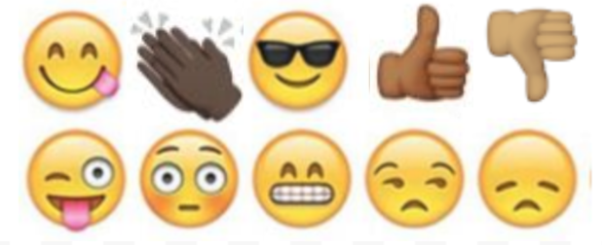  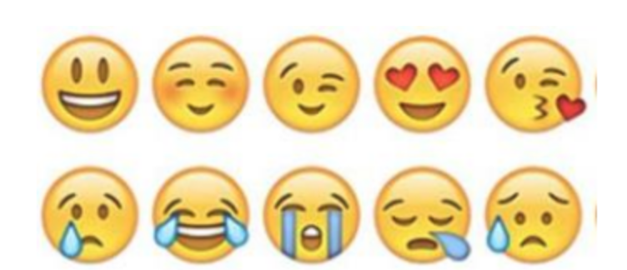

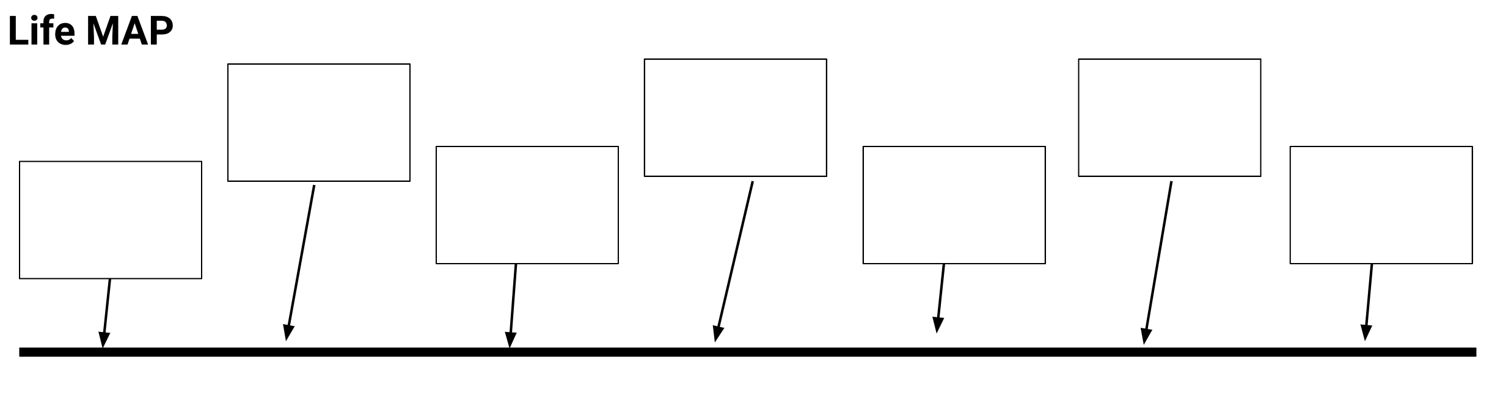
Mindfulness Moment!

Directions: Fill in the boxes on the timeline to build your life map. You may include pictures, videos, audio to make your timeline interactive.

Day 2: Power/Strikes
Health

What is this lesson about?: In this lesson we are going to look at some of the major strikes that have enabled groups of individuals to pull together in powerful ways.

Activity 1: United Farm Workers Strike and Wages, Background

In the late 1960s, the average wage for a farmworker -- someone working the fields harvesting grapes or strawberries -- was $1.20 per hour. Almost none had any sort of health insurance; most were ‘forced’ to work 10 hour shifts during the peak seasons.

Over the course of a few years, the United Farm Workers, led by Cesar Chavez, held a number of strikes. One of their most successful campaigns focused on getting lots and lots of Americans to join their cause--not by striking (refusing to work), but by refusing to buy (boycotting) certain fruits.

In fact, in 1973, more than 17 million Americans joined their cause and stopped buying grapes. Over the years, the wages and benefits of farm workers have continued to be well below that of other occupations, but the major breakthrough that happened in the late 1960s and early 1970s, were critical and paved the way for the average farmworker in California to now be earning between $12 and $15 per hour.

Use the charts below to answer the questions about the impact of the United Farm Workers Strikes.
 | Pre-Strike | Post-Strike
Grape Picker
Hourly Wage | $1.10 | $1.40
Add-on per bucket | $0.10 | $0.43

Assume the average farmworker picked 4 buckets of grapes per hour and worked 9 hours a day.

Daily, weekly, yearly earnings-
- In one day how much would he earn in one day (9 hours) pre-strike?
Hint: calculate how much he would earn through the add-on per hour, then use his hourly wage plus his hourly add-on to calculate how much he would earn over 9 hours.

- In one day how much would he earn in one day (9 hours) post-strike?

- In one week (5 days) how much would he earn pre-strike?

- In one week (5 days) how much would he earn post-strike?

- In one year (52 weeks) how much would he earn pre-strike?

- In one year (52 weeks) how much would he earn post-strike?

Another way of looking at wages is to compare how one job pays compared to another one. Before the strikes, farm workers earned about 45% of what a person working in a manufacturing job earned (like a welder or someone or making aluminum products). The chart below shows how the wages of the farm works change compared to manufacturing jobs over a 12 year span.
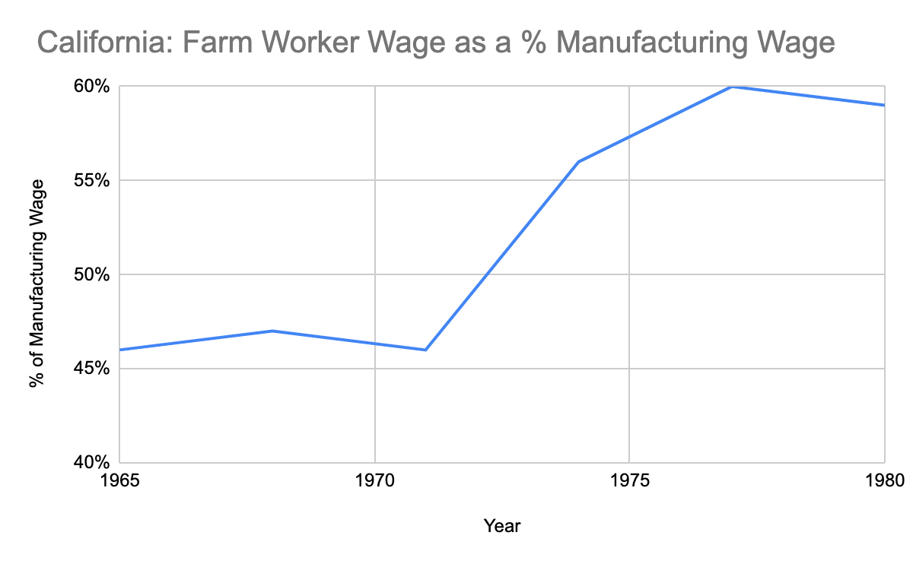
Based on this chart:
- For every $100 that a welder earned how much did a farm worker earn…
  - In 1965? ______ In 1971? ______

  - In 1974? ______ In 1977? ______

- Even with these improvements, why do you think that a welder or someone who works in an automobile factory would earn more than someone who works a farmworker?

For the first years of the attempted strikes, every time the farmworkers would try to strike and to demand higher wages, the companies that owned the big farms would bring in other workers to work for them as substitutes. This was hard for the farm workers to stop because lots of people in California were desperate for work, especially many recent immigrants.

- Why was it hard for the farmworkers to convince the substitutes to NOT take the jobs, do you think?

- How do you think the farm workers union was able, over time, to convince the substitutes to not take the work at lower wages?

Activity 2: United Farm Workers Strike, the Boycott

This chart shows the demand for grapes across the US from 1965 to 1977.

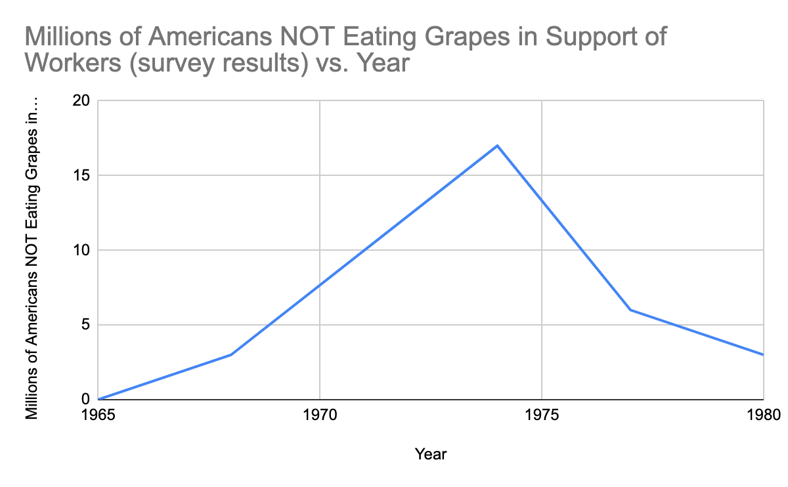
- How many Americans reported that they were NOT eating grapes in 1965?
- How about by 1970?

- In about what year did the number of consumers boycotting grapes reach its peak?

- In 1973 it is estimated that nearly one in three US homes was not eating grapes….

- What did this boycott do to the demand for grapes?

- How did this impact the profit of the farm owners?

- Ultimately, how did this boycott help the striking farm workers?

Activity 3: Montgomery Bus Boycott and impact on the local economy, etc.

Many of you are familiar with the Montgomery Bus Boycott. The boycott took place from December 5, 1955 and lasted for just over a year, until December 20, 1956. Rosa Parks is famous for starting to build support for the boycott, which was aimed at ending the city’s policy of forcing African Americans to sit in a separate section in the back of the city’s public busses. The Montgomery Bus Boycott is considered one of the seminal events of the Civil Rights movement, with the US Supreme Court upholding a ruling that the City’s ordinance violated the 14th Amendment of the US Constitution.

What may be less familiar is some of the math of the Boycott. The chart below provides a slightly simplified analysis of bus ridership in Montgomery in 1955 and 1956. Nearly 40,000 African Americans took the bus daily prior to the strike; approximately 13,000 whites took the bus daily.

Montgomery Bus Boycott
Average total ridership on Montgomery, AL Buses, November 1955
Black | 40,000
White | 13,000
Total | 53,000
Average total ridership on Montgomery, AL Buses, November 1956
Black | 0
White | 13,000
Total | 13,000

It cost $.075 (7.5 cents) to ride the bus.
- About how much money did this City take in each day in November 1955?
- About how much money did the City take in each day in November 1956?
- So, how much was the strike costing the City each day?

Activity 3: Montgomery Bus Boycott, Keeping it Going!
African Americans organized carpools and all sorts of other ways to help each other get to work during the year-long strike. But nearly 20,000 of the daily ridership ended up walking to work each day. The average person who walked to work covered over 3 miles each way, for over a year.

Assuming that 20,000 people walked 3 miles to work and 3 miles home from work each day…
- How many miles did they all walk together each day?
- Over the course of 5 days how many miles did each person walk, on average?
- If each person did that for 52 weeks (1 year), how many miles on average did each person walk during the strike?

Discuss/Consider: Based on this information:
- What are some essential elements to using a strike to exercise power and create change?
- How much power did each person who decided to not take the bus each day have?
- How much power did the group of people have once they committed to sticking together?
Student Feedback:
Circle the emojis that best represents how this activity made you feel.

Day 2: What do you say? Showing respect
Health

What is this lesson about?: In today’s lesson, we will look at put downs and respect in our work relationships.

Step 1: Warm-Up In the relationship below do you feel like one person has more power than the other person?

Who’s got the POWER?
A boy notices his girlfriend is getting a lot of attention from two different people at school. He goes up to each of them separately and warns them to stay away from her, “or else.”

Who has the POWER? Why?

Step 2: Read about the behaviors below.
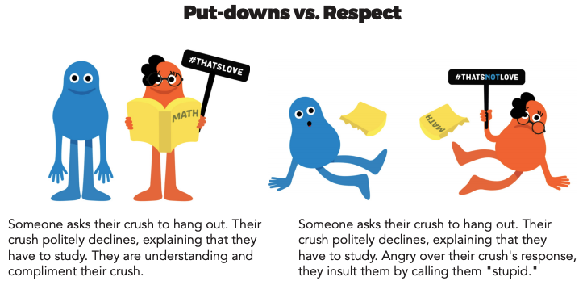
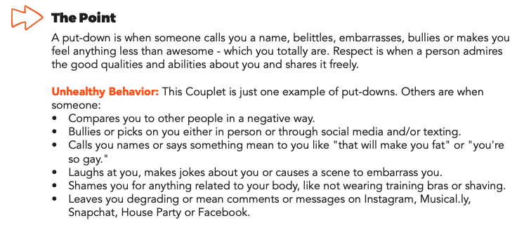
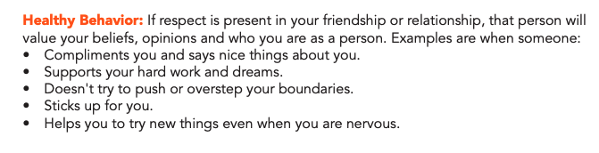
Step 3: Complete the Activity.

Read the following Facebook post and comments. Respond to the questions.
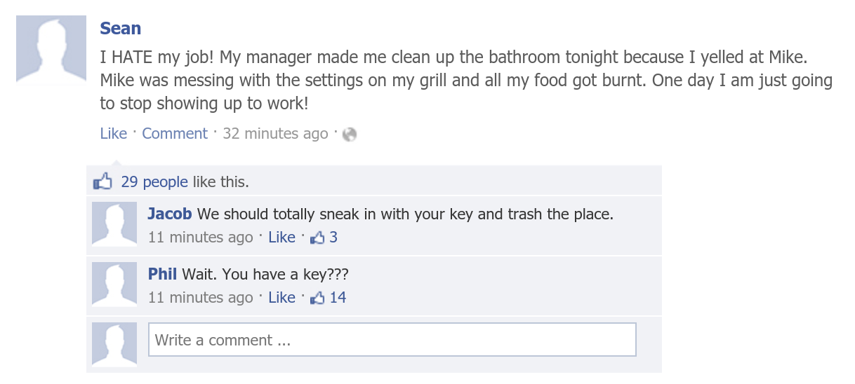

- What should Sean do?

- What impact will that have on Sean’s relationship with his boss?

- Was Sean’s reaction to Mike Healthy, Unhealthy, or Abusive?

- How could Sean have handled his reaction to Mike differently?

Student Feedback:
Circle the emojis that best represents how this activity made you feel.

Mindfulness Moment!

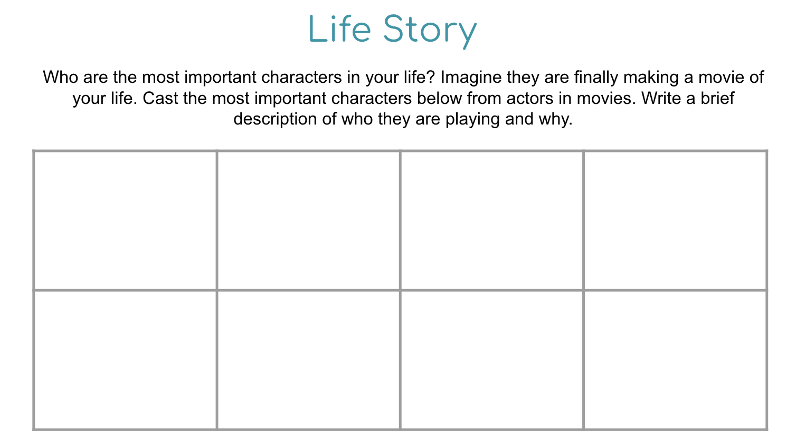

Day 2: Governmental Powers: Dictatorship v. Theocracy
Social Studies/Civics

What is this lesson about?: Today you will continue exploring different types of government, and will focus on dictatorships and oligarchies. Below is a reminder of our Elite 8 bracket. Fill in who won the face-off in yesterday’s lesson below.

Types of Government Bracket
Monarchy
Oligarchy
Dictatorship
Theocracy
Direct Democracy
Representative Dem.
Communism
Anarchy

Step 1: Compare Dictatorship and Oligarchy

Dictatorship  A dictatorship is a form of government where one leader has absolute control over citizens’ lives. Typically the dictator has obtained control by force. If there is a constitution, the dictator has control over that, too—so it doesn’t matter much. Although other parts of the government may exist, such as courts or a lawmaking body, these branches always do what the dictator wants them to do. They do not represent citizens. The advantages to a dictatorship include speed of making decisions as there is onlu one person to make the decision. Also, during emergencies, it is easier for a single ruler to make decisions. On the other hand, the dictator has absolute power to make any and all rules. Opinions of the citizens barely matter, which means rules and laws are not likely to be fair and rights of citizens aren't valued as much. | Theocracy  When someone who has a religious authority rules a government or a country it is called a Theocracy. Often, the ruling person is viewed to be a god or to have authority given by God. In a theocracy the leader has governmental as well as religious power. Since there are only a few people who make all the laws and rules, the process of the system is faster. Also, not many people are involved in the jurisdiction, which reduces the corruption rate in the government system. However, as authority is in the hands of religious groups, laws are based on religious beliefs and this may not be fair if people practice different religions in the country. Also, there are a small number of people in power, hence individual vote does not count and there is no political freedom.

Step 2: Read about Dictatorship in Chile

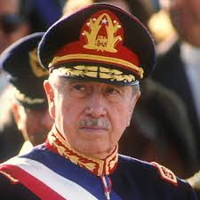
World politics explainer: Pinochet’s Chile
(Excerpt) By Peter Read, The Conversation, adapted by Newsela staff
General Augusto Pinochet Ugarte (1915–2006) was a Chilean military officer. In August 1973, Chile's president, Salvador Allende, made him commander in chief of the Chilean army. Eighteen days later, Pinochet turned on Allende's socialist government. With the help of the American CIA, he and troops loyal to him removed Allende from office. Pinochet then set up a military dictatorship.
Pinochet's rule was not the first, last or worst dictatorship in the history of Latin America. However, it did grip the attention of western countries. This was because before Pinochet's rule, Chile was the first freely elected Marxist government in the west. Marxism is the name for a set of political and economic ideas created by Karl Max. In Marxism, there are no classes. The government controls all the resources, and distributes them to people. This is supposed to ensure equality.
On hearing the news of the coup, Allende returned quickly to the capital city of Santiago. He gave one last remarkable radio address. Then, he shot himself rather than becoming a prisoner.
Pinochet named himself president of the military junta, or dictatorship, that followed.
Pinochet at first claimed that he would rule only for a year. However, he continued to rule up until 1988. At that point, he held a national vote, which he and his followers were sure he would win. Unexpectedly, however, 55 percent of the country voted against him.

Criminal Charges In Britain And Chile
Pinochet stepped down soon after, in 1990. In 1998, he was arrested in Britain to answer charges of torturing Spanish citizens in Chile during his rule. He was held in Britain for 18 months. Then, he was allowed to return to Chile to answer further charges.
Pinochet returned to face 59 criminal complaints for kidnapping, murder and torture. Those charges were never pursued, however. The Chilean Supreme Court ruled that Pinochet was too sick to stand trial. Pinochet died in 2006.
By then, even many of his supporters had turned against him. Their minds had been changed by the findings of two national commissions. These findings detailed the many crimes that had happened under Pinochet's dictatorship. They revealed that many innocent people had been arrested and jailed. Many of them were tortured, put to death or simply disappeared.

National Commission Reports Accused Pinochet Of Many Crimes
After taking power, Pinochet at first only attacked the most extreme communist groups, such as the Armed Revolutionary Movement (El MIR). Later, however, his attacks broadened. No member of any left-wing party was safe.
Many Chileans had supported Pinochet's attempt to rid the country of communism. They excused the arrests and executions as necessary evils. Yet, even some of these faithful supporters changed their minds after the national commission reports were released. The reports showed that Pinochet might have misused government money to make himself rich.
Despite all the charges leveled against him, Pinochet admitted nothing. Instead, he blamed others for the terrible crimes he himself had authorized. In particular, he heaped blame on Manuel Contreras, his much-hated head of the secret police.

Remembered for Sensational Arrest
During his years in power, Pinochet pushed through various economic reforms. Pinochet did have some major success in improving Chile's economic condition. Today, some still consider these improvements to be a Chilean miracle. However, for most people the good Pinochet may have done is far outweighed by his many terrible crimes.
Internationally, Pinochet is now remembered not so much for what he did while in power. Rather, he is most recalled for his sensational arrest in the U.K. What happened to him might make every retired dictator think twice before traveling abroad.
Step 3: Answer questions

How did Pinochet gain power in Chile?

What are two things that his dictatorship is remembered by? (pull your answers from the text)

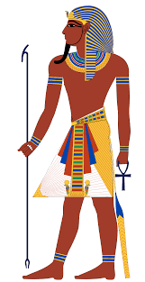
Step 4: Read about Theocracy in Ancient Egypt

Ancient Egypt
One of the most well-known theocratic governments was that of Ancient Egypt. Though it is divided into different periods, the theocracy of Egypt lasted for about 3,000 years. In Egypt, pharaohs were seen as divine connections to the gods. They were actually thought of as being descendents (family) of the god Ra (the sun god). The people believed the pharaoh protected them during hard times.While the pharaoh was the top representative, he or she was also guided by advisors and high priests in carrying out the gods' wishes for temples, laws and defense of Egypt.

The pharaoh had total power. He could use all the land in Egypt any way he wanted. His orders were obeyed without question. Pharaohs appointed officials called bureaucrats. They were in charge of irrigation canals and crop planting. They made sure grain was saved to help people get through hard times. Bureaucrats also controlled trade and collected tax payments from farmers.
As a religious leader, a pharaoh participated in ceremonies that helped the kingdom. For example, he was the first to cut the grain at harvest time.

Step 5: To truly understand theocratic governments, look at a couple more historical examples.

Historical Theocracy Examples
Separation of church and state isn't a new idea, but it is more prevalent than it once was. Early civilizations often had a king that was guided by a god or gods. A few examples of countries ruled by theocracy include Ancient Egypt, Tibet and China.
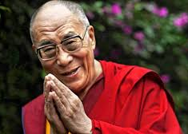

Tibet

Prior to 1959, the Tibetan government was headed by the Dalai Lama. This Buddhist leader is considered to be a reincarnation (the rebirth of a soul in a new body) of the previous Dalai Lama. He is seen as a ruling god. There have only been 14 Dalai Lamas throughout history. The reincarnation of the Dalai Lama is chosen by the High Lamas through a dream, smoke or holy lake.

China

There were several Chinese dynasties that practiced a theocratic government, including the Shang and Zhou Dynasties. During the Shang Dynasty, the priest king was thought to communicate and interpret the wishes of the gods and ancestors. The Shang Dynasty was overthrown by the Zhou Dynasty, which used the Mandate of Heaven as a way to overthrow the government. This mandate stated that the current ruler was chosen by a divine force.
Step 6: Answer questions

Based on the reading, do you think the Pharaohs of Egypt were liked or disliked by the people? Why?

What gives a theocratic ruler, like the Pharaoh power? Why do people obey theocratic leaders?

Step 7: Organize your thoughts
Complete the graphic organizer on the next page to help you compare and contrast dictatorship and theocracy. After completing the graphic organizer, you will reflect on these forms of governments and choose which one you prefer.
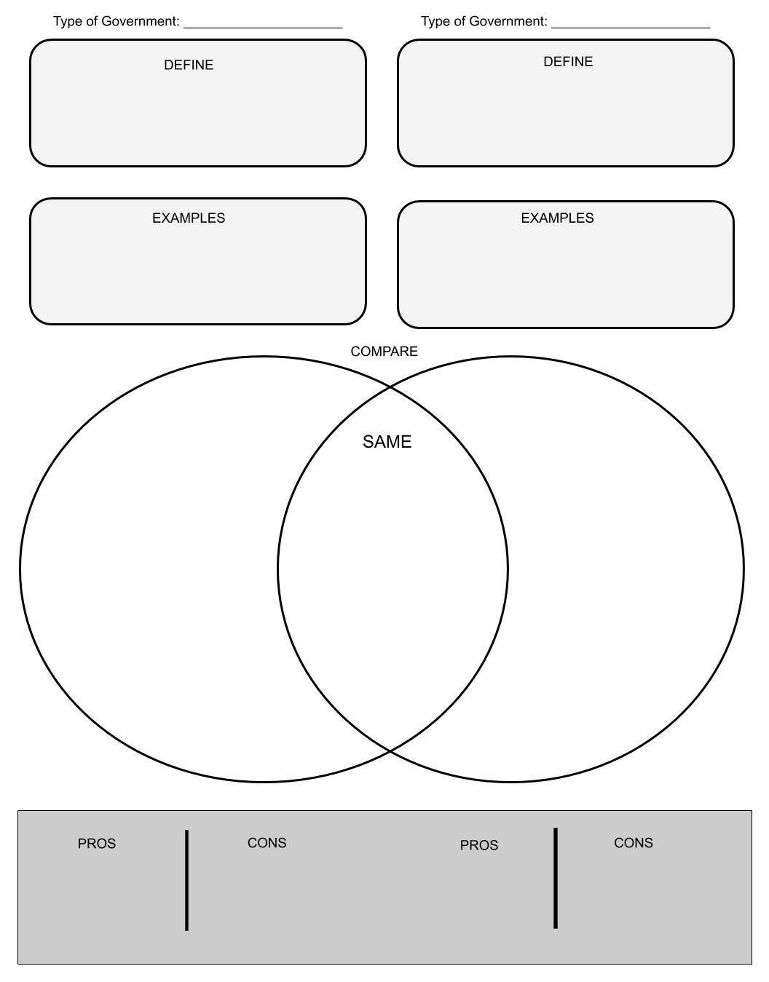

Step 8: Reflect

Complete the bracket below and choose which type of government you prefer:
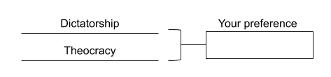

- Why do you prefer that governmental system? (share three reasons)

- How does it compare to the current governmental system you live in now? (share three reasons)

Step 9: Discuss
- With a partner, share and compare your graphic organizer.
- Can you improve your graphic organizer after discussing with your partner?
- Share what you chose as your winner for this bracket face-off and why.

Student Feedback:

Circle the emojis that best represents how this activity made you feel.

