Week 6
Change

Day 3

NAME:______________________

Day 3 Agenda

Topic | Activity
Warm-Up!
English Language Arts | - Read the short story, The Circuit.  - Respond to questions about the text.  - Read and analyze the poem Coming of Age  - Write a structured poem, I used to, but now I...
Science | - Read about Structural Changes  - Answer questions about what you read  - Draw a picture and explain
Mindfulness Moment!
Math | - Change and the Environment, Day 2: Earth Day
Health | - How can we deal with change?
Mindfulness Moment!
Civics/Social Studies | - Changing Historical Interpretations of Columbus  - Read and respond to the text

Warm-up Activity: Write a journal entry around the daily quote on identity.
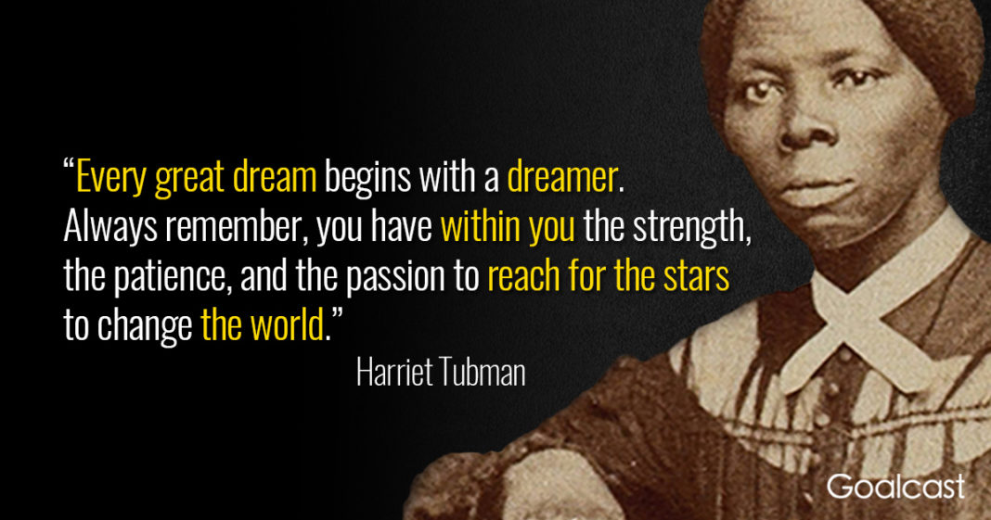

Day 3: Coming of Age
English Language Arts

What is this lesson about?: Today you will read two literary pieces about the the changes people go through as they grow up and mature.
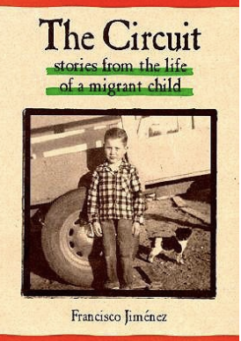
Before you Read:
Francisco Jiménez (1943–) was born in Tlaquepaque, Mexico, and grew up in a family of migrant workers in California. He spent much of his childhood moving around California with no permanent home or regular schooling. Nevertheless, he went on to attend and graduate from Santa Clara University. He also attended Harvard University and received both a master’s degree and a PhD from Columbia University. He is currently a full-time writer and professor at Santa Clara University. “The Circuit” is based on his childhood.

Some vocabulary and phrases to review:
There are some words and phrases in Spanish in the text. Translations are provided below.

Bracero: Mexican workers who were invited to the U.S. to work as laborers during WW2. | corrido: Mexican narrative song and poetry that forms a ballad | migrant: a person who moves to another country or area to find employment, usually seasonal or temporary work
listo: ready | grade: a slope or incline | Es todo: that’s all
jalopy: old worn down ca | vamonos: let’s go | quince: 15
Ya esora: It’s time | Mi olla: my pot (cooking pot) | Tienen que tener cuidado: You have to be careful.

Step 1: Read the following text.

The Circuit
by Francisco Jiménez

It was that time of year again. Ito, the strawberry sharecropper, did not smile. It was natural. The peak of the strawberry season was over and the last few days the workers, most of them braceros, were not picking as many boxes as they had during the months of June and July.
As the last days of August disappeared, so did the number of braceros. Sunday, only one—the best picker—came to work. I liked him. Sometimes we talked during our half-hour lunch break. That is how I found out he was from Jalisco, the same state in Mexico my family was from. That Sunday was the last time I saw him.

When the sun had tired and sunk behind the mountains, Ito signaled us that it was time to go home. “Ya esora,” he yelled in his broken Spanish. Those were the words I waited for twelve hours a day, every day, seven days a week, week after week. And the thought of not hearing them again saddened me.

As we drove home Papá did not say a word. With both hands on the wheel, he stared at the dirt road. My older brother, Roberto, was also silent. He leaned his head back and closed his eyes. Once in a while he cleared from his throat the dust that blew in from outside.

Yes, it was that time of year. When I opened the front door to the shack, I stopped. Everything we owned was neatly packed in cardboard boxes. Suddenly I felt even more the weight of hours, days, weeks, and months of work. I sat down on a box. The thought of having to move to Fresno and knowing what was in store for me there brought tears to my eyes.

That night I could not sleep. I lay in bed thinking about how much I hated this move.

A little before five o’clock in the morning, Papá woke everyone up. A few minutes later, the yelling and screaming of my little brothers and sisters, for whom the move was a great adventure, broke the silence of dawn. Shortly, the barking of the dogs accompanied them.

While we packed the breakfast dishes, Papá went outside to start the “Carcanchita.” That was the name Papá gave his old ‘38 black Plymouth. He bought it in a used-car lot in Santa Rosa in the winter of 1949. Papá was very proud of his little jalopy. He had a right to be proud of it. He spent a lot of time looking at other cars before buying this one. When he finally chose the Carcanchita, he checked it thoroughly before driving it out of the car lot. He examined every inch of the car. He listened to the motor, tilting his head from side to side like a parrot, trying to detect any noises that spelled car trouble. After being satisfied with the looks and sounds of the car, Papá then insisted on knowing who the original owner was. He never did find out from the car salesman, but he bought the car anyway. Papá figured the original owner must have been an important man because behind the rear seat of the car he found a blue necktie.

Papá parked the car out in front and left the motor running. “Listo,” he yelled. Without saying a word, Roberto and I began to carry the boxes out to the car. Roberto carried the two big boxes and I carried the two smaller ones. Papá then threw the mattress on top of the car roof and tied it with ropes to the front and rear bumpers.

Everything was packed except Mamá’s pot. It was an old large galvanized pot she had picked up at an army surplus store in Santa María the year I was born. The pot had many dents and nicks, and the more dents and nicks it acquired the more Mamá liked it. “Mi olla,” she used to say proudly.

I held the front door open as Mamá carefully carried out her pot by both handles, making sure not to spill the cooked beans. When she got to the car, Papá reached out to help her with it. Roberto opened the rear car door and Papá gently placed it on the fl oor behind the front seat. All of us then climbed in. Papá sighed, wiped the sweat off his forehead with his sleeve, and said wearily: “Es todo.”

As we drove away, I felt a lump in my throat. I turned around and looked at our little shack for the last time.

At sunset we drove into a labor camp near Fresno. Since Papá did not speak English, Mamá asked the camp foreman if he needed any more workers. “We don’t need no more,” said the foreman, scratching his head. “Check with Sullivan down the road. Can’t miss him. He lives in a big white house with a fence around it.”

When we got there, Mamá walked up to the house. She went through a white gate, past a row of rose bushes, up the stairs to the front door. She rang the doorbell. The porch light went on and a tall husky man came out. They exchanged a few words. After the man went in, Mamá clasped her hands and hurried back to the car. “We have work! Mr. Sullivan said we can stay there the whole season,” she said, gasping and pointing to an old garage near the stables.

The garage was worn out by the years. It had no windows. The walls, eaten by termites, strained to support the roof full of holes. The dirt floor, populated by earth worms, looked like a gray road map.

That night, by the light of a kerosene lamp, we unpacked and cleaned our new home. Roberto swept away the loose dirt, leaving the hard ground. Papá plugged the holes in the walls with old newspapers and tin can tops. Mamá fed my little brothers and sisters. Papá and Roberto then brought in the mattress and placed it on the far corner of the garage. “Mamá, you and the little ones sleep on the mattress. Roberto, Panchito, and I will sleep outside under the trees,” Papá said.

Early next morning Mr. Sullivan showed us where his crop was, and after breakfast, Papá , Roberto, and I headed for the vineyard to pick.

Around nine o’clock the temperature had risen to almost one hundred degrees. I was completely soaked in sweat and my mouth felt as if I had been chewing on a handkerchief. I walked over to the end of the row, picked up the jug of water we had brought, and began drinking. “Don’t drink too much; you’ll get sick,” Roberto shouted. No sooner had he said that than I felt sick to my stomach. I dropped to my knees and let the jug roll off my hands. I remained motionless with my eyes glued on the hot sandy ground. All I could hear was the drone of insects. Slowly I began to recover. I poured water over my face and neck and watched the dirty water run down my arms to the ground.

I still felt a little dizzy when we took a break to eat lunch. It was past two o’clock and we sat underneath a large walnut tree that was on the side of the road. While we ate, Papá jotted down the number of boxes we had picked. Roberto drew designs on the ground with a stick. Suddenly I noticed Papá’s face turn pale as he looked down the road. “Here comes the school bus,” he whispered loudly in alarm. Instinctively, Roberto and I ran and hid in the vineyards. We did not want to get in trouble for not going to school. The neatly dressed boys about my age got off . They carried books under their arms. After they crossed the street, the bus drove away. Roberto and I came out from hiding and joined Papá. “Tienen que tener cuidado,” he warned us.

After lunch we went back to work. The sun kept beating down. The buzzing insects, the wet sweat, and the hot dry dust made the afternoon seem to last forever. Finally the mountains around the valley reached out and swallowed the sun. Within an hour it was too dark to continue picking. The vines blanketed the grapes, making it difficult to see the bunches. “Vámonos,” said Papá, signaling to us that it was time to quit work. Papá then took out a pencil and began to figure out how much we had earned our first day. He wrote down numbers, crossed some out, wrote down some more. “Quince,” he murmured.

When we arrived home, we took a cold shower underneath a water-hose. We then sat down to eat dinner around some wooden crates that served as a table. Mamá had cooked a special meal for us. We had rice and tortillas with carne con chile, my favorite dish.

The next morning I could hardly move. My body ached all over. I felt little control over my arms and legs. This feeling went on every morning for days until my muscles finally got used to the work.

It was Monday, the first week of November. The grape season was over and I could now go to school. I woke up early that morning and lay in bed, looking at the stars and savoring the thought of not going to work and of starting sixth grade for the first time that year. Since I could not sleep, I decided to get up and join Papá and Roberto at breakfast. I sat at the table across from Roberto, but I kept my head down. I did not want to look up and face him. I knew he was sad. He was not going to school today. He was not going tomorrow, or next week, or next month. He would not go until the cotton season was over, and that was sometime in February. I rubbed my hands together and watched the dry, acid stained skin fall to the floor in little rolls.

When Papá and Roberto left for work, I felt relief. I walked to the top of a small grade next to the shack and watched the “Carcanchita” disappear in the distance in a cloud of dust.

Two hours later, around eight o’clock, I stood by the side of the road waiting for school bus number twenty. When it arrived I climbed in. Everyone was busy either talking or yelling. I sat in an empty seat in the back.

When the bus stopped in front of the school, I felt very nervous. I looked out the bus window and saw boys and girls carrying books under their arms. I put my hands in my pant pockets and walked to the principal’s office. When I entered I heard a woman’s voice say: “May I help you?” I was startled. I had not heard English for months. For a few seconds I remained speechless. I looked at the lady who waited for an answer. My first instinct was to answer her in Spanish, but I held back. Finally, after struggling for English words, I managed to tell her that I wanted to enroll in the sixth grade. After answering many questions, I was led to the classroom.

Mr. Lema, the sixth grade teacher, greeted me and assigned me a desk. He then introduced me to the class. I was so nervous and scared at that moment when everyone’s eyes were on me that I wished I were with Papá and Roberto picking cotton. After taking roll, Mr. Lema gave the class the assignment for the first hour. “The first thing we have to do this morning is finish reading the story we began yesterday,” he said enthusiastically. He walked up to me, handed me an English book, and asked me to read. “We are on page 125,” he said politely. When I heard this, I felt my blood rush to my head; I felt dizzy. “Would you like to read?” he asked hesitantly. I opened the book to page 125. My mouth was dry. My eyes began to water. I could not begin. “You can read later,” Mr. Lema said understandingly.

For the rest of the reading period I kept getting angrier and angrier with myself. I should have read, I thought to myself.
During recess I went into the restroom and opened my English book to page 125. I began to read in a low voice, pretending I was in class. There were many words I did not know. I closed the book and headed back to the classroom.

Mr. Lema was sitting at his desk correcting papers. When I entered he looked up at me and smiled. I felt better. I walked up to him and asked if he could help me with the new words. “Gladly,” he said.

The rest of the month I spent my lunch hours working on English with Mr. Lema, my best friend at school.

One Friday during lunch hour Mr. Lema asked me to take a walk with him to the music room. “Do you like music?” he asked me as we entered the building.

“Yes, I like corridos,” I answered. He then picked up a trumpet, blew on it, and handed it to me. The sound gave me goosebumps. I knew that sound. I had heard it in many corridos. “How would you like to learn how to play it?” he asked. He must have read my face because before I could answer, he added: “I’ll teach you how to play it during our lunch hours.”

That day I could hardly wait to get home to tell Papá and Mamá the great news. As I got off the bus, my little brothers and sisters ran up to meet me. They were yelling and screaming. I thought they were happy to see me, but when I opened the door to our shack, I saw that everything we owned was neatly packed in cardboard boxes.

Step 2: Answer the following questions.

- Reread the opening paragraphs. What kind of work do the narrator and his family do? Cite details from the story that support your answers.

- How does the narrator feel about moving? How do you know? Cite examples from the text.

- Describe the narrator’s work day once he moves to Fresno.

- Why does the narrator consider Mr. Lema his “only friend”?

- Reread the last paragraph of the story. How do you think that the constant change of moving so often affects the narrator? What do you predict will happen to him?

Step 3: Read the following poem
Coming of age stories are stories about the transition from childhood to adulthood. That transition often involves rituals and experiences that symbolize the person’s maturation. As you read this poem, think about how the speaker has changed as she has grown.

 | Coming of Age  Kells Garcia | Notes:
1 | Everyday momma would take me to the window  she would sit me on her lap  reach across and open the curtains  Sweetie, What do you see?
2 | I see children laughing momma  I see trees so high  their leaves look like they're caressing the sky  I see a new born baby opening its eyes for the first time  I see oceans, so beautiful they look endless  One day I may sail on them  the possibilities endless  And the sky, Oh the sky  so blue so innocent
3 | But it's not always a pretty blue  Sometimes it’s gray  Sometimes I see children crying  starving, I see  famine momma and poverty  I see wars and blood  I see guns with bullets not meant to protect but to kill  I see innocent people dying  Momma closed the curtains
4 | And that day momma did the strangest thing  she hugged me and whispered  you’ve come of age  it’s time you knew the world isn't such a pretty place.

Step 4: Answer the following questions.
Note: If possible, use these questions as discussion questions instead of having to write out the answers. If this is not possible, then have students write out their answers.

- What ritual does the speaker in the poem experience with her mother?

- Her mother asks her the same question each day. Is she asking the speaker to literally describe what she sees out the window? Explain your answer.

- Explain the speaker’s view of the world as a child. Use specific examples from the text.

- How does the speaker’s tone change? Cite examples from the text.

- How does the mother interpret these changes?

- What does knowing “the world isn't such a pretty place” symbolize? Explain how the change in how she sees the world has signalled her change from child to adult.

Step 5: Reflect, Brainstorm and Write: I Used to...Now, I Poem

Reflect on the two characters you just read about. Each is growing and changing. Think about how you have changed in the last 2-3 years. Some questions you might consider as you think about this change:

- How has your role in your family changed? (as an older/younger brother/sister or role model or your relationship with an adult in your family: parent, grandparent, guardian, etc..)
- How you view your education and your role in it.
- Your relationships with friends.
- Your own view of yourself.
- How you view your future and what you need to do to achieve your goals.
- Your role in your community.
- Something you used to like (or hate) and now you don’t or you do differently.
- A skill or talent that you have acquired or honed (improved).

You are going to write a poem using the template below where you will describe how your have changed. Only write what you feel comfortable sharing, but please be thoughtful and reflective of how you have changed.

Sample Poem:
I Used To, But Now I
I used to torment my little brother every day just for fun
But now I see how he looks up to me and try to set the example
I always focused on the cheap phone my mom gave me on my birthday
But I never realized she had worked overtime to afford it because she thought I deserved a nice phone.
I never wanted to raise my hand in class
But I might speak up this time because I have something to say
I can’t go back in time
But I can make the future better
I won’t ever be perfect
But I might do better if I stay focused on what I have to do
I used to follow anyone
But now I realize I have my own places to go.

I Used To, But Now I

I used to___________________________________________________

But now I __________________________________________________

I always ___________________________________________________

But I never _________________________________________________

I never ____________________________________________________

But I might _________________________________________________

I can’t _____________________________________________________

But I can___________________________________________________

I won’t ____________________________________________________

But I might _________________________________________________

I used to___________________________________________________

But now I __________________________________________________

Student Feedback:

Circle the emojis that best represents how this activity made you feel.

Day 3: Structural Changes
Science

What is this lesson about?: Today you will read through the Virus could cause biggest emissions drop since World War II passage. You will answer a few questions about what you read. You will complete a Structural Change activity.

Step 1: Read through the Virus could cause biggest emissions drop since World War II passage

Virus could cause biggest emissions drop since World War II
But analysts warn this positive change could be short-lived if no structural changes occur.
(Aljazeera - April 3, 2020)
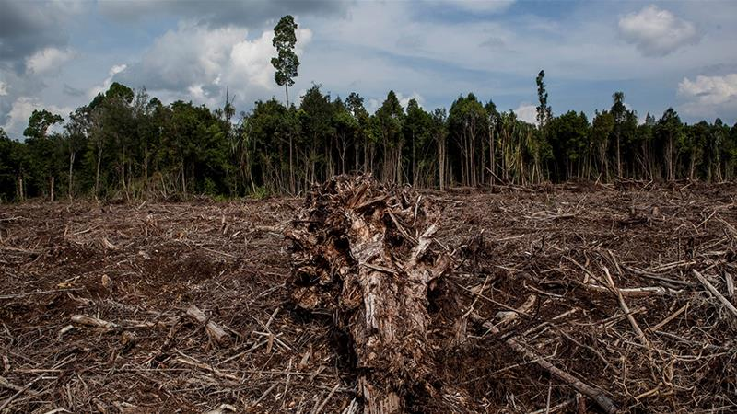
Carbon dioxide emissions could fall by the largest amount since World War II this year as the coronavirus outbreak brings economies to a virtual standstill, according to the chair of a network of scientists providing benchmark emissions data.
Rob Jackson, who chairs the Global Carbon Project, which produces widely watched annual emissions estimates, said carbon output could fall by more than 5 percent year-on-year - the first dip since a 1.4 percent reduction after the 2008 financial crisis.
"I wouldn't be shocked to see a 5 percent or more drop in carbon dioxide emissions this year, something not seen since the end of World War II," Jackson, a professor of Earth system science at Stanford University in California, told Reuters news agency in an email.
"Neither the fall of the Soviet Union nor the various oil or savings and loan crises of the past 50 years are likely to have affected emissions the way this crisis is," he said.
The prediction - among a range of new forecasts being produced by climate researchers - represents a tiny sliver of good news in the midst of crisis: Climate scientists had warned world governments that global emissions must start dropping by 2020 to avoid the worst impacts of climate change.
But the improvements are for all the wrong reasons, tied to a world-shaking global health emergency that has infected more than 950,000 people - while shuttering factories, grounding airlines and forcing hundreds of millions of people to stay at home to slow the contagion.
Experts warn that without structural change, the emissions declines caused by coronavirus could be short-lived and have little effect on the concentrations of carbon dioxide that have accumulated in the atmosphere over decades.
"This drop is not due to structural changes so as soon as confinement ends, I expect the emissions will go back close to where they were," said Corinne Le Quere, a climate scientist at the University of East Anglia in eastern England.
After world greenhouse gas emissions dipped in the aftermath of the 2007-2008 global financial crisis, they shot back up a whopping 5.1 percent in the recovery, according to Jackson.
The pattern of a swift rebound has already begun to play out in China, where emissions fell by an estimated 25 percent as the country closed factories and put in place strict measures on people's movement to contain the coronavirus earlier this year, but have since returned to a normal range.
That kind of resilience underscores the magnitude of the economic transformation that would be needed to meet the goals of an international deal brokered in Paris in 2015 to try to avert the most catastrophic climate change scenarios.
A United Nations report published in November found that emissions would have to start falling by an average of 7.6 percent per year to give the world a viable chance of limiting the rise in average global temperatures to 1.5 celsius (2.7 Fahrenheit), the most ambitious Paris goal.
"I don't see any way that this is good news except for proving that humans drive greenhouse gas emissions," said Kristopher Karnauskas, associate professor at the Department of Atmospheric and Oceanic Sciences at the University of Colorado Boulder.

A thinner silver lining
With the world dependent for fossil fuels for 80 percent of its energy, emissions forecasts are often based on projections for global economic growth.
Last month, Glen Peters, research director of the Center for International Climate Research in Oslo, predicted carbon emissions would fall between 0.3 percent and 1.2 percent this year, using higher and lower forecasts for global GDP growth from the Organisation for Economic Co-operation and Development or OECD.
A few days later, The Breakthrough Institute, a research center in California, predicted emissions would decline 0.5-2.2 percent, basing its calculations on growth forecasts from JP Morgan, and assuming the global economy recovers in the second half.
"Our estimates indicate that the pandemic's climate silver lining is vanishingly thin," said Seaver Wang, a climate and energy analyst at the institute.
"It's as if we went back in time and emitted the same amount we were a few years ago - which was already too much. In the grand scheme of things, it really makes no difference."
Some foresee a bigger hit to the economy. The London-based Centre for Economics and Business Research estimates that world GDP will fall by at least 4 percent this year - albeit with a "huge margin of error."
That drop would be more than twice as large as the contraction during the financial crisis and the largest annual fall in GDP since 1931, barring wartime, the centre said.
With governments launching gigantic stimulus packages to stop their economies collapsing, investors are now watching to see how far the United States, and China, the European Union, Japan and others embrace lower-emission energy sources.
"Even if there is a decline in emissions in 2020, let's say 10 percent or 20 percent, it's not negligible, it's important, but from a climate point of view, it would be a small dent if emissions go back to pre-COVID-19 crisis levels in 2021," said Pierre Friedlingstein, chair in mathematical modelling of the climate system at the University of Exeter in southwest England.
"This is why it is important to think about the nature of the economic stimulus packages around the world as countries come out of the most immediate health crisis," said Dan Lashof, US director at the World Resources Institute.

Step 2: Answer the following questions

- What problem/issue is discussed in this article?

- What structural changes do you think are important to address this issue/problem?

Step 3: Draw an image/picture

Draw a picture of a structural change that is needed to address the emissions problem.

What recommendations would you make to help the environment?

________________________________________________________________________________________________________________________________________________________________________________________________________________________________________________________________________________________________________________________________________________________________________________________________________________________________________________________________________________________________________________________________________

Student Feedback:

Circle the emojis that best represents how this activity made you feel.

Mindfulness Moment!

Day 3: Change/Population
Math

What is this lesson about?: This lesson is about world population and the percentage change over time.

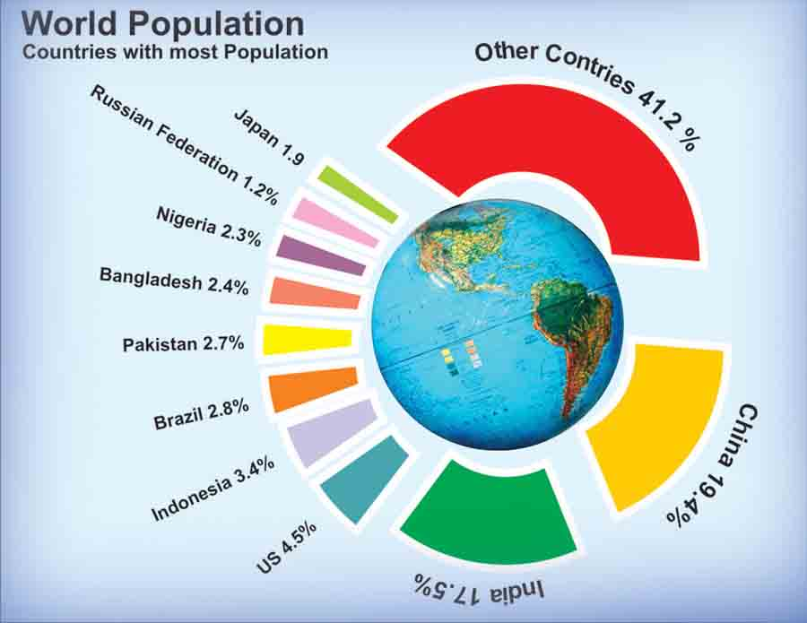

Step 1: Country populations
The United Nations estimates that the world population for April 2020 is approximately 7.8 Billion people. In standard numeric form that’s 7,800,000,000. Wow! Our global population is growing and there are currently more people on the Earth today then combining all the people who have ever died. Certain countries are continuing to grow, such as China, India and many African countries. Others, such as the Russian federation and Japan have shrinking populations.

To calculate how many people are currently in our country, we need to multiply 4.3%(.043) times 7,800,000,000. That is the percent of the world’s population that is in the U.S. multiplied by the total world population.

7,800,000,000 times .043 = 335,400,000.

There are roughly 335 Million people currently living in the U.S. Using this method, please calculate the population for these three countries.

Country | Population
United States | 335,400,000
Nigeria
Pakistan
India

Step 2: Differing populations by country

You can see from the pie chart above that the U.S. has a greater population than both Nigeria and Pakistan, but how much greater?

If you calculated step 1 correctly you should have found Nigeria’s population to be 179,400,000. If we subtract Nigeria’s population from the population of the U.S.(335,400,000-179,400,000) we find the difference to be 156,000,000. The U.S. has 156 Million more people than Nigeria.

Please fill out the chart below with the correct differences in populations for the other two countries compared with the U.S. Remember, if we are comparing them to the U.S. we use a negative sign if they are smaller and a positive sign if they are larger.

Country | Population | Population difference
United States | 335,400,000 | 0
Nigeria | 179,400,000 | -156,000,000
Pakistan
India

Step 3: Calculating a percentage difference

To calculate a percent difference we need to use a ratio (fancy word for a fraction.) If we take the difference in population for a country as the numerator, we then divide it by the U.S. population, the denominator.

In the case of Nigeria we would calculate 156,000,000 divided by 335,400,000 to get .465. Then we convert our decimal to a percentage by moving the decimal point 2 units to the right which equals 46.5%. In other words, Nigeria has 46.5% less people than the U.S.

Using the information you found in step 2, please calculate the percent difference in population for Pakistan and India.

Country | Population | Population difference | Percent difference
United States | 335,400,000 | 0 | 0
Nigeria | 179,400,000 | -156,000,000 | -46.5
Pakistan
India

Step 4: Population and pollution
One of the challenges of a huge and growing population in India and China, is pollution. Both countries have historically relied on coal to produce electricity for their citizens, leading to dangerous levels of air pollution. Coal is the dirtiest, most inefficient way to produce electricity,

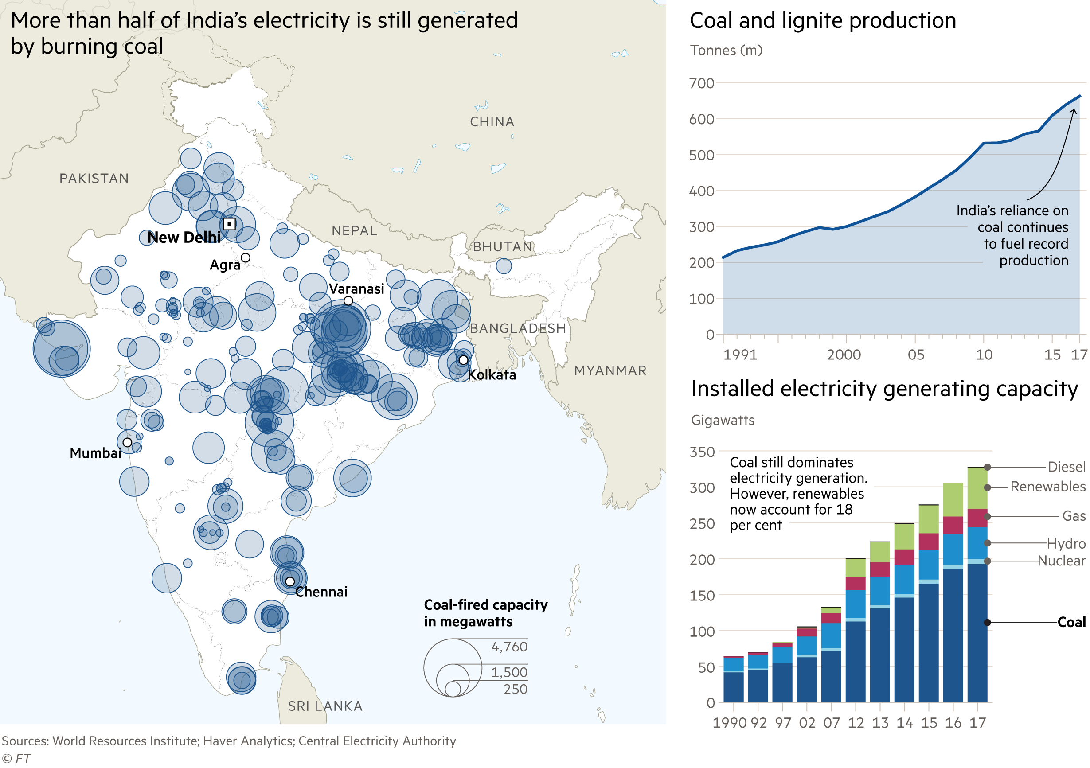
Based on these charts and graphs, answer the following questions:
- How many approximately how many tons of coal did India produce back in 1990?
- And how much are they producing now (2017)
- Back in 1990, coal was used to generate most of the electricity in India. Today (2017), renewable energy such as solar and wind are a pretty big part (18%) of how India produces electricity. That is good. But...
- Does India use more coal now (2017) or in 1990 to produce electricity?

- Why, do you think, does India use so much more electricity today than in 1990?

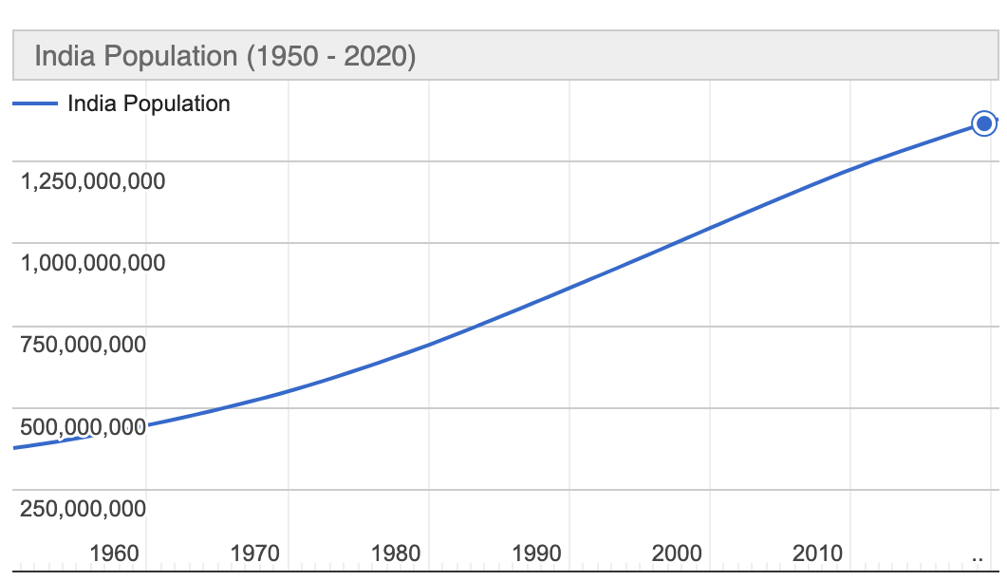
- Based on this chart, what was India’s population, approximately in 1990? And what is it today, approximately?

- Discuss/consider: As populations increase, what pressure does that put on energy needs? How can we provide energy needs to an increasing population and keep pollution down and keep the environment clean?

Student Feedback:

Circle the emojis that best represents how this activity made you feel.

Day 3: How can we deal with change?
Health

What is this lesson about?: In today’s lesson, you will think of ways that you can deal with change. Dealing with change can have a big impact on your mental and physical health.

Step 1: Respond to the prompts below by using the scale.

Place a letter for each prompt below on the scale.

- How confident are you in identifying changes that can take place in adolescence?

- How confident are you in understanding the effect that change can have? (eg. on friendships, mood, routines, confidence, etc.)

- How confident are you in knowing strategies to manage change and where to seek support?

Reflect: Did your answers change from Monday?

Step 2: Read this excerpt from Chicken Soup for the Soul. 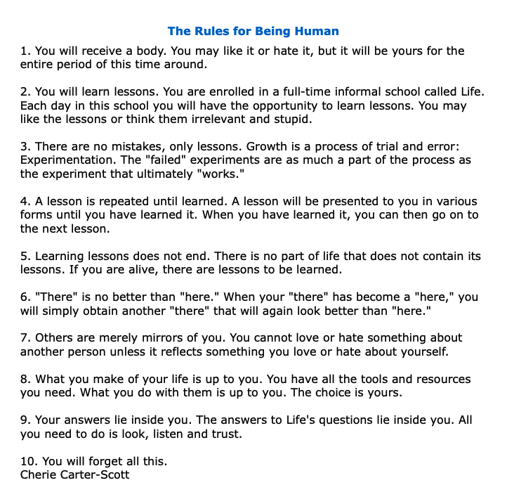
Which rule was most important to you? Why?

Which rule do you think will change you the most? Why?

What rule do you think is missing? Why?

Step 3: Dealing with Change

You have been asked to give advice to each person in the situations below. Use some of the strategies below if you need ideas.
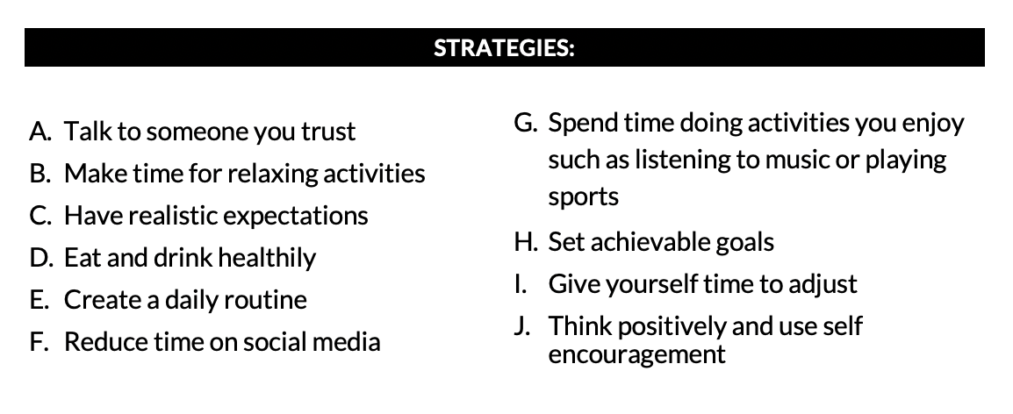
Who Scenario What advice would you give to these students?
Someone who is starting a new job.
Someone who has just moved to this country.
Someone who is going through a physical change as they grow.
Someone whose parents are separating.
Someone who has experienced a change in their friendship group.

Step 4: Reflect

Which scenario was hardest to give advice on?

Can you think of a scenario that we could add?

Why do you think it is important to practice these scenarios?

Student Feedback:

Circle the emojis that best represents how this activity made you feel.

Mindfulness Moment!
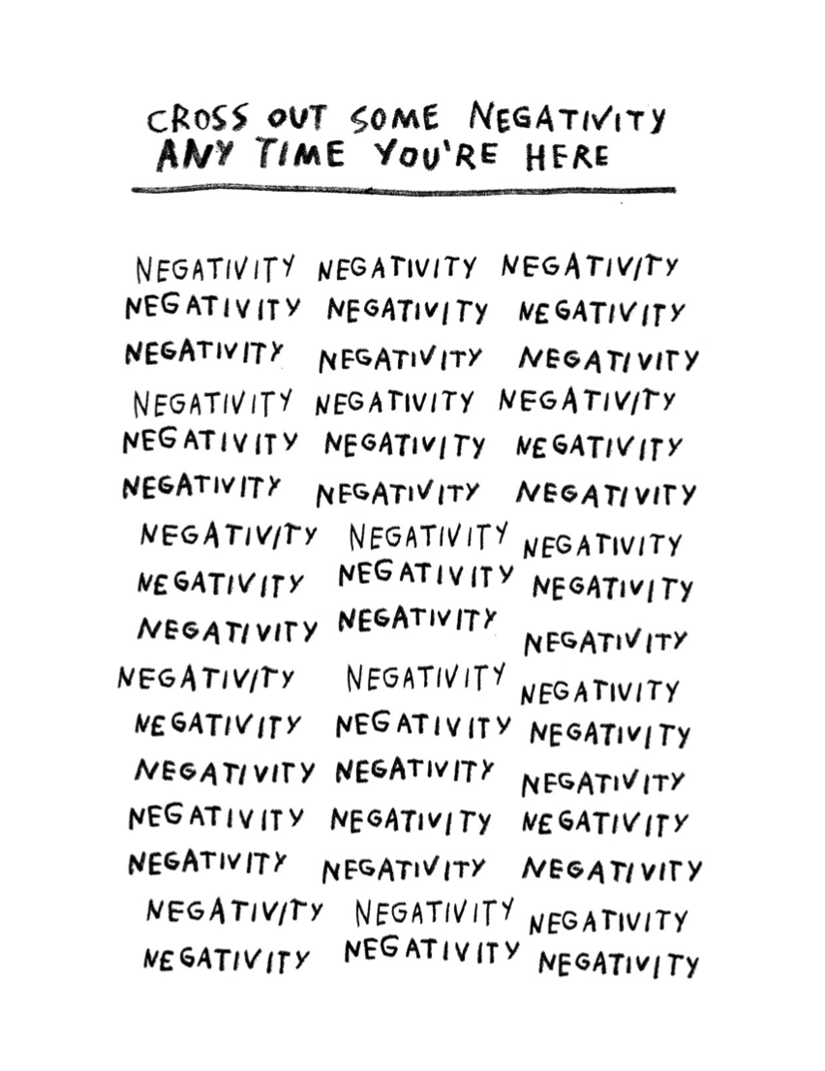

Day 3: Changing Historical Interpretations of Columbus
Social Studies

What is this lesson about?:

Warm-up: free-write

Take 5 minutes to read the quote below and reflect on it. Write what you think it means?
"Each age tries to form its own conception of the past. Each age writes the history of the past anew with reference to the conditions uppermost in its own time." – Frederick Jackson Turner

Step 1: Consider what you know

Before you begin reading about Christopher Columbus, take a few minutes to write down 5 things on what you already know about him.

Step 2: Read the text

Historical Interpretations of Christopher Columbus

As historians write history, they analyze and interpret sources (evidence). Because they bring different approaches to their work, they often interpret the past in different ways. Consider the following interpretations of one of the best-known figures in our history – Christopher Columbus. Few historians would disagree that his four voyages to the Americas set in motion events that would change the world. But historians do differ in how they view Columbus and his legacy, or impact on future generations.

Washington Irving: Columbus as a mythic hero
Nineteenth-century author Washington Irving spent years in Spain researching the life of Columbus. Irving was one of the first American writers to focus on subjects and themes of American life. His four-volume biography of Columbus portrayed the explorer as an American icon, painting him in heroic terms.
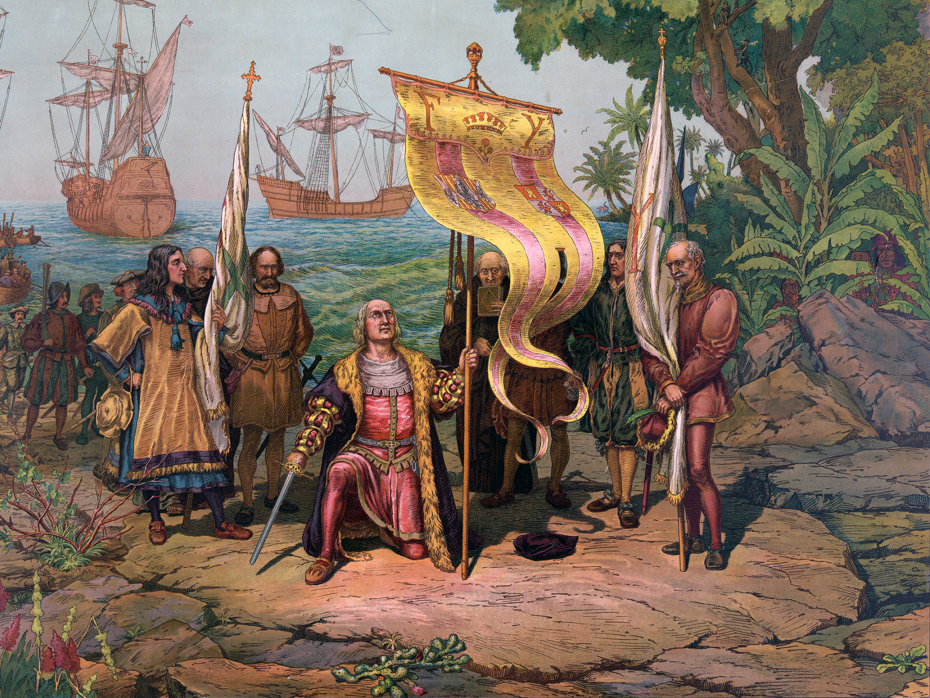
“Columbus was a man of great and inventive genius...His ambition was lofty and noble, inspiring him with high thoughts, and an anxiety to distinguish himself from great achievements...His conduct was characterized by the grandeur of his views and the nobility of his spirit. Instead of ravaging the newly found countries...he sought to colonize and cultivate them, to civilize the natives...A valiant and indignant spirit...a visionary of an uncommon kind.”
-Washington Irving, The Life and Voyage of Christopher Columbus, 1828

Irving admitted that Columbus made mistakes, such as enslaving and killing native peoples, but he dismissed them as “errors of the times.”

Samuel Eliot Morison: Columbus as Master Mariner
Writing more than a century after Irving, historian Samuel Eliot Morison portrayed Columbus as a real
person with both strengths and flaws. Morison, a naval historian, focused on Columbus’s skills as a mariner, or sailor and navigator.

“Now, more than five hundred years after his birth...(Columbus’s discovery of the New World) is celebrated throughout the length and breadth of the Americas, his fame and reputation may be considered secure for all time. He had his faults and his defects, but they are largely the defects of the qualities that made him great – his indomitable will, his superb faith in God and in his own mission as the Christ-bearer to lands beyond the seas, his stubborn persistence despite neglect, poverty and discouragement. But there is no flaw, no dark side to the most outstanding...of all his qualities, his navigation skills. As a master mariner and navigator, Columbus was supreme in his generation. Never was a title more justly bestowed than the one which he most jealously guarded, Admiral of the Ocean Sea.”
-Samuel Eliot Morison,Christopher Columbus, Mariner, 1955

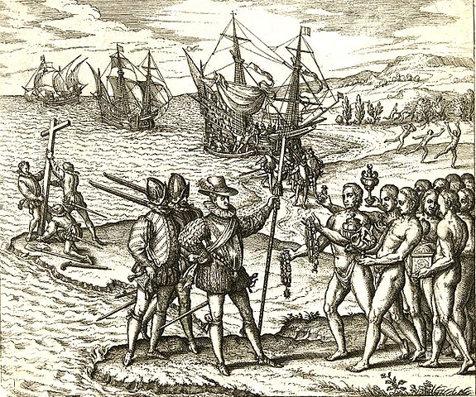
Kirkpatrick Sale: Columbus as overrated hero
Writer and environmentalist Kirkpatrick Sale is far more critical of Columbus. In a 1990 book, Sale portrays Columbus as a ruthless fortune hunter who set in motion the destruction of native peoples and the American landscape that continues to this day. Sale also takes issue with the view of Columbus as a “master mariner.”

“For all his navigational skills, about which the salty types make such a fuss, and all his fortuitous headings, (accidental but lucky directions), about which they are largely silent, Admiral Columbus could be a wretched mariner. The four voyages, properly seen, quite apart from bravery and endurance, are replete with clumsy mistakes, misconceived sailing plans, foolish disregard of elementary maintenance, and stubborn neglect of basic safety...Almost every time Columbus went wrong it was because he had refused to bend to the inevitabilities of tide and wind and reef, or, more arrogantly still, had not botherend to learn about them; the very same reckless courage that led his across the ocean in the first place, same his through storm and tumult to return, lay behind his numerous misfortunes.”
-Kirkpatrick Sale, The Conquest of Paradise, 1990

Different interpretations serving different purposes
You may be wondering how three different writers could produce such different interpretations of the same subject. The answer lies, in part, in each one’s purpose in writing about Columbus and his legacy.

Irving was an author and essayist looking for a heroic story that would appeal to American readers in the 1800s. His colorful biography of Columbus was filled with dramatic episodes, with many based on more myth than on reliable sources.

Morison’s purpose was quite different. He wanted to rescue Columbus from earlier mythmakers like Irving. A sailor himself, Morison was impressed by Columbus’s seafaring skills. He acknowledged that Columbus was not a saint but portrayed him as a master sailor who, through persistence, daring and courage, changed the course of history.

Sale had yet another purpose. He wanted to show how Columbus’s legacy looked from the point of view of its victims – Native Americans and Africans brought as slaves to the Americas. From Sale’s perspective, Columbus and those who followed him across the Atlantic, set in motion a dark history of exploitation and environmental destruction that had been ignored far too long.

The facts of Columbus’s life and legacy have not changed in all this time. But how people view those facts has and will continue to change.

Step 3: Reflect and answer questions

Look back to your answer above in step 1. Based on what you wrote, what version of Columbus’ history have you been taught? Which one matches up best with what you already knew about columbus.

After reading the different interpretations of Columbus’ voyage to America, has your opinion changed? Why or why not? Write at least three sentences explaining your answer.

What more do you want to learn or study about Columbus to better understand him and his actions?

Step 4: Read one more article

Opinions- PRO/CON: Should we celebrate Christopher Columbus?
By Silvio Laccetti, McClatchy Tribune, and Los Angeles Times Editorial Board, adapted by Newsela staff

PRO: Columbus was a man of his time, history shows he is worth celebrating
Monuments honoring Christopher Columbus are being defaced and destroyed. This year’s Columbus Day celebrations will spark strong debate over the explorer’s legacy. However, looking at Columbus in the big picture of history, one can see today’s anti-Columbus sentiment is misguided.

First, let’s consider the spread of European disease, principally smallpox. Smallpox is estimated to have killed 70 to 80 percent of Native Americans. Though these numbers are staggering, the deaths happened over many decades. Holding Columbus responsible is not logical. Further, calculating an actual number of deaths is impossible. Estimates of pre-Columbus populations vary widely. In Hispaniola, the island that now makes up the countries of Haiti and the Dominican Republic, for example, the estimates run from 250,000 to 3 million.

It’s also worth remembering all other epidemics. The Black Death, originating in Central Asia, killed 40 percent or more of the European population. Roughly 50 million people died between 1346 and 1353. This is a negative result of the interaction of any civilizations.

Let’s also remember the exchange of disease worked both ways. Most historians believe the Great Pox that killed 5 million in Renaissance Europe came from the Americas.

Mayans Were Barbaric People
Next, consider the early civilizations of the Americas. They have left behind beautiful monuments. However, the earliest societies, like the Mayans, were as brutal in exploiting subject peoples as any civilization elsewhere.

Tourists love to visit the magnificent pyramids of Teotihuacan and Mayan sites close to resorts.

So beautiful! So inspiring! So conveniently located! Not so beautiful if you consider the human sacrifice that regularly occurred there.

War, slavery and human sacrifice pre-dated the 1492 arrival of Columbus.

European civilization has evolved, but 20th century wars, atrocities, genocide and terrorism show humanity is prone to the same savage impulses.

Columbus was a product of his time. He was also a great explorer, a fearless adventurer, a man of faith and a leader who blazed a path to the modern world.

Italian And Hispanic Descendants Celebrated Him
He holds a special place in the minds of Italian-Americans and Hispanic-Americans in particular. These groups celebrate Columbus Day with parades and statues.

Parks, playgrounds, streets, squares and schools throughout the U.S. bear Columbus' name.

No question, we must examine the accomplishments of Columbus. Doing so in the proper context shows there’s no reason to destroy, deface or remove his monuments — or minimize his legacy.

Silvio Laccetti is a retired professor of social sciences at Stevens Institute of Technology in Hoboken, New Jersey.

***
CON: We must recognize that progress for some led to injustice for others
The Los Angeles City Council in California has joined many other cities in replacing Columbus Day. A holiday called Indigenous Peoples Day will instead recognize the contributions, and suffering, of Native Americans.

Of course, giving workers a day off does not make up for centuries of discrimination, enslavement and government-approved killing of Native Americans., nor would wiping Columbus Day off the calendar.

Without question, the nation must do a far better job recognizing the violent history against the country’s indigenous people. California’s leaders in the 1850s made no secret of their desire to destroy the area’s native people. Legislators funded anti-Indian armed forces. Natives were massacred. Villages were destroyed and tribes forcibly relocated.

Special Holiday Could Appease Opponents
Would a holiday help Californians learn about this shameful period? Would it encourage reconciliation? Possibly.

Leaders could consider an official public apology. Or they could consider compensating tribes that lost sacred sites or returning land of special value. Los Angeles, in particular, could provide greater protection for sacred sites. It could offer official support for local tribes. Many tribes still seek federal recognition.

The true stories of native peoples, beyond the simplistic portrayal of the first Thanksgiving meal, must become part of our national story. Schools should be required to teach the history, even the parts we'd like to forget.

Supporters of Indigenous Peoples Day say the government also must remove Columbus Day from the calendar. Columbus was a cruel slave trader who brought about the mass killing of native peoples.

Columbus Day Appeased Special Interests
But why must this be a choice? The debate over Columbus Day reflects confusion about how the history of racism and oppression in the U.S. fits into a proud national identity. The U.S. has taken in millions of needy immigrants but also grew through colonization that devastated native populations. Columbus Day wasn’t created to celebrate colonial domination. It was designated a federal holiday in 1934 after a campaign by Italian-Americans and Catholics. They were targets of ethnic and religious discrimination at the time.

Erasing history is not the answer. The better approach is confronting it honestly.

Whether the holiday is called Columbus Day or Indigenous Peoples Day or Explorers Day or History Day, isn’t there a way to celebrate a nation rising on a promise of liberty and equality, while also recognizing that progress for some led to displacement, injustice and death for others? There should be.

The Los Angeles Times Editorial Board represents the opinions of the staff of the newspaper.
Step 5: Reflect and respond

Do you think interpretations of Christopher Columbus have changed since the time Columbus Day was created to today? Why or why not?

Respond to the following statements and explain your position. Write in the corner of the graph that represents the position you have on the statement.
Agree
Strongly Agree

Columbus Day should be a national holiday.
Strongly Agree
Agree
Strongly Disagree
Disagree

Step 4:

Student Feedback:
Circle the emojis that best represents how this activity made you feel.

