Week 7
Rights

Day 3

NAME:______________________

Day 3 Agenda

Topic | Activity
Warm-Up!
English Language Arts | - Read an informational text on Women’s Suffrage.  - Read and analyze a speech by Sojourner Truth  - Respond to questions about both texts.  - Create a visual representation of equality using symbols.
Science | - Read about Electricity Rights  - Answer questions about what you read  - Draw a picture and explain
Mindfulness Moment!
Math | - Rights-the Math of Recent Voting Rights Initiatives
Health | - Internet Acccess Rights
Mindfulness Moment!
Civics/Social Studies | - Creating Additional Rights - Amending the Constitution

Warm-up Activity: Write a journal entry around the daily quote on identity.
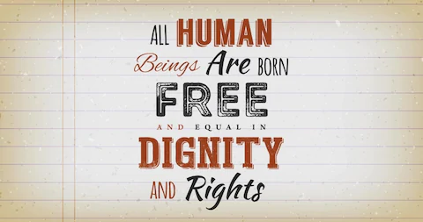

Day 3: Women’s Rights
English Language Arts

What is this lesson about? Today you will read about the fight for Women’s Rights in the United States. As you read, think about how the fight for rights needs to consider one’s own needs but also the needs of others.

Before you Read:
Some vocabulary to review:
domestic: relating to the running of a home or family relations. | sweatshop: a factory or workshop where manual workers are employed at very low wages for long hours and under poor conditions | Moderate (adj): (of a person, party, or policy) not radical or extreme in their opinions and actions.
delegation: a group of representatives; | subordinate: lower in position or importance | affront: insult
ratification: the action of signing a treaty, contract, or agreement, or law making it officially valid. | enfranchisement: the giving of a right or privilege, especially the right to vote. | lobby (v): seek to influence (a politician or public official) on an issue.
suffrage: the right to vote in political elections. | picket: demonstrate or protest against | Abridged: shortened

Step 1: Read the following text.

Overview of Women's Suffrage in the United States Compiled by the Center for American Women and Politics

Women in the Nineteenth Century
For many women in the early nineteenth century (1800s), activity was limited to the domestic life of the home and care of the children. Women were dependent on the men in their lives, including fathers, husbands, or brothers. Once married, women did not have the right to own property, maintain their wages, or sign a contract, much less vote. In colonial America, most Black women were considered property. Women were expected to obey their husbands, not express opinions independent of, or counter to, their husbands’. It was considered improper for women to travel alone or to speak in public.

Immigrant women, women of color, and low-income women nevertheless had to work outside the home, often in domestic labor or sweatshops. In the nineteenth century taking a job was considered neither respectable nor something that an “honest” woman would do, and women who did so were considered to have given up their claim to “gentle treatment” and were often exploited by their employers.

The Seneca Falls Convention
The women's suffrage movement was formally set into motion in July 1848 with the first Women's Rights Convention in Seneca Falls, New York.

Lucretia Mott and Elizabeth Cady Stanton were among the American delegation to attend the World Anti-Slavery Convention held in London in 1840. Because they were women, they were forced to sit in the galleries as observers. Upon returning home, they decided to hold their own convention to "discuss the social, civil and religious rights of women." Using the Declaration of Independence as a guide, Stanton drafted the Declaration of Sentiments which drew attention to women's subordinate status and made recommendations for change, including calling for women to have “immediate admission to all the rights and privileges which belong to them as these citizens of the United States.”

After the Seneca Falls Convention, the demand for the vote became the centerpiece of the women's rights movement.

Suffrage during the Civil War
During the Civil War, women's suffrage and the abolition movement were closely connected. Activists such as Elizabeth Cady Stanton, Susan B. Anthony, Harriet Tubman, and Sojourner Truth lectured and petitioned the government for the emancipation of slaves with the belief that, once the war was over, women and slaves alike would be granted the same rights as white men.

At the end of the war, however, the Fourteenth and Fifteenth Amendments fractured the suffrage movement. The 1868 ratification of the Fourteenth Amendment proved an affront to the women's movement; it defined "citizenship" and "voters" as "male," and raised the question of whether women were considered citizens of the United States at all. The exclusion of women was further reinforced with the ratification of the Fifteenth Amendment in 1870, which enfranchised Black men.

In a disagreement over these Amendments, the women's movement split into two factions. In New York, Stanton and Anthony established the National Woman Suffrage Association (NWSA), which promoted universal suffrage and opposed the Fifteenth Amendment. Lucy Stone, Julia Ward Howe, and Henry Blackwell organized the American Woman Suffrage Association (AWSA) in Boston, which supported the Fifteenth Amendment and had Black and white members. Many Black women worked for women’s suffrage and leading reformers, including Harriet Tubman, Frances E.W. Harper, Ida B. Wells, and Mary Church Terrell, established the National Association of Colored Women’s Clubs (NACWC) and campaigned in favor of women’s suffrage and improved education.

The NWSA and AWSA merged in 1890 to form the National American Woman Suffrage Association (NAWSA) under the leadership of Elizabeth Cady Stanton, and later Susan B. Anthony and Carrie Chapman Catt. The NAWSA campaigned for women’s suffrage at both the national and state levels, and several key states approved women’s suffrage because of the organization’s lobbying. In 1916, one of NAWSA’s members, Alice Paul, believing the organization was too moderate in its approach and focus on state-level campaigns, founded the National Women’s Party, which protested at the White House in support of a national amendment and resulted in the imprisonment of suffragists. In response to public outcry about the prison abuse of suffragists, President Woodrow Wilson reversed his position and publicly supported a suffrage amendment.

Winning the Vote
In 1878, the Woman's Suffrage Amendment was first introduced to Congress. With the formation of numerous groups, such as the Women's Christian Temperance Union (WCTU), the National Council of Jewish Women (NCJW), the National Association of Colored Women (NACW) and the Women's Trade Union League, the women's movement gained momentum and attention during the 1890s and early 1900s. During the U.S. involvement in World War I, the suffrage campaign was eclipsed as women pitched in for the war effort. However, in 1919, after years of petitioning, picketing, and protest parades, the Nineteenth Amendment was passed by both houses of Congress, and in 1920 it became ratified under the presidency of Woodrow Wilson.
AMENDMENT XIX, Ratified August 26, 1920
1. The right of citizens of the United States to vote shall not be denied or abridged by the United States or by any State on account of sex. 2. Congress shall have power to enforce this Article by appropriate legislation.

Taken from: http://tag.rutgers.edu/wp-content/uploads/2020/01/Overview-of-US-Women-Suffrage-4.pdf

Step 2: Answer the following questions.

- List 3-4 of the limitations put on women during the 1800’s.

- What was the purpose of the Seneca Falls Convention?

- Why did the women’s movement break apart into two different organizations?
What was the position of each?

NWSA believed…

AWSA believed…

- Why did President Wilson decide to support women’s suffrage?

Step 3: Read Sojourner Truth’s Speech:
Before you read: Some vocabulary to review:
abolitionist: someone who fought against slavery | denounce: to speak out against | palatable: easier to accept
On May 29, 1851, Sojourner Truth, an abolitionist and formerly enslaved black woman, addressed a Women’s Rights Convention in Akron, Ohio which was organized to urge lawmakers to ensure that the new document expand the legal rights of women.
The women’s rights movement of the 19th century was largely led by white women and shaped around their experiences. Some white women’s rights activists were also active abolitionists who believed in a common womanhood across racial lines. But others had no interest in advocating for the rights of non-white women. Even some white activists sympathetic to the needs of black women advised against interracial coalitions, fearing that the movement for [white] women’s voting rights and legal equality would only attract fiercer opposition if it attempted to also promote racial equality and denounce slavery. In many ways, the women's movement did adopt a segregated approach. The 1851 Ohio Women’s Rights Convention, however, did not and included among the event's speakers a black woman named Sojourner Truth.

Born into slavery in New York in 1797, Truth’s birth name was Isabella Baumfree but she adopted the name Sojourner Truth after escaping enslavement as an adult. As a speaker, preacher, and leader, Truth traveled and worked tirelessly to denounce slavery and defend the rights of African Americans and women. In her speech, she asserted her belief in women's equality and urged men to not fear giving women their rights.

Today, many people learn about Sojourner Truth's famous speech as, "Ain't I A Woman" -- but historians widely believe that the speech she actually gave on that date did not include that phrase. The text below is taken from a transcription published in the Anti-Slavery Bugle in 1851. A later version of the address, printed in The New York Independent in June 1861, is believed to have been rewritten by white feminist and abolitionist Francis Gage in an effort to make the message more palatable to white audiences. Unlike the 1851 transcription, "Ain't I A Woman" is written in a Southern dialect that Sojourner Truth -- who never lived in the South and spoke low-Dutch for much of her childhood -- would not have used. Gage also inserted biographical details that were not included in the original version, such as a reference to having "birthed thirteen chillen," when Sojourner Truth regularly stated that she had five children. The later version became widely popular and soon was the only version most people knew existed.

Sojourner Truth survived the Civil War and the abolition of slavery that followed, dying in Michigan in 1883. We do not know what she thought of Gage's version of her speech or the attention it received. Today, "Ain't I A Woman" is the phrase most widely associated with Truth's name, and the speech is among the most famous addresses by a black woman in America. But the story of that speech's creation, and the way it grew to overshadow and obscure the actual words of the real Sojourner Truth, may offer an even truer statement about the reality of black womanhood and the struggle to be seen as equals.

Below is the original transcript of her speech which was transcribed by Marius Robinson, a journalist, who was in the audience at the Woman's Rights Convention in Akron, Ohio on May 29, 1851. Marius Robinson and Sojourner Truth were good friends and it was documented that they went over his transcription of her speech before he published it. One could infer from this pre printing meeting, that even if he did not capture every word she said, that she must have blessed his transcription and given permission to print her speech in the Anti‐Slavery Bugle. As you read, take note of how Sojourner Truth seeks to persuade her audience.

1 | May I say a few words? I want to say a few words about this matter. I am a woman’s rights. I have as much muscle as any man, and can do as much work as any man. I have plowed and reaped and husked and chopped and mowed, and can any man do more than that? I have heard much about the sexes being equal; I can carry as much as any man, and can eat as much too, if I can get it. I am as strong as any man that is now.
2 | As for intellect, all I can say is, if women have a pint and man a quart - why can’t she have her little pint full? You need not be afraid to give us our rights for fear we will take too much, for we can’t take more than our pint’ll hold.
3 | The poor men seem to be all in confusion, and don’t know what to do. Why children, if you have woman’s rights, give it to her and you will feel better. You will have your own rights, and they won’t be so much trouble.
4 | I can't read, but I can hear. I have heard the bible and have learned that Eve caused man to sin. Well if woman upset the world, do give her a chance to set it right side up again. The Lady has spoken about Jesus, how he never spurned woman from him, and she was right. When Lazarus died, Mary and Martha came to him with faith and love and besought him to raise their brother. And Jesus wept - and Lazarus came forth. And how came Jesus into the world? Through God who created him and woman who bore him. Man, where is your part?
5 | But the women are coming up blessed be God and a few of the men are coming up with them. But man is in a tight place, the poor slave is on him, woman is coming on him, and he is surely between-a hawk and a buzzard.

Step 4: Answer the following questions.
Note: If possible, use these questions as discussion questions instead of having to write out the answers. If this is not possible, then have students write out their answers.

- Even though she was speaking at a women’s conference, who is Sojourner Truth talking to in her speech?

- In paragraph 1, why does Sojourner Truth compare herself to men? What point is she trying to make?

- In paragraph 2, Truth changes her tone when she states that men have a “quart” of intellect and women just a “little pint”. Why would she say this? How might this help her persuade lawmakers to grant women the right to vote?

- In paragraph 4, Sojourner Truth asks men “where is your part?” in the story from the Bible. What is she claiming about the role of women?

- In paragraph 5, she acknowledges that white men are feeling pressure from different groups. Who are these groups and what does each want?

Step 5: Create a mural
Create a mural type of drawing that advocates for equality. Make sure to include 2-3 symbols that represent your ideas without words.

Student Feedback:

Circle the emojis that best represents how this activity made you feel. | 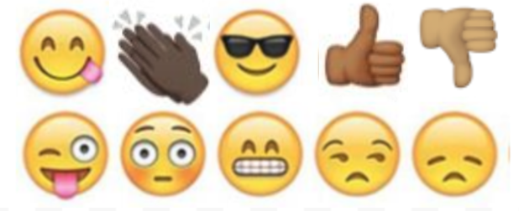  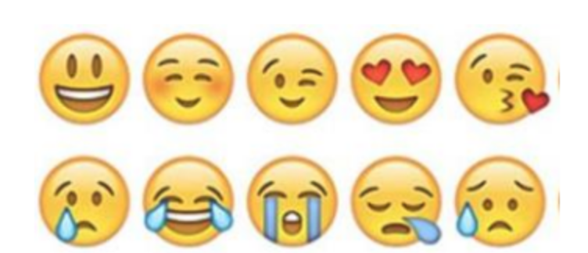

Day 3: Electricity Rights
Science

What is this lesson about?: Today you will read through the Should electricity be established as a basic human right? passage. You will answer a few questions about what you read. You will complete a Structural Change activity.

Step 1: Read through the passage

Should Electricity Be Established as a Basic Human Right?
(electric choice)
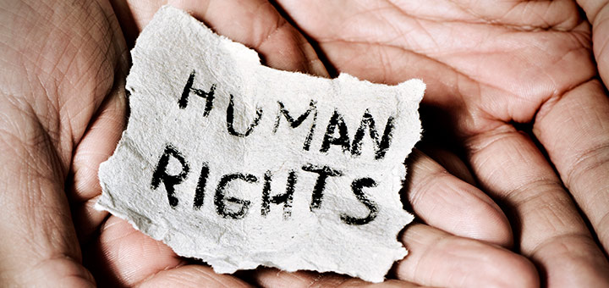
There is no question that electricity has become a completely integrated part of our lives. But does that — and should that — make electricity a basic human right?

The National Association for the Advancement of Colored People (NAACP) recently released a report called Lights Out in the Cold, Reforming Utility Shut-Off Policies as if Human Rights Matter. NAACP believes that electricity and its related services are a basic human right. Through their report, they provide evidence that supports this claim, stating that access to electricity is a critical component to the prosperity, safety and general well-being of every human being.

Utility Disconnection Policies
NAACP believes that utility disconnection policies across the United States significantly contribute to the issues residential customers face when it comes to losing access to power.

The purpose of these disconnection policies is to outline for the consumer the exact steps a utility company will take prior to disconnecting electricity. The major issue claimed here is that these policies become particularly problematic in situations where the consumer can’t afford to pay their bills. In particular, the report states that “The interests of these customers often compete with the interests of utility companies, regulators, and other utility customers.”

Current State Policies
To support the need for re-evaluating current disconnection policies, the report identified many different state policies that prevent electricity and electricity services from being a basic human right.

While there are policies that have been adopted by all states, there are some that have not. For example, before a customer’s electricity is disconnected, the utility company must call or write to inform the customer before the disconnection occurs. That being said, different states have different rules surrounding the actual disconnection process. Some imply that they will not disconnect power during certain times during the week. Others state they will not disconnect before or during a holiday.

When it comes to reconnecting power, there are fifteen states that do not outline any policy regarding reconnection fees. This means that it is up to the utility to decide how much someone has to pay to turn their power back on.

What about disconnection policies around different seasons, like winter or fall? Many states will not disconnect a customer’s power if the temperature drops “below 32°F or above 95°F”, but again, this is not a countrywide standard. There are currently nine states that “Do not provide any state regulated seasonal protections for utility customers. These states include: Alaska, California, Colorado, Connecticut, Florida, North Dakota, Oregon, Tennessee, and Virginia.”

Electricity Assistance and/or Protection
NAACP states that “Eight states do not have regulations establishing standard protections for socially vulnerable groups. Among these states are: Alaska, Arkansas, Colorado, Florida, Kentucky, North Carolina, North Dakota, and Rhode Island.”

Many utilities in many states also charge a fee to reconnect services, but there are many states that offer customers a payment plan to help them pay their bills.
When it comes to medical protection, options are primarily offered to elderly or disabled consumers. In these cases, the utility requires a medical certificate. The medical certificate will help to keep the power on, but only for a defined period of time.

Impacts of Current Policies on Human Rights
According to the report, the impact of current utility disconnection policies has a discriminatory impact on several groups including:
- Low income people
- People of color
- Elderly people
- People with special health needs
- Socially vulnerable customers

“This new report reiterates what low-income communities have known for years — living in poverty is more expensive,” said Cecil Corbin-Mark, deputy director of WE ACT for Environmental Justice, a Harlem-based environmental group. “Poor access to energy efficiency and lower incomes means it is harder to pay your bills.”

Corbin-Mark’s statement helps to highlight several of the NAACP report’s details including the fact that it is more than twice as likely for African Americans to live in poverty compared to non-African Americans. In addition, in general, low income households are required to pay just as much for heat and energy as high income households. However, for low income households, around 13% of their money goes towards energy purchases compared to only the 5% that higher income households spend. As a result, low income African Americans see the greatest impact when utilities or energy companies raise their rates.

Dangers of Disconnected Electricity
The report also notes that this particular group of energy consumers (low income African American households) are the most likely to go without electricity in order to afford other basic necessities. These necessities include health care and food. As a result, “High energy prices can represent a significant health hazard.”

The results of a 2011 survey revealed some insight into low income households. It’s claimed that due to high energy bills:
- Someone within the household was sick because of the cold = 19%
- A person within the household went without food for a minimum of 1 day = 24%
- Someone within the home did not refill a prescription (or take a full dosage) = 34%
- A person within the home did not receive medical or dental care = 24%

Not only do low income households go without other basic necessities to pay their energy bills, they also resort to different methods of obtaining electricity. This is very dangerous to the well-being of every individual living within the household. The NAACP report offers this quote from David Fox of the National Low-Income Energy Consortium (NLIEC), “Regardless of whether it’s shut off or simply that bills are so high that people voluntarily limit usage, several things happen. People use space heaters, kerosene heaters, that increase risk of fire and carbon monoxide poisoning. And people limit use of electricity. They light the home with candles, which are often too close to something combustible.”

The report also states, “According to the National Fire Protection Association, while only 32 percent of home heating fires involve space heaters, heaters are involved in 79 percent of home heating fire deaths.”

Making Electricity a Basic Human Right
To change these policies for the better, NAACP suggests 5 principles that will help utilities to make electricity available to everyone. These policies include,
- INCLUSION: “Ensure INCLUSION of all customers in the development of utility policies and regulations.”
- ACCESS: “Secure ACCESS to utility services for all households.”
- PROTECTION: “Guarantee the PROTECTION of the human and civil rights of all customers.”
- TRANSPARENCY: “Create full TRANSPARENCY of the information and actions of utility companies, regulating bodies, legislatures, and utility affiliated organizations.”
- ELIMINATE POVERTY: “Advance programs that help ELIMINATE POVERTY, so that all customers can pay utility bills.”

NAACP's Vision
The organization firmly believes that if every state implemented policies that prevented instead of implemented disconnections, society as a whole would greatly improve.
These new policies would include:
- If the weather is extremely hot or cold, the power will not shut off.
- Access to programs that help customers pay for their electricity
- Better energy efficient upgrade programs
- Consumers who require life-saving medical technologies gain are protected from losing their power
- Whether or not you believe that electricity should be a basic human right, it is clear that more discussion and attention is required to current utility policies.

The NAACP would like to see a complete overhaul of the way the United States currently offers electricity to consumers. They believe that if every state steps up to take measures to offer their residents better access to affordable electricity, it will, “transform social and structural inequities that render households vulnerable.”

Step 2: Answer the following questions

After reading the article:

- Write down three things that you learned from this article.

________________________________________________________________________________________________________________________________________________________________________________________________________________
____________________________________________________

- Do you believe electricity should be considered a basic human right? Why or why not?

________________________________________________________________________________________________________________________________________________________________________________________________________________

- What recommendations would you make so that everyone has electricity whether they can afford it or not?
________________________________________________________________________________________________________________________________________________________________________________________________________________
____________________________________________________

Step 3: Draw an image/picture

Design a system that would provide electricity for your community and the world. How will you make sure the electricity is available for everyone no matter how much money they make?

________________________________________________________________________________________________________________________________________________________________________________________________________________
________________________________________________________________________________________________________
________________________________________________________________________________________________________________________________________________________________________________________________________________
____________________________________________________

Student Feedback:

Circle the emojis that best represents how this activity made you feel.

Mindfulness Moment!

Equal Breathing
To do it:
- Choose a comfortable seated position.
- Breathe in and out through your nose.
- Count during each inhale and exhale to make sure they are even in duration. Alternatively, choose a word or short phrase to repeat during each inhale and exhale.
- You can add a slight pause or breath retention after each inhale and exhale if you feel comfortable. (Normal breathing involves a natural pause.)
- Continue practicing this breath for at least 5 minutes.

Day 3: Voting Rights-Florida and Beyond
Math

What is this lesson about?: In this lesson we will look at the math of restoring voting rights to individuals once they return from prison. Over the last 25 years, many states have started to enable individuals who are released from prison to vote. In some cases this is immediately, or nearly immediately, upon release. In other cases, individuals remain eligible to vote so long as they are on parole or probation.

Warm Up Problem
Fifty years ago, 58% of college enrollees were men. Today, 56% of all college enrollees are women.

If there were 5,700,000 adults enrolled in college 50 years ago, how many would have been men? How many would have been women?

Today there are approximately 1,400,000 people in college. How many are men? How many are women?

What has taken place over the last 50 years, do you think, that has led to more women than men going to college?

Activity #1: Louisiana

For years, Louisiana has refused to let individuals who have been convicted of felonies to vote once released from prison, even after completing the terms of their parole/probation. This restriction has led thousands unable to vote. Finally, in 2018, Louisiana passed a law that enables individuals who have been released and completed 5 years of parole/probation.

Researchers estimate that there are nearly 37,000 Lousianians who could have had their right to vote restored by this new law.

- In 2016, approximately 1,900,000 individuals voted statewide in Louisiana. Approximately what percentage of 1,900,000 is 37,000?

By January 2020, VOTE (voice of the experienced), estimated that out of the 37,000 people, only 12,000 had registered.

- What percentage of eligible new voters registered during this time?

Based on a survey of those who have NOT registered, the three main reasons the 25,000 individuals gave for not registering are summarized in the chart below.
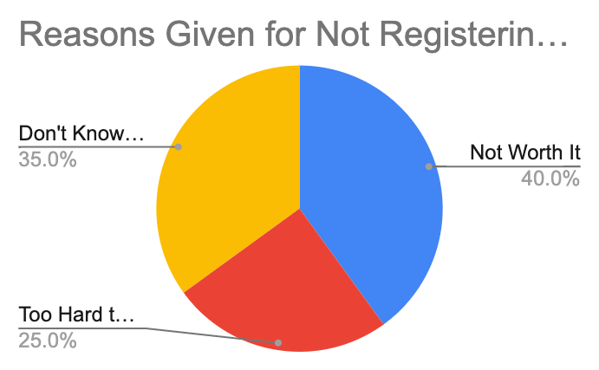
Of the 25,000 individual who didn’t register, how many indicated they didn’t because-
- It’s Not Worth it? _________
- It’s Too Hard to Register? __________
- They don’t know how to get the ‘cleared letter’ from their Parole Officer? _______

If Louisiana got rid of the requirement to get a ‘cleared letter’ and the requirement that they go register in person, approximately how many of the 37,000 individuals would be registered?

Discuss/Consider: Why didn’t Louisiana do that?

Step 2: Nevada

In 2018, Nevado also amended its laws related to allowing former prisoners to vote. BBefore 2018, Nevada had restored voting rights, but not until after an individual was no longer on parole and probation. Further, with specific crimes, there was even a waiting period after that, and in some other circumstances, a former inmate would have to petition a court to get his or her voting rights restored.

Those restrictions limited the percentage of eligible voters who went on to register and vote.
But in 2018, with the passage of its latest law, restoration of voting rights is automatic once an individual leaves prison, making Nevada one of 16 states and the District of Columbia that does that. With the passage of this law, 77,000 formerly incarcerated individuals in Nevada will automatically be registered to vote!
In Nevada, based on estimates in late 2019, there were a total of 1,827,386 registered voters. What percentage, approximately is 77,000 of 1,827,386. If you are not using a calculator round off 77,000 to 80,000 and round off 1,827,386 to 1,800,000.

Office of Nevada Secretary of State Barbara K. Cegavske Voter Registration Statistics
January 2020
Total Voters by County and Party
County | Democrat | Republican | Total
Carson City | 10,813 | 15,674 | 36,370
Churchill | 2,717 | 8,667 | 15,196
Clark | 539,363 | 363,596 | 1,294,147
Douglas | 9,179 | 21,449 | 40,587
Elko | 4,579 | 15,244 | 27,992
Esmeralda | 101 | 322 | 569
Eureka | 93 | 756 | 1,076
Humboldt | 1,742 | 5,134 | 9,596
Lander | 520 | 1,824 | 3,096
Lincoln | 579 | 1,785 | 2,968
Lyon | 8,368 | 19,645 | 39,349
Mineral | 899 | 1,263 | 2,898
Nye | 8,166 | 15,815 | 33,289
Pershing | 579 | 1,542 | 2,887
Storey | 779 | 1,720 | 3,439
Washoe | 108,363 | 110,026 | 308,573
White Pine | 1,204 | 2,736 | 5,354
Statewide | 698,044 | 587,198 | 1,827,386

The chart above lists the state counties and the number of registered voters in each county. Based on this chart, what 2 counties have a larger number of registered voters than the number of now eligible, former inmates?
What would happen if all of the returning citizens registered as Republican in Nevada? How close would the number of Democrats and Republicans be in the state?
Discuss: What would have led the residents of Nevada to vote for a law that would automatically restore voting rights to former inmates immediately (instead of imposing some wait time).
Separately, notice on the chart that more than 1.2 million voters live in Clark County. That is where the city of Las Vegas is. The number of people who voted in the whole state is just over 1.8 million.
- Approximately what percentage of the state’s population lives in Clark County?
- What does that do to voting power in the state?
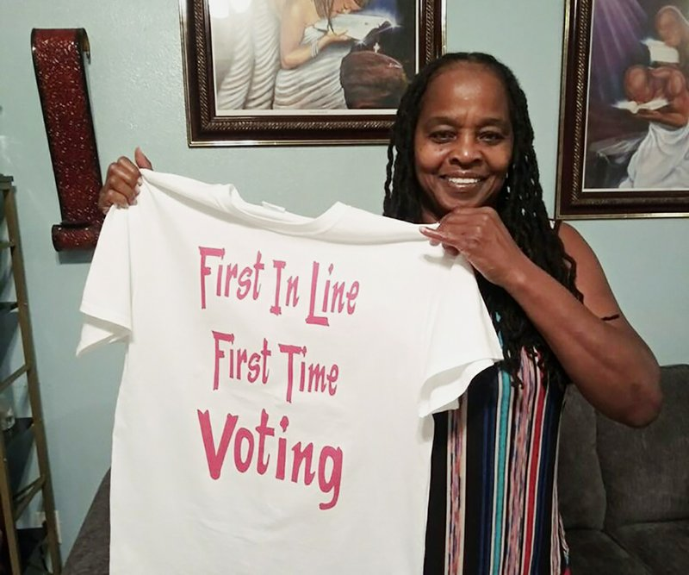
Activity #4: Florida

In Florida, they passed a law in 2018 that “restores voting rights to felons after they complete all terms of their sentence, including parole and probation.” Even with the constraints of having to finish their parole and probation obligations, it was estimated that this law would restore voting rights to nearly 1.1 million people in Florida.

Later, the Florida Supreme Court ruled that the words “all terms of their sentence” would mean that nearly 775,000 of them would not be able to vote because of fines and penalties they owed related to court and other fees. There are estimates that 60% or more of the 775,000 owe more than $1,000 in fines related to their cases.

The Florida court’s ruling was temporarily halted, with a Federal Court ruling that the fines were similar to a poll tax and were discriminatory and ran afoul of the US Constitution.

This case is now (April 2020) being reheard in Federal Courts, with the right to vote of nearly 775,000 people at stake.

The chart below shows you the number of registered voters in Florida in early 2020.
 | Republican | Democratic | Minor Party | No Party | Total
TOTALS | 4,832,285 | 5,115,768 | 152,175 | 3,630,535 | 13,730,763
About what percentage of total registered voters would 1,100,000 be (round off)?

Researchers estimate that approximately 70% of former inmates would register Democrat and 30% would register Republican. If this were true, how many of the 1,100 would register Democrat? How many would register Republican?

Would this make the overall number of Republicans and Democrats closer together or further apart?

Discuss/consider: Should released individuals have to pay off fines related to their crime before gaining the right to vote? Would it matter to you if the fines were big or small?

Student Feedback:
Circle the emojis that best represents how this activity made you feel.

Day 3: Internet Access Rights
Digital Health

What is this lesson about?: Today you learn about your right to internet access. How accessible is the Internet in the United States? And does our access differ from other countries?

Step 1: Warm-up- Answer the questions below.

What percentage of people do you think to have internet access?
___________

Do you think that Internet access should be free? Why or Why not?

Step 2: Read the article on your digital rights.

Frank Camallerys walks up and down the Malecon, a wide street along the seashore in Havana, Cuba. He has a telephone at the end of a pole, which records what he is looking at. His videos attract thousands of views on the Internet, giving them a glimpse of life in Cuba.
The island in the Caribbean Sea has little Internet access, and until recently, it was cut off to visitors from the United States.

Camallerys is a 19-year-old communications student. Like most Cubans, he has no Internet at home, but that has not prevented him from gaining a following on YouTube. When he wants to post a video, he has to trek across the city to a plaza where wireless Internet is available for a dollar an hour. On his latest trip, it took more than half an hour to upload his video.

Unlikely Internet Celebrities
His videos on YouTube usually begin with his cheerful greeting: "Hello everyone, this is a new adventure in Cuba." He is among about 50 young Cubans who have become Internet celebrities.
His channel on YouTube, called Camallerys Vlogs, launched a year ago and now has more than 7,000 followers.

"Create a video, walk 2 or 3 kilometers (up to 2 miles) to put it online, then wait 40 minutes while it uploads: that shows very well how much I like this," Camallerys says.

Other Cubans who want to access the Internet face similar obstacles, in contrast to much of the rest of the world. Most places now have widespread Internet service, which makes accessing sites such as YouTube and Facebook easy through mobile phones or wireless Internet, also called Wi-Fi, at home.

USB Entrepreneurs
Cuba is ruled by the Cuban Communist Party and has been for more than 50 years. Communism, one way of thinking about a government's role in the economy, is a system where the government controls almost everything.
There is a lack of widespread Internet access in Cuba.
Cubans have found creative ways to get access to the online world. Many use what they call the "package," which is a USB storage device that lets them save content from the Internet and then pass it to others by hand.
The distributors of the "package" get the content from a regular Internet connection. Then, they sell the content, which can include everything from bestselling novels to the latest international soccer match, for about a dollar.
A dollar a day is roughly the average income for a government worker but those in private businesses can make more than that. The package menu is updated weekly.

Successful Marketing Within Limits
Another YouTuber, Emma Lopez, 18, says that the "package" has helped her get her videos seen by fellow Cubans.
"The first time, my video was viewed by three people, until the 'package' began circulating and it helped me progress so that I eventually went countrywide," she says.
Her channel, Emma Style, gives makeup tips to young Cubans. Her advice is adapted to life in Cuba, where some makeup products cannot be purchased.
Part of the reason for that has to do with the relationship between Cuba and the United States. Due to longstanding disagreements, the United States does not allow most of its companies to sell products to Cuba, so most of what can be bought in Cuba has to be made on the island.
"If you don't have a brush, use your fingers" to apply eyeshadow, Lopez advises in her show.

Government Has One Eye On The "Package"
These mini-stars of the Internet find audiences well beyond their home country.
"Normally when a YouTuber starts out, he hopes to have support of the population. But among my followers, a small percentage live in Cuba," says Pedro Veitia, 24, of the Pedrito el Paketero channel.
"There are perhaps 50 of us in Havana," he says of the small Cuban YouTube community.
According to the Cuban government, 4.5 million people on the island have Internet access. Unofficial estimates show the "package" has 9 million users, out of a total Cuban population of 11 million, says Max Barbosa, a professor of communications at the University of Havana.
The Cuban government controls people's access to Internet content but it continues to allow the "package" to be widely sold. The government has even tried to compete with it by launching a similar device called the "backpack."
"Even if they don't have Internet to be connected all the time or to generate content, merely saying 'I want to be a YouTuber,' even by alternative means like the USB, is praiseworthy," Barbosa says.

Not Just Cuban YouTubers
Their challenge now "is to start to create experiences more linked to the Cuban reality, to strike up a direct dialogue with the Cuban followers," he adds.
For Lopez, that is a goal worth pursuing.
"We don't seek to be known as Cuban YouTubers just because it's complicated for us or because we live in a communist island. We want to be recognized for our content," she says.

Step 3: Answer the following questions about

- Why do you think these Cuban Youtube stars go to great lengths to upload their video content?

- Do you think Cuba should make Internet access more accessible? Why or Why not?

- How long do you think it will take for Cubans to have regular internet access?

Step 4: Use the graph below to answer your question.
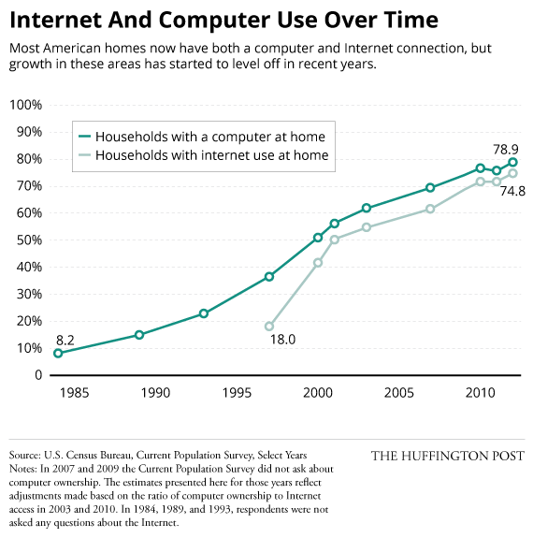

How accurate was your prediction at the beginning of this lesson?

Why do you think not all people in America have Internet access?

Mindfulness Moment!

Zentangles: Easy Patterns for Drawing Meditation
Draw one below:

Day 3: Creating Additional Rights - Amending the Constitution
Social Studies

What is this lesson about?: So far you have learned about the Bill of Rights, which refers to the first 10 amendments added to the U.S. Constitution in 1791. But those are not the only amendments that have been added to the constitution. More amendments can still be added to the constitution as time goes on! Today you will explore how amendments are added to the U.S. Constitution. Do you think it's an easy process? Let’s find out!

Step 1: Introduction

How and why did the Framers devise an amendment process?
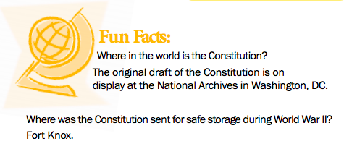
The Framers intended the Constitution to be, and to remain, a fundamental framework of law. They didn't want the Constitution to become confused with ordinary laws and regulations or to be changed in response to short-lived, impulsive ideas. However, they also recognized that American society and conditions would change over time in ways they could not predict in 1787. The Constitution that they proposed, George Mason argued, would “certainly be defective,” just as the Articles of Confederation had proved to be. Mason said, “Amendments therefore will be necessary, and it will be better to provide for them, in an easy, regular, and Constitutional way than to trust to chance and violence.”

The Framers made the Constitution difficult to amend but not too difficult. Article V of the Constitution describes how amendments may be proposed. Amendments may be proposed by both houses of Congress or by a petition of the states calling for a special convention. You’ll read more on this below.

Americans have not been reluctant to suggest changes. Since 1789 more than ten thousand proposed amendments have been introduced in Congress. Only thirty-three amendments have gained enough votes to be submitted to the states for ratification (approval). Of those thirty-three, twenty-seven have been ratified. The other process for proposing amendments—by state legislatures calling a convention—has never been used.

Some critics of the amending process argue that amendments, once proposed, should be put before
a national popular referendum (a vote where if a majority of voters agree on something it will go into effect). They point out that forty-nine of the fifty states now submit state constitutional amendments to popular vote. Delaware is the only exception.

Step 2: Answer questions

Do you think the amendment process should allow for a national popular vote? Why or why not?

Step 3: Read how to amend the constitution

Changing the Constitution
Adapted from: http://www.trumanlibrary.org/whistlestop/teacher_lessons/3branches/15b.htm

In the early 1800s, Chief Justice of the Supreme Court, John Marshall wrote that the United States Constitution was written “to endure for ages to come”. To ensure it would last, the framers made it possible to amend the document in the future. Not all proposed amendments are successful because the process is very difficult.
Article V (five) of the U.S. Constitution outlines two ways to propose amendments, or changes, to the U.S. Constitution and two ways to ratify a proposed amendment by the states. To ratify means to officially accept or approve.
To propose amendments to the U.S. Constitution:
1. Congressional method: two-thirds (2/3) of each house of Congress has to vote in favor of a proposed amendment. This means that 290 of the 435 members of the House of Representatives and 66 of the 100 members of the U.S. Senate have to vote for the proposed amendment.
OR
2. Convention method: two-thirds (2/3) of the states call for a constitutional convention and vote in favor of the proposed amendment. This method has not yet been used successfully.

To ratify amendments to the U.S. Constitution:
1. Three-fourths (3/4) of the state legislatures approve the amendment.
OR
2. State ratifying conventions are held and three-fourths (3/4) of the state conventions approve the amendment. This method was used only once to ratify the 21st Amendment.

Challenges to the amendment process

Between 1789 and 2014, over 11,000 amendments have been proposed; however, only 27 amendments have been ratified. Why is it so hard for proposed amendments to receive support for final ratification? A few roadblocks are standing in the way.

First, every amendment must receive support from three-fourths of state conventions or state legislatures. It’s incredibly difficult to get that many states to agree on a permanent change to the Constitution.

Take, for example, the Equal Rights Amendment, or ERA. The ERA was introduced in 1923. It finally passed Congress in 1972 and was sent to the states for ratification. The ERA was designed to guarantee equal rights for all citizens regardless of sex. It fell three states short of ratification and so was not added to the Constitution.

Second, for an amendment to be passed through the congressional proposal method, two-thirds of Congress must propose the amendment. To introduce a new amendment the two parties must cooperate, as no one party has controlled two-thirds of both the House of Representatives and the Senate. With each party supporting different ideological goals, getting two-thirds of Congress to agree on a change to the Constitution is nearly impossible without some level of cooperation.
The process is so difficult that it could take years before the US Constitution has its 28th amendment. Some amendments continue to pop up in Congress, including an amendment requiring Congress to pass a balanced budget, an amendment setting term limits for members of Congress, and amendments defining who can get married.
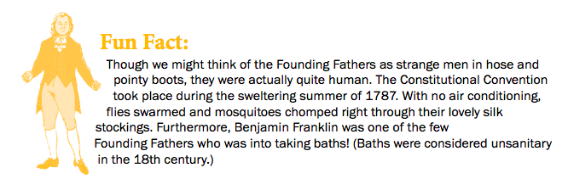

Step 4: Complete the graphic organizer

Use the information you read above about the process for amending the constitution to fill in the graphic organizer below.

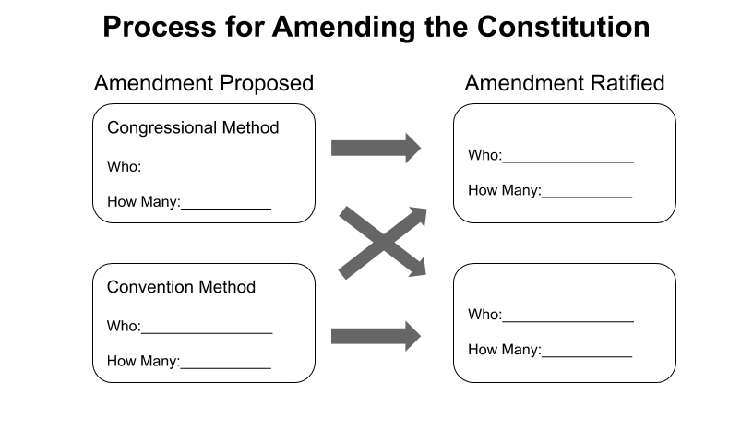
Step 5: Answer questions

Why do you think Chief Justice John Marshall said that the United States Constitution was “written to endure for ages to come”?

Explain why changing the Constitution is so difficult?

Why do you think the framers wanted to make the Constitution difficult to change?

Step 6: Consider the political cartoon
What is the cartoonist saying about the amendment process?

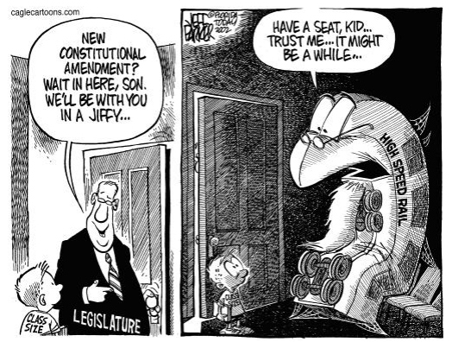

Student Feedback:

Circle the emojis that best represents how this activity made you feel.

