Week 2
Identity

Day 1

NAME:______________________

Day 1 Agenda

Topic | Activity
Warm-Up!
English Language Arts | - Read an excerpt “My Name” from The House on Mango Street by Sandra Cisneros.  - Read an article about Hasan Minhaj teaching Ellen Degeneres the correct pronunciation of his name.  - Respond to questions about the story and the article.
Science | - Read about DNA and Genes  - Answer questions about what you read  - Complete the activity
Mindfulness Moment!
Math | - Real World Math: Identity and the clothes you wear: The Cost of Brand Name Clothes and Shoes  - Practice Problems: Organizing Data in Tables
Health | - Digital Identity
Mindfulness Moment!
Civics/Social Studies | - Read articles and answer questions on identity and diversity
PE | - Bingo!

Warm-up Activity: Write a journal entry around the daily quote on identity.
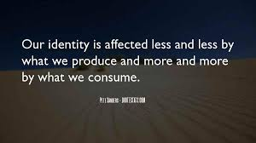

Day 1:The Importance of a Name
English Language Arts

What is this lesson about?: Over the next week, you will be reading and reflecting on the idea of Identity. Today, you will have the opportunity to read about the importance of names and reflect on your own name and how it contributes to who you are.

Step 1: Before reading

Do a 5 minute quick-write where you just write your ideas, don’t worry about your spelling or grammar, just focus on what you feel and want to say.

Write your full name on the line below:

Write for 5 minutes: Do you like your name? Why or why not? If you could change your name, would you? What would you change it to? Explain your choice of name if you would change it.

When you are finished. Share your response with a partner.

Did you and your partner have similar or different opinions?

Step 2: Read the Text

The excerpt you are going to read comes from a book by author Sandra Cisneros called The House on Mango Street which is a collection of memories and short stories about growing up in Chicago. As you read, think about how the author uses imagery (descriptive words that create pictures or images in your mind) to make her reader understand how she feels about her name. Underline or circle words or phrases that create images in your head about how the author feels about her name.

My Name
By Sandra Cisneros

      - In English my name means hope. In Spanish it means too many letters. It means sadness, it means waiting. It is like the number nine. A muddy color. It is the Mexican records my father plays on Sunday mornings when he is shaving, songs like sobbing.

      - It was my great-grandmother’s name and now it is mine. She was a horse woman too, born like me in the Chinese year of the horse—which is supposed to be bad luck of you’re born female—but I think this is a Chinese lie because the Chinese, like the Mexicans, don’t like their women strong.

      - My great-grandmother. I would’ve liked to have known her, a wild horse of a woman, so wild she wouldn’t marry until my great-grandfather threw a sack over her head and carried her off. Just like that, as if she were a fancy chandelier. That’s the way he did it.

      - And the story goes she never forgave him. She looked out the window all her life, the way so many women sit their sadness on an elbow. I wonder if she made the best with what she got or was she sorry because she couldn’t be all the things she wanted to be. Esperanza. I have inherited her name, but I don’t want to inherit her place by the window.

- At school they say my name funny as if the syllables were made out of tin and hurt the roof of your mouth. But in Spanish my name is made out of a softer something, like silver, not quite as thick as sister’s name Magdalena which is uglier than mine. Magdalena who at least can come home and become Nenny. But I am always Esperanza.

- I would like to baptize myself under a new name, a name more like the real me, the one nobody sees. Esperanza as Lisandra or Maritza or Zeze the X. Yes. Something like Zeze the X will do.

Taken from: Cisneros, Sandra. The House on Mango Street. Thorndike Press, a Part of Gale, a Cengage Company, 2019.

Step 2: Answer the following questions.

Look at paragraph 1: how does the narrator describe her name? What are some words that give you a sense of “tone” or the attitude that the author has towards her name?

2. In paragraph 4, the narrator uses the phrase “the way so many women sit their sadness on their elbow”. Act that out, what would that look like? Why do you think the narrator uses this image?

3. The narrator seems to admire her grandmother but she also does not want to be like her. Explain why she feels the same way.

4. The narrator wishes she had a name like Lisandra or Zeze the X. Why does she think these names would be more like the “real” her? What does she reveal about her herself by picking these names over Esperanza?

Step 3: Read the following article.
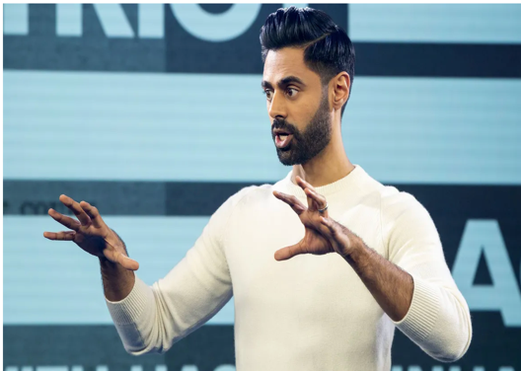
Hasan Minhaj is the first Indian American host of a weekly satirical news show on Netflix called “Patriot Act”. The show covers issues from elections to the changing styles of hip-hop. The following article describes his first appearance on The Ellen Show where he was being introduced to a wide audience of Americans. Video of his conversation with Ellen DeGeneres went viral. As you read, think about his reasons for correcting DeGeneres and what he sees as the importance of the correct pronunciation of his name.

Comedian Hasan Minhaj Explains Why He Corrected Ellen DeGeneres' Pronunciation of His Name
The Netflix star went viral in April after correcting the host during an appearance on the Ellen DeGeneres Show
By Aurelie Corinthios

In his own words, Hasan Minhaj is “trying to live.”
The comedian went viral in April during an appearance on the Ellen DeGeneres Show when he corrected host Ellen DeGeneres‘ pronunciation of his name during an interview. It’s HA-sun MIN-haj, not Ha-SAHN Mi-NAHJ, and the clip sparked a larger conversation about the double standard that exists when it comes to making an effort to correctly pronounce names of people of color vs. names of white people in Hollywood.
During a recent “Deep Cuts” episode of his Netflix show, Patriot Act with Hasan Minhaj, Minhaj, 34, reflected on the moment as he revealed the variations on his name he’s used while performing.
“I remember when I first started comedy, at the first open mics, there was this host,” he recalled. “You’d write your name down and he’d be like, ‘Look, man, nobody’s going to be able to pronounce this. You’ve got to change your name.'”
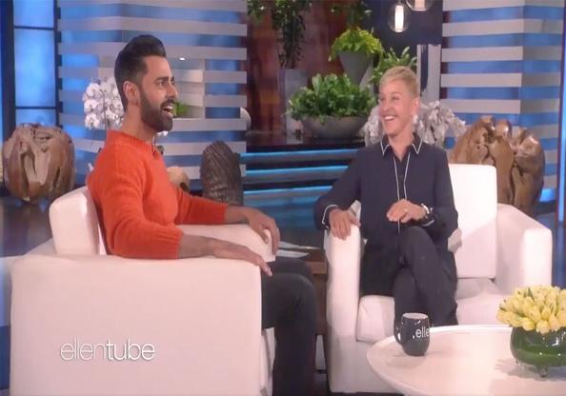
“So for like, two months I’d go to open mics and I was Sean,” he continued. “I kept trying to negotiate. I was like, ‘All right, Hasan — people can pronounce Hasan.’ And it just got weirder and weirder … but I’d always have that open mic host in my head: ‘You’ve got to do it to make it.'”
Minhaj explained that his parents, who are immigrants from India, drove down from their home in Sacramento, California, to attend his Ellen taping in Los Angeles. And so when DeGeneres incorrectly pronounced his name in front of the audience, emphasizing the second syllable of his first name instead of the first, he decided he had to say something.
“I looked in the audience … and [my mom] kind of cringed,” he said. “And I was like, ‘Dude, what am I doing?’ I have a show with my f—ing name on it and I’m still being like, ‘It’s with Sean!'”
“So I was like, ‘All right, Ellen, let’s just do this right now.’ Because we can pronounce Timothée Chalamet, so we’re going to do this right now,” he continued. “I just had her do it and I didn’t know it would be this viral moment or whatever.”
Interestingly, Minhaj said his dad was “super pissed” at him afterwards.
“He was like, ‘Hasan, you wasted your chance! You had seven minutes with her and for four minutes you’re correcting her, why are you doing this?'” he recalled. “And I think that’s the big difference between our generation and our parents’ generation. They’re always trying to survive.”
“Survival is the thing, so just go by whatever she calls you,” he continued. “And that’s cool, when Dad came in ’82, he survived for us. But I’m trying to live.”
“So I’m going to go on Ellen, the most American show ever, and make you hit all the syllables,” he added.
Minhaj rose to prominence as The Daily Show‘s senior correspondent from 2014 to 2018.
The comedian, who has won two Peabody Awards and two Webby Awards, also hosted the White House correspondents’ dinner in 2017.

Step 4: Answer the following questions

      - Why did Hasan Minhaj use an Americanized name when he first started doing comedy?

      - To cringe means that you physically shrink or flinch in distaste or discomfort. What effect did his mother “cringing” when Ellen DeGeneres mispronounced his name have on Hasan? Why do you think he felt this way?

      - Why was Hasan’s father so angry at him? Why do you think his father saw what he did as the wasting of an opportunity?

      - Hasan Minhaj says that his father has always tried to “survive” but that he wants to “live”. What do you think he is trying to say? What is the difference between surviving and living?

Step 5: Share your responses with a partner
With a classmate, discuss your answer to the following question.
            - What is the difference between how the narrator in My Name feels about her name and how Hasan Minhaj feels about his?

Step 6: Think and write.

Go back and look at your quick write. Then think about the two readings. Esperanza wants to change her name so that it can reflect more of who she is even though the name already has meaning in her family. Hasan Minhaj wants to make sure that people pronounce his name correctly because it reflects his culture and his identity. Reflect on what you have read and what you initially wrote about your name at the beginning of the lesson.
Write for 5 minutes: What does your name say about you? Is it important for people to remember your name and pronounce it correctly? Why or why not?

Student Feedback:

Circle the emojis that best represents how this activity made you feel. | 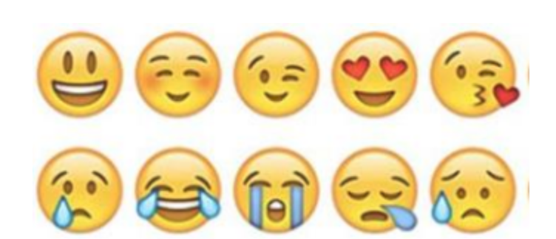  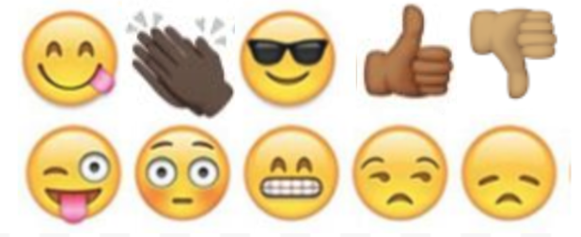

Day 1: Science
DNA and Genes

What is this lesson about?: Today you will read through the DNA and Genes passage. You will answer a few questions about what you read. You will complete a DNA activity.

Step 1: Read through the DNA and Genes passage

DNA and Genes
(Technological Solutions, 2020)

DNA is an essential molecule for life. It acts like a recipe holding the instructions telling our bodies how to develop and function.

What does DNA stand for?
DNA is short for deoxyribonucleic acid.

What is DNA made of?
DNA is a long thin molecule made up of something called nucleotides. There are four different types of nucleotides: adenine, thymine, cytosine, and guanine. They are usually represented by their first letter:
- A- adenine
- T- thymine
- C - cytosine
- G - guanine
Holding the nucleotides together is a backbone made of phosphate and deoxyribose. The nucleotides are sometimes referred to as "bases".
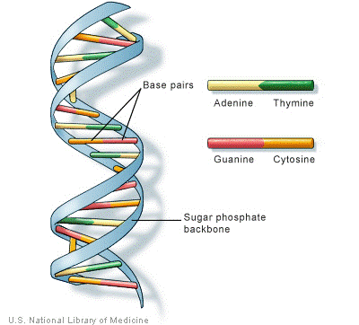
The basic structure of the DNA molecule

Different Cells in the Body
Our bodies have around 210 different types of cells. Each cell does a different job to help our body to function. There are blood cells, bone cells, and cells that make our muscles.

How do cells know what to do?
Cells get their instructions on what to do from DNA. DNA acts sort of like a computer program. The cell is the computer or the hardware and the DNA is the program or code.

The DNA Code
The DNA code is held by the different letters of the nucleotides. As the cell "reads" the instructions on the DNA the different letters represent instructions. Every three letters makes up a word called a codon. A string of codons may look like this:

ATC TGA GGA AAT GAC CAG

Even though there are only four different letters, DNA molecules are thousands of letters long. This allows for billions and billions of different combinations.

Genes
Within each string of DNA are sets of instructions called genes. A gene tells a cell how to make a specific protein. Proteins are used by the cell to perform certain functions, to grow, and to survive.

What are genes?
Genes are the basic units of heredity. They consist of DNA and are part of a larger structure called the chromosome. Genes carry information that determine what characteristics are inherited from an organism's parents. They determine traits such as the color of your hair, how tall you are, and the color of your eyes.

Shape of the DNA Molecule
Although DNA looks like very thin long strings under a microscope, it turns out that DNA has a specific shape. This shape is called a double helix. On the outside of the double helix is the backbone which holds the DNA together. There are two sets of backbones that twist together. Between the backbones are the nucleotides represented by the letters A, T, C, and G. A different nucleotide connects to each backbone and then connects to another nucleotide in the center.

Only certain sets of nucleotides can fit together. You can think of them like puzzle pieces: A only connects with T and G only connects with C.

Interesting Facts about DNA and Genes
- About 99.9 percent of the DNA of every person on the planet is exactly the same. It's that 0.1 percent that is different that makes us all unique.
- The double helix structure of DNA was discovered by Dr. James Watson and Francis Crick in 1953.
- If you unraveled all the DNA molecules in your body and placed them end to end, it would stretch to the Sun and back several times.
- DNA is organized into structures called chromosomes within the cell.
- DNA was first isolated and identified by Swiss biologist Friedrich Meischer in 1869.
- We get 23 chromosomes from our mother and 23 from our father.
- Some diseases are inherited through genes.
- Doctors may be able to cure diseases in the future by replacing bad DNA with good DNA using a process called gene therapy.
- Some inherited traits are determined by multiple different genes.

Step 2: Answer the following questions

- What does DNA stand for?
  - Double nitrogen argon
  - Dioxide nickel acid
  - Deoxyribonucleic acid

- How many types of nucleotides are there in DNA?
  - Three
  - Four
  - Five

- Which of the following is not a letter that represents a nucleotide in DNA?
  - C
  - G
  - R

- Three letters in DNA make up a word called a _________.
  - Codon
  - Chromosome
  - Gene

- What is the shape of a DNA molecule called?
  - Octahedral
  - Covalent
  - Double Helix

- Most genes within DNA hold instructions for the cell to make a specific ______.
  - Chromosome
  - Protein
  - Carbohydrate

- Over 99% of DNA in different human beings is the same.
  - TRUE
  - FALSE

Step 3: Complete the activity

Design your own DNA molecule. You can refer to the sample model that was provided in the text. Remember, A only connects with T and G only connects with C.

Student Feedback:

Circle the emojis that best represents how this activity made you feel. | 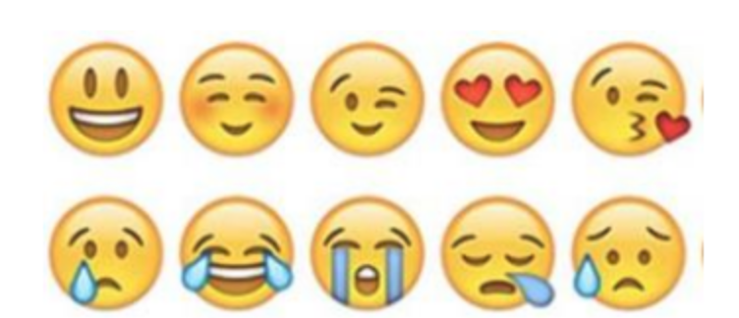  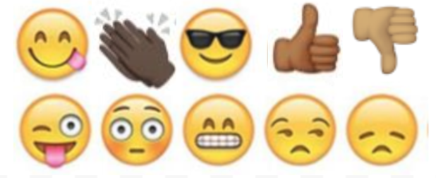

Mindfulness Moment!
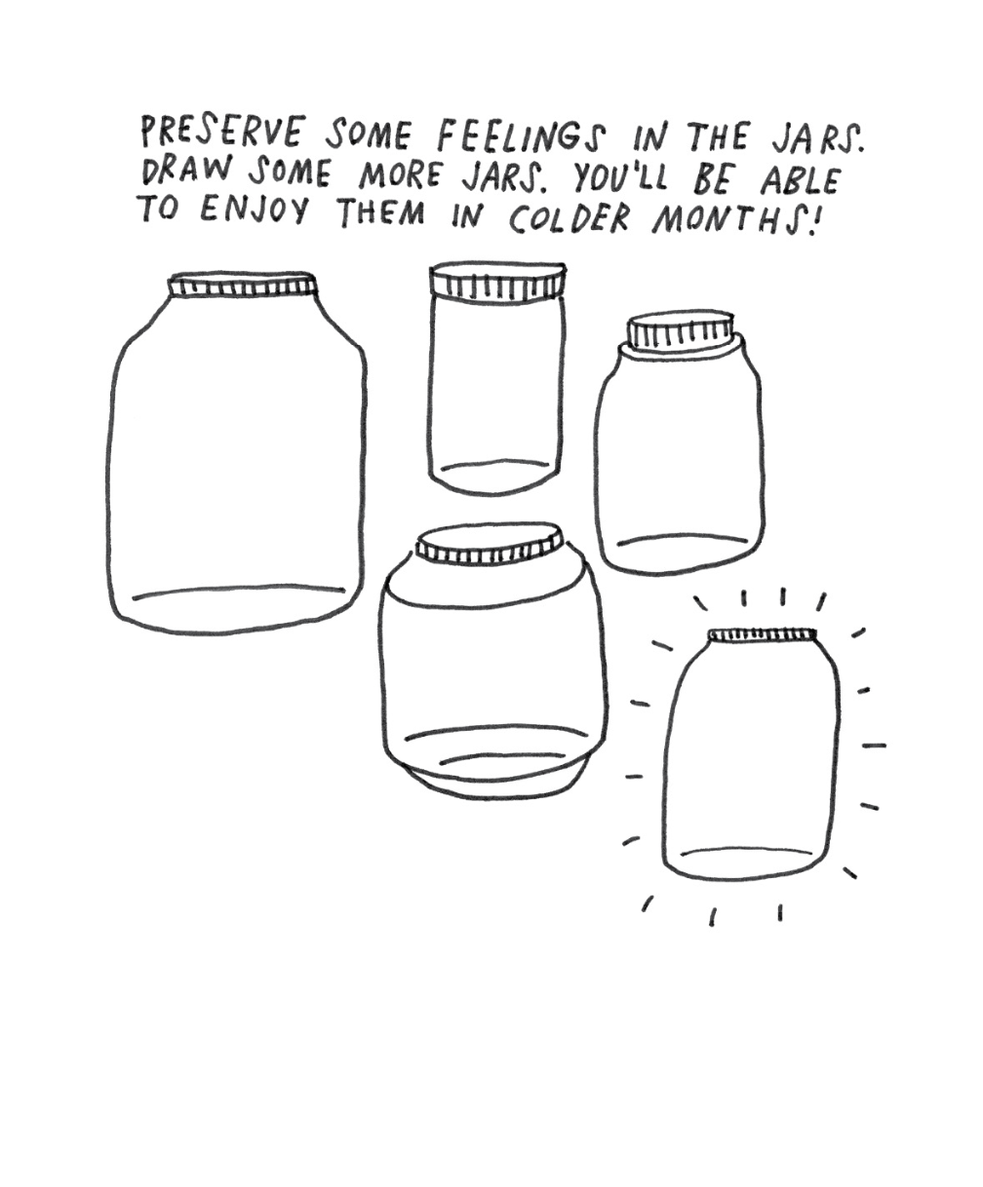

Day 1: Identity/Brand Name Clothes, Shoes, etc.
Math

What is this lesson about?:
Today we are going to take a look at the clothes and shoes we wear, and spend some time thinking about how the prices for these items are set. At the end of the activity, we will pose the questions: how much of your identity is tied up in the brands you wear? And is that worth it?

But first: Today’s Warm-Up
Because of the current situation with COVID-19, people are driving less, and most airline travel has stopped.
- What do you think has happened to the prices of a gallon of gas? Are gasoline prices going up or down?

- What is one good side of lower gas prices?

- What is one bad side of lower gas prices?

Step 1/Activity 1: What goes into that Nike Brand, NBA hoodie?
The chart below shows the cost of making Nike/NBA sweatshirts, as well as the amount that Nike charges when they sell them, to retailers, or directly to you, the consumer.

Costs for Nike/NBA 2019-20 Labron Hoodies
# of Hoodies | 1
Cotton and other material |  | 2.00
Labor |  | 1.00
Shipping (from China to US) |  | 5.00
Marketing/Advertising |  | 6.00
Other fixed costs |  | 3.50
Total Cost to Nike |  | 17.50
Revenu to Nike
Option 1: Nike sells hoodie to Modells, or Foot Locker
- Price to Retailer |  | 20.00
Profit before taxes if Nike sells to first line retailers
Option 2: Nike sells on line from its own website |  | 22.00
Profit before taxes if Nike sells online from it's site

Step 2/Activity 2: Understanding the charts

How much does it cost Nike to make 1 sweatshirt?

How much would it cost Nike to make 1,000 sweatshirts?

Assume that a person working in the Nike Factory can sew 3 sweatshirts in 1 hour, how much money does that person make per hour?

What is the most expensive cost to Nike for each sweatshirt?

Explain in your words where all that advertising and marketing money goes?

How much money (before taxes) does Nike make on each sweatshirt it sells to a retail store like Foot Locker? (first grey box in the above chart)

How much money (before taxes) does Nike make on each sweatshirt it sells directly to a person from its website? (second grey box in the above chart)

Explain: Why does Nike sell its clothes through retail stores at all if it makes more money selling them online from it’s own site?

Step 3/Activity 3: Ok, let’s take a look at Foot Locker and see how a local Foot Locker Store makes money.

Assume that Foot Locker sells the sweatshirt for $30. How much money does it make on one sweatshirt? How about if it sold 1,000 sweatshirts?

Write down some of the costs that Foot Locker has each month other than the cost of buying all of its shoes and clothes.

Do you think the owners of Foot Locker get to keep all of the money they make off of each sale? Yes/No?

Let’s take a closer look:
Footlocker Costs of Selling Hoodies
Fixed Costs Monthly
Rent |  | 3,500
Labor (everyone who works in the store) |  | 24,000
Insurance |  | 3,500
Monthly costs (utilities, technology, ) |  | 1,500
Advertising |  | 2,000
Total Fixed Monthly Costs |  | 34,500
# of Hoodies purchased from Nike | 5,000
Price per Hoodie (Nike) | 20
Cost of purchasing from Nike |  | 100,000
TOTAL MONTHLY COSTS |  | 134,500
Sales
# of Hoodies Sold | 5000
Retail Price | 30
TOTAL SALES FOR THE MONTH |  | 150,000
How much profit did the store owner make? |  | 15,500

Just to keep it straightforward, looking at the chart above, if the Foot Locker buys 5,000 sweatshirts from Nike and sells all of them @ $30 each, how much profit or loss (before taxes) does Foot Locker earn in 1 month?

How about if it (buys and) sells 6,000 sweatshirts @ $30 each and didn’t have to bring on any additional staff or other costs?

Fill in the grey boxes below.

What happens if Foot Locker buys 5,000 sweatshirts but at the end of the season has only sold 3,000 of them (say LaBron gets hurt and no one wants his sweatshirt now)? (fill in the grey boxes)

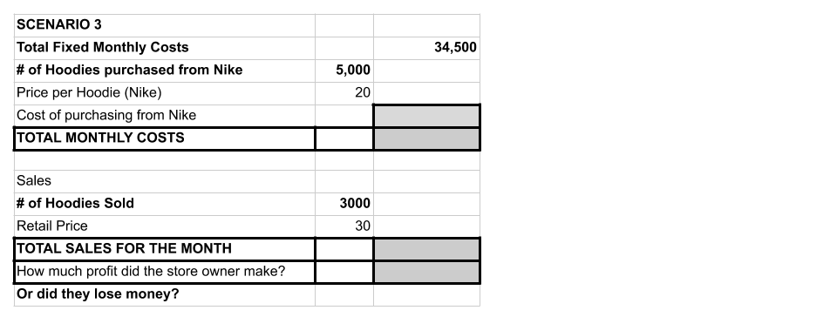

Step 4/Activity 4: Ok, bringing this home to you!
Compare the two charts below, one for the Nike/NBA sweatshirt, the other for a ‘generic’ sweatshirt, sold under the Target Label.

Assume that these two sweatshirts are made in the same factory, with the same materials and by the same workers.

What are the two main differences in costs between making a Nike/NBA hoodie compared to a Target Brand hoodie?

So, looking at the chart below, how much are you ‘paying’ for the Nike/NBA label on each hoodie that you wear?

Consumer Prices
Nike Labron @ Foot Locker |  | 30.00
Nike LaBron @ Nike Shop Online |  | 32.00
Target Brand @ Target |  | 18.00

Is that $ worth it to you? What about over 5-10 years, and all the clothes you are buying ‘for’ the label. Is that worth it? Use this chart to do a rough calculation of how much $ you're spending to support the marketing budget of Nike.

Number of Nike Products Bought Each Year | 10
Amount you ‘overpay; for Nike Brand | $12
Amount overpaid each year
Amount overpaid after 10 years...

Step 5: Sales, Sales….

You are the owner of a Foot Locker. You have lots of the hoodies on your racks and it is nearly summer. You have two choices. Which one would you select?

- Sell 500 of them to Marshalls for $12 each. Marshalls pays cash on the spot.
  - If you do this, how much money will you take in?

  - How much did you spend on those 500 hoodies when you bought them from Nike?

- Keep them on your shelves for 3 more months, taking up space, hoping to sell them $15?

- Discuss: Which one would you do? Explain your answer?

Skill Builders and Review Problems
- Organizing Data in Tables

Student Feedback:

Circle the emojis that best represents how this activity made you feel.

Day 1: Digital Identity
Health

Step 1: Warm-up
How can information you post online affect your future opportunities?

Step 2: What’s this Lesson About?
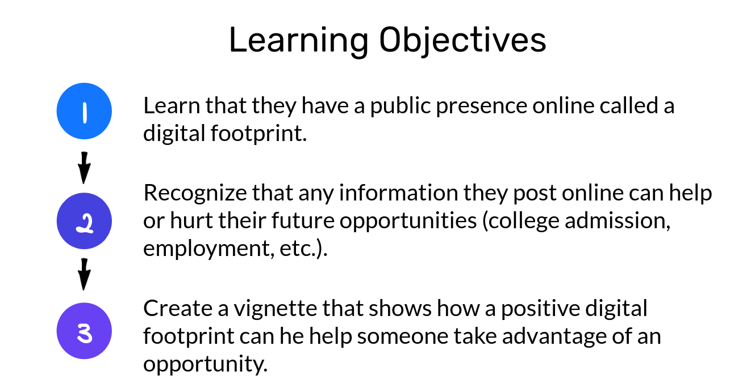
Step 3: What’s a digital footprint?
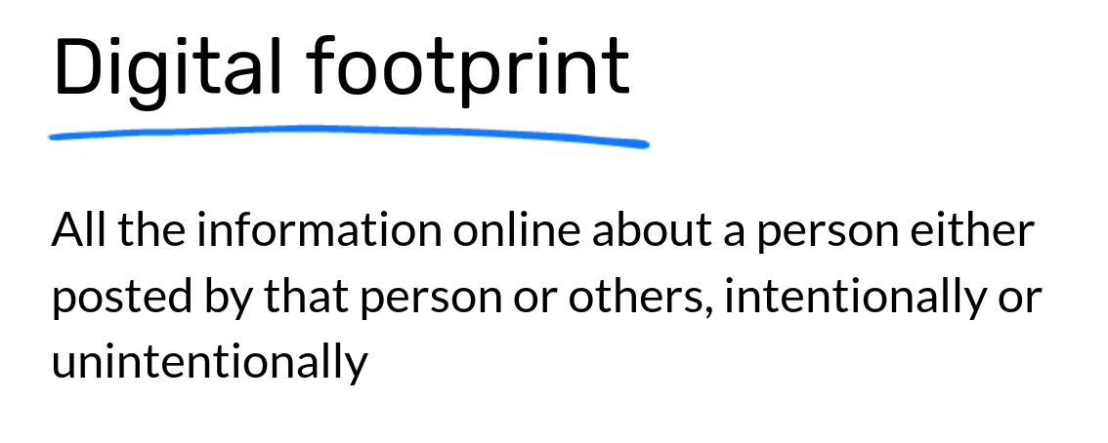
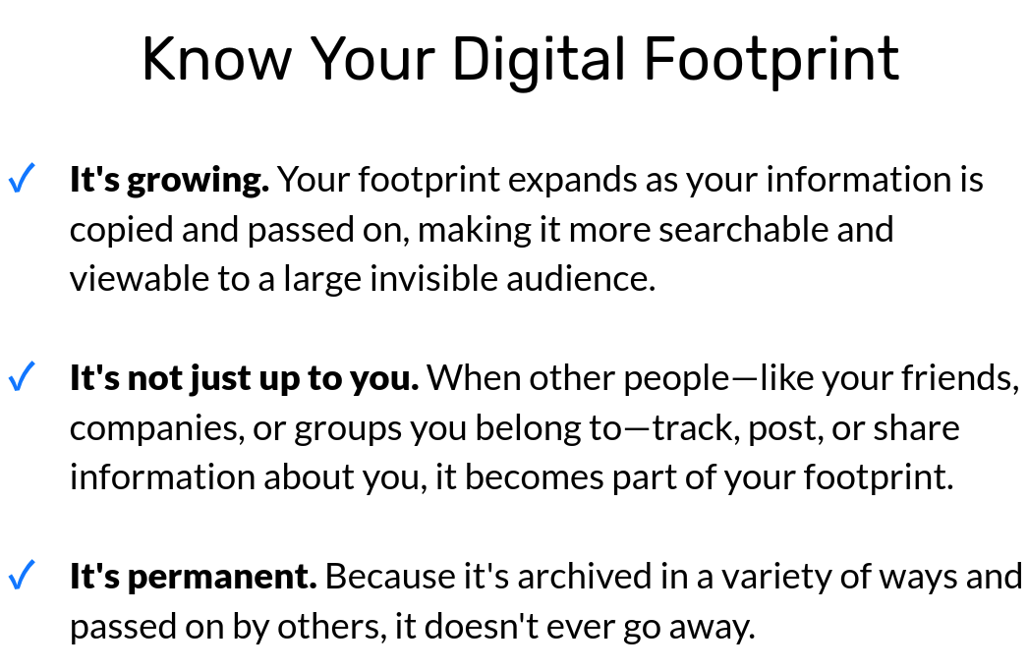

Step 4: Read the text.

Harvard Rescinds Acceptances for At Least Ten Students for Obscene Memes

Harvard College rescinded admissions offers to at least ten prospective members of the Class of 2021 after the students traded explicit memes and messages that sometimes targeted minority groups in a private Facebook group chat.

After discovering the existence and contents of the chat, Harvard administrators revoked admissions offers to at least ten participants in mid-April, according to several members of the group. University officials have previously said that Harvard’s decision to rescind a student’s offer is final.

College spokesperson Rachael Dane wrote in an emailed statement Saturday that “we do not comment publicly on the admissions status of individual applicants.”

The chat grew out of a roughly 100-member messaging group that members of the Class of 2021 set up in early December to share memes about popular culture. Admitted students found and contacted each other using the official Harvard College Class of 2021 Facebook group.

“A lot of students were excited about forming group chats with people who shared similar interests,” Jessica Zhang ’21, an incoming freshman who joined both chats, wrote in an email. “Someone posted about starting a chat for people who liked memes.”

Messages shared in the original group were mostly “lighthearted,” wrote Zhang, who said she did not post in the split off meme group and that her admission offer was not rescinded. Luca said the founders of the “dark” group chat demanded that students post provocative memes in the larger messaging group before allowing them to join the splinter group.

“They were like, ‘Oh, you have to send a meme to the original group to prove that you could get into the new one,’” Luca said. “This was a just-because-we-got-into-Harvard-doesn’t-mean-we-can’t-have- fun kind of thing.”

Employees in the Admissions Office emailed students who posted offensive memes in mid-April asking them to disclose every picture they sent over the group, according to one member of the chat whose admission offer was revoked. The student spoke only on the condition of anonymity because they did not want to be publicly identified with the messages.

“The Admissions Committee was disappointed to learn that several students in a private group chat for the Class of 2021 were sending messages that contained offensive messages and graphics,” reads a copy of the Admissions Office’s email obtained by The Crimson. “As we understand you were among the members contributing such material to this chat, we are asking that you submit a statement by tomorrow at noon to explain your contributions and actions for discussion with the Admissions Committee.”

“It is unfortunate that I have to reach out about this situation,” the email reads.

What do you think about Harvard’s decision?

This isn’t the first time this has happened. How do you think we can help prevent this situation in the future?

Can you fill your digital footprint with things you think make up your digital identity?
Student Feedback:
Circle the emojis that best represents how this activity made you feel.
Mindfulness Moment!
Day 1: Diversity & Intersectionality
Social Studies

What is this lesson about?: In today’s lesson you will read about different areas of our society that are becoming more divers, from emojis to our government leaders. You will learn what :intersectionality means.”

Step 1: Read the article

How diverse emojis encourage more social Inclusion
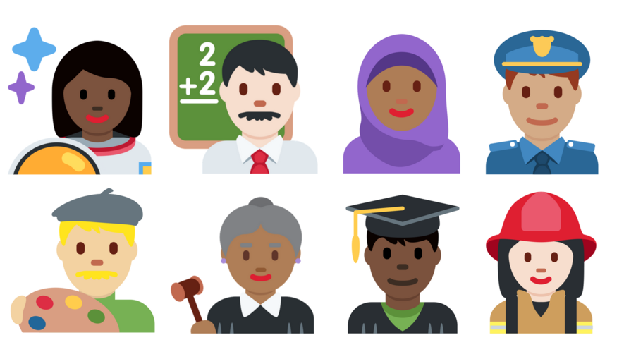
In 2010, emojis looked pretty different. They were all the same generic yellow skin tone. By 2015, emoji-makers had added new codes. People could change their emojis' skin color. The icons still defaulted to yellow, but now they came in five skin tones. They ranged from "pale white" to "darkest brown."

Concerns About Racism On Internet
Not everybody was happy about the new emojis. Some people thought they should all stay yellow. Others argued icons in different colors could be misused on social media. They could lead to hurtful racist comments or other bad behavior. Some people, though, celebrated the new colors. They were excited for the skin tone of the icons to look more like the people using them.
So far, most of those early fears haven't come true. A new study shows that social media users don't use the emojis with different skin tones for anything mean. In fact, these emojis have
actually made the Internet a more welcoming place. More people feel comfortable using emojis when they can find one that looks like them.

"It makes perfect sense" to have emojis that look like the people using them, said Debra Adams Simmons. Simmons is an editor with the magazine National Geographic. In April 2018, she put together a special issue of the magazine. It focuses on race.

People's Skin Color Matches Up With Emojis, Study Says
Researchers at the University of Edinburgh in Scotland have been spending a lot of time on Twitter. To see how people's skin color matches up with the emojis they use, they read through a billion tweets. The researchers found that most people who changed their emojis' skin color picked one similar to their own. Users with darker skin tones were more likely to change their emojis than people with lighter skin tones. Emojis, the researchers say, is one way people express themselves online. Twitter users didn't just make their emojis darker, though. Nearly half of non- yellow emojis used light skin tones.

Positive Tweets
Some tweets used emojis that were darker or lighter than the user's skin tone. These tweets might have been talking about people from a different race. Thankfully, most of these tweets were positive.

According to another study, there are more white people who use Twitter. However, black people use Twitter more often. White people don't usually use emojis with pale skin tones. Why? As emoticon researcher Tyler Schnoebelen told the Atlantic, "they're kind of represented by the default anyway." In other words, people with light skin look more like the yellow emojis than people with dark skin.

Throughout most of the world, the darkest skin tones were used the least. The authors have a guess as to why. Fewer people have Internet access in poorer parts of the world. That also tends to be where people with dark skin make up the majority.

Meeting Demand
"The introduction of skin tone choices for emojis has been a success," said Walid Magdy. He was one of the Edinburgh researchers. The use of these emojis, he said, "shows that they meet a real demand from users."

Not Just Black And White
In the National Geographic issue on race, photographer Angélica Dass took snapshots of 4,000 people. Then she paired their portraits with paint color swatches. The project covers people from
18 countries. Dass' point was to show that the world is not just black and white. People come in all kinds of colors. These days, so do their emojis.

That's no surprise, said Simmons. A person's emoji choice often tells a lot about how they see themselves.

Step 2: Answer the questions

1. Read the section "Concerns About Racism On Internet."
Which sentence from the section shows why some people were concerned about the new emoji colors?
(A) Others argued icons in different colors could be misused on social media.
(B) More people feel comfortable using emojis when they can find one that looks like them.
(C) "It makes perfect sense" to have emojis that look like the people using them, said Debra Adams Simmons.
(D) They were excited for the skin tone of the icons to look more like the people using them.

2. Read the selection from the section "Positive Tweets."
According to another study, there are more white people who use Twitter. However, black people use Twitter more often. White people don't usually use emojis with pale skin tones. Why? As emoticon researcher Tyler Schnoebelen told the Atlantic, "they're kind of represented by the default anyway." In other words, people with light skin look more like the yellow emojis than people with dark skin.

Which of the following is the MOST accurate explanation of this paragraph?
(A) People with darker skin tones prefer to change their emoji's skin tone.
(B) People prefer emojis that match their own skin tone.
(C) People use the darkest skin tones the least for emojis.
(D) People with light skin feel represented by the yellow emojis.

3. Read the paragraph from the article.
In the National Geographic issue on race, photographer Angélica Dass took snapshots of 4,000 people. Then she paired their portraits with paint color swatches. The project covers people from 18 countries. Dass' point was to show that the world is not just black and white. People come in all kinds of colors. These days, so do their emojis.

How does this paragraph support the MAIN idea of the article?
(A) It shows that there are over 4,000 skin tones.
(B) It highlights the diversity of skin tones in the real world.
(C) It explains how the emoji skin tones were developed.
(D) It proves that the skin tone choices have been a success.

4. Which sentence from the article BEST supports the article's CENTRAL idea?
(A) Users with darker skin tones were more likely to change their emojis than people with lighter skin tones.
(B) More people feel comfortable using emojis when they can find one that looks like them.
(C) These tweets might have been talking about people from a different race.
(D) In other words, people with light skin look more like the yellow emojis than people with dark skin.

Step 3: Read the second article.

Elections add a number of firsts for Congressional diversity
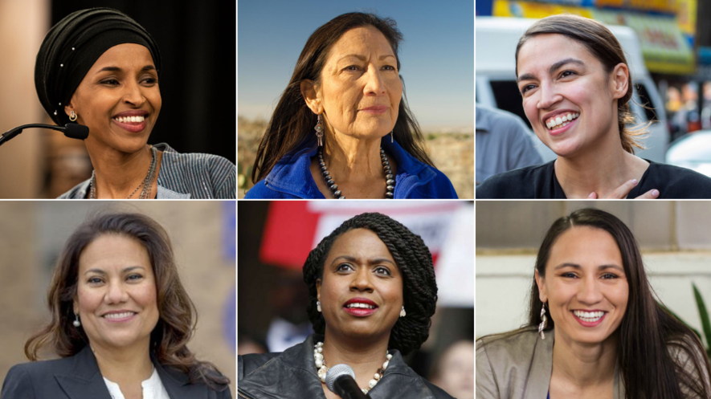
WASHINGTON, D.C. — The United States elected new members of Congress on November 6. The new lawmakers will take office in January. When they do, it will be the most diverse Congress ever.
It will include lawmakers from many different backgrounds.

Congress is made up of two chambers, the House of Representatives and the Senate. For the first time, a pair of Native American women are headed to the House of Representatives. So are two Muslim women. Muslims are those who practice Islam, which is a major world religion.
Massachusetts and Connecticut will also send black women to Congress as firsts for their states.
Meanwhile, Arizona and Tennessee are getting their first female senators.

The midterm elections received a lot of attention. Republicans and Democrats are the country's
two main political parties. They were fighting to win a majority of seats in Congress. Democrats
will now have a majority in the House. Republicans will keep their majority in the Senate.
President Donald Trump is a Republican.

Pioneering Lawmakers
The midterms produced a record number of women candidates and candidates of color. This

means a number of winners will make history as trailblazers by taking office. Kimberly Peeler-
Allen is a leader of Higher Heights for America. The group is focused on encouraging black women to vote and electing black women as candidates. The election victories for women and people of color are a good sign for future election cycles, Peeler-Allen said.

Electing a Congress that reflects the population of the United States is still going to take a long
time, Peeler-Allen said. Congress is still more white and more male than the general population.
She said these victories were a big step forward, though. She added that even women of color who were unsuccessful still made a difference. Their experience will show a new group of candidates that they should run, too.

Many First-Time Candidates
Some of the election's black female winners were first-time candidates. They include Illinois nurse
Lauren Underwood and Connecticut teacher Jahana Hayes. Others, like Massachusetts' Ayanna
Pressley, were already lawmakers. Many were considered to have a slim chance of winning.
Several will represent districts that are majority white. Some of those districts have historically
supported more traditional ideas. These candidates' victories challenge common ideas about who
is electable and who is not.

Pressley is currently a Boston city councilwoman. Now she will represent Massachusetts in the
next Congress. Pressley surprised her state's politicians in September by defeating a lawmaker
who had been in office for 20 years. She then ran unopposed in the election on November 6.
Making Change And History "None of us ran to make history," Pressley told supporters in her victory speech on November 6.

"We ran to make change." She said she recognized that her victory was a significant moment in
history, though.

New York's Shirley Chisholm was the first black woman in Congress. She was elected almost
exactly 50 years ago. Several of the black women elected on November 6 have said they were
following her example.

The first two Muslim women to serve in Congress will also be joining the House of
Representatives. They are Ilhan Omar of Minnesota and Rashida Tlaib of Michigan. Both are
Democrats. New Mexico's Deb Haaland and Kansas' Sharice Davids won their elections, too. They will be the first Native American women to serve in Congress. They are also both Democrats.Mike Espy will face Mississippi lawmaker Cindy Hyde-Smith in a December runoff election. Espy could become the state's first black senator since the late 1800s.

Arizona's Senate race is too close to declare a winner yet. Either Republican Martha McSally or
Democrat Kyrsten Sinema will become the state's first woman senator. Marsha Blackburn will become Tennessee's first woman senator.

Significant Governor's Races

Georgia candidate Stacey Abrams was in a fierce battle to become America's first black woman
governor. The race is still too close to call. Democrat Andrew Gillum lost a close race to become
the first black governor of Florida.

Idaho candidate for governor Paulette Jordan also lost her race. She would have become the
country's first Native American governor.

Election night also saw victories for the LGBT community. LGBT stands for lesbian, gay, bisexual
and transgender. Jared Polis became the governor of Colorado. He will be the country's first
openly gay man elected governor.

Step 4: Read the third article.

What is intersectionality?
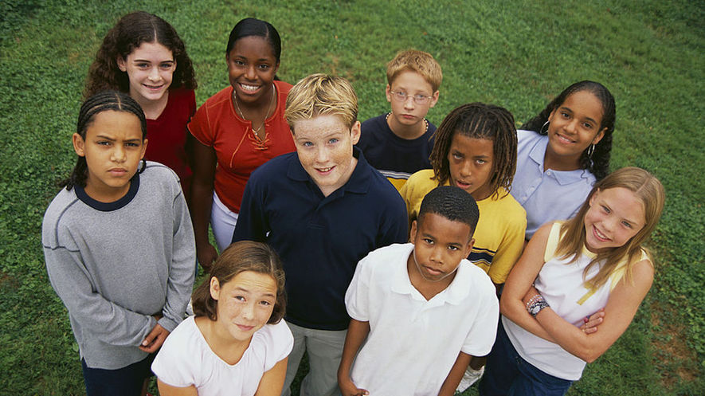
Intersectionality refers to the different kinds of identities people have. It studies how these multiple identities connect and affect a person’s life. These identities are race, gender, sex, disability, and sexual orientation, as well as where they live and socioeconomic status. Intersectionality also impacts how oppression and privilege connect and influence each other. Oppression is when someone faces unfair treatment because of their identity. Privilege is when someone has a special advantage because of their identity.

Nicole: An Intersectional Case Study
Nicole is in the ninth grade. She is a mature, creative, hardworking student, and gets along well with others. The only thing is, she’s always late for school. She frequently misses her first-period class and rarely turns in homework, and as a result, her grades are suffering. Nicole’s teachers know very little about her life, and when they look at her, they may only see an African-American student who isn’t doing well. They may think of Nicole as an example of the fact that most students who miss class or drop out of school are black or Latino.
If teachers took the time to peel back the layers of Nicole’s life they would see another part of her identity — her socioeconomic status. This would offer a better understanding of who Nicole is. Nicole isn’t just a black student, she has other identities. She identifies as a girl and as a kid from a low-income family. She is responsible for taking care of her two younger siblings. To fully and properly support Nicole, a teacher must know and respect these kinds of details. They must see her situation through the many identities that makeup who Nicole is. That is the best way to understand how her identities impact her performance at school. Understanding these can help teachers better understand the circumstances surrounding Nicole that are affecting her grades and absences.
Legal scholar and law professor Kimberlé Crenshaw coined the term intersectionality in 1989. She makes the case that society usually ignores many parts of people’s identities. People may see only the race, religion, or economic status of others, which can lead to prejudice and oppression.
In Nicole’s case, the problems she faces aren’t just about her multiple identities, but also stem from the oppressions that come with her identities. Her situation reflects the experiences of low-income people more than rich people and shows what specific challenges she faces as a girl and a black student. Specifically, Nicole must navigate parents who work long hours outside the home while also facing expectations as a female. As a female she is expected to take care of her siblings as their caretaker while her mother is at work. At school, teachers may have low expectations for her because she is a girl and African-American.

Oppression, Power And Privilege In The Classroom
In the classroom, understanding multiple identities can help teachers and classmates better relate to each other. It can also help them understand the relationship between power and privilege in the classroom.
Christina Torres is a teacher at the University Laboratory School in Honolulu, Hawaii. She makes sure to view her students through their multiple identities. She describes this mindset as “understanding that there’s a long background” to who her students are. In general, girls have different life experiences than boys; blacks have different life experiences than whites; children from rich families have different life experiences than children from low-income families. Understanding context is also key, Torres says. “A woman who is Latina in L.A. is going to have a very different experience from someone who’s in the middle of Arkansas. The place matters, too.”
Torres’ ninth-grade class also explores internalized oppression. Internalized oppression is when people give in to the negative messages about who they are. For example, a mother playing catch with her daughter may tell her not to “throw like a girl.” In this example, the mother has bought into the negative message that boys are better than girls at sports, and may be passing that message to her daughter.

Navigating The Intersections
Discussions about intersectionality and oppression might seem too difficult to talk about in class, but when a teacher brings up these difficult topics they show they care deeply about their students. In fact, Torres begins the year by asking her students to consider where and how they fit into their communities. She asks them to explore what makes them feel worthwhile there.
By emphasizing intersectionality, she equips her students with the skills to examine why they believe what they believe. They learn to question why their beliefs might differ from others’ and to determine how their ideas might be influenced by power and privilege. For Torres, helping students like Nicole navigate the world — and the way the world responds to them — is an important part of her responsibility as an educator.
“Every day kids enter our class, there’s an opportunity for them to be empowered or oppressed,” she says. “When I don’t consider intersectionality and what they might need, I run the risk of oppressing my kids. ... When we stop seeing our kids as whole people ... we stop seeing them as real people.”
Step 5: Answer the Questions

Which sentence from the article is MOST important to include in its summary?
(A) The understanding of how identities overlap and affect each other is called intersectionality.
(B) If her teachers knew more about Nicole, they would find out about the intersectionality within her
identity.
(C) For example, a mother playing catch with her daughter may say "don't throw like a girl."
(D) They learn to question why they may have different ideas than a friend or classmate.

2 What is the MAIN idea of the section "Navigating The Intersections"?
(A) Children should always question their ideas and the ideas of their peers.
(B) Torres believes that her biggest responsibility is to care for her student Nicole.
(C) Being aware of intersectionality in students can help them understand themselves and the world.
(D) Torres is a caring teacher who supports her students no matter what their intersectionality represents.

3 Based on the article, WHY is intersectionality important for understanding oppression?
(A) because it helps people understand that there are many factors that explain a person's situation in life
(B) because it explains why people are born with different races, genders and disabilities
(C) because it is a major cause of all of the unfairness and inequality that everyone faces in the world
(D) because it is the reason why Nicole is struggling in school even though she is a good student and gets along with others

4 Which section of the article explains HOW intersectionality can affect people?
(A) Introduction [paragraphs 1-2]
(B) "Nicole: An Intersectional Case Study"
(C) "Intersectionality In The Classroom"
(D) "Navigating The Intersections"
Student Feedback:

Circle the emojis that best represents how this activity made you feel.

